Virom-Charakterisierung anhand unprozessierter lokaler und öffentlich verfügbarer Sequenzierungsdaten
Virome characterisation from unprocessed local and publicly available sequencing data

Masterarbeit
zur Erlangung des Hochschulgrades
Master of Science (M.Sc.)

im Studiengang Biomedizinische Datenwissenschaft
der Medizinischen Hochschule Hannover

vorgelegt von
Sergej Ruff
Geboren am 23.12.1997
In Kustanai, Kasachstan

Hannover, <Monat (ausgeschrieben) Jahr (Zahl)>

Die vorliegende Masterarbeit wurde im Zeitraum vom 08.04.2024 bis 08.10.2024
im Twincore, Zentrum für Experimentelle und Klinische Infektionsforschung GmbH
angefertigt.

Erstgutachter/in: | Jun. Prof. Dr. Chris Lauber
 | Leiter der Forschungsgruppe Computergestützte Virologie
 | TWINCORE – Zentrum für Experimentelle und Klinische Infektionsforschung
Zweitgutachter/in: | Prof. Dr. rer. nat. Helena U. Zacharias
 | Leiterin Bereich Klinische Datenwissenschaften
 | Peter L. Reichertz Institut für Medizinische Informatik der TU Braunschweig und der Medizinischen Hochschule Hannover
Abgabedatum:

1 Introduction 1
1.1 The need for virus discovery 1
1.1.1 Pandemics are increasing and they are caused by viruses 2
1.1.2 The virome: ‘our’ viruses 4
1.1.3 Tracing the evolutionary history and surrogates viruses 8
1.2 History of viral discovery 10
1.3 VirusHunter and VirusGatherer 13
1.3.1 ‘Hunting’ for viruses in unprocessed data 16
1.3.2 Viral taxonomy 18
1.3.3 ‘Gathering’ viral reads for assembly 22
1.3.4 Comparison to other approaches 23
1.4 Aim of thesis 25
2 Material and Methods 26
2.1 Code Availability Statement 26
2.2 Data Availability Statement 26
2.3 Software used 26
2.4 Sequencing data 27
2.4.1 Taubert liver transplant data 27
2.4.2 Mammalia data 28
2.5 VirusHunter 30
2.5.1 SRA download 30
2.5.2 Preprocessing of FASTQ files for VirusHunter 30
2.5.3 Sensitive homology-based detection of viral sequence reads in unprocessed data 30
2.5.4 Filtering against contaminants and viral reference sequences 31
2.5.5 Output of VirusHunter 32
2.6 VirusGatherer 33
2.6.1 Assembly of Contigs 33
2.6.2 Compare against viral reference database 34
2.6.3 Output of VirusGatherer 34
2.7 Virusparies 35
3 Results 37
3.1 Characterization of the virome after liver transplantation 37
3.1.1 37
3.1.2 39
3.1.3 40
3.2 Characterization and assembly of RNA viruses from mammalian samples 42
3.2.1 42
3.2.2 42
4 Discussion 45
5 Appendix 46
6 List of references 47

List of Abbreviations

Abbreviations | Meaning
pHMM | Profile Hidden Markov Model
SRA | Sequence Read Archive

Table of Figures

Index of Tables

Introduction

1.1 The need for virus discovery
Viruses are omnipresent. In aquatic environments, a single millilitre can contain up to hundreds of millions of viral particles [Source: High abundance of viruses found in aquatic environments]; while in soil, a gram can hold as many as a billion. [Source: Viruses in soils: morphological diversity and abundance in the rhizosphere]. However, one need not dig into the earth or dive into the ocean to encounter viruses, as the human body itself is a viral ecosystem, housing over 10¹³ viral particles. With an estimated 10³¹ viral particles globally, viruses outnumber all other life forms combined – including animals, plants, fungi, bacteria, and archaea [Quelle 1: Evolutionary relashionship among diverse bacteriophages and prophages. Quelle 2: Are there 1031 virus particles on earth, or more, or fewer?].
Viruses also exhibit remarkable structural diversity, displaying a range of genomic configurations that set them apart from other life forms. While most organisms utilize double-stranded DNA to store genetic information, viruses can possess either DNA or RNA, existing in forms that are single-stranded or double-stranded, linear or circular [Buch Virologie]. Their genomes may consist of a single continuous piece of nucleic acid or be segmented, and they can be classified as positive-sense (read in the 5' to 3' direction) or negative-sense (read from 3' to 5') [BUCH Virologie].
While viruses are abundant and exhibit notable genomic diversity, our historical understanding of them has often been overly simplistic, framing them primarily as pathogenic agents without considering any potential beneficial roles they might play in their hosts or ecosystems. Contemporary research has begun to reshape this perspective. In addition to their ability to cause disease and pandemics, viruses may also contribute positively to the environment. For example, viruses lyse ~40% of marine prokaryotes daily, stimulating the plankton growth [The ecological virus]. In humans, viruses have also played a role in shaping our evolution. Around 8% of the human genome consists of human endogenous retroviruses (HERVs), which resulted from the integration of these viruses into our genome. Although these viral sequences are no longer infectious, some still produce transcripts and have been linked to various cancers, including ovarian cancer [Expression of multiple human endogenous retroviruses surface envelope proteins in ovarian cancer], prostate cancer [selective changes of retroelements expression in human prostate cancer], breast cancer, and lymphoma [Human Endogenous Retrovirus K elements in plasma of people with Lymphoma and brest cancer], and melanoma [The activation of human endogenous retrovirus K is implicated in melanoma of malignant transformation]. On the other hand, HERVs also play beneficial roles, such as contributing to human placental morphogenesis [Syncytin is captive retroviral envelope protein involved in human placental morphogenesis].
Despite these insights, the virosphere remains largely unexplored, as do its complex interactions with hosts and ecosytems. It is estimated that 1.67 million unknown viral species exist, with up to 827,000 potentially capable of infecting humans [The global virome project, A strategy to extimate unknown viral diversity in mammals].
Virus discovery focuses on identifying these new and unknown viruses. The thesis explores the history of viral discovery and introduces a modern, data-driven approach that leverages publicly available, unprocessed data. Specifically, it presents VirusHunter, a tool for data-driven viral discovery (DDVD), alongside VirusGatherer, which assembles identified viral contigs. The competition landscape to VirusHunter and VirusGatherer is also be discussed, concluding the Introduction with the goals of the master thesis.
But first, I begin by addressing a key question: 'Why do we need virus discovery?'

1.1.1 The increasing frequency of pandemics and their viral origins
Between 1918 and 1919, an avian influenza virus that had previously infected only waterfowl began to spread to farm poultry and pigs. Eventually, it breached the species barrier, posing a global threat to humans. Known as the ‘Spanish’ influenza H1N1, this pandemic infected one-third of the global population with more than 50 million deaths. Historically, major pandemics like the ‘Spanish Flu’ were rare, occurring perhaps once or twice per century. However, in recent decades, the frequency of pandemics has significantly increased due to factors such as globalization, increased air travel, population growth, and human encroachment into wildlife habitats.
The first two decades of the 21st century alone have witnessed six major pandemics. The first was the SARS pandemic from 2002 to 2004, caused by the SARS-CoV virus from the Coronaviridae family. This was followed by the H1N1 ‘swine flu’ pandemic in 2009. Between 2012 and 2016, several viral outbreaks emerged, including Middle East Respiratory Syndrome (MERS), the Ebola virus epidemic, and the Zika virus outbreak. Most recently, the global COVID-19 pandemic, caused by SARS-CoV-2, emerged in 2019.
Notably, all six major pandemics of this century have been caused by viral infections, with the majority originating from animals and transmitted primarily through airborne means. Viruses that emerge through zoonosis pose a significant threat because the new host species lacks existing immunity. As the host's immune system has not previously encountered these viruses, this lack of immunity, combined with the airborne transmission, increasing population densities, and intensified human-animal interactions, facilitates rapid viral spread across populations.
Effective prevention of global pandemics relies on the prompt identification of the causative virus. Early identification is critical for the development of diagnostic tools, vaccines, and treatments, as these depends on knowing the infectious agent and its pathogenic mechanisms. Monitoring existing viruses and discovering new ones has long been feasible through methods like metagenomic analyses of wastewater and other environments [Raw sewage harbors diverse viral populations,Diverse circovirus-like genome architecture revealed by environmental metagenomics, Eukaryotic viruses in wastewater samples from US;]. However, viral discovery is notably more challenging than the identification of bacteria or fungi. Bacteria can often be identified using cultures and 16S rRNA sequencing, and fungi through internal transcribed spacer (ITS) region sequencing. In contrast, viruses lack standardized culture methods and universal sequencing markers, complicating the discovery process. Instead, thorough sampling of the viral community, genome sequencing, and comparison with existing reference genomes are necessary. This is complicated by the absence of yet uncharacterized viruses in reference databases and the difficulty of detecting sequences with low homology to known viruses. Yet, despite these challenges, rapid monitoring of viral activity is crucial, as climate change and global interconnectedness elevate our contact with both humans and animals, heightening the risk of new outbreaks and potential pandemics [Did Climate change influence the emergence, transmission and expression of the covid-19 pandemic].

1.1.2 The virome: viruses within the body
Besides the identification of viruses during possible pandemic and disease scenarios, viral discovery could also enhance our understanding of the virome—the collective population of eukaryotic and prokaryotic viruses inhabiting the host body. Traditionally, viruses were viewed solely as disease-causing agents with no benefits to their hosts or the environment. However, this perception has radically shifted. Today, we recognize that each human harbors a virome consisting of over 10¹³ viral particles, with each body site creating its own niche, and each niche harboring viruses that may have no pathogenic effects or even offer beneficial effects to the host.
For example, the digestive system houses the most abundant population of viruses, most of which target the bacteria in our gut. These viruses, known as bacteriophages, inject their genome into bacterial cells, after which they can take one of two pathways. In the lytic cycle, they exploit the host’s replication machinery to produce more viral particles, which are released by lysing/destroying the host cell. Alternatively, in the lysogenic cycle, the bacteriophage genome integrates into the host’s genome and remains dormant, switching to the lytic cycle when stress signals indicate a threat to the virus's genomic stability [The human virome: assembly, composition and host interactions]. This integration may benefit the host by inducing mutations that help bacterial adaptation [Ecological and evolutionary Benefits of temperate Phage: What does or doesn’t kill you makes you stronger], or by providing immunity against further viral infections through mechanisms like CRISPR-Cas systems [Analysis of virus genomes from glacial environments reveals novel virus groups with unusual host interactions]. On the other hand, direct lysis of bacteria controls the composition and functionality of the microbiome by removing non-resistant strains, while bacteriophage composition adapts to bacterial resistances, driving antagonistic co-evolution [“I will survive”: a tale of bacteriophage-bacteria coevolution in the gut; Explaining microbial population genomics through phage predation; Coevolution with viruses drives the evolution of bacterial mutation rates: Coevolution with bacteriophages drives genome-wide host evolution and constrains the acquisition of abiotic-beneficial mutations]. Direct lysis has also been shown to contribute to human innate immunity, as some T4 phages can associate with the mucosal surface of the gastrointestinal tract, preventing bacterial infection of epithelial cells by eliminating invading bacteria [Subdiffuse motion of bacteriophage in mucosal surfaces increases the frequency of bacterial encounters]. This means the virome can play a direct role in establishing an innate immune barrier.
Some eukaryotic viruses can integrate their genomes into host cells, including human cells. About 8% of the human genome consists of human endogenous retroviruses (HERVs), which are the result of viral integrations that have occurred throughout human evolution. While these HERVs are no longer infectious, they can still produce transcripts linked to several cancers, such as ovarian cancer [Expression of multiple human endogenous retroviruses surface envelope proteins in ovarian cancer], prostate cancer [Selective changes of retroelements expression in human prostate cancer], breast cancer and lymphoma [Human Endogenous Retrovirus K elements in plasma of people with lymphoma and breast cancer], and melanoma [The activation of human endogenous retrovirus K is implicated in melanoma of malignant transformation]. Conversely, some HERVs have beneficial roles, such as contributing to human placental development [Syncytin is a captive retroviral envelope protein involved in human placental morphogenesis].
Some viruses can remain latent but may reactivate under certain conditions. Human herpesvirus 6, which affects nearly 90% of the population, can cause a range of symptoms when active, including reduced production of blood cells in the bone marrow (myelosuppression), inflammation of the lung (pneumonitis) and brain tissue (encephalitis), and skin rashes. Additionally, herpesvirus 6, along with adenoviruses, can play a role in graft-versus-host disease, where donor immune cells attack the recipient's cells after transplantation [Adenovirus infection and disease in paediatric hsc transplant; The complex relashionship between human herpesvirus 6 and acute GvHD; HHV-6 Reactivation and associated sequelae after HCT]. Conversely, while viruses from the families Redondoviridae and Anelloviridae may become more abundant in immunosuppressed individuals, no health issues are currently known to be associated with them. This illustrates the dual nature of viruses, where some can cause significant health problems while others may coexist peacefully within the host. [human virome: assembly ….].
Various host-related factors can further influence the virome's composition and abundance over time. Under normal circumstances, the virome develops shortly after birth [Viral diversity and dynamics in an infant gut;Amniotic fluid from healthy term pregnancies does not harbor a detectable microbial community], remains stable through adulthood, and decreases in old age [The gut virome database reveals age-dependent patterns of virome diversity in human gut], but smoking, for instance, has been shown to alter the composition of phages in the lung [The human gut virome: Inter-individual variation and dynamic reponse to diet]. Dietary habits also influence the virome, with many gut viruses originating from the food we consume, including plant-based viruses from the family Virgaviridae. One study examined how different diets affect the virome and found that individuals with similar diets had more closely related viromes than those with differing diets. A shift in diet throughout life can also influence the gastrointestinal virome. Research that fed mice a high-fat diet observed a decrease in viruses from the families Myoviridae, Siphoviridae, and Podoviridae, alongside an increase in Microviridae. As previously mentioned, phages can be either lytic or lysogenic, with most phages in the virome typically in the lysogenic state. However, this project also detected a shift toward more lytic viral communities, suggesting that phages can influence bacterial composition in response to dietary changes [Fecal viral community response to high fat diet in mice].
Recent work in both twins and non-twins emphasize the greater influence of shared environmental factors compared to genetic factors in shaping the virome [Gut DNA viromes of malawia twins discordant for severe acute malnutrition; Enviroment dominates over host genetics in shaping human gut microbiota;Virome diversity correlates with insetinal microbiome diversity in adult monozygotic twins]. Although genetics can affect the virome, especially in cases of immunodeficiencies [Genetics of epidermodyplasia verruciformis: Insight into host defense against paillomavirus], environmental factors like geography and social interactions play a crucial role. As an illustration, findings indicate that individuals from the same household typically have more similar oral viromes compared to those from different households, underscoring the impact of shared living environments on viral exposure. The exchange of viruses is not confined to humans; it crosses species barriers. Pets of individuals with COVID-19 have tested positive for the SARS-CoV-2 N gene and, in some cases, developed antibodies, indicating that humans can transmit the virus to their pets [Pet Animals Were infected with SARS-Cov 19 from their Owners]. Furthermore, humans themselves are not the natural reservoirs for SARS-CoV-2. Instead, the viruses responsible for major pandemics over the last 20 years—SARS-CoV-1, SARS-CoV-2, and MERS—are zoonotic diseases, originating in animals and transmitted to humans [Zootonic disease and virome diversity in bats]. This exchange of SARS-CoV-2 from animals to humans and from humans to animals illustrates the intricate web of viral transmission that connects different species.
Geography impacts the virome, as evidenced by the lower virome diversity observed in individuals from the highly urbanized city of Hong Kong compared to those in the less urban, partially rural Yunnan province in China. Notably, residents of Hong Kong exhibited an increased presence of phages targeting Lactobacillus and Lactococcus bacteria Human-Gut-DNA Virome Variantions across geography,Ethnicity, and Urbanisation]. Similarly, research indicated that Australian children in the Northern Territory with diarrhea displayed a higher prevalence of viruses from the Picornaviridae and Adenoviridae families compared to their counterparts in Melbourne [Geographic variation in the eukaryotic virome of human diarrhea].The environment not only shapes our virome but is also in return influenced by viruses. For instance, viruses lyse 40% of marine prokaryotes each day, stimulating plankton growth [The Ecological Virus]. Furthermore, they regulate the global carbon cycle by breaking down biomass, which contributes to new dissolved carbon sources in soil and water [The regulator function of viruses on Ecosystem Carbon Cycling in the Anthropocene].
In conclusion, viruses establish highly diverse and abundant populations within their hosts, interacting in various ways: they can cause disease, benefit the host, or have no known pathogenic effects. These interactions occur either directly or by altering the composition and functionality of the host’s microorganisms. Conversely, the host can influence its virome through changes in habits or environment. The environment affects the host, microorganisms, and virome, and is itself influenced by the virome. This creates a complex network of interactions. Many viruses remain unknown, leaving the complex mechanisms of this network largely unexplored. Virus discovery through metagenomic analysis of the virome and environmental samples can help identify these unknown viruses, leading to a better understanding of the virome and its interactions with other organisms and the environment.

1.1.3 Tracing the evolutionary history and surrogates viruses
Virus discovery can also aid in identifying surrogate viruses. The disease mechanisms and host responses of some viruses cannot be directly studied in their natural hosts, complicating the development of treatments and vaccines. In such cases, studying closely related viruses can provide a valuable alternative for research. An example of such a virus is the hepatitis C virus (HCV), a positive-sense-single-stranded RNA virus from the genus Hepacivirus within the Flaviviridae family, part of the phylum Kitrinoviricota [ICTV profile Flaviviridae]. An HCV infection can result in accumulation of scar tissue in the liver due to chronic inflammation (liver fibrosis), followed by impaired liver function (decompressed cirrhosis), and potentially develop into liver cancer (hepatocellular carcinoma, or HCC). According to the global hepatitis report 2024, 50 million people live with HCV infection, with nearly one million new cases reported in 2022 alone [Golbal hepatitis report 2024]. HCV is globally prevalent, with injection drug users being particularly at risk, exacerbated by the opioid epidemic in the United States. [Increase in hepatitis C virus infection related to injection drug use].
Current treatment for chronic hepatitis C infection in both children and adults relies on inhibiting components of the viral replication machinery and polyprotein processing using direct-acting antiviral regimens, such as sofosbuvir/declatasvir,sofosbuvir/velpatasvir, or glecaprevir/pibrentasvir [Hepatistic report 2024]. Yet, despite the availability of these treatments, access is still restricted in under-resourced areas, for those without sufficient health coverage, and among injection drug users who face a higher risk of reinfection [ethnic and cultural determinants influence risk assessment of hepatitis c acquision;Implementanting scaling up HCV treatment services for people who inject drugs and other high risk groups in ukraine]. Given that certain populations are at higher risk of reinfection and may not have access to repeated treatments, a long-term solution would necessitate the development of a vaccine against HCV.
Clinical studies for vaccine development typically involve a phase where the vaccine is tested on animal models [The clinical development process for a novel preventive vaccine: an overview]. For HCV, chimpanzees have been used as animal models because they are the only species, besides humans, that naturally hosts the virus. In chimpanzees, the first HCV clone was developed [Transcripts from single full-length cDNA clone of hepatitis C viruses are infected when directly transfected into the liver of a chimpanzee; Transmission of hepatitis C by intrahepatic inoculation with transcribed RNA], and significant insights into the role of CD8+ and CD4+ cells during infection were obtained [Memory Cd8 T cells are required for protection from persistent hepatitiss c virus infection;conserved hierarchy of helper T cell responses in a chimpanzee during primary and secondary hepatitis c infections.]. Despite these advances, chimpanzee use in biomedical research is now heavily restricted following the national center for research’ decision to halt funding for chimpanzee breeding [The beginning of the end for chimpanzee experiments] and their 2015 designation as endangered by the U.S fish and wildlife service [US Fish and Wildlife serice finalizes Rule listing all chimanzees as eendangered]. Consequently, the national institute of health (NIH) has since ceased support for such studies as well [NIH will no longer support biomedical research on chimpanzees].
Since then, alternative approaches have been sought to ensure continued HCV research. One approach involves discovering and developing new model organisms, particularly in small animals, but this has proven challenging due to HCV’s limited host range [Animal Models used in HCV research]. Another strategy relies on discovering new viruses closely related to HCV as potential replacement for HCV and chimpanzees. So far, over 250 viruses from the Flaviviridae family have been discovered, with hosts being both primates and other mammals such as horses, dogs, and bovines [Animal Models used in HCV research]. In 2016, the discovery of the first Hepacivirus infecting non-mammals in catsharks significantly broadened our understanding of Flaviviridae diversity, as Hepaciviruses had previously been known to infect only mammals, and before 2011, exclusively humans and primates [Divergent Viruses Discovered in Arthropods and Vertebrates revise the evolutionary history of Flaviviridae and related viruses; The Strange expanding world of animal Hepaciviruses]. As for primates, the George Baker Virus B (GBV-B) has shown to be highly valuable in research. GBV-B, a positive-sense single stranded RNA virus of the family Flaviviridae and genus Hepacivirus, was first identified in tamarins that developed hepatitis after exposure to serum from a patient named George Baker [Animal Models used in HCV research, Identification of two flavivirus-like genomes in the GB hepatitis agent]. Tamarins are more manageable in laboratory setting due to their smaller size and their immune response after infection shows similarities to humans. A virus more closely related to HCV than GBV-B is the equine hepacivirus, which has also been found in canines (canine hepacivirus). Hepaciviruses have been also identified in other mammals, such as bats, cattle, and rodents. However, these non-primate hepaciviruses have not yet proven to be effective substitutes for HCV [Animal Models used in HCV research]. For that reason, GBV-B serves as the current surrogate for HCV in research, but it has its limitations. Chimeric vectors combining HCV and HBV-B sequences exhibit reduced efficacy [Animal Models used in HCV research].Moreover, tamarin breeding is costly, and while chronic infection is a common symptom of HCV, tamarins rarely develop it naturally after GBV-B infection, with current lab methods proving inadequate for establishing chronic infection. Similarly to research involving chimpanzees, studies with tamarins raise ethical concerns about animal welfare and necessitate specialized facilities and expert veterinary care, driving up costs [Marmosets as models of infectious diseases].This highlight the need for further optimizing current methods, and also identifying additional surrogate viruses for HCV.
The role of viral discovery is of note here. Prior to 2011, hepaciviruses were thought to infect only humans and chimpanzees. However, the discovery of new mammalian and non-mammalian hepaciviruses has revealed the diverse nature of Flaviviridae and enabled continued HCV research despite the restrictions on chimpanzees as models. Meaning, viral discovery enables us to identify both new and known viruses, understand their evolutionary history and relationship, and use closely related viruses as surrogates for other members of their family.

1.2 History of viral discovery
The history of virus discovery began with the work of Russian biologist Dmitri Iosifovich Ivanovsky in the late 19th century. While studying at the University of Saint Petersburg, Ivanovsky investigated a disease affecting tobacco plant crops in Ukraine and Bessarabia, which he named "pock disease". Later, he was sent to Crimea to study tobacco plants afflicted with brown spots, consistent with the disease he had described. The plants also displayed dark-green and yellow areas on their leaves, symptoms now recognized as tobacco mosaic disease.
This disease had first been described by Adolf Mayer, who noted that it could infect nearby tobacco plants but lost its infectious quality if bacteria were filtered from the plant sap. To test this, Ivanovsky used a porcelain Chamberland filter, which retained bacteria and other microorganisms but allowed particles smaller than bacteria to pass through. He inoculated healthy plants with the filtered homogenate from affected plants. The inoculated plants soon exhibited the same distinct mosaic pattern on their leaves. Ivanovsky published the discovery of the tobacco mosaic virus in 1892, revealing the existence of infectious agents smaller than bacteria. In 1989, Martinus Willem Beijerinck independently identified the tabacco mosaic virus and introduced the concept of a virus as infectious particles that could only replicate inside living cells. Seven years after Ivanovsky and the discovery of the first (plant) virus, the presence of viruses in animals was confirmed. Notably, up to this point, only the presence of small infectious particles could be proven, but their identity, structure, and sequence remained unknown.
It was not until 1935 that Wendell Meredith Stanley managed to crystallize the infectious particles of TMV, and another six years later, John Desmond Bernal and Isidor Fankuchen used X-ray diffraction on these crystallized particles, leading to the first description of the viral structure’s size and shape in 1941. Meaning it took 49 years between Ivanovsky's first viral discovery and the first description of the viral structure of the same virus, and it would take until 1977 for the invention of Sanger sequencing, which allowed for the identification of the viral genome. Today, viruses can be identified by both their structure and nucleic acid sequences, with new technologies such as polymerase chain reaction (PCR) and second- and third-generation sequencers enabling faster virus discovery on a larger scale. High-throughput sequencers led to metagenomics, enabling the sequencing and analysis of entire microbial populations, including complete viral communities from specific environments. In 2002, Breitbart et a. conducted the first study of environmental viral communities, identifying a large and diverse collection of phage sequences in seawater. Another significant development took place on January 1, 1983, when the Advanced Research Projects Agency Network (ARPANET) adopted the Transmission Control Protocol/Internet Protocol (TCP/IP), enabling communication between computers on different networks and paving the way for the modern Internet. There is no longer a need to distribute viral genome data on physical media, which previously limited the amount of information that could be shared or accessed. Instead, public repositories like the Sequence Read Archive (SRA) have been established, enabling researchers to share unprocessed genome data openly. New sequencing technologies have significantly increased the volume of sequencing data generated simultaneously. As of September 2024, approximately 91.91 petabases have been uploaded to SRA, with 53 petabases being open access [Quelle].
Previous studies that mined publicly available sequencing data repositories have demonstrated that viral genes and genome sequences are often detected as by-products when sequencing a host, even when the research was not intended to study viruses [Quelle]. Lauber et al. highlighted that raw sequencing data from public repositories, like those in the SRA, offer new opportunities for virus discovery using computational approaches. Traditionally, identifying viruses—both known and novel—depended on collecting biological samples and performing laboratory-based processing and analysis, which constrained research to the data labs could physically handle. In contrast, data-driven methods tap into these vast archives of unprocessed sequencing data, leveraging powerful, parallelized computing to uncover viral sequences retrospectively. This allows researchers to examine far more data than was possible with conventional lab-based techniques. Lauber et al. also noted that viral sequences can be present in samples collected for purposes other than viral identification. Conventional viral discovery often focuses on predefined pathogens, specific hosts, or geographically restricted areas, which can result in unnoticed viral presence. By analyzing large volumes of existing data without focusing on predefined factors, data-driven approaches can capture viral diversity that conventional methods may miss. Besides sequencing data, detailed metadata about the study, host, and host tissue is usually also provided, enabling assignment of host information to the identified virus. Free access to public sequencing data also reduces costs compared to traditional laboratory-based viral discovery, as it eliminates laboratory expenses and requires only personnel and computing resources. For these reasons, DDVD offers a novel approach to exploring the natural diversity of viruses, complementing traditional discovery methods that rely on wet lab experiments.

1.3 VirusHunter and VirusGatherer
Various computational solutions have emerged for virus discovery [Quelle]. Zayed et al. compared RNA-dependent RNA polymerase (RdRp) sequences across 28 terabases of RNA data from the global ocean. By aligning these sequences with the RdRp motif, they uncovered 5,500 new RNA viruses, demonstrating the potential of finding novel viruses in large datasets. Another significant development, Serratus, the first cloud-based platform for viral discovery, analyzed 5.7 million samples, totaling 10.2 petabases. By aligning these samples with three conserved regions of the RdRp catalytic core, Serratus identified 132,000 new viruses from publicly available SRA data. Additionally, another software solution has attempted to integrate viral discovery with cohort analysis, focusing on identifying which novel viruses could be linked to specific diseases in patients.
The VirusHunter and VirusGatherer pipeline represents another advancement in data-driven virus discovery [See figure …]. VirusHunter identifies highly conserved viral sequences, either from local or SRA-downloaded unprocessed sequencing data, by matching them against protein profiles in a profile Hidden Markov Model indicative of a specific virus group. Thus, it is the VirusHunter step that carries out the core step of DDVD. The reads identified by VirusHunter as viral sequences are then used as seed in the next stage, VirusGatherer, where overlapping reads are assembled to reconstruct longer viral contigs or complete viral genomes. The following subchapter details the VirusHunter and Gatherer pipeline (hereafter sometimes referred to as `VirusHunterGatherer`).

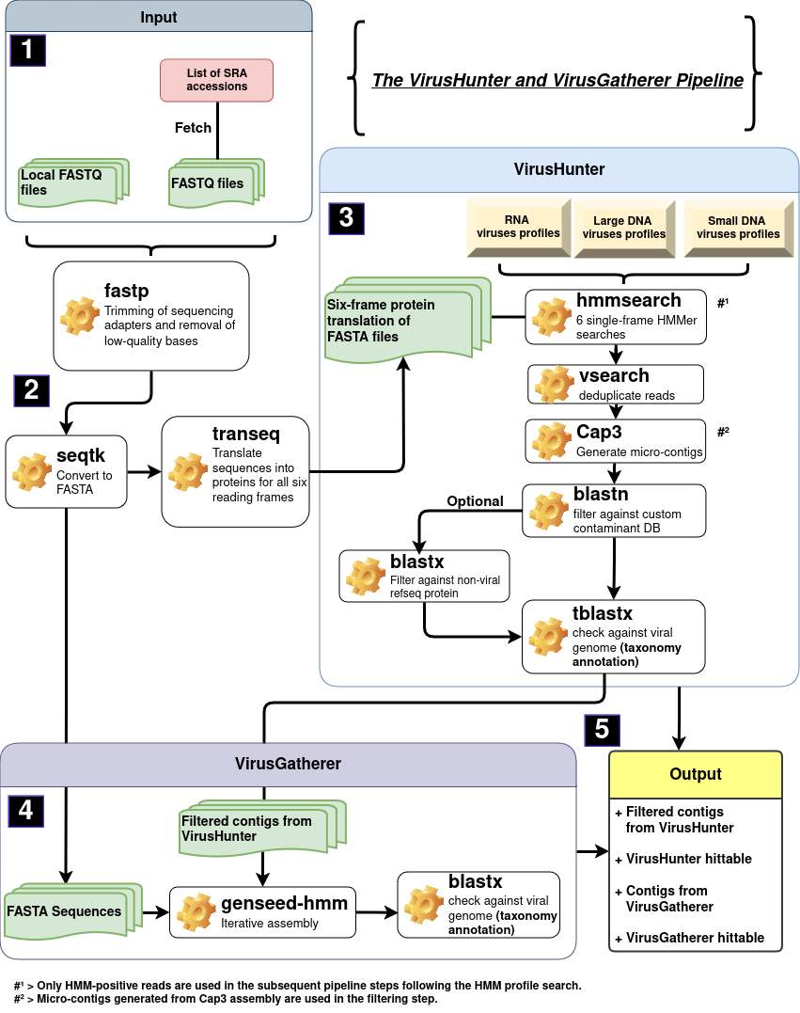
Figure 1: The VirusHunter and VirusGatherer pipeline can process local FASTQ files or download sequencing data from the NCBI SRA database using SRA accessions (1). For both VirusHunter and VirusGatherer, the FASTQ files must be processed and converted into FASTA format (2). For VirusHunter, the nucleotide sequences need to be translated into proteins across all six reading frames. (3) A profile hidden Markov model, with profiles for either DNA or RNA viruses, is employed to detect viral reads within the translated six reading frames. After deduplicating the detected viral reads, they are assembled into micro-contigs. Custom contaminants and, optionally, non-viral reference sequences are filtered out. Finally, taxonomic annotation is conducted by pairwise aligning the remaining viral contigs against a viral database. (4) The contigs from the VirusHunter output, along with the initial input data that has been quality controlled and converted into FASTA format without protein translation, are used for iterative assembly of longer viral contigs. A final taxonomic annotation is then performed on these longer contigs. (5) The outputs from VirusHunter and VirusGatherer include contigs and hittables, which document the best results.

1.3.1 ‘Hunting’ for viruses in unprocessed data
The Basic Local Alignment Search Tool (BLAST) and its variants have become standard tools for finding regions of similarity between a query sequence and a database. They are widely used to identify novel sequences and have been employed in viral discovery [Quelle], including computational pipelines like VirusSeeker [Quelle]. However, BLAST has been shown to lack the sensitivity required to detect distant relationships between sequences [Quelle]. This complicates virus discovery, as distantly related viruses may exhibit low sequence identity with the viral reference genome used for alignment. To address this, alternative methods have been developed to detect evolutionary relationships among sequences with low identity [Quelle zu PSI BLAST, pHMM und ISS ]. Instead of comparing a single sequence to another, these methods involve comparing the input sequence against a collection of related query sequences or a representation of that collection with the same characteristics.
Profile hidden Markov models, as implemented in VirusHunter, exemplifiy this approach. Here, multiple sequence alignments (MSA) of protein domains, widely conserved within a virus group of interest, are constructed, representing the collection of sequences mentioned above. Rather than using the collection of sequences directly, the MSA is converted into profile hidden markov models, which use a position-specific scoring system to generate a probabilistic representation of the sequences.
Probabilistic representation, in this context, involves capturing the probability of a specific amino acid appearing at each position across a set of aligned sequences used in the MSA, as well as the probability of transitioning to a particular amino acid at the next position. As a result, the models can be used to compare against new sequences, determining how likely a given amino acid from the input sequence is to appear at each position in the viral protein domain. It is this ability of profile hidden markov models to assess the probability of a query sequence aligning to a viral protein family, rather than individual sequences, that increases their sensitivity in comparison to BLAST. That is why in a previous study, VirusHunter identified homologs with as low as 35 % identity to viral reference genomes.
Both locally available sequencing data and downloaded sequencing data from the NCBI SRA database can serve as input for VirusHunter. For the latter, a list of SRA accessions that need to be retrieved should be provided (Figure … 1). After trimming potential sequencing adapters and removing low-quality bases, VirusHunter converts the FASTQ files into FASTA, removing the quality indicators in the fourth line and retaining only the sequences and headers. It then translates the nucleotide sequences into proteins for all six reading frames (Figure 1 2). Alignment is conducted at the proteome level because homologous viral proteins often diverge beyond recognition at the nucleotide level [Double-stranded DAN virusws: 20 families and only five different architectural principles for virion assembly; Comparison of sequence-based and structure-based phylogenetic trees of homologous proteins: inference of protein evolution]. This is particularly true for RNA viruses, where high mutation rates cause significant sequence divergence, even among copies of the same virus within a single host [Quelle: Mutation rates,mutation frequencies, and Proof-Repair Activities in RNA virus Genomes.]. Viral proteins, on the other hand, are the functional building blocks of biology and tend to preserve their structure and function over long evolutionary periods [Are viruses a source of new protein folds for organisms –Virosphere structure space and evolution]. This conservation allows for the comparison of viral protein sequences, even among distantly related viruses [Use of database of structureal alignments and phylogenetic trees in investigating the relashionshio between sequence and structural variability among homologous proteins, Comparison of solvent-inaccessible cores of homologous proteins; The relation between the divergence of sequence and structure of protein; Evolution of function in protein superfamilies, from structure perspective;protein-level assembly increases proteins equence recovery from metgenomc samples manyfold]. The translated query sequences are aligned against profiles of RNA, small DNA, or large DNA viruses (fig 1 3). Ideally, these sequences align only, when they share the same protein family as the profiles used. Duplicate sequences resulting from wet-lab processes, such as duplicates from PCR amplification [On the causes, consequences, and avoidance of PCR duplicates: towards a theory of library complexity], are removed, and the remaining reads are assembled into ‘micro-contigs’.
The ‘micro-contigs’ are run through two BLAST filtering steps, one of which is optional; followed by a final BLAST step to filter out remaining non-viral contigs; and add taxonomic annotations to each identified viral contig. The initial filtering step removes sequences that match predefined custom contaminants, such as proteins from the hosts that might falsely align with short viral contigs due to high sequence similarity [Viral proteins acquired from host convergence to simplified Domain Architecture]. The optional filter includes databases of host sequences, enabling the removal of host-specific sequences. Finally, the remaining contigs are aligned against a database of known viral reference sequences to eliminate any residual non-viral sequences. The output of VirusHunter includes the filtered contigs and an exported table file called ‘hittable,’ which contains the top hits from the homology search (pHMM positive reads) along with the final taxonomic annotation based on the alignment against the viral database.

1.3.2 Viral taxonomy
The input data is aligned with profiles of small DNA, large DNA, or RNA viruses. RNA virus profiles are defined by the six phyla within the Orthornavirae kingdom, under the Riboviria realm. These include Lenarviricota, Pisuviricota, Kitrinoviricota, Duplornaviricota, Negarnaviricota, as first described by Wolf et al., and the recently added phylum Ambiviricota. As of September 9, 2023, the International Committee on Taxonomy of Viruses (ICTV) recognizes nine families, four classes, and five orders within the Lenarviricota phylum, comprising 749 genera and 2,806 species. Viruses in this phylum are positive-strand RNA viruses. The family Leviviridae is unique as the only known group of positive-strand RNA viruses that infect bacteria. Other families in this phylum, such as Narnaviridae and Mitoviridae, infect eukaryotes.
The Pisuviricota phylum is composed of 38 viral families, organized into 8 suborders and 7 orders, spanning 3 classes. It encompasses a total of 1,044 species, grouped into 82 subgenera and 197 genera. Picornavirales is the largest order within this phylum, which is why Pisuviricota is also referred to as the 'picornavirus supergroup' [Quelle: Origins of evolution of the global RNA virome]. This order comprises positive-sense RNA viruses, with Picornaviridae and Secoviridae as some of the earliest identified families. Picornaviridae are known to infect a diverse array of hosts, including mammals, birds, reptiles, amphibians, and bony fishes. Secoviridae target dicotyledonous plants. Other families can also infect invertebrates such as insects [Quelle zu iflaviviridae]. Nidovirales is the second-largest order and includes 14 families, such as Coronaviridae, Tobaniviridae, and Roniviridae. These viruses are notable for having some of the largest known RNA genomes [Quelle:Nidovirales; evolving the largest RNA virus genome]. Members of the Coronaviridae family are notable here, as they have gained increased attention in the 21st century due to their role in several major pandemics: the emergence of SARS-CoV in 2002, the MERS-CoV outbreak in 2012, and the SARS-CoV-2 pandemic in 2019. Not all viruses within the Pisuviricota phylum have a single-stranded positive genome. For instance, viruses from the order Durnavirales possess double-stranded RNA genomes and infect a range of eukaryotic hosts, including fungi, plants, and both vertebrates and invertebrate.
Another phylum containing positive-strand RNA viruses is Kitrinoviricota, which, unlike Lenarviricota, includes only viruses that infect eukaryotes. Across 91 genera, 21 families, 6 orders, and 4 classes, there are 746 species that belong to Kitrinoviricota. Members of the Flaviviridae family include known human pathogens, such as the hepatitis C virus (genus: Hepacivirus), which causes chronic liver disease and cirrhosis. Other members, such as those in the genus Orthoflavivirus, are transmitted to humans through the bites of infected ticks and mosquitoes and include pathogens like the Orthoflavivirus flavi (yellow fever virus), Orthoflavivirus dengue (dengue virus), Orthoflavivirus zikaense (Zika virus), Orthoflavivirus japonicum (Japanese encephalitis virus), and Orthoflavivirus nilense (west nile virus). Besides flavivirus-like viruses, the Kitrinoviricota phylum also includes the class Alsuviricetes, formerly known as the 'alphavirus supergroup.' While most viruses in this class infect plants, exceptions include Paslahepevirus balayani from the Hepeviridae family, known as hepatitis E virus, and Rubivirus rubella from the Matonaviridae family, known as the rubella virus.
Members of Duplornaviricota are double-stranded RNA viruses characterized by a conserved capsid protein structure. Their capsid is organized into an unusual T=1 lattice (also known as Pseudo-T=2 lattice), composed of 60 homo- or heterodimers of the capsid protein subunits. To date, 321 viral species have been identified across 39 genera, 22 families, 3 orders, and 3 classes. Among those 22 families is Cystoviridae, which contains the only double stranded RNA viruses that can infect prokaryotes. Plant-, fungi-, and invertebrate-infecting viruses are dominant in this phylum, with one exception: the Reoviridae family, which, for example, contains the human pathogen rotavirus A.
Negarnaviricota comprises negative-sense, single-stranded RNA viruses that infect all hosts except prokaryotes. Negarnaviricota comprises 1,473 negative-strand RNA viruses across 264 genera, 37 families, and 6 classes. Notable examples include Rabies lyssavirus (rabies virus), Zaire ebolavirus (Ebola virus), and the influenza viruses, which belong to the Orthomyxoviridae family.
Ambiviricota is the most recently discovered RNA virus phylum, currently comprising only 20 species distributed across 4 families: Dumbiviridae, Quambiviridae, Trimbiviridae, and Unambiviridae. These viruses have circular RNA genomes with at least two non-overlapping open reading frames in an ambisense orientation and are known to infect fungi.
The differentiation between small DNA viruses and large DNA viruses is not an official classification but rather a system conceived by the Computational Virology Research Group to categorize DNA viruses with genomes smaller than 10,000 kb as small DNA viruses and those larger than 10,000 kb as large DNA viruses. Beyond this, most small DNA viruses are single-stranded, whereas large DNA viruses are predominantly double-stranded.
Large DNA viruses include six phyla: Peploviricota, Uroviricota, Taleaviricota, Nucleocytoviricota, Preplasmaviricota, and Dividoviricota. Peploviricota and Uroviricota belong to the kingdom Heunggongvirae, which is part of the realm Duplodnaviria. Both phyla share only one class, Peploviricota contains just 133 species across 23 genera and 3 families, whereas Uroviricota encompasses 4,840 viral species distributed across 1,497 genera and 74 families. An example for the former include herpesviruses such as Epstein-Barr virus, Kaposi’s sarcoma virus, and herpes simplex virus types 1 and 2, all of which can infect humans. An example of the latter is members of the class Caudoviricetes, part of Uroviricota, which are the most abundant phages in the human virome [Quelle: The humane virome: assembly,composition and host interactions]. Taleaviricota currently comprises 32 archaeal viral species, organized into 14 genera and 5 families.
Both the African swine fever virus, which spread out of Africa in 2007 and is currently spreading through the European pig population, and poxviruses (Poxviridae), including Orthopoxvirus variola (smallpox), belong to the class Pokkesviricetes, part of the phylum Nucleocytoviricota. So far, 132 species, organized into 58 genera and 14 families, belong to the phylum Nucleocytoviricota. Preplasmiviricota, which are also part of the realm Viridnaviria, include 146 species in 28 genera, and 16 families. Most known among them are the Adenoviridae, with hosts ranging from mammals and birds to reptiles, amphibians, and fish, depending on the genus. The last large DNA virus phylum, Dividoviricota, consists of the order Halopanivirales, which infect thermophilic bacteria and archaea, and contains only 9 species across 3 genera.
Cressdnaviricota is the first phylum of small DNA viruses, comprising 1,490 viral species, 266 genera, and 23 families. This phylum is characterized by eukaryotic viruses with circular single-stranded DNA genomes that encode the Rep protein, enabling genome replication through a rolling-circle mechanism. The Geminiviridae and Nanoviridae families include plant-infecting viruses, while Bacilladnaviridae infect diatoms, and Circoviridae are found in mammals, birds, and fish. Hoffneiviricota is a phylum comprising a single class and order. It includes 60 prokaryotic viral species, 32 genera, and 3 families: Plectoviridae, Paulinoviridae, and Inoviridae. Similarly, Phixviricota also feature just one class and order. This phylum encompasses 22 species and 7 genera, with Microviridae as its sole family. The penultimate small DNA viruses phylum, Cossaviricota, includes 440 species and 90 genera across 4 families (Bidnaviridae, Polyomaviridae, Papillomaviridae, and Parvoviridae), while the last phylum, Saleviricota, comprises 16 species and 3 genera within a single family (Pleolipoviridae). All viruses in the Pleolipoviridae family target Halobacteria, which are halophilic archaea. Human papillomavirus (HPV), a prevalent sexually transmitted infection (STI), can lead to warts and, in some cases, penile, vaginal, anal, or cervical cancer. Other members of the Papillomaviridae family have been documented in mammals, birds, and fish. Similarly, Polyomaviridae and Parvovirinae have been observed in mammals, birds, and fish. However, Densovirina, a subfamily within Parvoviridae, target invertebrates such as insects and crustaceans.
VirusHunter does not exclusively utilize the defined phyla from small DNA, large DNA, and RNA viruses. Profiles were also constructed for families such as Anelloviridae (small DNA viruses), Yaraviridae (large DNA viruses), and Birnaviridae and Permutotetraviridae (RNA viruses). None of these families are yet assigned to a specific phylum. In addition to the known phyla for small DNA, large DNA, and RNA viruses, there are other phyla do not fit into these categories. Currently, only the phylum Artvericota falls into this category. Artvericota also belongs to the realm Riboviria, like the six phyla defined as RNA viruses. However, Artvericota is distinct in that it falls under the kingdom Pararnaviriae, which includes viruses with RNA genomes that utilize a reverse transcriptase. Examples include the family Hepadnaviridae and the genus Lentivirus, some members of which are associated with acquired immunodeficiency syndrome (AIDS).

1.3.3 ‘Gathering’ viral reads for assembly
Viral discovery extends beyond VirusHunter. Although viral ‘micro-contigs’ are identified at this stage, the contigs may not represent a complete protein-coding sequence, let alone a coding-complete viral genome, which is required to establish a new viral taxon [Guidelines for public database submission of uncultivated virus genome sequences for taxonomic classification]. In response to this requirement, the viral ‘micro-contigs’ identified in VirusHunter serve as seeds for a progressive assembly in the VirusGatherer step of the pipeline, aimed at generating long viral contigs, or coding-complete viral genomes. Internally, VirusGatherer implements the seed-based assembly tool GenSeed-HMM [GenSeed-HMM: A tool for progressive assembly using profile HMMs …] (fig 1 4). A key advantage of GenSeed-HMM it its ability to accept input as nucleotide sequences, protein sequences, or pHMMs. GenSeed-HMM begins by conducting similarity searches with different tools depending on the input data: blastn for nucleotides, tblastn for proteins, and hmmsearch for pHMMs. These searches retrieve sequences where the seeds aligns with the initial input data used at the start of the pipeline (Figure … 2). The sequences are then assembled into longer contigs using third-party assemblers like Cap3, Newbler, Velvet, SOAPdenovo, or ABySS. Further contig assembly continues iteratively, with each round using contig ends from the previous iteration for homology searches against the initial seed sequences. Overlapping regions from the sequences identified in the homology search are merged with the contig ends. The resulting contig ends then serve as starting points for the next round of assembly. This allows the contig to grow in length as long as new sequences can be found in the homology search step. If no new sequences are found, GenSeed-HMM performs three additional extensions, trimming 25% of the contig end in each iteration before proceeding with the extension. If no new sequences are found for further extension in these three additional iterations, or if the contig length or number of iterations reaches a user-defined maximum, the assembly process stops. The resulting contigs are then aligned against a viral database, similar to the final VirusHunter step, to remove any remaining non-viral contigs and perform taxonomic annotation. The final output is the above-mentioned VirusHunter output, the viral contigs generated from the assembly in VirusGatherer, and a VirusGatherer ‘hittable’ with the best results for the taxonomic annotation and assembly (fig 5).

1.3.4 Comparison to other approaches
The RNA-dependent RNA polymerase (RdRp) is a conserved protein found in all RNA viruses, linking them evolutionarily. Because of its presence in all RNA viruses, computational tools such as Serratus search for RdRp in sequences to distinguish RNA viruses from non-RNA virus sequences. This enables the identification of both known and novel RNA viruses and helps monitor and anticipate for potential health crises arising from RNA viruses, at the cost of not being able to detect DNA viruses. In contrast, the VirusHunter and VirusGatherer pipeline is designed to detect both RNA and DNA viruses by aligning query sequences with dedicated profiled for each virus type. Serratus, with its ability to process 5.7 million samples, appears to handle more samples than previous works utilizing VirusHunterGatherer. However, it relies on Amazon Web Services (AWS), incurring a cost of 2,350 USD per petabase and requiring AWS infrastructure. In contrast, VirusHuntergatherer can be installed and run on non-commercial high-performance computing infrastructure, avoiding the need for AWS and associated costs. Notably, Serratus exhibits decreased sensitivity when the sequence identity between RdRp motive and query sequences falls below 60 %, whereas earlier studies using VirusHunterGatherer successfully identified divergent viruses with as little as 27 % protein sequence identity. VirusHunter can be time-consuming due to its reliance on multiple alignments against both viral protein/nucleotide sequence databases and profile models [See figure to pipeline 3]. VirusGatherer, in contrast, reduces the assembly time compared to conventional de novo assemblers by focusing on assembling only viral contigs based on seed sequences, rather than attempting to assembly every query sequence. On top of that, VirusGatherer´s use of Genseed-HMM, unlike other seed-based assemblers, may enable the assembly of longer contigs beyond the conserved domain used in homology searches (for example RdRp), while also generating fewer chimeric sequences. Generating clear and accessible reports should also be a high priority to make virus discovery data both comprehensible and useful for informed decision-making and further application. While DAMIAN provides tabular reports designed for easy interpretation by diagnosticians, and Serratus offers graphical reports via a web interface for users without programming expertise, VirusHunter and VirusGatherer´s hittables may require additional downstream analysis, such as data visualization and summary statistics, which can be challenging for people lacking skills in programming and statistics.

1.4 Aim of thesis
The aim of this thesis is to identify known and novel viruses in two datasets: a human clinical sequencing dataset and a public mammalian dataset. For this, I applied the VirusHunterGatherer pipeline, which conducts a sensitive homology search to detect viral sequences from raw sequencing data and assembles longer viral contigs.
A dataset was provided by the Taubert working group from the Department of Gastroenterology, Hepatology, Infectious Diseases, and Endocrinology at Hannover Medical School (MHH). This dataset comprises sequencing data from liver biopsies of liver transplant patients, where the samples indicate either no rejection or rejection mediated by T-cell or antibody responses. The complete VirusHunter and VirusGatherer pipeline was applied to this dataset, covering all three viral groups—small DNA, large DNA, and RNA viruses—to detect viral presence and assemble viral contigs from the liver sequencing data. The primary focus of this analysis is to identify viruses present in the patient samples and to assess whether these identified viruses are associated with transplant rejection and, if so, whether they can be linked to one of the two types of rejection: T-cell-mediated or antibody-mediated responses.
The Computational Virology Research Group also supplied an existing VirusHunter hittable, generated from a previous search for RNA viruses in public sequencing data from mammalian samples. In this thesis, a selected subset of virus-positive SRA entries from that hittable is utilized as the second dataset, and longer viral contigs are assembled with VirusGatherer, which has not been done before. Both the provided hittable and the analyzed subset represent a substantial collection of public unprocessed sequencing data. The assembly of longer viral contigs allows for the potential discovery of both known and novel viruses. To ensure that the identified contigs are indeed viral in nature, functional annotation of the viral proteins is performed for the ten longest viral contigs identified.
Finally, one of the outcomes of this master’s thesis is the development of the R package Virusparies. Virusparies provides functions to subset and process hittables, calculate summary statistics, and create plots and graphical tables for VirusHunter and VirusGatherer data.

- Material and Methods

2.1 Code Availability Statement
All code, programs, and scripts developed as part of this work have been provided to the 'Computational Virology Research Group,' led by Jun. Prof. Dr. Chris Lauber. The VirusHunterGatherer tool, which was utilized in this study, is available for download on GitHub at https://github.com/lauberlab/VirusHunterGatherer. Additionally, an R package named 'Virusparies,' which includes functions for processing and visualizing VirusHunterGatherer output and generating summary statistics, was developed as part of this master's thesis. The package is available at https://github.com/SergejRuff/Virusparies.

2.2 Data Availability Statement
All data generated during this study, including the VirusHunter and VirusGatherer output tables, are available in a dedicated GitHub repository created for this master's thesis. This repository contains the specific datasets used in the analysis and the results presented in this work. The repository can be accessed at https://github.com/SergejRuff/MasterThesis.

2.3 Software used
Viral discovery in raw and unprocessed sequencing data was first performed via VirusHunter, which conducts a homology search with profile Hidden Markov Models (pHMMs) of proteins specific to a virus group to identify potential viral sequences. Following this, VirusGatherer utilized these identified sequences, or micro contigs, from the VirusHunter step as seeds to assemble the complete viral genomes or larger yet incomplete viral contigs. Twincore´s 'Aeternitas' computing cluster was utilized to concurrently execute VirusHunterGatherer across multiple runs. VirusHunterGatherer is implemented in Perl but was executed using Snakemake, a Python-based workflow management system. Meaning, each component of the VirusHunterGatherer pipeline was represented by a rule, managed by Snakemake. A configuration file in .yaml format specified the paths of filter databases and input data on the 'Aeternitas' server. Both local FASTQ files and a list of SRA accessions, which are downloaded and converted to FASTQ format, are supported as input. Additionally, the configuration file allowed users to enable or disable the filter against host sequences. A table listing all necessary dependencies for runnning VirusHunterGatherer is provided (Table x).

2.4 Sequencing data
Two data sets were utilized for viral discovery of large DNA, small DNA, and RNA viruses, with each data set originating from different working groups. The samples in all two sets were derived from distinct viral host organisms.

2.4.1 Taubert liver transplant data
The working group Taubert from the Department of Gastroenterology, Hepatology, Infectious Diseases, and Endocrinology at MHH provided patient liver sequencing data. The data was provided locally in 11 folders, encompassing a total of 323 samples distributed across 557 FASTQ files (see Table X).

Table 1: Taubert sequencing data was provided locally in 11 folders, consisting of 323 samples distributed unevenly across these folders. For some samples, Read 1 and Read 2 were stored in separate FASTQ files, resulting in a total of 557 FASTQ files. Analysis was completed for small DNA, large DNA, and RNA viruses for all datasets.
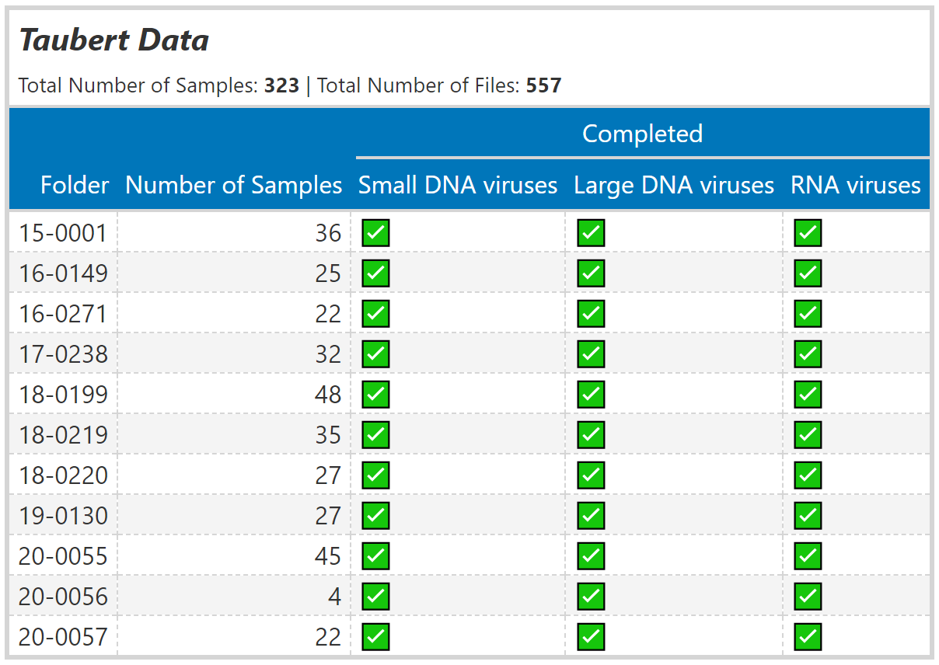

2.4.2 Mammalia data
The Computational Virology Research Group provided an existing VirusHunter hittable with data analyzed from January to March 2023. No viral contig assembly via VirusGatherer was performed to this point. The data consisted of SRA data downloaded from NCBI, containing viral reads detected in mammalian hosts, with a total of 34,337 unique SRA accessions. This is in contrast to the Taubert sequencing data, which consisted of locally provided FASTQ data. The hittable was filtered to include only rows where the E-value from the BLAST search against the viral database was below 1e-5, ensuring that only significant results were retained. Additionally, to exclude non-novel viruses, the Hittable was filtered to include only entries with viral sequenced identity below 90% against the viral BLAST database. A minimum of four reads, as identified in comparison with the profiles during VirusHunter, was also required to ensure that some contigs would be assembled during the Virusgatherer step.

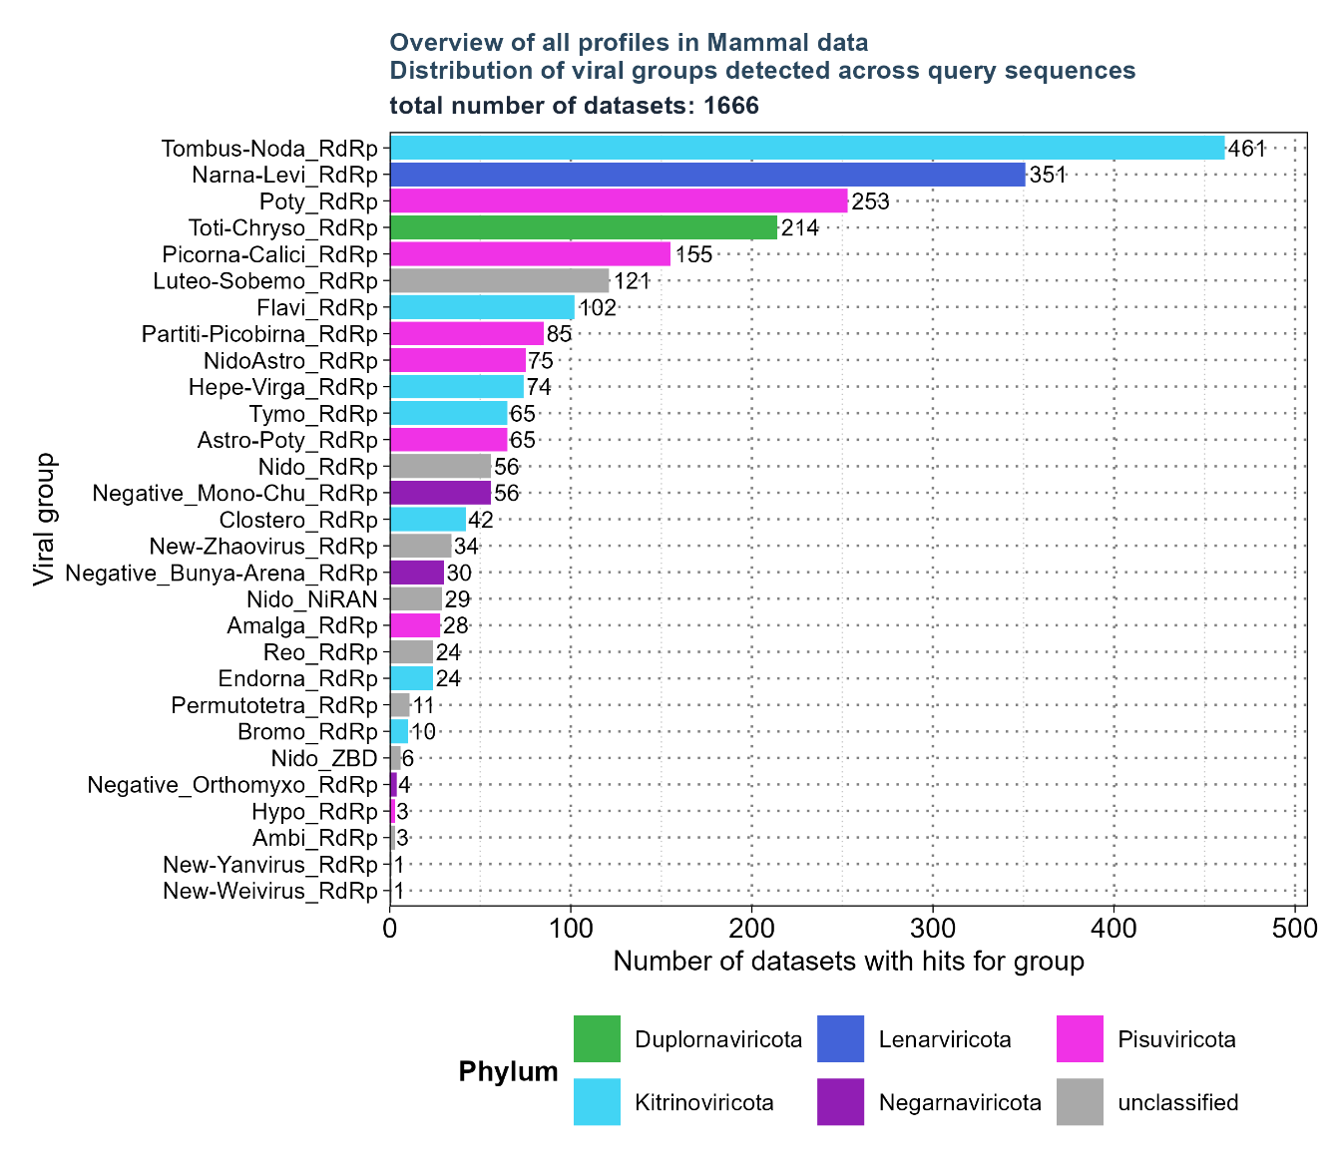
Figure 1: Distribution of viral groups detected across query sequences for all profiles identified after filtering the existing hit table. 1,666 unique SRA accessions with 29 profiles were found after applying filters for E-value < 1e-5, number of reads > 4, and viral sequence identity against the viral BLAST reference < 90%.

After filtering, 1,666 unique SRA accessions with 29 profiles remained (see figure X). To further limit the number of profiles required for analysis, eight profiles of interest were selected from the filtered Hittable. These included Flavi_RdRp, found in 102 out of 1,666 SRA accessions; NidoAstro_RdRp, found in 75; Hepe-Virga_RdRp, found in 74; Nido_RdRp, found in 56; Negative_Mono-Chu_RdRp, found in 56; Negative_Bunya-Arena_RdRp, found in 30; Nido_NiRAN, found in 29; and Negative_Orthomyxo_RdRp, found in 4. These profiles were then reanalyzed with VirusHunter, which was utilized specifically for RNA virus detection. Identified RNA viral micro-contigs were subsequently assembled into larger contigs with VirusGatherer for the first time in this master’s thesis.

2.5 VirusHunter
At the first stage of the data-driven Virus discovery, VirusHunter was employed to identify viral sequences within raw sequencing datasets using a sensitive homology search with profile Hidden Markov Models. This subchapter provides an overview of how VirusHunter was implemented and utilized within the context of this master´s thesis.

2.5.1 SRA download
Both locally available FASTQ files and a list of SRA accessions are valid input files for VirusHunterGatherer. If a list containing SRA accession numbers is not provided, but a path with locally available FASTQ files is given, the locally available data will be used as input. Alternatively, when a list of SRA accession numbers is provided, the SRA Toolkit's prefetch and fastq-dump tools download sequencing data from the NCBI SRA database. Both types of input were used in this thesis: the data provided by Prof. Dr. med. Richard Taubert was available locally on the ‘Aeternitas’ server, while the datasets containing mammalian data were downloaded from the NCBI SRA database.

2.5.2 Preprocessing of FASTQ files for VirusHunter
Trimming of sequencing adapters and removal of low-quality bases occurred in parallel for each file using fastp. Auto-detection identified and removed adapter sequences. Reads shorter than 15 bases, containing more than 5 ‘N’ bases, or having more than 40% of bases with a Phred quality score of 15 were classified as low quality and discarded. For paired-end reads, a single FASTQ file combined both reads in an alternating order. Fastp generates report files in JSON and HTML format, along with a trimmed FASTQ file. The processed FASTQ files were transformed into FASTA format via seqtk, preserving only the sequence information. Thereafter, transeq translated the sequences into protein for each of the six reading frames.

2.5.3 Sensitive homology-based detection of viral sequence reads in unprocessed data
Detection of viral reads in unprocessed sequencing data was accomplished using the hmmsearch tool, which allows for the identification of viral sequences by querying a set of pHMMs. The protein sequences translated from each of the six reading frames were applied in six separate HMMer searches, each against query pHMMs specific to protein domains associated with RNA, small DNA, or large DNA viruses. Profiles for RNA viruses predominantly featured RNA-dependent RNA polymerase (RdRp) domains. However, for hepatitis delta virus and nidoviruses, the profile included hepatitis delta antigen (HDAg) domains for hepatitis delta virus and RNA-dependent RNA-polymerase-associated Nucleotidyltransferase (NiRAN) domain for nidoviruses. For large DNA viruses, profiles mainly comprised major capsid protein (MCP) domains, whereas small DNA viruses queried mostly against the replication initiator protein (Rep) domains. A complete list of all profiles is provided [Anhang]. The size of the target database for E-value calculations was set to six times the number of reads, accounting for each reading frame. An E-value of 10 was applied to report hits in the sequence search. The significance of each search result was then assessed using two criteria: the number of hits and the minimum E-value observed. If the total number of hits met or exceeded a threshold of two, or if the globally best E-value was below 0.01, the results were considered significant. Score, E-value, and query profile for each significant hit were then exported. FASTA files with non-significant results were deleted and not used further.

2.5.4 Filtering against contaminants and viral reference sequences
Further filtering was performed only on data with significant hits. First, vsearch deduplicated hits by removing sequences that had identical length and nucleotide content. Deduplicated reads were then assembled to micro contigs via CAP3 assembler. Only those sequences that had a minimum overlap length of 20 nucleotides and a maximum overhang percentage length of 75 % were considered. The overhang percentage is calculated by dividing the total length of all overhangs by the length of the overlap, then multiplying by 100. As part of the master´s thesis, modifications were made to the VirusHunter pipeline to make the filter against host sequences optional. Consequently, only the filters against custom contaminants and the viral database were applied. Filtering against custom contaminants was performed using blastn. The contaminant database included ubiquitin sequences, and any matches with an E-value above 1e-4 were excluded. Afterwards, the remaining contigs were filtered against a viral database via TBLASTX, and only matches with an E-Value lower than one were retained.

2.5.5 Output of VirusHunter
VirusHunter exported the sequences of the filtered contigs in a compressed FASTA file. Furthermore, results for hits found at each step of the pipeline were documented in separate hittables files for each sequencing experiment. These individual results were then compiled into a final VirusHunter hittable. A VirusHunter hittable contained 11 to 15 characteristic columns, depending on whether the input sequencing data was local or downloaded from the NCBI SRA database [Tabell emit typischen Aufbau für beide haben und drauf verweisen].

Table 1: Columns of the VirusHunter Hittable, including data types (chr’ for character, ‘num’ for numeric, and ‘date’ for date values in ISO 8601 format) and three representative example values for each column. The ‘run_id’ column (yellow) is specific to locally processed input data. In contrast, columns related to SRA identifiers and host information are exclusive to SRA data downloaded from NCBI (violet). For each viral read detection, the best HMM profile match, its E-value, and the number of hits are recorded in separate columns. After comparing contigs against viral reference database, the best-matching viral subject and taxonomy, the best E-value, and the percentage of sequence identity with the viral reference are documented in their respective columns. Lastly, the date of analysis is also included.

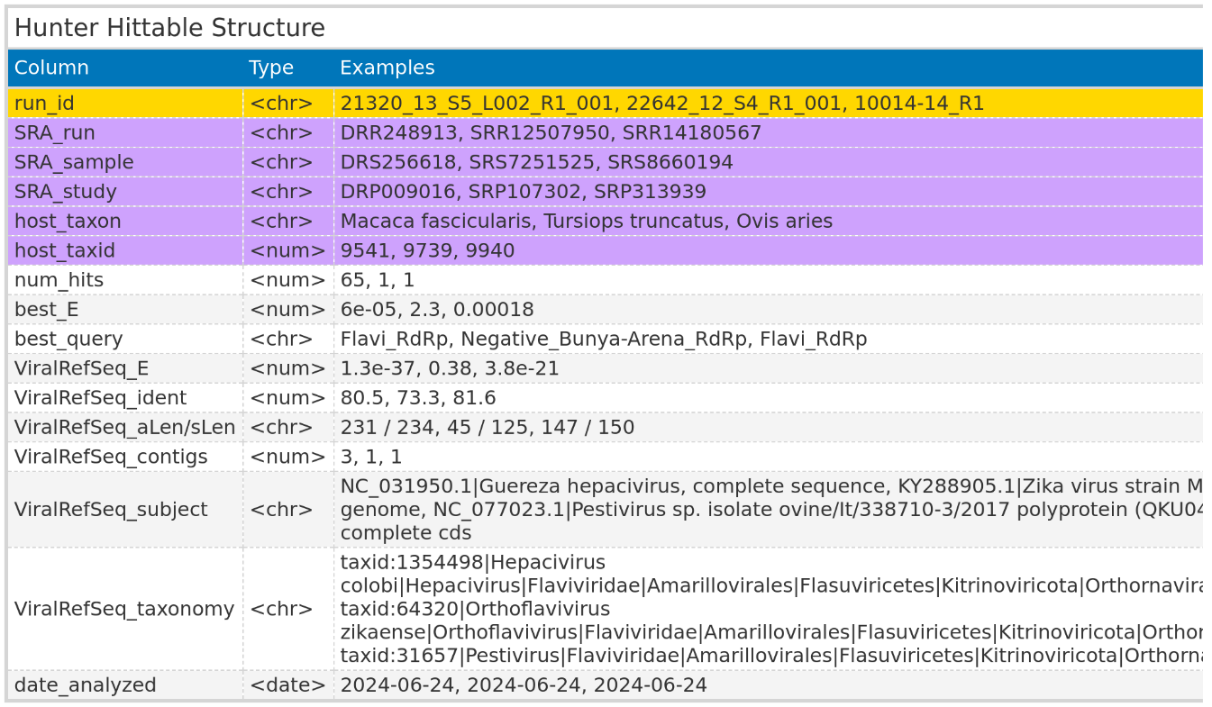

For Data downloaded from NCBI, the hittable included columns with identifiers for each SRA run, sample, and study identifier. Additionally, the Hittable featured columns with details about the host taxon and the host taxon identifier. For each SRA run, the best match against the viral reference database was documented, providing details such as the viral reference taxonomy name, the percentage of sequence identity with the viral reference, and the E-value of the best match. The E-value and the name of the best HMM profile match were also documented in separate columns, along the number of viral contigs identified for each SRA run.
For locally processed data, the Hittable omitted the columns related to SRA identifiers and host information, replacing them with a single column for the Identifiers of the local FASTQ files.

2.6 VirusGatherer
The identified viral contigs found in the VirusHunter stage serve as seeds for the progressive assembly of full-length viral genome sequences. This section details how VirusGatherer was utilized in this work.

2.6.1 Assembly of Contigs
For VirusGatherer, fastp was used to trim adapters and remove low-quality bases from each unprocessed FASTQ file, which was then converted to FASTA format. Unlike the VirusHunter stage, no translation into protein for each reading frame was performed. The viral contigs were assembled into larger contigs via CAP3, considering only sequences with an overhang percentage of 99% or less, and a minimum overlap length of 20 bases for assembly. These were then utilized as seeds for a targeted assembly of viral contigs found in the FASTQ files, with the help of a modified version of Genseed-HMM. The progressive assembly was performed using CAP3, with a maximum of 100 iterations. Contig ends with a length of 30 were used for further assembly, and the maximum contig length was set to 50.000. For CAP3, the minimum percentage identity for an overlap was set to 85%, with the minimum overlap length required being 20 nucleotides. Additionally, the maximum allowable overhang was set to 99%. For the initial similarity search, BLASTN with an E-value cutoff of 1e-3, a percentage identity of 85%, and a word size of 7 was applied. Lastly, the modified version of Genseed-HMM performed deduplication in each iteration to decrease CAP3 assembly time.

2.6.2 Compare against viral reference database
Assembled contigs were compared against NCBI’s database of reference viral proteins using BLASTX. For the BLASTX queries, the maximum number of reported high-scoring segment pairs (HSPs) – which are local alignments with the highest scores and no gaps – was set to 1. Additionally, the maximum number of target sequences returned per query was also set to 1.

2.6.3 Output of VirusGatherer

Table 2: Columns of the VirusGatherer Hittable, including data types (chr’ for character, ‘num’ for numeric, and ‘date’ for date values in ISO 8601 format) and three representative example values for each column. The ‘run_id’ column (yellow) is specific to locally processed input data. In contrast, columns related to SRA identifiers and host information are exclusive to SRA data downloaded from NCBI (violet). The contig identifier and its length after assembly are reported. After comparing contigs against viral reference database, the best-matching viral subject and taxonomy, the best E-value, and the percentage of sequence identity with the viral reference are documented in their respective columns. Lastly, the date of analysis is also included.
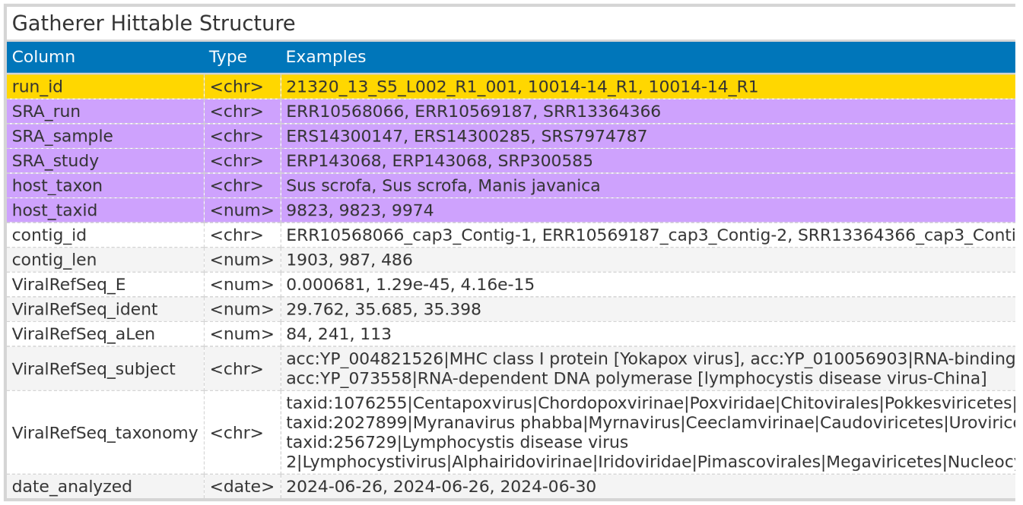

VirusGatherer returned the sequences of the assembled viral contigs/ whole genomes. Furthermore, hittables similar to the VirusHunter Hittables were generated [Bild von VirusGatherer hittable aufbau]. Virusgatherer Hittables also contained columns related to SRA identifiers and host information, or the identifiers for the locally available FASTQ files, depending on the input used. Unique columns in VirusGatherer Hittables included viral contig name and its length, as well as details of the best viral match from the viral reference database comparison.

2.7 Virusparies
One of the outcomes of this master´s thesis was the development of the R package Virusparies. Virusparies provides functions to subset and process Hittables, calculate summary statistics, and create plots and graphical tables for VirusHunter and VirusGatherer hittables. Both import of hittables into R and export of results in a user-specified file format was handled by Virusparies. Virus family names were extracted from the ‘ViralRefSeq_taxonomy’ column for each observation of the hittables via the VhgPreprocessTaxa function. Where no family name is present, but it is possible to infer the phylum from other information in the ‘ViralRefSeq_taxonomy’ column, ‘unclassified’ followed by the phylum name was used. If inferring the phylum was not possible, only ‘unclassified’ was assigned to the observation. The processed taxonomy data was subsequently used to group data for plots and summary statistics calculations. Boxplots were generated to visualize the distribution of E-values (‘ViralRefSeq_E’), identity percentages (‘ViralRefSeq_ident’), and contig lengths (‘contig_len’) for each group. The sum of hits for each virus group and the distribution of viral groups detected across query sequences were plotted in bar charts. The relationship between viral reference sequence identity and the negative logarithm of viral E-values was depicted in scatter plots. When VirusGatherer were used as input, a bubble plot was generated instead, with contig lengths represented by the size of the bubbles. Crucially, each dataset was filtered to include only observations with an E-value of 1e-5 or lower in the ‘ViralRefSeq_E’ column before plotting. When E-values were plotted, the negative logarithm of the threshold served as a cutoff line instead, and no filtering was applied. In some cases where E-values were visualized, E-values of exactly zero resulted in infinite values when transforming to their negative logarithm. To address this, all E-values of zero were replaced with the smallest E-value greater than zero. If the smallest E-value was above the cutoff (1e-5), zeros were replaced with the cutoff multiplied by ten raised to the power of negative ten. The mode, median, mean, standard deviation, and first (Q1) and third (Q3) quartiles were calculated for viral E-values, identity percentages, and contig lengths, and the results were summarized in tables.

2.8 Prediction and visualization of predicted functional domains
For the viral screening of mammalian sequencing data, the three longest contigs from each RNA virus phylum were chosen to examine their predicted functional domains. The analysis utilized contigs assembled by VirusGatherer. Protein domains for each contig were predicted with InterProScan by comparing the assembled sequences against the InterPro database, using an E-value threshold of < 1e-5 for filtering. To ensure the most relevant matches, the protein match with the lowest E-value was selected, as multiple matches from different databases often corresponded to the same protein. Contigs with an open reading frame (ORF) comprising less than half of the sequence length were excluded from further analysis, leaving only 10 contigs. The length of each protein domain was multiplied by 3 to reflect the nucleic acid sequence length since VirusGatherer returns nucleic acid output. The selected viral genomes were visualized using the gggenomes R package (version 1.0.1).

Results

3.1 Characterization of the virome after liver transplantation
In this study, I employed the VirusHunter and VirusGatherer pipeline to characterize the virome of liver sequencing data. This data, provided by the Taubert working group, included 323 patient samples across 557 FASTQ files. VirusHunter performed a sensitive sequence homology search within this data using profile Hidden Markov models based on conserved protein sequences typical of for RNA, large DNA, and small DNA viruses [Verweis of appendix mit den phmm].
The sequences identified during the screening acted as seeds in the VirusGatherer step, enabling the progressive assembly of longer contigs up to complete viral genomes. Both pipeline steps included a pairwise comparison of contigs against a viral database and produced tabular output capturing the best results from screening, assembly, and comparison. I incorporated this output into ‘Virusparies’, an R package developed for this master thesis, to visualize the results and generate summary statistics.

3.1.1 The majority of contigs identified in the liver sequencing data are not significant
Using the described approach, I obtained five FASTQ files corresponding to four samples that matched at least once against a small DNA virus profile in the VirusHunter step, representing only 0.89% of the total input files. For large DNA virus profiles, I retrieved 165 files (29.62%), corresponding to 142 samples, and for RNA viruses, there were 17 files (3.05%), totaling 13 samples. The output from VirusHunter and VirusGatherer was deemed significant only when the comparison against the viral reference database yielded an E-value smaller than 1e-5. In the run against small DNA virus profiles, the contigs aligned with three viral families in the reference database; however, none had an E-value below 1e-5 and, therefore, could not be considered significant (Fig _ A). VirusHunter identified eight large DNA virus families, along with one unclassified group for which no taxonomic information was available. Among them, only two families were deemed significant: Adenoviridae from the phylum Preplasmaviricota and Orthoherpesviridae from the phylum Peploviricota. For RNA viruses, 31 families matched, along with one unclassified family from the phylum Kitrinoviricota and one unclassified group without phylum information. The significant families included Flaviviridae and Hepeviridae from the phylum Kitrinoviricota, as well as Potyviridae from the phylum Duplornaviricota and Totiviridae from Pisuviricota.

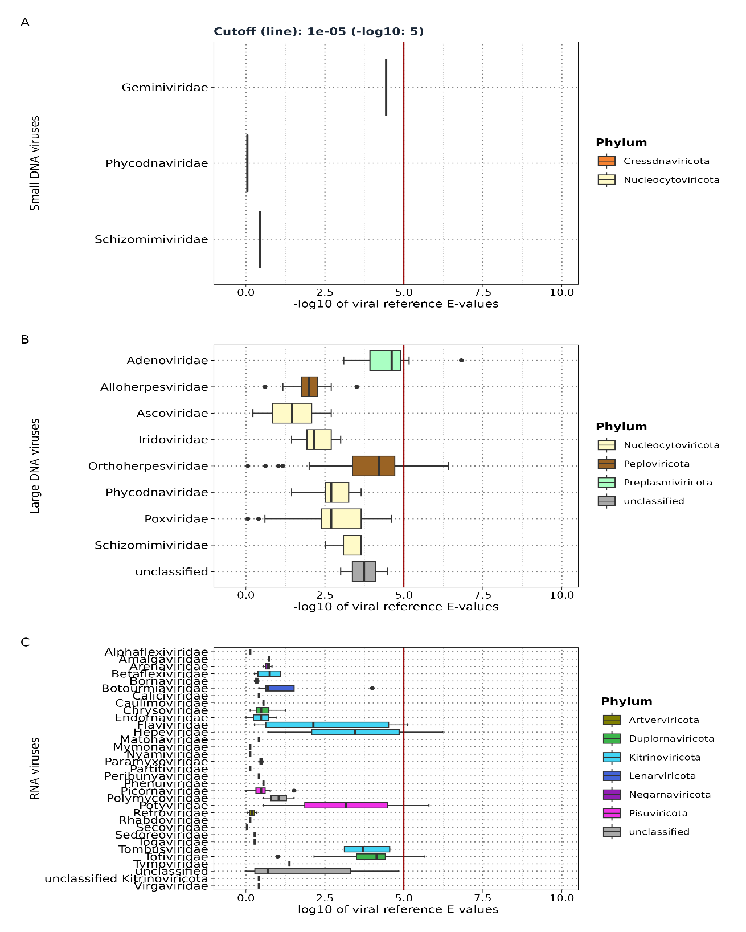
Figure _: Distribution of viral reference E-values for each viral family detected by VirusHunter runs against profiles for small DNA viruses (A), large DNA viruses (B), and RNA viruses (C). E-values from contig alignment against viral reference database are transformed to their negative logarithm base 10. The vertical red line in the plot marks the 1e-5 cutoff: values right of the line (E-value<1e-5) are significant, while those on the left (E-value>1e-5) are not.

3.1.2 Only a small fraction of liver of the liver sequencing data detected viral contigs
Next, I focused on the number of files (and samples) that yielded significant results (E-value<1e-5) during the alignment against the viral database, as documented in the VirusHunter hittable. As noted earlier, screening for small DNA viruses returned no significant results. The search for small DNA viruses in the Taubert sequencing data yielded results from 3 out of 165 files (1.81%) matching Adenoviridae and 8 files (4.85%) matching Orthoherpesviridae (Fig _ A). The number of samples matched the number of files, with only 11 remaining files having at least one significant result. This represented 1.97% of the original 557 files and amounts to just 3.4% of the 323 samples. Only four files contained contigs identified as potential RNA viruses, with the number of files corresponding to the number of samples. Each of these files/samples aligned with a distinct RNA virus family (Fig _ D). This accounted for 0.71% of the original files and 1.23% of the samples with potential RNA virus sequences. Accounting for the presence of multiple contigs from specific viral families within each sample, I tracked the distribution of these contigs across all families for both large DNA and RNA viruses (Fig_ B,E). A total of 18 contigs aligned with Orthoherpesviridae, while 5 aligned with Adenoviridae among large DNA viruses. RNA viruses had more contigs than large DNA viruses, with Totiviridae and Potyviridae exceeding Orthoherpesviridae and Adenoviridae, while the Kitrinoviricora viruses had the fewest contigs overall. All viral contigs in the large DNA virus screening showed an exact match to known viruses (Fig _ C), while Totiviridae was the only family with a protein sequence identity below 90%, suggesting these sequences came from novel viruses.

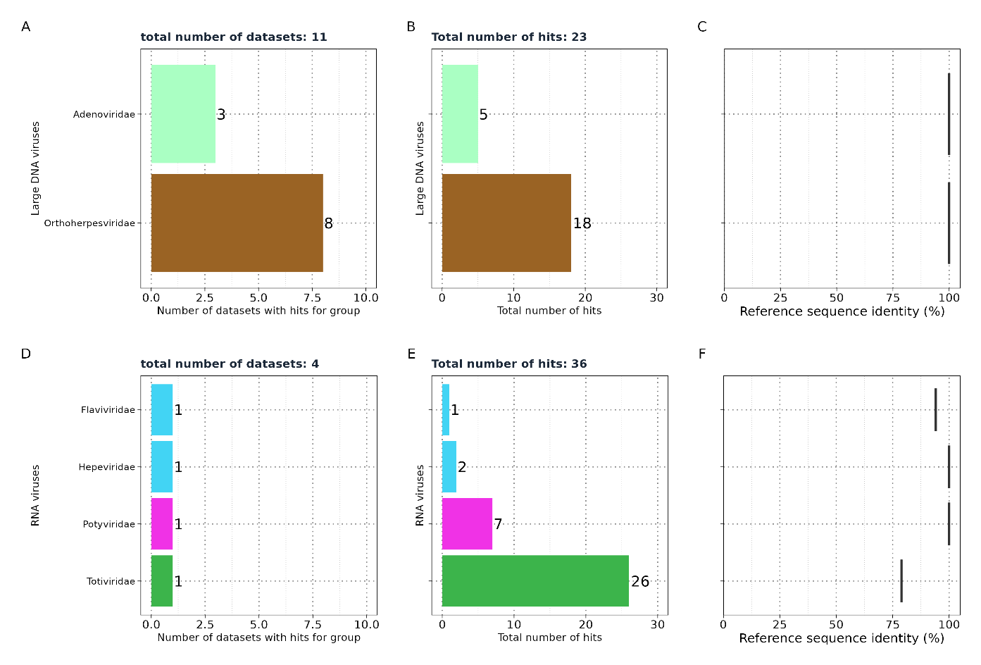

3.1.3 All contigs identified in the liver sequencing data are short
VirusGatherer assembled longer viral contigs by leveraging viral sequences identified in VirusHunter as seeds. It aligned these sequences in an internal pair aligner against a viral database, selecting only contigs with an E-value smaller than 1e-3 for assembly. This relaxed E-value criterion, compared to the significance cutoff of 1e-5, enabled the inclusion of viral contigs that were not deemed significant in VirusHunter. Consequently, the assembly of small DNA viruses produced a contig aligning with the family Hepadnaviridae from the phylum Artverviricota (Fig _A), exhibiting a protein sequence identity of 95% (fig _ B) and a contig length of 70 (fig _ C), despite no significant results in the VirusHunter step. Flaviviridae, Potyviridae, and Adenoviridae, detected by VirusHunter, were not found by VirusGatherer. Additionally, while both Totiviridae, Hepeviridae, and Orthoherpesviridae were identified as significant matches in VirusHunter and also appear in Gatherer, six contigs aligned with the families Poxviridae and Kolmioviridae. The alignment of 179 contigs to Poxviridae surpasses that of Orthoherpesviridae, but none of these contigs were significant, as they did not meet the cutoff criteria. Kolmioviridae did not appear in VirusHunter but was found in VirusGatherer. Across six datasets, six contigs were identified as potentially representing large DNA viruses, while four files revealed ten contigs associated with RNA viruses. Out of the 17 viral contigs, seven (41.17%) displayed less than 90% protein sequence identity to the closest known virus. All contigs were shorter than 300 nucleotides, with the largest measuring 259 nucleotides and aligning with the Kolmioviridae family, while the shortest contig was 59 nucleotides, associated with Orthoherpesviridae.
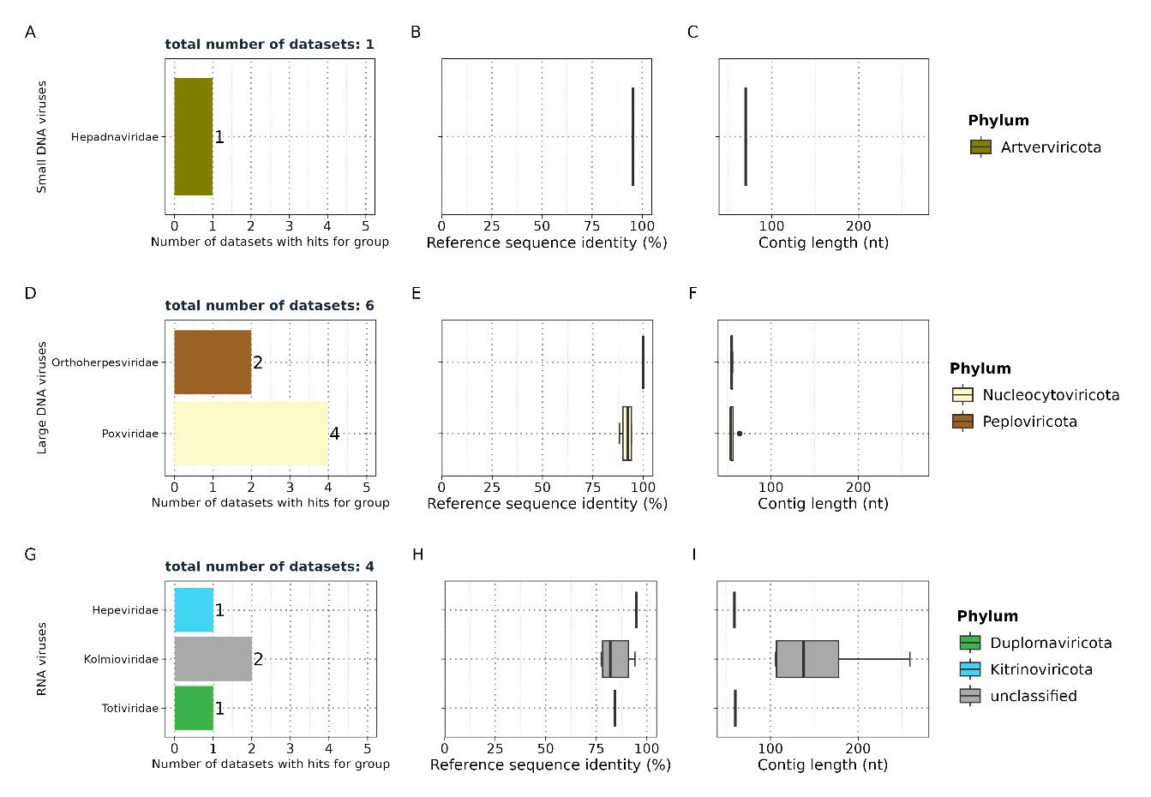

Although VirusHunterGatherer categorized the contigs into various viral families using human liver sequencing data as input, the closest related viruses appeared to be animal-infecting viruses (Table _). Among the potential RNA viruses, nine contigs aligned with Hepatitis D or Hepatitis E viruses (Paslahepevirus balayani). The contigs related to Hepatitis E showed high protein sequence identity, with a maximum of 94.74%. In contrast, five out of eight contigs aligning with Hepatitis D displayed less than 90% sequence identity to the reference sequences. For contigs matching Orthoherpesviridae, the closest related viruses were Betaherpesvirus 5 (human) and Betaherpesvirus 2 (primates), both exhibiting 100% sequence identity. However, both contigs were among the smallest in size, measuring only 54 and 56 nucleotides, respectively.
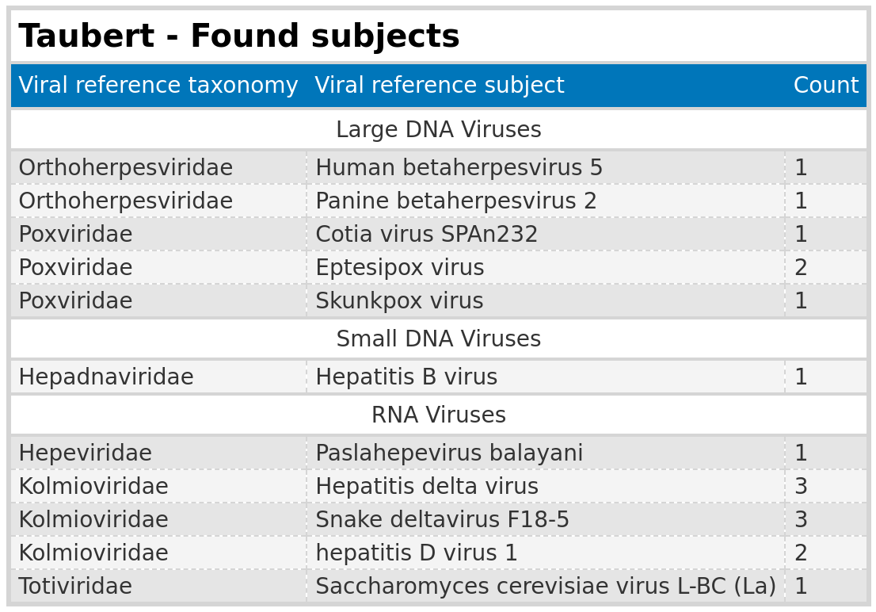

3.2 Characterization and assembly of RNA viruses from mammalian samples
A pre-existing VirusHunter hittable with 1,666 experiments, containing significant and novel RNA virus contigs from mammalian samples, served as the second data source in this thesis. Since no assembly has been performed previously, I selected a subset of data matching eight profile Hidden Markov models. This subset included 19,113 micro-contigs, which VirusGatherer used as seeds for assembly.

3.2.1 The majority of contigs found in mammalian sequencing data are significant
I discovered 8,232 contigs aligning to 128 known families and six unclassified viruses. Of these, 6,209 contigs have an E-value smaller than 1e-5, suggesting that they represent genuine viral contigs. Pisuviricota exhibited the highest number of significant viral contigs, with 2,212 out of 2,553 contigs (86.64%) having an E-value below 1e-5. Lenarviricota followed; with 686 out of 773 contigs deemed significant (88.75%). Next were Kitrinoviicota (453 out of 552; 86.78%), Negarnaviricota (209 out of 281; 74.37%), and Duplorrnaviricota (115 out of 124; 92.74%). Of the remaining viral contigs, including unclassified contigs, 2,534 out of 3,979 (63.68%) were found to be significant.
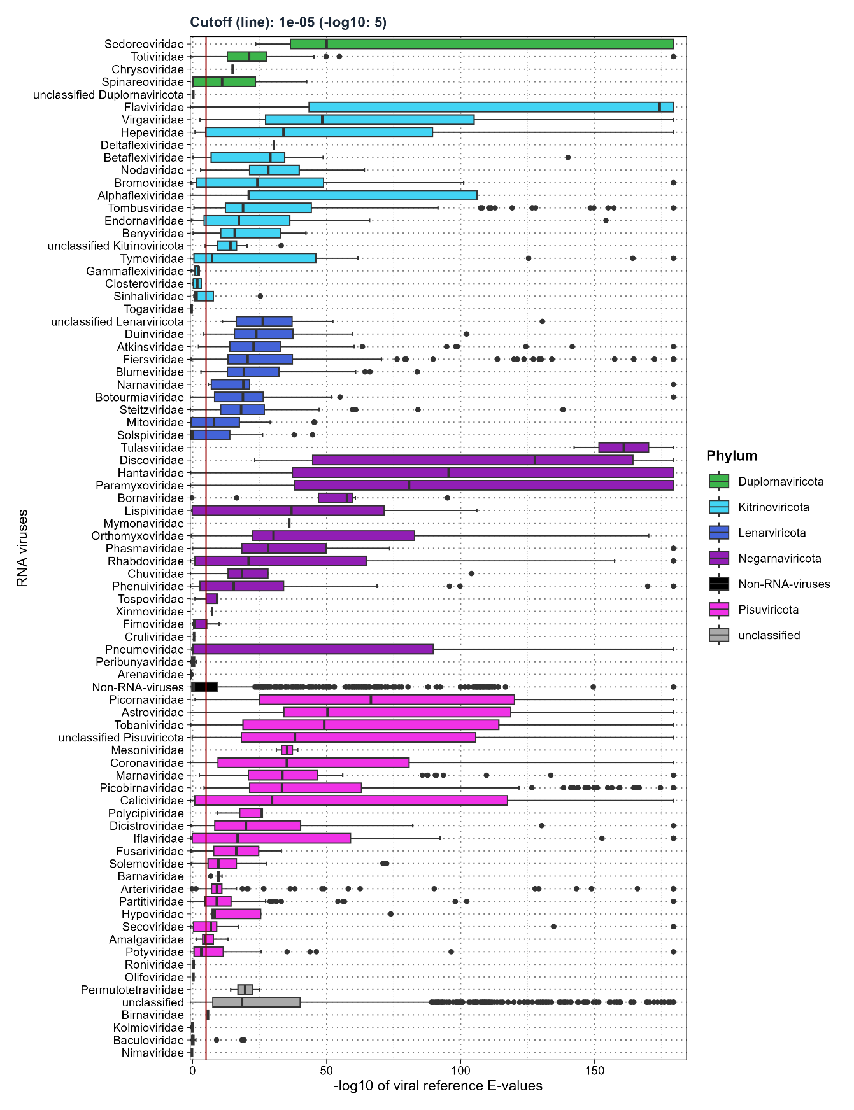

3.2.2 VirusGatherer assembled contigs from over 300 SRA experiments, identifying 69 RNA virus families
The assembly generated 6,209 viral contigs with an E-value below 1e-5 from 332 experiments. Within the phylum Pisuviricota, I identified 21 viral families. Dominating this group was Arteriviridae, which comprised 1,082 of the 2,212 viral contigs (48.92%) found across 36 of the 332 datasets. Picobirnaviridae followed with 312 contigs (14.10%), and Astroviridae contributed 234 contigs (10.58%). Collectively, these three families accounted for 73.6% of all Pisuviricota contigs. Excluding unclassified entries, Arteriviridae and Picobirnaviridae had the highest counts among all phyla, with Fiersviridae adding 284 viral contigs (41.40%) from a total of 686 Lenarviricota contigs. Steitzviridae appeared in 16 samples, contributing 114 contigs (16.61%), while Blumeviridae was present in 12 samples with 70 contigs (10.20%). The remaining Lenarviricota families each accounted for less than 10%.
In the Negarnaviricota phylum, a similar trend emerged, with Paramyxoviridae leading at 66 contigs (31.57%), followed by Rhabdoviridae with 41 contigs (19.62%) and Phenuiviridae with 34 contigs (16.27%). Other families in this phylum contributed less than 10% each. Totiviridae was the predominant family within the Duplornaviricota, representing 79 of the 115 contigs (70%) found across 22 samples. Flaviviridae was the most frequently detected family in Kitrinoviricota, appearing in more samples (94) than all other families combined. Despite this prevalence, it accounted for only 38.41% of the total viral contigs (174 out of 453), slightly surpassing Tombusviridae, which had 136 contigs (30.02%); the remaining families contributed less than 10% each.
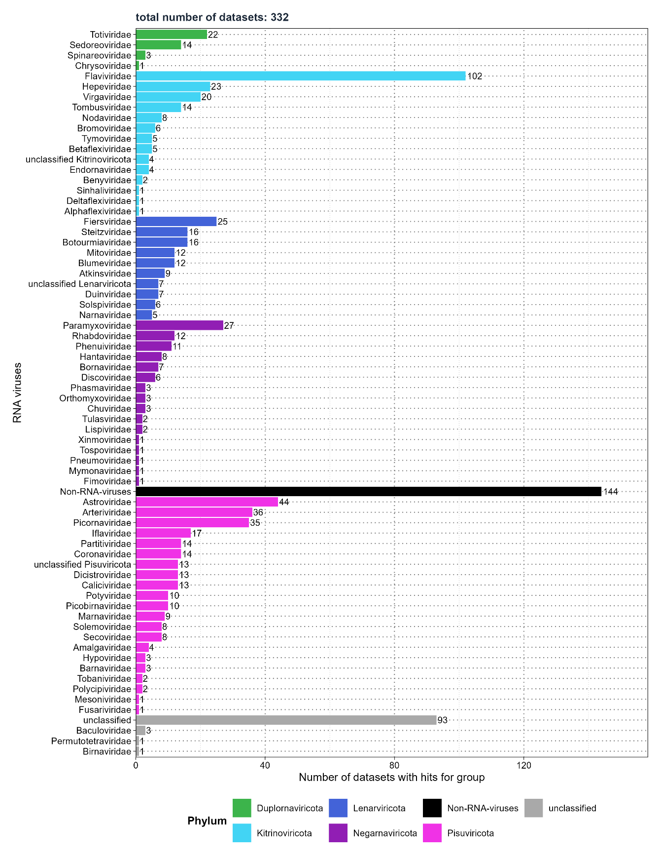

Additionally, 144 samples included 10 families of potential non-RNA viruses. Retroviridae, belonging to the phylum Artverviricota within the kingdom Pararnavirae, was detected despite the primary focus of my screening and assembly on RNA virus families from the kingdom Orthornavirae. The remaining families comprised DNA viruses within the RNA virus assembly. The comparison of E-values between non-RNA viruses and RNA viruses revealed differences in their distributions. Non-RNA viruses exhibited lower −log10 ​median E-values of 0.43 (IQR: -0.3 to 9.13). The median E-value from VirusGatherer prior to transformation was 0.37 (IQR: 7.41e-10 to 1.99). RNA viruses displayed higher −log10​ median E-values of 14.87 (IQR: 6.55 to 38.01), with the original median E-value being 1.34e-15 (IQR: 9.74e-39 to 2.85e-7).

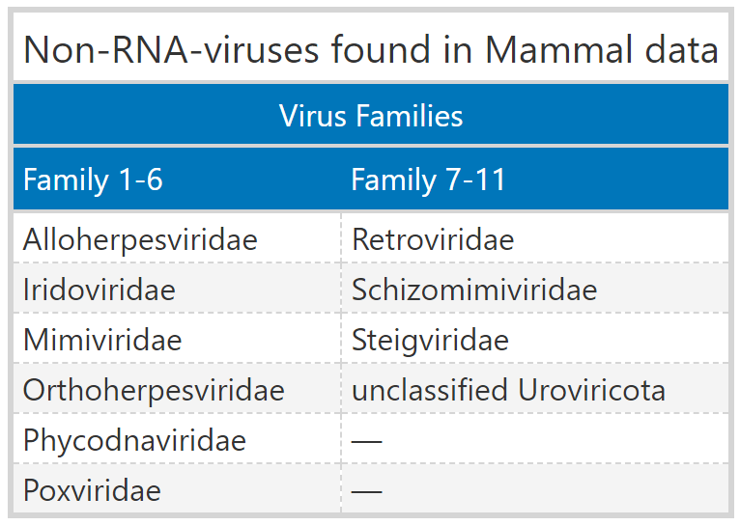

3.2.3 Most of assembled contigs originate from novel viruses
A substantial 80.59% of viral contigs (5,004 out of 6,209) exhibited less than 90% protein sequence identity with their closest known virus, suggesting they come from new viruses. Starting with the highest percentage, the phylum Lenarviricota had 97.81% classified as novel, followed closely by Kitrinoviricota at 75.72%. Duplornaviricota and Negarnaviricota ranked third and fourth, with 73.04% and 70.33%, respectively. Although Pisuviricota contained the largest total number of contigs among RNA phyla, only 57.05% were classified as novel. Lastly, 98% of all unclassified contigs displayed protein sequence identities below 90%, and non-RNA viruses had no contigs with identities of 90% or higher.
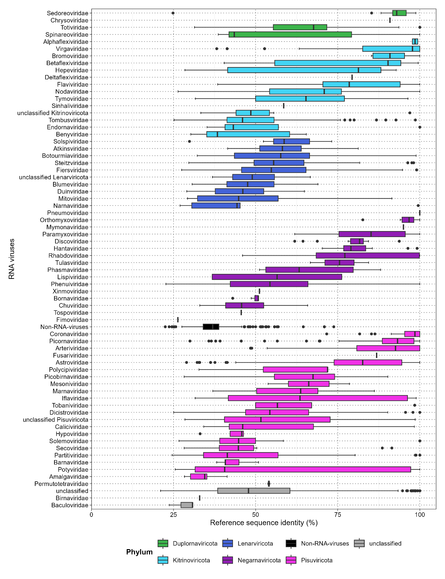

Among the 10 families with the highest number of contigs, five—Picobirnaviridae, Fiersviridae, Tombusviridae, Steitzviridae, and Partitiviridae—demonstrated that over 90% of their viral contigs were classified as novel sequences. Steitzviridae and Fiersviridae belong to the phylum Lenarviricota, while Picobirnaviridae and Partitiviridae are part of Pisuviricota, and Tombusviridae falls under Kitrinoviricota. Despite Arteriviridae having the highest total number of contigs, only 36.14% were novel sequences, representing the second-lowest percentage, just above Picornaviridae. Together, these 10 families accounted for 42.25% of all viral contigs identified. Additionally, when including Astroviridae from Pisuviricota and Flaviviridae from Kitrinoviricota, three phyla emerged as dominant: Lenarviricota, Kitrinoviricota, and the most represented, Pisuviricota.

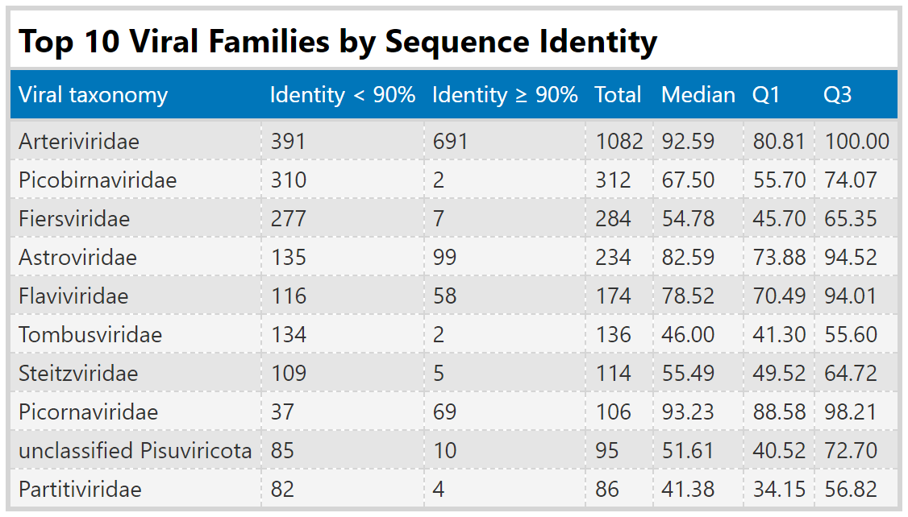

3.2.4 Four-fifths of all assembled contigs measure less than 1,000 nucleotides
The median contig length varied significantly, ranging from 104 nucleotides (IQR: 97 to 114) in the family Arteriviridae to a single contig measuring 10,373 nucleotides that aligned with Pneumoviridae from the phylum Negarnaviricota. Notably, Arteriviridae had both the lowest median length and the shortest individual contig at 78 nucleotides, alongside the second-longest contig at 18,735 nucleotides. The longest contig overall measured 26,579 nucleotides and aligned with the family Coronaviridae. Across all phyla, only 19.72% (1,225) of the contigs exceeded 1,000 nucleotides in length, with Pisuviricota accounting for the highest number—258 out of 2,212 contigs, or 11.66%. Among these, 202 contigs within Pisuviricota exhibited a sequence identity below 90% and a length greater than 1,000 nucleotides.

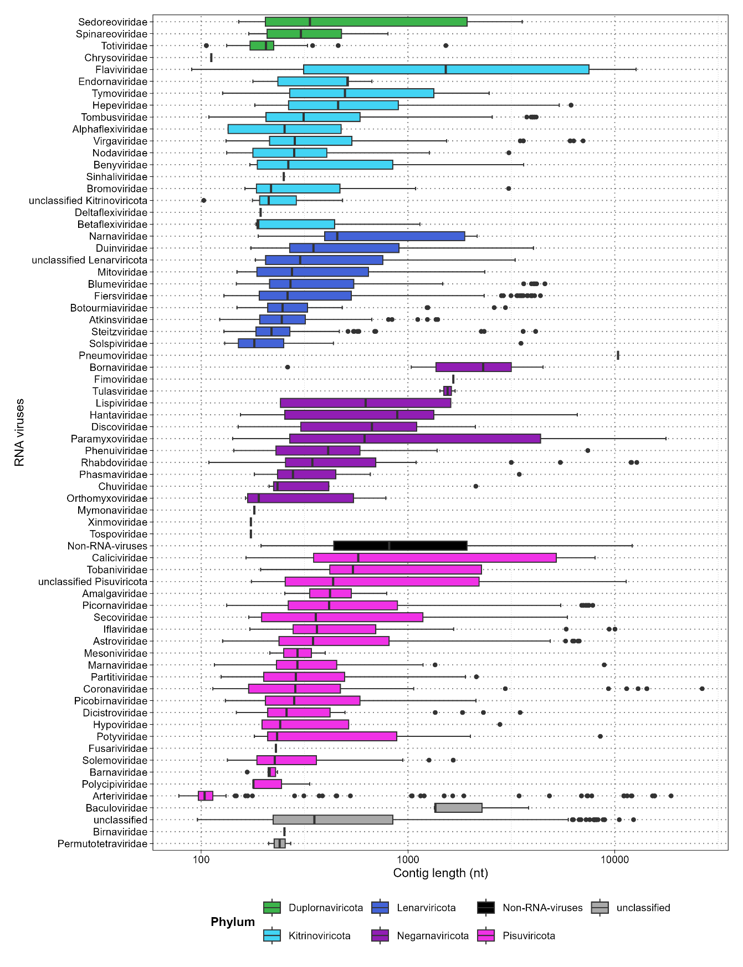

Following Pisuviricota, Kitrinoviricota had the second-largest number of contigs exceeding 1,000 nucleotides, totaling 148 contigs (32.67%), of which 103 were classified as novel. Lenarviricota contributed 97 contigs (14.14%), with 95 of these being novel. The top ten viral families with the most contigs were dominated by these three phyla, and this trend was also evident in the count of contigs longer than 1,000 nucleotides. Negarnaviricota had 54 contigs (25.84%), including 42 classified as novel, while Duplornaviricota had only 10 contigs (8.70%), with two of them identified as novel.
To ensure that the identified contigs represent genuine viral sequences, a functional annotation of the viral proteins for the ten longest contigs originating from different RNA virus phyla was performed. The lengths of the top ten longest contigs varied from 3,569 to 26,479 nucleotides. Remarkably, all contigs aligned to different virus families, and with the exception of one, each exhibited a protein sequence identity below 90%. What is more, the functional annotation consistently identified the RNA dependent RNA polymerase (RdRp), which served as the profile for screening, while most contigs also found characteristic protein domains specific to their respective virus families.
As an illustration, The longest contig corresponds to a novel alphacoronavirus identified in a sample from Harrison's large-eared giant mastiff bat (Otomops harrisoni). This sample was obtained during a metatranscriptomic analysis of oral and rectal swabs collected from bats inhabiting caves in Kenya (Quelle zu SRA project Seite). The second largest contig, measuring 18,735 nucleotides, was one of the few identified novel sequences of Porcine reproductive and respiratory syndrome virus 2 found in wild boars (Sus scrofa), rather than in green monkeys (Chlorocebus sabaeus). Typical proteins of Coronaviridae and Arteriviridae were identified in both contigs, aligning with the correct open reading frames (ORF) and arranged in the expected order, with only previously known proteins found. The longest contig identified ORF1a along with its known non-structural proteins (NSP), while ORF1b included the RdRp, non-structural protein 14 (NSP14), and helicase; the subsequent open reading frames (ORFs) also contained the structural proteins. Similarly, the contig aligning to the family Arteriviridae identified ORF1a and ORF1b with their associated proteins, as well as envelope glycoproteins 2-5 arranged (EnvGP2a, 3 and 5) in the correct order.
Lastly, the third largest cntig was classified as Mount Mabu Lophuromys virus 1 from the Paramyxoviridae family. When compared to the known genome structure of this virus, the characteristic ORFs were identified, containing the nucleocapsid (N-protein), phosphoprotein (P/V-PP), glycoprotein (GP), and the final ORF with the RdRp.
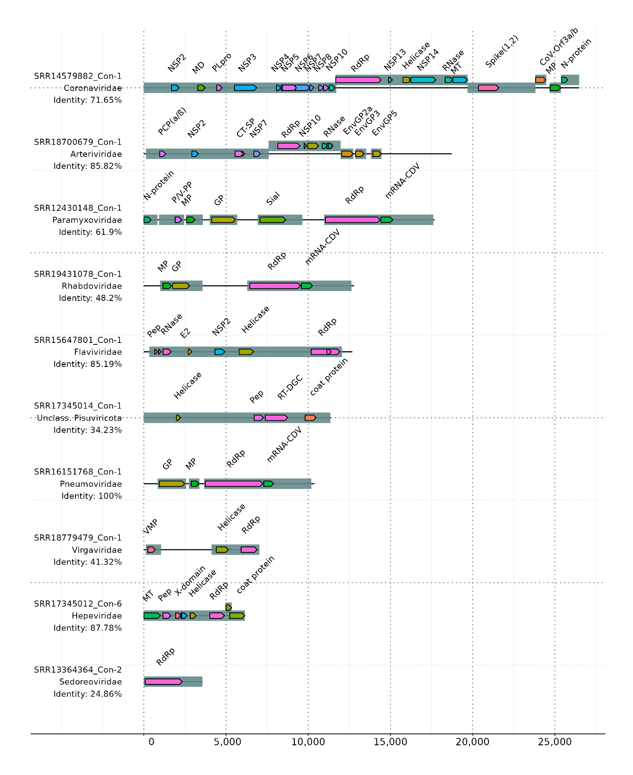

3.2.5 Mammalian hosts are mainly farm animals and Old World monkeys
I was particularly interested in the most prevalent viral subjects assigned to each contig, so I extracted the top 10. Porcine reproductive and respiratory syndrome virus (PRRSV) and PRRSV-2 were identified 987 times within the family Arteriviridae, representing approximately 91.22% of all Arteriviridae-aligned contigs, with 298 classified as novel. Notably, these two viruses and Otarine picobirnavirus were the only ones where the total number of contigs differed from those with a protein sequence identity below 90%. Among the hosts, African green monkeys (Chlorocebus sabaeus), often used in biomedical research, appeared in 981 contigs, of which 293 might be novel. Wild boars (Sus scrofa) seemed to host 4 contigs (three of which were novel), while two novel contigs were identified in Bushy-tailed woodrats (Neotoma cinerea). Another rodent arterivirus was found in Old World monkeys of the genus Chlorocebus (46, Chlorocebus sabaeus) and Eastern gray squirrels (2, Sciurus carolinensis). Closer inspection revealed that all instances of PRRSV-1 and PRRSV-2 found in green monkeys originated from the same study (ERP130049), which involved infecting a cell line derived from the fetal kidney tissue of African green monkeys in vitro with PRRSV-1. Meaning that these infections did not occur naturally.

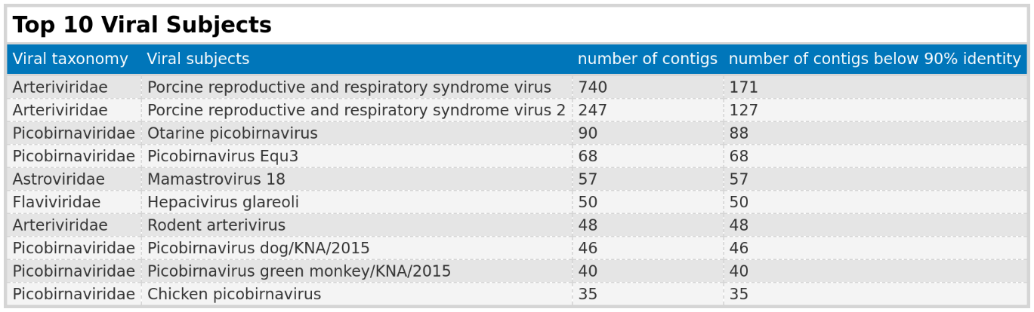

Of the top 10 viral subjects, half were found in the family Picobirnaviridae, comprising 279 viral contigs, with 277 having a protein sequence identity below 90%. Otarine picobirnavirus, typically associated with sea lions, was identified 90 times. In this study, the primary host appears to be domesticated pigs (Sus scrofa domesticus, 85 contigs), a finding also noted by Chauhan et al. Additionally, 4 contigs were found in donkeys (Equus asinus) and 1 in cattle (Bos taurus), suggesting that all instances of this aquatic mammal virus occurred in farm animals. Chicken picobirnavirus was detected in domesticated pigs (32), donkeys (2), and cattle (1). The dog variant was observed in pigs (44) and donkeys (2), while the variant associated with green monkeys seems to have been found in 38 pigs and 2 donkeys. Lastly, the variant primarily associated with horses (Equus caballus) was detected in pigs (60), rats (Rattus, 2), and cattle (3). Remarkably, it was also found in two Rhesus macaques (Macaca mulatta) and one Sunda pangolin (Manis javanica).
Mamastrovirus 18, typically associated with bats, was identified in three bat species (Miniopterus africanus, Rhinolophus, and Myotis tricolor). Additionally, novel contigs aligning to a hepacivirus were found in Middle East blind mole-rats (46, Nannospalax ehrenbergi), Eastern deer mice (2, Peromyscus maniculatus), and one each in muskrats (Ondatra zibethicus) and Desmarest's spiny pocket mice (Heteromys desmarestianus).

3.2.6 Unclassified Viral Families and the Specificity of Hidden Markov Model Profiles

I generated all figures and tables presented (except Figure X) and performed preprocessing and calculations of summary statistics in the results section using Virusparies, the R package I created for this master’s thesis. Contigs were grouped into different viral families on the y-axis of each figure by extracting the virus family from the ViralRefSeq_taxonomy column in both VirusHunter and VirusGatherer hittables. This extraction was handled internally by Virusparies functions.
Values in this column consist of a taxid and taxonomic information about the detected virus sequence, derived from the alignment of query sequences against the viral database, and are separated by the "|" character (e.g., taxid:1354498|Hepacivirus colobi|Hepacivirus|Flaviviridae|Amarillovirales|Flasuviricetes|Kitrinoviricota|Orthornavirae|Riboviria).
Occasionally, the VirusHunter and VirusGatherer pipelines fail to extract information about the viral family, resulting in contigs being grouped into the 'unclassified' category or 'unclassified' followed by the phylum name if phylum information is still present. I observed that approximately one-third of all contigs provided no information about family or phylum, while 3.35% provided information about the phylum but not the virus family. Only 2,894 out of the 6,209 viral contigs provided information about the family.
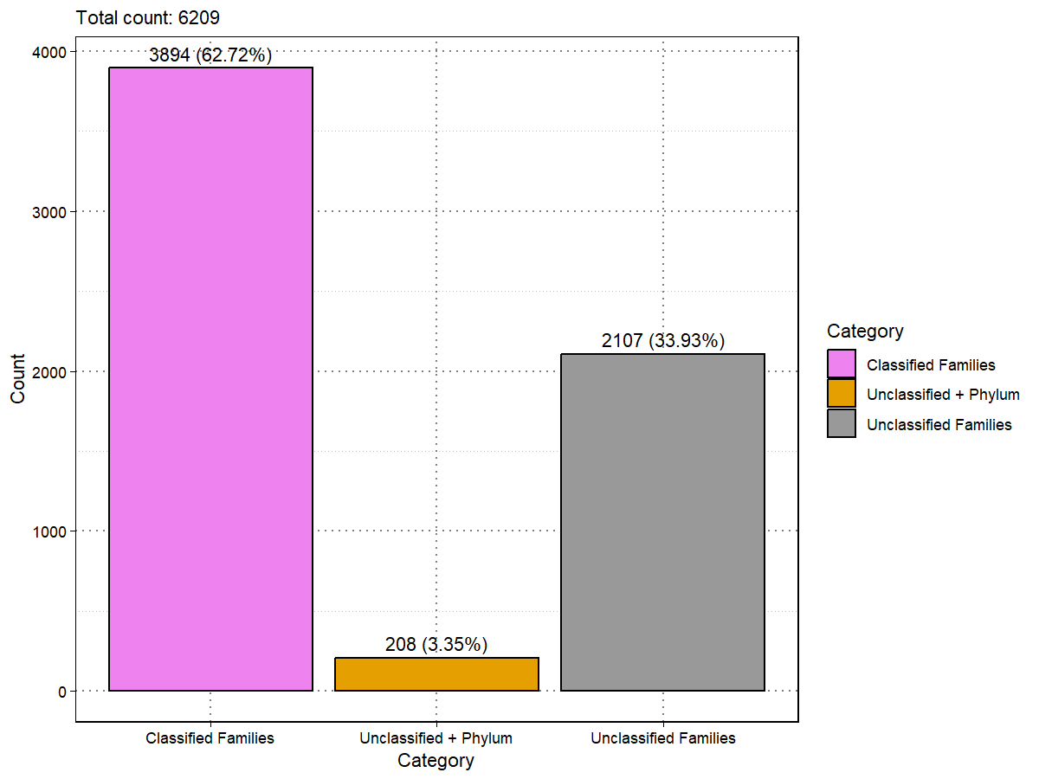

VirusHunter was employed to screen for viral sequences within unprocessed data by utilizing profiles of conserved proteins characteristic of specific virus families. The identified contigs were subsequently assembled using VirusGatherer. A total of eight profiles were applied (see Materials and Methods), and the results were consolidated into a single output file.
When running VirusHunter independently, it became apparent that the profiles used were not exclusively specific to their corresponding virus families. For example, when VirusHunter was run with SRA experiments aligned solely against the RNA-dependent RNA polymerase (RdRp) of the Flaviviridae family (Flavi_RdRp), 14 other families were identified within my VirusHunter hittable. Notably, some of these identified profiles—such as NidoAstro_RdRp, Nido_NiRAN, and Negative_Bunya-Arena_RdRp—correspond to the eight profiles utilized in this study. This suggeststhat the run for Flavi_RdRp also contributed to the assembly of contigs belonging to families associated with the other profiles
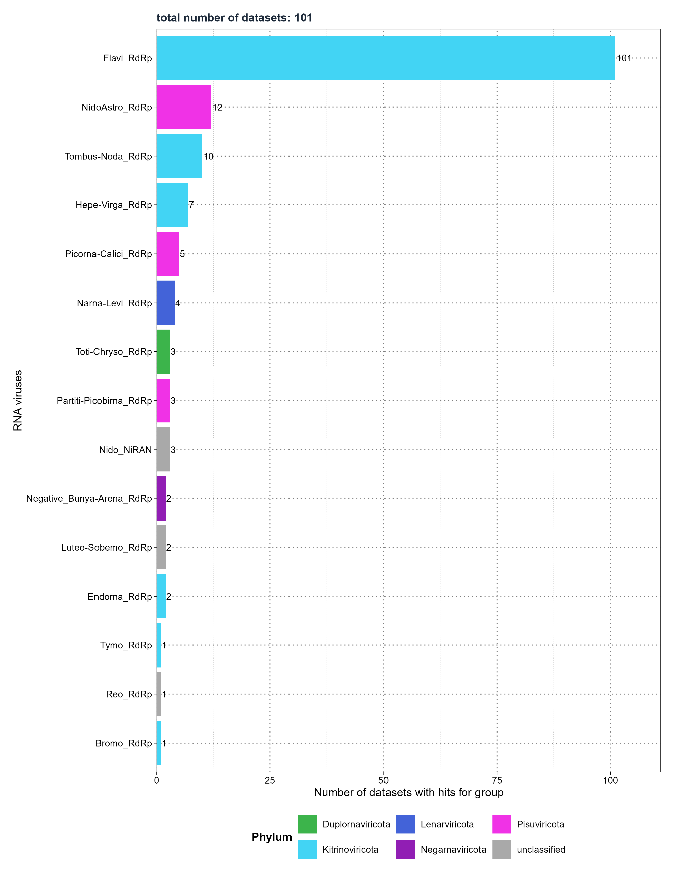

Discussion
Currently, an estimated 1.67 million viral species are still unknown. Half of these species may be capable of infecting humans, with some potentially contributing to future outbreaks as the frequency of pandemics rises. Other viruses are part of the virome. Meaning that living organisms, including humans harbor viruses in their cells or within the microorganisms that comprise their microbiota. The virome comprises viruses that can cause disease, particularly in immunosuppressed individuals, while others coexist as commensal viruses in our body without known pathogenicity. A few even integrate into the genome, contributing to the evolution of their hosts. Factors such as the host’s lifestyle choices and environmental conditions influence the composition of the virome. Conversely, the virome affects the host, their microbiota, and the surrounding environment, resulting in a complex network of interactions.
Virus discovery aims to identify these novel and previously unknown viruses. Allowing us to improve our understanding of the evolutionary history of viruses, their disease-causing mechanisms, and the intricate relationships they have with their host and environment. This new knowledge could have practical applications, such as helping to find surrogate viruses when the original virus may not be suitable for biomedical research. Historically, virus discovery relied on sample collection and wet lab analysis, with progress tied to technological advancements. X-ray diffraction enabled structural analysis, polymerase chain reaction (PCR) and Sanger sequencing allowed to study the viral genomes, and next-generation sequencing made large-scale metagenomics analysis possible, enabling the identification of viral sequences directly from environmental samples.
Internet access, along with the ability to upload large files to public repositories, has allowed researchers to share vast amounts of sequencing data. One such repository is the Sequencing Read Archive (SRA), which hosts 53 petabases of open-access sequencing data. It has been shown that sequencing data deposited in the SRA often come from samples that may have been infected by one or multiple viruses at the time of collection. This suggests that the SRA, with its large amount of unprocessed sequencing data, could contain unnoticed viral sequences – some from known viruses and others potentially novel – that were undetected during initial sampling. New Data-Driven Virus Discovery (DDVD) approaches leverage the SRA to screen for viral sequences in deposited sequencing data, enabling the monitoring of viruses from existing samples. DDVD is primarily computational; performing homology searches for virus-positive samples, aligning them to viral reference genomes, and assembling longer viral contigs. These approaches offer advantages such as lower costs compared to wet lab methods and the ability to use metadata associated with the sequencing data to gain insights about the host. While not a replacement for wet lab experiments, DDVD tools serve as complementary approaches.
The aim of this thesis is to characterize novel and known viruses in sequencing data from liver biopsies of liver transplant patients provided by the Taubert working group, and to assess whether the identified viruses are associated with liver rejection. It further involves the characterization, assembly, and functional annotation of mammalian RNA viruses from existing screenings.
To archive this, I applied the VirusHunterGatherer pipeline developed by the Computational Virology Research Group at Twincore, a computational workflow designed for data-driven virus discovery. VirusHunter performs a sensitive homology search for conserved viral protein families to identify virus-positive samples from unprocessed sequencing data, either locally available or fetched from a public repository. Then, VirusGatherer assembles longer viral contigs and classifies them. The pipeline is employed on the Taubert dataset across all three viral groups (Small DNA, Large DNA, and RNA viruses), while only screening for RNA viruses in the dataset with the mammalian samples. The following subsections discuss the results.

4.1 Discussion of the results obtained from Taubert sequencing data
The results from the screening of the Taubert sequencing data, as detailed in section 3.1.1, indicate that only a small fraction of the initial dataset was capable of detecting viral sequences. Among the 557 FASTQ files (representing 323 samples) provided by the Taubert working group, only 0.89% (5 files) identified small DNA viruses, while 3.05% (17 files) detected RNA viruses. The largest proportion was observed for large DNA viruses, with 29.62% (165 files). However, upon excluding all non-significant results (E-value > 1e-5), no files remained for small DNA viruses. For the screenings against RNA viruses and large DNA viruses, the number of files detecting potential viral contigs was low (maximum of 11), as was the number of viral families identified (maximum of 4). The low number of files detecting potential viral contigs may suggest two possibilities: 1) the samples could genuinely contain few viral sequences, or 2) viral sequences may have been present in the liver samples but went undetected, possibly because the sequencing approach was not optimal for detecting viruses. There may have been no specific enrichment for viral sequences, or the viral sequences could have been lost during preprocessing steps before sequencing. Both scenarios are plausible, as the samples were not originally collected for viral discovery. At this stage, no definitive conclusions can be made regarding which of the two possibilities is correct. Further investigation would be needed to determine whether the low detection rate is due to a genuine lack of viral sequences in the samples or the result of decisions made during sample pre-processing.
VirusGatherer identified 17 virus-positive contigs with sequence similarity to six viral families. However, the families Hepadnaviridae and Poxviridae were considered not significant in VirusHunter, while Flaviviridae, Potyviridae, and Adenoviridae, detected by VirusHunter, were not found by VirusGatherer. This may be due to the low number of contigs aligning to these families in the VirusHunter step. The assembly of longer contigs typically requires sufficient coverage, and if coverage is too low, successful assembly may not occur. Among the remaining contigs, some aligned with betaherpesviruses and hepatitis viruses, with the majority having animal-infecting viruses as their closest match. Importantly, the maximum length of all contigs was under 300 nucleotides. Assigning taxonomy based on homology searches may prove challenging when the sequences used for alignment are short and potentially diverge from the reference sequence, as they contain limited taxonomic information [critical assessment of metagenome interpretation – a benchmark of computational software].
Since no host substraction was performed and the host genome is typically much more abundant than viral sequences, there is the possibility that short sequences from the hot may align with the viral reference sequences. Meaning it is difficult to ascertain whether these contigs are genuinely viral in nature due to their limited contig size.
Overall, due to the small fraction of data with detected contigs, their E-values being close to the cutoff for significance, and the short lengths of all contigs, it is not possible to make definitive statements about whether the few contigs identified by VirusHunterGatherer are genuine viral sequences or if they result from contamination. Consequently, no clear absolute statements can be made regarding whether viruses were truly absent in the liver samples post-transplantation or, if present, whether they can be associated with liver rejection.

Taubert
- Only a fraction of runs identified viral contigs: Small DNA virus run found 0.89% of total input. RNA viruses 3.05% (17 files) and large DNA viruses found in 29.62% (165 files) of all data.
- Most of the contigs are not significant or near the threshold of significance: No significant viruses for small DNA in Hunter, 11 out of 165 find for large DNA, and 4 for RNA viruses. Meaning 98.2%-100% of the original 557 fastq files did not find viral contigs.
- Viral subjects were primarly animal viruses from skunks, bats, primates, and snakes with a high protein sequence identity, but their contig length is short with under 300 nt max. For that reason: We cannot tell if sequences stem from real infections or contamination, nor link them to disease phenotypes.
- ! Nur weil das nachstverwandte Virus ein Snakevirus ist, heißt es nicht, dass es auch ein Snakevirus ist. Man muss das vorsichtlich und ordentlich formulieren.

4.2 Discussion of the results obtained from screening and assembling mammalian viral sequences
Mammal
- 6,209 assembled contigs have an E-value smaller than 1e-5
- 69 viral families mapped against those contigs
- 10 non-rna viruses -> No filtering against host, might be potential alignments against host, as Retroviridae match might be host RT. Crossreaction of profiles for RNA viruses against non-RNA-viruses. It is expected than under a cross reaction the E-values of non-rna viruses would be significantly higher than those of genuine RNA viruses. This is exactly what was observed here: Non-RNA viruses have higher E-values than RNA viruses. Crossreaction of profiles against non-RNA viruses.
- 80.59% of viral contigs are novel -> less than 90% identity. Bezieht sich auf den Zeitpunkt an dem die in unserem Server etabliert wurde und benutzt wurde. Neuere Daten können eingeführt wurden sein, die die Zahl runterbringen. In einem nebensatz erwähnen: as to the currect point of analysis.
- Among the top 10 virus families with the most contigs most novel + 3 dominant phyla: Lenarviricota, Kitrinoviricota, and the most represented, Pisuviricota
- . Across all phyla, only 19.72% (1,225) of the contigs exceeded 1,000 nucleotides in length
- median contig length varied significantly, ranging from 104 nucleotides in the family Arteriviridae to a single contig measuring 10,373 nucleotides that aligned with Pneumoviridae
- Arteriviridae had both the lowest median length and the shortest individual contig at 78 nucleotides, alongside the second-longest contig at 18,735 nucleotides. The longest contig overall measured 26,579 nucleotides and aligned with the family Coronaviridae
- Arteriviridae also has the most contigs and the most novel contigs.
- The top ten viral families with the most contigs were dominated by these three phyla, and this trend was also evident in the count of contigs longer than 1,000 nucleotides
- Mammalian hosts are mainly farm animals and Old World monkeys
- Bei Affen nicht klar, ob der Virus eine natürliche Infektion ist oder ob Sie als Teil eines Experiments infiziert wurden durch einen Virus, der nicht natürlich bei ihnen auftaucht. – Keine natürliche Infektion.
- Otarine picobirnavirus, typically associated with sea lions, was identified 90 times. In this study, the primary host appears to be domesticated pigs (Sus scrofa domesticus, 85 contigs), a finding also noted by Chauhan et al.

Vorteile von VirusHunterGatherer
- Hohe Sensitivität durch pHMM
- Nicht gebunden an kostenpflichtige Server wie Serratus.
- Map Host direkt zum gefundenen Virus. So können Surrogate gleich direkt zum Tier gemapped werden und das Tier als Model identifiziert werden.

Nachteile VirusHunterGatherer
- Sequenzen mit geringer Komplexität und hoher Ähnlichleit sorgen für Probleme bei Homology Search Approaches
-Lange Laufzeit von VirusHunter
-Kann nur Sequenzen assemblieren, die im pHMM ein Hit waren; Vien mit segmentierten Genomen wie Influenza haben das problem, dass nur 1/8 Segmenten das RdRp hat. Die anderen segmente brauchen ihr eigenes pHMM. Würde andere Segmente nicht erkennen. Bei neuen Viren sind nicht alle Segmente bekannt. Suche nach segmentierten Viren erschwert.
- Profile nicht spezifisch
- Taxonomy in vielen Fällen nicht aufrufbar.

Virusparies:
- Vorteile von r packages hier gültig: Reproduciability of methods.
- Weiterhin hat es weiteren Nutzen für zukünftige Projekte.
- make virus discovery data both comprehensible and useful for informed decision-making and further application

Outlook:

- Rückschlüsse durch Litertaur Machen: Sind die Green monkeys natürliche Hosts.

- Appendix

List of references

