Charakterisierung des Viroms nach Lebertransplantation
Characterization of the virome after liver transplantation

Masterarbeit
zur Erlangung des Hochschulgrades
Master of Science (M.Sc.)

im Studiengang Biomedizinische Datenwissenschaft
der Medizinischen Hochschule Hannover

vorgelegt von
Sergej Ruff
Geboren am 23.12.1997
In Kustanai, Kasachstan

Hannover, <Monat (ausgeschrieben) Jahr (Zahl)>

Die vorliegende Masterarbeit wurde im Zeitraum vom 08.04.2024 bis 08.10.2024
im Twincore, Zentrum für Experimentelle und Klinische Infektionsforschung GmbH
angefertigt.
Erstgutachter/in: | Jun. Prof. Dr. Chris Lauber
 | Head of Computational Virology research group
 | TWINCORE - Centre for Experimental and Clinical Infection Research
Zweitgutachter/in:
Abgabedatum:

1 Introduction 7
1.1 The need for virus discovery 7
1.1.1 Pandemics are increasing and they are caused by viruses 7
1.1.2 The human virome: ‘our” viruses 8
1.2 History of viral discovery 8
1.3 A new approach: Data-driven Virus discovery 8
1.3.1 ‘Hunting’ for viruses in unprocessed data 9
1.3.2 Profile Hidden Markov Models 9
1.3.3 ‘gathering’ their genome sequences for assembly 12
1.4 Competition 12
1.5 Aim of thesis 12
2 Material and Methods 13
3 Results 14
4 Discussion 15
5 Bibliography 16

List of Abbreviations

Abbreviations | Meaning
pHMM | Profile Hidden Markov Model
SRA | Sequence Read Archive

Table of Figures

Index of Tables

Introduction

1.1 The need for virus discovery
Virus discovery focuses on identifying new and previously unknown viruses. The thesis explores the history of viral discovery and introduces a modern, data-driven approach that leverages publicly available, unprocessed data. It presents VirusHunter, a tool for data-driven viral discovery, alongside VirusGatherer, which assembles identified viral contigs. The competition to VirusHunter and VirusGatherer will also be discussed, concluding the Introduction with the goals of the master thesis.
But first, I will begin the master’s thesis by asking the question: 'Why do we need virus discovery?'

1.1.1 Pandemics are increasing and they are caused by viruses
Between 1918 and 1919, an avian influenza virus, previously exclusively infecting waterfowl, spread to farm poultry and pigs. Eventually, it breached the species barrier, posing a global threat to humans. It infected one-third of the global population with more than 50 million deaths. Historically, major pandemics like the ‘Spanish Flu’ of 1918-1919 were rare, occurring once or twice per century. However, in recent decades, the frequency of pandemics has significantly increased due to factors such as globalization, increased air travel, population growth, and human encroachment into wildlife habitats.
The first 20 years of the 21st century have seen six major pandemics alone. The first was the SARS pandemic from 2002 to 2004, caused by the SARS-CoV-1 virus from the Coronaviridae family. This was followed by the H1N1 ‘swine flu’ pandemic in 2009. Between 2012 and 2016, the world faced several viral outbreaks, including the Middle East Respiratory Syndrome (MERS), the Ebola virus pandemic, and the Zika virus pandemic. Most recently, the global COVID-19 pandemic, caused by SARS-CoV-2, emerged in 2019.
Notably, all six major pandemics of this century have been caused by viral infections, with the majority originating from animals and being transmitted through airborne means. Viruses that emerge through zoonosis face no existing immunity in the new host species, as the host's immune system has not previously encountered them. This lack of immunity, combined with airborne transmission, increasing population densities, and intensified human-animal interactions, allows these viruses to spread rapidly across entire populations.

Effectively preventing global pandemics relies on promptly identifying the infecting virus. This critical process allows for the rapid development of diagnostic tools, vaccines, and treatments. However, viral discovery is considerably more challenging than identifying bacteria or fungi. While bacteria can be identified through cultures and 16S rRNA sequencing, and fungi through internal transcribed spacer (ITS) region sequencing, viruses lack standardized culture methods and universal sequencing markers. Despite these challenges, virus discovery has become increasingly important due to the rapid rise in viral outbreaks and pandemics. For instance, less than two years after the COVID-19 pandemic began, the first outbreak of the Mpox virus was reported, highlighting concerns about the potential for further spread.

1.1.2 The virome: ‘our’ viruses

Besides identification of viruses during possible pandemic and disease scenarios, viral discovery could enhance our understanding of the virome – the collective population of eukaryotic and prokaryotic viruses inhabiting the host body. Each human has a virome consisting of over 10¹³ viral particles, with each body site creating their own niche. Meaning, different body parts host distinct viruses that infect cells or microorganisms living in or on the host. Moreover, factors such as the host´s age, genetics, immune system, lifestyle choices (for example diet and smoking), and infections can alter the composition and abundance of the virome throughout the host´s life.
- Beispiele für Menschen haben, wo Assoziation zwischen Krankheit und Virome gefunden wurde
- Beispiele für Tiere haben
- Auch positive Aspekte des Viromes nennen
- Beispiel, wo Bakterielle Ökosystem kontrolliert wird durch Virome

- Conclusion für den Teil: Virome hat positive Seiten (Bakterielle Ökosystem erhalten). Assoziert mit Krankheiten. Virome noch nicht zu 100 % identifiziert. Großteil noch unbekannt. Deshalb virus discovery wichtig.

1.1.3 Viral history

1.1.4 Discovering surrogates viruses and new model organisms
-> Lese Paper zu Hepatitis C und Animal Models. Lese die Paper, die da genannt werden.
-> Nenne Grund, wieso man neue Modelle braucht (Affen nicht mehr erlaubt, aber man braucht Impfstoff). Ohne neuen Wirten kann Impfstoff nicht entwickelt werden, man muss aber auch das Tierwohl erhalten, leiden minimieren und Affenart ehalten.
- Vielleicht andere Beispiele nennen, wenn du welche findest

1.2 History of viral discovery
The history of virus discovery begins with the work of Russian biologist Dmitri Iosifovich Ivanovsky in the late 19th century. While studying at the University of Saint Petersburg, Ivanovsky investigated a disease impacting tobacco plant crops in Ukraine and Bessarabia, and named it "pock virus". Later, he was sent to Crimea to investigate tobacco plants affected by brown spots, which were consistent with the disease he had described. The plants also exhibited dark-green and yellow areas on their leaves, mirroring the symptoms of tobacco mosaic disease. This disease was first described by Adolf Mayer, who noted that it could infect nearby tobacco plants but would lose its infectious quality if bacteria were filtered out from the plant sap. To test this hypothesis, Ivanovsky used a porcelain Chamberland filter, which retained bacteria and other microorganisms but allowed particles smaller than bacteria to pass through. He then inoculated unaffected plants with the filtered homogenate from affected plants. The inoculated plants soon exhibited the same distinct mosaic pattern on their leaves, demonstrating that the disease was caused by an agent smaller than bacteria. The discovery of the tobacco mosaic virus was published by Ivanovsky in 1892, revealing the existence of infectious agents smaller than bacteria. Seven years after the discovery of the first (plant) virus, the presence of viruses in animals was confirmed. Notably, up to this point, only the presence of small infectious particles could be proven, but their identity, structure, and sequence remained unknown.

It was not until the 20th century, with the advent of techniques utilizing shorter electromagnetic waves like X-rays and electrons, that scientists could use electron microscopy to identify viral structures and sequencing technologies, such as Sanger sequencing, to determine the primary sequence of each virus.
→ Erwähnen, dass unprozessierte Daten existieren, die viele virale Daten enthalten, selbst wenn die Daten nicht zu diesem Zweck erhoben wurden. Das gibt einem die Möglichkeit neue Viren in hochdurchsatz Format zu analysieren. Ein beispielsquelle ist SRA (vollen Namen nutzen und dann im Abbreviation erwähnen).
→ Notwendig betonen, dass man virusdaten aus unprozessierten Daten analysieren sollte.

1.3 VirusHunter and VirusGatherer: Data-driven Virus discovery
- Intro für Gatherer und Hunter.
Hunter ist der Data driven approach, der aus unprozessierten öffentlicen Daten Viren raussucht.
Gatherer assembliert sie.
- Bild haben hier, für den Workflow von HunterGatherer. Dann drauf verweisen und sagen, dass man im folgenden ins Detail geht.

1.3.1 ‘Hunting’ for viruses in unprocessed data
- Erwähnen, dass Virus suche gegen RNA , Small DANN und Large DANN separat durchgeführt werden muss, da du es im Methodenteil nur kurz erwähnst.
-> Sagen, dass idealerweise nur die RNA, Small DANN und Large Dann gefunden werden bei der jeweiligen suche : Large DANN viren sollen nicht bei Small DANN auftauchen (das wird im Ergebnisteil und Diskussionsteil wichtig).
- Input Output nennen
- Kurz pHMM beschreiben : Es ist ein propabalistisches Modell. Sagen, wieso es besser als paarweises alignment ist, auch wenn Paarweisen alignment eigentlich am meisten für Vergleiche von Sequenzen benutzt wird.

1.3.2 ‘Gathering’ viral reads for assembly
- Input Output nennen
Sagen, dass es Output aus Hunter als Seeds nutzt für Assembly

1.4 Competition

DAMIAN

Petabase-scale sequence alignment catalyses viral discovery

Seratus → A cloud computing infrastructure.
Performs ultra-high-throuout sequence alignment at petabase scale → meaned for large datasets in petabase size.

1.5 Aim of thesis

- Material and Methods

2.1 Code Availability Statement

All code, programs, and scripts developed as part of this work have been provided to the 'Computational Virology Research Group,' led by Jun. Prof. Dr. Chris Lauber. The VirusHunterGatherer tool, which was utilized in this study, is available for download on GitHub at https://github.com/lauberlab/VirusHunterGatherer. Additionally, an R package named 'Virusparies,' which includes functions for processing and visualizing VirusHunterGatherer output and generating summary statistics, was developed as part of this master's thesis. The package is available at https://github.com/SergejRuff/Virusparies.

2.2 Data Availability Statement

All data generated during this study, including the VirusHunter and VirusGatherer output tables, are available in a dedicated GitHub repository created for this master's thesis. This repository contains the specific datasets used in the analysis and the results presented in this work. The repository can be accessed at https://github.com/SergejRuff/MasterThesis.

2.3 Software used

Viral discovery in raw and unprocessed sequencing data was first performed via VirusHunter, which conducts a homology search with profile Hidden Markov Models (pHMMs) of proteins specific to a virus group to identify potential viral sequences. Following this, VirusGatherer utilized these identified sequences, or micro contigs, from the VirusHunter step as seeds to assemble the complete viral genomes or larger yet incomplete viral contigs. Twincore´s 'Aeternitas' computing cluster was utilized to concurrently execute VirusHunterGatherer across multiple runs. VirusHunterGatherer is implemented in Perl but was executed using Snakemake, a Python-based workflow management system. Meaning, each component of the VirusHunterGatherer pipeline was represented by a rule, managed by Snakemake. A configuration file in .yaml format specified the paths of filter databases and input data on the 'Aeternitas' server. Both local FASTQ files and a list of SRA accessions, which are downloaded and converted to FASTQ format, are supported as input. Additionally, the configuration file allowed users to enable or disable the filter against host sequences. A table listing all necessary dependencies for runnning VirusHunterGatherer is provided (Table x).

2.4 Sequencing data
Two data sets were utilized for viral discovery of large DNA, small DNA, and RNA viruses, with each data set originating from different working groups. The samples in all two sets were derived from distinct viral host organisms.

2.4.1 Taubert liver transplant data

The working group Taubert from the Department of Gastroenterology, Hepatology, Infectious Diseases, and Endocrinology at MHH provided patient liver sequencing data. The data was provided locally in 11 folders, encompassing a total of 323 samples distributed across 557 FASTQ files (see Table X).

Table 1: Taubert sequencing data was provided locally in 11 folders, consisting of 323 samples distributed unevenly across these folders. For some samples, Read 1 and Read 2 were stored in separate FASTQ files, resulting in a total of 557 FASTQ files. Analysis was completed for small DNA, large DNA, and RNA viruses for all datasets.
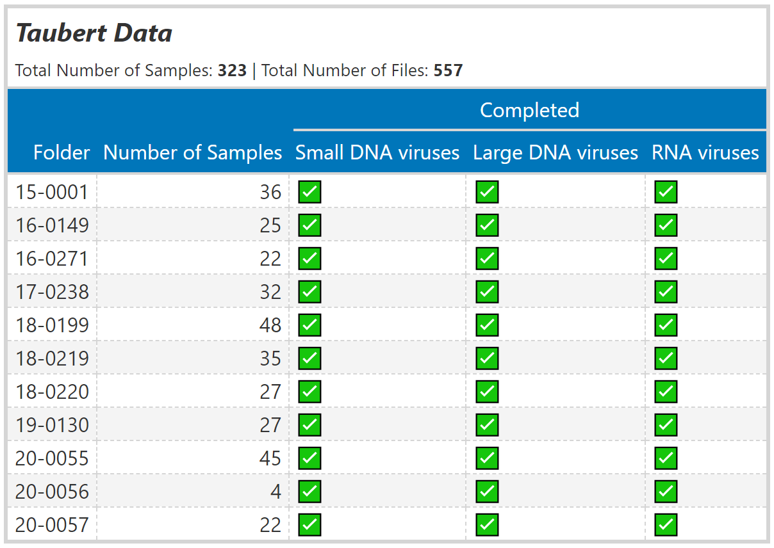

Viral discovery was conducted for Small DNA, large DNA, and RNA viruses utilizing VirusHunter. Furthermore, VirusGatherer was employed to assemble viral contigs from the micro-contigs identified during the Hunter step.

2.4.2 Mammalia data

The 'Computational Virology Research Group' provided an existing VirusHunter hittable with data analyzed from January to March 2023. No viral contig assembly via VirusGatherer was performed to this point. The data consisted of SRA data downloaded from NCBI, containing viral reads detected in mammalian hosts, with a total of 34,337 unique SRA accessions. This is in contrast to the Taubert sequencing data, which consisted of locally provided FASTQ data. The hittable was filtered to include only rows where the E-value from the BLAST search against the viral database was below 1e-5, ensuring that only significant results were retained. Additionally, to exclude non-novel viruses, the Hittable was filtered to include only entries with viral sequenced identity below 90% against the viral BLAST database. A minimum of four reads, as identified in comparison with the profiles during VirusHunter, was also required to ensure that some contigs would be assembled during the Virusgatherer step.

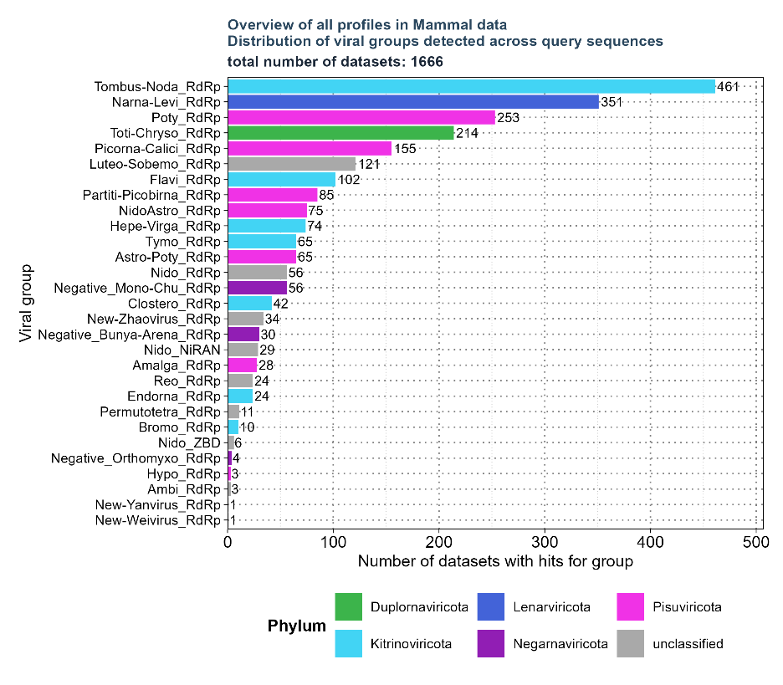
Figure 1: Distribution of viral groups detected across query sequences for all profiles identified after filtering the existing hit table. 1,666 unique SRA accessions with 29 profiles were found after applying filters for E-value < 1e-5, number of reads > 4, and viral sequence identity against the viral BLAST reference < 90%.

After filtering, 1,666 unique SRA accessions with 29 profiles remained (see figure X). To further limit the number of profiles required for analysis, eight profiles of interest were selected from the filtered Hittable. These included Flavi_RdRp, found in 102 out of 1,666 SRA accessions; NidoAstro_RdRp, found in 75; Hepe-Virga_RdRp, found in 74; Nido_RdRp, found in 56; Negative_Mono-Chu_RdRp, found in 56; Negative_Bunya-Arena_RdRp, found in 30; Nido_NiRAN, found in 29; and Negative_Orthomyxo_RdRp, found in 4. These profiles were then reanalyzed with VirusHunter, which was utilized specifically for RNA virus detection. Identified RNA viral micro-contigs were subsequently assembled into larger contigs with VirusGatherer for the first time in this master’s thesis.

2.5 VirusHunter
At the first stage of the data-driven Virus discovery, VirusHunter was employed to identify viral sequences within raw sequencing datasets using a sensitive homology search with profile Hidden Markov Models. This subchapter provides an overview of how VirusHunter was implemented and utilized within the context of this master´s thesis.

2.5.1 SRA download

Both locally available FASTQ files and a list of SRA accessions are valid input files for VirusHunterGatherer. If a list containing SRA accession numbers is not provided, but a path with locally available FASTQ files is given, the locally available data will be used as input. Alternatively, when a list of SRA accession numbers is provided, the SRA Toolkit's prefetch and fastq-dump tools download sequencing data from the NCBI SRA database. Both types of input were used in this thesis: the data provided by Prof. Dr. med. Richard Taubert was available locally on the ‘Aeternitas’ server, while the datasets containing mammalian data were downloaded from the NCBI SRA database.

2.5.2 Preprocessing of FASTQ files for VirusHunter

Trimming of sequencing adapters and removal of low-quality bases occurred in parallel for each file using fastp. Auto-detection identified and removed adapter sequences. Reads shorter than 15 bases, containing more than 5 ‘N’ bases, or having more than 40% of bases with a Phred quality score of 15 were classified as low quality and discarded. For paired-end reads, a single FASTQ file combined both reads in an alternating order. Fastp generates report files in JSON and HTML format, along with a trimmed FASTQ file. The processed FASTQ files were transformed into FASTA format via seqtk, preserving only the sequence information. Thereafter, transeq translated the sequences into protein for each of the six reading frames.

2.5.3 Sensitive homology-based detection of viral sequence reads in unprocessed data

Detection of viral reads in unprocessed sequencing data was accomplished using the hmmsearch tool, which allows for the identification of viral sequences by querying a set of pHMMs. The protein sequences translated from each of the six reading frames were applied in six separate HMMer searches, each against query pHMMs specific to protein domains associated with RNA, small DNA, or large DNA viruses. The size of the target database for E-value calculations was set to six times the number of reads, accounting for each reading frame. An E-value of 10 was applied to report hits in the sequence search. The significance of each search result was then assessed using two criteria: the number of hits and the minimum E-value observed. If the total number of hits met or exceeded a threshold of two, or if the globally best E-value was below 0.01, the results were considered significant. Score, E-value, and query profile for each significant hit were then exported. FASTA files with non-significant results were deleted and not used further.

2.5.4 Filtering against contaminants and viral reference sequences

Further filtering was performed only on data with significant hits. First, vsearch deduplicated hits by removing sequences that had identical length and nucleotide content. Deduplicated reads were then assembled to micro contigs via CAP3 assembler. Only those sequences that had a minimum overlap length of 20 nucleotides and a maximum overhang percentage length of 75 % were considered. The overhang percentage is calculated by dividing the total length of all overhangs by the length of the overlap, then multiplying by 100. As part of the master´s thesis, modifications were made to the VirusHunter Pipeline to make the filter against host sequences optional. Consequently, only the filters against custom contaminants and the viral database were applied. Filtering against custom contaminants was performed using BLASTN. The contaminant database included ubiquitin sequences, and any matches with an E-value above 1e-4 were excluded. Afterwards, the remaining contigs were filtered against a viral database via TBLASTX, and only matches with an E-Value lower than 1 were retained.

2.5.5 Output of VirusHunter

VirusHunter exported the sequences of the filtered contigs in a compressed FASTA file. Furthermore, results for hits found at each step of the pipeline were documented in separate hittables files for each sequencing experiment. These individual results were then compiled into a final VirusHunter hittable. A VirusHunter hittable contained 11 to 15 characteristic columns, depending on whether the input sequencing data was local or downloaded from the NCBI SRA database [Tabell emit typischen Aufbau für beide haben und drauf verweisen].

Table 1: Columns of the VirusHunter Hittable, including data types (chr’ for character, ‘num’ for numeric, and ‘date’ for date values in ISO 8601 format) and three representative example values for each column. The ‘run_id’ column (yellow) is specific to locally processed input data. In contrast, columns related to SRA identifiers and host information are exclusive to SRA data downloaded from NCBI (violet). For each viral read detection, the best HMM profile match, its E-value, and the number of hits are recorded in separate columns. After comparing contigs against viral reference database, the best-matching viral subject and taxonomy, the best E-value, and the percentage of sequence identity with the viral reference are documented in their respective columns. Lastly, the date of analysis is also included.

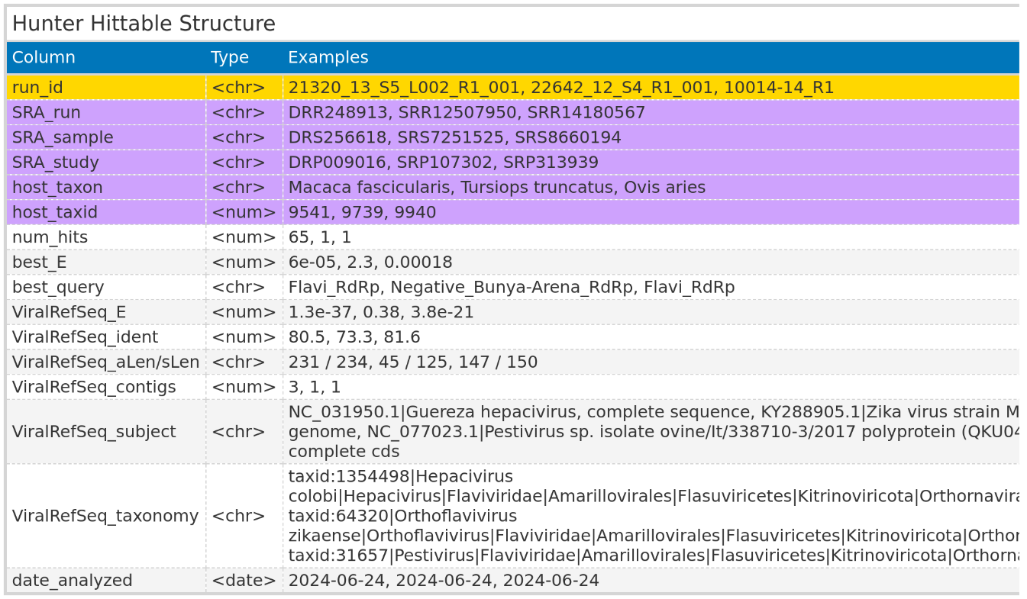

For Data downloaded from NCBI, the hittable included columns with identifiers for each SRA run, sample, and study identifier. Additionally, the Hittable featured columns with details about the host taxon and the host taxon identifier. For each SRA run, the best match against the viral reference database was documented, providing details such as the viral reference taxonomy name, the percentage of sequence identity with the viral reference, and the E-value of the best match. The E-value and the name of the best HMM profile match were also documented in separate columns, along the number of viral contigs identified for each SRA run.
For locally processed data, the Hittable omitted the columns related to SRA identifiers and host information, replacing them with a single column for the Identifiers of the local FASTQ files.

2.6 VirusGatherer

The identified viral contigs found in the VirusHunter stage serve as seeds for the progressive assembly of full-length viral genome sequences. This section details how VirusGatherer was utilized in this work.

2.6.1 Assembly of Contigs

For VirusGatherer, fastp was used to trim adapters and remove low-quality bases from each unprocessed FASTQ file, which was then converted to FASTA format. Unlike the VirusHunter stage, no translation into protein for each reading frame was performed. The viral contigs were assembled into super-contigs via CAP3, considering only sequences with an overhang percentage of 99% or less, and a minimum overlap length of 20 bases for assembly. These were then utilized as seeds for a targeted assembly of viral contigs found in the FASTQ files, with the help of a modified version of Genseed-HMM. The progressive assembly was performed using CAP3, with a maximum of 100 iterations. Contig ends with a length of 30 were used for further assembly, and the maximum contig length was set to 50.000. For CAP3, the minimum percentage identity for an overlap was set to 85%, with the minimum overlap length required being 20 nucleotides. Additionally, the maximum allowable overhang was set to 99%. For the initial similarity search, BLASTN with an E-value cutoff of 1e-3, a percentage identity of 85%, and a word size of 7 was applied. Lastly, the modified version of Genseed-HMM performed deduplication in each iteration to decrease CAP3 assembly time.

2.6.2 Compare against viral reference database

Assembled contigs were compared against NCBI’s database of reference viral proteins using BLASTX. For the BLASTX queries, the maximum number of reported high-scoring segment pairs (HSPs) – which are local alignments with the highest scores and no gaps – was set to 1. Additionally, the maximum number of target sequences returned per query was also set to 1.

2.6.3 Output of VirusGatherer

Table 2: Columns of the VirusGatherer Hittable, including data types (chr’ for character, ‘num’ for numeric, and ‘date’ for date values in ISO 8601 format) and three representative example values for each column. The ‘run_id’ column (yellow) is specific to locally processed input data. In contrast, columns related to SRA identifiers and host information are exclusive to SRA data downloaded from NCBI (violet). The contig identifier and its length after assembly are reported. After comparing contigs against viral reference database, the best-matching viral subject and taxonomy, the best E-value, and the percentage of sequence identity with the viral reference are documented in their respective columns. Lastly, the date of analysis is also included.
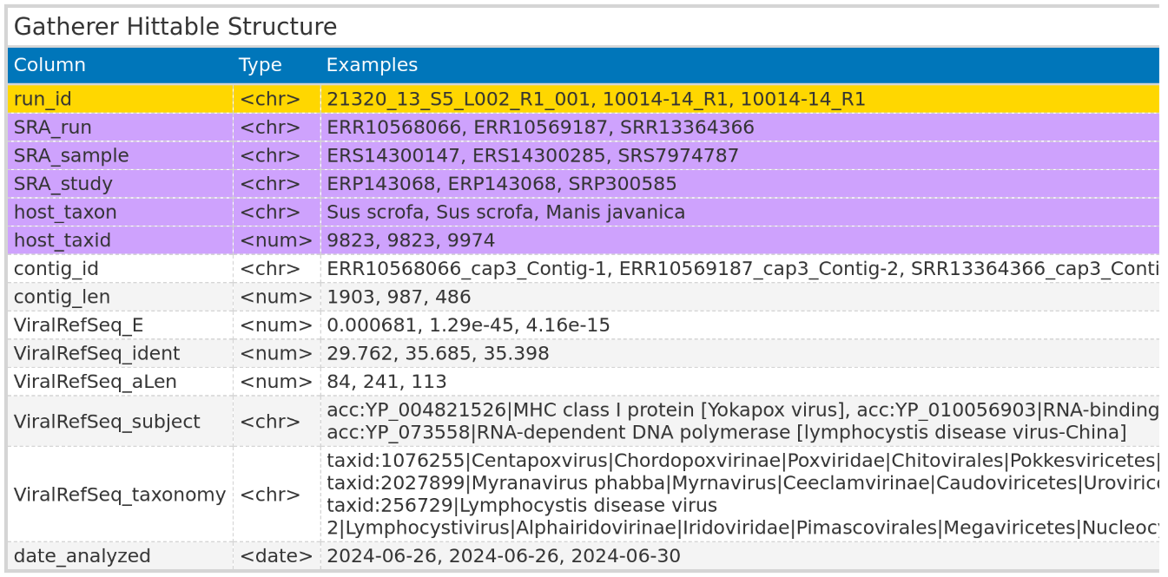

VirusGatherer returned the sequences of the assembled viral contigs/ whole genomes. Furthermore, hittables similar to the VirusHunter Hittables were generated [Bild von VirusGatherer hittable aufbau]. Virusgatherer Hittables also contained columns related to SRA identifiers and host information, or the identifiers for the locally available FASTQ files, depending on the input used. Unique columns in VirusGatherer Hittables included viral contig name and its length, as well as details of the best viral match from the viral reference database comparison.

2.7 Virusparies

One of the outcomes of this master´s thesis was the development of the R package Virusparies. Virusparies provides functions to subset and process Hittables, calculate summary statistics, and create plots and graphical tables for VirusHunter and VirusGatherer hittables. Both import of hittables into R and export of results in a user-specified file format was handled by Virusparies. Virus family names were extracted from the ‘ViralRefSeq_taxonomy’ column for each observation of the hittables via the VhgPreprocessTaxa function. Where no family name is present, but it is possible to infer the phylum from other information in the ‘ViralRefSeq_taxonomy’ column, ‘unclassified’ followed by the phylum name was used. If inferring the phylum was not possible, only ‘unclassified’ was assigned to the observation. The processed taxonomy data was subsequently used to group data for plots and summary statistics calculations. Boxplots were generated to visualize the distribution of E-values (‘ViralRefSeq_E’), identity percentages (‘ViralRefSeq_ident’), and contig lengths (‘contig_len’) for each group. The sum of hits for each virus group and the distribution of viral groups detected across query sequences were plotted in bar charts. The relationship between viral reference sequence identity and the negative logarithm of viral E-values was depicted in scatter plots. When VirusGatherer were used as input, a bubble plot was generated instead, with contig lengths represented by the size of the bubbles. Crucially, each dataset was filtered to include only observations with an E-value of 1e-5 or lower in the ‘ViralRefSeq_E’ column before plotting. When E-values were plotted, the negative logarithm of the threshold served as a cutoff line instead, and no filtering was applied. In some cases where E-values were visualized, E-values of exactly zero resulted in infinite values when transforming to their negative logarithm. To address this, all E-values of zero were replaced with the smallest E-value greater than zero. If the smallest E-value was above the cutoff (1e-5), zeros were replaced with the cutoff multiplied by ten raised to the power of negative ten. The mode, median, mean, standard deviation, and first (Q1) and third (Q3) quartiles were calculated for viral E-values, identity percentages, and contig lengths, and the results were summarized in tables.

Sum of hits Teil und Scatterplot Teil entfernen, da du es nicht nutzt

Erwähnen, dass Linie in Boxplot cutoff darstellt.

Besser umschreiben.

Results

Discussion

- Appendix

- List of references

