**ATHLONE INSTITUTE OF TECHNOLOGY**

**Faculty of Engineering and Informatics**

**Department of Electronics, Computer and Software Engineering**



**Bachelor of Engineering (Honours) in Software Engineering**

**Year 4 Semester 2 2016/17**

**Databases 4**

**JDBC Assignment Report**

**Lecturer Name: Sheila Fallon**

**Student Name: Sergejs Trubacovs**

**Student Id: A00212878**

**Date Submitted: 26 February 2017**

**The Project Key Concept.**

The application key concept is gross pay calculation for college employees. It also has features to add, update, delete employee records in database and export lists of employees and payslips into a *.csv* file. Reports on number of lectures for department, average pay for department and department list are also can be exported into the *.csv* file.

**Java GUI and Exported into *.csv* File Screenshots.**

1. **Insert into *employee*.**

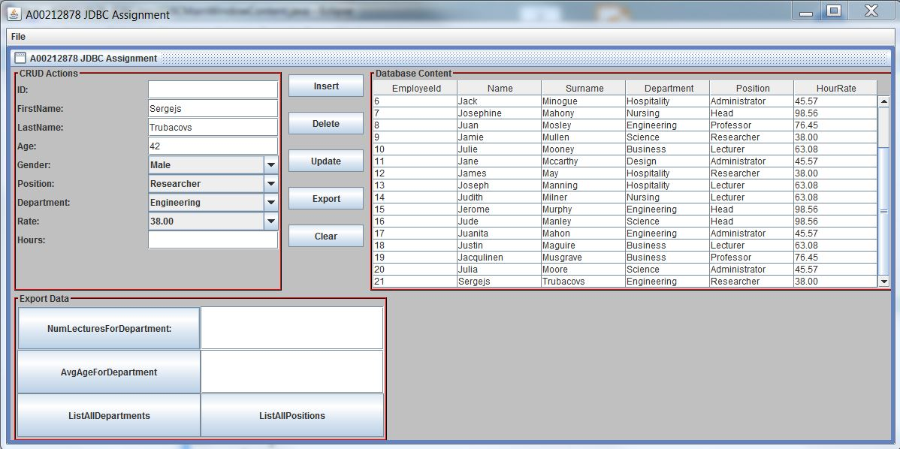

1. **Update *employee*.**

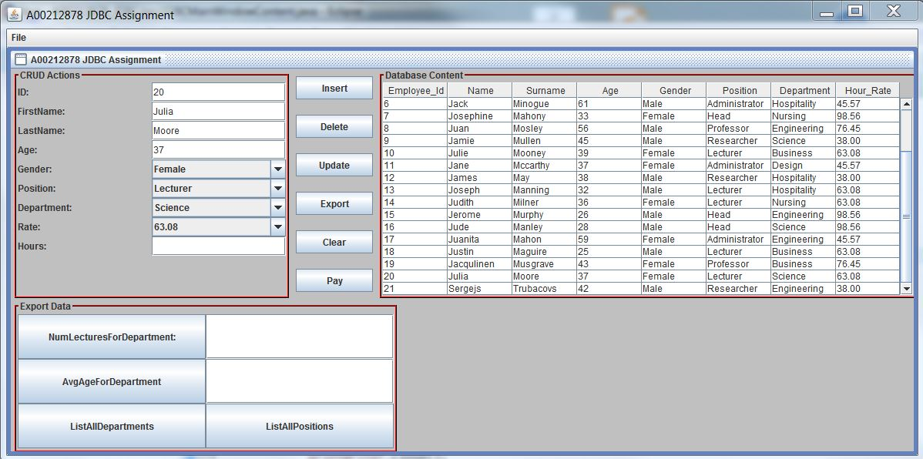

1. **Export *gross_pay_view.***

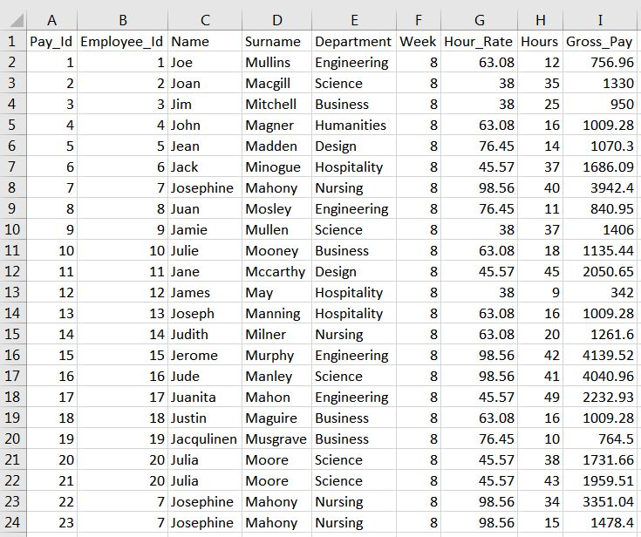

1. **Export List of All Employees (*employee_view*).**

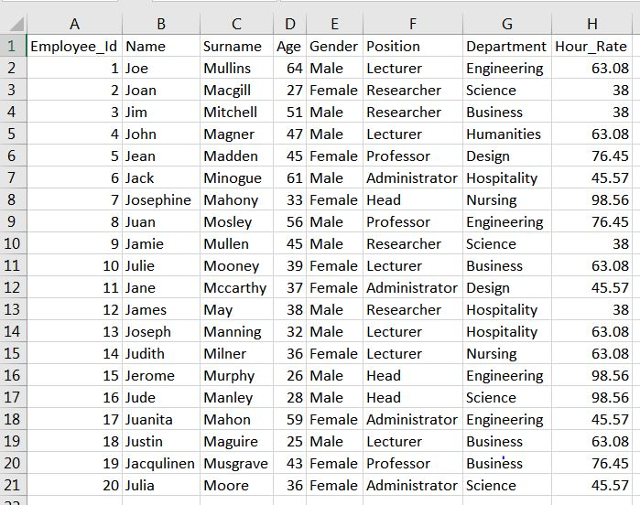

1. **Export Number of Lecturers for Department.**

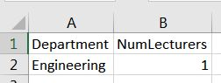

1. **Export Average Gross Pay for Department.**

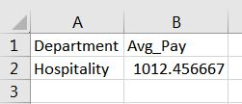

**Extra Features.**

I used *details* database as a template for my own database design. All sample data is from *details* database as well. I normalised *details* table to eliminate anomalies and got 5 tables in total. The designed database has 2 views. I also implemented Pay button to calculate gross pay.

1. **EER Diagram.**

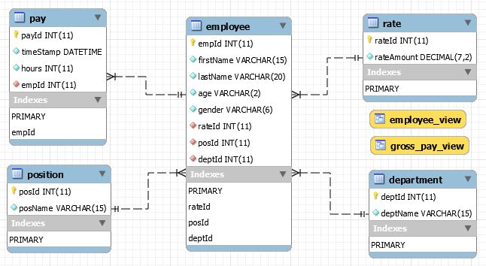

1. **Pay Button.**

