VEHICLE SERVICE REPORT
Comprehensive Maintenance Report

Vehicle Information
Registration Number: 191-D-00001
VIN: WF0XXXXXXXXXXXXX1
Make/Model: Toyota Camry 2023
Service Date: 15 January 2025
Current Mileage: 45,230 km

Owner Information
Owner: John Murphy
Contact: +353 86 123 4567
Email: john.murphy@example.ie
Address: 15 Main Street, Dublin 2, Ireland

Service Overview
This comprehensive service report documents all maintenance activities performed on the vehicle during the scheduled 45,000 km service interval. All work was completed in accordance with Toyota manufacturer specifications and European Union vehicle safety standards.

Services Performed
- Full engine oil and filter replacement
- Brake system inspection and pad replacement
- Tire rotation and pressure adjustment
- Air conditioning system service
- Battery health check and terminal cleaning
- Fluid level inspection (coolant, brake, power steering)
- Lighting system check (all bulbs and indicators)
- Windscreen wiper blade replacement

Complete Service History
The following table shows the complete maintenance history for this vehicle. This data is critical for warranty validation and resale value assessment.
Date | Mileage | Service Type | Parts Replaced | Cost (€) | Technician
15/01/2025 | 45,230 km | Full Service | Oil filter, Air filter, Wiper blades | €285.00 | John Smith
10/12/2024 | 44,100 km | Tire Service | Tire rotation, Pressure adjustment | €45.00 | Mary Jones
05/11/2024 | 43,000 km | Brake Inspection | Brake pads (front), Brake fluid | €320.00 | John Smith
20/10/2024 | 42,500 km | NCT Preparation | NCT inspection, Emissions test | €95.00 | Mary Jones
15/09/2024 | 41,800 km | Oil Change | Engine oil, Oil filter | €120.00 | Tom Brown
10/08/2024 | 40,200 km | Air Conditioning | AC service, Refrigerant refill | €150.00 | John Smith
05/07/2024 | 39,100 km | Tire Replacement | Front tires (2x Michelin) | €380.00 | Mary Jones
15/06/2024 | 38,500 km | Battery Service | Battery replacement, Terminal cleaning | €180.00 | Tom Brown
10/05/2024 | 37,200 km | Brake Service | Brake pads (rear), Brake disc machining | €340.00 | John Smith
05/04/2024 | 36,000 km | Major Service | Oil, filters, spark plugs, coolant | €450.00 | John Smith
15/03/2024 | 35,100 km | Suspension Check | Suspension inspection, Alignment | €110.00 | Mary Jones
10/02/2024 | 34,500 km | Light Repair | Headlight bulb replacement | €45.00 | Tom Brown
05/01/2024 | 33,800 km | Oil Change | Engine oil, Oil filter | €120.00 | John Smith
20/12/2023 | 32,500 km | Winter Check | Antifreeze top-up, Battery check | €65.00 | Mary Jones
15/11/2023 | 31,200 km | Tire Service | Winter tire installation | €80.00 | Tom Brown
TOTAL |  |  |  | €2,785.00

Note: This table should remain intact during chunking. HybridChunker should not split table rows across chunks.

Vehicle Identification
The Vehicle Identification Number (VIN) is located on the dashboard visible through the windscreen, and also on the vehicle registration certificate.

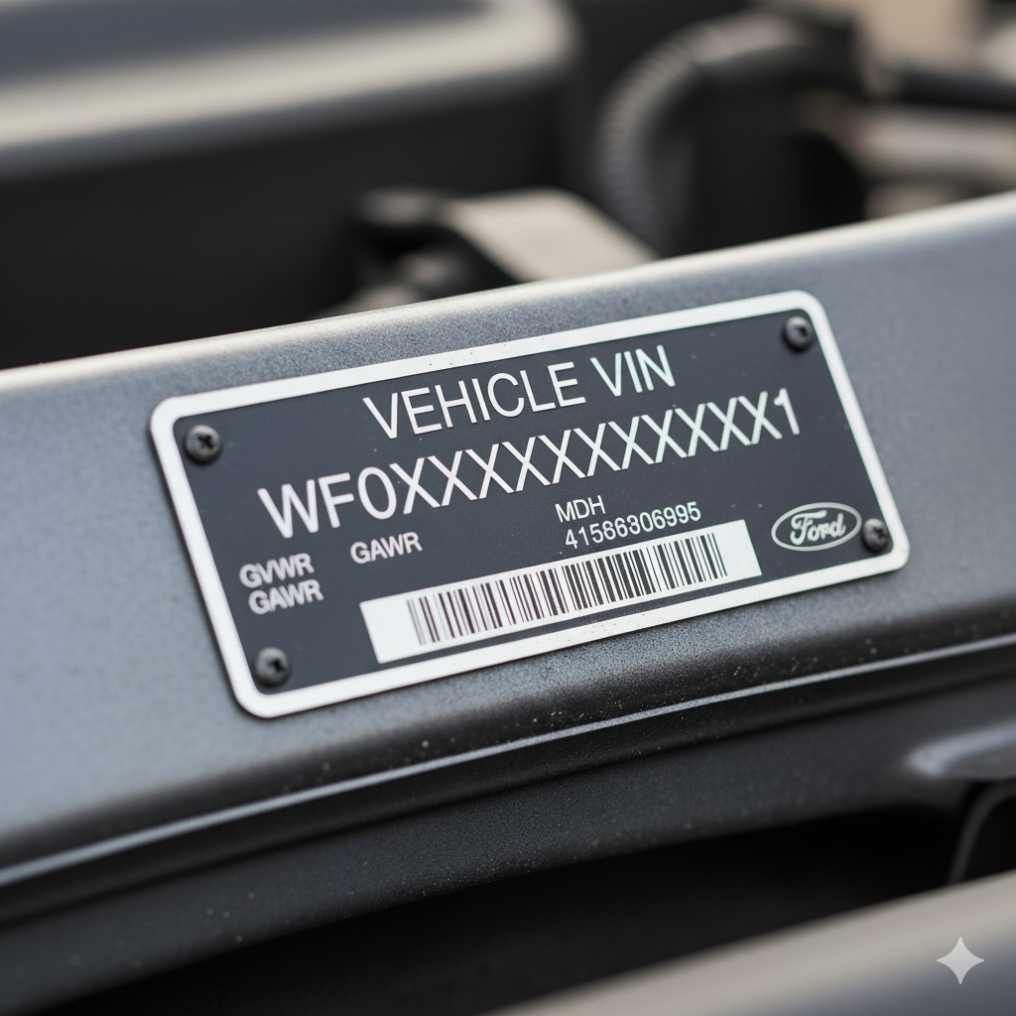
(Note: Replace this with actual VIN plate image for OCR testing)

VIN Breakdown
- WF0 - World Manufacturer Identifier (Toyota Europe)
- XXXXXXXX - Vehicle Descriptor Section

Detailed Parts and Labor Breakdown

Engine Components

Oil System
Engine oil (5W-30 synthetic, 4.5L): €45.00
Oil filter (OEM Toyota): €18.00

Air Intake
Air filter (high-performance): €25.00
Cabin air filter (activated carbon): €22.00

Brake System

Front Brakes
Brake pads (ceramic, set of 4): €120.00
Brake disc machining (front): €60.00

Brake Fluids
DOT 4 brake fluid (1L): €15.00

Service Cost Summary
Item | Amount (€)
Parts Total | €305.00
Labor (3.5 hours @ €65/hr) | €227.50
Subtotal | €532.50
VAT (23%) | €122.48
TOTAL | €654.98

Total Service Cost: €654.98

Payment and Warranty
Payment received in full on 15/01/2025 via credit card. All parts and labor are covered by a 12-month warranty in accordance with EU consumer protection regulations. This warranty covers defects in materials and workmanship.

Service Certification
Certified by: John Smith, Senior Technician
Certification Number: TC-2025-001234
Date: 15 January 2025

