RESUME

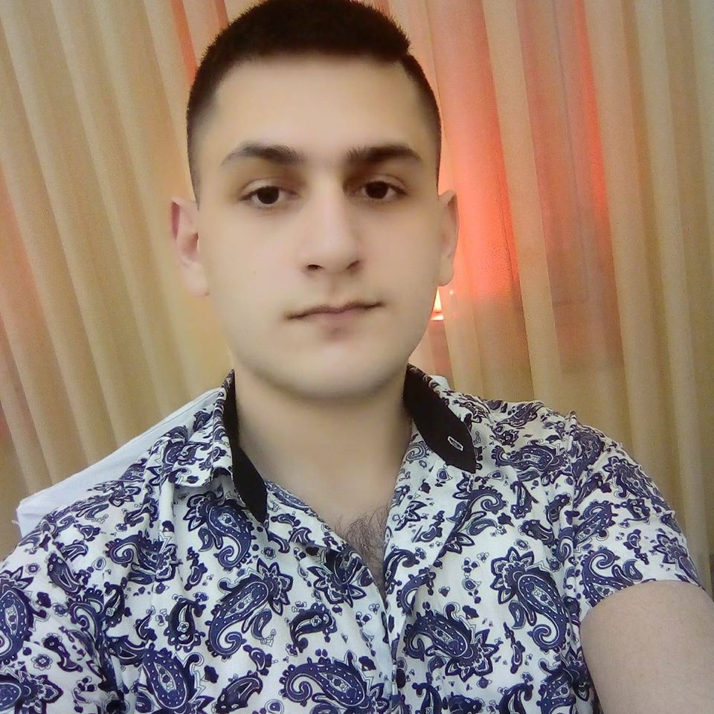

Personal Information

|  |  |
| --- | --- |
| Name: | Sergey |
| Lastname: | Gabrielyan |
| Date Of Birth: | 01.10.1998 |
| Nation: | Armenian |
| Place Of Birth: | Russia, Ryazan |
| Lives: | Armenia, Yerevan |
| School: | 185 |
| College: | Haybusak |
| E-mail: | Serg98barca@gmail..com |
| Studied Programming: | IT-TALENTS |

Programming

|  |  |
| --- | --- |
| HTML | CSS |
| JavaScript | jQuery |
| PHP | MySQL |

|  |
| --- |
| Laravel |

Contacts

|  |
| --- |
| +374 91 222-502 |