Government of the Russian Federation

Federal State Autonomous Educational Institution

higher professional education

"National Research University

"Higher School of Economics"

Faculty of Economics and Management

Department of Agrarian Economics

Sergey Nikolaevich Mikhailov

**Analysis of regional policy in the sphere of land relations and its impact on the agro-industrial complex of the Tver Oblast**

Abstract of a 1st year Master's student

On "Land economics"

*(name of discipline)*

Scientific supervisor, candidate of economic sciences.

Professor of the State University for Land Management

Fomin A.A.________________

Date 18.03.2023.

Moscow 2023

Table of contents

Introduction 2

Review of the Order of the Government of the Russian Federation No. 297-r of 3 March 2012 "On Approval of the Fundamentals of the State Policy for the Use of the Land Fund of the Russian Federation for 2012-2020". 3

Objectives 3

Tasks according to objectives 3

Allocation of directions by task 3

Brief analysis of the Tver Oblast agro-industrial complex (current state and potential) 6

Tver region 6

Characteristics of agricultural development in Tver Oblast. 7

Analysis of the land fund of the Tver Oblast 15

AIC support programmes 17

Analysis of cadastral value in the Tver region 21

Comparison of cadastral value depending on the location of the land object 21

Comparison of average cadastral value of residential and agricultural land by municipalities 28

Conclusion 32

List of references: 34

# Introduction

Regional policy in the sphere of land relations can be defined as a strategic combination of tools applied by regional authorities for the management, use and distribution of land. The degree of effectiveness of such policies determines the socio-economic condition of the region, as well as its resilience to social and economic shocks. Regional authorities face the difficult task of developing such policies to address land management challenges.

This research is aimed at studying the issues of what is the basis of regional land policy strategy, what are the prerequisites for choosing a particular strategy, what is the role of land policy in the formation of an efficient agro-industrial complex and cadastral value of land. In this regard, we would like to analyse the regional land policy in the Tver region and assess the impact of this policy on the agro-industrial complex of the region. This is the main objective of this paper.

In the first part we will get acquainted with the Russian Federation Government Order No. 297-r dated 3 March 2012 "On Approval of the Fundamentals of the State Policy for the Use of the Land Fund of the Russian Federation for 2012-2020". It is necessary to establish the legal aspects that influenced the formation of this or that regional land use policy strategy. Compare the objectives of this document, its tasks and directions. In the second part we will briefly analyse the region: the state of its land management and agro-industrial complex. We will analyse the normative-legal acts to support the agro-industrial complex. The third section will be devoted to a brief analysis of the cadastral value of the Tver Oblast.

The object of this study is the agro-industrial sector of the Tver Oblast and the structure of land management.

The subject will be the study of the peculiarities of regional policy in the sphere of land relations from the point of view of the main normative-legal documents and comparative analysis on the example of the Tver region.

# Review of the Order of the Government of the Russian Federation No. 297-r dated 3 March 2012 "On Approval of the Fundamentals of the State Policy on the Use of the Land Fund of the Russian Federation for 2012-2020".

## Objectives

According to the decree, "The objectives of the state policy on the management of the land fund are to increase the efficiency of land utilisation, to protect land as the main component of the environment and the main means of production in agriculture while ensuring food security of the country" [1]

## Tasks according to objectives

1. "Improving Land Utilisation Efficiency:
   1. creation of conditions for the organisation of rational and efficient use of land plots, including consideration of public and sectoral needs, requirements for sustainable development of territories, as well as observance of guarantees of the rights of participants in land relations;
   2. Preservation and improvement of the quality of land ;
   3. Ensuring conditions for improving the efficiency of civil turnover of land plots, including those aimed at protecting rights to real estate, as well as reducing administrative barriers and ensuring real estate taxation
2. Protection of land as the main component of the environment and the main means of production in agriculture while ensuring food security of the country:
   1. ensuring the protection of nature and the environment, including the protection of land and the preservation of cultural heritage sites;
   2. preservation of the status of specially protected natural territories as specially protected lands within the land fund". [1]

This distribution is of a conditional nature, since, for example, "preservation of the qualitative condition of lands" definitely refers to the protection of lands as the main means of production. Also, the observance of guarantees of the rights of participants in land relations contributes to the preservation of land as the main means of production. The higher the guarantees and rights of owners are developed, the more the owner is interested in the preservation of land as the main means of production.

## Allocation of directions by tasks

The direction of state policy to improve "the procedure for determining the legal regime of land plots by excluding from land legislation the principle of dividing land by its intended purpose into categories" is aimed both at ensuring the protection of land and preserving the status of specially protected natural areas, and at ensuring conditions for increasing the efficiency of civil turnover of land plots, since a more transparent and clear classifier of types of permitted use of land makes it possible to increase land turnover The time for making decisions on land acquisition with regard to the intended use of these lands is reduced. In addition, it increases the conditions "for the organisation of rational and efficient use of land plots" [1]. [1].

"Improvement of the procedure for granting land plots to citizens and organisations" solves the task of providing "conditions for improving the efficiency of civil turnover of land plots. This direction of state policy is narrowly focused and solves a specific problem [1].

The next direction of state policy to ensure guarantees of land rights and protection of the rights and legitimate interests of owners, land users, landowners and lessees of land plots" provides mainly "observance of guarantees of the rights of participants of land relations", and also concerns the protection of nature and the environment [1].

"Improvement of the procedure for the formation of land plots" provides conditions "to improve the efficiency of civil turnover of land plots" [1].

"Improvement of state land supervision and municipal land control" realises two tasks at once, which relate to the protection of "land as the main component of the environment and the main means of production in agriculture in providing food" [1].

"Improvement of the procedure for withdrawal of land plots for state and municipal needs" solves the problem of creating "conditions for the organisation of rational and effective use of land plots, including consideration of public needs, requirements of sustainable development of territories". In some cases, public interests, i.e. the interests represented by the state may run counter to private interests. "Improving the procedure for withdrawal of land plots for state and municipal needs" is precisely aimed at trying to resolve such a conflict as far as possible. In fact, in this direction of state policy, public interests prevail over private interests, and it is quite difficult to determine the fairness of such a solution of problems. However, clearer rules of the game definitely improve the position of both sides. In addition, according to subparagraph 1 of paragraph 2 of Article 56.3 of the Land Code of the Russian Federation from 25.10.2001 N 136-FZ withdrawal can be carried out for the purpose of expansion of "specially protected natural territory", that is aimed at solving the problem of preserving the "status of specially protected natural territories" [1][2]. [1][2].

"Clarification of the procedure for establishing restrictions on ownership rights to a land plot without withdrawal of the land plot, as well as rights of limited use of another's land plot (hereinafter - easement) to ensure the placement of linear objects and objects associated with the use of subsoil, which are of state or municipal importance" actually duplicates the previous direction of state policy with the only difference being that the land plot is not withdrawn, but only the rights to use it are restricted.[1].

"Development of state land monitoring" is aimed at realising both tasks related to the goal of land protection. We would especially like to note the creation of publicly accessible information systems, which provide access to any player to the necessary information and thus also contribute to improving the efficiency of land use. And the collection of such data itself allows improving the system of land use and reducing the disadvantages of land relations related to the lack of information [1].

The next direction is "Improving the interaction between public authorities and local governments in the implementation of state policy on land fund management, as well as the procedure for providing public services in the field of land relations". It provides conditions "to improve the efficiency of civil turnover of land plots" by reducing the lack of information and faster interaction between municipal and federal authorities [1].

The task of preserving and improving the quality of land is solved by the following direction of state policy: "establishment of mechanisms to protect agricultural land from being taken out of agricultural turnover". This measure prevents the loss of especially valuable agricultural land, thus providing a necessary resource for the future generation of Russia [1].

"Improving the turnover of agricultural land" is aimed not only at "ensuring conditions for increasing the efficiency of civil turnover of land plots", but also increases "the preservation and improvement of the qualitative condition of land". However, it remains unclear how determining the share of foreign participation in the charter capital to be less than 50 per cent can improve the turnover of agricultural land. In my opinion, on the contrary, an increase in the share of foreign participation will contribute to the increase in the turnover of agricultural land and its improvement [1].

As for the last direction of state policy to improve land management, it envisages both "preservation and improvement of the qualitative condition of lands" and their protection in general. To a greater extent, such measures ensure precisely the preservation of the state of land, including as a resource for the future generation.

# Brief analysis of the agro-industrial complex and land fund of the Tver Oblast

## Tver region

**Key indicators of the Tver Oblast.**

|  |  |
| --- | --- |
| * + 1. **headcount** | * + 1. **1 million 300 thousand inhabitants** |
| * + 1. **budget revenue** | **More than 70 billion roubles** |
| * + 1. **GRP** | * + 1. **RUB 490.83 billion** |
| * + 1. **history** | * + 1. **It has been inhabited since ancient times. Tver was once the main centre of Russia. Its geographical location (between Moscow and St. Petersburg) is still potentially economically favourable.** |
| * + 1. **climatic conditions** | * + 1. **Most of the area is made up of plains, forests and fields.**     2. **Climate: temperate continental.**     3. **Soils: sandy loamy (and in some places clayey) sod-podzolic soils, the region is rich in peat-bog soils, which are found in patches throughout the oblast. The most fertile soils are located in the east of the region.**     4. **Forests occupy most of the area.**     5. **A huge number of lakes and rivers.** |
| * + 1. **resources** | * + 1. **Forests, peat deposits, brown coal, quartz sand, underground mineral waters, agricultural lands, large fresh water reserves (1769 lakes, about 800 rivers, 9 reservoirs).** |
| * + 1. **Agro-industrial complex** | * + 1. **Traditional specialisation of the Tver Region. The region has about 2.5 million hectares of agricultural land. The region holds leading positions in Russia in terms of lignum flax acreage, production and processing of meat products, and cultivation of fur-bearing animals.** |

Table 1 - key indicators of the Tver Oblast[1] .

The geographical location of the Tver Region is shown in Figure 1. The region is located in the Central Federal District. The Tver Oblast's neighbours are: Yaroslavl, Smolensk, Pskov, Novgorod, Vologda and Moscow Oblasts.

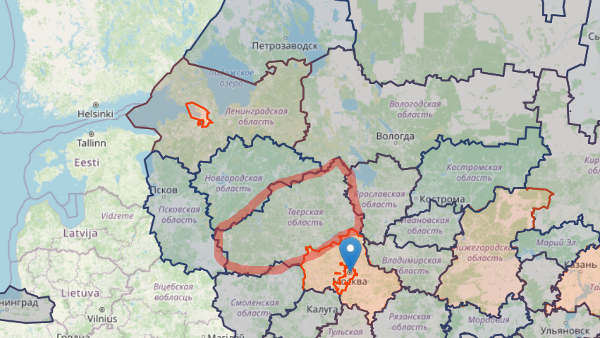

Figure 1 - Geographical location of the Tver Oblast[2]

## Characteristics of agricultural development in Tver Oblast.

The agro-industrial complex of the Tver Region is represented by agricultural enterprises of various forms of ownership, milk processing, meat processing, poultry farms, flax mills, as well as a flax combing factory with a line for the production of construction insulation. Interestingly, "the index of crop production in farms of all categories at the end of 2021 (129.9 % of the 2020 level in comparable prices), the Tver Region ranked 1st among the regions of the Central Federal District and 6th in Russia as a whole"[3] . The Tver Region has 11 major flax-growing enterprises, 5 flax primary processing plants and 2 flax fibre processing enterprises.

Peasant (farm) farms, individual entrepreneurs, agricultural consumer co-operatives and household farms are also represented in the region. There are quite large players in meat and flour processing. To look at the strengths and weaknesses of our region, let us first analyse the general indicators of agricultural production, and then look in more detail at the crop and livestock sectors separately.

Most of the neighbouring regions, including the Tver Oblast itself, are classified as regions with average absolute indicators of agro-industrial complex development and low growth rates. The exceptions are: Moscow Oblast, which is characterised by both high absolute indicators of agro-industrial complex development and high growth rates, and Pskov Oblast with its low absolute indicators of agro-industrial complex development but significant positive growth dynamics[4] . That is, the Tver Oblast falls into the risk group for further development in the agro-industrial complex.

As of 2020, the Tver Oblast ranked only 51st in the rating of regions by agro-industrial complex efficiency, behind the Moscow, Pskov, Vologda and Yaroslavl Oblasts. This is evident from Figure 2. Such a low place in the rating speaks about weak indicators of agricultural production, insurance in the sphere of agro-industrial complex and financing in the sphere of agro-industrial complex. Such things are related to the low investment attractiveness of the Tver Oblast, despite its good geographical location between Moscow and St. Petersburg. And investment attractiveness depends on the policy pursued by a constituent entity of the Russian Federation.

Figure 2 - Rating of regions by efficiency of agro-industrial complex[5] .

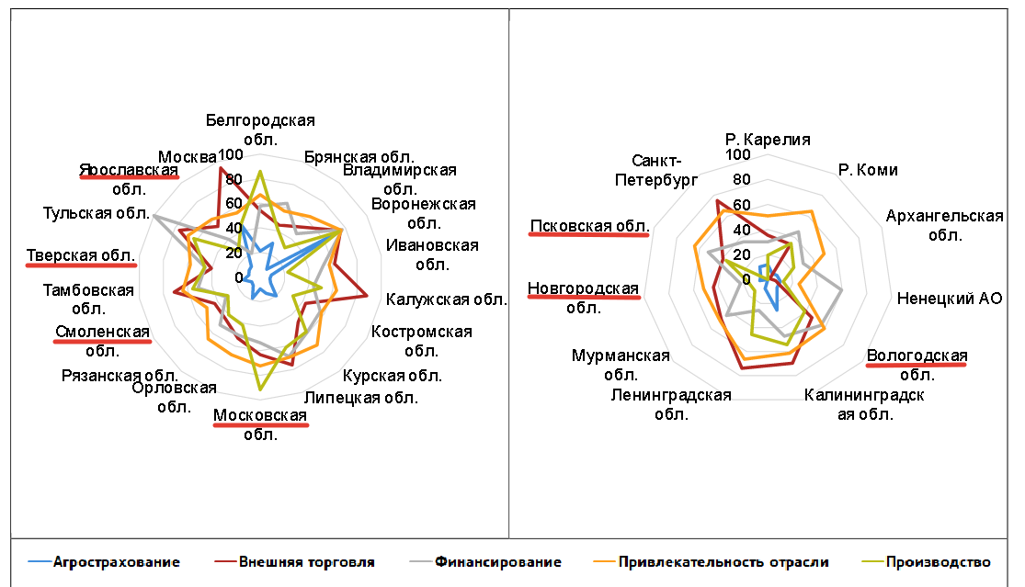

Figure 3 - Integral assessment of AIC performance efficiency of Russian regions by federal districts and groups of indicators[6] .

Figure 3 shows that the agro-insurance sector is not developed at all in the Tver Oblast, although the attractiveness of the sector is quite good, which indicates a good potential of the Oblast if the insurance system is established and financial attractiveness is improved. This, in turn, will push the agro-industrial complex of the Tver Oblast to increase agricultural production, as well as increase the volume of foreign trade.

Figure 4 shows the dynamics of agricultural development in Tver Oblast from 2005 to 2021 in comparison with neighbouring regions, except for Moscow Oblast. The dynamics of development is clearly inferior to the Pskov Oblast.

Figure 4 - Agricultural output by region (million rubles)[7] .

Now let's take a closer look at the sectors individually. For this purpose, let us first compare sown areas of crops.

Figure 2.1 - Sown areas of crops, thousand hectares, Rosstat

The Tver Oblast is in a good position relative to other regions (Figure 2.1). It also ranks second in the number of pigs after the Vologda Oblast (Figure 2.2). But the number of cattle is not so numerous.

Figure 2.2 - Number of pigs and cattle (thousand heads), Rosstat

Table 2.1 presents data for 2021 on production of main agricultural products.



Table 2.1 - Production of main types of agricultural products by region, Rosstat

To look at these indicators in more detail, let us look at the Tver Oblast's crop production position (Figure 2.3). The data are taken without taking into account the flax fibre harvest. It can be seen that we have a well-developed potato production (second place after the Moscow Oblast), as well as a fairly high, at least relative to border regions, collection of fruits and berries (second place after the Moscow Oblast). However, the situation in grain and vegetable production is not so good. This can be explained by low grain and legume and vegetable yields in the Tver Oblast, i.e. low land and production efficiency in this sector. More detailed dynamics is presented in Figures 2.5, 2.7. The dynamics of potato yields (Figure 2.6) explains the good performance of potato harvest.

Figure 2.3 - Gross harvest by region in crop production for 2021, Rosstat

Figure 2.5 - Grain and legume yields, in centners per ha, Rosstat

Figure 2.6 - Potato yields, in centnes per ha, Rosstat

Figure 2.7 - Vegetable yields, in centners per ha

In terms of flax fiber harvesting, the region ranks second after Smolensk in this sector (Figure 2.8), and this market is likely to develop further due to the existence of a separate flax fiber development programmer.

Figure 2. 8 - Gross flax fiber harvest (thousand tons), Rosstat

After a brief comparison of the crop production market, let us analysis the livestock production market. If we look at Figure 2.9, we can see the average position of the Tver Oblast for both types of livestock products. Although, if we compare the region's position in terms of milk yield per cow (Figure 3.1), it is clearly low compared to the leaders (Pskov Oblast, Vologda Oblast, Moscow Oblast and Yaroslavl Oblast).

In terms of egg production (Figure 3.2), the Tver Oblast is only slightly above the Novgorod and Pskov Oblasts.

Figure 2.9 - Gross harvest by main types of livestock production for 2021, Rosstat

Figure 3.1 - Milk yield, centners/cow, Rosstat

Figure 3.2 - Egg production, mln eggs, Rosstat

Summarising the above, we can say that the Tver Oblast does not have any qualitative superiority compared to neighbouring regions in either crop or livestock production. Only flax fibre and potato production can be singled out.

## Analysis of the land fund of the Tver Oblast

Before analysing the land resources of the Tver Oblast, let us compare the distribution of these resources with neighbouring oblasts in order to determine where our Oblast stands in terms of available land for agricultural use.

|  |  |  |  |  |
| --- | --- | --- | --- | --- |
|  | Total land area, thousand hectares | Agricultural land, thousand hectares | Forest lands, thousand hectares | Surface water, thousand ha |
| Tver region | 8420,1 | 2417,7 | 4744,8 | 713,3 |
| Smolensk region | 4977,9 | 2093,7 | 2167,6 | 169 |
| Yaroslavl region | 3617,7 | 1127,4 | 1743,8 | 496,6 |
| Vologda Oblast | 14452,7 | 1447,9 | 10456,5 | 1930,4 |
| Novgorod region | 5450,1 | 827,7 | 3578,1 | 723,3 |
| Pskov region | 5539,9 | 1511,1 | 2249 | 851,5 |
| Moscow region | 4432,9 | 1663,2 | 1998,3 | 140,7 |

Table 1.1 - land size by category, Rosstat

Figure 1.2 - Share of land of different categories in total land area, Rosstat

Table 1.1 and Figure 1.2 show that the Tver Oblast ranks 2nd in terms of total land area after the Vologda Oblast, but only 4th in terms of the percentage of agricultural land to total land area.

Land resources of the Tver Oblast are presented in Figure 5. The majority of land in Tver Oblast is non-agricultural (about 71.3% of the total land area), and only 28.7% is agricultural land. At the same time, the soils prevailing in Tver Oblast (sandy loam and sod-podzolic soils) allow growing various garden and vegetable crops. Horticultural crops potentially suitable for cultivation include seed crops (apples, some types of pears), stone crops (plum, cherry), berry crops (currants, gooseberries, cranberries, blueberries, strawberries). Apples and plums accounted for the majority of the agro-industrial complex's volume in terms of horticultural crops in previous years (USSR times and the 1990s). Tver region is also potentially suitable for growing some types of field crops: potatoes, flax (also actively grown in the USSR).

A more precise division of the land fund is presented in Figure 5. More than half of the territory is occupied by forests. Agricultural land is about 30%.

Figure 5 - distribution of the land fund in Tver Oblast as of 2017[8] .

As for the land used for crop production, according to the Tverstat data, in "2021, the total sown area of agricultural crops in farms of all categories in the Tver Oblast totalled 477.7 thousand hectares. In 2021, farms of all categories in the Tver Region sowed 67.2 thousand hectares of grain and leguminous crops, 13.25 thousand hectares of potatoes, 2.27 thousand hectares of vegetables, and 5.74 thousand hectares of industrial crops. Sown areas under fodder crops totalled 389.28 thousand hectares, of which 356.99 thousand hectares - perennial grasses, 28.53 thousand hectares - annual grasses, 3.74 thousand hectares - corn for fodder, 0.03 thousand hectares - fodder root crops and melons".

## AIC support programmes

The main document in the area of agribusiness support programmes is Resolution No. 717 of the Government of the Russian Federation of 14 July 2012 "On the State Programme for Agricultural Development and Regulation of Markets for Agricultural Products, Raw Materials and Foodstuffs". Based on the goals and objectives set out in the decree, the Tver Oblast government has developed its own agribusiness support programmes taking into account regional specifics. The main programme is the Resolution of the Government of the Tver Oblast No. 25-pp "On the State Programme of the Tver Oblast 'Agriculture of the Tver Oblast' for 2021-2022" dated 25 January 2021 [3][4].

Let us highlight the main objectives of the Tver Oblast programme:

The main administrator of the programme is the Ministry of Agriculture, Food and Processing Industry of the Tver Oblast. Let's see how these goals meet the objectives of the federal programme and to what extent they are adapted to the realities of the Tver region.

The main message of the federal programme is to increase the pace of technological development in the agro-industrial complex, including: improving the quality of our products in order to increase exports, development of the processing industry, greater digitalisation, breeding, and optimisation of logistics processes. In this respect, the goal of the regional programme to "create conditions for sustainable development of the agro-industrial complex" is the most "consonant". Modernisation in the Tver Oblast is carried out at the expense of the regional budget, which is used to cover the costs of enterprises for the purchase of more modern equipment. As for subsidising agricultural production, the support is provided in two directions: stimulating (for priority sectors and small business development) and compensating. The priority sectors for the Tver Oblast are dairy, meat processing (beef), and vegetable production. This is necessary to ensure food security of the region, as the Tver Oblast is currently self-sufficient in potatoes, pork and poultry meat. Particular attention is paid to further development of flax cultivation and production, as well as support for small businesses through grants and reimbursement of a portion of costs. Recently, a new direction of support for compensations in the sphere of baking industry has been added. All the above-mentioned directions are consistent with the main state programme and even complement it in some sectors [2].

The programme budget and its structure are presented in Table 4.1 and Figure 4.1. A significant part of the budget is allocated for the development of the agro-industrial complex. 16% of the budget is earmarked for the organisation of training of professional staff for the agro-industrial complex, and 11% for the integrated development of rural areas.

|  |  |
| --- | --- |
| Subprogrammes | Total budget for each category of tasks, RUB thousand |
| Development of agro-industrial sectors | 6538714,3 |
| Organisation of training of professional staff for the agro-industrial complex | 1727098,1 |
| Efficient involvement of agricultural land into turnover and development of land reclamation complex in Tver Oblast | 229241,8 |
| Ensuring conditions for the development of the agro-industrial complex | 375159,8 |
| Integrated development of rural areas in the Tver Oblast | 1238151,3 |
| Development of the flax complex in the Tver Oblast | 395480 |
| Supporting subprogramme | 368504 |

Table 4.1 - Budget of the Tver Oblast Agriculture Programme [4]

Figure 4.1 - budget structure of the Tver Oblast programme "Tver Oblast Agriculture" for 2021-2026 [4].

The issue of increasing exports of agricultural products in the Tver Oblast will be solved at the expense of existing business centres aimed at "development of information and consulting assistance to enterprises". The effectiveness of such centres, which have existed for quite a long time, is not clear yet, and it is not clear how the increase in exports will be improved [4].

Resolution No. 25-pp of the Tver Oblast Government of 25 January 2021, in addition, set the task to increase the number of professional personnel for the agro-industrial complex. This will primarily concern the financing of educational organisations. It is planned to allocate approximately RUB 295 million from the Tver Oblast regional budget for this purpose in 2023.

A very important area of regional agricultural policy is the policy of involving agricultural land into turnover, including through the development of land reclamation complex. As we have seen above, the Tver Oblast has sufficient water resources, and the development of the land reclamation system will definitely contribute to faster rates of agricultural land turnover. The only question is how such a programme will be conducted, whether landscape conditions will be taken into account when creating such systems, and how such projects will be regulated so as not to harm the landscape.

The demographic crisis is a separate problem in the Tver Oblast. Population decline has been observed for many years, especially among the rural population. In order to reduce the negative impact of this crisis and to develop abandoned rural areas, the Tver Oblast Rural Development Programme is aimed at developing rural areas. The programme should create infrastructure in rural areas, assist agricultural producers in providing qualified specialists, and provide the rural population with affordable and comfortable housing. Such areas of the programme will have an effect only if agricultural producers come to such places. Therefore, we need a more consistent programme, structured in time, which starts with attracting producers and providing the necessary conditions for investment in the agricultural sector of the Tver Oblast. This can be achieved, among other things, by developing the insurance system and a more efficient system of financial support for agricultural producers.

# Analysis of cadastral value in Tver region

## Comparison of cadastral value depending on the location of the land object

On the territory of Tver the cost of residential land for individual construction is equal to 1,612 roubles/square metre (Figure 1). This is one example of a land plot located closer to suburban areas.

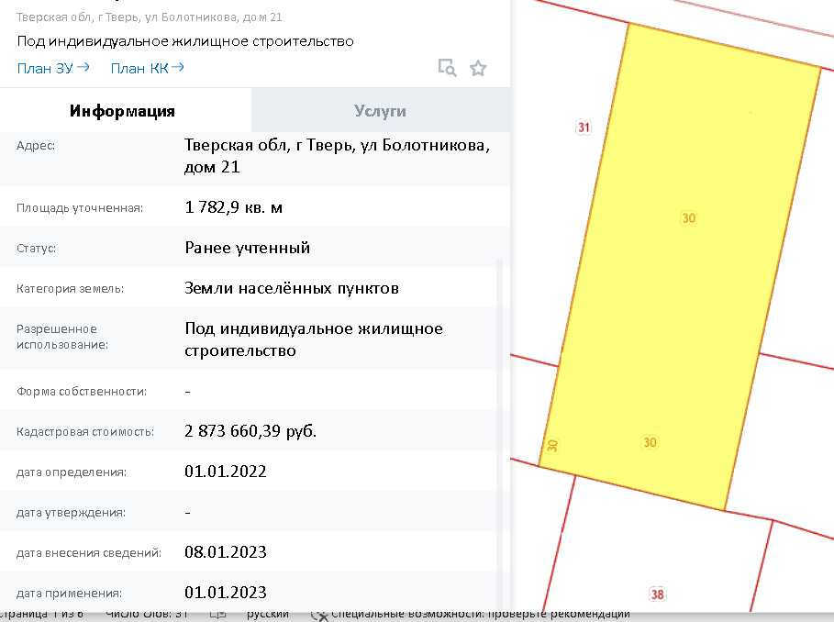

Figure 1 - Settlement land for individual residential construction (non-central district)

In the centre, the cadastral value of land of similar category for individual residential construction will cost already 6853 rubles/sq. m. (Figure 2). Figure 3 shows the cost of land outside the territory of Tver, in the suburban area. As can be seen, the cost of 459 rubles/sq. m has fallen even more strongly, which proves the correctness of William Alonso's model. A similar cost for household farming and individual housing construction is observed in the border districts of Kalinin Oblast, 496 rubles per square metre.

The price of land for a production base in Tver near the suburbs in the area of Peterburgskoye Shosse costs 971 rubles, next to the area in Figure 1. That is, the cost of land for industrial base is lower than the cost of the same land for individual residential construction.

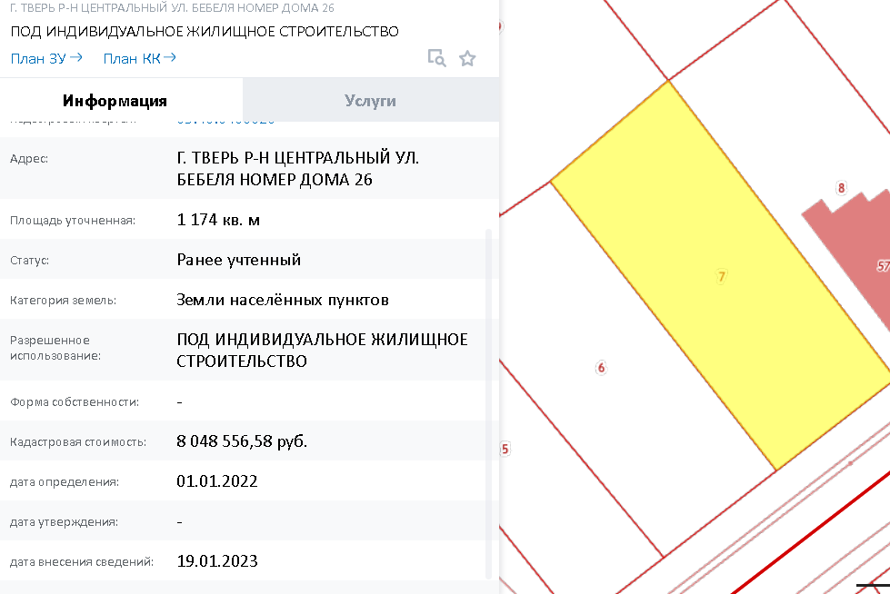

Figure 2 - Settlement land for individual housing construction (central district)

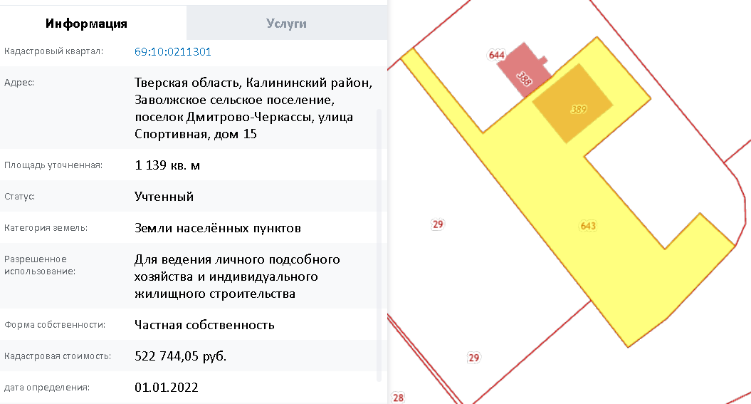

Figure 3 - land of the populated area for household farming and individual housing construction (suburbs)

If we consider the category of agricultural land for agricultural production, in the peri-urban area in one example, a square metre of land costs 3.2 rubles (Figure 4). In another place the price is about 2 roubles per square metre (Figure 5). Already further away from the suburbs the prices do not vary much. In Figure 7, it is 3.3 rubles per square metre. However, it depends on the category of land. Figure 6 shows that the price for a garden plot is already 375 rubles per square metre.

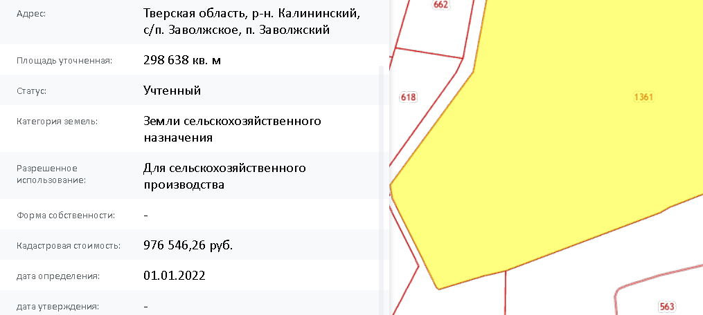

Figure 4 - land for agricultural production.

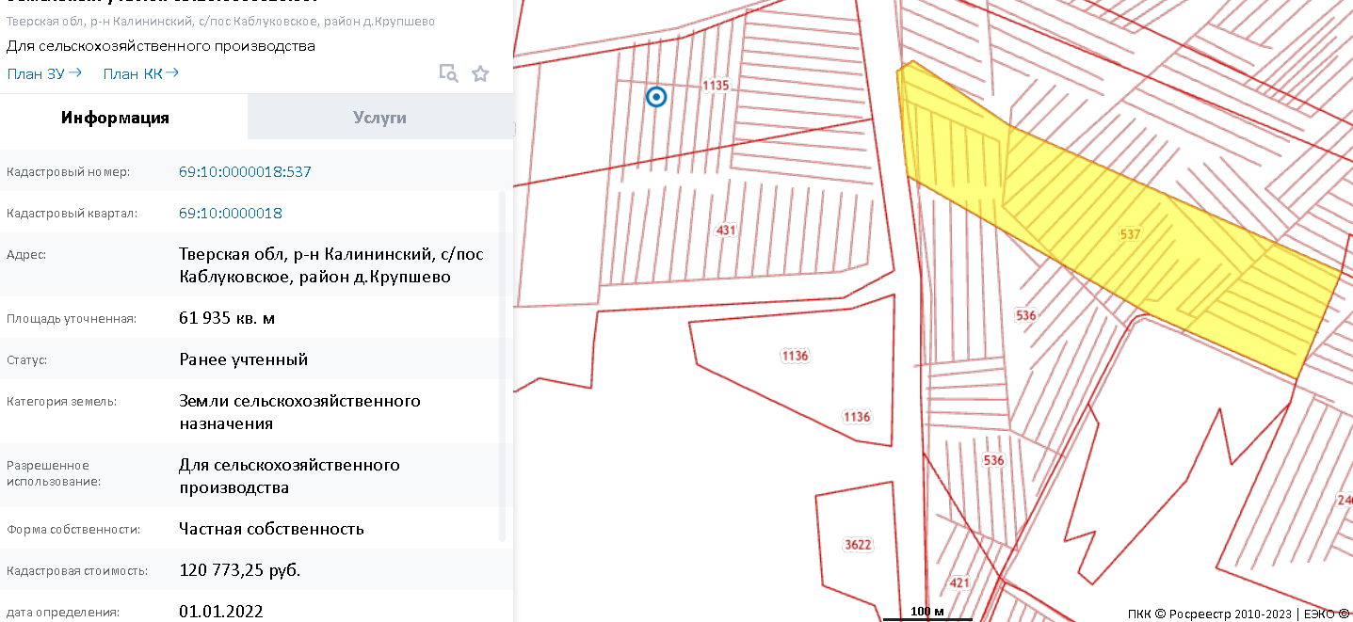

Figure 5 - land for agricultural production. 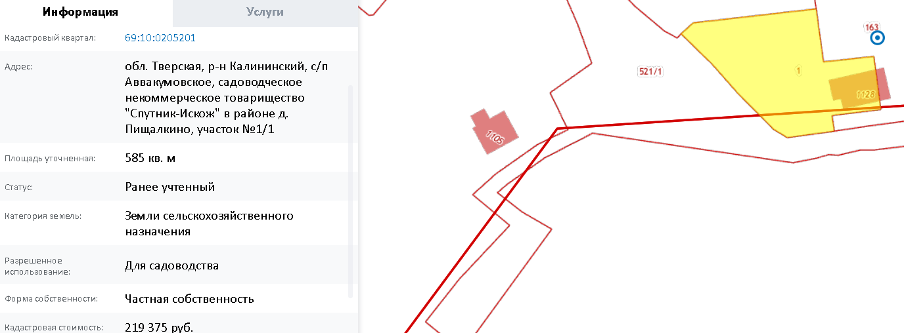

Figure 6 - land for gardening.

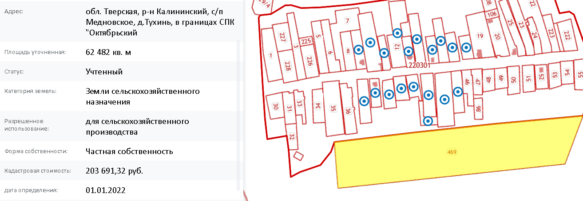

Figure 7 - land for agricultural production.

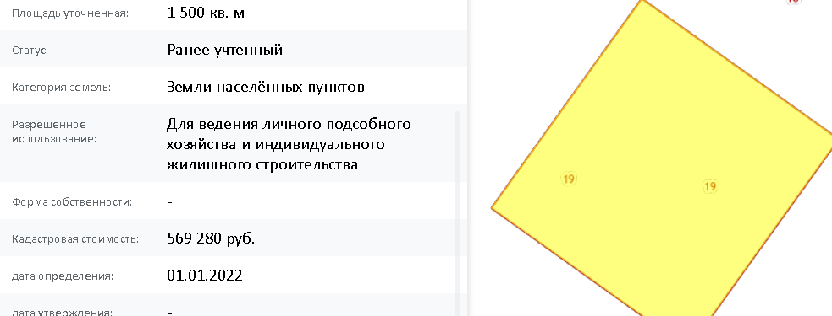

Figure 8 - for farming.

Land for personal subsidiary farming away from the suburbs is already cheaper. This can be seen from Figure 8. This is 380 rubles per square metre, compared to 496 rubles per square metre in the suburbs. Nevertheless, the cost per square metre is higher than for land intended for agricultural production. And it is much higher than the cadastral value of forest fund land for forestry: 0.6 roubles per square metre (Figure 9). By the way, the cadastral value of park areas in the city differs many times from the value of forest fund land and even the value of land of settlements in the city centre.

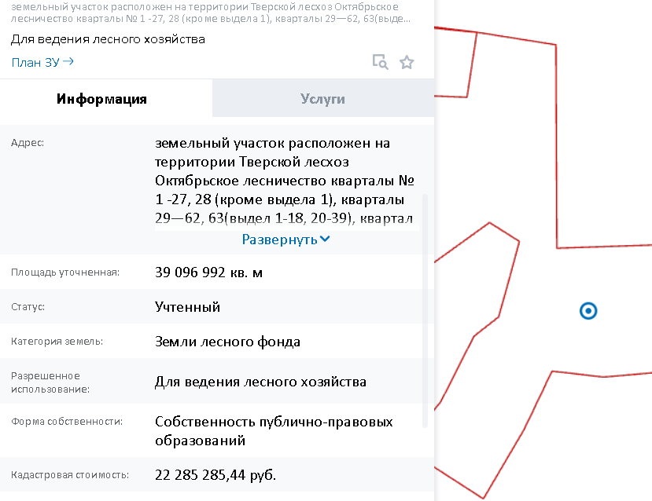

Figure 9 - lands of the forest fund of Kalininsky district.

Let us now look at prices in other districts of the Tver Oblast. Let's take, for example, the city of Torzhok and its district. Near the centre, the price per square metre of the plot shown in Figure 10 is 1046 roubles.

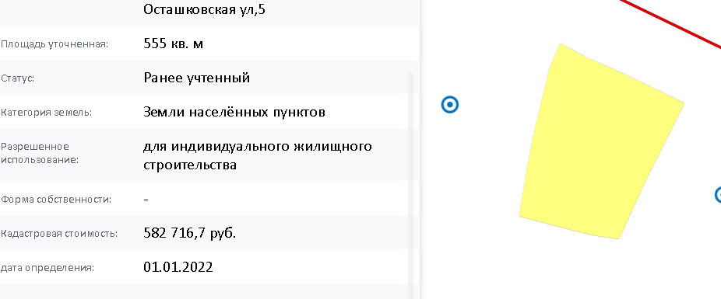

Figure 10 - individual development, Torzhok.

Already in the suburban area (Figure 11), the cadastral value of LPH varies from 80 to 110. In remote areas, for example, in Yakonovo village, the price is already about 54 rubles (Figure 12), which is twice cheaper. The price for 1 square metre of land for agricultural production is 2.25 kopecks (Figure 12.1). This picture is generally observed throughout the Tver Oblast. Of course, prices depend on many factors and remoteness from the centre is only one of these factors affecting the cadastral value. Other important aspects influencing the cadastral price include: technical parameters of the object, general condition of the property, average income of the inhabitants of the settlement and, as we mentioned above, the sphere of use.

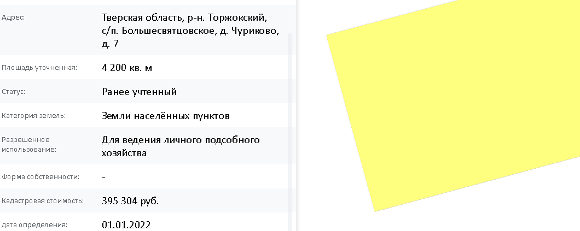

Figure 11 - value of LPH (Torzhoksky district) (suburbs)

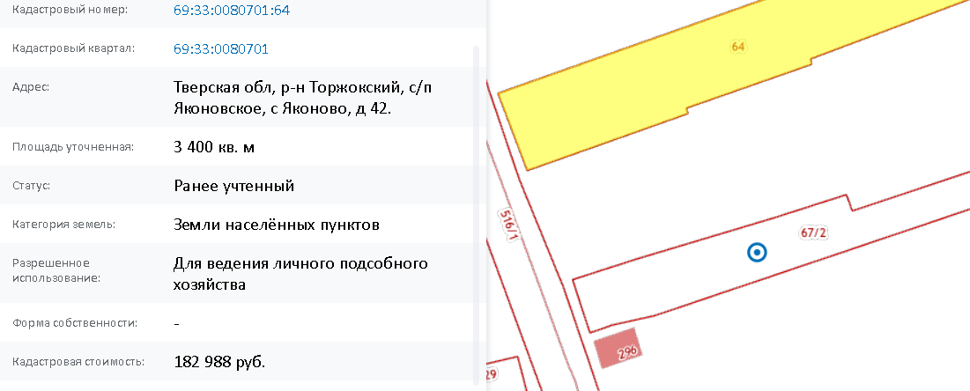

Figure 12 - value of LPH (Torzhoksky District)

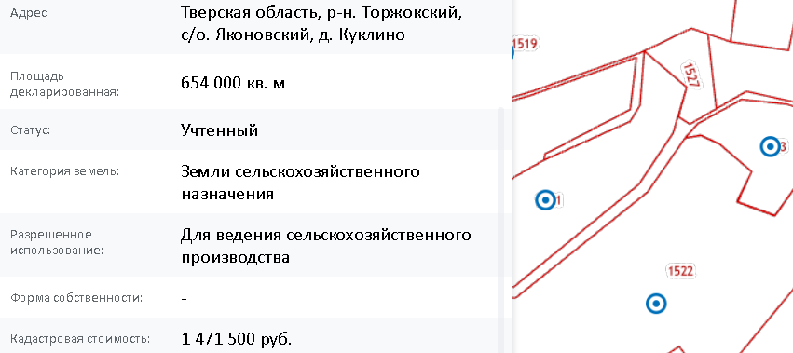

Figure 12.1 - value of land for agricultural production (Torzhoksky District)

The difference in price between lands intended for farming and lands intended for agricultural production can be explained by several factors: location, purpose (possibility to build residential premises on the plot), availability of residential and household premises, taking into account their condition, and infrastructure development. Theoretically, it can also be caused by market factors: the demand for purchase of such LPHs, for example, as dacha plots, possibly also by the tax component.

|  |  |  |
| --- | --- | --- |
|  | **LPH, RUB/sq. m** | **Agricultural land, RUB/sq. m** |
| **Kalininsky district** |  |  |
| **Suburb** | **459** | **3,2** |
| **Away from the centre** | **380** | **3,3** |
| **Torzhoksky district** |  |  |
| **Suburb** | **100** | **2,25** |
| **Away from the centre** | **54** | **2** |

Table 3.1 - Comparative table of cadastral value of land of different types

## Comparison of average cadastral value of residential and agricultural land by municipalities

Figure 13 - Average cadastral value of residential land by districts [6].

Figure 13 shows the location of Tver Oblast districts by average cadastral value of residential land in descending order. Tver stands out significantly against the background of the others. Konakovo is also economically developed, with the Dmitrogorsky product and Konakovskaya GRES located there. In general, the districts are evenly distributed. The only thing is that it is not clear why Torzhoksky district has such a low cadastral value. The city ranks 4th in the region in terms of population, has a good economy in comparison with the rest. Konakovo district.

Figure 14 - Average cadastral value of agricultural land by districts [6].

Figure 14 shows the already ranked list of districts by average cadastral value of agricultural land. It is very indicative that Konakovo district, due to the presence of such an enterprise as "Dmitrogorsky Product" takes the first place by cadastral value.

Figure 15 - Average cadastral value of agricultural and residential land by districts [6].

Figure 15 is more detailed and shows some anomalies. In Toropetsky District, there is a high cadastral value of residential land with an extremely low cadastral value of agricultural land. In this case, this can be explained by the agricultural specialisation of the district: meat and dairy farming prevails here, and prices for pasture-type land are much lower than for arable land.

Figure 16 - dependence of the cadastral value of the land value of settlements.

It is also interesting to look at the regression dependence of the cadastral value of agricultural land on the value of residential land. It can be seen that the dependence is rather linear with some deviations in the form of Konakovo district (red dot at the top in Figure 16). The reasons for such deviation have already been described above. The Toropets District (green point on the chart) also stands out. The figure shows that when the cadastral value of residential land increases by one unit, the cadastral value of agricultural land increases by 0.22.

# Conclusion

Having conducted the research, we found out that the formation of regional policy strategy starts from the federal level and takes into account many other peculiarities inherent in a particular region. These features include: economic, geographical, social, infrastructural, etc.

In the first part we found out that according to the Order of the Government of the Russian Federation dated 3 March 2012 №297-r "On Approval of the Fundamentals of State Policy on the Use of the Land Fund of the Russian Federation for 2012-2020" the main "objectives of the state policy on land fund management are to increase the efficiency of land use, protection of land as the main component of the environment and the main means of production in agriculture while ensuring food security of the country" [1]. [1]. At the same time, the very intertwining of different directions of state policy on land fund management, their correlation with each other, is inevitable, and that is why the very structure of the construction of goals, objectives and directions does not look quite clear. Many directions from this Regulation solve several tasks at once, and the tasks themselves can be attributed to different objectives. Certainly, the Regulation itself was a necessary reaction to the imperfections of land relations, it was of a transitional nature and therefore had some shortcomings.

In the second part, we conducted a brief analysis comparing the agro-industrial complex and land fund of the Tver Oblast with border regions. Tver region has a good potential for agribusiness development, at least in some sectors, due to its good location between Moscow and St. Petersburg. The Moscow market could provide economic growth for the region. We also got acquainted with the programme to support agro-industrial complex in the Tver Oblast, from which we derived three main objectives: to create conditions for sustainable development of the agro-industrial complex in the Tver Oblast, to increase the efficiency of land use in agriculture, and to improve the quality of life of the rural population. This programme has been developed taking into account the specific features of the region, but has a number of omissions. In particular, there is no programme to improve the quality of agro-insurance and no clear sub-programme to improve agro-industrial complex financing.

The cadastral analysis carried out in the third part of the paper showed a rather significant impact of the cadastral value of settlements on the cadastral value of agricultural land. We also saw the influence on this value of the presence of various agricultural organisations, which increase the cadastral value of agricultural land. An important observation was the presence of a significant difference between the value of land for household farms and land for agricultural production. This difference, in our opinion, can be explained by several factors: location, purpose (possibility to build dwellings on the plot), the very presence of dwellings and household premises taking into account their condition, and infrastructure development. Theoretically, it can also be caused by market factors: the demand for the purchase of such LPHs, for example, as dacha plots, possibly also by the tax component.

# List of references:

1. "On Approval of the Fundamentals of the State Policy on the Use of the Land Fund of the Russian Federation for 2012-2020"// Order of the Government of the Russian Federation of 3 March 2012 №297-r// [Electronic document]: https://docs.cntd.ru/document/902334110?marker=6560IO.
2. "Land Code of the Russian Federation" from 25.10.2001 N 136-FZ (ed. from 06.02.2023)// [Electronic resource]: access point 23.02.2023 http://www.consultant.ru/document/cons_doc_LAW_33773/ce84a87dc1e7b39b770f22b8bfd0c5899ff8ba9d/
3. "On the State Programme for the Development of Agriculture and Regulation of Markets in Agricultural Products, Raw Materials and Foodstuffs (as amended on 9 February 2023)"// Resolution of the Government of the Russian Federation of 14 July 2012 No. 717// https://docs.cntd.ru/document/902361843?ysclid=lesmyn6237106632519
4. "On the Tver Oblast State Programme 'Agriculture in the Tver Oblast' for 2021-2026 (amended on 29 December 2022)"// Resolution of the Government of the Tver Oblast of 25 January 2021 No. 25-pp// https://docs.cntd.ru/document/571098623?ysclid=lestpryzjr949281482
5. Regions of Russia. Socio-economic indicators // Official publication // Federal State Statistics Service // 2022.
6. On Approval of the Results of Determination of the Cadastral Value of Land Plots Located in the Tver Region // Order of the Ministry of Property and Land Relations of the Tver Region dated 28 November 2022 N 9-np // GARANT

1. data: Rosstat, Tver Oblast government website
2. <https://geotree.ru/karta-region?lat=56.94214&lon=34.76234&z=4&mlat=55.7483&mlon=37.6171&c=>
3. Website of the Tver Oblast Government
4. Rating of AIC performance efficiency in Russian regions in the first quarter of 2020 (ICSI)
5. ICSI - Institute for Integrated Strategic Studies
6. ICSI (Institute for Integrated Strategic Studies)
7. Rosstat
8. Government of the Tver Oblast