Assessment of the structural parameters of the US economy based on the flexible accelerator model

[Укажите здесь источник.]

2022

**Problem statement**

As a task, we need to estimate structural parameters of the US economy on the basis of at least 50 observations. We need to use the following approaches to estimate the model: ANC, GMM, 2SLS, ARIMAX. In addition, it is necessary to carry out a comparative analysis of the obtained estimates and perform all known tests to substantiate the validity of the estimates obtained by the used estimation approaches.

The estimation will be based on the flexible accelerator model. The accelerator model itself is described in the book "Econometrics (Advanced Course)" by Vakulenko E.S. and consists in the idea of "a stable relationship between the amount of capital needed by a firm and the amount of output that the firm wants to produce". In our case, we will analyse the economy of the country [1].

The book gives a rather detailed description of the model itself and, following a chain of some transformations and the limited availability of the necessary data, the model itself eventually takes the following form:

It = b0 + b1 *Y +bt2 * Yt-1 +b3 * It-1 + Ԑt , where Ԑt = ut -λ*ut-1

|λ| < 1, ut ~N(0, Ϭ2 *I)

I is real fixed capital investment in the United States

Y is the real GDP of the United States

We will also need definitions of structural parameter estimates. The speed of adjustment (or speed of adaptation) is the speed at which the actual volumes of fixed assets reach their optimum value. Depreciation rate is the proportion of the value of fixed assets expressed as a percentage of annual depreciation to the initial value of fixed assets. Accelerator is the ratio of fixed assets to actual output.

**Data description**

We have taken US data for the period 1960-2020, which includes time series of US real GDP (gdp_real) and real fixed investment (inv_real). Data source: Federal Reserve Bank of St. Louis [2] [3]. Data are seasonally adjusted (seasonally cleansed) to 2012 prices. All observations presented here and hereafter will have the same unit of measurement - billion USD. US DOLLARS.

Ultimately, our model will have the following form:

inv_realt = b0 + b1 *gdp_real +bt2 *gdp_realt-1 +b3 *inv_realt-1 + Ԑt

**Descriptive statistics and graphing**

First of all, let us conduct a preliminary analysis of descriptive statistics in the Stata package. We have the following table 1 with data:

|  |  |  |  |  |  |
| --- | --- | --- | --- | --- | --- |
| **Variable** | **Obs** | **Mean** | **Std. Dev.** | **Min** | **Max** |
| **inv_real** | 61 | 1650.592 | 1349.841 | 122.4813 | 4558.261 |
| **gdp_real** | 61 | 10144.64 | 4861.818 | 3262.061 | 19036.05 |

Table 1 is a table of descriptive statistics of real investment and GDP.

A total of 61 observations are obtained and this satisfies the objective. Table 1 also shows that the minimum and maximum values have a strong scatter, which affects the high figures of the standard deviation. Of course, superficial descriptive statistics tell us little about the intrinsic nature of the model, its dynamic behavior. It would be better to look at the graphical interpretation of the variables.



Figure 1 - from left to right: trends in US real GDP, trends in US real fixed investment, scatter plot between GDP and investment.

As can be seen from Figure 1, the dynamics of real GDP of the USA is monotonic practically throughout the entire period, there is some bend in the area of 2008 (during the crisis), but it is almost imperceptible. The violation of monotonicity is more clearly seen in the graph of real investment dynamics, here the decline is more tangible and also refers to the crisis of 2008. As for the scatter diagram, there is a slightly curved, but in general almost straight line. Most likely, this is a false regression, but for now it is only an assumption.

**Estimation of the accelerator model**

|  |  |  |  |  |  |  |
| --- | --- | --- | --- | --- | --- | --- |
| **Source** | **SS** | **df** | **MS** | **Number of obs** | = | 60 |
| **F( 3, 56)** | = | 6738.96 |
| **Model** | 1,07E+08 | 3 | 35551584.1 | **Prob > F** | = | 0.0000 |
| **Residual** | 295429.582 | 56 | 5275.52824 | **R-squared** | = | 0.997 2 |
|  |  |  |  | **Adj R-squared** | = | 0.9971 |
| **Total** | 1,07E+08 | 59 | 1812714.95 | **Root MSE** | = | 72.633 |
| inv_real | **Coef.** | **Std. Err.** | **t** | **P>t** | **[95% Conf.** | **Interval]** |
| gdp_real | .4909713 | .0473977 | 10,36 | 0.000 | .3960222 | .5859204 |
| inv_real L1. | .9803447 | .0543831 | 18,03 | 0.000 | .8714022 | 1.089287 |
| gdp_real L. | -.4823461 | .0533948 | -9.03 | 0.000 | -.5893086 | -.3753835 |
| _cons | -107.6812 | 63.0876 | -1.71 | 0.093 | -234.0609 | 18.69843 |

Table 2 - Estimates of the accelerator model

Table 2 shows the significance of the regression. R2 and R2 adj are very high and equal to almost 100%. The only thing is that the intercept coefficient is significant only at 10% significance level, but this coefficient is not meaningful to interpret as investment cannot be equal to -108 when the other variables are equal to zero.

**Analyzing the quality of the fit**

Let's first create column variables inv_real_hat, which will be responsible for the forecast line, and e_hat, which will be responsible for the stationary residual line.



Figure 2 - analyzing the quality of the fit

Figure 2 shows that the green line, representing the accelerator model errors, cleaned of both seasonality and trend, shows good stationarity. There is a small anomaly in the same year 2008, but in any case, the fluctuations run plus or minus around zero.

**Heteroskedasticity test**

To test our model for heteroscedasticity, we use the Breusch-Pagan Test, which will determine whether there is a relationship between the independent variables and the residuals. The test for heteroscedasticity showed the following results: **chi2(1) = 35.82, Prob > chi2 = 0.0000.** This indicates that the null hypothesis is rejected and heteroscedasticity is present in the residuals.

However, the rank test for heteroscedasticity showed different results, and at 5% significance level the hypothesis of homoscedasticity is not rejected: **chi2(1) = 3.45, Prob > chi2 = 0.0632**. This suggests that atypical observations are certainly present, including the 2008 crisis, but their spikes and spread are not so high. However, our task will be to analyse the impact of heteroscedasticity specifically on the estimates of structural parameters.

**Specification errors**

To identify missing variables, we will use the Ramsey test. **F(3, 53) = 6.27, Prob > F = 0.0010. A** very low p-value indicates the presence of missing variables, i.e. the probability of making an error by rejecting the hypothesis that there are no significant variables is 0.1%. Hence, errors in functional form are present. Nevertheless, the low value of the F-statistic suggests that the effect of omitted variables is not significant, although certainly the diagnostics showed the presence of specification errors. Missing variables may also signal the presence of endogeneity.

**Autocorrelation**

As we have seen above, R2  in our model showed a very high result and therefore the Durbin-Watson test should be applied. Both factors, with overestimated R2  and Durbin-Watson statistic less than 2, will indicate the falsity of our model, or the absence of falsity. We obtained the following result **Durbin-Watson d-statistic( 4, 60) = 1.19297** with R value2  = 0.997. We did not get an unambiguous clear answer about the falsehood of the regression, because low DW is only a sign of falsehood. DW=1.2 is close to zero, but nevertheless it is not equal and there is some probability that the regression is not actually false. Thus, within the framework of this hypothesis we diagnose the falsehood, but with some probability, but not a hundred per cent certainty.

Next, we check the Durbin statistic to look at the possible presence of autocorrelation.

|  |  |  |  |
| --- | --- | --- | --- |
| **lags(p)** | chi2 | Df | Prob > chi2 |
| **1** | 9.906 | 1 | 0.0016 |

Table 3 - results of Durbin's alternative test for autocorrelation

Table 3 summarises the results of the test. In this case, the null hypothesis is rejected at any reasonable significance level, since the p-value is close to zero. The test is very good at detecting the presence of autocorrelation in dynamic models, so its result is plausible and does not contradict the graphical conclusions about the temporal nature of the dependence in our model.

|  |  |  |  |
| --- | --- | --- | --- |
| **lags(p)** | chi2 | Df | Prob > chi2 |
| 2 | 9.158 | 2 | 0.0103 |

Table 4 - results of the Breusch-Godfrey test for AR(2)

The Breusch-Godfrey test for second-order autocorrelation showed (Table 4) that at the significance level of 1 per cent the hypothesis should not be rejected, but at the significance level of 2 per cent the hypothesis is rejected and there is second-order autocorrelation in the model. That is, at the significance level of more than one per cent, there is not only autocorrelation between the coefficients t and t-1, but also t-2.

Now let us check the dependence of dispersions on their past values. For this purpose, we use the Lagrange multipliers test.

|  |  |  |  |
| --- | --- | --- | --- |
| **lags(p)** | chi2 | Df | Prob > chi2 |
| 2 | 1.364 | 2 | 0.5056 |

Table 5 - results of the Lagrange multipliers test

As can be seen in Table 5, the p-value was found to be very high and the null hypothesis is not rejected at any reasonable level of significance. Consequently, there is no autocorrelation between the variances of the residuals, and this also does not contradict Figure 2, i.e. that the errors are stationary.

Next, let us determine the type of autocorrelation. For this purpose, we will use the graphs of AC and PAC functions, as well as the correlogram table.



Figure 3 - Diagram plots (right-to-left) of AC, PAC of ISC residuals

Both graphs (Figure 3) show spikes on the first lag, indicating the presence of a first-order autoregressive process, but the first-order moving average process can no longer give such a definite answer. The PAC plot, at lag values between 20 and 30, also shows peaks. The upward peak shows the surge in the US economy before the 2008 crisis, while the downward peak shows the recession itself.

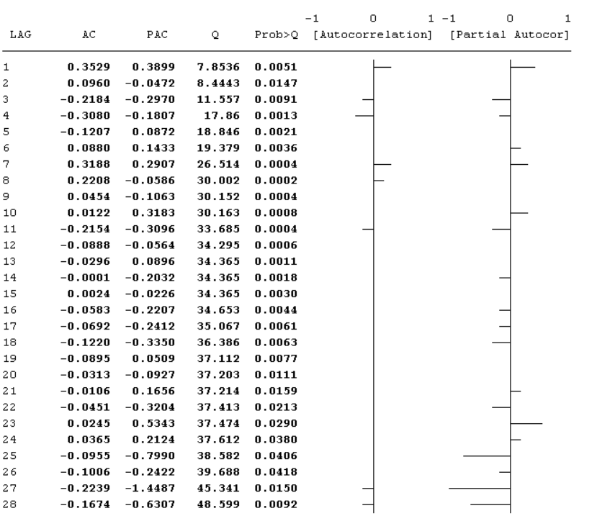

Figure 4 - graphs and correlogram table

The P-value of the Box-Lewing Q-statistics (Figure 4) is in most cases quite low, at least there are no values above 5% significance level. At the 1% significance level, autocorrelation is absent for lags numbered 2 and 20-27. A total of 9 lags out of 28 do not confirm autocorrelation at the 1% significance level.

We still have an open question about the possible falsity of the regression. To finally confirm that the errors of our model are stationary, we use the Dickey-Fuller test.

|  |  |  |  |  |
| --- | --- | --- | --- | --- |
|  | Test | 1% Critical | 5% Critical | 10% Critical |
|  | Statistic | Value | Value | Value |
| Z(t) | **-4.735** | **-3.567** | **-2.923** | **-2.596** |
| MacKinnon approximate p-value for Z(t) = 0.0001 | | | | |

Table 6 - Dickey-Fuller baseline test

|  |  |  |  |  |
| --- | --- | --- | --- | --- |
|  | Test | 1% Critical | 5% Critical | 10% Critical |
|  | Statistic | Value | Value | Value |
| Z(t) | **-4.656** | **-4.130** | **-3.491** | **-3.175** |
| MacKinnon approximate p-value for Z(t) = 0.0008 | | | | |

Table 7 - Dickey-Fuller test with linear trend

|  |  |  |  |  |
| --- | --- | --- | --- | --- |
|  | Test | 1% Critical | 5% Critical | 10% Critical |
|  | Statistic | Value | Value | Value |
| Z(t) | -4.735 | -2.394 | -1.672 | -1.297 |
| p-value for Z(t) = 0.0000 | | | | |

Table 8 - Dickey-Fuller test with drift

Tables 6 to 8 show that the test statistic Z(t) falls into the critical region at any reasonable significance level. Consequently, the hypothesis of a unit root is rejected and the error series is stationary. It is worth noting that the critical value using the linear trend test of 4.13 is quite close to Z(t). Given that the test itself does not always give qualitative results, we should note this fact, i.e. it is theoretically possible that the series is non-stationary.

**Application of the ARIMA model**

In this section, we will apply the ARIMA model using both a first-order autoregressive process and a first-order moving average process. We will then compare the AIC and BIC results of both estimations as well as the significance of the variables.

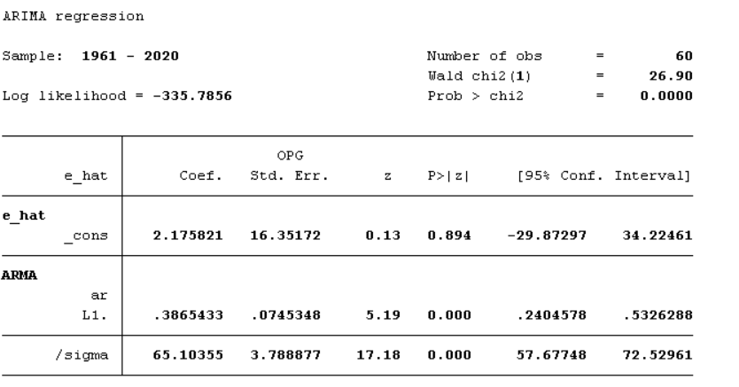

Figure 5 - estimation of regression model by maximum likelihood method (ARIMA(1.0.0))

|  |  |  |  |  |  |  |
| --- | --- | --- | --- | --- | --- | --- |
| Model | Obs | ll(null) | ll(model) | df | AIC | BIC |
|  |  |  |  |  |  |  |
| . | 60 | . | -335.7856 | 3 | 677.5712 | 683.8542 |

Table 9 - Akaike and Schwartz criteria for ARIMA(1.0.0)

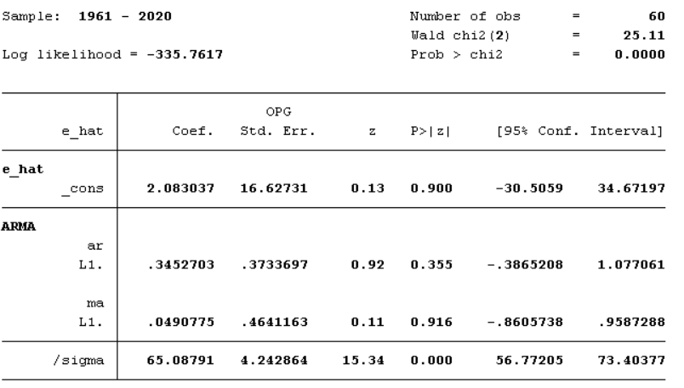

Figure 6 - estimation of regression model by maximum likelihood method (ARIMA(1.0.1))

|  |  |  |  |  |  |  |
| --- | --- | --- | --- | --- | --- | --- |
| Model | Obs | ll(null) | ll(model) | df | AIC | BIC |
| . | 60 | . | -335.7617 | 4 | 679.5234 | 687.9008 |

Table 10 - Akaike and Schwartz criteria for ARIMA(1.0.1)

The Akaike and Schwartz criteria are lower in the model estimated using first order autoregression. This can be seen by comparing Tables 9 and 10. Also, only in this model were the regressors found to be significant. This can be seen from the p-values in Figures 5 and 6. That is, the first model outperforms the second model on both criteria.

We calculate the structural parameter estimates for this model with standard errors to see if the estimates are adequate in terms of efficiency and economic interpretation. We denote **mu** as **the accelerator**, **delta** as the rate of depreciation, and **lambda** as the rate of adjustment.

|  |  |  |  |  |  |  |
| --- | --- | --- | --- | --- | --- | --- |
| inv_real | Coef. | Std. Err. | t | P>t | [95% Conf. | Interval] |
| mu | 24.97927 | 69.74742 | 0.36 | 0.722 | -114.7416 | 164.7001 |
| delta | .0175675 | .0310618 | 0.57 | 0.574 | -.0446568 | .0797918 |
| lambda | .0196552 | .0543831 | 0.36 | 0.719 | -.0892874 | .1285977 |

Table 11 - Estimates of structural parameters with standard errors using the ISC model

Table 11 shows that all structural parameter estimates are insignificant at any reasonable level of significance. Their interpretation suggests that the depreciation rate is less than 2%, which is very low. At the same time, the speed of adjustment of the volume of fixed assets to the optimal one is equal to 0.02, and the optimal volume of fixed assets exceeds the volume of output by 25 times.

**Two-step ISC**

The absence of a significant variable may signal the presence of endogeneity; moreover, the autocorrelation of errors in the dynamic model (Durbin test) also indicates its presence in our model. Estimates, therefore, may be invalid or are. Let us apply the two-step MNC method. As instrumental variables we take the second lags of investment (inv_realt-2 ), GDP (gdp_realt-2 ), inventory growth (inventory t-2 ) of the USA [4].

The formula will take the form:

inv_realt = b0 + b1 *gdp_realt +b2 *gdp_realt-1 +b3 *inv_realt-1 + gdp_realt-2 + inv_realt-2  + inventory t-2 + Ԑt



Figure 7 - results of estimation by two-step ANC

Estimating the model by two-step ANC (Figure 7) we can see that, firstly, the instruments are more than relevant, with the Cragg-Donald Wald F-statistic far exceeding the values of the domain boundaries. Secondly, the instruments are valid. This is evidenced by the p-value, which is greater than 5%. Plus, all coefficients are significant and the number of observations is reduced to 59.

We now compute the structural parameter estimates for the two-step MNC.

|  |  |  |  |  |  |  |
| --- | --- | --- | --- | --- | --- | --- |
| inv_real | Coef. | Std. Err. | z | P>t | [95% Conf. | Interval] |
| mu | 5.029953 | 3.305689 | 1,52 | 0.128 | -1.449079 | 11.50898 |
| delta | .0618783 | .0365666 | 1,69 | 0.091 | -.0097909 | .1335474 |
| lambda | .0950889 | .0594966 | 1,60 | 0.110 | -.0215222 | .2117001 |

Table 12 - Estimates of structural parameters with standard errors using the two-step ANC model

The P-value of the estimates is again high, although this time much lower than for the ISC. With two-step MNC, their interpretation suggests that the depreciation rate is less than 6%, which is already more plausible. The speed of adjustment of the volume of fixed assets to the optimal one also increased and was 0.095. The optimal volume of fixed assets has decreased and now exceeds the volume of output by 5 times, which is also more adequate to the real economic interpretation.

**Generalised method of moments**

When estimated using the generalised method of moments, the coefficients remained significant as before (Figure 8). The instruments are also relevant (Cragg-Donald Wald F-statistic equal to 109.2, Kleibergen-Paap rk Wald F-statistic 134) and valid, as the p-value by Hansen's test is again greater than 5%. The coefficient values themselves are very similar to those of the two-step ANC. Overall, almost nothing has changed except for some parameters. What has changed is the standard errors, which are larger in the OMM for the coefficients of real investment and their lags. R2 is still high. F-statistics have become higher. It is worth noting that the calculation of the standard error in this model has become the lowest, although the difference is not particularly noticeable.



Figure 8 - results of estimation by generalised method of moments

Let's see how the structural parameter estimates have changed.

|  |  |  |  |  |  |  |
| --- | --- | --- | --- | --- | --- | --- |
| inv_real | Coef. | Std. Err. | z | P>t | [95% Conf. | Interval] |
| mu | 6.460081 | 4.980311 | 1,30 | 0.195 | -3.30115 | 16.22131 |
| delta | .0514668 | .0328224 | 1,57 | 0.117 | -.012864 | .1157976 |
| lambda | .0689647 | .0518912 | 1,33 | 0.184 | -.0327402 | .1706695 |

Table 13 - Estimates of structural parameters with standard errors by the generalised method of moments model

Table 13 shows little change from the same estimates of the two-step ANC. To compare the parameter estimates between the three methods let us look at Table 14.

|  |  |  |  |
| --- | --- | --- | --- |
| Evaluation methods | OLS (ISC) | 2SLS (two-step ISC) | GMM (Generalised Method of Moments) |
| Variables | inv_real | inv_real | inv_real |
| mu | **24,98** | **5,03** | **6,5** |
| delta | **0,018** | **0,06** | **0,051** |
| lambda | **0,02** | **0,095** | **0,069** |
| Observations | **60** | **59** | **59** |

Table 14 - comparative table of structural parameters.

It can be seen that in our case, the ISC overestimates the accelerator (mu) and underestimates the amortisation (delta) and adaptation rate (lambda). While the two-step MNC and the generalised method of moments are almost identical to each other but oppositely different from the MNC on the same measures. All three tests do not provide high efficiency of structural parameter estimates.

Let us try to compare two-step MNC and OMM with MNC using the Hausman test to answer the question of whether endogeneity was indeed present and we needed to use methods with instrumental variables. As we have seen above, the instruments were valid, so the test will allow us to verify this with high precision.

|  |  |  |  |
| --- | --- | --- | --- |
|  | (b) (B) | (b-B) | sqrt(diag(V_b-V_B)) |
|  | sls ols | Difference | S.E. |
| L.inv_real | .9049111 .9803448 | -.0754338 | .0241313 |
| gdp_real | .4782928 .4909715 | -.0126787 | . |
| L.gdp_real | -.4486968 -.4823464 | .0336495 | .0048737 |
| **chi2(3) = (b-B)'[(V_b-V_B)^(-1)](b-B) = 4.58**  **Prob>chi2 = 0.2055** | | | |

Table 20 - results of comparison of the ISC and two-step ISC models by Hausman test

It can be seen that the null hypothesis is not rejected at any possible level of significance, as p-value=0.21 (Table 20). That is, the difference in the coefficients is not systematic. Hence, there was no endogeneity. Absolutely the same results are observed when comparing the ISC with the OMM (without taking robustness into account). The results are absolutely identical.

However, the MNC cannot claim to be a qualitative model for estimation because the structural parameters in this model are completely insignificant. In addition, we have seen that there are missing variables in our model and our model may be misspecified. We need to see how the estimates of structural parameters will behave when ARIMAX is used.

**ARIMAX (1.0.0).**

One of our objectives was to compare the estimates obtained by other methods. Therefore, we estimate the model inv_realt = b0 + b1 *gdp_realt +b2 *gdp_realt-1 +b3 *inv_realt-1 + Ԑt using ARIMAX(1.0.0).



Figure 9 - regression estimation by ARIMAX(1.0.0) model

|  |  |  |  |  |  |  |
| --- | --- | --- | --- | --- | --- | --- |
| Model | Obs | ll(null) | ll(model) | df | AIC | BIC |
| ARIMAX | 60 | . | -335.361 | 6 | 682.7221 | 695.2882 |
| ARMA | 60 | . | -335.7856 | 3 | 677.5712 | 683.8542 |

Table 15 - Akaike and Schwartz criteria for ARIMAX (1.0.0) and ARIMA( 1.0.0 )

The Akaike and Schwartz criteria turned out to be slightly higher than when the model was estimated using ARIMA(1.0.0). This can be seen in Table 15. The coefficients are significant at 5% level of significance. This is evidenced by figure 9. A total of 24 iterations of the maximum likelihood method were needed.

To make the picture clearer, we need to look at the AC and PAC process graphs and the correlogram table.



Figure 10 - Diagram plots (right-to-left) of AC, PAC of ARIMAX residuals (1,0,0)

As the AC diagram in Figure 10 shows, we managed to remove all peaks. As for PAC, the first peaks were removed, and in total we managed to remove 3 peaks.

All Box-Lewing P-value Q-statistics (Figure 11) also showed good results. At any reasonable significance level, there is no autocorrelation at all lags.

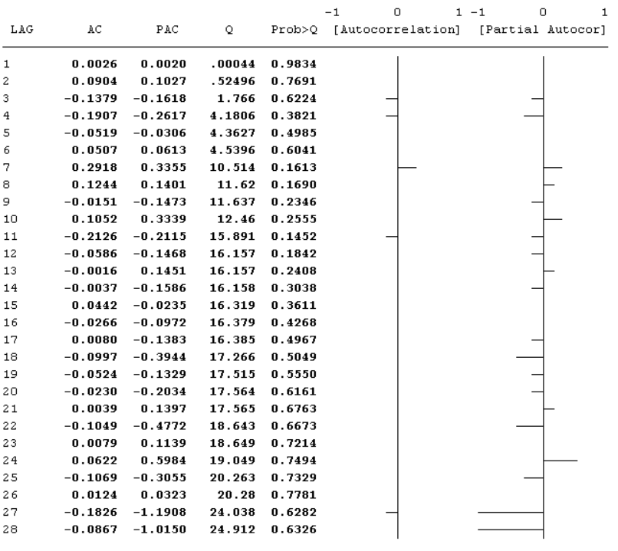

Figure 11 - ARIMAX(1,0,0) graphs and correlogram table

Let us perform the Breusch-Pagan test for heteroscedasticity: **chi2(1) = 27.38, Prob > chi2 = 0.0000**. It can be seen that it is still present.

The analysis of the quality of the fit of this model (Figure 12) is almost identical to Figure 2. There are some differences in the prediction line and in the residuals line, but they are hardly noticeable. At least we do not observe any critical changes.



Figure 12 - analysis of the quality of the ARIMAX model fit (1,0,0)

**ARIMAX (1.0.1).**

Having estimated the ARIMAX(1,0,1) model, after 28 iterations we obtained the following estimates, shown in Figure 13. The coefficients of GDP, lag GDP and lag investment remained the same, but now the first order values of autocorrelation and moving average are statistically insignificant at any reasonable level of significance. The AR(1) coefficient of the process has also remained the same, the only thing is that its standard error has increased. The plots of the residuals diagrams have not actually changed (Figure 14). A similar picture is observed when analysing the correlogram table: the changes are insignificant (Figure 15). Nothing has changed in the test for heteroscedasticity: **chi2(1) = 27.43, Prob > chi2 = 0.0000**. It is still present. There was also no change in the fit quality analysis plot (Figure 16). The criteria **AIC=684.7198, BIC=699.3802** have become expectedly higher.

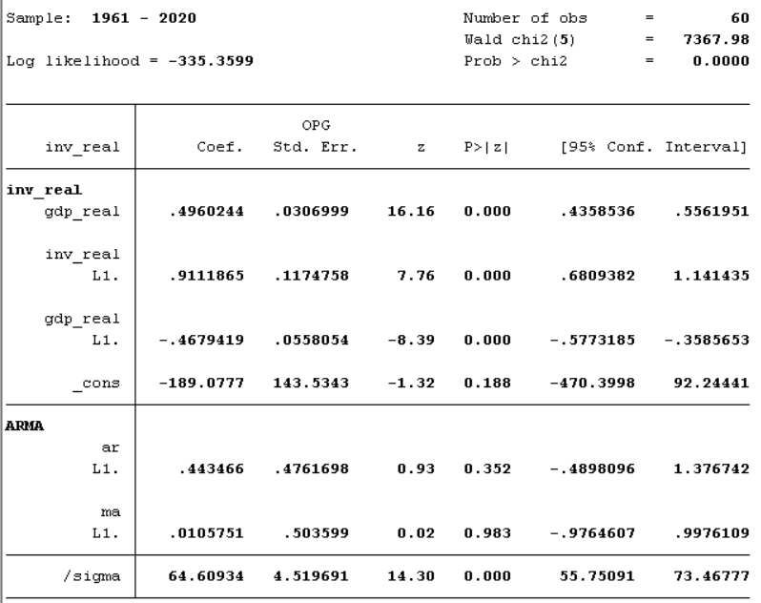

Figure 13 - ARIMAX(1,0,1) model estimation



Figure 14 - Diagram plots (right-to-left) of AC, PAC of ARIMAX(1,0,1) residuals

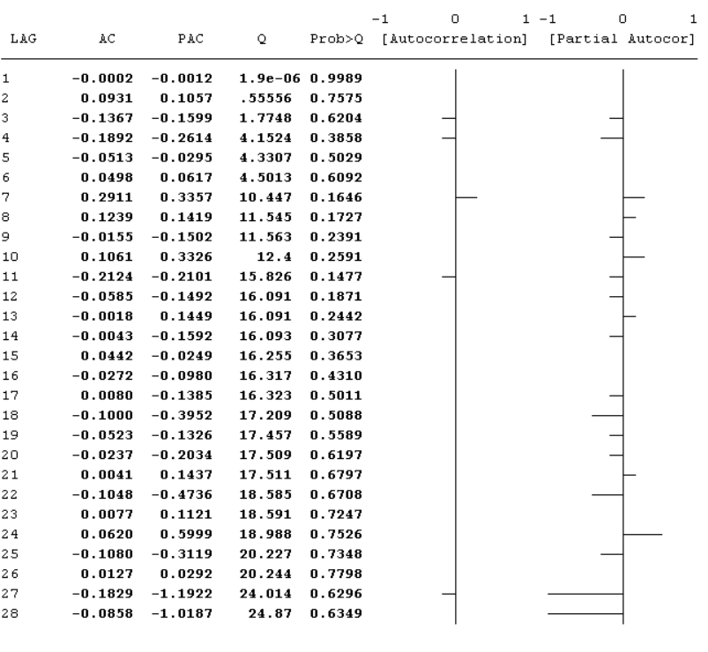

Figure 15 - ARIMAX(1,0,1) graphs and correlogram table



Figure 16 - analysis of the quality of the ARIMAX model fit (1,0,1)

Now it is necessary to see what has become of the estimates of structural parameters. Tables 16, 17 show the estimation results. In fact, the estimates are very similar to those obtained by the two-step ANC and the generalised method of moments.

|  |  |  |  |  |  |  |
| --- | --- | --- | --- | --- | --- | --- |
| inv_real | Coef. | Std. Err. | z | P>t | [95% Conf. | Interval] |
| mu | 5.528919 | 6.947491 | 0.80 | 0.426 | -8.087914 | 19.14575 |
| delta | .0571288 | .0654927 | 0.87 | 0.383 | -.0712344 | .1854921 |
| lambda | .0897295 | .1098971 | 0.82 | 0.414 | -.1256648 | .3051239 |

Table 16 - Estimates of structural parameters with standard errors by ARIMAX(1,0,0) model

|  |  |  |  |  |  |  |
| --- | --- | --- | --- | --- | --- | --- |
| inv_real | Coef. | Std. Err. | z | P>t | [95% Conf. | Interval] |
| mu | 5.585012 | 7.584382 | 0.74 | 0.461 | -9.280103 | 20.45013 |
| delta | .0566152 | .069178 | 0.82 | 0.413 | -.0789712 | .1922016 |
| lambda | .0888135 | .1174758 | 0.76 | 0.450 | -.1414348 | .3190618 |

Table 17 - Estimates of structural parameters with standard errors by ARIMAX(1,0,1) model

**Conclusions**

As we can see from Table 18, the Akaike and Schwartz information criteria do not differ too much from method to method, although there is an increase. The lowest criterion was obtained when estimating the model with the help of MNC, but our task was to analyse the estimates of structural parameters, and they turned out to be contradictory or, better to say, implausible when estimated by this method.

|  |  |  |  |  |  |
| --- | --- | --- | --- | --- | --- |
|  | OLS (ISC) | 2SLS (two-step ISC) | GMM (Generalised Method of Moments) | ARIMAX(1,0,1) | ARIMAX(1,0,1) |
| AIC | 677.5712 | 679.0326 | 678.8722 | 682.7221 | 684.7198 |
| BIC | 683.8542 | 687.3428 | 687.1823 | 695.2882 | 699.3802 |

Table 18 - AIC and BIC summary table



Table 19 - Estimates of structural parameters (p-value estimates in parentheses, standard errors in square brackets)

Table 19 shows quite similar results in the coefficient values of all methods except for ANC. The inadequate estimation of the accelerator by the ISC method is also evidenced by the huge standard error. It can be seen that the indicator is overestimated and is also therefore implausible. In addition, the significance of the coefficients is the lowest among all presented models. It is also interesting to observe how the significance of the coefficients decreases for all three structural parameters starting from the two-step ISC, and at the same time there is an increase in the standard errors for the damping and accelerator parameters. On the contrary, the standard errors of the adaptation speed fall together with the significance.

In general, based on the conclusions drawn in the textbook "Vakulenko, E. S. Econometrics", the low significance of the coefficients can be justified both by the asymptotic nature of the maximum likelihood method and methods using instrumental variables, and by the presence of heteroskedasticity, which we observed throughout the study. In our case, the instrumental variable methods produced the most significant estimates. They also have lower standard errors for accelerator and amortisation. In addition, the instruments themselves turned out to be relevant and valid in both methods.

Estimating the model by two-step MNC we obtained that the volume of fixed assets of the USA exceeds the volume of output by 5 times. The depreciation rate is 6% and the adjustment rate is 0.095. For the generalised method of moments, the volume of fixed assets is 6.5 times the volume of output. The rate of depreciation is equal to 5%. The speed of adjustment of the actual volume of fixed assets to the optimal one is 0.069. The ARIMAX(1,0,0) model shows a depreciation rate of 5.7% and a speed of adjustment of 0.089. The excess of optimal fixed assets over output is 5.5. The ARIMAX(1,0,1) model has the same amortisation rate, almost identical adjustment rate and the same ratio of optimal capital stock to output.

List of Sources:

1. Vakulenko, E. S. Econometrics (advanced course). Application of Stata package : textbook for universities / E. S. Vakulenko, T. A. Ratnikova, K. K. Furmanov. - Moscow : Yurait Publishing House, 2020. - 246 с. - (Higher Education). - ISBN 978-5-534-12244-2. - Text : electronic // Educational platform Yurait [website]. - URL: [https:](https://urait.ru/bcode/447095)//urait.ru/bcode/447095 (date of address: 24.02.2023).
2. Gross domestic investment // FRAD // https://fred.stlouisfed.org/series/W170RC1Q027SBEA
3. Gross domestic product // FRAD // https://fred.stlouisfed.org/series/GDPC1#0
4. Real private inventories// FRAD // https://fred.stlouisfed.org/series/A371RX1Q020SBEA#0