OAuth 2.0 provides authorization so that a client (for example, a mobile photo viewer application) can make authorized requests to protected resources on a service (for example, user's photographs on an online storage service) on behalf of the resource owner.

Resource owner
A resource owner is an entity who is capable of granting access to a protected resource. When this entity is a person the term end user or user can be used as well

Authorization server
In order for a client to access protected resources, this must first be authorized by the resource owner.
This is what the authorization server does—it asks the user (resource owner) for confirmation that the client should be authorized to have access. For every successful authorization request, the server issues the client a so called 'access token.' It is a token that the client uses to specify for which user it is making the requests.

Resource server
A resource server is the one who serves the protected resources, which are to be accessed by making authorized requests from a client application.
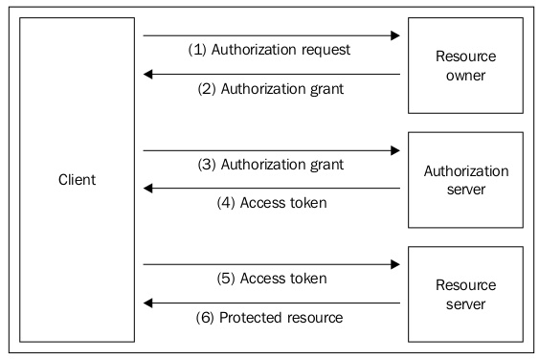
the authorization and resource servers can be on separate servers, they can be on the same server,
one authorization server can be used for several resource servers

Client
A client is an application that makes requests to protected resources on the resource server, on behalf of the resource owner (the user). A client application can be a web application, desktop application, mobile application

OAuth 2.0 grant flows
- Authorization code grant flow: This is used for web server applications in general and it's the most frequently used grant
- Implicit grant flow: This is used for client applications that are not capable of keeping the credentials secure and it is frequently used for applications that need read-only access to some data
- Resource owner password credentials grant flow: This is the only grant flow where the actual username and password from the resource owner (the user) are sent in exchange for an access token
- Client credentials grant flow: This is used for client applications that want to request access to some service provider on behalf of themselves and not on behalf of some end user, and it is useful when in need to access some service APIs that are 'userless' (for example, for maintenance, statistics, and so on)

