**Курс " Javascript Fullstack Developer" и "Javascript Frontend"**

# **Кожевников Сергей 2024 год**

# **Задание 3**

Продумать и разработать базу данных для:  
1) todo-листа.  
2) интернет-магазина.  
3) социальной сети.  
4) системы управления обучающими курсами.

Опциональное дз:

1) Придумать свою идею для проекта и описать структуру БД для него.

2) Установить PostgreSQL и с помощью SQL запросов создать описанную структуру.

3) Ознакомиться с GUI для баз данных (напр. DataGrip) и попробовать поработать с БД через нее.

**Установил PostgreSQL 16.2 for Windows 10 x64**

<https://www.postgresql.org/download/>

[**https://www.enterprisedb.com/downloads/postgres-postgresql-downloads**](https://www.enterprisedb.com/downloads/postgres-postgresql-downloads)

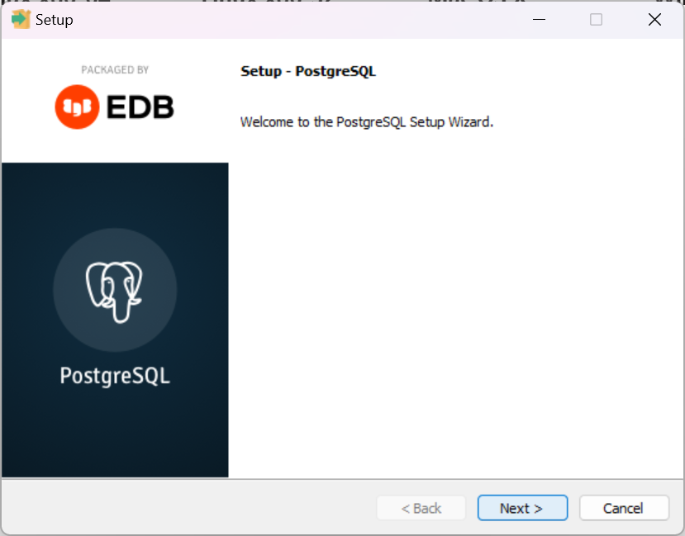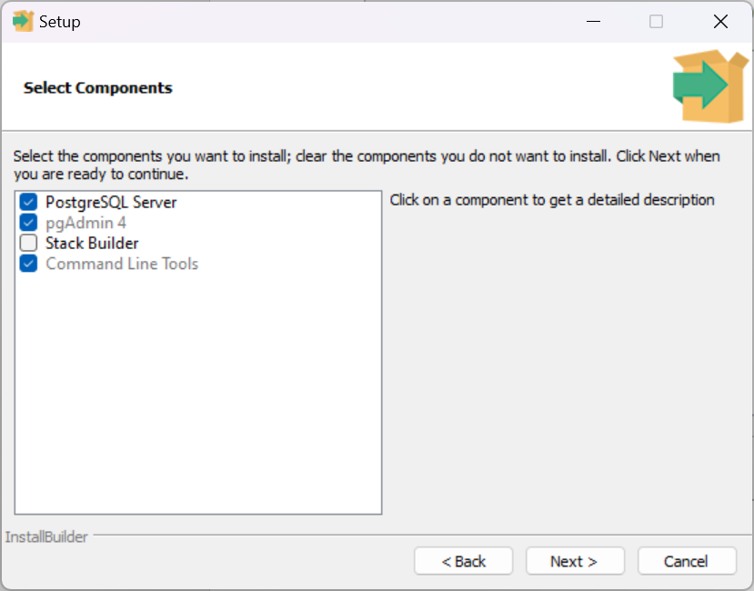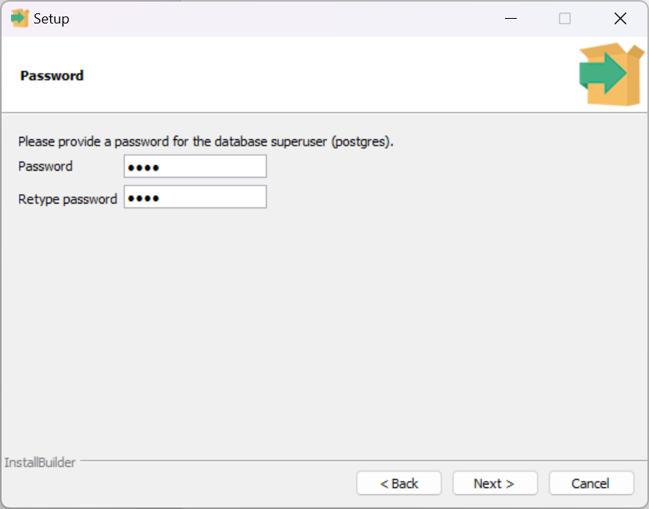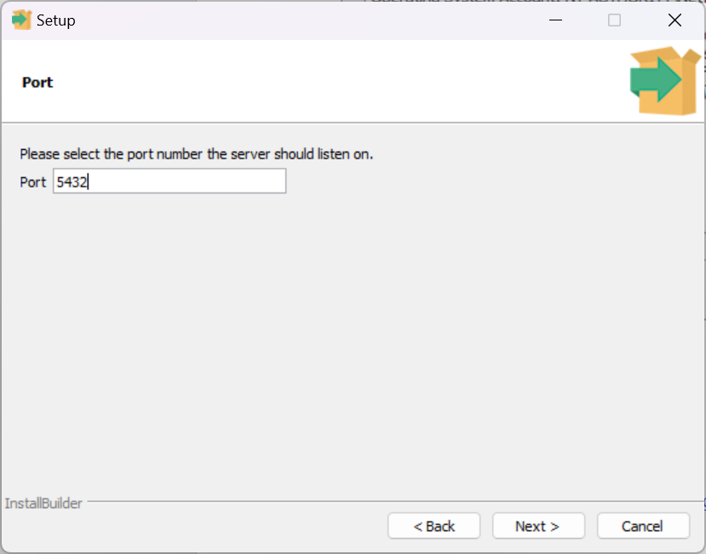

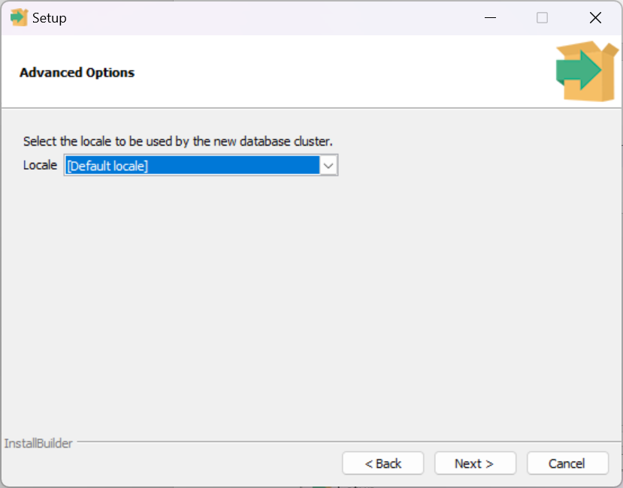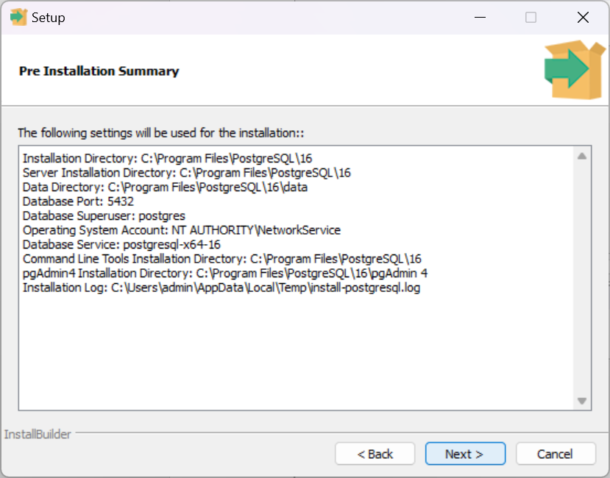

**Запустил и настроил pgAdmin**

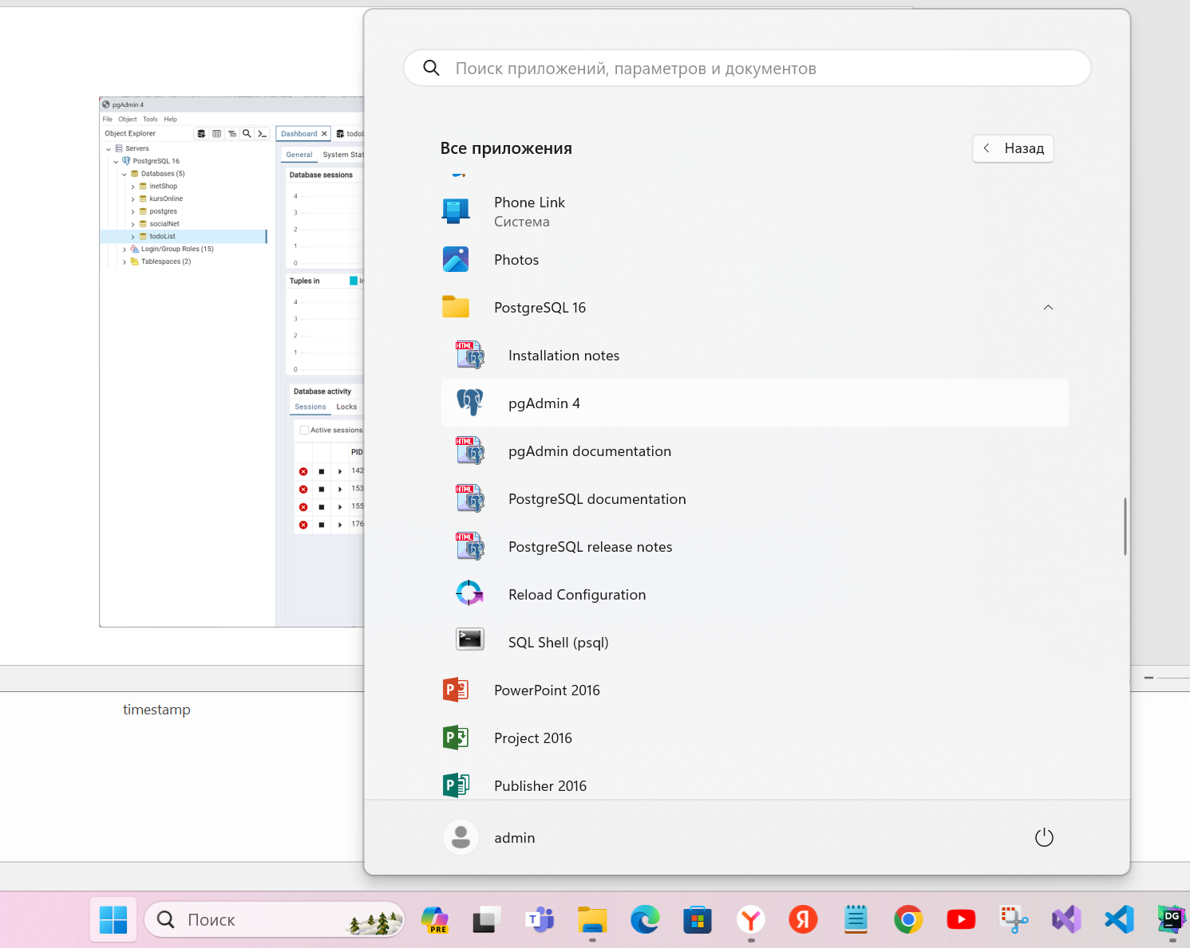

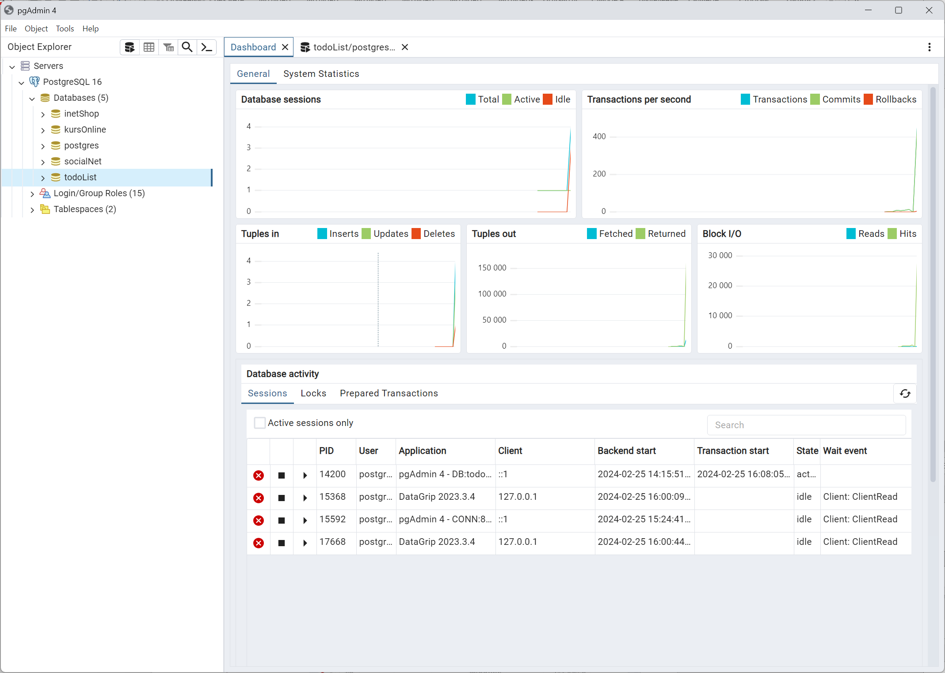

**Установил ODBC for PostgresSQL**

https://www.postgresql.org/ftp/odbc/versions/msi/

Установил DataGrip (<https://www.jetbrains.com/datagrip/>), ознакомился с GUI для баз данных и попробовал поработать с БД через нее.

Подключил локальный сервер PostgreSQL. Проверил соединение.

DBMS: PostgreSQL (ver. 16.2)

Case sensitivity: plain=lower, delimited=exact

Driver: PostgreSQL JDBC Driver (ver. 42.6.0, JDBC4.2)

Ping: 12 ms

SSL: no

Подключил базы в DataGrip и вывел запрос данных.

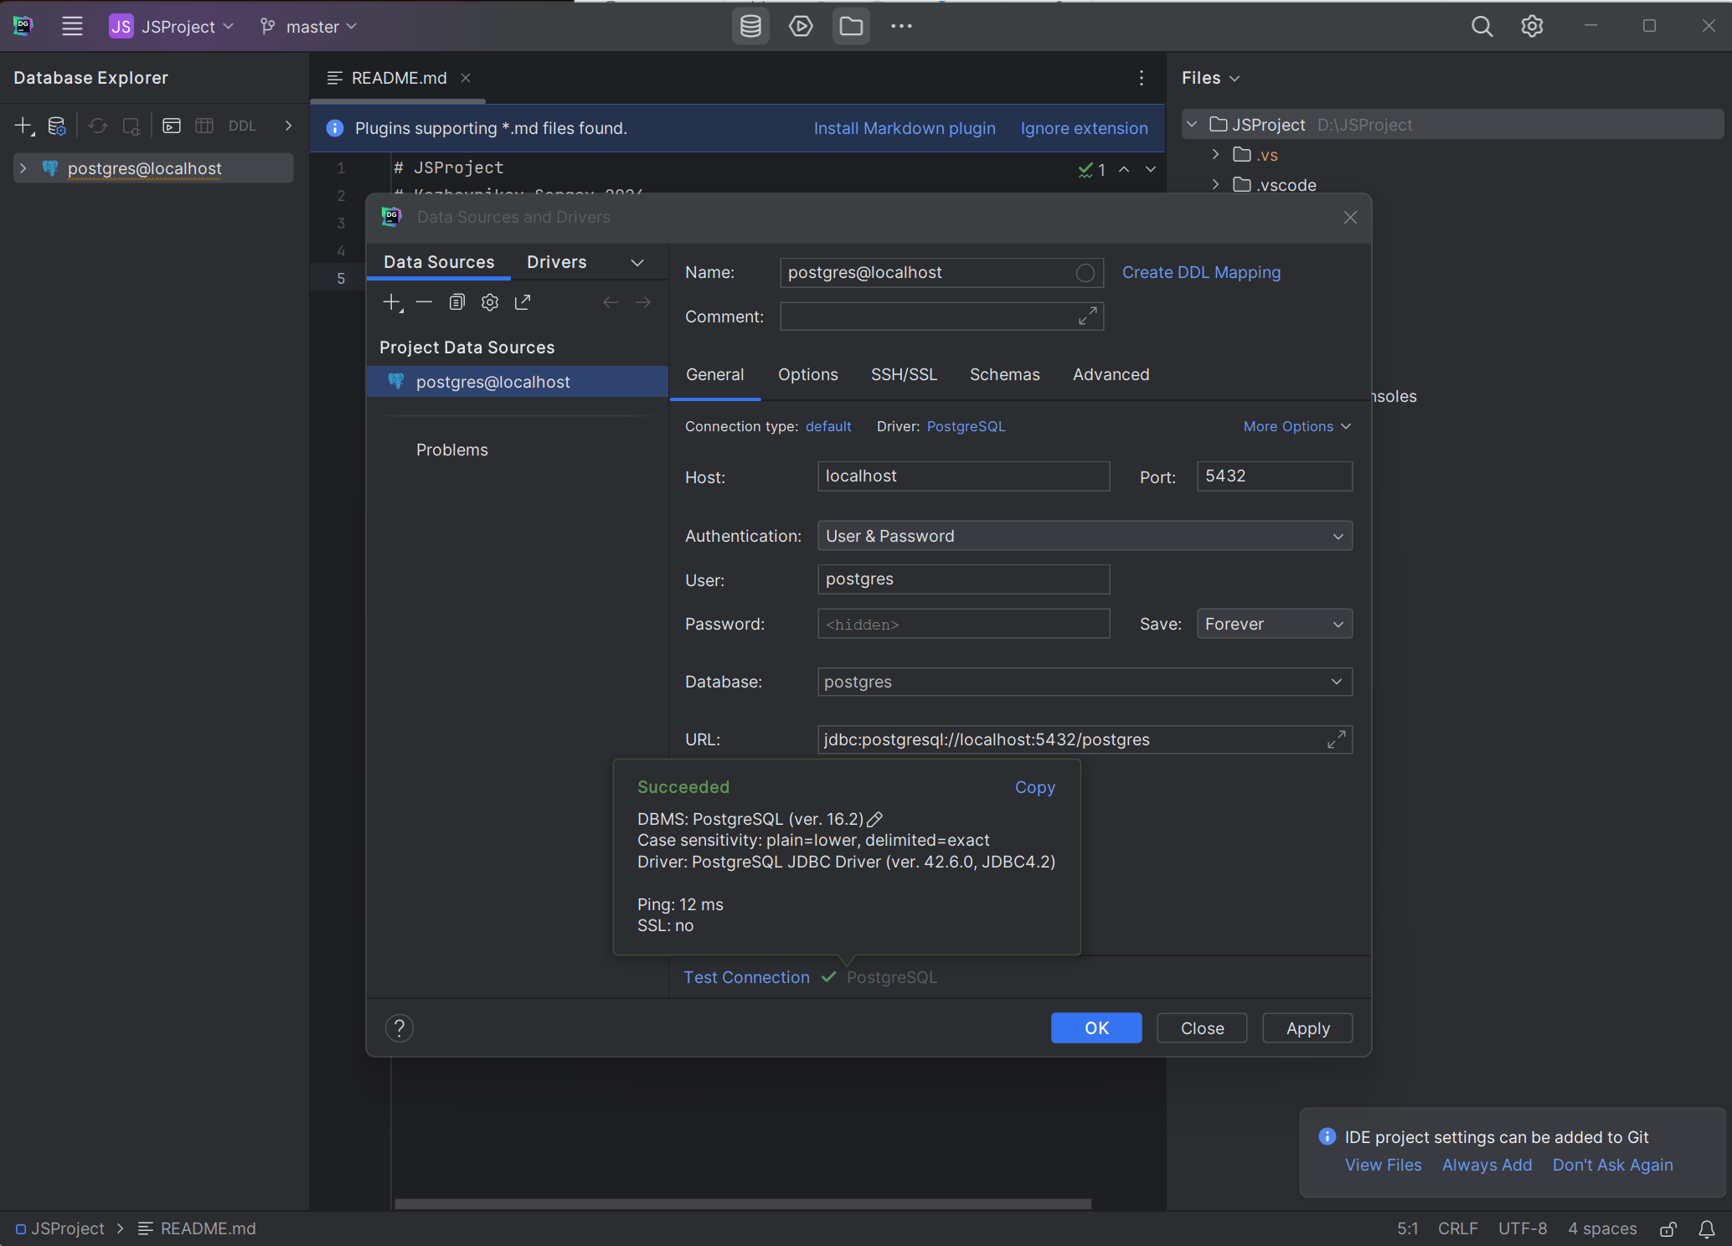

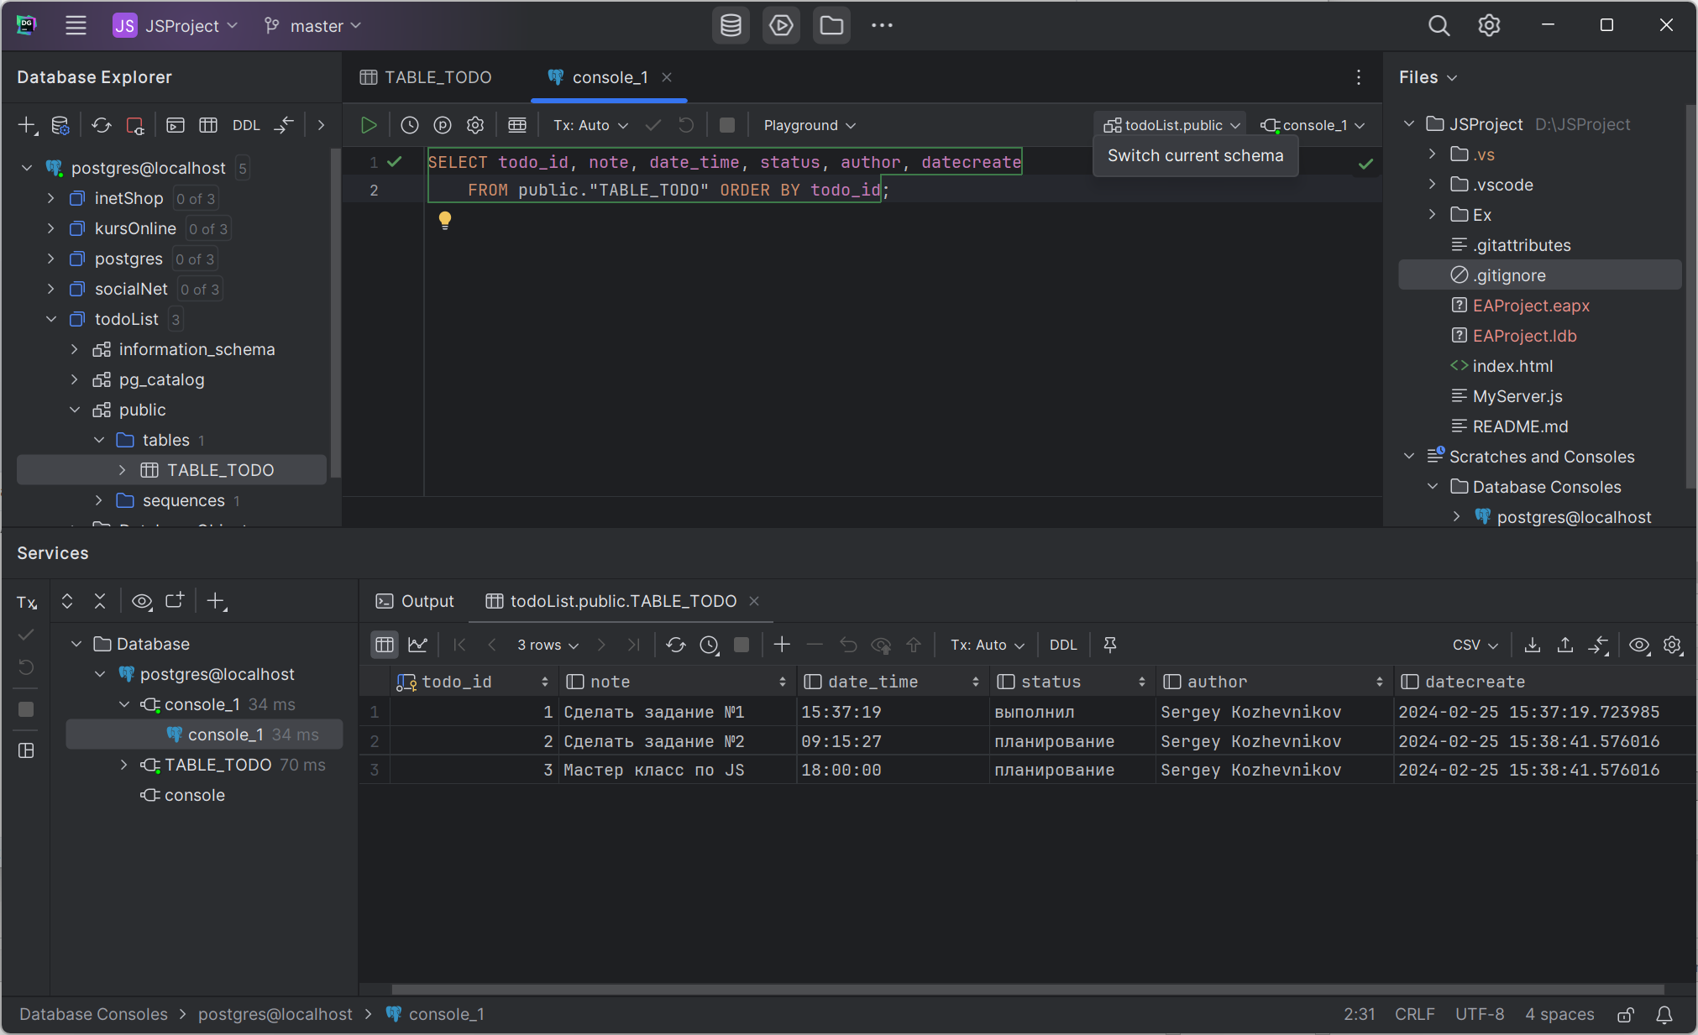

# **Решение**

# База данных TODO

### Tables diagram

Data Modeling diagram in package 'Tables'

Tables

Version 1.0

admin created on 25.02.2024. Last modified 26.02.2024



1. Tables

### t_kurs

Database table in package 'Tables'

t_kurs

Version 1.0 Phase 1.0 Proposed

admin created on 26.02.2024. Last modified 26.02.2024

DBMS PostgreSQL

| COLUMN NAME | DATATYPE | NOT NULL | COMMENTS |
| --- | --- | --- | --- |
| kurs_id | integer | True | Properties:  AutoNum = True  property = AutoNum=True;  SequenceName = kurs_id_seq |
| kurs_name | varchar(255) | False |  |
| user_id | integer | False |  |
| todo_id | integer | False |  |

|  |  |  |
| --- | --- | --- |
| PRIMARY KEY NAME | COLUMNS | COMMENTS |
| PK_t_kurs | kurs_id |  |

|  |  |  |
| --- | --- | --- |
| TYPE / NAME | COLUMNS | COMMENTS |
| «index» IXFK_t_kurs_t_TODO | todo_id |  |
| «index» IXFK_t_kurs_t_User | user_id |  |

|  |  |  |
| --- | --- | --- |
| FOREIGN KEY NAME | COLUMNS | REFERENCES |
| FK_t_kurs_t_TODO | todo_id | t_TODO(todo_id) |
| FK_t_kurs_t_User | user_id | t_User(user_id) |

### t_order

Database table in package 'Tables'

t_order

Version 1.0 Phase 1.0 Proposed

admin created on 26.02.2024. Last modified 26.02.2024

DBMS PostgreSQL

| COLUMN NAME | DATATYPE | NOT NULL | COMMENTS |
| --- | --- | --- | --- |
| order_id | integer | True | Properties:  AutoNum = True  property = AutoNum=True;  SequenceName = order_id_seq |
| product_name | varchar(50) | False |  |
| product_count | integer | False | Initial value: 0 |
| product_cost | double precision | False |  |
| notes | text | False |  |
| user_id | integer | False | Initial value: 0 |
| date_create | time without time zone | False |  |

|  |  |  |
| --- | --- | --- |
| PRIMARY KEY NAME | COLUMNS | COMMENTS |
| PK_t_order | order_id |  |

|  |  |  |
| --- | --- | --- |
| TYPE / NAME | COLUMNS | COMMENTS |
| «index» IXFK_t_order_t_User | user_id |  |

|  |  |  |
| --- | --- | --- |
| FOREIGN KEY NAME | COLUMNS | REFERENCES |
| FK_t_order_t_User | user_id | t_User(user_id) |

### t_TODO

Database table in package 'Tables'

t_TODO

Version 1.0 Phase 1.0 Proposed

admin created on 25.02.2024. Last modified 26.02.2024

DBMS PostgreSQL

| COLUMN NAME | DATATYPE | NOT NULL | COMMENTS |
| --- | --- | --- | --- |
| todo_id | integer | True | Properties:  AutoNum = True  property = AutoNum=True;  SequenceName = todo_id_seq |
| notes | text | False |  |
| date_time | timestamp | False |  |
| status | varchar(50) | False | планирование, отложен, в работе, выполнил |
| user_id | integer | False |  |
| datecreate | timestamp | False |  |

|  |  |  |
| --- | --- | --- |
| PRIMARY KEY NAME | COLUMNS | COMMENTS |
| PK_t_TODO | todo_id |  |

|  |  |  |
| --- | --- | --- |
| TYPE / NAME | COLUMNS | COMMENTS |
| «index» IXFK_t_TODO_T_User | user_id |  |

|  |  |  |
| --- | --- | --- |
| FOREIGN KEY NAME | COLUMNS | REFERENCES |
| FK_t_TODO_T_User | user_id | t_User(user_id) |

### t_User

Database table in package 'Tables'

t_User

Version 1.0 Phase 1.0 Proposed

admin created on 26.02.2024. Last modified 26.02.2024

DBMS PostgreSQL

| COLUMN NAME | DATATYPE | NOT NULL | COMMENTS |
| --- | --- | --- | --- |
| user_id | integer | True | Properties:  AutoNum = True  property = AutoNum=True;  SequenceName = user_id_seq |
| user_name | varchar(255) | False |  |
| user_email | varchar(50) | False |  |
| user_tell | varchar(50) | False |  |

|  |  |  |
| --- | --- | --- |
| PRIMARY KEY NAME | COLUMNS | COMMENTS |
| PK_t_User | user_id |  |

SELECT todo_id, notes, date_time, status, user_id, datecreate

FROM public."t_TODO" ORDER BY todo_id; -- Вывел результат

INSERT INTO public."t_TODO" as todo (notes, date_time, status, user_id, datecreate)

VALUES

('Задание 1','2024-02-26 09:55:27','планирование',1, current_timestamp),

('Задание 2','2024-02-24 11:11:27','планирование',2, current_timestamp),

('Задание 3','2023-06-24 12:11:27','планирование',2, current_timestamp),

('Задание 4','2023-05-24 05:11:27','планирование',2, current_timestamp),

('Задание 5','2024-01-24 09:11:27','планирование',1, current_timestamp),

('Задание 6','2024-01-26 15:12:27','планирование',3, current_timestamp),

('Мастер класс по JS','2024.02.25 18:00:00','выполнил',3, current_timestamp); -- Создал новую строку

INSERT INTO public."t_User" as usr (user_name, user_email, user_tell)

VALUES

('Sergey Kozhevnikov','kozhevnikov.su@gmail.com','+7 (985) 867 04 89'), -- Создал нового пользователя

('Sidor Sidorov','sidor234@gmail.com','+7 (432) 324 02 11'), -- Создал нового пользователя

('Ivan Ivanov','ivan3423@gmail.com','+7 (985) 342 01 32'); -- Создал нового пользователя

SELECT user_id, user_name, user_email, user_tell

FROM public."t_User" order by user_id ;

INSERT INTO public.t_kurs(kurs_id, kurs_name, user_id, todo_id)

VALUES

(2,'Курс 2', 2, 2),

(3,'Курс 3', 3, 3),

(4,'Курс 4', 1, 4),

(5,'Курс 5', 2, 5),

(6,'Курс 6', 3, 6);

SELECT kurs_id, kurs_name, user_id, todo_id

FROM public."t_kurs" order by kurs_id ;

INSERT INTO public.t_order(

order_id, product_name, product_count, product_cost, notes, user_id, date_create)

VALUES

(2,'Товар 2', 11, 1223.28,'Описание товара 2', 2,current_timestamp),

(3,'Товар 3', 12, 6523.12,'Описание товара 3', 3,current_timestamp),

(4,'Товар 4', 13, 5561.22,'Описание товара 4', 1,current_timestamp),

(5,'Товар 5', 14, 45233.3,'Описание товара 5', 2,current_timestamp);

SELECT order_id, product_name, product_count, product_cost, notes, user_id, date_create

FROM public.t_order;

UPDATE public."t_TODO"

SET date_time = '2024-02-25 15:37:19'

WHERE todo_id = 2; -- Обновил дату

UPDATE public."t_TODO"

SET status = 'в работе'

--планирование, отложен, в работе, выполнил

WHERE todo_id = 3; -- Обновил статус

delete FROM public."t_TODO"

WHERE todo_id = 4; -- Удалил строку

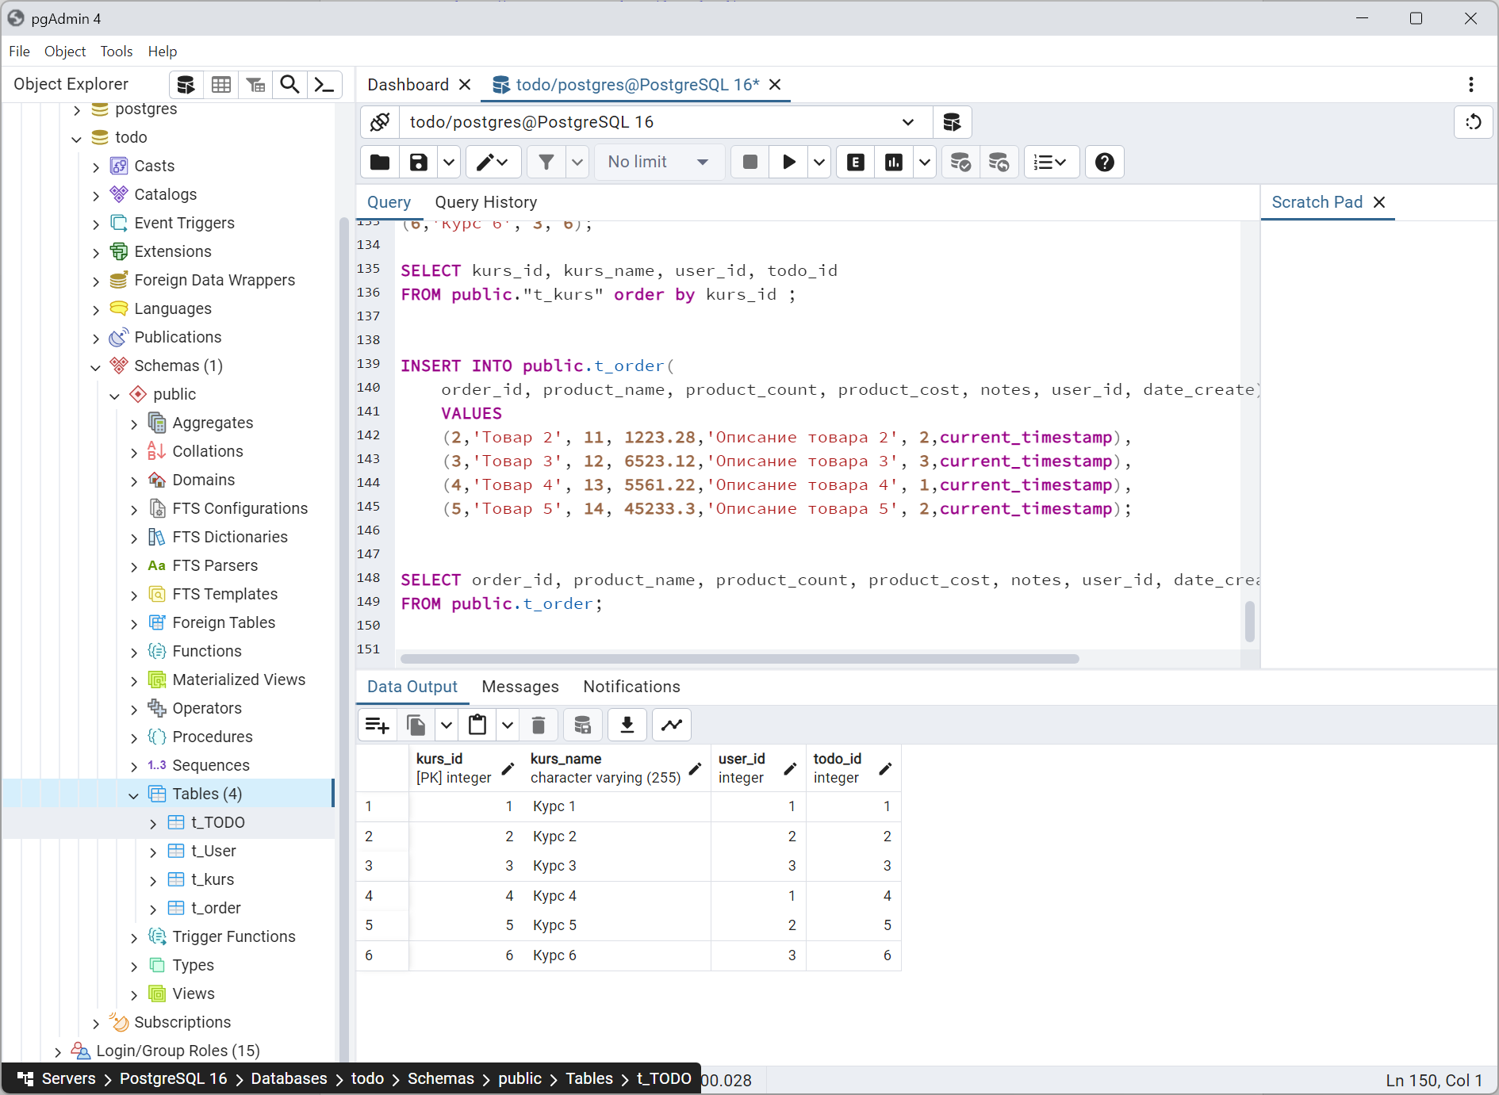

# База данных проекта IMS

### Tables diagram

Data Modeling diagram in package 'Tables'

Tables

Version 1.0

Сергей Кожевников created on 21.02.2024. Last modified 26.02.2024



1. Tables

### t_connector

Database table in package 'Tables'

t_connector

Version 1.0 Phase 1.0 Proposed

Сергей Кожевников created on 26.02.2024. Last modified 26.02.2024

DBMS PostgreSQL

| COLUMN NAME | DATATYPE | NOT NULL | COMMENTS |
| --- | --- | --- | --- |
| connector_id | integer | True | Properties:  AutoNum = True  property = AutoNum=True;  SequenceName = connector_id_seq |
| name | varchar(255) | False |  |
| direction | varchar(50) | False |  |
| notes | text | False |  |
| connector_type | varchar(50) | False |  |
| start_object_id | integer | False | Initial value: 0 |
| end_object_id | integer | False | Initial value: 0 |
| ims_guid | varchar(40) | False |  |

|  |  |  |
| --- | --- | --- |
| PRIMARY KEY NAME | COLUMNS | COMMENTS |
| PK_t_connector | connector_id |  |

|  |  |  |
| --- | --- | --- |
| TYPE / NAME | COLUMNS | COMMENTS |
| «index» IXFK_t_connector_t_object | start_object_id |  |
| «index» IXFK_t_connector_t_object_02 | end_object_id |  |

|  |  |  |
| --- | --- | --- |
| FOREIGN KEY NAME | COLUMNS | REFERENCES |
| FK_t_connector_t_object_02 | end_object_id | public.t_object(object_id) |
| FK_t_connector_t_object | start_object_id | public.t_object(object_id) |

### public.t_documents

Database table in package 'Tables'

t_documents

Version 1.0 Phase 1.0 Proposed

Сергей Кожевников created on 21.02.2024. Last modified 21.02.2024

DBMS PostgreSQL

| COLUMN NAME | DATATYPE | NOT NULL | COMMENTS |
| --- | --- | --- | --- |
| doc_id | varchar(40) | True |  |
| docname | varchar(100) | False |  |
| notes | varchar(255) | False |  |
| style | varchar(255) | False |  |
| element_id | varchar(40) | True |  |
| elementtype | varchar(50) | True |  |
| strcontent | text | False |  |
| bincontent | bytea | False |  |
| doctype | varchar(100) | False |  |
| author | varchar(50) | False |  |
| isactive | integer | False | Initial value: 1 |
| sequence | integer | False | Initial value: 0 |
| docdate | timestamp without time zone | False |  |
| object_id | integer | False |  |

|  |  |  |
| --- | --- | --- |
| PRIMARY KEY NAME | COLUMNS | COMMENTS |
| PK_t_documents | doc_id |  |

|  |  |  |
| --- | --- | --- |
| TYPE / NAME | COLUMNS | COMMENTS |
| «index» IXFK_t_documents_t_object | object_id |  |

|  |  |  |
| --- | --- | --- |
| FOREIGN KEY NAME | COLUMNS | REFERENCES |
| FK_t_documents_t_object | object_id | public.t_object(object_id) |

### public.t_glossary

Database table in package 'Tables'

t_glossary

Version 1.0 Phase 1.0 Proposed

SYKozhevnikov created on 21.02.2024. Last modified 21.02.2024

DBMS PostgreSQL

| COLUMN NAME | DATATYPE | NOT NULL | COMMENTS |
| --- | --- | --- | --- |
| term | varchar(255) | False |  |
| type | varchar(255) | False |  |
| meaning | text | False |  |
| glossaryid | integer | True | Properties:  AutoNum = 1  Increment = 1  property = AutoNum=1;StartNum=1;Increment=1;  SequenceName = glossaryid_seq  StartNum = 1 |

|  |  |  |
| --- | --- | --- |
| PRIMARY KEY NAME | COLUMNS | COMMENTS |
| pk_glossary | glossaryid |  |

|  |  |  |
| --- | --- | --- |
| TYPE / NAME | COLUMNS | COMMENTS |
| «index» idx_glossary_term | term |  |
| «index» idx_glossary_type | type |  |

### public.t_object

Database table in package 'Tables'

t_object

Version 1.0 Phase 1.0 Proposed

Сергей Кожевников created on 21.02.2024. Last modified 21.02.2024

DBMS PostgreSQL

| COLUMN NAME | DATATYPE | NOT NULL | COMMENTS |
| --- | --- | --- | --- |
| object_id | integer | True | Properties:  AutoNum = True  property = AutoNum=True;  SequenceName = object_id_seq |
| object_type | varchar(255) | False |  |
| name | varchar(255) | False |  |
| alias | varchar(255) | False |  |
| author | varchar(255) | False |  |
| version | varchar(50) | False | Initial value: '1.0' |
| note | text | False |  |
| package_id | integer | False | Initial value: 0 |
| stereotype | varchar(255) | False |  |
| status | varchar(50) | False |  |
| ims_guid | varchar(40) | False |  |
| property_id | integer | False |  |
| connector_id | integer | False |  |

|  |  |  |
| --- | --- | --- |
| PRIMARY KEY NAME | COLUMNS | COMMENTS |
| PK_t_object | object_id |  |

|  |  |  |
| --- | --- | --- |
| TYPE / NAME | COLUMNS | COMMENTS |
| «index» IXFK_t_object_t_objectproperties | property_id |  |
| «index» IXFK_t_object_t_package | package_id |  |

|  |  |  |
| --- | --- | --- |
| FOREIGN KEY NAME | COLUMNS | REFERENCES |
| FK_t_object_t_objectproperties | property_id | t_objectproperties(property_id) |
| FK_t_object_t_package | package_id | t_package(package_id) |

### t_objectproperties

Database table in package 'Tables'

t_objectproperties

Version 1.0 Phase 1.0 Proposed

Сергей Кожевников created on 26.02.2024. Last modified 26.02.2024

DBMS PostgreSQL

| COLUMN NAME | DATATYPE | NOT NULL | COMMENTS |
| --- | --- | --- | --- |
| property_id | integer | True |  |
| object_id | integer | False | Initial value: 0 |
| property | varchar(255) | False |  |
| value | varchar(255) | False |  |
| notes | text | False |  |
| ims_guid | varchar(40) | False |  |

|  |  |  |
| --- | --- | --- |
| PRIMARY KEY NAME | COLUMNS | COMMENTS |
| PK_t_objectproperties | property_id |  |

### t_package

Database table in package 'Tables'

t_package

Version 1.0 Phase 1.0 Proposed

Сергей Кожевников created on 26.02.2024. Last modified 26.02.2024

DBMS PostgreSQL

| COLUMN NAME | DATATYPE | NOT NULL | COMMENTS |
| --- | --- | --- | --- |
| package_id | integer | True | Properties:  AutoNum = True  property = AutoNum=True;  SequenceName = package_id_seq |
| name | varchar(255) | False |  |
| parent_id | integer | False | Initial value: 0 |
| notes | text | False |  |
| ims_guid | varchar(40) | False |  |

|  |  |  |
| --- | --- | --- |
| PRIMARY KEY NAME | COLUMNS | COMMENTS |
| PK_t_package | package_id |  |

|  |  |  |
| --- | --- | --- |
| TYPE / NAME | COLUMNS | COMMENTS |
| «index» ix_package_name | name |  |

### public.t_taggedvalue

Database table in package 'Tables'

t_taggedvalue

Version 1.0 Phase 1.0 Proposed

Сергей Кожевников created on 21.02.2024. Last modified 26.02.2024

DBMS PostgreSQL

| COLUMN NAME | DATATYPE | NOT NULL | COMMENTS |
| --- | --- | --- | --- |
| property_id | varchar(40) | True |  |
| element_id | varchar(40) | True |  |
| tagvalue | text | True |  |
| notes | text | False |  |
| baseclass | varchar(100) | False |  |
| object_id | integer | False |  |

|  |  |  |
| --- | --- | --- |
| PRIMARY KEY NAME | COLUMNS | COMMENTS |
| PK_t_taggedvalue | property_id |  |

|  |  |  |
| --- | --- | --- |
| TYPE / NAME | COLUMNS | COMMENTS |
| «index» IXFK_t_taggedvalue_t_object | object_id |  |

|  |  |  |
| --- | --- | --- |
| FOREIGN KEY NAME | COLUMNS | REFERENCES |
| FK_t_taggedvalue_t_object | object_id | public.t_object(object_id) |

