**Задание:**

Продукт - TeamСity ([https://www.jetbrains.com/teamcity/](https://api.thetopinbox.com/track/v2/link?id=25f96c0b-ac3b-4baf-bc3a-5980fe3d74aa&url=https%3A%2F%2Fwww.jetbrains.com%2Fteamcity%2F)).

Бюджет на его продвижение в Adwords - 15 000 $ на месяц.

Конверсия = скачивание продукта.

Средний показатель конверсии по всем видам таргетинга на Adwords - 5%.

**Требуется:**

1. Описать целевую аудиторию и основные задачи, которые помогает решить продукт
2. Подобрать ключевые слова для продвижения продукта на поиске
3. Написать 3 примера рекламных объявлений в Adwords
4. Подобрать минимум 3 вида таргетинга для Google Display Network
5. Отсортировать виды таргетинга по прогнозируемому показателю конверсии (обосновать порядок);
6. Предоставить медиаплан и прогноз по количеству скачиваний продукта в месяц;
7. Предложить методику оценки эффективности кампаний в дальнейшем, возможные пути оптимизации;
8. Источники (*собственный пункт меню* – прим. автора)
9. Приложение 1
10. Приложение 2

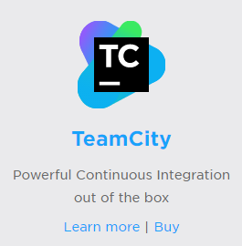

* 1. **Описать целевую аудиторию и основные задачи, которые помогает решить продукт**

Target audience of product is primarily build, QA and test engineers and DevOps engineers, because their tasks closely related to product’s purposes. For example, these are main goals of DevOps:

* maximize the predictability, efficiency, security, and maintainability of operational processes. Very often it is done by automation.
* product delivery, continuous testing, quality testing, feature development, and maintenance releases in order to improve reliability and security and provide faster development and deployment cycles.

All of this could be done by TeamCity, that is built for continuous integration with wide range developer-oriented features. Continuous integration is a development practice that requires developers to integrate code into a shared repository several times a day. Each check-in is then verified by an automated build, allowing teams to detect problems early.

The main tasks of the product that it helps to solve are:

1. Continuous Integration:

* building, checking and running automated tests on the server even before committing your changes;
* tracking different stages of the build and reports all the information on the fly - both in the web UI and in all supported IDEs;
* detecting tests which behave unstable with the same code;
* notifying by multiple ways about build problems or any other changes in your projects;

1. Technology Awareness:

* intelligent CI server: it supports a lot of technologies for Java, .Net, Ruby, XCode and etc. without installing any plugins and with no modifications to build scripts;

1. Cloud Integrations:

* with Amazon EC2, Microsoft Azure, VMware vSphere;

1. Configuration:

* providing several ways to reuse settings by project hierarchy, meta-runner, building chains and dependencies, templates, shared resources and etc.;

1. Code Quality Tracking:

* duplicating code analysis for Java and .NET;
* static code analysis;
* code quality reports right in your IDE;
* code coverage;
* building failure conditions;

1. VCS Interoperability:

* flexible VCS Configuration
* feature branches
* enhanced mercurial support
* advanced VCS build triggering
* file diff and patches
* storing project settings in VCS

1. Build Infrastructure:

* multiple build agents
* agents pool
* build agents statistics

1. Pre-Tested Commit:

* no broken code in your version control. Ever.

1. User Management:

* audit of user actions
* user Authentication
* user groups
* user Roles

1. System Maintenance:

* backup, restore, and projects import
* disk usage report
* build history cleanup
* build time report
* server health reports

1. Extensibility and Customization

**2.** **Подобрать ключевые слова для продвижения продукта на поиске**

Lists of keywords are in [attached excel file](Keywords_MediaPlan.xlsx): Relevant, Brand (TeamСity), Competitors, Remarketing and Negative.

|  |  |
| --- | --- |
| **Group name** | **Description** |
| Relevant | Includes all keywords that are best to target from my point of view. |
| Brand | Keywords that contain “TeamСity”. Not all with this containment was good to target. For example, “TeamСity login”, because it means that user is already ours. So it’s recommended to exclude them from this group. |
| Competitors | Keys that mention our competitors (of course with some exceptions) |
| Remarketing | Includes Relevant + Brand + additional keywords that are too broad in their meaning for being in Relevant group (“ci”) or not as relevant as we want (“continuous integration example”) |
| Negative | Keywords that are not relevant at all. |

**3.** **3 примера рекламных объявлений в Adwords**

Expanded text ads (30-30-80):

|  |  |  |
| --- | --- | --- |
| Headline-1 | Headline-2 | Description |
| Continuous integration tool | Upraise your code quatily | Free continuous integration tool. Download and start your project right now! |
| Continuous integration tool | Performance of the new level | Powerful continuous integration out of the box. Today's top choice. Download! |
| Continuous integration software | Tool with great performance | TeamCity – free continuous integration software. Download it now! |
| {Keyword: Continuous integration tool} | Powerful, unique,high-end tool | 20 build configurations, 3 build agents. Great for small teams and individuals! |

Do NOT use this dynamic ad in group “Competitors”!!!

|  |  |  |
| --- | --- | --- |
| Build automation software | Powerful, unique,high-end tool | Free professional continuous integration software for You. Download now! |

From my point of view, it’s better to test not different ads but unique selling proposition in it. So they have one structure but different USP:

|  |  |  |
| --- | --- | --- |
| Headline-1 | Headline-2 | Description |
| Continuous integration tool | Upraise your code quatily | Free continuous integration tool. Download and start your project right now! |
| Performance of the new level |
| Powerful, unique,high-end tool |

And etc.

You can check character limits on list “Ads” in [attached excel file.](Keywords_MediaPlan.xlsx)

1. **3 (минимум) вида таргетинга для Google Display Network**
   1. Combined targeting (Target and Bid):
      * Custom affinity audience[1]:

continuous integrating,

software testing,

developing,

test-driven development,

github,

integration test tools,

java ci,

c# ci,

net ci,

c++ ci,

python ci,

php ci,

nodejs ci,

xcode ci,

* + - Topics: Computers and Electronics:

-> Programming && Software

* + - Keywords:

continuous integrating;

github;

integration test tools;

java;

ci;

c#;

c sharp;

php;

python;

c++;

nodejs;

* 1. Remarketing_Audience_Visitors (page: /teamcity):
* (Bid Only): all Topics (to exclude if not effective);
  1. Audience_Similar to those, who downloaded TeamCity:
* (Bid Only): all Topics (to exclude if not effective);
  1. Audience_Competitors:
* Custom Audience:

travis-ci.org; jenkins.io; hudson-ci.org; go.cd; cruisecontrol.sourceforge.net;

* (Bid Only): all Topics (to exclude if not effective);
  1. Gmail (with gmail ads only!):
* Site: mail.google;
* Keywords:

continuous integrating; github; java; c#; c sharp; travis ci; go ci; jenkins hudson; jenkins automated build; cruise control ci; cc ci;

* 1. Sites. I guess, if you don’t know that sites to target, the best practice first of all is to check competitor’s audience and referrals on SimilarWeb:
* Travis: github.com; jade-lang.com; npmjs.com; pcsx2.net;
* Jenkins: mybatis-user.963551.n3.nabble.com (I know, it looks like a trash, but who knows!?);
* Hudson: infoq.com; homeservershow.com;
* CruiseControl: trac.edgewall.org;
* (Bid Only): all Topics and Audiences[2] (to exclude if not effective);
  1. Sites_Conversion: contains all sites from other groups (except gmail), which gave conversions (more than 10 – it shows that this site is conversional).
* (Bid Only): all Audiences[3] (to exclude if not effective);

[Another two suggestions are “Selected Display Keywords”[4] targeting and new “Smart Campaign”[5] with automatic targeting and optimization.]

1. **Виды таргетинга по прогнозируемому показателю конверсии (обосновать порядок)**
   1. Remarketing_Audience_Visitors

People, who were on our site, are more likely to download TeamCity after remarketing because their visit shows their interest.

* 1. Audience_Similar to those, who downloaded TeamCity

The similar audiences enable to find people who share characteristics with those, who had already downloaded TeamCity, so these new visitors are probably more interested in product.

* 1. Audience_Competitors

The same thing here, but only with few differences: we know that they *are* our audience, but now they are with our competitor(s). Let’s show them that they have the alternative!

* 1. Gmail

Gmail ad is cheap and very effective, because it looks in every gmail account for keywords that we targeted. Chances for conversion are very high, but traffic won’t be so big.

* 1. Combined: very targeted (Target and Bid)

This target audience is built by common sense. It’s sound good, it promises conversions, but this is only opinion without proper statistic.

* 1. Sites_Conversion

These are all sites that gave us conversion in other groups. Due to the low reach in next few months we won’t get as much conversions as we want from them. Statistic won’t be representing.

* 1. Sites

Like Combined audience it is built mostly by common sense, SimilarWeb and Display Planner.

1. **Медиаплан и прогноз по количеству скачиваний продукта в месяц**

Media Plan is in attached excel file: [Keywords_Media Plan.xls](Keywords_MediaPlan.xlsx)

1. **Методика оценки эффективности кампаний в дальнейшем, возможные пути оптимизации;**

We should monitor campaign’s performance measuring[6] key metrics on:

Campaign level:

* Number of conversions in each campaign
* Cost of each conversion
* Conversion’s rate
* CTR

If something worked not as good as we want, we go to the group level, checking the same things. Then we decide pause or optimize ad group. It depends how critical our statistics is.

For example, if CTR is below the average, we should change ad’s message to make it more relevant. If Conversion’s rate is below 5%, maybe we need to make a new landing or work with usability of the old one.

For unsatisfying cost of conversion, it is recommended to change targeting/make exclusions in it or to pause ad group or even campaign.

As for the number of conversions – it is a good idea to make CPC higher if the it’s possible due to the budget.

Also it is a good practice to make an optimization by automated rules:

Search:

Pause keywords:

* + - 1. Clicks > 100; Conversion rate < 5%, Last 90 days; Everyday
      2. Conversions > 10, Cost of conversion > 2x Average Cost of Conversion, All time; Once a day
      3. Clicks >15, QS < 3, Last 90 days; Everyday;

Enable:

* + - 1. Impressions = 0, Last 30 days; 1-st day of the month.

Bid Management:

* + - 1. Increase: Status = Below First Page; CPC < Cost of Conversion, Same day – 8 times in a day;
      2. Decrease: CPC > Cost of Conversion, Status NOT equal to “Below First Page”, Same day – 8 times in a day;

GDN:

Scripts that exclude sites with:

* 1. Clicks > 100; Conversion rate < 5%, All time;
  2. Conversions > 10, Cost of conversion > 2x Average Cost of Conversion, All time; Once a day
  3. Domains with ‘minecraft’, ‘bitcoin’ and other dumb-names.
  4. **Источники**

<https://www.jetbrains.com/teamcity/features/>

<https://en.wikipedia.org/wiki/Continuous_integration>

<https://en.wikipedia.org/wiki/List_of_build_automation_software>

<https://www.similarweb.com>

<https://en.wikipedia.org/wiki/Comparison_of_continuous_integration_software>

<https://en.wikipedia.org/wiki/DevOps>

**Приложение №1:**

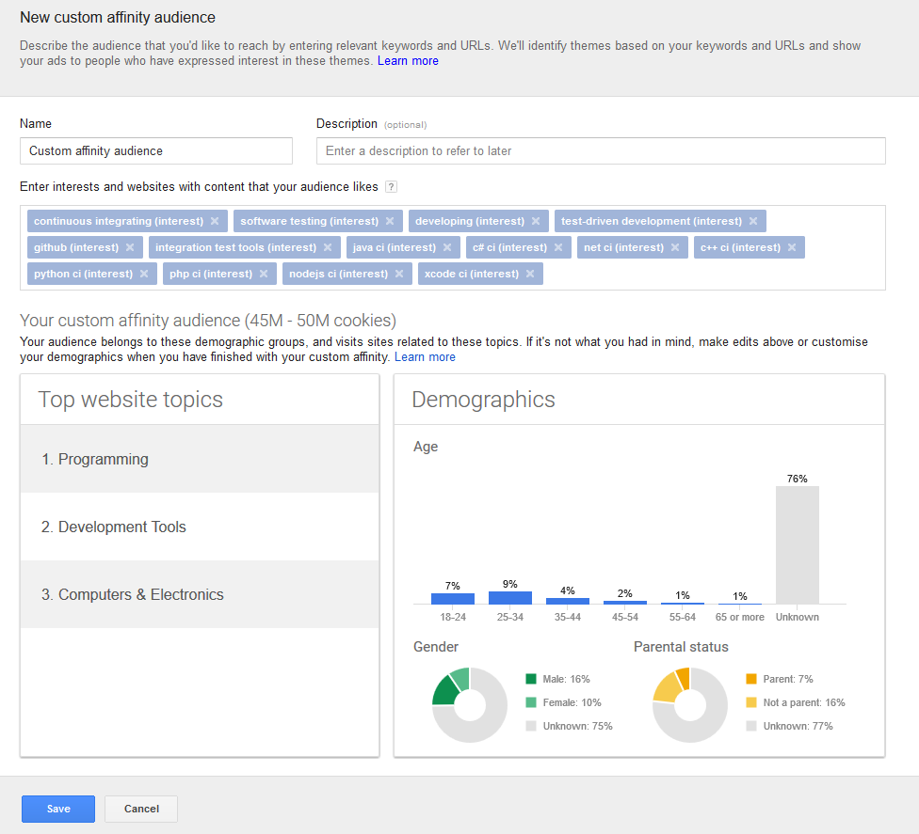

**Приложение №2:**

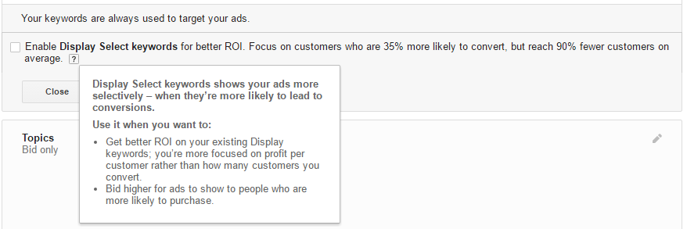

1. Приложение 1
2. With LaL from audiences for remarketing.
3. Same thing.
4. “Display Select keywords shows your ads more selectively – when they’re more likely to lead to conversions.”; “Focus on customers who are 35% more likely to convert, but reach 90% fewer customers on average.” Приложение 2
5. New type of GDN campaign. Ask your official manager from Google for beta.
6. Don’t forget about time scale: statistic must be representative.