A promising new approach to asthma assessment—diagnosis as well as monitoring treatment-
follows 30 years of investigating patients⁹ responses to vigorous exercise.

Asthma diagnosis at the primary and tertiary care levels
relies upon a patient's ability to recognize symptom expe-
rience and communicate it effectively to a physician.
Further, assigning the correct severity to the diagnosis (to
aid in the tailoring of an optimal treatment regimen)
requires the physician's understanding of asthma and inter-
pretation of published guidelines that are largely based on
symptoms.¹
Unlike other chronic diseases in which it is possible to
make a routine diagnosis using a reliable measurement
(such as blood pressure in hypertension or blood sugar in
diabetes melhtus) asthma has as yet no simple diagnostic
test Currently symptoms of asthma and measurement of
lung function (before and after bronchodilator admimstra
tion) are important for asthma diagnosis Symptoms how
ever are not related to the level of airway inflammation
and many asthma patients have normal lung function even
though they have significant airway hyperresponsiveness ³
so that spirometry results alone do not indicate the seven
ty of asthma Further current end points that indicate asth
ma control are the resolution of asthma symptoms and
decreased variability in peak expiratory flow rates
Following treatment however these indices do not neces
sarily reflect the target of the prescribed anti inflammatory
agent airway inflammation
A promising new approach to asthma assessment has
resulted from 30 years of investigating why the asthma
patients airways narrow following vigorous exercise
Exercise induced asthma (E1A) is a physiological response
that can be induced in the majority of people with asth
ma ⁵ Over the past 30 years it has been elucidated that the
primary cause of narrowing of the asthma patients airways
following exercise is loss of water through conditioning
large volumes of air in a short time This water loss caus
es an increase in the osmolarity of the airway surface
Inflammatory cells (for example mast cells and
eosmophils) release potent bronchoconstrictmg mediators
in the presence of an osmotic stimulus These act on the
bronchial smooth muscle causing airways to narrow
(Figure 1 page 30) Thus active asthma can be identified
based on a positive response to a standardized exercise
challenge test Exercise testing requires sophisticated
equipment and a source of dry air however there are now
alternative methods that are simpler safer less expensive
and less time consuming to perform Such tests are prom
ismg in that they appear to provide an indirect measure of
airway inflammation The tests include inhaling a fine wet

RT- Interna

MANNITOL
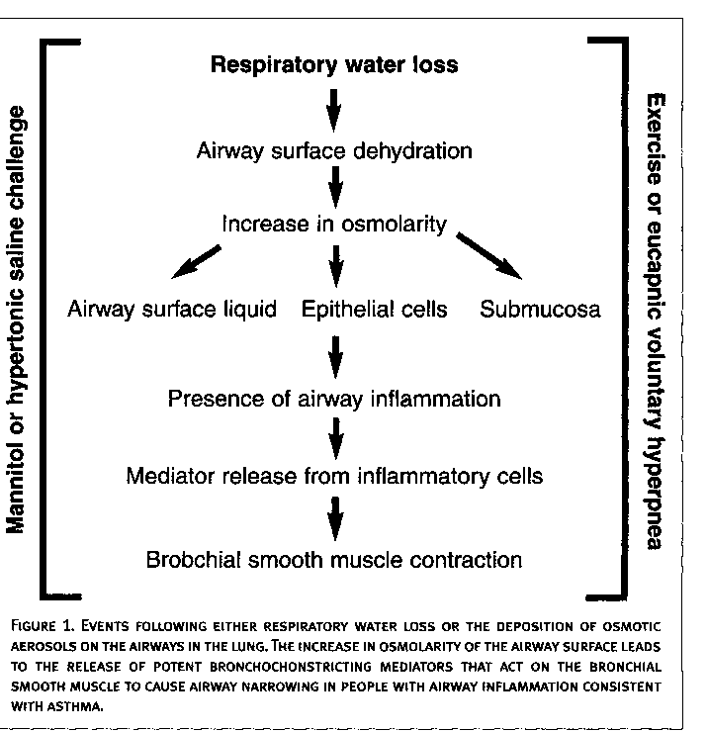
aerosol of hypertonic (4.5%) saline or an
aerosolized, dry-powder preparation of
mannitol. Further, as the presence of air-
way inflammation is an important deter-
minant of the airway response to these
tests, they can be used to monitor
improvement during anti-inflammatory
treatment.
Historical Development
Early investigations into the mechanism of
EIA began in children in whom there was a
need for an objective measurement of asth-
ma severity. Symptom-based assessment of
asthma in children was difficult; this led to
the development of a standardized exercise
protocol using a treadmill. The major
determinants of the airway response were
found to be both the intensity and dura-
tion of exercise. ' Further investigation
began to reveal that heat and water loss
from the airway during exercise were
important determinants of the severity of
the airway response to exercise. Water loss
from the airways could be increased by
altering the intensity of the exercise and the
water content of the inspired air.
It was realized in the early 1970s that
exercise was not essential to cause airway
narrowing. In the early 1980s, a bronchial
provocation challenge test using eucapnic
voluntary hyperpnea (EVH) was developed
and standardized.¹⁰ EVH and exercise pro-
duced a similar degree of bronchoconstric-
tion in people with asthma. Not only was
this an important finding, but the stan-
dardization of this test permitted identifica-
tion of active asthma using a technique that
was easier to perform than exercise. This
test was recently recommended by the
International Olympic Committee-Medical
Commission Independent Panel for assess-
ing the use of b₂-agonists at the Winter
Olympics held in Salt Lake City.¹¹
The observation that inhalation of hot,
dry air could cause severe EIA caused
Anderson,¹² working in Australia, to
hypothesize that water loss from the air-
way surface increases the osmolarity of the
airway surface fluid, an event causing
mediator release. Osmolarity, Anderson
suggested, was the stimulus that caused the
airways to narrow, rather than airway cool-
ing. This important hypothesis was
strengthened by a number of in vitro stud-
ies of mast cells by Eggleston et al.¹³ They
demonstrated that mast cells released their
mediators in response to changes in osmo-
larity. They reported that an increase in
osmolarity led to the release of the hista-
mine from these cells. Based on these and
other observations, and further investiga-
tion, diagnostic tests using aerosols of
hypertonic saline to identify people with
active asthma were developed.¹⁴ These
osmotic tests are currently used effectively
and safely in hospital laboratories through-
out Australia. The hypertonic saline test
further simplified the administration of
testing for asthma and improved the safety
of such testing. The tests are still confined
to pulmonary function laboratories. In an
effort to liberate testing from such an envi-
ronment and to simplify the administration
of this stimulus, a preparation of mannitol
has been developed that can be adminis-
tered using a simple dry-powder inhaler.
Because mannitol mimics the airway
response to exercise, it has become a very
valuable research tool.
Identifying Inflammation
The protocol used for bronchial provoca-
tion testing with osmotic aerosols has a
dose-response design, similar to that of
the protocol used to administer pharma-
cological agents such as methacholine.
The response is measured using forced
expiratory volume in 1 second (FEV₁) and
the end point is the dose required to cause
a certain fall (usually 15% or 20%) in
FEV1. The result is expressed as the pro-
voking dose (Figure 2, page 31). The
advantage of a dose-response curve is that
the decrease in FEV} can be controlled.
Mannitol is prepared especially for inhala-
tion and is encapsulated. It is delivered
using a simple, commercially available
inhaler. Patients are asked to inhale
sequential doses of mannitol consisting of
an empty capsule (acting as a placebo), 5
mg, 10 mg, 20 mg, 40 mg, 60 mg, 160
mg, 160 mg, and 160 mg of mannitol. The
larger doses are administered as multiple
doses of 40-mg capsules. At least two
repeatable FEV1 maneuvers are performed
60 seconds after each dose, and the high-
est FEV1 is recorded. The challenge is fin-
ished when a 15% fall in FEV1has been
documented or a cumulative dose of 635
mg has been administered. Some patients
cough after inhalation of mannitol, but
this has rarely affected the test (and may
provide useful information about another
aspect of asthma symptoms).
Mannitol is effective at identifying sub-
jects with asthma who are also responsive
to hypertonic saline, EVH, and exer-

30 RT- International
Fall • 2003

Cumulative dose of mannitol (mg)
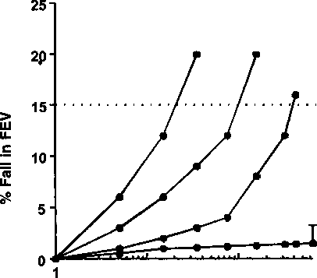
Severe Moderate Mild
<35 mg <155 mg >155 mg
Normal
635
100
10
else.³ ¹⁵ ¹⁶ Mannitol also identifies both
adults and children with currently active
asthma who are responsive to metha-
choline, as well as others who are not
responsive.¹⁵¹⁷'¹⁸ The mannitol challenge
demonstrates good repeatability in both
adults and children, and responses are
rapidly reversible using a standard dose of
a bronchodilator.¹⁵
Pharmacological agents known to be
effective in the treatment of asthma have
contributed greatly to the understanding
of airway narrowing due to mannitol and
figure 2. classification of the response to a dry powder of mannitol delivered using
capsules. the severity of the response is based on the cumulative dose of mannitol
REQUIRED TO PROVOKE A 15% REDUCTION IN FORCED EXPIRATORY VOLUME IN 1 SECOND (FEVJ. THE
MEAN MAXIMUM RESPONSE (+2 STANDARD DEVIATIONS) IN FEV_{a} AFTER A CUMULATIVE DOSE OF 635 MG
IS SHOWN FOR HEALTHY SUBJECTS.
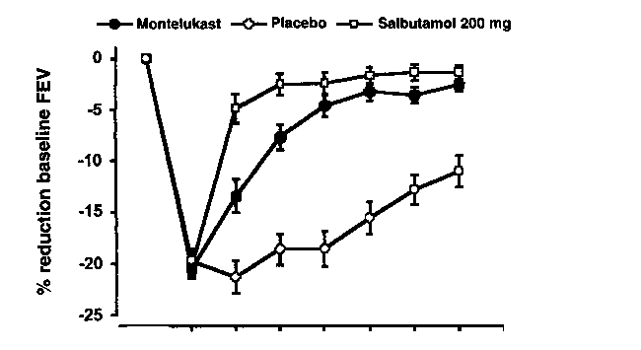
0 5 10 15 20 25 30
Time following mannitol challenge (minutes)
figure 3. percent reduction from baseline forced expiratory volume in 1 second
(mean±sem) and spontaneous recovery in 19 subjects for 30 minutes following challenge
with inhaled mannitol after the administration of montelukast or placebo. following the
mannitol challenge on the control day, subjects recovered using 200 mg of salbutamol.
its relevance to the diagnosis of asthma.
For example, corticosteroids, known to
decrease the number of airway inflamma-
tory cells when given by inhalation,
markedly decrease airway responsiveness
to mannitol.¹⁹ As mast cells and
eosinophils decrease, the concentration of
mediators also decreases; the airways may
become less responsive (or even unre-
sponsive) simply because there are not
enough cells or mediators. Mannitol
response correlates with the symptoms and
signs of EIA, suggesting that a negative
MANNITOL
response to mannitol may be a useful end
point signifying adequate asthma control.
Nedocromil sodium is known to inhibit
the release of bronchoconstricting media-
tors and to reduce sensory nerve activation.
This agent can inhibit the airway response
to mannitol,²⁰ ²¹ just as it can inhibit the
response to exercise. It is thought that the
mediators released by inflammatory cells in
the presence of mannitol are prevented
from being released by the direct action of
nedocromil on the surface of the inflam-
matory cells, possibly at a volume-regulated
channel activated by changes in osmolarity
To understand the involvement of indi-
vidual mediators, investigators studied the
effects of fexofenadine and montelukast.²²
It was found that fexofenadine was effective
in decreasing airway sensitivity to manni-
tol, but montelukast resulted in no change
in airway sensitivity, although its use result-
ed in a rapid recovery of lung function
(Figure 3). These findings suggest that
mast cells are likely to be involved in the
response. Histamine, a preformed media-
tor, is released initially, while newly synthe-
sized mediators (such as the leukotrienes)
help sustain the airway response to manni-
tol. This profile of mediator release appears
similar to that seen in response to exer-
cise. ' More recently, direct evidence for
the presence of these mediators in the
response to mannitol has been found. An
increase in urinary excretion of leukotriene
E4 and a metabolite of prostaglandin D2, a
mediator specific to the mast cell, was
measured following a mannitol challenge.
The same mediators have also been found
to increase in asthma patients following
exercise. Future research will, no
doubt, increase understanding of the simi-
larities between these two stimuli and the
relative role of mediators in airway
response. •
John D. Brannan, PhD, is a research fellow,
Department of Respiratory Medicine, Royal
Prince Alfred Hospital, Sydney, Australia,
and is supported by the National Health &>
Medical Research Council of Australia.
Acknowledgements
The use for mannitol described in this
study is covered in the United States by
patent number 5,817,028 and i.nterna.tion
ally by PCT/AU95000086. The patent is owned by the Central Sydney Area Health Service and has been licensed to an Australian company.

Fall • 2003

MANNITOL

(continued from page 31)
References
1. Global Initiative for Asthma. Global strategy for
asthma management and prevention. In: US
Department of Health and Human Services.
' NHLBI/WHO Workshop Report. Bethesda, Md:
Medical Communications Resources; 1995:1-8.
- Gibson PG, Wlodarczyk J, Hensley MJ, et al.
Epidemiological association of airway inflamma-
tion with asthma symptoms and airway hyperre-
sponsiveness in childhood. Am J Respir Crit Care
Med. 1998;158:36-41.
- Holzer K, Anderson SD, Chan H-K, Douglass J.
Mannitol as a challenge test to identify exercise-
induced bronchoconstriction in elite athletes. Am
J Respir Crit Care Med. 2003;167:534-547.
4. Sont JK, Han J, van Krieken JM, et al.
Relationship between the inflammatory infiltrate
in bronchial biopsy specimens and clinical sever-
ity of asthma in patients treated with inhaled
steroids. Thorax. 1996;51:496-502.
5. Anderson SD, Silverman M, Konig P, Godfrey S.
Exercise-induced asthma. A review. BrJ Dis Chest.
1975;69:1-39.
- Anderson SD, Daviskas E. The mechanism of
exercise-induced asthma is .... J Allergy Clin
Immunol. 2000;106:453-459.
- Anderson SD, Brannan JD. Methods for 'indi-
rect' challenge tests including exercise, eucapnic
voluntary hyperpnea and hypertonic aerosols.
Clin Rev Allergy Immunol. 2003;24:63-90.
- Silverman M, Anderson SD. Standardization of
exercise tests in asthmatic children. Arch Dis
I Child. 1972;47:882-889.
9. Anderson SD, Schoeffel RE, Follet R, Perry CP,
Daviskas E, Kendall M. Sensitivity to heat and
water loss at rest and during exercise in asthmat-
ic patients. Eur J Respir Dis. 1982;63:459-471.
10. Phillips YY, Jaeger JJ, Laube BL, Rosenthal RR.
Eucapnic voluntary hyperventilation of com-
pressed gas mixture. A simple system for
bronchial challenge by respiratory heat loss. Am
Rev Respir Dis. 1985;131:31-35.
- Anderson SD, Fitch K, Perry CP, et al.
Responses to bronchial challenge submitted for
approval to use inhaled beta₂ agonists prior to an
event at the 2002 Winter Olympics. J Allergy Clin
Immunol. 2003;111:4"49-
- Anderson SD. Is there a unifying hypothesis
for exercise-induced asthma? J Allergy Clin
Immunol. 1984;73:660-665.
- Eggleston PA, Kagey-Sobotka A, Proud D,
Franklin-Adkinson K, Lichtenstein L.
Disassociation of the release of histamine and
arachidonic acid metabolites from osmotically
activated basophils and human lung mast cells.
Am Rev Respir Dis. 1990;141:960-964.
- Anderson SD, Smith CM. Osmotic challenges
in the assessment of bronchial hyperresponsive-
jiess. Am Rev Respir Dis. 1991;143:543-546.
- Anderson SD, Brannan J, Spring J, et al. A new
method for bronchial-provocation testing in asth-
matic subjects using a dry powder of mannitol.
Am J Respir Crit Care Med. 1997;156:758-765.
- Brannan JD, Koskela H, Anderson SD, Chew N.
Responsiveness to mannitol in asthmatic sub-
jects with exercise- and hyperventilation-induced
asthma. Am J Respir Crit Care Med. 1998;
158:1120-1126.
- Subbarao P, Brannan JD, Ho B, Anderson SD,
Chan H-K, Coates AL Inhaled mannitol identifies
methacholine-responsive children with active
asthma. PediatrPulmonol. 2000;29:291-298.
- Holzer K, Anderson SD, Douglass j. Exercise in
elite summer athletes: challenges for diagnosis, y
Allergy Clin Immunol. 2002;110:374-380.
- Brannan JD, Koskela H, Anderson SD, Chan H-
K. Budesonide reduces sensitivity and reactivity
to inhaled mannitol in asthmatic subjects.
Respirology. 2002;7:37-44.
- Brannan JD, Anderson SD, Freed R, Leuppi JD,
Koskela H, Chan H-K. Nedocromil sodium inhibits
responsiveness to inhaled mannitol in asthmatic
subjects. Am J Respir Crit Care Med. 2000;
161:2096-2099.
21. Spooner C, Rowe BH, Saunders LD.
Nedocromil sodium in the treatment of exercise-
induced asthma: a meta-analysis. Eur Respir J.
2000;16:30-37.
- Brannan JD, Anderson SD, Gomes K, King GG,
Chan H-K, Seale JP. Fexofenadine decreases sen-
sitivity to and montelukast improves recovery
from inhaled mannitol. Am J Respir Crit Care Med.
2001;163:1420-1425.
- Patel KR. Terfenadine in exercise-induced
asthma. BMJ. 1984;85:1496-1497.
- Kemp JP, Dockhorn RJ, Shapiro GG, et al.
Montelukast once daily inhibits exercise-induced
bronchoconstriction in 6- to 14-year-old children
with asthma. J Pediatr. 1998;133:424-428.
- Brannan JD, Gulliksson M, Anderson SD, Chew
N, Kumlin M. Evidence of mast cell activation and
leukotriene release after mannitol inhalation. Eur
Respir J. In press.
- Reiss TF, Hill JB, Harman E, et al. Increased
urinary excretion of LTE4 after exercise and atten-
uation of exercise-induced bronchospasm by
montelukast, a cysteinyl leukotriene receptor
antagonist. Thorax. 1997;52:1030-1035.
- O'Sullivan S, Roquet A, Dahlen B, Dahlen S-E,
Kumlin M. Urinary excretion of inflammatory
mediators during allergen-induced early and late
phase asthmatic reactions. Clin Exp Allergy.
1998;228:1332-1339.

