И. В. Лещенко
НОВЫЕ НАПРАВЛЕНИЯ В КЛАССИФИКАЦИИ, ДИАГНОСТИКЕ И ЛЕЧЕНИИ ХРОНИЧЕСКОЙ
ОБСТРУКТИВНОЙ БОЛЕЗНИ ЛЕГКИХ
Уральская государственная медицинская академия, Екатеринбург
Ключей ы е слова : обзор, хроническая обструктивная болезнь легких, классификация, диагностика, лечение
Key words' review, chronic obstructive pulmonary disease, classification, diagnosis, treatment

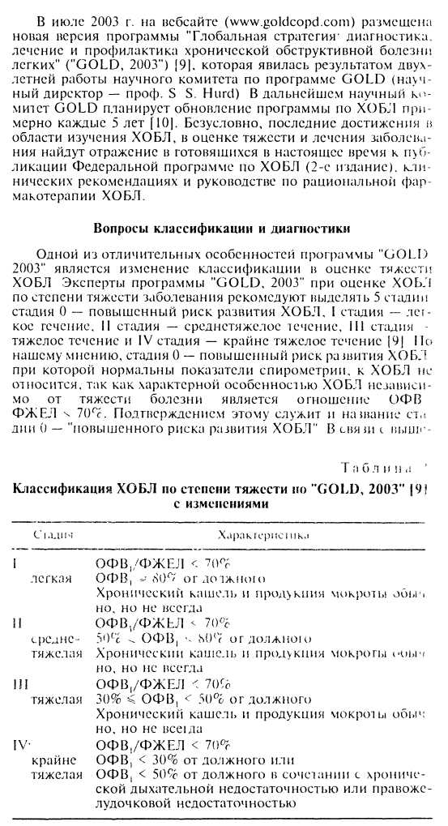
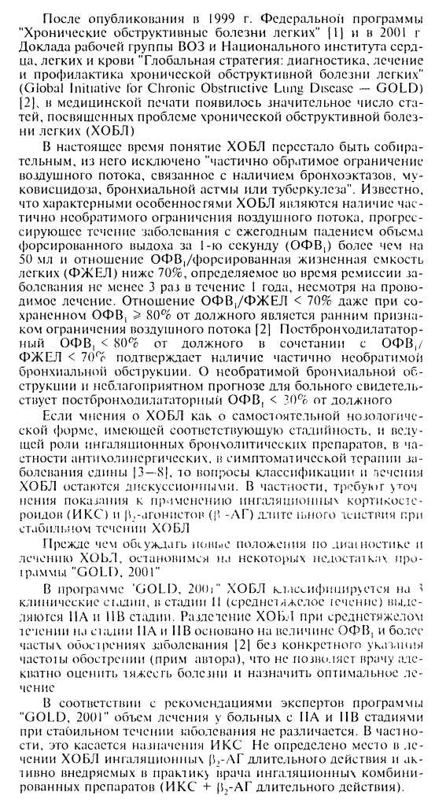

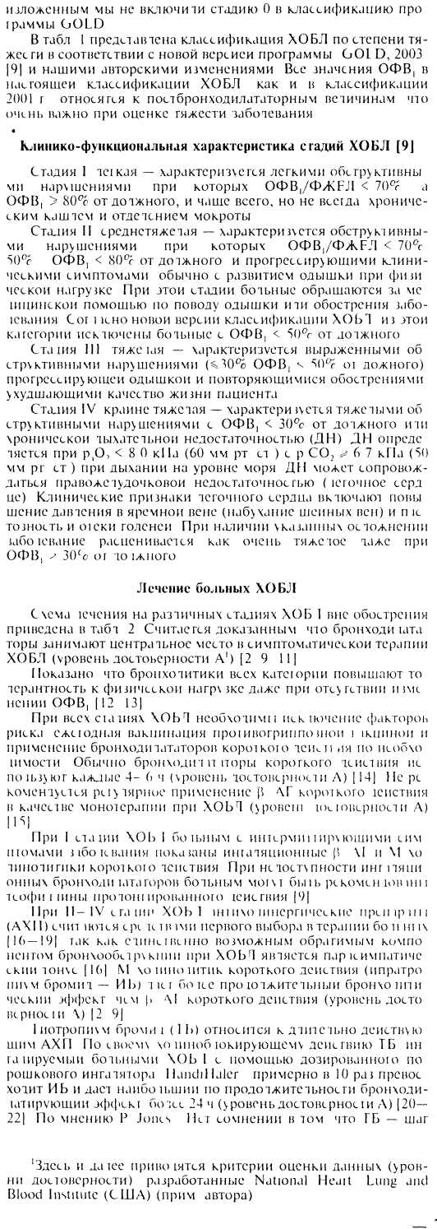
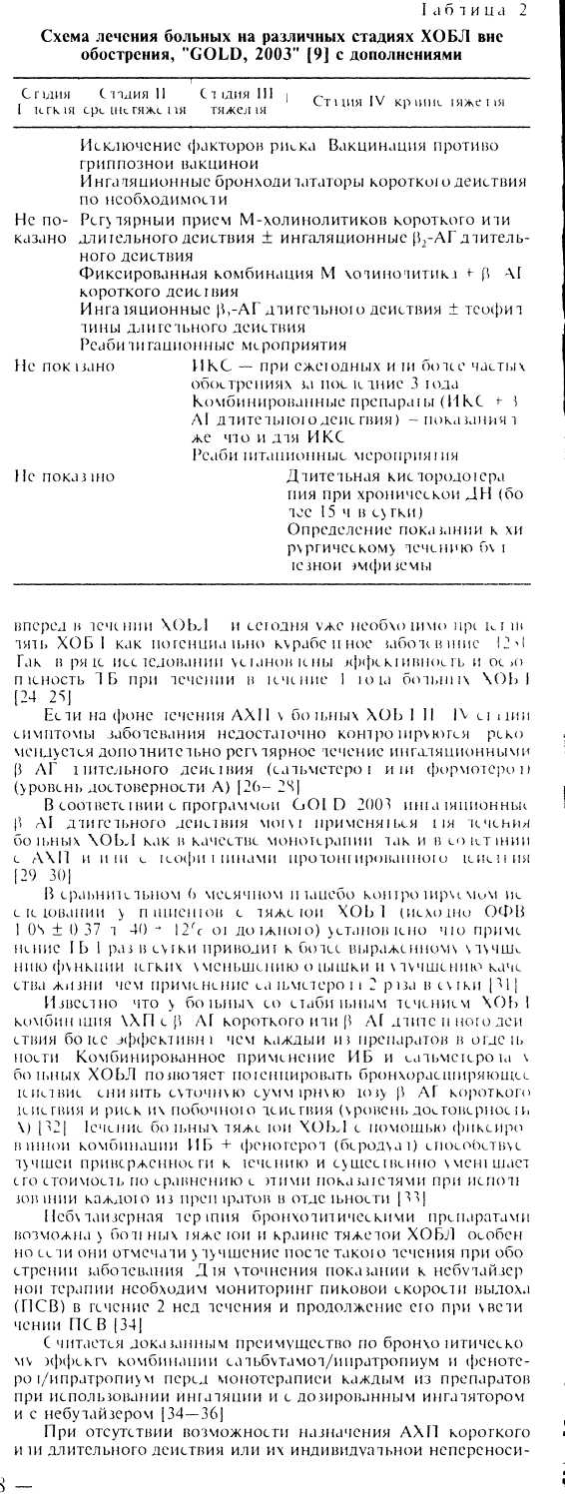
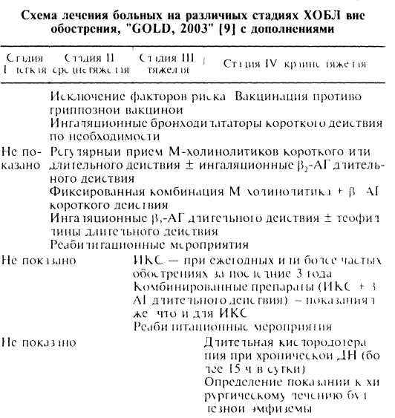
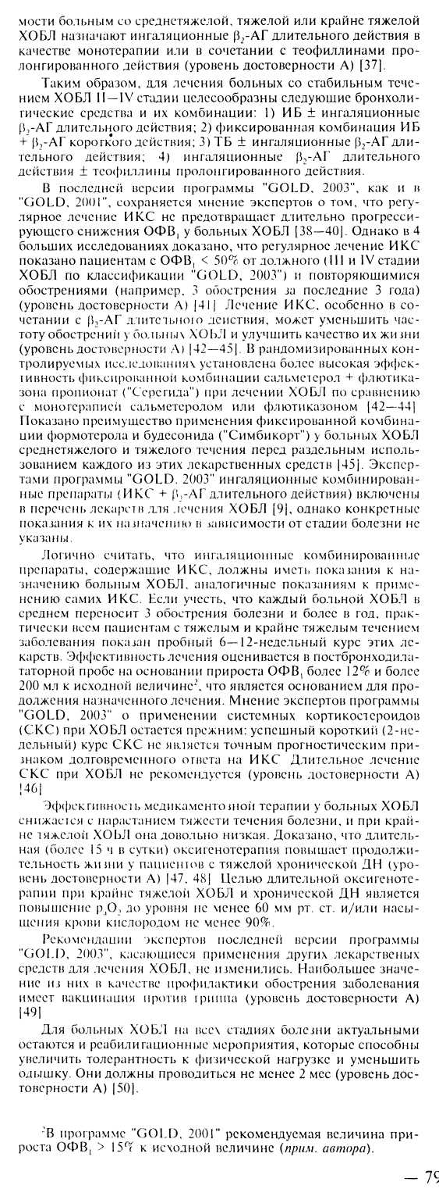
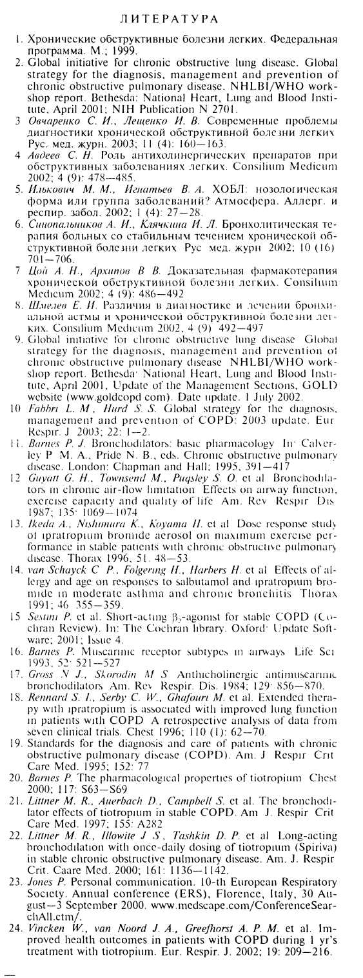

- Casaburi R., Mahler D. A., Jones P. W. et al. A long-term eval
uation of once-daily inhaled tiotropium in chronic obstructive
pulmonary disease. Eur. Resp. J. 2002; 19: 217-224.

- Ulrik С S. Efficacy of inhaled salmeterol in the management
of smokers with chronic obstructive pulmonary disease: a sin
gle center randomized, double blind, placebo controlled, cross
over study. Thorax 1995; 50: 750-754.
- Boyd G., Мог ice A. H., Pounsford J. C. et al. An evaluation of
salmeterol in the treatment of chronic obstructive pulmonary
disease (COPD). Eur. Respir. J. 1997; 10: 815-821.
- Rossi A., Kristufec K.} Levine В. E. et al. Comparison of the ef
ficacy, tolerability and safety of formoterol dry powder and
oral, slow-release theophylline in the treatment of COPD.
Chest 2002: 121: 1058-1069.
- Mahler D. A., Donohue J. E., Barbee R. A. et al. Efficacy of
salmeterol xinafoate in the treatment of COPD. Chest 1999;
115: 957-965.
- Dahl R., Greefhorst L. A., Nowak D. et al. Inhaled formoterol
dry powder versus ipratropium bromide in chronic obstructive
pulmonary disease. Am. J. Respir. Crit. Care Mcd. 2001; 164:
778-784.
- Donohue J. F., van Noord J. A., Bateman ED. et al. A 6-
month, placebo-controlled study comparing lung function and
health status changes in COPD patients treated with tiotro
pium or salmeterol. Chest 2002; 122: 47—55.
- van Noord J. A., de Munck D. A., Bantje T. A. et al. Long-term
treatment of chronic obstructive pulmonary disease with salm
eterol and the additive effect of ipratropium. Eur. Respir. J.
2000; 15: 878-885.
- Hilleman D. E., Dewan N., Malesker M. et al. Pharmacoeco-
nomic evaluation of COPD. Chest 2000: 118' 1278-1285.
- Tashkin D P.. Bleecker E., Braun S. et al. Results of multi
combination in chronic obstructive pulmonary disease center
study of nebulized inhalant bronchodilator solutions. Am. J.
Med. 1996; 100: 62-69.
- The COMBIVENT inhalation solution study group. Routine
nebulized ipratropium and albuterol together are better than
either alone in COPD. Chest 1997; 112: 1514-1521.
- Gross N., Tashkin D. P., Miller R. et al. Inhalation by ncbuli-
zation of albuterol—ipratropium combination (Dey combina
tion) is superior to either agent alone in the treatment of
chronic obstructive pulmonary disease. Dey combination solu
tion study group. Respiration 1998; 65: 354—362.
- ZuWollack R. L, Mahler D. A., Re illy D. et al. Salmeterol plus
theophylline combination therapy in the treatment of COPD.
Chest 2001; 119: 1661-1670.
- Vestbo J., Sorensen Т., Lange P. ct al. Long-term effect of in
haled budesonide in mild and moderate chronic obstructive
pulmonary disease: a randomized controlled trial. Lancet 1999;
353: 1819-1823.

- Pauwels R. A., Lofdahl С G._{f} Laitinen L. A. et al. Lo
treatment with inhaled budesonide in persons with mild
ic obstructive pulmonary disease who continue smoking
pean Respiratory Society Study on Chronic Obstruct!
monary Disease. N. Engl. J. Med. 1999; 340: 1948—19.
- Burge P. S., Calverley P. M., Jones P. W. et al. Ranch
double blind, placebo controlled study of fluticasone p
ate in patients with moderate to severe chronic obstruct
monary disease: the ISOLDE trial. Br. Med. J. 200
1297-1303.
- Jones P. W., WiUits L. R., Burge P. S. et al. Disease
and the effect of fluticasone propionate on chronic obs
pulmonary disease exacerbations. Eur. Respir. J. 2003; 2
73.
- Calverley P. M., Pauwels R._{t} Vestbo J. et al. Combined
terol and fluticasone in the chronic obstructive pulmont
ease: a randomized controlled trial. Lancet 2003; 361
456.
- Mahler D. A., Wire P., Horstman D. et al. Effectiveness
ticasone propionate and salmeterol combination dehve
the diskus device in the treatment of chronic obstructs
monary disease. Am. J. Respir. Crit. Care Mcd. 2002: I
1084-1091.
44 Lyseng-Williamson K. A., Keating G. Inhaled salmetero casone propionate combination in chronic obstructive p nary disease. Am. J. Respir. Med. 2002; 1 (4): 273—283.
- Szafranski W., Cukier A., Ramirez A. et al. Efficacy and
of budesonide/formoterol in the management of chron
structive pulmonary disease. Eur. Respir. J. 2003; 21: 74-
- Rice K. L._{t} Rubins J. В., Lebahn F. et al. Withdrawal of с
ic systemic corticosteroids in patients with COPD: a
omized trial. Am. J. Respir. Crit. Care Med. 2000; !62:
178.
- American Thoracic Society. Standards for the diagnosi
care of patients with chronic obstructive pulmonary di
Am. J. Respir. Crit. Care Med. 1995; 152: S77-S12L
- Siafakas N. A/., Vermeire P., Pride N. B. et al Optimal a
ment and management of chronic obstructive pulmonar
ease (COPD). A consensus statement of the European Ь
ratory Society (ERS) Eur. Respir. J. 1995; 8: 1398-1421
- Nichol K. L., Margolis K. L., Wuorenma J., Von Stemhi
The efficacy and cost effectiveness of vaccination against
enza among elderly persons living in the community. N
J. Med. 1994; 331: 778-784.
- Berry M. J., Rejeski W. J., Adair N. E., Zaccaro D. Exerci:
habilitation and chronic obstructive pulmonary disease <
Am. J. Respir. Crit. Care Med. 1999; 160: 1248-1253.
iiocrymna S

