Key points
1 An exercise test should be performed: if there is impaired exercise tolerance; to |find out which system is limiting exercise; to establish which organ systems have an abnormal response during or after exercise; to investigate how much exercise is appropriate/safe in a patient; and to determine the response to treatment.
1 Prediction of exercise performance based solely on resting pulmonary function tests is inaccurate.
1 The gold standard in exercise testing is the incremental exercise test.
1 Two types of ergometers can be selected for incremental exercise testing: a treadmill or a cycle ergometer. More muscle mass is put to work using a treadmill when compared with cycling.
1 Incremental exercise testing and field
testing have complementary value in, for '
example, pulmonary rehabilitation.
1 Exercise laboratories should be encouraged to test some healthy control subjects in the age span of interest to evaluate which normal values best suit their laboratory setting.

Exercise testing: why, which and how to interpret
R. Gosselink T. Troosters M. Decramer

Educational aims
To address some questions that often arise when exercise testing is performed in the clinical routine: 1 What are the indications to perform an exercise test? I Which test should be used for which situation? I How should the test be carried out in practice? 1 How should the results of the test be interpreted?
Summary
Exercise testing is widely applied in clinical practice. The aim of this article is to address some questions that often arise when exercise testing is performed in clinical routine. Two complementary tests will be discussed in more detail: the maximal incremental ergometer test and the timed walk test
First, the indication to perform exercise testing is discussed. The second question is which test to apply and how to carry out the test in practice. Finally, the interpretation of the results of the tests are discussed.
Respiratory Rehabilitation and Respiratory Division, University Hospitals, and Faculty of Physical Education and Physiotherapy, Katholieke Universiteit Leuven, Leuven, Belgium.
Correspondence:
R. Gosselink
Professor of Respiratory
Rehabilitation
Respiratory Rehabilitation
Division
University Hospital Gasthuisberg
Herestraat 49
B-3000 Leuven
Belgium
Fax: 32 16346866
E-mail:
nk.gosselink@uz. kuleuven. ac. be

Is exercise testing useful?
When deciding to carry out an exercise test, the reason(s) for doing it should be specified and, in addition, the appropriate type of exercise test and protocol should be chosen.
Exercise tests are performed in patients in order to establish whether exercise capacity is impaired, to investigate the underlying cause of the limitation and to establish the risks of exercise. In addition, dyspnoea during exercise is a frequent reason to perform an exercise test. Evidence suggests that symptoms such as dyspnoea, impaired exercise tolerance and reduced quality of life, common experiences in patients with chronic respiratory disease, have only a weak correlation with lung function impairment (figure 1) [1 ], and that prediction
of exercise performance based solely on resting pulmonary function tests is inaccurate [3-5].
Exercise testing can be performed in order to obtain a specific diagnosis [e.g. exercise-
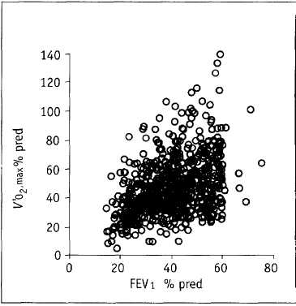
Figure 1
Relationship between pulmonary function (forced expiratory volume in one second (FEVi)) and exercise capacity (maximal oxygen uptake (V'o₂,max)) in patients with chronic obstructive pulmonary disease. Figure modified from [2].

induced asthma), to answer particular questions concerning working capacity (employment) or to a predict a level of risk (i.e. operability for lung resection, survival). In many diseases, including chronic obstructive pulmonary disease (COPD), primary pulmonary hypertension and cystic fibro-sis, exercise tolerance has been shown to be one of the most important predictors of mortality or morbidity. Finally, exercise testing can be used to quantify objective gains after interventions, for example after medication, surgical procedures or rehabilitation.
If a specific question is being asked, clinicians may use complex exercise tests that can accurately measure pulmonary gas exchange and aspects ofthecardiocirculatory and muscular systems, or they may prefer more simple, yet useful, tests to answer clinical questions. Maximal incremental exercise tests may be required in the first case, whereas field walking tests may suffice in the latter.
Which tests are available and how should the appropriate test be chosen?
Incremental exercise testing
The gold standard in exercise testing is the incremental exercise test. Incremental exercise testing is the first choice for the following: assessing impaired exercise capacity, investigating factors limiting exercise performance, or assessing the risks of participating in exercise programmes or prescribing exercise training. For all these indications, incremental exercise testing is needed to provide clinicians with key data that cannot be obtained from resting measures of pulmonary function, cardiac function, blood gases or other exercise tests. The introduction of computerised breath-by-breath equipment has made incremental exercise testing available in most clinical settings [6], and, subsequently, standardised maximal exercise tests have been developed [7-9]. In addition, the estimation of peak exercise responses based upon submaximal exercise data (mainly heart rate (HR)) is inappropriate in COPD patients, since these patients often do not reach their maximal HR.
Two types of ergometer can be used for
incremental exercise testing: a treadmill ora cycle ergometer. When a motor-driven treadmill is used, increasing the speed and/or inclination imposes the external workload, and this workload is dependent on body weight. Factors such as walking efficiency (depending on footwear, length of the lower limb and training status on treadmills) and the use of arm support may have an unpredictable influence on the oxygen uptake (Vo₂) profile during treadmill testing. However, compared with cycling, walking is a more natural movement and less lactate is produced at iso-Vo₂. Treadmill walking is generally advised for paediatric exercise testing. When a cycle ergometer is used, the workload is better controlled and the external work needed is less dependent on body weight as compared with the treadmill. The unloaded cycling Vo₂ is dependent on the weight of the lower limbs; however, when a load is added, the Vo₂ will increase further, independent of body weight(«10 mLmin^W¹). In addition, cycle ergometry, unlike treadmill ergometry, allows the investigator to compare patients' responses to iso-submaximal work and permits a more clear insight into mechanical efficiency. The stability of the patient on a bicycle results in less noise on electrocardiography (ECC) and blood pressure recordings. Arterial and venous catheters can also be accessed more easily on a cycle ergometer when compared with a treadmill. If a cycle ergometer is going to be used for exercise testing, it should be electromagnetically braked and the workload should be adjustable in steps of 5-1OW.
Field tests
Field tests, such as the 6- or 12-minute walk test (6- or 12MWT), shuttle walk test (SWT) or constant workload endurance test, are used to investigate the effects of interventions that alter submaximal or endurance exercise capacity, for example in respiratory rehabilitation [6]. The outcome of these walk tests is able to more closely mimic the functional abilities needed in everyday life [10]. It has been reported that field tests are performed in -80% of the rehabilitation programmes in the USA [11]. Although patients are free to change their speed during a timed walk test, they generally maintain a very stable speed [12], which results in a steady-state Vo₂ and a walking speed that represents the critical walking speed (i.e. thespeed that can be maintained) [13]. This property may make the test sensitive to changes due to interventions improving the critical power (i.e. exercise training).
A combination
Incremental exercise testing and field testing have complementary value in areas such as pulmonary rehabilitation [14]. Prior to participation in a respiratory rehabilitation programme, maximal exercise performance has to be established for the diagnosis of impaired exercise capacity to be made, the identification of factors limiting exercise performance and the prescription of exercise training. However, during follow-up, valuable clinical information can be obtained from constant work rate tests or walk tests. Field exercise tests, such as the 6- or 12MWT [3], the shuttle run test, the SWT [15] and the step test, are easy to perform and are valid, as they are more related to activities of daily living [16]. For some of these tests, however, lack of reference values and the absence of physiological measures are important limitations. In healthy subjects, a fairly good correlation with maximal Vo₂ (Vo₂,max) is observed, although it is not good enough to predict Vo₂,max in individual subjects [17-19].
Incremental exercise testing
An incremental exercise test consists of baseline measurements lasting at least 2-3 minutes, then a warm-up period of 3 minutes unloaded work, followed by the incremental part of the exercise test. The choice of an adequate increment size is one of the important steps in tailoring a test to each individual patient Ideally, peak work rate should be reached within 8-12 minutes. Work rate increments have important consequences when the exercise results are to be used for exercise prescription in a pulmonary rehabilitation programme. Workload increment size does not affect \Zo₂,max, ventilation or HR, but results in significant differences in maximal workload [20]:
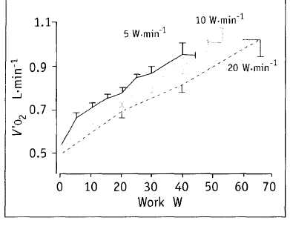
protocols with larger increments result in a higher peak workload (figure 2). Consequently, this may impact on the exercise prescription, as it is frequently based on peak work rate.
After peakexercise is reached, patients should continue cycling at very low work rate levels to avoid sudden drops in blood pressure due to pooling of venous blood. When patients are tested consecutively, the increment size should be kept identical.
Measurements
In clinical practice, the measurements taken include the following: work rate, 12-lead ECC, blood pressure, pulmonary gas exchange (Vo₂ and carbon dioxide production (Vco₂)), ventilation, transcutaneous oxygen saturation and symptom scores. When arterial blood gases are available at rest and peak exercise, most clinical problems regarding exercise limitation can be addressed. Standardisation and technical procedures for reproducible exercise testing have been described in a recent American Thoracic Society (ATS)-American College of Chest Physicians (ACCP) document [6]. Overthe last 15 years it has become more routine to have specially trained non-physicians (physiologists, physiotherapists and technicians) conducting exercise tests, with a consultant immediately avalible for consulation or emergency situations [21]. Symptom scores for dyspnoea and exertion have also been shown to be valuable tools during exercise testing. Visual analogue scales and Borg scales cannot be interchanged, but both show good agreement and, hence, are valid tools for evaluating symptoms of dyspnoea and perceived exertion [22]. Variables at submaximal exercise and at peak exercise are integrated to answer questions on exercise capacity, safety of exercise and limitation of exercise, and specific questions, such as exercise prescription.
How to interpret the maximal exercise test
The main outcome of the maximal exercise test is Vo₂,max, standardised per kilogram of body weight. Alternatively, comparison with reference values allows the level of exercise impairment to be judged. The European Respiratory Society (ERS) report on exercise impairment in patients with respiratory disease [23] describes two equations used as reference values for V/o₂,max. The equation of Jones et al. [24] seems useful in clinical practice for cycle ergometry (table 1). Exercise laboratories should be encouraged to
Figure 2
Exercise protocols for incremental exercise testing. Reproduced with permission from [20].

test some healthy control subjects in the age span of interest to evaluate which normal values best suit their laboratory setting.
In physiological terms, exercise is maximal when one or more components of the oxygen transport chain are are loaded to their limit. The components of the oxygen transport chain are considered to be pulmonary gas exchange, ventilation, circulation and muscle function (including peripheral gas exchange). However, in most clinical instances, the termination of exercise is due to intolerable symptoms. Killian et al. [26] found that Borg scores of 7 or 8 were perceived as unacceptable symptoms.
Causes of exercise limitation
Several flow charts have been proposed for the interpretation of cardiopulmonary exercise testing [25,27]. During an incremental exercise test, an increase of 10 mL in \Zo₂,max is expected per Watt increment in workload. A higher value is observed in obese subjects or when mechanical efficiency is low. In addition, the exercise intensity
at which aerobic metabolism converts to more anaerobic metabolism (the lactic threshold) can be identified. This point can be ideally identified on plots of Vo₂ and Vco₂ and plots of minute ventilation (Ve)/Vo₂ and Ve/Vco₂ (figure 3). The lactic threshold (--; normally at 50-60% Vo₂,max or >40% \/o₂,max predicted [28]) is the point where the linear relationship between Vo₂ and Vco₂ changes (....), while Ve/ Vco₂remains unchanged [29, 30]. Finally, exercise performance will be limited by the weakest component of the physiological chain of ventilation: pulmonary gas exchange, muscle cell metabolism, muscle force, or perception of fatigue and dyspnoea [25, 31 ]. More specifically, the limitations presented in table 2 might be identified.
A cardiocirculatory limitation is identified when cardiac output fails to increase in order to meet the oxygen demands of the working muscles. HR assessment is used as a non-invasive indicator of cardiac output, and a linear relationship exists between HRand Vo₂. Achievement of the age-specific maximal HR (HRmax; 220-age

Table 1 Reference values for maximal oxygen uptake
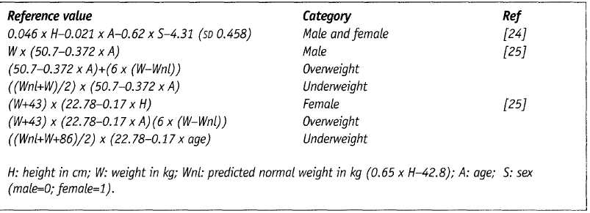
Table 2 Causes of exercise limitation
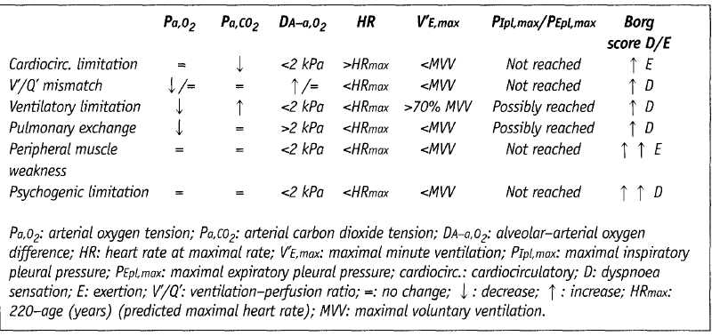

Suggested answers
- The main indications for exercise tesing are: impaired exercise tolerance; to find out which system
is limiting exercise; to establish which organ systems have an abnormal response during or after
exercise; to investigate how much exercise is appropriate/safe in a patient; and to determine the
response to treatment.
- Incremental exercise tesing is used to assess impaired exercise capacity, to investigate factors limi
ting exercise performance or to prescribe exercise training. Field tests are used to investigate the
effects of interventions that alter submaximal or endurance exercise capacity.
- Differences in work load increment size result in changes in maximal work load: larger incre-
ments=higher peak work load.
- See table 3 for full guidelines.
- Ventilatory limitation is caused by an imbalance between the workload and the capacity of the
respiratory muscles. See table 2 for more details.
- The changes in oxygen saturation, Vo₂, HR and hypercapnia observed during 6MWT are close to
those obtained during incremental exercise tests, and, therefore, investigators should look out for
alarm symptoms that may occur.
- Yes, in patients with less severe airway obstruction (FEVi >50% predicted).
- No, field tests are the test of choice for the longtitudinal assessment of exercise performance, e.g.
when assessing the effects of pulmonary rehabiliation.
- Yes, especially in patients with significant complaints of leg fatigue at the end of the exercice test
- Exercise laboratories should be encouraged to test some healthy control subjects in the age span
of interest to evaluate which normal values best suit their laboratory setting.
- Saey D, Debigare R, Leblanc P, et al. Contractile leg
fatigue after cycle exercise: a factor limiting exercise in
patients with chronic obstructive pulmonary disease.
Am J Respir Crit Care Med 2003; 168: 425-430.
- Guyatt GH, Pugsley SO, Sullivan MJ, Thompson P3,
Berman L, Jones NJ. Effect of encouragement on walk
ing'test performance. Thorax 1984; 39: 818-822.
- van Stel HF, Bogaard JM, Rijssenbeek-Nouwens LH,
Colland VT. Multivariable assessment of the 6-min
walking test in patients with chronic obstructive pul
monary disease. Am J Respir Crit Care Med 2001; 163:
1567-1571.
- American Thoracic Society. ATS Statement: guidelines
for the six-minute walking test. Am J Respir Crit Care
Med 2002; 166: 111-117.
- Sdurba F, Criner G3, Lee SM, et al. Six-minute walk dis
tance in chronic obstructive pulmonary disease: repro-
ducibility and effect of walking course layout and
length. Am J Respir Crit Care Med 2003; 167:
1522-1527.
- Rabinovich RA, Vitaro J, Roca J. Evaluation exercise
tolerance in COPD patients: the 6-minute walking test.
Arch Bronconeumol 2004; 40: 80-85.
- Singh SJ, Morgan MDL, Hardman AE, Rowe C, Bardsley
PA. Comparison of oxygen uptake during conventional
treadmill test and the shuttle walking test in chronic
airflow limitation. Eur Respir J 1994; 7: 2016-2020.
- Revill SM, Morgan MDL, Singh SJ, Williams J, Hardman
AE. The endurance shuttle walk: a new field test for
the assessment of endurance capacity in chronic
obstructive pulmonary disease. Thorax 1999; 54: 213-222.
- O'Donnell DE, McGuire MA, Samis L, Webb KA. General
exercise training improves ventilatory and peripheral
muscle strength and endurance in chronic airflow limi
tation. Am J Respir Crit Care Med 1998; 157:
1489-1497.
- O'Donnell DE, Webb KA. Measurement of symptoms,
lung hyperinflation, and endurance during exercise in
chronic obstructive pulmonary disease. Am J Respir Crit
Care Med 1998; 158: 1557-1565.
- van t Hul AJ, Gosselink R, Kwakkel G. Constant-load
cycle endurance performance: test-retest reliability and
validity in patients with COPD. J Cardiopulm Rehabil
2003; 23: 143-150.
- NederJA, Jones PW, Nery LE, Whipp BJ. Determinants
of exercise endurance capacity in patients with chronic
obstructive pulmonary disease. The power-duration
relationship. Am J Respir Crit Care Med 2000; 162:
497-504.
- Enright PL, Sherrill DL. Reference equations for the six-
minute walk in healthy adults. Am J Respir Crit Care
Med 1998; 158: 1384-1387.
- boosters T, Gosselink R, Decramer M. Six minute walk
ing distance in healthy elderly subjects. Eur Respir J
1999; 14: 270-274.
- Redelmeier DA, Bayoumi AM, Goldstein RS, Guyatt GH.
Interpreting smalt differences in functional status: the
six minute walk test in chronic lung disease patients.
Am J Respir Crit Care Med 1997; 155:1278-1282.
Suggested websites
www. ace. org/clinical/guidelines/ exercise/dirindex. htm American College of Cardiology Foundation. ACC/AHA 2002 Guideline Update for Exercise Testing.
www. americanheart. org American Heart Association. Guidelines for Clinical Exercise Testing Laboratories.
www. Iww. com/product/J)-683-30355-4
American College Sports Medicine. Guidelines for exercise testing and prescription.
www.guidetine.gov/summary/su mmary. aspxjdoc_id=2844
National Guideline Clearinghouse: exercise testing for evaluation of hypoxemia and/or desaturation.
www.guideline.gov/summary/su mmary. aspx_doc_id=3427 American College of Cardiology/American Heart Association Task Force on Practice Guidelines.
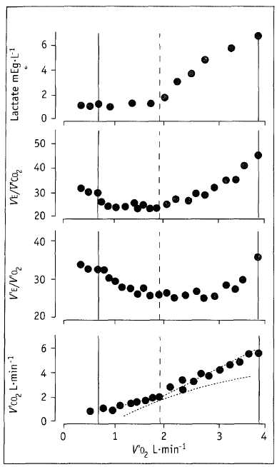
(±10) beats^minute¹) is indicative of maximum cardiac output. This limitation is observed in healthy subjects and, frequently, in patients with a forced expiratory volume in one second (FEVi) >50% predicted [32]. This exercise limitation is nota direct consequence of pulmonarydisease. In other conditions, such as heart failure or ischaemia, the HRmax may not be reached, but a low ratio of \/o₂/HR (oxygen puls) and a high submaximal HR, together with other findings (echocardiography, ECC changes), may help to identify cardiocirculatory limits.
A ventilatory limitation is related to an imbalance between load and capacity of the respiratory muscles (pump). The load on the pump can be increased due to airway obstruction, altered lung/chest wall compliance and hyperinflation. In addition to altered lung mechanics, the capacity of the ventilatory pump might be impaired due to respiratory muscle weakness [33] and/or reduced ventilatory drive. This might be indicated as a decrease in the slope of V/e to Vco₂ or by an increase in end-tidal carbon dioxide. The increased ratio of the pressure needed and the pressure that can be maximally generated indicates the risk for potential respiratory muscle failure.
A ventilatory limitation is frequently observed in patients with more advanced lung disease,
airway obstruction, chest wall deformities, respiratory muscle disease/weakness and in patients with interstitial lung disease. A ventilatory limitation can be identified in different ways. First, an increase in arterial CO₂ tension (Pa,co₂) can be observed during the exercise test, but this response is also influenced by central drive. Secondly, V'e that exceeds 70-80% of the maximal voluntary ventilation (MW; often calculated as -37.5 x FEVi) is considered a ventilatory limitation. More recently, the assessment of dynamic hyperinflation during exercise (reducing the capacity of the ventilatory pump) by measurements of inspiratory capacity or flow-volume loops has been found to be useful [34].
Pulmonary gas exchange limitation is identified by an isolated reduction in arterial oxygen tension (Pa,o₂) and/or an increase in the alveolar-arterial oxygen gradient (DA-a,o₂) of >2 kPa [25]. It is often unclear why patients with pulmonary gas limitation stop exercising; some do not sense hypoxaemia and continue to exercise up to very lowvaluesofPa,o₂, while other patients stop exercise when Pa,o₂ has hardly decreased [35]. The maximal exercise test will be terminated by the investigator when oxygen saturation drops below 80%. A low transfer factor of the lung for carbon monoxide (7l,co) has some prediction for exercise-induced hypoxaemia [36]. In the absence of significant airflow limitation, 7L,co values <50% predicted will be associated with hypoxaemia in most patients. In contrast, in patients with more severe COPD (and loss of diffusion capacity), ventilation-perfusion in-homogeneity mightdecrease during exercise and the net effect will be that Pa,o₂ and DA-a,o₂ do not alter [37].
Peripheral muscle weakness may also contribute to reduced exercise capacity [38-40]. In this case, at the end of the exercise test, patients will rate their level of exertion as high, using the Borg score. Muscle strength measurements of leg and arm muscles are needed to further explore muscle weakness as the limiting factor of exercise performance. Peripheral gas exchange problems are more difficult to address. In routine clinical testing, complaints of claudicate pain may be suggestive of peripheral gas exchange limitation.
Finally, psychological factors, such as fear, anxiety or lack of motivation, can also contribute to low exercise performance. A psychological limitation is diagnosed when no other limitations of exercise performance (as listed previously) can be identified and the behaviour of the patient would suggest it.
Figure 3
Lactate, V% V'co₂, V% V'o₂ response and V-sbpe plot during an incremental maximal exercise test. Figure modified from [29].
Field tests and endurance tests
Six or twelve minute walk test
In the 6- or 12MWT, functional exercise capacity is expressed as the distance in meters covered by the patient in 6 or 12 minutes, respectively [2,41 ]. The test is performed in a corridor with a known track length. Patients are instructed to cover as many meters as possible in the time scheduled. If needed, patients are allowed to have rest periods during the test, and they are also allowed to restart or change the walking speed. At the end of the test, patients must have the feeling that the covered distance was the maximal that could be achieved. In addition to the distance covered, HR, transcutaneous oxygen saturation (5tc,o₂), and Borg ratings for dyspnoea and fatigue can easily be obtained at the end of the walking test. All these measures provide further information about the patient [42].
Encouragement during the test is standardised, and the test has to be repeated at least once [41 ]. It has been shown previously that further repetitions of the test produce only a limited improvement in the result (~3%). A recent guideline published by the ATS [43] and results obtained from the National Emphysema TreatmentTrial [44] have both stressed the importance of proper standardisation. Indeed, appropriate standardisation resulted in a low coefficient of variation («8%) [43]. To ensure reproducible and reliable results, the guidelines in table 3 have been proposed.
Shuttle walk test
The SWT is an incremental, externally paced exercise test that stresses the patient to a symptom-limited maximum [15]. The patient walks around a 9-m course, defined by two marker cones (total distance covered per shuttle is 10
Table 3 Guidelines for reproducible and reliable results in timed walk tests
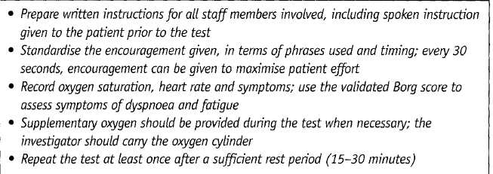
m). The speed of walking is dictated by signals played from a tape cassette and increases every minute until the patient is unable to keep up with the speed due to breathlessnessorfatigue. Hence, the Vo₂ profile during an incremental SWT mimics thatofthe maximal incremental tests [45].The walking distance correlates fairly well with Vo₂,max[46], but, to date, no reference values are available. As this is a maximal incremental exercise test, the results obtained may overlap with those from an incremental exercise test. However, since no physiological measurements other than HR and 5tc,o₂ are performed, the test does not allow interpretation of the cause of exercise limitation.
Oxygen desaturation, hypercapnia, Vo₂ and HR during field tests such as the 6MWT and the SWT are close to those obtained during incremental exercise testing [12]. Therefore, investigators should be trained in detecting alarm symptoms that may occur during this field exercise test (including pallor, angina, dizziness, extreme dyspnoea) and in basic life-saving procedures.
Endurance shuttle walk test
The endurance SWT is based on the SWT. The patient is asked to sustain walking as long as possible at a speed equal to 85% of the maximal walking speed during the SWT (after a practice walk) [47]. Walking speed during the endurance SWT is dictated by signals played from a tape cassette. The test is terminated when the patient is, for the second consecutive lap, unable to reach the cone in the time allowed. Good reproducibil-ity is obtained after one practice test. The endurance SWT appears to be more sensitive to changes due to respiratory rehabilitation than the SWT [47].
Cycle endurance test
It has been shown that constant work rate tests performed on a cycle or treadmill are sensitive when following-up patients after respiratory rehabilitation and medication [48, 49]. In addition, test-retest reliability is good [50]. These tests, however, require at least one maximal incremental exercise test preceding the consecutive follow-up tests. The follow-up tests are made at a fixed work rate (mostly 75% of the peak work rate of the preceding incremental test). Nevertheless, the data obtained during a constant work rate testare of physiological relevance. These tests can vary in complexity from analysis of exercise time, ventilation, HR and symptom scores to the

analysis of the organ system responses at the onset of exercise. Vo₂, Йсо₂, ventilation and HR responses are characterised by a time constant. This is the time needed to reach 63% of the final steady-state change [29]. This last approach is mostly reserved for research, and standardisation is critical to obtain reliable results. The power output that can be sustained (theoretically) forever is called the critical power. No data are available on normal values, but the critical power in normal subjects is ~65% of the peak workload, whereas, in COPD patients, it was found to be slightly higher [51].
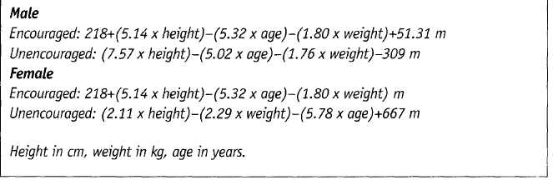
How to interpret field tests
The main outcome of a field test for the assessment of exercise capacity is the distance walked orthe change in distance.The walking distance in the SWT correlates well with \/о₂,шах [46]. The availability of normal values for the 6MWT has contributed to the interpretability of the data from this test (table 4) [52, 53]. A walking distance <82°/o predicted is considered abnormal [53]. No reference values are available for other field exercise tests. Most of these field tests are particularly important when evaluating changes overtime.The interpretation of the clinical significance of changes (minimal clinically relevant
Table 4 Reference values for the encouraged [53] and unencouraged [52] б-minute walk test
difference (MCID)) is available for the 6MWT (an MCIDisachangeof54minthe6MWT[54]).This has also contributed to the interpretability of data from the 6MWT.
Conclusion
In conclusion, exercise testing has gained popularity in a variety of clinical conditions and specifically in respiratory rehabilitation. Maximal incremental exercise testing has its main emphasis on the diagnosis of exercise impairment and the mechanisms related to this impairment. Field tests are most important in the longitudinal assessment of exercise performance, such as in the evaluation of treatment.

Educational questions (Answers on page 129)
- What are the main indications for exercise testing?
- When would you choose a maximal incremental test and when would you chose a field test in the
evaluation of exercise performance?
- Is the size of the increments of the work load in a maximal exercise test of importance to the out
come of the test?
- Which guidelines have to be followed to ensure reliable field testing?
- How is 'Ventilatory limitation" as a cause of exercise limitation defined?
- Should the 6MWT be considered a submaximal test?
- Can patients with COPD be limited in their exercise performance by reaching the boundaries of
the cardiocirculatory system?
- Is a maximal jncremental test the test of choice to assess the effects of pulmonary rehabilitation?
- Are measurements of peripheral muscle strength complementary to the information obtained
from a maximal incremental exercise test?
- Which reference value for Vo₂,max should be used?

Suggested further reading
American Thoracic Society/American College of Chest Physicians. Statement on cardiopulmonary exercise testing. Am J Respir Grit Care Med 2003; 167:211-277.
Roca J, Whipp BJ. Clinical exercise testing. Eur Respir Mon 1997; 2: 6.
Wasserman K, Hansen JE, Sue DY, Whipp BJ, Casaburi R. Principles of Exercise Testing and Interpretation, 2nd Edn. Philadelphia, Lea & Febiger, 1994.
Weisman IM, Zeballos RJ. Clinical txercise Testing. Basel, Karger, 2002.
American Thoracic Society. ATS Statement: Guidelines for the six-minute walking test Am J Respir Crit Care Med 2002; 166: 111-117.
References
- Wasserman K, Sue DY, Casaburi R, Moricca RB.
Selection criteria or exercise training in pulmonary
rehabilitation. Eur Respir J 1989; 7: Suppl, 604s-610s.
- Mathiowetz V, Dove M, Kashman N, Rogers S. Grip and
pinch strength: normative data for adults. Arch Phys
Med Rehabil 1985; 66: 69-72.
- McGavin CR, Gupta SP, McHardy GJR. Twelve-minute
walking test for assessing disability in chronic bronchi
tis. BM3 1976; 1: 822-823.
- Morgan AD, Peck DF, Buchanan DR, McHardy GJR.
Effect of attitudes and beliefs on exercise tolerance in
chronic bronchitis. BMJ 1983; 286: 171-173.
- Swinburn CR, Wakefield 3M, Jones PW. Performance,
ventilation, and oxygen consumption in three different
types of exercise test in patients with chronic obstruc
tive lung disease. Thorax 198; 40: 581-586.
- ATS/АССР Statement on cardiopulmonary exercise test
ing. Am J Respir Crit Care Med 2003; 167: 211-277.
- Hermansen L, Saltin B. Oxygen uptake during maximal
treadmill and bicycle exercise. J Appl Physiol 1969; 25:
31-37.
- McArdle WD, Katch FI, Pechar GS. Comparison of con
tinuous and discontinuous treadmill and bicycle tests
for max VO2. Med Sci Sports Exerc 1973; 5: 156-160.
- Astrand PO. Saltin B. Maximal oxygen uptake and heart
rate in various types of muscular activity. 3 Appl
Physiol 1961; 16: 977-981.
- Steele B, Holt N, Belza B, Ferris S, Lakshminaryan S,
Buchner B. Quantitating physical activity in COPD using
a triaxial accelerometer. Chest 2000; 117: 1359-1367.
- Stevens D, Elpern E, Sharma K, Szidon P, Ankin M,
Kesten S. Comparison of hallway and treadmill six-
minute walk tests. Am J Respir Crit Care Med 1999;
160: 1540-1543.
- Troosters T, Vilaro J, Rabinovich R, et al. Physiological
responses to the 6-min walk test in patients with
chronic obstructive pulmonary disease. Eur Respir J
2002; 20: 564-569.
- Casas A, Vilaro J, Rabinovich R, Mayer AF, Valera JL,
Bertoni E. Encouraged six minute walking test reflects
'maximal' sustainable exercise performance in COPD
patients. Eur Respir J 2002; 20: 285S.
- Solway S, Brooks D, Lacasse Y, Thomas S. A qualitative
systematic overview of the measurement properties of
functional walk tests used in the cardiorespiratory
domain. Chest 2001; 119: 256-270.
- Singh SJ, Morgan MDL, Scott S, Walters D, Hardman
AE. The development of the shuttle walking test of dis
ability in patients with chronic airways obstruction.
Thorax 1992; 47: 1019-1024.
- Belza B, Steele BG, HunzikerJ, Lakshminaryan S, Holt
L, Buchner DM. Correlates of physical activity in chron
ic obstructive pulmonary disease. Nurs Res 2001; 50:
195-202.
- Astrand I. Aerobic work capacity in men and women.
Ada Physiol Scand 1960; 49: Suppl. 169, 7-92.
- Froelicher VF, Brammel H, Davis G, Noguera I, Steward
A, Lancaster MC. A comparison of the reprodudbility
and physiologic response to three maximal treadmill
exercise protocols. Chest 1974; 65: 512-517.
- Froelicher VF, Thompson A3, Noguera I, Davis G,
Stewart A3, Triebwasser 3H. Prediction of maximal oxy
gen consumption. Comparison of the Bruce and Balke
protocols. Chest 1975; 68: 331-336.
- Debigare R, Maltais F, Mallet M, Casaburi R, Leblanc P.
Influence of work rate incremental rate on the exercise
responses in patients with COPD. Med Sci Sports Exerc
2000; 32: 1365-1368.
- Franklin BA, Gordon S, Timmis GC, O'Neill WW. Is direct
physician supervision of exercise stress testing routinely necessary? Chest 1997; 111: 262-265.
- Wilson RC, 3ones PW. Differentiation between the
intensity of breathlessness and the distress it evokes in
normal subjects during exercise. Clin Sci (Lond) 1991;
80: 65-70.
- Cotes 3E. Rating respiratory disability: a report on
behalf of a working group of the European Society for
Clinical Respiratory Physiology. Eur Respir 3 1990; 3:
1074-1077.
- 3ones NL, Makrides L, Hitchcock C, Chypchar T,
McCartney N. Normal standards for an incremental pro
gressive cycle ergometer test. Am Rev Respir Dis 1985;
131: 700-708.
- Wasserman K, Hansen 3E, Sue DY, Whipp B3, Casaburi
R. Principles of exercise testing and interpretation. 2nd
Edn. Philadelphia, Lea & Febiger, 1994.
- Killian КЗ, Leblanc P, Martin DH, Summers E, 3ones NL,
Campbell E3M. Exercise capacity and ventilatory, circu
latory, and symptom limitation in patients with chronic
airflow limitation. Am Rev Respir Dis 1992; 146:
935-940.
- Weisman IM, Zeballos R3, eds. Clinical Exercise Testing,
Basel, Karger, 2002.
- Weisman IM, Zeballos R3. An integrative approach to
the interpretation of cardiopulmonary exercise testing.
In: Weisman IM, Zeballos R3, eds. Clinical Exercise
Testing. Basel, Karger, 2002; pp. 300-320.
- Whipp B3, Wagner PD, Agusti A. Factors determining
the response to exercise in healthy subjects. In: Roca
3, Whipp B3, eds. Clinical Exercise Testing. Eur Respir
Mon 1998; 2: 6, 3-31.
- Roca 3, Whipp B3. Clinical exercise testing with refer
ence to lung diseases: indications, standardization and
interpretation strategies. Eur Respir 3 1997; 10:
2662-2689.
- Dempsey ЗА. Is the lung built for exercise? Med Sci
Sports Exer 1986; 2: 143-155.
- Dekhuijzen PNR, Folgering H Th M, van Herwaarden
CLA. Target-flow inspiratory muscle training during pul
monary rehabilitation in patients with COPD. Chest
1991; 99: 128-133.
- Efthimiou 3, Fleming 3, Gomes C, Spiro SG. The effect
of supplementary oral nutrition in poorly nourished
patients with chronic obstructive pulmonary disease.
Am Rev Respir Dis 1988; 137: 1075-1082.
- O'Donnell DE. Exercise limitation and clinical exercise
testing in chronic obstructive pulmonary disease. In:
Weisman IM, Zeballos R3, eds. Clinical Exercise Testing.
Basel, Karger, 2002: pp. 138-158.
- Мак VHF Bugler 3R, Roberts CM. Effect of arterial oxy
gen saturation on six minute walking distance, per
ceived effort, and perceived breathlessness in patients
with airflow limitation. Thorax 1993; 48: 33-38.
- Wijkstra P3, Ten Vergert EM, Van der Mark Th W, et at.
Relation of lung function, maximal inspiratory pres
sure, dyspnoea, and quality of life with exercise capaci
ty in patients with chronic obstructive pulmonary dis
ease. Thorax 1994; 49: 468-472.
- Agusti ACN, Barbera ЗА, Roca 3. Hypoxic pulmonary
vasoconstriction and gas exchange during exercise in
chronic obstructive pulmonary disease. Chest 1990; 97:
268-275.
- Gosselink R, Troosters T, Decramer M. Peripheral muscle
weakness contributes to exercise limitation in COPD.
Am 3 Respir Crit Care Med 1996; 153: 976-980.
- Mador M3, Kufel T3, Pineda L. Quadriceps fatigue after
cycle exercise in patients with chronic obstructive pul
monary disease. Am 3 Respir Crit Care Med 2000; 161:
447-453.

