Adenosine level in exhaled breath increases during 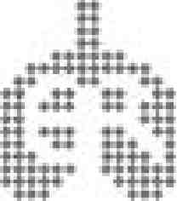
exercise-induced bronchoconstriction

Z. Csoma*, E. Huszar , Ё. Vizi*, G. Vass , Z. Szabo*, I. Herjavecz*, M. Kollai and I. Horvath

ABSTRACT: In asthmatic patients, airway obstruction provoked by exercise challenge is accompanied by an increase in plasma adenosine level. In this study, the current authors investigated if exercise-induced bronchoconstriction was associated with local changes of adenosine concentration in the airways.
Oral exhaled breath condensate (EBC) collection (5-min duration) and forced expiratory volume in one second (FEV1) measurements were performed at rest (baseline) and 4–8 times after treadmill exercise challenge in healthy and asthmatic subjects. Adenosine concentration in EBC was determined by HPLC.
Observations indicated that physical exercise results in bronchoconstriction together with a significant increase of adenosine level in EBC in asthmatic patients (meanЎSD maximal fall in FEV1 27Ў13%; associated increase in adenosine 110Ў76% as compared to baseline), but not in healthy control subjects. Exercise-induced changes in adenosine concentration correlated significantly with the fall in FEV1 values in asthmatic patients.
In conclusion, the observed increase in adenosine concentration of oral exhaled breath condensate most probably reflects changes in the airways during exercise-induced bronchocon-striction. Due to its known bronchoconstrictor property in asthma, adenosine may contribute to the development of bronchospasm.
KEYWORDS: Adenosine, airway inflammation, asthma, exercise-induced bronchoconstriction, exhaled breath condensate

Exercise-induced bronchoconstriction (EIB) is a common feature of asthma, and its severity is likely to be associated with airway inflammation [1]. The mechanism of EIB is not completely understood, but it has been widely accepted that exercise-induced hyperp-noea plays a substantial role as an initiating stimulus [2] through cooling (heat-loss theory) and dehydration (water-loss theory) of the airway [3, 4]. In line with the water-loss theory suggesting that dehydration stimulates inflammatory cells in the airways to release broncho-constrictor mediators [5, 6], pharmacological studies provide evidence for the contribution of histamine [7], cysteinyl-leukotrienes [8] and bronchoconstrictor prostanoids [9] to the development of EIB.
A number of in vitro and in vivo observations suggest that the bronchoconstrictor mechanisms involved in exercise and adenosine challenges may be interrelated. Both challenges cause mast cell activation, resulting in the release of various
bronchoconstrictor mediators, including hista-mine and cys-leukotrienes [5, 10, 11]. Indeed, inhibition of the 5-lipoxygenase pathway in asthmatic patients significantly attenuates EIB and adenosine-induced bronchoconstriction, indicating that leukotrienes are important mediators in both challenges [12]. Furthermore, a similarity between hyperresponsiveness to exercise and adenosine 59-monophosphate was demonstrated in children with asthma [13].
Based on the previously mentioned lines of evidence, it is plausible that, during exercise, adenosine released by adenosine triphospate mobilisation and metabolisation could participate in the development of exercise-induced broncho-spasm. Previously, it was demonstrated that, during EIB, plasma adenosine concentration increased and this change was related to the degree of airway obstruction [14]. In the present study, the aim was to determine if EIB was associated with local changes of adenosine concentration in the airways of asthmatic patients by comparing the time course of changes in mediator level and lung function following exercise.
Collection of exhaled breath condensate (EBC) is a simple, noninvasive mode of obtaining samples from the airways. This type of sample collection can be repeated in short intervals without side-effects and, therefore, it provides an opportunity to follow the changes in mediator levels in the airways, although possible confounding effects of the mouth and the nasal cavities cannot be completely excluded. The level of adenosine in EBC can be determined with good reproducibility [15]. Adenosine concentrations of oral and tracheal EBC samples do not differ significantly [16]. Furthermore, the mode of inhalation (oral or nasal) has no influence on EBC adenosine concentration in subjects without upper airway disease [16].
In this study, EBC adenosine concentrations were determined at rest and several times during the development of EIB in asthmatic patients, and these were compared to those found in samples collected from healthy volunteers before and after exercise challenge. To study the direct effect of bronchocon-striction by itself, the EBC adenosine level was determined after methacholine (MCh) provocation in asthmatic patients.
METHODS
Subjects
Eight nonatopic healthy volunteers (aged 28Ў7 yrs; five males) and 10 patients with mild asthma (aged 32Ў11 yrs; four males) participated in the study. All patients met the American Thoracic Society (ATS) diagnostic criteria for bronchial asthma [17] and had elevated levels of exhaled nitric oxide (NO). Seven of the asthmatic patients had a history of EIB and, in addition, seven of them were atopic, as demonstrated by at least two positive results to skin tests with the following common aeroallergens: house dust mite, cat dander, dog dander, grass pollen and Aspergillus fumigatus (Soluprick; ALK Abello, Copenhagen, Denmark). Treatment of patients consisted of inhalation of short-acting b₂-agonists as needed.
The protocol was approved by the local ethics committee, and written informed consent was obtained from each subject before the study. All subjects were nonsmokers, and were instructed to avoid consuming caffeinated drinks and foods,
and refrain from exercise for o12 h before the study. b₂-Agonists were withdrawn o12 h before the exercise and MCh challenges. No subjects were studied within 6 weeks of having an upper respiratory tract infection or any chronic upper airway/sinus disease.
Study design
Effect of methacholine challenge
When preparing the study, a control experiment was performed in six patients with mild asthma to establish the effect of bronchoconstriction on EBC adenosine concentration (table 1). In this pre-study, EBC samples were collected for adenosine measurement from patients twice before and 3–6 times after MCh inhalation, which caused .20% decrease in forced expiratory volume in one second (FEV1).
Effect of exercise challenge
Seven asthmatic patients with a history of EIB (table 2) and eight nonatopic healthy volunteers performed an exercise test. The scheme of the test is shown in figure 1. First, EBC was collected twice for 5 min with a minimal pause between samplings to change condensing tubes. This was followed by the measurement of exhaled NO and FEV1 in each study participant. Participants were then subjected to a standardised treadmill exercise test. At the completion of exercise challenge, minute ventilation was determined. Next, a cycle of FEV1 measurement, followed immediately by EBC collection for 5 min, was performed. This cycle was repeated four times in healthy volunteers and 4–8 times in asthmatic patients until FEV1 had returned to baseline either spontaneously or following inhalation of short-acting b₂-agonists as required by the patient. FEV1 measurement and replacement of condensing tubes lasted 2 min each time. This study protocol was performed between 07:00 and 08:00 h in all subjects.
Collection of exhaled breath condensate EBC was collected using the EcoScreen condenser (Jaeger, Hoechberg, Germany), as reported previously [15]. At rest, subjects breathed at a normal frequency and tidal volume. EBC collection was performed without wearing a nose-clip (inhaling through the nose and/or mouth and exhaling orally). Subjects were instructed not to alter their breathing pattern,
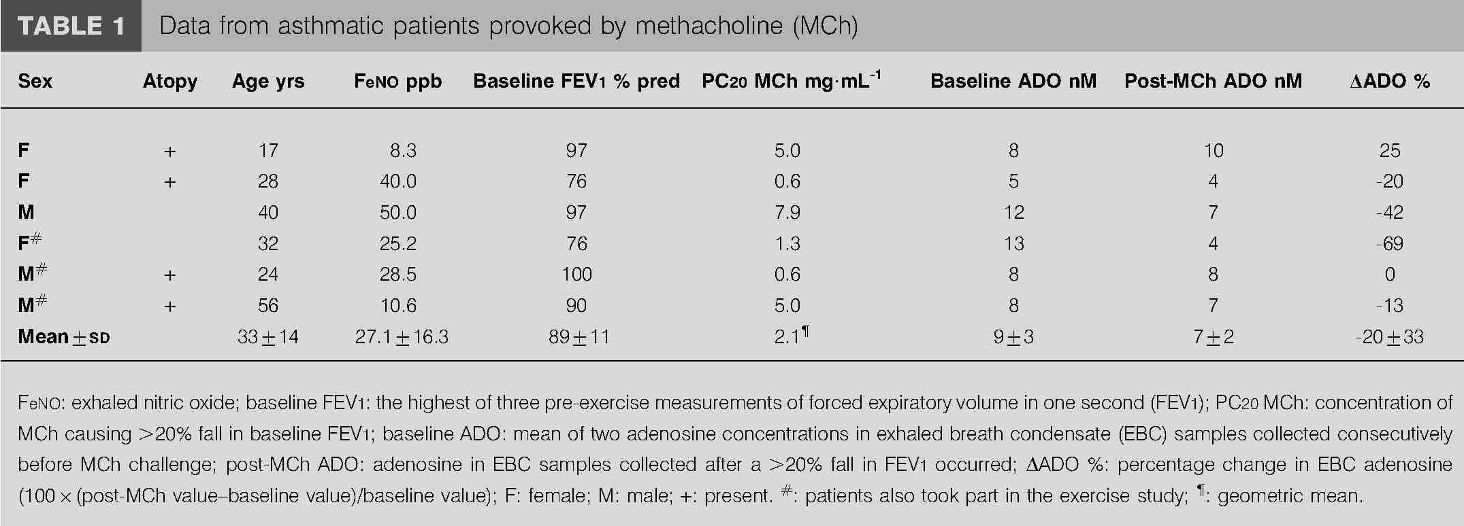
FIGURE 1. Schematic diagram of the study protocol. : collection of exhaled breath condensate (EBC); h: measurement of exhaled nitric oxide; &: measurement of forced expiratory volume in one second (FEV1); &: measurement of minute ventilation; R: paired EBC samples and FEV1 measurements to study the effect of exercise-induced changes in EBC adenosine in the development of airway obstruction; dashed arrow: the cycles of measurement were repeated more times in some cases.
volume and the route of inhalation (oral/nasal) during EBC collection. Collected samples were stored frozen (at -20˚C) until analysis (EBC samples collected from each subject were analysed within 60 min after the end of the visit).
Lung function test and exhaled NO measurement FEV1 was measured by means of an electronic spirometer (MS-11; MEDICOR, Budapest, Hungary) according to the ATS guidelines [18]. At rest, three technically acceptable manoeuvres were performed and the highest of them was used in the analysis. After exercise, only single acceptable manoeuvres were performed.
Exhaled NO was measured by a chemiluminescence analyser (Model LR2000; Logan Research, Rochester, UK), sensitive to NO from 1–5,000 ppb by volume, and with a resolution of 0.3 ppb [19].
Methacholine challenge
MCh bronchial challenge was performed using a standardised dosimetric method, as previously described [20]. Briefly, after an initial 0.9% sodium chloride inhalation, patients were exposed to doubling concentrations of MCh chloride (Sigma Chemical Co., St Louis, MO, USA) as five breaths from a breath-actuated dosimeter (MEFAR MB-3; Mefar S.P.A., Bovezzo, Italy). FEV1 was measured 2 min after each inhalation, and the challenge was discontinued when the fall in FEV1 was o20% from the post-saline value.
Exercise challenge
Subjects exercised on an electrically driven treadmill at room temperature wearing a nose-clip. The speed, gradient, time of exercise and heart rate were displayed continuously during running. Exercise intensity was set to raise the subjects’ heart rate to 90% of the age-adjusted maximum target level. Each subject exercised for 6 min under these target conditions. At the end of the challenge, minute ventilation was not significantly different between healthy subjects (meanЎSD 26.2Ў7.2 L?min⁻¹) and asthmatic patients (31.2Ў15.6 L?min⁻¹).
Determination of adenosine
EBC adenosine concentrations were determined by reverse-phased isocratic HPLC [15, 21]. Separation was performed on a 3-mm Microspher C18 (10064.6 mm internal diameter; Chrompack, Middelburg, The Netherlands) analytical column with a 5-mm Chromsep C18 guard column (1063 mm internal diameter; Chrompack) by a mixture of 0.05 M Na₂HPO₄ buffer (pH 3.8) and acetonitrile (97.5:2.5 v/v), as a mobile phase. Detection of adenosine was at 260 nm with a dual wavelength ultraviolet detector (LKB 2141; Pharmacia, Uppsala, Sweden). EBC adenosine identity was verified by retention time (6– 8 min, depending on flow rate) and/or coelution with an aqueous adenosine standard. When needed, an aliquot of the sample was treated with adenosine deaminase to differentiate the adenosine peak from possible coeluting peaks. To obtain a calibration curve, aliquots of pooled EBC samples were spiked with aqueous adenosine standards to give 3-, 6-, 12-, 24- and 48-nM adenosine concentrations above the original value. The chromatogram of the unspiked, original sample was subtracted from the chromatogram of spiked samples. By plotting adenosine peak areas against adenosine concentrations, a line was calculated, which served for determination of adenosine levels. The calibration line was checked at two concentrations before each set of adenosine measurements. The stability of
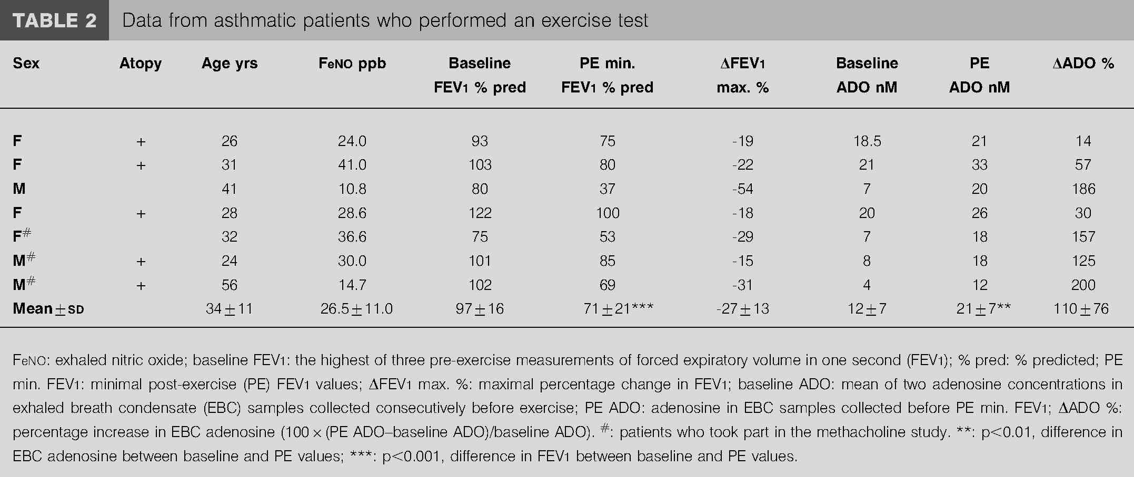
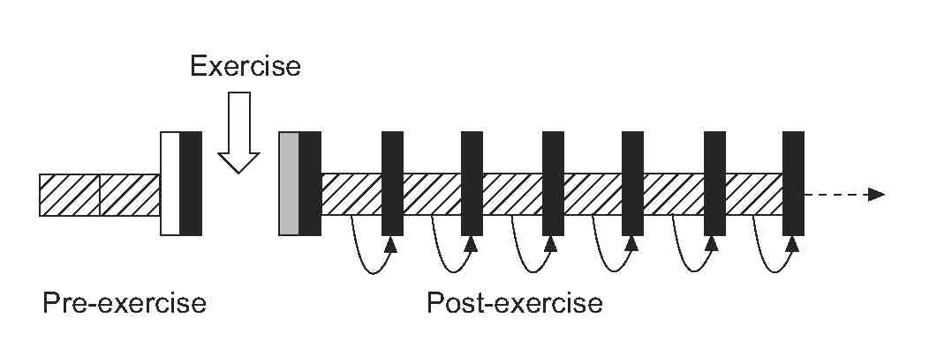
adenosine in EBC at room temperature, plus both the within-run precision and the day-to-day repeatability of EBC adenosine measurement, was determined previously [15]. In this study, an agreement between EBC adenosine measurements was also examined by determining the adenosine concentration in two consecutive samples collected before exercise challenge.
Statistical analysis
Results are expressed as meanЎSD. The Bland and Altman test was used to assess repeatability of adenosine measurement in EBC at rest [22]. Repeated-measures ANOVA, followed by Newman-Keuls post hoc comparison testing, was performed to compare baseline and post-exercise data from healthy volunteers and asthmatic subjects within and between groups. Linear regression analysis was performed to determine the correlation between exercise-induced changes in EBC adeno-sine concentrations and the decrease in FEV1 values. Areas under the curves (AUC; for DFEV1 and DEBC adenosine) were calculated by trapezoid integration (GraphPad Prism Version 3; GraphPad, San Diego, CA, USA).
RESULTS Baseline values
Determination of EBC adenosine showed good repeatability. Adenosine concentrations in two consecutive samples collected at rest were 11Ў6 and 11Ў5 nM, respectively (n521, all subjects participating in exercise and/or MCh challenges). The mean difference with coefficient of repeatability was -0.2Ў2.6 nM, and all differences were within Ў2SD.
In healthy volunteers, the baseline values of FEV1 and EBC adenosine were 98Ў9% and 11Ў4 nM, respectively. There was no significant difference either in baseline FEV1 values or in EBC adenosine between healthy subjects and asthmatic patients (baseline characteristics of asthmatic patients in tables 1 and 2).
Effect of methacholine provocation and exercise challenge In asthmatic patients provoked by MCh, no significant change was observed in EBC adenosine concentration in association with a 26Ў6% mean of maximal fall in FEV1 caused by MCh inhalation (table 1, fig. 2).
Exercise did not induce significant changes either in FEV1 or EBC adenosine in healthy volunteers, but it caused a significant decrease in FEV1, accompanied by a significant increase in EBC adenosine in asthmatic patients (table 2). The time course of changes both in post-exercise FEV1 and EBC adenosine showed wide individual variability, but there was a significant difference in the time course of changes both in EBC adenosine concentrations and in FEV1 values between healthy and asthmatic subjects (fig. 3a and b).
Relationship between post-exercise FEV1 values and exercise-induced changes in EBC adenosine In asthmatic patients, the relationship between the exercise-induced fall in FEV1 and changes in EBC adenosine concentration were analysed to uncover a possible effect of increased adenosine level in the development of airway obstruction (fig. 4a). Each post-exercise EBC adenosine measurement was matched with subsequent FEV1 measurements (as outlined in fig. 1). Individual AUC values of percentage changes in FEV1
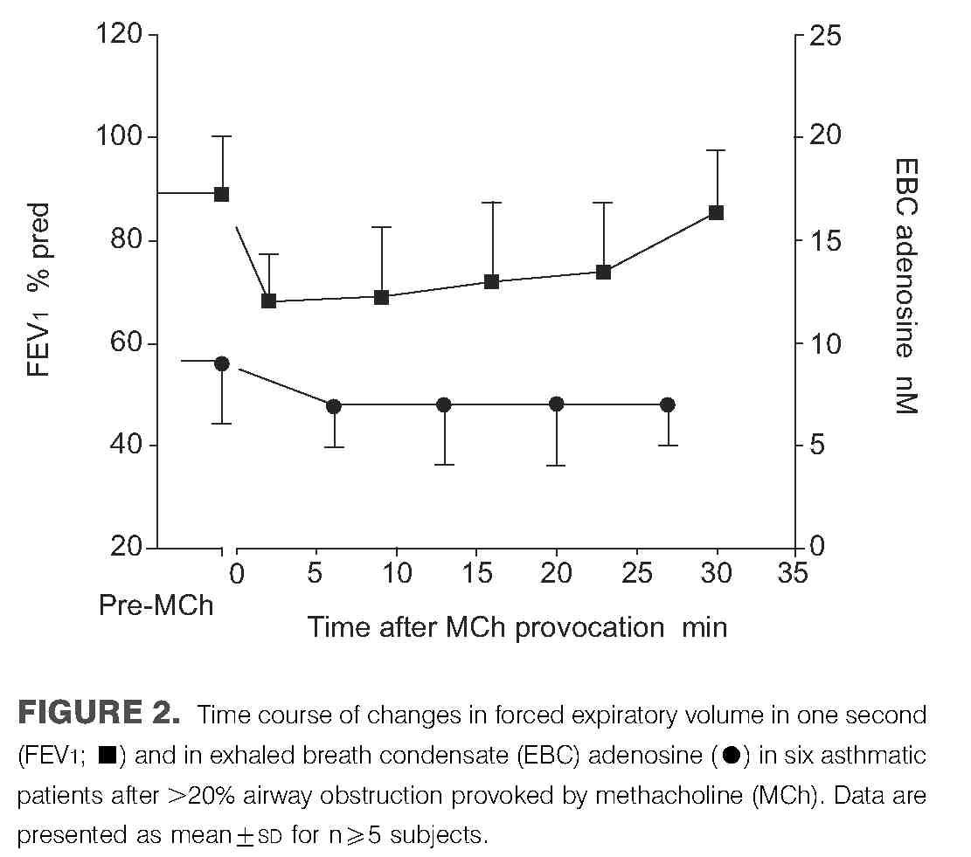
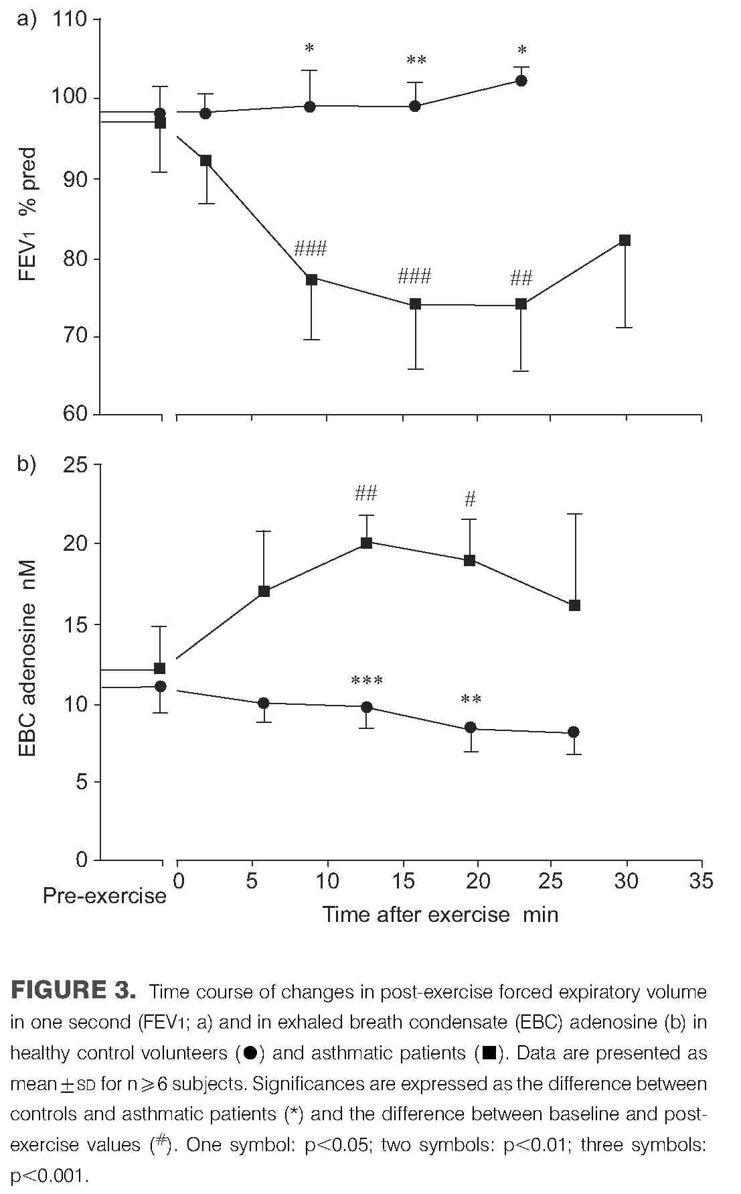
were also plotted against that of percentage changes in EBC adenosine (fig. 4b).
DISCUSSION
In the current study, the exercise-induced changes of EBC adenosine levels in asthmatic patients with EIB and healthy volunteers were investigated. While EBC adenosine did not change following exercise in healthy subjects, there was a pronounced increase in its level during EIB in asthmatic patients, and this increase was related to the degree of bronchospasm. The present observations suggest that adeno-sine is present in the airways in a considerable concentration and provide further evidence for its contribution to the development of EIB.
Orally collected EBC was used to sample the airways in the current study, with the presumption that it would be suitable
to reflect lower airway adenosine concentration. This is because no difference in adenosine concentrations had been found between orally collected EBC samples and those obtained through tracheostomies [16]. Furthermore, taking its dilution factor (5,000–10,000-fold) into account, the concentration of airway adenosine calculated from the current EBC values was similar to that proposed by others in broncho-alveolar lavage [23, 24]. Both calculations showed that the airway concentration of adenosine is ,50–200 mM. This local concentration is .1,000 higher than what is found in plasma (50–100 nM) [14] and is in the range of having biological activity [24]. The adenosine concentration in oral EBC samples mainly reflects adenosine arising from the lower airways/ alveoli, but adenosine produced in the nasal cavities and/or the mouth may also contribute to it. It had been previously found that the adenosine concentration in saliva is approximately 10-fold higher than in orally collected EBC samples [15]. There was no difference between healthy and asthmatic subjects, and no relationship between saliva adenosine and EBC adenosine in subject-matched samples. In the absence of upper airway inflammation, the adenosine concentration of oral EBC samples remains constant, regardless of the mode of inhalation (via the nose or mouth) [16]. Although the previously mentioned pieces of evidence are only indirect, suggesting that oral EBC adenosine arises from the lower airways, and the possibility of contribution of the nasal cavities and the mouth cannot be excluded completely, the data warrant further investigation of adenosine as a mediator participating in airway regulation.
Previously, it was found that EBC adenosine levels were elevated in steroid naЁıve atopic asthmatic patients as compared with healthy volunteers, with some overlap between the two groups [15]. The baseline adenosine values of the patients selected for the present study represented the whole range of adenosine levels found in asthmatic patients, from normal low values to elevated ones without a significant difference between asthmatic and healthy subjects. The mean concentrations of adenosine were equal in healthy and asthmatic subjects (with higher variability in the patients). This finding is probably attributable to the relatively low number of patients involved in the study and the mild nature of their disease. In the group of healthy volunteers, no change in EBC adenosine concentration was observed, in contrast to the increase found in asthmatic patients after exercise. Therefore, the current authors do not think that potential changes in EBC formation/collection due to exercise have caused any important bias to the results. One may assume that an increase in EBC adenosine observed during EIB is caused by changes in airway calibre per se. This is unlikely, however, because the MCh challenge did not cause an elevation in EBC adenosine. Similarly, others did not find changes in EBC histamine and leukotriene levels during bronchospasm caused by MCh [25].
The exact source of adenosine during EIB was not examined. The potential source of increased adenosine release might include structural cells of the airway wall (smooth muscle cells, injured epithelial cells), inflammatory cells, including mast cells, and overactivated nerve endings [26, 27].
Although only an association was shown between adenosine and airway obstruction, not a direct causal relationship,
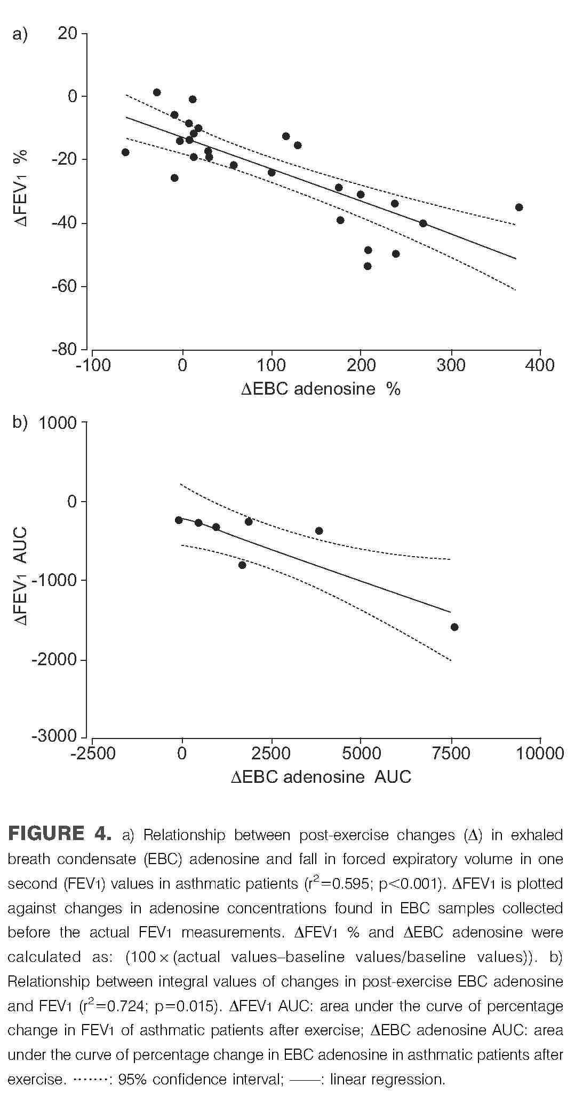
previous studies have suggested that whatever is the source of adenosine in the airways, an increase in its level would potentiate the airway obstruction produced by other broncho-constrictor stimuli [28, 29].
In conclusion, the current data show that exercise-induced airway obstruction is associated with a pronounced increase in adenosine concentration in exhaled breath condensate. The time course of exhaled breath condensate adenosine tracked the time course of forced expiratory volume in one second after exercise, and the post-exercise changes in airway function and adenosine concentrations were related. These findings suggest a possible contribution of adenosine in exercise-induced airway obstruction, but a causal relationship between adeno-sine and exercise-induced bronchoconstriction could only be assessed by using specific adenosine receptor antagonists.
ACKNOWLEDGEMENTS
The authors would like to thank N. Szilaґgyi for statistical analysis; I. Barta for his useful suggestions; and M. Hernaґdi, M. Mikoss and M. Keneґz for lung function measurements, and the collection and processing of condensate samples.
REFERENCES
1 Yoshikawa T, Shoji S, Fujii T, et al. Severity of exercise-induced bronchoconstriction is related to airway eosino-philic inflammation in patients with asthma. Eur Respir J 1998; 12: 879–884.
2 Gotshall RW. Exercise-induced bronchoconstriction. Drugs 2002; 62: 1725–1739.
3 McFadden ER Jr, Nelson JA, Skowronski ME, et al. Thermally induced asthma and airway drying. Am J Respir Crit Care Med 1999; 160: 221–226.
4 Anderson SD, Daviskas E. The mechanism of exercise-induced asthma is…. J Allergy Clin Immunol 2000; 106: 453–459.
5 O’Sullivan S, Roquet A, Dahle€n B, et al. Evidence for mast cell activation during exercise-induced bronchoconstric-tion. Eur Respir J 1998; 12: 345–350.
6 Koskela H, Di Sciascio MB, Anderson SD, et al. Nasal hyperosmolar challenge with a dry power of mannitol in patients with allergic rhinitis. Evidence for epithelial cell involvement. Clin Exp Allergy 2000; 30: 1627–1636.
7 Ghosh SK, De Vos C, McIlroy I, et al. Effect of cetirizine on exercise-induced asthma. Thorax 1991; 46: 242–244.
8 Coreno A, Skowronski M, Kotaru C, McFadden ER Jr. Comparative effects of long-acting b2-agonists, leukotriene receptor antagonists, and 5-lipoxygenase inhibitor on exercise-induced asthma. J Allergy Clin Immunol 2000; 106: 500–506.
9 Finnerty JP, Holgate ST. Evidence for the roles of histamine and prostaglandins as mediators in exercise-induced asthma: the inhibitory effect of terfenadine and flurbipro-fen alone and in combination. Eur Respir J 1990; 3: 540–547.
10 Forsythe P, McGarvey LP, Heaney LG, MacMahon J, Ennis M. Adenosine induces histamine release from human bronchoalveolar lavage mast cells. Clin Sci (Lond) 1999; 96: 349–355.
11 Peachell PT, Columbo M, Kagey-Sobatka A, Lichtenstein LM, Marone G. Adenosine potentiates mediator release from human lung mast cells. Am Rev Respir Dis 1988; 138: 1143–1151.
12 Van Schoor J, Joos GF, Kips JC, Drajesk JF, Carpentier PJ, Pauwels RA. The effect of ABT-761, a novel 5-lipoxygenase inhibitor, on exercise- and adenosine-induced broncho-constriction in asthmatic subjects. Am J Respir Crit Care Med 1997; 155: 875–880.
13 Avital A, Springer C, Bar-Yishay E, Godfrey S. Adenosine, methacholine and exercise challenges in children with asthma or paediatric chronic obstructive pulmonary disease. Thorax 1995; 50: 511–516.
14 Vizi Eґ, Huszaґr Eґ, Csoma Z, et al. Plasma adenosine concentration increases during exercise: a possible contributing factor in exercise-induced bronchoconstriction in asthma. J Allergy Clin Immunol 2002; 109: 446–448.
15 Huszaґr Eґ, Vass G, Vizi Eґ, et al. Adenosine in exhaled breath condensate in healthy volunteers and in patients with asthma. Eur Respir J 2002; 20: 1393–1398.
16 Vass G, Huszaґr Eґ, Baraґt E, et al. Comparison of nasal and oral inhalation during exhaled breath condensate collection. Am J Respir Crit Care Med 2003; 167: 850–855.
17 American Thoracic Society. Standards for the diagnosis and care of patients with chronic obstructive pulmonary disease (COPD) and asthma. Am Rev Respir Dis 1987; 136: 225–244.
18 American Thoracic Society. Standardization of spirometry. 1994 update. Am J Respir Crit Care Med 1995; 152: 1107–1136.
19 Kharitonov SA, Alving K, Barnes PJ. Exhaled and nasal nitric oxide measurements: recommendations. Eur Respir J 1997; 10: 1683–1693.
20 Horvaґth I, Donnelly LE, Kiss A, et al. Combined use of exhaled hydrogen peroxide and nitric oxide in monitoring asthma. Am J Respir Crit Care Med 1998; 158: 1042–1046.
21 Huszaґr Eґ, Baraґt E, Kollai M. Isocratic high-performance liquid chromatographic determination of plasma adeno-sine. Chromatographia 1996; 42: 318–322.
22 Bland JM, Altman DG. Statistical method for assessing agreement between two methods of clinical measurement. Lancet 1986; 1: 307–310.
23 Effros RM, Biller J, Foss B, et al. A simple method for estimating respiratory solute dilution in exhaled breath condensates. Am J Respir Crit Care Med 2003; 168: 1500–1505.
24 Driver AG, Kukoly CA, Ali S, Mustafa SJ. Adenosine in bronchoalveolar lavage fluid in asthma. Am Rev Respir Dis 1993; 148: 91–97.
25 Bucchioni E, Csoma Z, Allegra L, Chung KF, Barnes PJ, Kharitonov SA. Adenosine 59-monophosphate increases levels of leukotrienes in breath condensate in asthma. Respir Med 2004; 98: 651–655.
26 Pauwels R. The role of adenosine in bronchial asthma. Bull Eur Physiopathol Respir 1987; 23: 203–208.
27 Marquardt DL, Gruber HE, Wasserman SI. Adenosine release from stimulated mast cells. Proc Natl Acad Sci USA 1984; 81: 6192–6196.
28 Huszaґr Eґ, Horvaґth I, Baraґt E, Herjavecz I, Boszormenyi-Nagy G, Kollai M. Elevated circulating adenosine level potentiates antigen-induced immediate bronchospasm and bronchoconstrictor mediator release in sensitized guinea pigs. J Allergy Clin Immunol 1998; 102: 687–691.
29 Mann JS, Holgate ST, Renwick AG, Cushley MJ. Airway effects of purine nucleosides and nucleotides and release with bronchial provocation in asthma. J Appl Physiol 1986; 61: 1667–1676.

