Eur Respir J 2002; 20:108- 111
DOL:10.1183/09031936.02/00/00237702
Printed in UK all rights reserved

Relationship between exhaled air temperature and exhaled nitric
oxide in childhood asthma
G.L. Piacentini*, A. Bodini*, L.Zerman*, S. Costella*, L.Zanolla*, D.G. Peroni*, A.L. Boner*

Relationship between exhaled air temperature and exhaled nitric oxide in childhood asthma. G. L. Piacentini, A. Bodini, L. Zerman, S. Costella, L. Zanolla, D.G. Peroni, A.L. Boner. ERS Journals Ltd 2002.
ABSTRACT: Air inflammation is a characteristic of airway inflammation in asthmatic patient. The purpose of this study was to investigate whether the temperature of exhaled air is related to eNO levels.
Temperature of exhaled air and eNO were measured in 52 asthmatic children with a cross-sectional design.
A significant relationship was demonstrated between eNO and temperature of peak and plateau exhaled air temperature/ The relationship between both the peak and the plateau values and eNO was more evident when it was corrected for environmental temperature.
These results suggest a relationship between exhaled nitric oxide and the temperature of exhaled air in asthmatic patients not tread with systemic steroids.
*Dept of Pediatrics, University of Verona and #Dept of Cardiology, Istituto Pio XII, Misurina, ltaly.
Correspondence: A.L. Boner, Dipatimento di Pediatria, Policlinico G.B.
Rossi, 37134 Verona, Italy.
Fax:39458200993
E-mail:boner@borgoroma.univr.it
Keywords: Airway inflammation asthma in childhood exhaled air temperature exhaled nitric oxide
Received:April20 2001
Accepted after revision: February 4 2002
Asthma is an inflammatory disease of the airways characterized by cellular infiltration and oedema of the mucosa epithelial damage, mucus production and plasma exudation [1-3].
Bronchoscopy with biopsies is regarded as the most reliable method of of evaluating the level of airway inflammation in asthmatic patients [4], but it is hardly applicable as a routine test, particularly in children. Therefore, a variety of noninvasive markers have been proposed [5]. Exhaled nitric oxide (eNO) has been demonstrated to be related to the actual level of airway inflammation [6, 7] and to reflect the effect of treatment with anti-inflammatory agents [8 9].
By directly viewing the airway of and asthmatic patient through a bronchoscope, at least two of the characteristics of inflammation stated by Celsus(30b.c.-38a.c.), i.e. rubor and(oedema of the mucosa)tumor, can be observed. On this basis, and due to the current knowledge of Celsus’ cardinal signs of the actual degree of airway inflammation in asthmatic patients.
To test this hypothesis, the relationship of the temperature of the exhaled sir and eNo in asthmatic children was investigated.
Material and methods
Patients
Fifty – two allergic asthmatic children (age 6-15 yrs) were evaluated at the Istituto Pio XII (Misurina, Italian Dolomites) with a cross-sectional study design.
None of the children had infectious diseases in the 4 weeks before the study day and none of them had received oral steroids for >2 months previously. Thirty-five of the patients were treated with B2-agonists alone, as required, and they had not been receiving any regular treatment with inhaled steroids for 2 months before the study. Seventeen of the patients were receiving regular treatment with inhaled steroids, either fluticasone 200 ug-day"' or beclomethasone 400 ug-day"1.
The study was approved by the ethical committee of the Istituto Pio XII. The patients and their parents were informed about the purposes and methods of the study and they gave their consent before the enrolment.

Nitric oxide measurement
eNO was measured by chemiluminescence analyser (Logan LR 2149; Logan, Rochester. Kent. UK before spirometry was performed [10. 11].
Briefly, the subjects were asked to perform a single slow exhalation starling from total lung capacity through a mouthpiece, against a resistance (mouth pressure >5 cmH₂O), and with a biofeedback used to maintain a 5 6 L-mm steady flow. This method allowed for the separation of the nasopharynx from the oropharynx by the soft palate, hense preventing the contamination of eNO with nasal NO. This method has been applied successfully both in adults and children. NO values were measured at the
plateau of the end-exhaled reading and expressed in parts per billion [12-14]
EXHALED AIR TEMPERATURE AND ASTHMA
Exhaled air temperature evaluation
The temperature of the exhaled air was evaluated by a high performance temperature indicator(DP41-TC; Omega Engineering Ltd. CA. US) connected to e thermocouple (COCO-0.001. Omega Engineering Ltd; response time in still air 0.05 s) during a slow expiratorv act. The thermocouple was fitted in a T plastic tube with replaceable mouthpieces in order to keep the distance from the mouth of the patients constant. The maximum reading value, defined as peak expiratory temperature (PET) and the plateau value at the end of the expiration (PLET) were recorded.
The patient was asked to perform a slow expiratory manoeuvre, the patients by spirometry. Three evaluation with samples taken at 5- min intervals were performed and the mean of the tow closest values was used for analysis. All the measurements were performed early in the morning, between07:30 – 09:00h, before the children had drunk anything or performed exercise, in order to minimize the possible effects of extraneous factors. Body temperature was measured at the ear by an instant thermometer (ThermoScan pro LT. Type 6007, professional model; Braun. ThermoScan Inc.. San Diego, CA, USA).Environmental temperature and humidity were controlled throughout the study period.

Statistical analysis

The repeatability of the temperature measurement was evaluated by calculating intra-individual coefficient of variation.
Since the analysis of frequent distribution fir PETand PLET failed to show a normal distribution, all the analyses were performed by nonparametric tests.
Relationships between eNO values and PET or PLET were performed using the Spearman Rank correlation coefficient. The correlations between eNO end PET or PLET used both raw data and normalised data, which were obtained by subtracting the environmental temperature from the actual PET or PLET velue. The normalised values are expressed as nPET and nPLET.
Comparison between steroid-treated and steroid untreated patients was performed by Mann-Whitney U-test. The level of probability was consider significant if p<0.05.
Results
Environment temperature ranged between 22 and 23C end relative humidity was between 60 and 65% ranged between either PET or PLET and of variation within subjects for PET was 2.8% (±0.25) and for PLET 2.23% (±0 23).
The mean values for eNO and temperature in the study group are reported in table 1.No significant difference was observed for eNO and exhaled air temperature between either steroid-untreated children. Considering the whole group of 52patients there was a significant relationship between PLET and eNO(r=0.46, p=0.012)and PET was moderately but still significantly related to eNO (r=0 27, p=0.039) In the steroid - untreated children (n=35) the relationship between PLET and eNO still showed a moderately significant (r=0.23 n\s), probably bue to the reduction in the number of cases in the group of children treated with inhaled steroids(n=17), PET versus eNO showed r=0.37(ns) and PLET versus NO showed r=0.45 (ns). Since in the last group, the r- values are still comparable to these observed in the larger group, it is oot possible to exclude the fact that he lack in significance could be due to the reduction in the number of cases.
When considering the values corrected for environmental temperature, the relationships with eNO were more evident. In the whole group. nPET versus eNO was r=0.42 (p=0.0027) and nPLET versus eNO was r=0.54 (p=0.0001) (fig. 1). In the steroid-untreated group nPET versus eNO was r=0.337 (p=0 0503) and nPLET versus eNO was r=0.513 (p=0.028). Similarly in the steroid-treated group nPET versus eNO was r=0.547 (p=0.294) and nPLET versus eNO was r=0.552 (p=0.276).
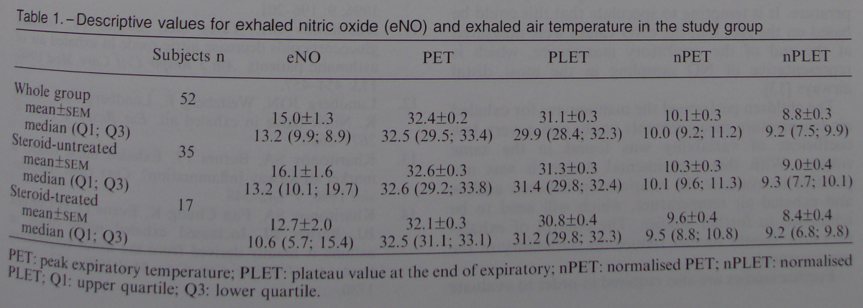

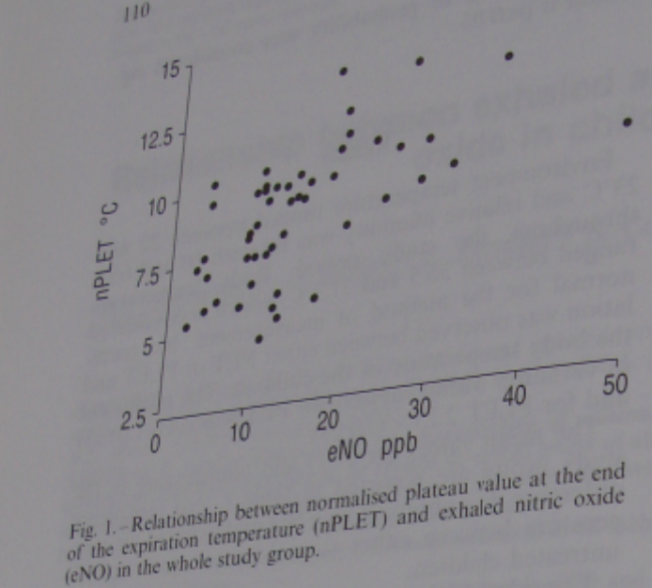
Discussion
In this study, significant positive correlations were found between the temperature of exhaled air
and eNO in allergic asthmatic children. This was a preliminary study aimed at exploring the hypothesis that airway
inflammation could be accompanied by an increase in temperature of exhaled air from asthmatic patients. The rationale of this hypothesis can be found both in increased vascularity and cell metabolism, which typically occurs in inflated airway wall in asthmatic subjects {1-3}. A possible relationship between the temperature of exhaled air and airway inflammation has recently been suggested by other groups. {15,16}
eNO was elected as surrogate marker of airway inflammation. Other more invasive assessments of airway inflammation might not be approved by the ethics committee in absence of any preliminary indicative results. However, since the relationship between eNO and airway inflammation is still under study and somewhat tenuous [8,17] further studies against “gold standards”, such as biopsies or sputum eosinophilia [18], need to be performed to validate the hypothesis that exhaled air can represent a marker of airway inflammation.
The present data suggest a better concordance between eNO levels and the end-exploratory air temperature. It is tempting to speculate that this could be based on the fact the the eNO values were measured at the end of the manoeuvre, which is representative of NO sampling in the most distal airways [13].
The children performed the manoeuvres for exhaled air temperature measurements easily and very low coefficient of variability was found in the same subject. With this experimental design it was not possible to evaluate the relationship between airflow and exhaled air temperature, which will need to be addressed in further studies. The control of exhalation flow should further reduce variability of the measurements. Further studies are also required in order to evaluate whether the level of concordance between the investigated parameters could be increased by controlling environmental temperature, exhaled air flow and pressure.
In conclusion the results of this preliminary study show that exhales air temperature is related to exhaled nitric oxide levels in asthmatic children. These results therefore suggest that the level of exhales air temperature could represent a potential method for assessment of airway inflammation in asthmatic patients and encourage a new filed of investigation in asthma research to be opened.

Kay AB. Asthma and inflammation. J. Allergy Clin Immonsol 1991; 87; 893-899
Djukanovic R, Roche WR, Wilson JW, Baedey CR, Twenyman OP, Holgate ST. Mucosal inflammation in asthma. Am Rev Respir Dis 1990;142;434-457
Busse WW.Inflammation and asthma : the cornerstone of the desease nad target therapy. J Albergy Clin Immonsol 1998; 102: 517-522.
Bousquet J, Jeffery PK, Busse WW, Johnson M, Vignola AM. Asthma from bronchoconstriction in airway inflammation and remodeling. Av J Renqic Crit Care Med 2000; 161; 1720-1745
Holgate ST. Biomarkers of asthma. Lancet 1998; 38; 1300-1301.
Kharitonov SA, Yates DH, Robbns RA, Logas-Sinclair R, Shinebourne EA, Barnes PJ. Increased nitric oxide in exhaled air of asthmatic patients Lncet 1994; 343; 133-135.
Jatakanon A, Kharitinov S, Chung K, Barnes PJ. Correlation between exhaled nitric oxide, spaten cosinophils and methacholine responsiveness in patients with mild asthma. Thorax 1998; 53; 93-95
Mattes J, van’s Gravesattide S, Reining U, et al . NO in exhaled air is correlated with markers eosinghale airway inflammation in corticolsteroid-dependent childhood asthma. Eur Respir J 1999; 13; 1391-1398.
Jatakanon A, Kharitinov SA, Lim S, Barnes PJ. Effect of differing doeses of inhaled budeosoride on markers of airway inflammation in patients with mild asthma. Thorax 1994 ; 54;108-114
Kharitonov SA, Yates DH, Chung K, Barnes PJ. Changes in the dose of inhaled steroid affect exhaled nitric oxide levels in asthmatic patients. Evr Respis J 1996; 9; 196-201.
Kharitonov SA, Yates DH, Barnes PJ. Inhaled glucorticoids decrease nitric oxide in exhaled air of asthmatic patients. Am J Respir Crit Care Med 1996; 153; 454-457
Lundberg JON, Weitzberg E, Lundberg JM, Alving K. Nitric oxide in exhaled air . Eur Respir 1996; 9;2671-2680
Kharitonov SA, Barnes PJ. Exhaled nitric oxide in marker of airway inflammation? Curr Opin Anesthoriol 1996; 9; 542-548
Kharitonov SA, Fan Chung K, Evans D, O’ Connor BJ, Barnes PJ. Increased exhaled nitric oxide in asthma is mainly derived from lower respiratory tract. Am J Respir Crit Care Med 1996; 153; 1773-1780

