Reflections: W05 – W08
Sergey Nelyapenko
Faculty of Computing & Data Sciences, Boston University
CDS DX 702 Experimental Design Semester 3
Professor Joshua Von Korff
November 02, 2025

Homework Reflection Week 5

Reflection 5.1 Draw a diagram for the following negative feedback loop
Here I model the negative feedback between sweating and body temperature with a time-indexed DAG to keep it acyclic. “High temperature at time t leads to more sweating at time t+1,” and “sweating at time t leads to lower temperature at time t+1.” This captures the idea that one variable increases the other while the second decreases the first, without drawing a forbidden two-way arrow in the same time step. Intuitively: when you get hot, you sweat more; that sweating cools you down, so next period your temperature drops, which then reduces the need to sweat. This is precisely the structure of a stabilizing (negative) feedback loop.
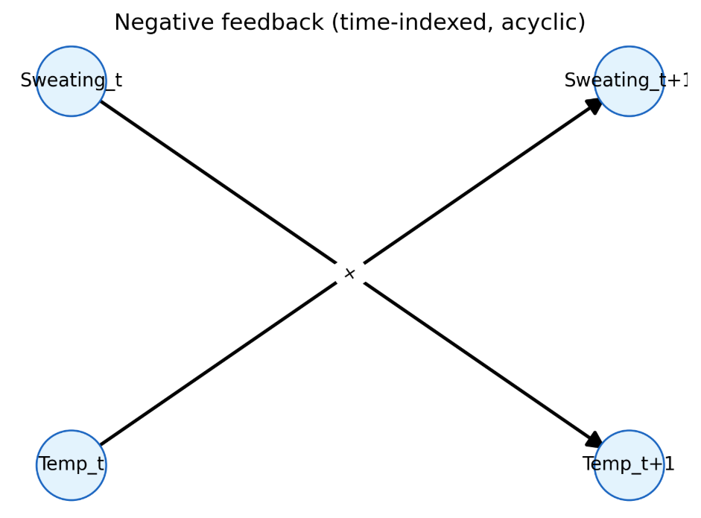
Figure 1. Negative feedback DAG (Sweating–Temperature, time-indexed).

Reflection 5.2 Positive feedback loop.
In this loop, increased study leads to higher skill, higher skill raises motivation, and greater motivation in turn increases future study. The result is a self-reinforcing cycle where early gains amplify over time. To keep the diagram acyclic, we time-index the links: Study_t -> Skill_t+1, Skill_t → Motivation_t+1, and Motivation_t -> Study_t+1.
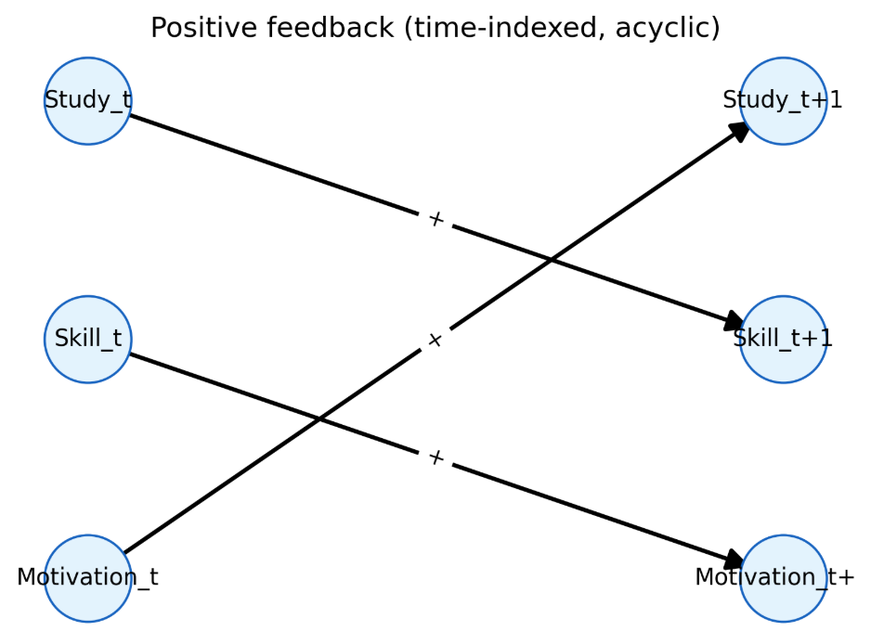
Figure 2. Positive feedback DAG.

Reflection 5.3 - Ecosystem DAG: Lightning, Bears, Deer, Flowers
This diagram encodes the ecosystem story: Lightning reduces Bears and Deer but increases Flowers; Bears reduce Deer; Deer reduce Flowers. The resulting DAG highlights the causal path Deer -> Flowers (negative) and the confounding backdoor Deer <- Lightning -> Flowers that must be blocked when estimating Deer’s effect on Flowers.

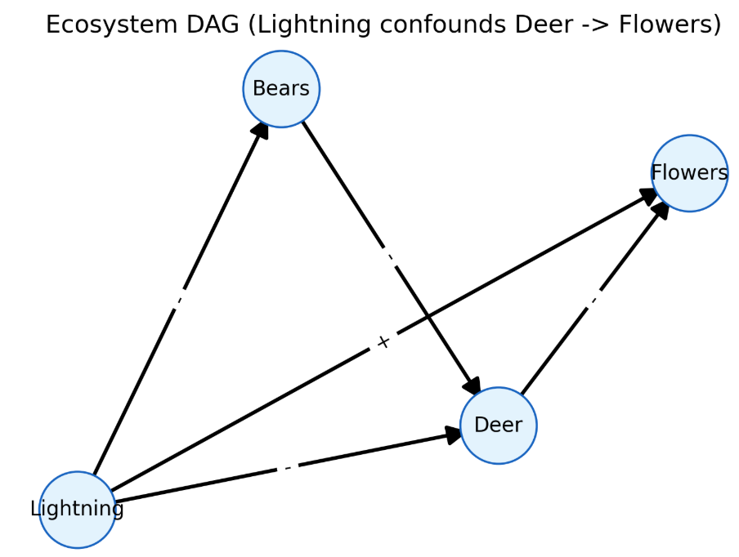
Figure 3. Ecosystem DAG: Lightning, Bears, Deer, Flowers.
Here is a snippet that generates a dataset simulating this scenario.
rng = np.random.default_rng(42)
n = 20000
Lightning = rng.binomial(1, 0.5, size=n) + rng.normal(0, 0.25, size=n)
# Bears - with Lightning + noise
Bears = 1.5 - 0.9 * Lightning + rng.normal(0, 0.5, size=n)
# Deer - with Lightning and - with Bears + noise
Deer = 2.0 - 0.8 * Lightning - 0.7 * Bears + rng.normal(0, 0.5, size=n)
# Flowers + with Lightning and - with Deer + noise
Flowers = 1.0 + 0.9 * Lightning - 0.8 * Deer + rng.normal(0, 0.5, size=n)
df = pd.DataFrame({"Lightning": Lightning, "Bears": Bears, "Deer": Deer, "Flowers": Flowers})

A clear backdoor path between deer and flowers is Deer <- Lightning -> Flowers. Lightning storms simultaneously reduce deer (they frighten deer away) and increase flowers (they stimulate growth), creating a spurious negative association between deer and flowers even if we’re trying to isolate the causal path Deer -> Flowers (deer eating flowers). In DAG terms, Lightning is a confounder opening the backdoor path Deer <- Lightning -> Flowers. To estimate the causal effect of deer on flowers, we should condition on Lightning (e.g., include it as a control), which blocks this backdoor and removes the confounding.

Reflection 5.4 - Draw a diagram for a situation of your own invention
This business DAG treats Ad Spend as the treatment-like node (X) and Sales as the outcome-like node (Y). Seasonality (holidays, promotions) is a confounder because it pushes up both Ad Spend and Sales, creating a spurious correlation that would bias the Ad-Spend->Sales effect if left uncontrolled. Online Buzz is a collider—it is increased by both Seasonality and an exogenous Viral Event—so conditioning on Buzz would open a backdoor path between its parents and induce bias; we therefore avoid controlling for it. The graph is acyclic and makes explicit which arrows encode the causal questions (Ad Spend -> Sales) and which arrows must be blocked (paths through Seasonality) to identify the effect.
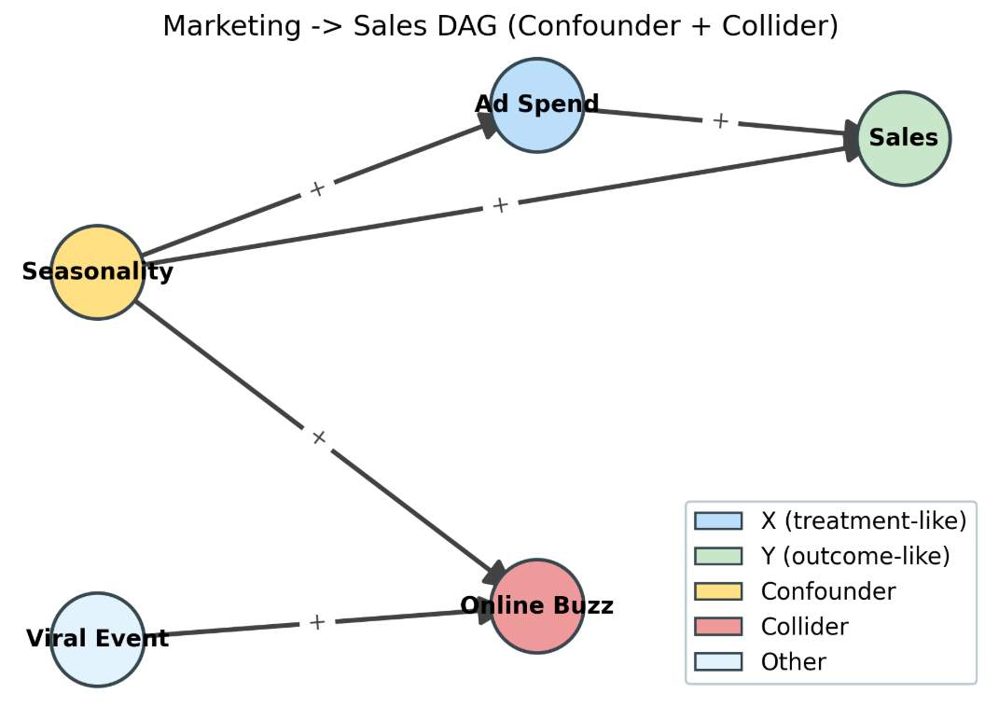
Figure 4. Invented business DAG: Ad Spend -> Sales with confounder and collider.

Homework Reflection Week 6

Reflection 6.1 Problem with Computing Marginal Treatment Effect
When we define the Marginal Treatment Effect (MTE) as the effect for the single untreated item with the largest estimated gain under treatment, a direct estimator that takes the sample maximum will tend to pick an extreme value that is large partly because of noise. In repeated samples, the maximum of noisy estimates is upward biased and very unstable (high variance). In other words, by definition we are selecting the noisiest tail observation, so randomness inflates the reported MTE.
The estimated maximum is on average larger than the true maximum and has much higher variability than a high percentile like the 90th. This demonstrates the instability of using the single most extreme counterfactual.

Reflection 6.2 Solution for Problem with Computing Marginal Treatment Effect
Estimating MTE using the single largest gain is unstable and upward-biased because the maximum of noisy estimates is extreme by chance. I report a high percentile of unit-level gains (here, the 90th) with a bootstrap confidence interval. This keeps the focus on high-gain units while reducing sensitivity to random extremes.
def mte_percentile(effects, q=0.90, n_boot=1000, rng=None):
rng = np.random.default_rng(rng)
effects = np.asarray(effects)
effects = effects[np.isfinite(effects)]
n = effects.size
if n == 0:
raise ValueError("effects is empty after removing NaNs/inf")

point = float(np.quantile(effects, q))
boots = []
for _ in range(n_boot):
idx = rng.integers(0, n, size=n)
boots.append(np.quantile(effects[idx], q))
boots = np.asarray(boots)
ci_low = float(np.quantile(boots, 0.025))
ci_high = float(np.quantile(boots, 0.975))
return {"percentile": q, "point": point, "ci_low": ci_low, "ci_high": ci_high, "n": n}
# Demo on simulated effects (stand in for your matched counterfactual estimates)
rng = np.random.default_rng(123)
n_untreated = 300
true_mte = 1.0
het_sd = 0.3
est_noise_sd = 0.5

true_eff = rng.normal(true_mte, het_sd, size=n_untreated)
est_eff = true_eff + rng.normal(0.0, est_noise_sd, size=n_untreated)
# Raw maximum vs percentile proxy
raw_max = float(np.max(est_eff))
proxy_90 = mte_percentile(est_eff, q=0.90, n_boot=1000, rng=999)

Homework Reflection Week 7

Reflection 7.1 Omitted confounder result
I create a data generating process where W is a confounder that affects both X and Y. The true model is Y = 1.0 * X + 2.0 * W + noise. I then estimate two regressions: the correct one (Y on X and W) and a misspecified one that omits W (Y on X only). Because X and W are positively correlated, omitting W pushes the X coefficient upward (overestimation). This is classic omitted variable bias: bias has the sign of beta_W times cov(X, W).
The histogram compares the sampling distribution of the X coefficient with and without the confounder W. When W is included (orange), estimates cluster around the true value near 1.0 (dashed line). When W is omitted (blue), the distribution shifts right to about 2.1- 2.3, clearly overestimating the effect of X. This occurs because W positively affects Y and is positively correlated with X; omitting W attributes some of W’s effect to X (classic omitted-variable bias).
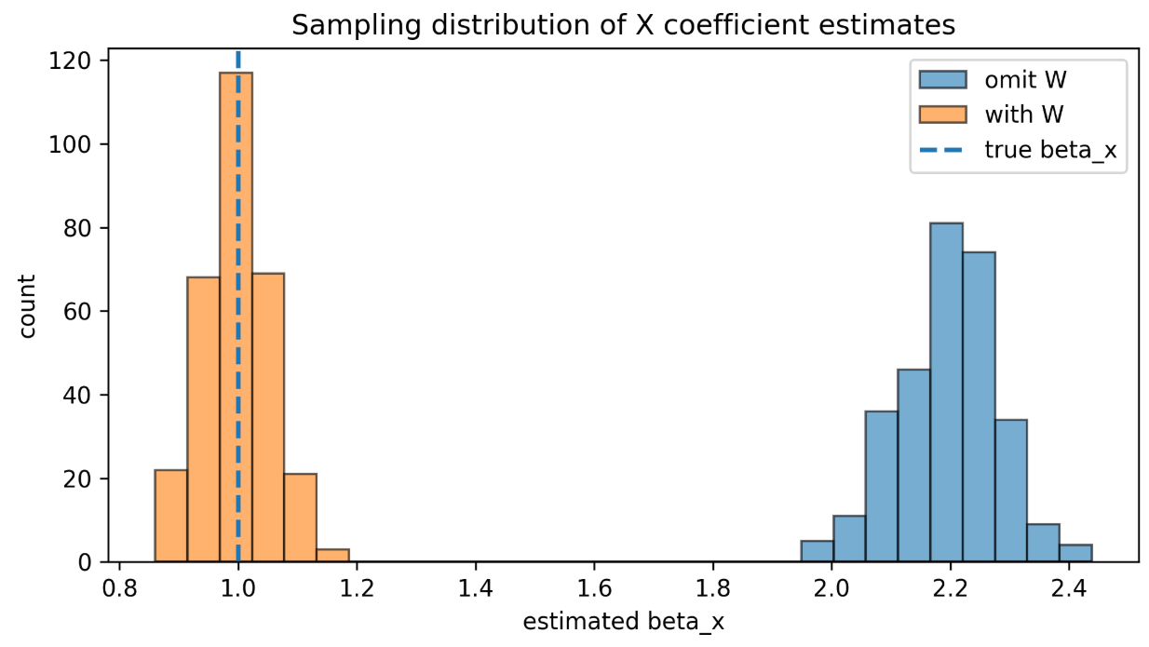
Figure 5. Sampling distribution of the X coefficient with and without the confounder W.

Reflection 7.2 False positives from repeated testing
I simulated a setting where the true effect of W is zero. Regressing Y on X and W across 1000 runs, the smallest p-value for W was very small, even though the true coefficient is zero. About 5% of runs produced p < 0.05, as expected under the null. Therefore, a single small p-value does not imply a real effect—repeating the analysis and cherry-picking the smallest p inflates the false-positive rate (p-hacking). Proper practice is to pre-specify the model or adjust for multiple testing and focus on effect sizes with confidence intervals.
The p-values are roughly uniform on [0,1] under the null, so about 5% fall below 0.05 by chance. The minimum p-value becomes smaller as the number of repeated runs increases, illustrating why rerunning analyses until a small p appears leads to spurious “discoveries.”
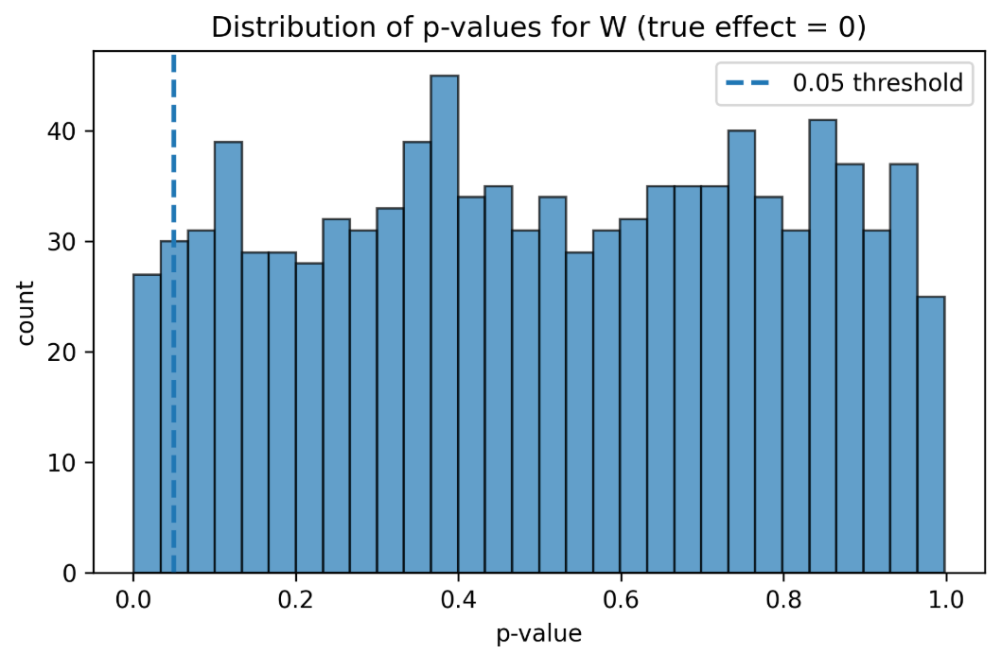
Figure 6. Distribution of p-values for W when the true effect is zero.
The share of significant results for W stays near 0.05 across T, as expected under the null. The minimum p-value drops rapidly as T grows, showing that repeated testing guarantees an extremely small p-value eventually. A small p after many tries does not imply a real effect; it reflects multiple testing.
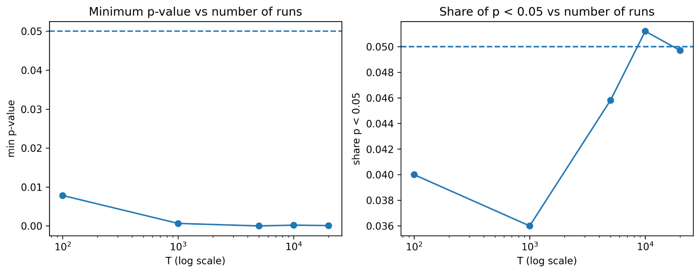
Figure 7. Minimum p-value vs. number of runs (log scale) and share of p-values below 0.05 vs. number of runs (log scale).

Homework Reflection Week 8

Reflection 8.1 Average treatment effect with inverse probability weighting
I estimated propensity scores with logistic regression P(X=1 | Z), clipped extreme probabilities, formed inverse probability weights, and computed an IPW ATE as the difference in weighted means of Y between treated and control units.
Obstacles and fixes
- Extreme propensities. Some units get p very close to 0 or 1, which explodes weights and variance. I clipped p to [eps, 1−eps]. This stabilizes the estimator but introduces a small bias; a common improvement is trimmed IPW or stabilized weights.
- Model misspecification. A single-variable logistic model P(X|Z) is simple and transparent, but if the true selection depends on nonlinearity or interactions, the weights can be noisy. A next step would be adding splines for Z or using cross-validated models while keeping interpretability.
- Positivity and overlap. IPW relies on overlap of Z across groups. I informally checked this via the range of propensities; a stronger approach would be plotting p(X=1|Z) histograms by treatment and considering trimming regions with poor overlap.
Insights
- IPW ATE is sensitive to a few highly weighted observations; clipping or trimming had an outsized effect on variance.
- “Model for treatment, not outcome” kept the workflow simple and matched the quiz instructions exactly.

Reflection 8.2 Average treatment effect with inverse probability weighting
I computed the inverse covariance of Z1, Z2, matched each treated unit to its nearest control by Mahalanobis distance (with replacement), reported ATT, then added a symmetric pass (controls matched to treated) and averaged the two directions as an ATE approximation. I also flagged the treated unit with the largest nearest-neighbor distance as “least common support.”
Obstacles and fixes
- Inverting the covariance. If Z columns are nearly collinear or poorly scaled, Σ can be ill-conditioned. Here it inverted cleanly, but in general I would standardize Z first or add a small ridge to Σ before inversion.
- With-replacement matching. It is simple and often lowers bias, but can reuse the same control many times, increasing variance. A caliper on distance is a useful guardrail; pairs beyond a threshold can be dropped to improve overlap quality.
- Estimand clarity. One-way treated -> control matching estimates ATT by design. To speak about ATE, I added the control→treated pass and averaged, which is a pragmatic but approximate fix; full ATE estimation may require different designs or weighting after matching.
Insights
- The “worst match” report (largest Mahalanobis distance) is a quick, interpretable common-support diagnostic that helped me justify trimming or sensitivity checks.
- Matching balances Z geometrically but does not guarantee balance in Y; post-match balance tables or standardized mean differences would be the next step before trusting effects.
What I would do next
- For IPW: try stabilized weights, bandwidth-free balance checks on Z, and trimming low-overlap regions.
- For matching: standardize Z, consider a caliper, report balance diagnostics, and bootstrap the ATT for uncertainty.

Acknowledgment
This document was reviewed with the assistance of ChatGPT, an AI language model developed by OpenAI, which was used solely to check grammar and spelling. All ideas and content presented in this work are entirely my own.

References
- Nelyapenko, (2025). Mod6-Sem3 Weekly Homework Repository GitHub. Homework-Reflections-5-8.ipynb. Retrieved from https://github.com/SergeyNelyapenkoBU/DX702-mod-6/blob/main/Homework-Reflections-5-8.ipynb
- Nelyapenko, (2025). Mod6-Sem3 Weekly Homework Repository GitHub. Week 5. Retrieved from https://github.com/SergeyNelyapenkoBU/DX702-mod-6/blob/main/homeworf_w05_quiz.py
- Nelyapenko, (2025). Mod6-Sem3 Weekly Homework Repository GitHub. Week 6. Retrieved from:
https://github.com/SergeyNelyapenkoBU/DX702-mod-6/blob/main/homeworf_w06_coding_quiz_01.py
https://github.com/SergeyNelyapenkoBU/DX702-mod-6/blob/main/homeworf_w06_reading_quiz.py
- Nelyapenko, (2025). Mod6-Sem3 Weekly Homework Repository GitHub. Week 7. Retrieved from:
https://github.com/SergeyNelyapenkoBU/DX702-mod-6/blob/main/homeworf_w07_01.py
https://github.com/SergeyNelyapenkoBU/DX702-mod-6/blob/main/homeworf_w07_02.py
https://github.com/SergeyNelyapenkoBU/DX702-mod-6/blob/main/homeworf_w07_03.py
- Nelyapenko, (2025). Mod6-Sem3 Weekly Homework Repository GitHub. Week 8. Retrieved from:
https://github.com/SergeyNelyapenkoBU/DX702-mod-6/blob/main/homeworf_w08_01.py
https://github.com/SergeyNelyapenkoBU/DX702-mod-6/blob/main/homeworf_w08_02.py

