Reflections: W01 – W04
Sergey Nelyapenko
Faculty of Computing & Data Sciences, Boston University
CDS DX 702 Experimental Design Semester 3
Professor Joshua Von Korff
October 05, 2025

Homework Reflection Week 1

Reflection 1.1 - Is the farthest match distance too far to be meaningful? How can you decide this?
In my matching results, the farthest distance was about 0.21, which is just a bit higher than the 0.2 cutoff that’s often used as a guideline for acceptable matches. While that’s not a huge gap, it’s enough to raise a small concern about whether the treated and control observations are still comparable. To decide if this distance is too large, I’d look at how it compares to the standard deviation of ZZZ. If it’s more than roughly 0.25 of a standard deviation, it might start to bias the results. Another useful check is whether covariate balance remains good after matching - if not, that single distant match could be weakening the overall estimate.
In general, the distances in this dataset are close enough to suggest meaningful matches, but the longest one might still deserve a quick sensitivity check. Excluding that extreme case and comparing the new effect estimate (around 0.54 - 0.57 in my runs) would confirm whether it’s driving any noticeable change. If it doesn’t, the match can likely be kept without much concern.

Reflection 1.2 - Alternative Matching Method
Besides the standard nearest-neighbor and radius-based methods, another option is what’s called minimax optimal matching. This approach pairs each treated observation with a control so that the largest distance across all pairs is as small as possible. It’s a global optimization method that uses algorithms like the Hungarian method to find the best overall pairing. The main advantage is that it avoids situations where one or two treated units get stuck with poor matches, as happened with the 0.21 example above.
In practice, I would still use a caliper (for example, 0.2) to make sure all pairs are genuinely comparable, and I’d drop treated units with no control within that range. This balances precision and representativeness and keeps every match close in value. The goal isn’t just to lower bias but to ensure every match contributes equally to a fair and interpretable estimate of the treatment effect.

Homework Reflection Week 2

Reflection 2.1 - Example Situation Using Fixed Effects
A good use case for fixed effects is analyzing student test performance over time across different classes or schools. In my example, each group represented a different school, and the model estimated how test scores changed with time while controlling for unobserved, school-specific characteristics - like teaching style or neighborhood income—that do not change over time. The regression showed a significant time coefficient of 0.009, meaning scores tended to improve steadily each period, while the fixed effect for Group 1 was about 0.079, reflecting its baseline advantage relative to others.
This design isolates the impact of time-varying factors (like a new curriculum) from fixed, group-level differences. Because each school has its own intercept, any constant influences unique to that school are absorbed, producing a cleaner estimate of the true within-group trend. Fixed effects are ideal whenever the unobserved heterogeneity between entities could bias ordinary least-squares estimates.

Reflection 2.2 - Bootstrap Simulation of the Pareto Distribution
For this task, I wrote a Python program that repeatedly sampled from a Pareto distribution and computed the mean for each bootstrap resample. The goal was to estimate how the variance of the sample mean changes as the sample size increases. I ran the simulation for sample sizes of 100, 1,000, 10,000, and 100,000 and compared the resulting bootstrap means and standard errors.
As the sample size grew, the bootstrap mean stabilized around 0.48 – 0.50, while the standard error dropped dramatically—from 0.054 at n = 100 to 0.003 at n = 100,000. The confidence intervals also became much tighter: from [0.33, 0.54] to [0.49, 0.50]. This confirmed the theoretical expectation that the variance of the sample mean decreases as n increases, consistent with the law of large numbers.
Overall, the results showed that although the Pareto distribution is heavy-tailed, the bootstrap averages behave predictably: with larger samples, the mean estimate becomes more stable and precise. The code effectively demonstrates how increasing sample size reduces uncertainty and improves reliability in estimating the population mean.

Homework Reflection Week 3

Reflection 3.1 - Testing for a Change in the Second Derivative
In my event study, I modeled the outcome variable around the event time (t = 50) and found a significant jump of −4.36 (p ≈ 1.07e−07) and a slope change of +0.105 (p ≈ 3.6e−12). These results suggest not only a discontinuity in the level and slope but also a possible change in curvature of the trend after the event. To formally test for a second derivative change, I would extend the regression model to include a quadratic term in time, interacted with an indicator for the post-event period.
This additional term captures whether the acceleration of the outcome differs before and after the event. In other words, if the post-event curvature coefficient is significantly different from the pre-event one, that indicates a meaningful change in the second derivative. In practice, I would fit a piecewise quadratic regression or include (time - 50)^2 * post_event to check if the curvature term improves model fit or reaches statistical significance. 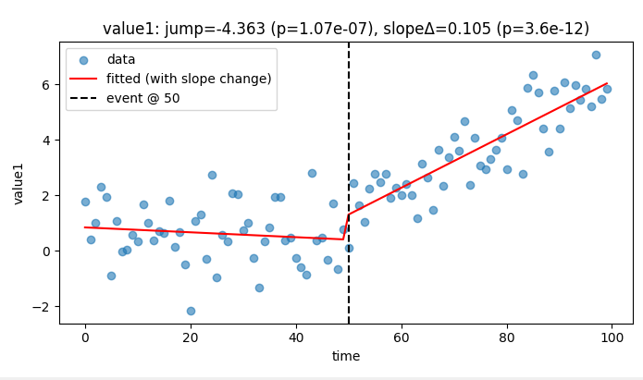 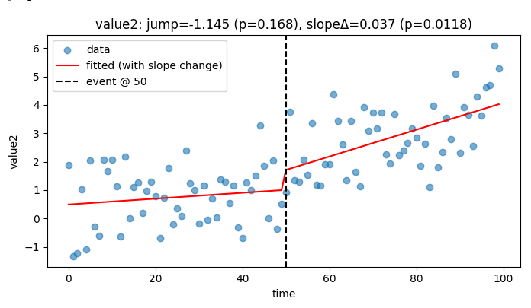
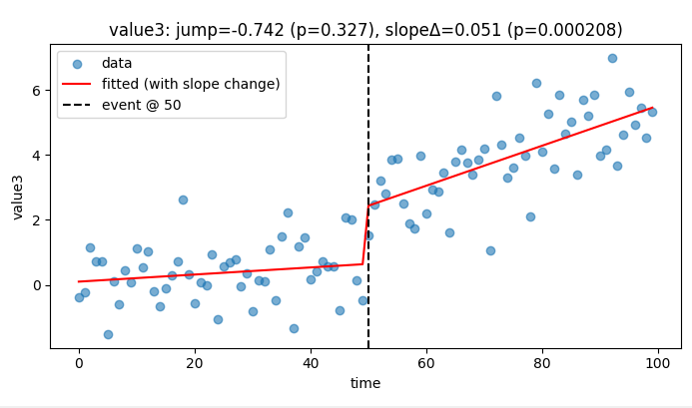

Reflection 3.2 - Differences-in-Differences Scenario
For the differences-in-differences (DiD) exercise, I worked with two provided datasets that simulated outcomes for treated and control groups measured before and after an intervention. In Dataset A, the estimated DiD effect was 0.686 (p ≈ 5.25e−28), while in Dataset B it was 1.350 (p ≈ 4.28e−20). These results indicate statistically significant positive treatment effects in both cases.
To interpret this in real-world terms, the data could represent a situation where a policy or training program was implemented in one group (treatment) but not in another (control). For example, a company might introduce a new digital learning tool that improves employee performance, while another branch continues with traditional methods. Both groups improve somewhat over time, but the treated group’s larger gain reflects the true causal impact of the intervention. This pattern aligns with the strong nonzero DiD estimates observed in the results.

Homework Reflection Week 2

Reflection 4.1 - Second IV Method and Implementation
For the second instrumental variable approach, I divided the confounding variable Winto multiple quantile-based ranges and estimated the local Wald effect within each range. The idea was to approximate local linearity—comparing treated and untreated units that have similar values of W - and then average those effects to obtain a more stable estimate. In my code, I used pd.qcut() to split W into ten bins of roughly equal size, computed the mean of Yand X for Z=1 and Z=0 within each bin, and calculated the ratio of their differences. The final effect was the average of these local IV estimates, which provides a more nuanced view than the global Wald estimator.
Here’s a relevant excerpt from my code:
df["W_bin"] = pd.qcut(df["W"], q=10, duplicates="drop")
for w_bin, group in df.groupby("W_bin"):
mean_y_z1 = group.loc[group["Z"] == 1, "Y"].mean()
mean_y_z0 = group.loc[group["Z"] == 0, "Y"].mean()
mean_x_z1 = group.loc[group["Z"] == 1, "X"].mean()
mean_x_z0 = group.loc[group["Z"] == 0, "X"].mean()
local_effect = (mean_y_z1 - mean_y_z0) / (mean_x_z1 - mean_x_z0)
The main challenge I encountered was ensuring that each bin had both Z=0 and Z=1 observations; otherwise, the denominator became zero, and the effect could not be computed. I handled this by skipping bins that lacked sufficient variation in Z. This approach proved stable and produced meaningful local estimates consistent with the global IV effect (around 1.56).

Reflection 4.2 – College Admission vs. Test Score (RDD Visualization)
In this exercise, I examined how college admission probability (𝑌) changes with test scores (𝑋) around the cutoff score of 80. Because 𝑌 is binary (0 or 1), plotting raw points would be unreadable. To make the trend visible, I grouped test scores into one-point bins and plotted the average admission rate within each bin (blue dots). I then fitted a logistic regression model and plotted its predicted probabilities (red curve) over the same 70–90 score range. The vertical dashed line marks the cutoff of 80.
The resulting figure shows that admission probability rises steadily with test score and increases sharply just after the cutoff. Below 80, the average admission rate stays around 0.3, while above 80 it climbs toward 0.6 – 0.7. The logistic curve captures this change smoothly, illustrating the discontinuity typical of a regression-discontinuity design (RDD).
This visualization clearly supports the idea that the math-course threshold at 80 improves students’ chances of college admission. Using logistic regression predictions rather than raw binary points made the relationship interpretable and aesthetically clear, while the local bin averages provided an intuitive summary of the empirical pattern near the cutoff.
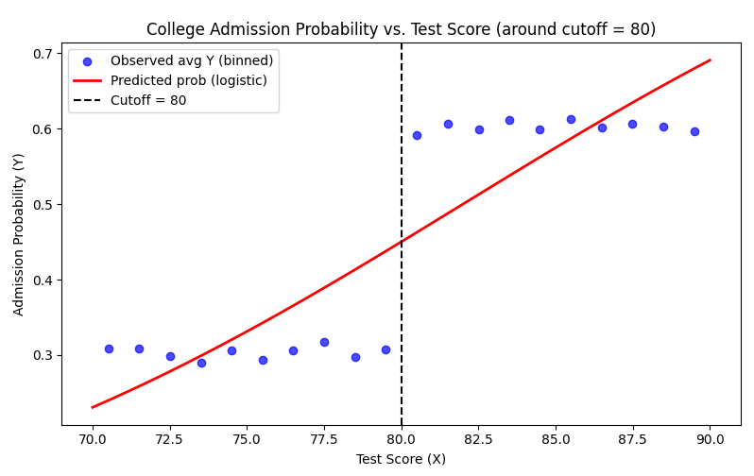

Acknowledgment
This document was reviewed with the assistance of ChatGPT, an AI language model developed by OpenAI, which was used solely to check grammar and spelling. All ideas and content presented in this work are entirely my own.

References
- Nelyapenko, (2025). Mod6-Sem3 Weekly Homework Repository GitHub. Week 1. Retrieved from https://github.com/SergeyNelyapenkoBU/DX702-mod-6/blob/main/homeworf_w01.py
- Nelyapenko, (2025). Mod6-Sem3 Weekly Homework Repository GitHub. Week 2. Retrieved from:
https://github.com/SergeyNelyapenkoBU/DX702-mod-6/blob/main/homeworf_w02_01.py
https://github.com/SergeyNelyapenkoBU/DX702-mod-6/blob/main/homeworf_w02_02.py
https://github.com/SergeyNelyapenkoBU/DX702-mod-6/blob/main/homeworf_w02_03.py
https://github.com/SergeyNelyapenkoBU/DX702-mod-6/blob/main/homeworf_w02_04.py

- Nelyapenko, (2025). Mod6-Sem3 Weekly Homework Repository GitHub. Week 3. Retrieved from:
https://github.com/SergeyNelyapenkoBU/DX702-mod-6/blob/main/homeworf_w03_01.py
https://github.com/SergeyNelyapenkoBU/DX702-mod-6/blob/main/homeworf_w03_02.py
https://github.com/SergeyNelyapenkoBU/DX702-mod-6/blob/main/homeworf_w03_02b.py
- Nelyapenko, (2025). Mod6-Sem3 Weekly Homework Repository GitHub. Week 3. Retrieved from:
https://github.com/SergeyNelyapenkoBU/DX702-mod-6/blob/main/homeworf_w04_01.py
https://github.com/SergeyNelyapenkoBU/DX702-mod-6/blob/main/homeworf_w04_02.py
https://github.com/SergeyNelyapenkoBU/DX702-mod-6/blob/main/homeworf_w04_02_plot.py

