|  |  |  |  |  |  |  |  |  |
| --- | --- | --- | --- | --- | --- | --- | --- | --- |
| № испытания | Число Компонентов | Число сетей | Max размер сети | Заполненость в % | Max по X | Max по Y | Ширина | Высота |
| 1 | 15 | 15 | 4 | 70 | 4 | 4 | 10 | 10 |
| 2 | 30 | 30 | 8 | 70 | 4 | 4 | 10 | 10 |
| 3 | 50 | 50 | 4 | 70 | 4 | 4 | 10 | 10 |
| 4 | 100 | 50 | 4 | 10 | 4 | 4 | 10 | 10 |
| 5 | 100 | 50 | 4 | 50 | 4 | 4 | 10 | 10 |
| 6 | 150 | 100 | 4 | 50 | 4 | 4 | 10 | 10 |
|  |  |  |  |  |  |  |  |  |
|  |  |  |  |  |  |  |  |  |
|  |  |  |  |  |  |  |  |  |
|  |  |  |  |  |  |  |  |  |
|  |  |  |  |  |  |  |  |  |

1.

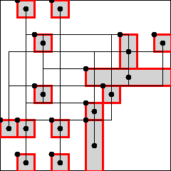

2.

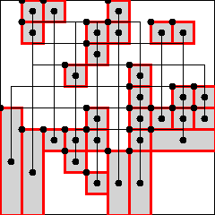

3.

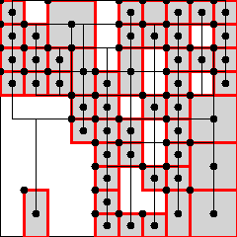

4.

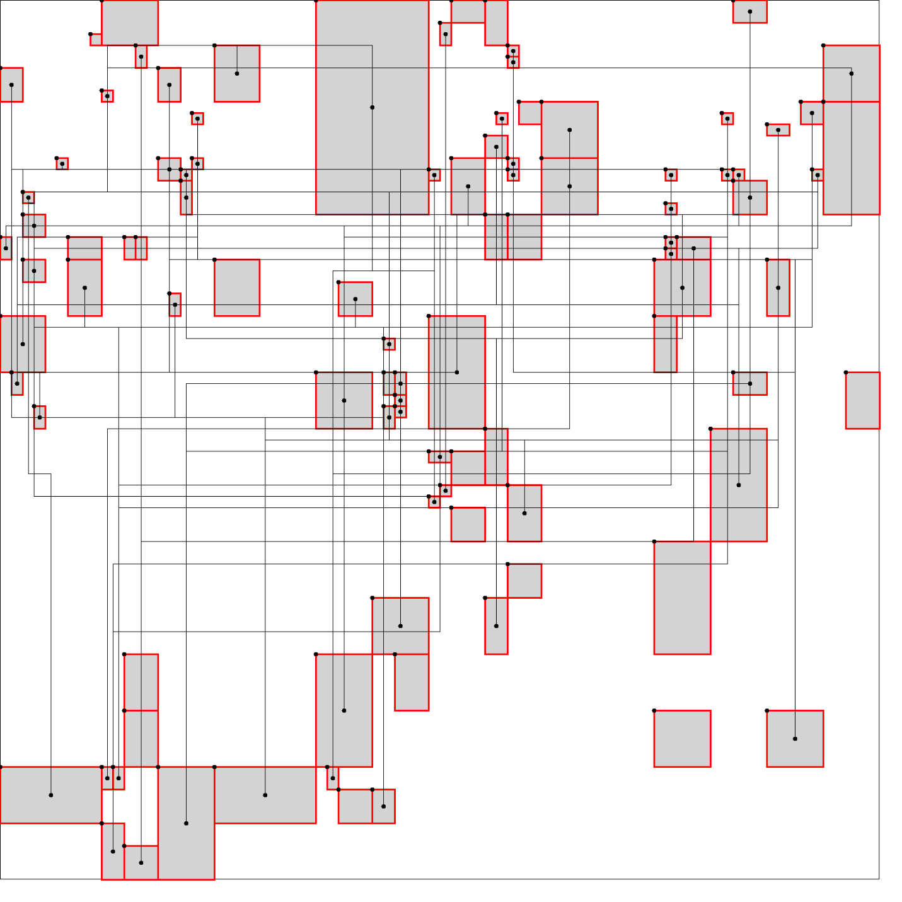

5.

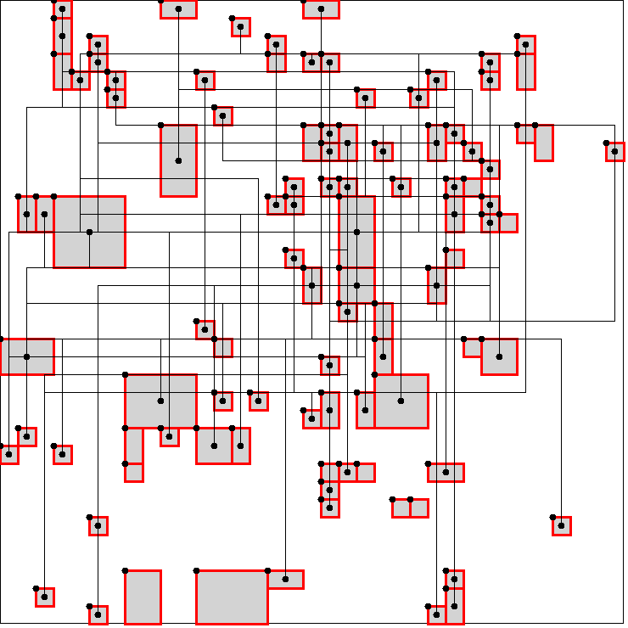

6.

