Touch Screen Kiosk

at

JOOLA Table Tennis Club

Author: Sergey Satskiy

Table of Contents

1. Overview 3

2. Hardware Bill of Materials 5

3. Software 5

4. Development Process 6

5. Reproducibility 6

# Overview

To make the Joola club even more attractive for members, for those who think about joining the club and people who help running the club it is possible to install a touch screen based kiosk in the playing area. It may look like a wall mounted touch screen and a PC to which the screen is attached can be completely hidden from players’ eyes. The touch screen is going to be the only way to communicate to the system.

The software which runs on the PC and displays information on the touch screen may serve the functions in the list below. Obviously this list can be extended later.

* Allow players to register themselves for routine competitions like Friday’s league, Sunday’s elite league etc.
* Form groups automatically or semi-automatically if there are many players.
* Provide a quick registration for those who played before at least once and retrieve the current official rating from USA TTF automatically via the Internet.
* Keep track of the round robin matches via an easy to use touch interface. The score is going to be entered by players.
* Provide access to the history of such tournaments.
* Export data to web site for easy access to the results from the Internet.
* Provide access to the players personal records. This may include many different views e.g. a player profile, a graph of the official rating, history of official and/or non-official matches.
* Support official tournaments.
* Printing certain tournaments results.

Some examples of non first priority features are data exporting to social networks, sending e-mails with results, pictures of players and ability for players to specify their own preferences as well as storing their pictures etc.

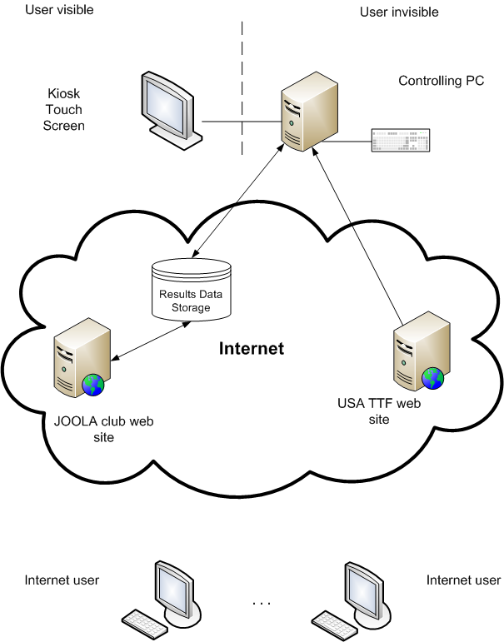

Figure 1. System Overview

There are a few scenarios of the data flow.

* The user comes to the touch screen and inputs the game results. The results are submitted to the data storage via a network interface. As soon as the results are submitted they become available for internet users to be seen via a web page on the Joola web server.
* The user comes to the touch screen and registers for a tournament. His current rating is retrieved from USA TTF web site and populated on the interface.
* The internet user visits the Joola web server and requests a page with last week tournament results. The results are retrieved from the data storage and shown on the generated web page.

These are just a few examples of the possible data flows.

# Hardware Bill of Materials

The required hardware may be split into the touch screen and the PC.

It seems to be reasonable to consider a 17 inches touch screen display as minimum for such a system. A smaller display will make it harder to be seen by many people simultaneously. Here are example quotes for some of the touch screen models taken from newegg.com:

|  |  |
| --- | --- |
| PLANAR PT1710mx, 1280 x 1024, 300 cd/m2, 17" | $550 |
| ELO TOUCHSYSTEMS 1939L(E171252) Black 19", 1024 x 768, 200 cd/m2 | $600 |
| ELO TOUCHSYSTEMS 2639L(E620330) Black 26", 1680 x 1050, 405 cd/m2 | $1050 |

There are no special requirements to the PC. Bearing in mind that the supposed software is not going to be greedy to the CPU speed it can be pretty much any Intel based hardware. Of course if it is necessary to have a blazing fast user interface then somewhat modern is required. So the PC price may vary from $200 to $500. It seems quite reasonable to have net top kind of compact modern PC equipped with a wireless network interface. It’ll make it easier to mount the PC, to move it from one place to another and to reduce electricity bills slightly. The disk space requirements are really minor so a small flash device will do the job.

# Software

It is reasonable to use Linux OS for this kind of project. It costs nothing, it can be customized for the certain application and it has minimal requirements to the disk space and to the hardware. The price of development tools for this OS is nothing as well. The OS can be customized for fast startup and shutdown time and for showing only the supposed user interface hiding from the end user how it is done.

The application part needs to be developed. It might be implemented as a set of Python scripts which run under X Server instead of a Window manager. This will make it impossible to hack the system using the user available hardware.

It seems to be reasonable to have from 1 to 3 developers involved into the process and a designer who will provide screen layouts and graphics.

Bearing in mind that:

* the complexity of the project is not high
* the reliability requirements are not strict

the stage of a dedicated testing can be omitted. All the found mistakes can be fixed without any special schedule and the newer versions of the software can be deployed as required.

# Development Process

The following steps need to be done:

* Setup a revision control system
* Setup a bug tracking system
* Write a complete set of requirements. These requirements should also consider some hardware specific aspects (e.g. screen resolution requirements, network connectivity)
* Arrange the requirements in a few groups in accordance with priorities.
* Write a system design document which describes how the system works at the certain level of details.
* Start designing a user interface and developing certain parts of the application.
* As soon as the first working prototype is ready the actual hardware should be purchased (at least the touch screen).
* Finishing the development of the first version of the application.
* Customize the Linux installation for the target hardware and deploy the first application version on the target hardware.
* Deploy the whole system in the club.

Starting from this point the new features can be added to the system step by step.

# Reproducibility

There is no actual need to provide a complex and absolutely safe transaction oriented mechanism of communicating to data storage. The only basic level of atomicity is required when data is committed. Therefore:

* the software can be simply copied from one kiosk to another
* both a touch screen and a PC should be purchased for another kiosk

This makes it very easy to have simultaneously working a kiosk in the club hall and a few of them in the playing area.