LabWork: Performance Issues

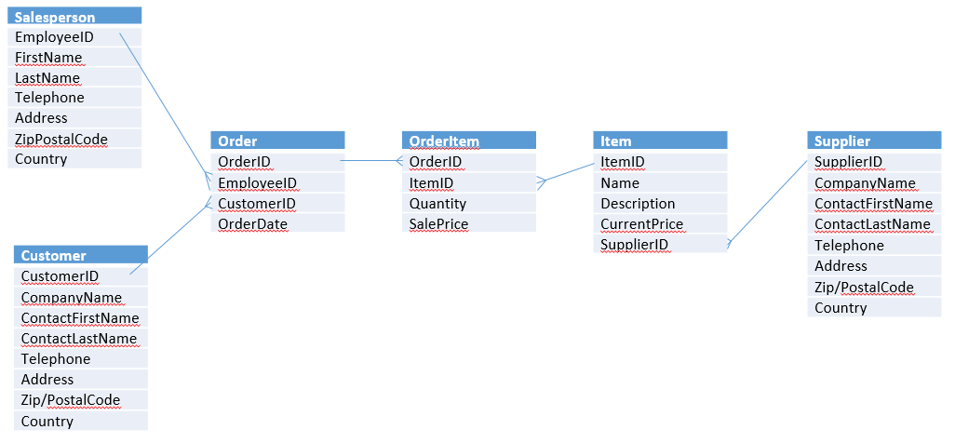

|  |  |  |
| --- | --- | --- |
| Таблица | Кластерный индекс | Не кластерный индекс |
| Salesperson | EnployeedID | LastName  Country |
| Customer | CustomerID | CompanyName |
| Order | OrderID | EnployeedID  OrderDate |
| OrderItem | OrderID | ItemID  Quantity  SalePrice |
| Item | ItemID | Name |
| Supplier | SupplierID | CompanyName |