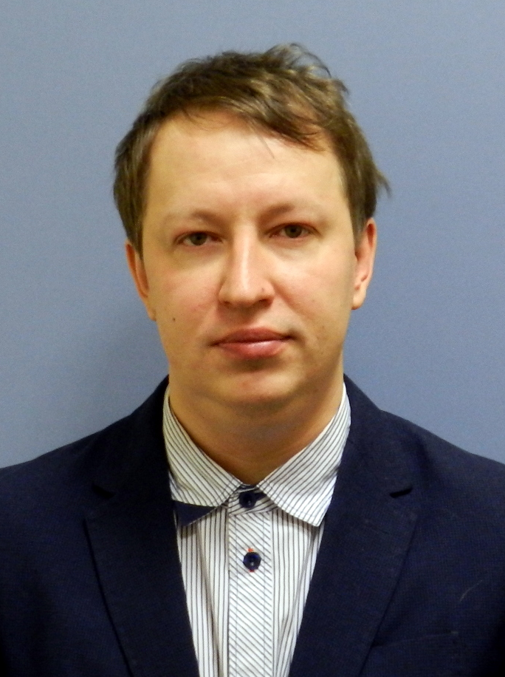
Sergey A. Solarev

E-mail: solarev@mail.ru
Phone/WhatsApp
/Telegram (preferred) : +7(960)249-3282
Telegram: Solamons
Skype: solarevw
Date of birth: 16 March 1979.
Residence: Russia, St. Petersburg

Software Test LEAD / SENIOR TEST Automation

Summary
- Mature results-oriented Automation QA with over 21 years of unparalleled experience in Software Testing and Development processes
- Proficient with backend automation testing using GO/C#/Java / Python, frontend automation testing using C#/Java/ QTP/JMeter
- Expert skills in Load/Performance testing using JMeter/C#
- Experience with Security and vulnerability testing
- Solid applied experience with databases testing (Oracle, MySQL, MSSQL, and PostgreSQL)
- Hands-on experience with desktop/browser GUI testing, mobile testing, server-side testing, REST testing
- More than three years of extensive experience with banking and trading software
- Since 2001 worked in cooperation with international teams including managing positions
Skills and Awards:
Testing:
- Test Types: Accessibility Testing; ESB-based System Testing; Embedded Software Testing; Exploratory testing; Extract, transform, and load (ETL) Testing; Functional testing; GUI Testing; Installation Testing; Mobile Testing; Performance Testing; Security and vulnerability Testing
- Test Levels: End2End / Component / Integration Testing, Unit testing
- Performance testing: Apache JMeter, C# based self-made application
- API Testing: REST Assured
- Web UI Testing: Selenium
- Unit Testing: GOLang test, JUnit, Microsoft Unit Test Framework (MS Unit), Pytest, TestNG
- Acceptance Testing: Cucumber
- Test Management Tools: Mercury Quality Center, QA Director, TestRail, Zephyr plug-in for JIRA
- Test Automation Frameworks: Robot Framework, Test Automation Framework Design
- Multipurpose Tools: Green Hat Tester, HP UFT (QuickTest Pro), IBM Rational Functional Tester, TestComplete
- Security Testing: Infrastructure Security Testing, Mobile Applications Security Testing, Web Applications Security Testing
Software Construction:
- Construction Languages: C# (.Net Framework 4.8, .Net core 2.0, .Net 6.0), Java8, Go lang, PL/SQL, Pascal, Python (2.4, 3.1), Borland Delphi, T-SQL, VB.Net, Visual Basic, VBA (Visual Basic for Applications), VBS (Visual Basic Script), C for embedded (no OS), C++
- Building Tools: Ant/NAnt/CPPAnt, Maven, Atlassian Bamboo, Jenkins, Make, TeamCity, MSBuild
- Programming Technologies: ActiveX, COM (including DCOM, COM+), Visual Studio Add-Ons, WinAPI, Atlassian Plugin Development Platform, Java SE
- Integrated Development Environments: Borland JBuilder, Eclipse IDE, IntelliJ IDEA, NetBeans IDE, Oracle JDeveloper, Borland CBuilder, Oracle SQL Developer, PL/SQL Developer, PyCharm, Toad for Oracle, MS Visual Studio
- Databases: H2, MySQL, PostgreSQL, SQLite, Oracle, Dynamo DB, Mongo DB
- Operating Systems: Android OS, FreeBSD, IBM AIX, Linux, Sun Solaris, MS Windows, Windows Server
- Scripting Languages: AWK, Bash, JavaScript, Lua, Sed, Tcl, VBScript, PySpark
- Version Control Systems: Team Foundation Version Control, Mercurial, Perforce, Subversion, GIT
- Methodologies: Acceptance Test-Driven Development/Behavior Driven Development, Feature Driven Development (FDD), Agile, KANBAN, SCRUM, SCRUMBAN, Waterfall model
- Cloud: Amazon CloudWatch, Amazon EC2 Container Service, Amazon Elasticsearch Service, Amazon Simple Storage Service (S3)
- Content management: Confluence
- Virtualization Tools: Oracle VirtualBox, VMware Server, VMware Workstation, Vagrant, Red Hat Enterprise Virtualization
Misc.:
- Project Management/Defect Tracking Systems: Gemini, HP ALM, HP Quality Center, JIRA, JetBrains YouTrack, MS Project, MS Project Server, Microsoft TFS
- Technical Writer Tools: Adobe Acrobat Professional, Help & Manual, MS Word, OpenOffice, Vim
- Network protocols: TCP, UDP, SCTP
- Spoken Languages: English, Russian

Work Experience
SELF Projects
- Market robot vs terminal (for internal use)
- 4 concurrent threads
- MS Machine Learning vs terminal
- C#, Tinkoff Broker API, FinnHub trade API, Windows Forms, 22000 lines of code
- Deep graph and history analysis
- Local FB2 Books library: C#

Oct2021 – Now – Senior Software Test Automation Engineer (GoLang), DINO Systems (Nordigy),
https://www.ringcentral.com/
Project: ArchOps Automation
Tasks performed:
- Create API automation tests using Go Lang
- Create CI using GitLab + Docker

Environment:
- Go Lang
- Git Lab, Docker, Docker-Compose, Puppet + foreman
- Jira, Confluence
- Open LDAP, Maria DB

Apr2020 – Sep 2021 – Senior Software Test Automation Engineer (Java), EPAM Systems,
https://www.epam.com
Project: IDBS
Tasks performed:
- Create UI automation tests using Robot Framework
- Create API automation tests using Robot Framework
- New keywords (Python, Robot) for IDBS automation framework
- Configure AWS environment (Linux EC2 instance)

Environment:
- Robot Framework, Python 2.4, Snowflake
- AWS S3, AWS EC2, AWS cloud watch, AWS lambda, Dynamo DB, Mongo DB, Snowflake
- Jenkins, TARA (IDBS Automation Reporting Application), Jira, Confluence

Jan2020- Mar2020 – Senior Software Developer, EPAM Systems,
https://www.epam.com
Project: JDI (JDI is EPAMs automation test framework)
Tasks performed:
- Bug fixing
Environment:
- Java 8, Node JS

May2019- Dec2019 – Senior Software Test Automation Engineer (Java), EPAM Systems, https://www.epam.com
Project: Novartis
Tasks performed:
- Created code analysis plugin for sonar qube (multi language analysis)
Environment:
- GIT, SonarQube SDK, Java 8, Hive, HBase, Impala, Linux

Jun-2018 – May2019 – Senior Software Test Automation Engineer (Java), EPAM Systems, https://www.epam.com
Project: Ebsco
Tasks performed:
- Created automation tests
Environment:
- AWS Cloud watch, AWS S3, AWS Batch, AWS Glue, Dynamo DB, Mongo DB, AWS Elastic Container Service, AWS Elastic, AWS Glue, AWS Steps Functions
- Java 8, Idea

Oct-2017 – May-2018) – Senior Software Test Automation Engineer (C#), EPAM Systems, https://www.epam.com
Project: Enhanced Automations Platform. Deliver news and data at both Low Latency (< 1s) for desktop customers and Ultra Low Latency for algorithmic traders (< 0.1s) Automating tasks that unnecessarily consume a journalist’s time, detracting from other news they could be adding value too
Tasks performed:
- Created test approach
- Developed QA test harness for working in AWS environment. Test harness contains file server, REST API, UI, proxy server and AWS clients
Environment:
- AWS Cloudwatch, AWS S3, AWS EC2, AWS Elastic Container Service, Visual Studio, Docker
- Dockers, Linux, C#, C# MVC

Oct-2015 - Sep-2017 - Test Manager, Luxoft, https://www.luxoft.com/
Project: Atlassian expertise (JIRA, Confluence, Crowd, Bitbucket, HipChat) for Luxoft internal projects and external customers.); Luxoft corporate portal and management platform; Luxoft corporate mobile application; Luxoft add-ons for Atlassian products (JIRA/Confluence)
Tasks performed:
- Carried out performance and load testing (Java/JMeter)
- Performed test automation driving (Selenium + Java, VBA)
- Provided testing practice management and driving
- Performed L3/L4 support
- Implemented Atlassian products support and maintenance: JIRA/Confluence administration
Environment:
- Oracle, HQL, MS SQL, MySQL, PostgreSQL
- Visio, MS Office, JMeter, Postman, IntelliJ IDEA, SQL Developer
- Altlassian stack (JIRA, Confluence, Crowd, Bitbucket, HipChat)
- Java + Test NG, VBA, Linux, Windows

Aug-2013 - Oct-2015 - Senior Performance Tester, Swordfish security, https://swordfishsecurity.ru/
Project: SSH/HTTPS keys protection and security
Tasks performed:
- Collaborated with colleagues from the US and Finland
- Wrote Test Plans and Test cases using TestRail
- Performed UI testing, HTTP/HTTPS testing (using C# framework, Java framework, Python framework, Wireshark, Fiddler, Chrome REST plug in)
- Created integration tests using Python (PyCharm IDE)
- Created integration tests using C# (using test.net from Visual Studio 2013 with Resharper)
- Created integration tests using Java
- Created test framework for SSH project using C# (it included remote command execution on Linux, Windows (SSH), Solaris, and AIX. HPUX, Rest API functions, MS SQL database access, TestRail integration, SSH keys creation, reporting and logging)
- Used JMeter for writing performance scripts
- Used Linux Bash and Windows Bat for writing scripts
- Analyzed performance results (time metrics, memory utilization, cpu utilization)
- Worked with the OpenSSH 5x-6.8, Tectia SSH 4x-6x protocols
- Configured Windows Server 2008//2012 (including IIS)
- Worked with command line on Linux, Windows, Sun Solaris, AIX, HPUX
- Created *nix bash scripts
- Created bat scripts on Windows (working with installer (msinstall.exe), wmic; databases: Oracle, MS SQL; SSH commands; add/remove OS users
- Worked with databases: Oracle and MSSQL: create/drop databases, huge selects (Oracle: users, synonyms, grants)
- Working with VMWare, Virtual Box, Vagrant
- Created load model
- Checked performance metrics for Perforce GITLAB project and Perforce swarm project
Environment:
- Oracle, MS SQL
- Virtual Box, VM Ware, Red Had virtualization, Visual Studio, IntelliJ IDEA, MS Office
- OpenSSH 5x-6.8, Tectia SSH 4x-6x, C# framework, Java framework, Python framework, Wireshark, Fiddler, Chrome Postman, Bash, VBS, VBA, JMeter + Selenium + JavaScript, Perforce p4, Linux, Windows

Nov-2012 - Jul-2013 - Senior QA Engineer, JetBrains, https://www.jetbrains.com/
Project: TeamCity continuous integration server
Tasks performed:
- Performed functional, performance, integration and vulnerability testing
Environment:
- Oracle, MySQL, PostgreSQL, HSQL
- TeamCity, Visual Studio, IntelliJ IDEA
- Version control systems: Git, Mercurial, CVS, SVN, Perforce, TFS
- OS: Linux, Win7, Win8, Android
- WEB & security: HTTP, HTTPS, SSH, XSS
- Scripts: VBS, VBA, Bash, DOS batch (with Cygwin)
- Bug tracker: YouTrack

Sep-2010 - Nov-2012 - QA Lead, Luxoft, https://www.luxoft.com/
Project: Observation and analysis of the excess of the limits trades for Deutsche Bank forex market
Tasks performed:
- Developed and managed QA Process
- Carried out SQL query analysis and performance analysis
- Wrote test script on VBS, VBA, QTP
- Performed manual and automation testing
- Improved test process
- Conducted all communications with English speaking German customers
- Carried out planning, team coordination, task delegation and risk management
- Wrote project documentation (e.t. trade workflow specification)
- Wrote test-plans and test-cases
- Analyzed new features and performed reporting
- Developed auxiliary tools (using Java, VBA, VBS)
Environment:
- Oracle
- VBA, QTP, MS Project, GreenHat, Pl/SQL developer, Visual Studio, SVN, MS Office, HP QC

Jan-2009 - Jun-2010 - Senior Performance Tester, The Now Factory (Acquired by IBM In 2013)
Project: Telecommunication industry. Network analyzer
Tasks performed:
- Performed GUI testing (Web + Java + Flash)
- Carried out performance analysis, DB Structure analysis, SQL query analysis
- Developed auxiliary tools (using Java, VBA, VB)
- Improved test process
Environment:
- Oracle, PostgreSQL
- NetBeans, Eclipse, Visual Studio 6, MS Office, TestComplete, SVN, Maven, PL/SQL Developer
- Web, Flash, HTTP

Jun-2009 - Sep-2009 - Senior Automation QA Engineer, Motorola
Project: Quality of WIMAX software
Tasks performed:
- Wrote test-plans and test-cases
- Wrote test scripts on LUA, VBA, Perl
- Improved test process
Environment:
- Motorola BCU, Telnet, MS Office, WiMAX, LUA, VBA, Perl

Oct-2005 - Dec-2008 - Automation QA/Manual QA, Alcatel-Lucent (Acquired by Nokia In 2016)
Project: Integration and system testing for mobile soft switch
Tasks performed:
- Wrote test-plans and test-cases
- Performed integration, validation and system testing
- Performed onsite testing
- Wrote scripts for SS7 emulators
- Sustained software releases for CIS deployments
- Carried out software maintenance
Environment:
- Oracle, TimesTen
- SS7 emulators, mobile soft switch, Visual Basic, TCL, Bash, SS7, 3G, sun Solaris

Sep-2001 - Sep-2005 – QA/Embedded Developer, Konvest-Inform (RonTelecom), http://www.rontel.ru/
Project: Rural digital exchange DRX-4
Tasks performed:
- Wrote test-plans, test-cases and test scripts
- Carried out functional, handshaking and interoperability testing
- Designed SORM tester using C++, script language for SORM tester, user interface and test report master
- Wrote scripts for DRX-4 operator actions emulations
- Fixed issues with code
- Created technical requirements
- Participated in SORM certification
- Participated in presale
Environment:
- Secure CRT, SNTLite, SORM tester CAD-UL ANSI C, CAD-UL ANSI Cross Assembler, SNT-LITE, E1, R1.5, Gemini (Issue control)
- Telecom protocols (PRI, SS7, E1, R1.5), C, ASM, x86 Architecture, Borland C++

Education
Graduation Year: 2001
Name of the Education Establishment: South Ural State University
Faculty/College: Computer Technologies, Control and Radio Electronics
Degree (diploma): Master

