CrazyTalk

Uml diagrams

Messages class diagram

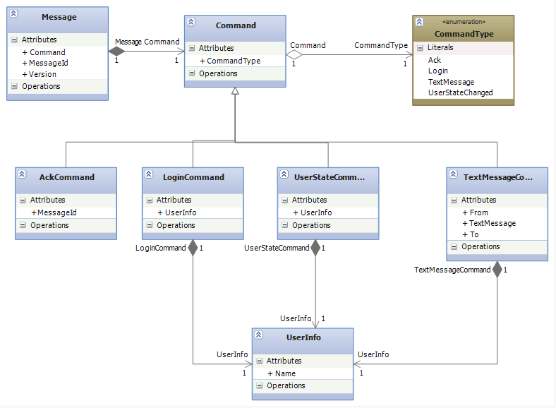

Login sequence diagram

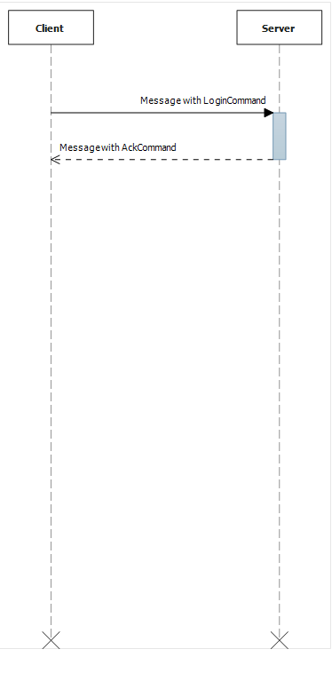

Message samples

Login

<message>  
  <version>1</version>  
  <messageId>123</messageId>  
  <command type=""Login"">  
    <userInfo>  
      <name>User name</name>  
    </userInfo>  
  </command>  
 </message>

Ack

<message>  
  <version>1</version>  
  <messageId>123</messageId>  
  <command type=""Ack"">  
    <messageId>321</messageId>  
  </command>  
 </message>

UserStateChanged

<message>  
  <version>1</version>  
  <messageId>123</messageId>  
  <command type=""UserState"">  
    <userInfo>  
      <name>Another user name</name>  
    </userInfo>  
    <userState>Some user state</userState>  
  </command>  
 </message>

TextMessage

<message>  
  <version>1</version>  
  <messageId>123</messageId>  
  <command type=""TextMessage"">  
    <from>  
      <userInfo>  
        <name>Sender</name>  
      </userInfo>  
    </from>  
    <to>  
      <userInfo>  
        <name>Receiver</name>  
      </userInfo>  
    </to>  
    <textMessage>Some silly text message</textMessage>  
  </command>  
 </message>