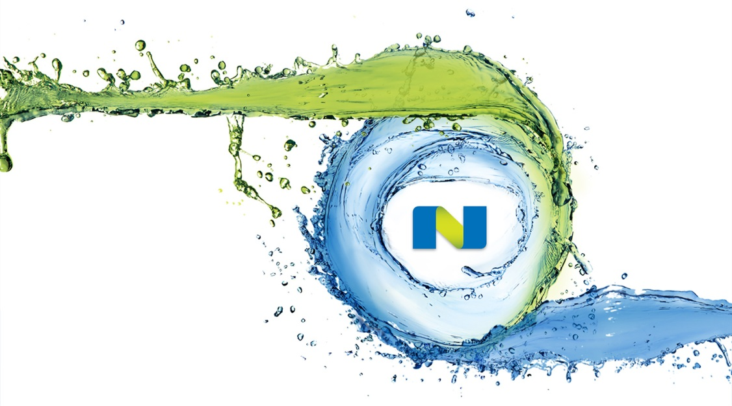VMware Horizon on Nutanix

Reference Architecture

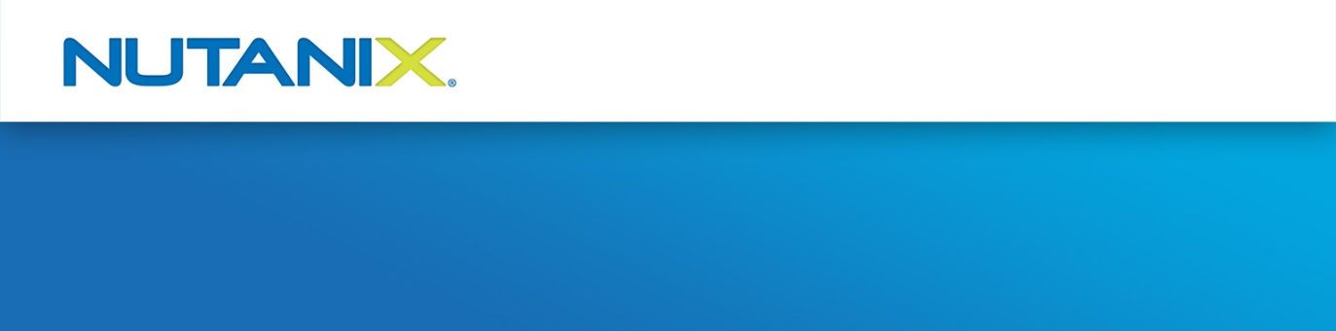v1.0 – February 2013

API Demo 2.0

Requirements & How-To Instructions

### Requirements

To run the SE Team’s API Demo 2.0 on a local workstation you’ll need an OS X or Windows workstation capable of operating as a development environment. The easiest way of doing this without manual configuration is to download and install MAMP (Mac/Apache/MySQL/PHP) from <https://www.mamp.info/en/downloads/>.

Notes for Windows users:

* .NET Framework 4.0 is required to install MAMP, although the MAMP installer can do this for you
* The ‘MAMP PRO’ component is optional and can be deselected during installation (it requires a license)

To get started:

* Using the ‘Download ZIP’ link, download the source repository from <https://github.com/digitalformula/public-scripts/>
* Extract the ZIP file to a location that makes sense e.g. ~/Documents/Demos on OS X or ‘Documents/Demos’ on Windows

Once installed, refer to the section below for further configuration. These steps should only take around 5 minutes.

### Option 1 – Use MAMP Application (Easiest)

* Open MAMP from the Applications folder (OS X) or Start button > All Programs (Windows)
* Select Preferences, open the Web Server tab and set the home directory to the following folder – this assumes the files are in *~/Documents/Demos* on OS X. Change the path to match your system, if necessary.

|  |
| --- |
| *~/Documents/Demos/public-scripts-master/nutanix/api-demo-2.0/public* |

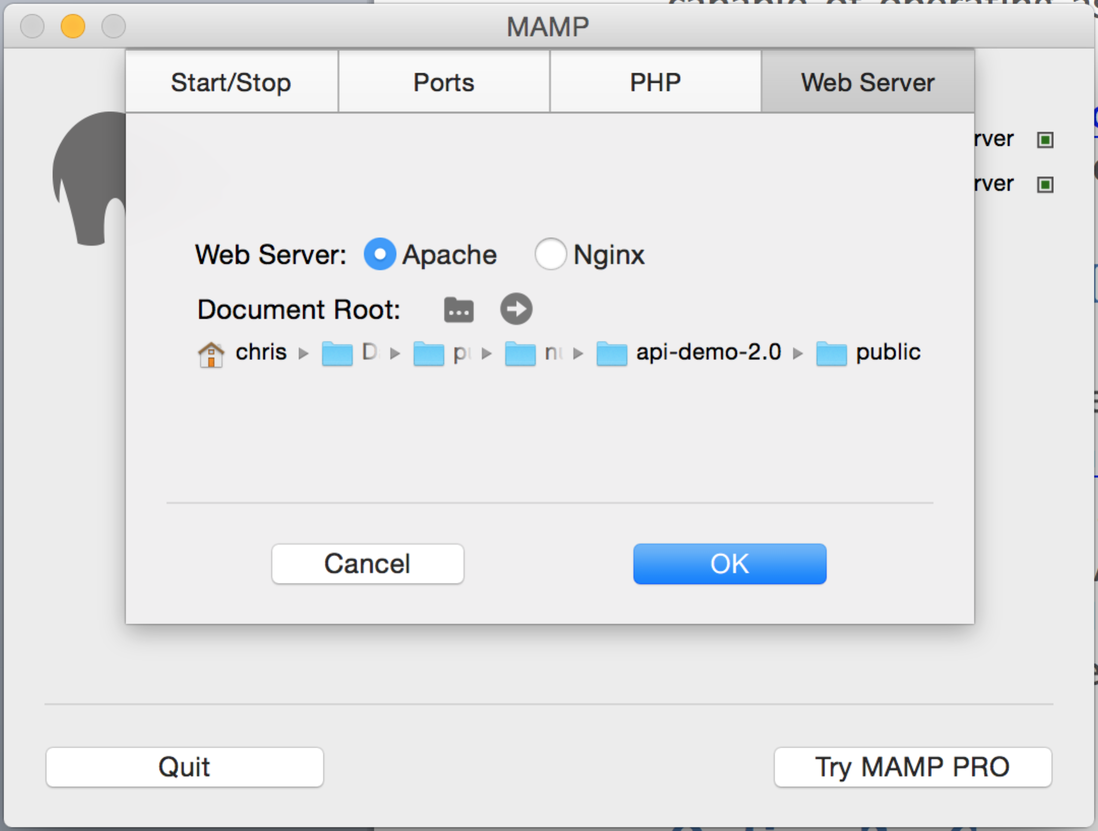

* Click ‘OK’
* Click ‘Start Servers’
* Browse <http://localhost:8888> (OS X) or <http://localhost:80> (Windows). If required, the Apache port can be changed by opening the ‘Ports’ tab after selecting ‘Preferences’.

At this point you should have a fully functioning demo environment that can successfully run the API demo.

### Option 2 – OS X Command Line (for CamO)

Why? I’ve found MAMP can use more resources than I want it to – running the demo from command line is lighter, e.g. if you are running a Windows or Foundation VM at the same time.

Open a terminal session or command prompt and enter the following command.

|  |
| --- |
| *which php* |

This will return the path to the PHP binary file, similar to the following:

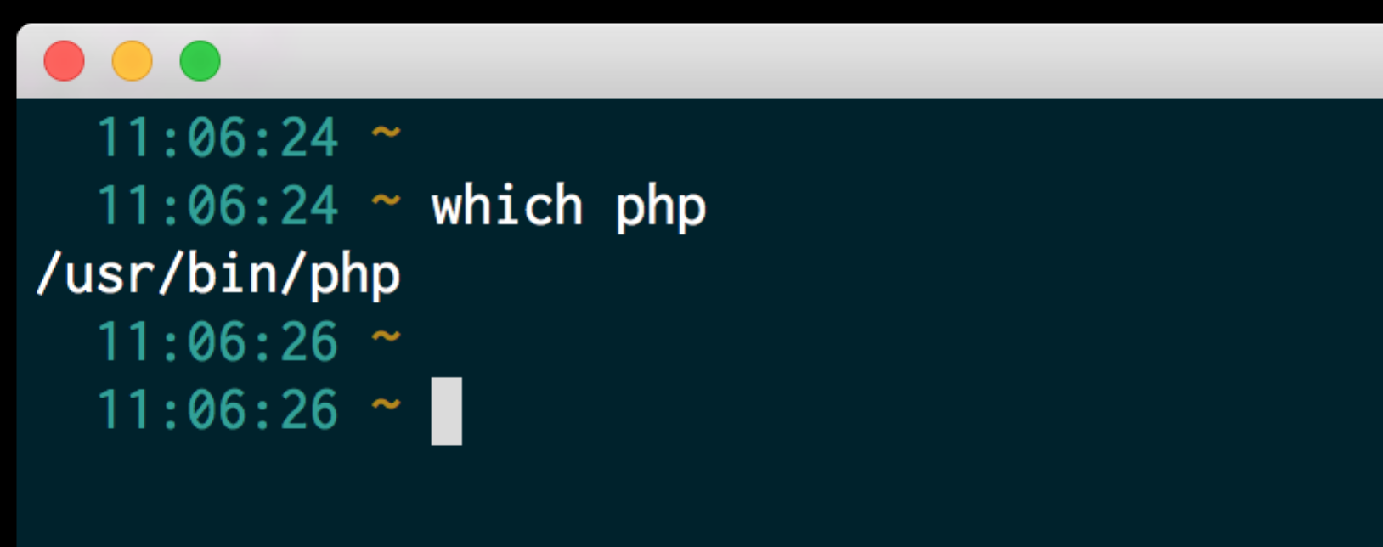

Fig 1. Default PHP binary path for OS X

If the default path is /usr/bin/php, you’ll need to change the PHP binary path so that it uses the PHP binary provided by MAMP (installed earlier).

On unmodified OS X systems you’ll likely be using the system default shell (Bash). Using your favourite editor e.g. nano, Emacs if you are Carlo or vi if you are Cam Stockwell ☺, create/edit the following file:

* ~/.bashrc for unmodified systems, as above
* ~/.zshrc if you are using Z shell (e.g. if you have installed Oh My Zsh)

In addition, an alias has been specified so that running ‘php’ uses the correct binary. These lines must go below all other lines that set/modify the shell path.

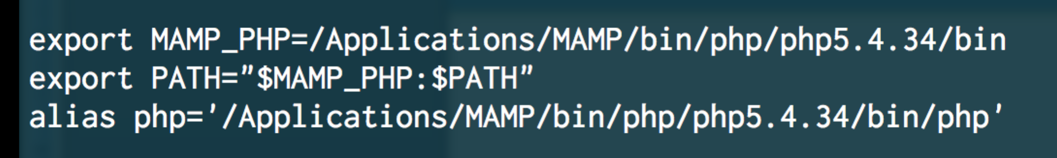

Fig 2. Lines to be added to ~/.bashrc or ~/.zshrc

Once this is done, close the Terminal session, open a new Terminal session (so the changes take effect) and check the $PATH variable, making sure the MAMP path specified above is present.

|  |
| --- |
| *echo $PATH* |

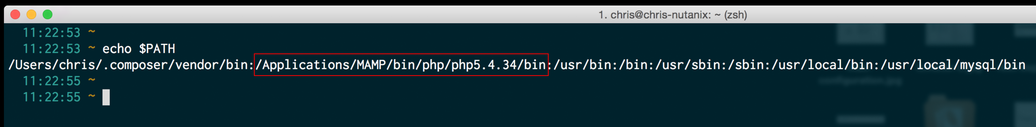

Finally, verify the PHP binary path has been set.

|  |
| --- |
| *which php* |

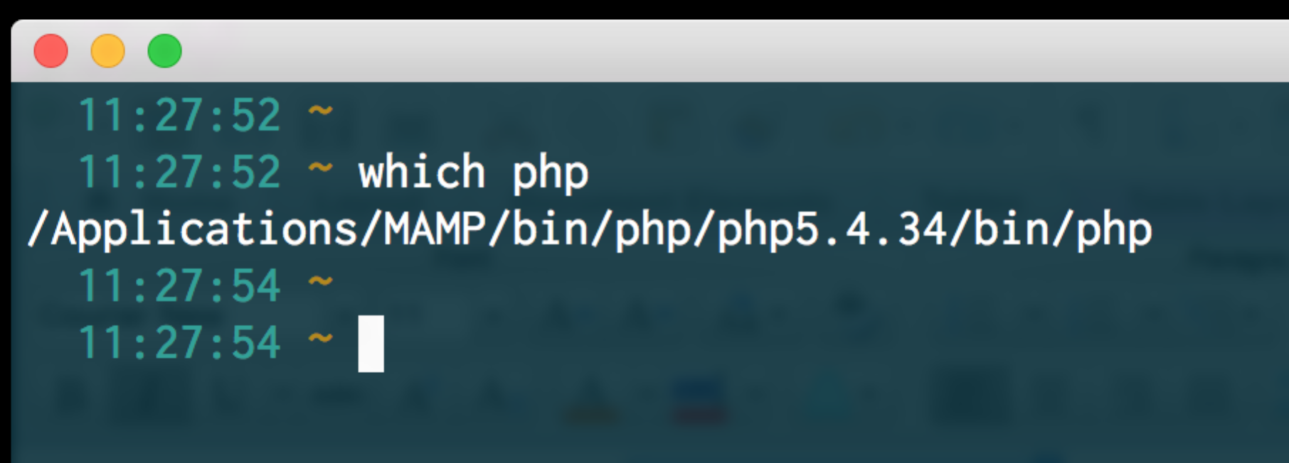

Why do all that? On default installations of OS X i.e. those not configured as development workstations, some required PHP extensions are not enabled, e.g. Mcrypt and cURL.

To run the demo, you can now run the following commands – this assumes the demo files are in ~/Documents/Demos