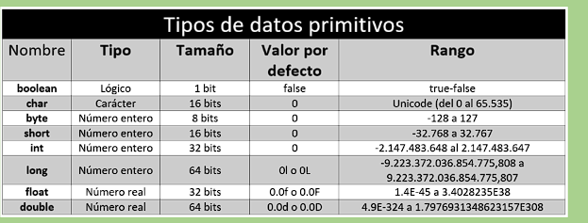

boolean: 2^1 = 2 🡪 2/2 = 1. (Solo tiene true y false)

char : 2^16= 65.536 🡪 SOLO TIENE POSITIVOS

byte: 2^8 = 256 🡪 256/2 = 128.

short: 2^16 = 65.536 🡪 65.536/2 = 32.768

int: 2^32 = 4.294.967.296🡪4.294.967.296/2 = 2.147.483.648.

long: 2^64 = 18.446.744.073.709.551.616 🡪 18.446.744.073.709.551.616/2= 9.223.372.036.854.775.808

float: 2^32 = 4.294.967.296🡪4.294.967.296/2 = 2.147.483.648.(con decimales incluidos)

double: 2^64 = 18.446.744.073.709.551.616 🡪 18.446.744.073.709.551.616/2= 9.223.372.036.854.775.808.(con decimales incluidos)