Unit 1. Introduction to measurement theory
- Basic metrological terms and concepts
  - What is to measure?
- Measure: assign objectively and empirically a number or symbol to a quality/attribute of an object or event in a representative way.
- Numerical assignment: comparison of the quality to be measured with a reference standard.
  - Some definitions
- Calibration: is the comparison of a test instrument or artefact against a more accurate standard
- Measurement traceability: refers to the unbroken chain of calibrations linking an instrument or standard to primary standards. Measurements are only traceable if the calibration corrections and uncertainties are applied at every step in the chain back to the reference.
- Accuracy: a qualitative term that describes how close a set of measurements are to the actual (true) value. Accuracy is a qualitative measure of how close a measurement is to the centre of the target – the “true value”.
- Precision: describes the spread of these measurements when repeated – a measurement that has high precision has good repeatability. Precision is represented by a cluster of consistent measurements, but there is no guarantee that these are accurate.
- Repeatability: is the closeness of agreement between repeated measurements of the same thing, carried out in the same place, by the same way, at similar times. It describes the agreement within sets of measurements where the same person uses the same equipment in the same way, under the same conditions.
- Reproducibility: is the closeness of agreement between measurements of the same thing carried out in different circumstances.
- Tolerance: is the maximum acceptable difference between the actual value of a quantity and the value specified for it.
- Direct measurement: that obtained from a single reading of a measuring instrument.
- Indirect measurement: that obtained from various direct measurement and a law that relates them.
- Measurement by comparison: the measured variable is compared with a reference quantity of the same type.
- Measurement by deflection is obtained from various direct measures and a law that relates.
  - Source and error classifications
    - What affects your measurements?
Many factors can reduce accuracy or precision and increase the uncertainty of your measurement result:
- Environmental conditions: changes in temperature or humidity can expand or contract materials as well as affect the performance of measurement equipment.
- Inferior measurement equipment: equipment, which is poorly maintained, damaged or not calibrated will give less reliable results.
- Poor measuring techniques: having consistent procedures for your measurements is vital.
- Inadequate staff training, not knowing how to make the right measurement, not having the confidence to challenge the results and not being willing to seek advice can all have a negative impact.
    - Types of errors
Two types of effects can modify the value of the readings of the instruments: the systematic effects and random effects. Also, occasionally absurd readings (aberrant reading may appear)
    - Bias
After removal the aberrant readings, one qi reading of one magnitude q can be modelled generally as: $q_{i}=q+b\left(q\right)+c\left(q,i\right)$. b(q) is the systematic effect and c(q,i) the random effect.
The bias can be:
- Constant (if time for measurement is short)
- Generated by drifts in the instrument due to factors that can not be controlled, or inherent to the method of measurement.
    - Random effects
Once the aberrant readings and corrected the systematic effects the only difference between the readings and the value of the quantity that you want measure is due to random effects.
- Characterized from its probability distribution function, which is usually symmetric.
- Values are bounded.
- Its mathematical expectation is zero.
By averaging several readings, the random effects are reduced if the readings are statistically independent.
- Methods for evaluation of measurement uncertainty
  - Introduction
The uncertainty in the measurement is the parameter that characterizes the dispersion of values that can be reasonably attributed to the measurand. Range of values within which it must be the value of the measurand with a certain level of confidence.
  - Mathematical modelling of uncertainty
The uncertainty estimation comes from a model of the measurement process in which all the factors that can affect the outcome of the measurement are included.
The measurand (Y) can be modelled as a function of several variables: Y=f(X1, X2, …, Xn). An estimate of the measurand (y) can be obtained from estimates of the input variables (x_{i}): y)f(x1, x2, …, xn).
Each estimator input variable xi has an associated standard uncertainty u(x_{i}), the uncertainty of the measurand will depend on the uncertainty of the input variables, and on the input variables.
u_{c}(y) is known as the combined uncertainty, because it is a combination of the uncertainties of the input variables. $u_{c}\left(y\right)=g\left(u\left(x_{1}\right), u\left(x_{2}\right), …. u\left(x_{n}\right), x_{1}, x_{2},…, x_{n}\right).$ To estimate the uncertainty of y is necessary to know the uncertainty of each of the input variables.
For this, ISO Guide to the expression of uncertainty in measurement describes two methods:
- Type A evaluation: use of statistical methods from a number of independent observations of the quantity to be measured under the same measurement conditions.
- Type B evaluation: use other methods (non statistical) coming from scientific judgment (analysis of instrument specifications, prior arrangements, calibration certificates, etc.)
  - Type A uncertainty evaluation
It is based on statistical methods and a set of measurement is needed.
- Measurements without bias.
- No change in the measurement conditions during the test.
- In order to have statistical significance the measurement must be statistically independent.
To do the measurement we have some concepts:
- True value: µ
- True value estimate (arithmetic mean): $\overline{q}=\frac{1}{N}\sum_{k=1}^{N}{q_{k}}$
- Dispersion estimate (adjusted standard deviation): $s\left(q\right)=\sqrt{\frac{1}{N-1}\sum_{k=1}^{n}{{\left(q_{k}- \overline{q}\right)}^{2}}}$
- Experimental standard deviation of the mean: $u\left(\overline{q}\right)=s\left(\overline{q}\right)=\frac{s\left(q\right)}{\sqrt{N}}$
Considerations: The number of observations N must be high enough so that the average $\overline{q}$ is a good estimator of the expected value of the population (µ). Normalment 5 i 10 observations. When the population variance is known $\left(σ^{2}\left(q\right)\right)$ the type A uncertainty is calculated:
$$u\left(\overline{q}\right)=s\left(\overline{q}\right)=\frac{σ\left(q\right)}{\sqrt{N}}$$
Methodology to follow:
- Make N independent measurements.
- Remove aberrant readings.
- Correct systematic effects.
- Calculate the arithmetic mean.
- Calculate the adjusted standard deviation.
- Calculate the uncertainty: $u\left(\overline{q}\right)=s\left(\overline{q}\right)=\frac{σ\left(q\right)}{\sqrt{N}}$
Central Limit Theorem
By the central limit theorem the function of probability distribution of $\overline{q}$ will approach a normal distribution if N∞, the contributions of each of the observations (qi) are small compared to $N\left(σ^{2}(\overline{q}\right)< σ^{2}(q_{i}))$.
We define a confidence interval with a risk α, the interval containing the true value of the measure (q) with probability 1- α (confidence level). If αthe population variance $\left(σ^{2}\left(q\right)\right)$ is known and the number of observations (N) is high enough to assume that $\overline{q}$ follows a normal (Gaussian) distribution, then the confidence interval is defined as:
$Prob\left(\overline{q}-k×\frac{σ\left(q\right)}{\sqrt{N}}<q<\overline{q}+k×\frac{σ\left(q\right)}{\sqrt{N}} \right)=Prob\left(\overline{q}-k×u\left(\overline{q}\right)<q<\overline{q}-k×u\left(\overline{q}\right)\right)=1-α$ where $k×u\left(\overline{q}\right)$ is known as expanded uncertainty (U($\overline{q}$)) and k is known as the coverage factor.
  - Type B uncertainty evaluation
It use all possible information related to the magnitude being measured such as data from previous measurements, knowledge of the behavior of materials and tools, manufacturers specifications and calibration certificates data.
It is not based on statistical methods, but on scientific judgment. A probability distribution function is assigned to each item of information available, and the uncertainty is computed.
Probability Density Functions
- Uniform distribution: All values within the range are equally likely and the probability outside the range in question is null. It is used when only the limits of the parameter being evaluated are known. It is the distribution that gives a more pessimistic estimate. If uncertainty obtained using the uniform distribution is much larger than the uncertainty of the other components under consideration, it is recommended to evaluate the uncertainty following another path. $u\left(x\right)=\frac{a}{\sqrt{3}}$
- Normal distribution: This distribution is important because it represents the statistical behaviour of most of the phenomena that occur in nature. It is the least pessimistic way of estimating the uncertainty as it is the estimation with a lower standard deviation. Usually, the calculation if performed considering uncertainty limits +-a, comprise a certain percentage of the distribution. $u\left(x\right)=\frac{a}{k}$
- Triangular distribution: This distribution, as uniform distribution, is used when the likelihood outside of the interval considered is zero. However,, the triangular distribution considers that there is grater chance in the middle of the range than at the ends. It offers a less conservative estimate of the uncertainty uniform distribution but more severe than the normal distribution. $u\left(x\right)=\frac{a}{\sqrt{6}}$
- U Distribution: It is used when it is known that the values of the variable being analysed have a sinusoidal cyclic behaviour. $u\left(x\right)=\frac{a}{\sqrt{2}}$
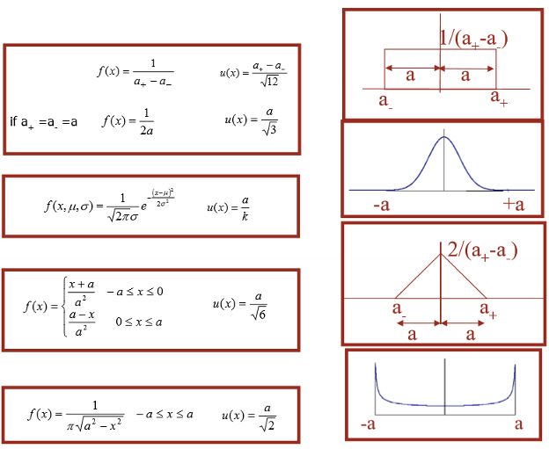
  - Combined uncertainty
Generally, the result of a measurement is a combination of several input parameter or variables x_{i}: $y=f\left(x_{1}, x_{2}, …, x_{n}\right)$. The uncertainty is then a combination of the uncertainties of the input variables: $u_{c}\left(y\right)=g\left(u\left(x_{1}\right), u\left(x_{2}\right), …, u\left(x_{n}\right), x_{1},x_{2}, …, x_{n}\right).$
The combined uncertainty is calculated as: $u_{c}\left(y\right)≅\sqrt{\sum_{i=1}^{N}{u_{i}^{2}\left(y\right)}}$
$$u_{i}\left(y\right)=c_{i}×u\left(x_{i}\right) c_{i}=\frac{df}{dx_{i}}$$
The input variables are considered to be independents.
If the input variables are not independents, the combined uncertainty is calculated as the following function, where c_{i} is the sensitivity coefficient and u(x_{i}, x_{k}) is the covariance between x_{i} and x_{k} magnitudes that can be obtained from the standard uncertainties of both magnitudes and its correlation coefficient.
$$U_{c}\left(Y\right)=\sqrt{\sum_{i=1}^{N}{\sum_{k=1}^{N}{c_{i}×c_{k}×u\left(x_{i}, x_{k}\right)}}}=\sqrt{\sum_{i=1}^{N}{c_{i}^{2}×u^{2}\left(x_{i}\right)}+2×\sum_{i=1}^{N-1}{\sum_{k=i+1}^{N}{c_{i}×c_{k}×u\left(x_{i}, x_{k}\right)}}}$$
  - Uncertainty Budget
In order to sort all the information necessary for calculating the combined uncertainty an uncertainty budged is constructed.

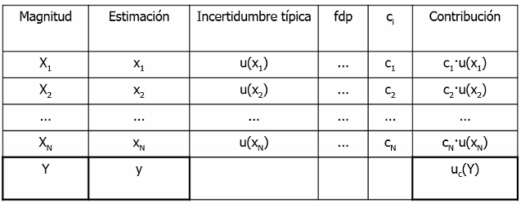

Unit 2: Basic instruments
- Time domain measurements
  - Measurement of electrical magnitudes
    - Digital multimeter
      - Input circuits
      - AC-RMS converter
      - Error sources
- Inherent errors: instrument-own and cannot be corrected by taking precautions during measurement. Specified by the manufacturer.
- Use error: they are preventable.
  - Load error (measuring V and I)
  - Input currents (measured Vdc, Idc)
  - Thermoelectric Forces (measured Vdc)
  - Cables
  - Bandwith of the measurement system (Vac measures Iac)
    - Total Error = Error (sine) + Error (crest factor) + Error (bandwidth)
- Interferc ences:
  - DC measurements (V, I): SMRR y CMRR
  - AC measurements (V, I): it is not possible to attenuate the interferences.
  - Measurements with oscilloscope
    - Input circuits and probes
    - Digital oscilloscope
      - Sampling
    - Measurements with oscilloscope

