Communication Networks - Assignment 1

WLAN
To take into account before doing these exercises:
Homework assignments are an integral part of this course. You are expected to complete your work on time and in an honest manner. You may collaborate with other students. However, you should write up and hand in your assignment separately, indicating in which parts and with whom you have collaborated. Failing to do that will be considered as cheating or plagiarism, and the student will be subject to disciplinary actions. The following list would help students to be aware of the related rules and obligations:
- Do not submit work that is not entirely yours, i.e., use of another student’s essay or use of a downloaded essay from the Internet.
- Acknowledge all assistance received, including help from friends or others in terms of proofreading, suggestions or information.
- Do not lend your work to other students unless you feel certain they will not use it dishonestly.
- When in doubt about any practice, ask the teachers. Do not rely on friends, relatives or fellow students for information about what is acceptable academic practice.
- When material you read impresses you, be particularly careful to use your own words.
- Cite sources whenever you use the words of another.
- Whenever you copy a text use quotation marks: "Literal text of a source".
- Make sure that you are able to explain any part of your work if asked by the teacher.
This assignment represents the 20% of the final mark of the course.

Exercise 1 (3%):
Explain what would happen to the IEEE 802.11 performance if the transmission power was large enough to enable transmissions between AP and MS which propagation time was larger than one slot. Suppose that there is not hidden terminal. Explain and reason your answer.
It is possible for the Short Interframe Space (SIFS) to be significantly shorter than either the propagation time (t_{prop}) or the Distributed Interframe Space (DIFS). As a result, when the destination terminal sends an acknowledgement (ACK) packet, it may take longer to arrive than the source terminal expects, causing the source to assume the packet is lost.
On the other hand, if two transmission packets are waiting to be sent, and their backoff times are very close together (e.g., b0=3 and b1=4), but the destination terminal is located far away, the source terminal may incorrectly assume that the first packet has been lost. The source may then begin to decrement the backoff counter, and when it reaches zero (which may happen within a few seconds due to the small difference in backoff times), it will begin transmitting. This can result in a collision occurring.
In summary, in certain scenarios involving the Short Interframe Space and backoff times, the source terminal may incorrectly assume that a packet has been lost, leading to either longer-than-expected transmission times or collisions. It is important to be aware of these potential issues when designing and using wireless communication systems.
Exercise 2 (3%):
With a network analyser, capture a beacon frame and study the fields about BSS management. If you are not able to capture beacons with your computer, use the already captured frames of file 802.11Traces.pcapng.
I am going to use the frame 37 from the file 802.11Traces.pcapng to analyse the fields.
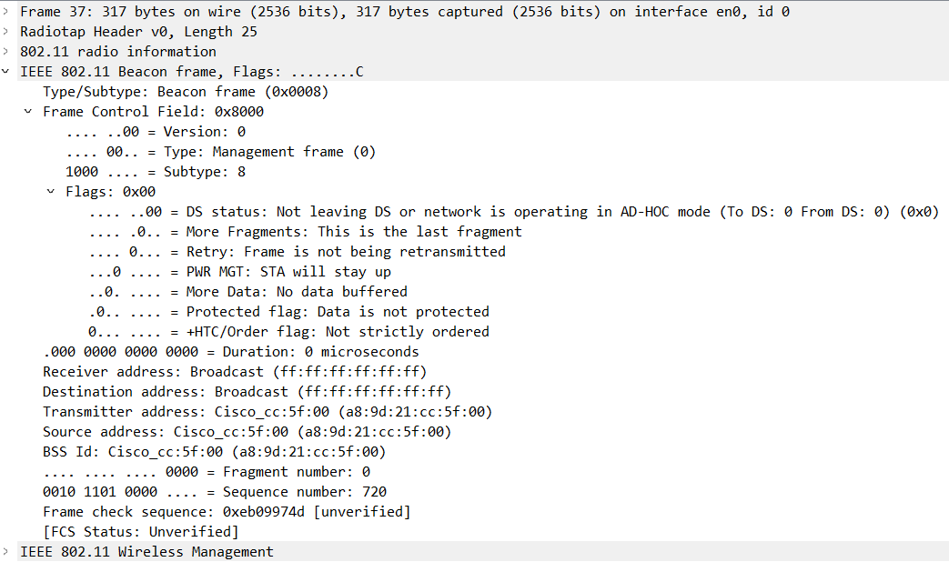
MAC LAYER, FRAME HEADER
In the first line it specifies that it is 0x0008 type/subtype frame, as expected from theory (Type 00 subtype 1000). It also indicates that is a management frame, as it can be predicted. We can observe that it has all the flags deactivated.
The receiver and destination addresses are both ff:ff:ff:ff:ff:ff because the beacon packet is a broadcast frame.
The transmitter address, source address and BSS Id are the access point MAC addresses as is the only device allowed to send beacon frames. We can observe that it is a Cisco access point.
We can observe that the fragment number is 0 which indicates that the data is not fragmented and the sequence number in this case is 720 just to maintain the correct communication. The next frames’ sequence has to be 720+1, 720+2, Etc.)
MAC LAYER, FRAME BODY 802.11 FRAME BODY
Fixed parameters
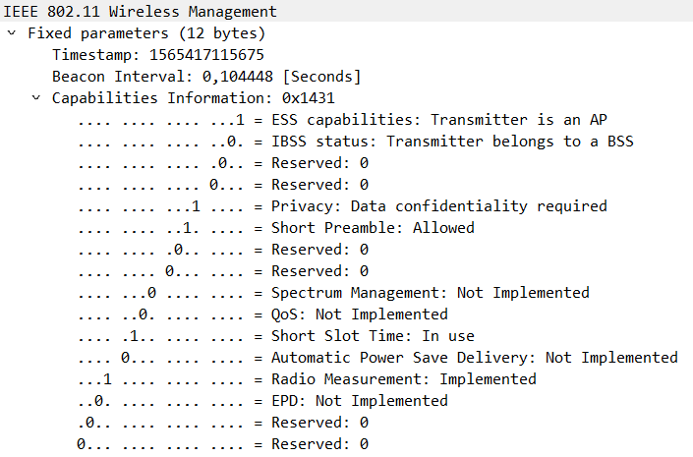
The timestamp field indicates us that the access point has been activated for 1565417115675μs. Also, beacons are sent periodically at the time called Target Beacon Transmission Time (TBTT) which is 1 TU =1024μs. That is why the beacon interval is almost 100TU (100x1024μs=102.4ms), default number.
Following we can observe the capabilities information:
- Supported capabilities information:
  - ESS capabilities: this beacon frame is transmitted by the access point.
  - IBSS status: IBSS is 0 because the transmitter access point belongs to IBSS.
  - Privacy: is activated meaning that it requires data confidentiality as a security measure.
  - Short preamble: the access point supports short preambles.
  - Short Slot Time: the access point uses the short slot time for the CSMA/CA procedure.
  - Radio measurement: it allows the measurement of the number of frames transmitted and the average RCPI for these frames.
- Not supported or not implemented capabilities information:
  - Spectrum Management
  - QoS
  - Automatic Power Save Delivery
  - EPD
Tagged parameters.
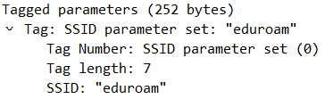
In this tagged parameter we can observe the SSID name of the access point as well as the length of the name. In this case the SSID is “eduroam”.
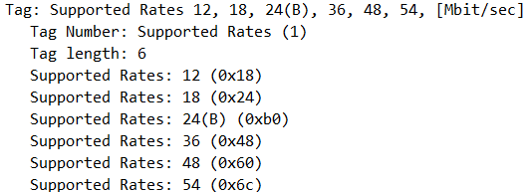
In this tag we can observe the supported rates of the access point with a maximum of 6 placed. In this case 12, 18, 24, 36, 48 and 54 Mbit/s. The B next to the 24 Mbit/s indicates the basic rate.
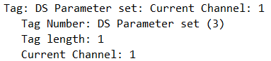
In this tag the access point indicates that it is operating in channel 1.
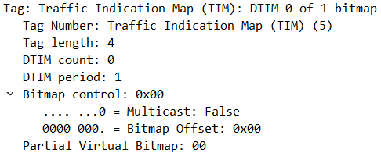
This is presented when beacon frames are generated by access point. This is most useful for low-power mode stations. DTIM count of 0 indicates the current frame TIM is a DTIM and that take one period. The bitmap control of 0x00 indicates that it does not use multicast/broadcast data and the partial virtual bitmap represents if the access point has traffic buffered or there is not, as is in this case.
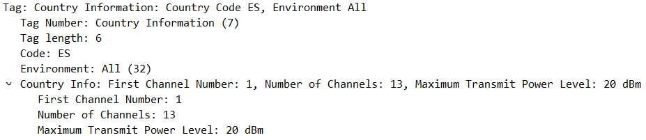
This tag it defines in which country is the device and which laws apply for limiting the channel or the maximum transmission power. In this case, 13 channels starting from 1 and a maximum transmit power level of 20 dBm.
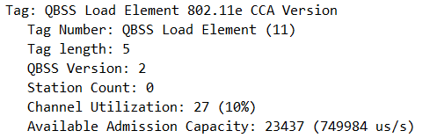
This QBSS (QoS Basic Service Set) advertises the cannel load information of the access point. In this case it is using the version 2. It also indicates the channel utilization in this case (10%) and the available admission capacity. The cannel utilization is calculated with the following formula:
$$Channel Utilization= \frac{channel busy time ×255}{dot11ChannelUtilizationBeaconInterval ×dot11BeaconPeriod ×1024}$$
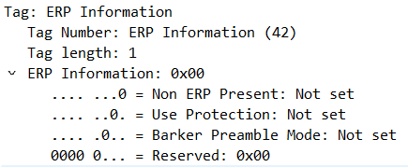
In this tag we can observe that there are no ERP STA connected to the access point. Therefore, the access point indicates that there is no need for protection. We can observe that the Barker Preamble Mode is 0 which corresponds to the previously mentioned support of the access point for short preamble.
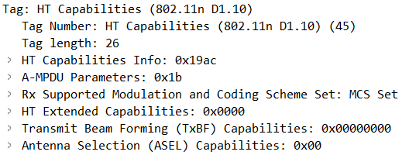
This tag provides Modulation Coding Scheme values which are supported by the wireless network. The access point and the client can send unicast traffic back and forth following these regulations.
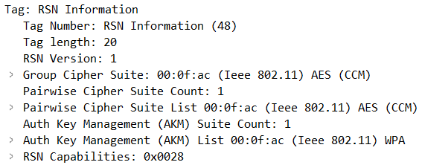
This RSN(Robust Secure Network) information tag element is used to indicate Authentication Cipher, Encryption Cipher & other RSN capability of stations.
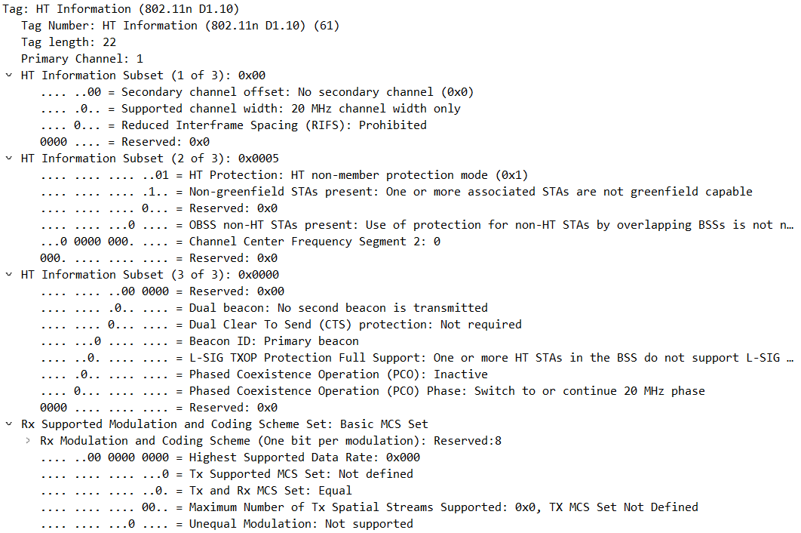
This tag indicates the tag number for the HT information, the tag length for HT information, the primary channel of the access point, the offset of the secondary channel relative to the primary channel, the current supported channel width and also if it allows Reduced Interframe Spacing.
The subset 2 it indicates the current protection mechanism that is used in BSS, the indication if all associates STAs are greenfield capable or not, the indication of the use of protection for non-HT STAs by overlapping BSSs is needed or not.
The subset 3 indicates if the access point transmits an STBC beacon or not, if it supports dual CTS for protection in BSS, it indicates if the beacon is a primary beacon or an STBC beacon, it also indicates if one or more HTR STAs in the BSS support or not the L-SIG TXOP protection and if is phased coexistence operation is used in BSS.
In the fourth sub-block it indicates if the modulation an coding scheme set is used for current BSS.
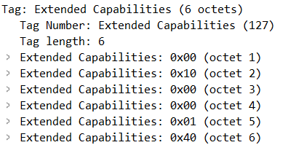
This tag represents the extended capabilities. In this case, for example, Proxy ARP Service is supported, QoS map and EBR is supported and WNM notification is supported.
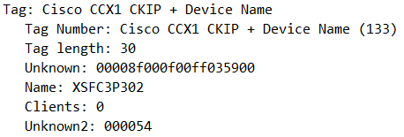
This Tag is just for specifying the device name.
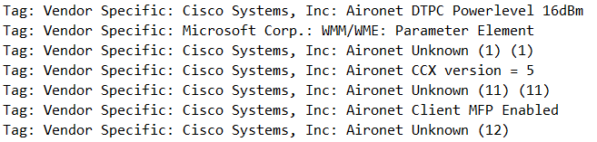
These additional tags are specific for each vendor, in this case a Cisco access point.
Exercise 3 (3%):
Download and read paper "A tutorial on IEEE 802.11ax High Efficiency WLAN" (CN-Assignment1_Reading_11ax.pdf). Write down a summary (1000-1200 words) of the paper.
Wi-Fi technology has become increasingly popular in recent years, leading to a surge in demand from users seeking to connect to the internet through this technology. However, this popularity poses a threat to the future success of Wi-Fi, and the latest Wi-Fi standard, 802.11ax, faces two main challenges: regulating throughput-per-area in dense areas to control the saturated mode and reducing asymmetry in traffic patterns. This paper sheds light on these challenges and discusses the various improvements made in the latest standard to address them.
Before delving into the challenges of 802.11ax, it is worth noting the evolution of Wi-Fi technology. The previous standards - 802.11a/b/g/n/ac - were developed to increase the nominal data rate. The first three standards achieved this through new modulation and coding schemes, but the data rate remained insufficient. 802.11n improved the data rate to 600Mbps by utilizing channels with a width of 40MHz and MIMO technology. 802.11ac widened transmission bands to 160MHz, increased the constellation to 256QAM, and proposed DL MU-MIMO to achieve a data rate of 7Gbps. However, it was not frequency efficient for short message transmission.
The 802.11ax standard represents the latest development in this area. This standard uses an OFDMA cellular network approach that groups adjacent subcarriers together into a resource unit (RU), allowing for higher SINR, MCS, and throughput. The standard also introduces new modulation techniques, increases symbol duration while reducing overhead due to GI, and includes an optional Dual Carrier Modulation (DCM) to enhance transmission robustness.
The paper also discusses the various types of PHY frames defined by 802.11ax for SU, extended SU, DL MU, and UL MU transmission. These formats share a baseline structure that changes depending on the type of transmission. In each 20 MHz subchannel, the preamble is duplicated and consists of a legacy part (training fields) and the HE. The paper examines their transmission and explains that the latest standard allocates channel resources over time and frequency, enabling coordinated OFDMA transmissions on a per-frame basis that can carry information from one or multiple STAs. During these transmissions, numerous tones are assigned to each STA, while the duration of the RUs remains the same.
One of the challenges facing the latest standard is dense deployment. To address this issue, the paper proposes increasing the BSS color field to 6 bits to determine the originator BSS. If there is a collision, the related STA will notice and create a new BSS color, which will be communicated in beacons. Additionally, two NAVs are inserted to prevent resenting NAV values and to detect channel availability during periods of low activity. The Quiet Time Period (QTP) mechanism allows STAs to request periodic time intervals to reduce channel busy time without adding interference during ad hoc or direct links operations.
Another method for improving spatial reuse is Dynamic Sensitivity Control (DSC), which adjusts the DSC threshold to regulate when the medium is busy. Preamble puncturing is another feature that manages channel resources, while Multiple BSSID sends the same information in a common beacon to handle virtualization exceed overhead.
Regarding power management, the paper explains that the 802.11ax standard implements a technique to awaken only the transmitting or receiving STA. Initially, the 802.11ax STA goes into microsleep mode, disabling its radio. After which, there is a negotiation phase where the STA transmits special information containing TWT parameters. These parameters can be interpreted in different ways, such as suggestion or acceptance, with the most important parameter being the Wake Interval which is the interval between two consecutive TWT SP. Additionally, there is a concept known as Opportunistic Power Save (OPS) that involves changing stages based on received information.
Despite the improvements made in the latest standard, there are still challenges to be addressed for future developments. The paper highlights the performance of BSS, optimal operations in dense areas, and energy conservation as areas that require further investigation. However, the implementation of OFDM for both UL and DL directions in 802.11ax represents a significant innovation in Wi-Fi technology that is poised to tackle some of the most pressing challenges facing the industry.
Another significant challenge for 802.11ax is reducing asymmetry in traffic patterns. This refers to the fact that most of the traffic in Wi-Fi networks is in the downstream direction from the AP to the clients. This creates a bottleneck and leads to decreased performance. To address this issue, 802.11ax introduces new mechanisms for uplink transmissions, such as UL MU-MIMO and UL OFDMA, which allow for simultaneous transmissions to multiple clients in the uplink direction. UL MU-MIMO enables multiple clients to transmit simultaneously to the AP, while UL OFDMA allows multiple clients to share the same channel resources in the uplink direction. These mechanisms increase network capacity and reduce latency, leading to better performance for all clients.
In addition, 802.11ax includes several features to improve the efficiency of Wi-Fi networks. One such feature is Target Wake Time (TWT), which allows the AP to schedule transmissions with clients to reduce power consumption and increase battery life. TWT enables devices to sleep for longer periods, reducing the amount of time they spend actively communicating with the network. This leads to significant energy savings, particularly for battery-powered devices such as smartphones and IoT devices.
Another feature is Basic Service Set (BSS) Coloring, which allows multiple APs in close proximity to operate on the same channel without interfering with each other. BSS Coloring assigns a unique color to each BSS, and clients only listen to packets that match their assigned color. This reduces the amount of interference between neighbouring APs and improves network efficiency.
802.11ax also includes features to improve network performance in dense deployments, such as Dynamic Sensitivity Control (DSC) and Enhanced Distributed Channel Access (EDCA). DSC adjusts the sensitivity threshold of devices to reduce interference and improve spatial reuse, while EDCA improves channel access by prioritizing access for high-priority traffic and reducing contention between devices.
Furthermore, the new standard introduces a range of security enhancements to protect against potential security threats. One such enhancement is Opportunistic Wireless Encryption (OWE), which provides automatic encryption and authentication for Wi-Fi networks without requiring a pre-shared key. OWE makes it easier for users to connect to public Wi-Fi networks securely and reduces the risk of man-in-the-middle attacks.
Overall, 802.11ax represents a significant improvement over previous Wi-Fi standards, with a range of new features and enhancements that improve network efficiency, performance, and security. However, there are still challenges to be addressed, particularly in dense deployments and reducing asymmetry in traffic patterns. As Wi-Fi continues to grow in popularity and demand, it is likely that future standards will build on the innovations of 802.11ax and address these challenges to further improve the performance and efficiency of Wi-Fi networks.

