Communication Networks - Assignment 3

Network level: IPv6
To take into account before doing these exercises:
Homework assignments are an integral part of this course. You are expected to complete your work on time and in an honest manner. You may collaborate with other students. However, you should write up and hand in your assignment separately, indicating in which parts and with whom you have collaborated. Failing to do that will be considered as cheating or plagiarism, and the student will be subject to disciplinary actions. The following list would help students to be aware of the related rules and obligations:
- Do not submit work that is not entirely yours, i.e., use of another student’s essay or use of a downloaded essay from the Internet.
- Acknowledge all assistance received, including help from friends or others in terms of proofreading, suggestions or information.
- Do not lend your work to other students unless you feel certain they will not use it dishonestly.
- When in doubt about any practice, ask the teachers. Do not rely on friends, relatives or fellow students for information about what is acceptable academic practice.
- When material you read impresses you, be particularly careful to use your own words.
- Cite sources whenever you use the words of another.
- Whenever you copy a text use quotation marks: "Literal text of a source".
- Make sure that you are able to explain any part of your work if asked by the teacher.
This assignment represents the 7,5% of the final mark of the course.
In the theoretical questions, answer approximately in the blank spaces provided for writing.

Exercise 1 (2%):
Most computers are IPv6 ready. Execute ifconfig -a or ipconfig /all in your computer and answer:
- Which is your MAC address?
My Ethernet MAC address is D0-50-99-00-51-60
- Which IPv6 address do you have?
My IPv6 address for my ethernet adapter is fe80::b830:e295:748d:6c3d
- Is it Global Unicast or Link Local?
As the first four hexadecimal digits are FE80, my IPv6 address for my ethernet adapter is a Link Local address.
- Which is its Interface ID? is it based on the MAC address or it is random?
The interface ID of my IPv6 address for my ethernet adapter are the last 64 bits, so b830:e295:748d:6c3d. My interface ID is random, because if it was based on the MAC address using the Modified EUI-64 process my interface ID should have to be b230:99ff:fe00:5156, which is different from my interface ID b830:e295:748d:6c3d
- Which are the IPv4 and IPv6 addresses of your loopback interface?
The IPv4 address for the loopback interface is 127.0.0.1 ant the IPv6 address for the loopback interface is 0:0:0:0:0:0:0:1 or ::1
Sorces: CN3-Slides_IPv6 and sciencedirect.com/topics/computer-science/loopback-address
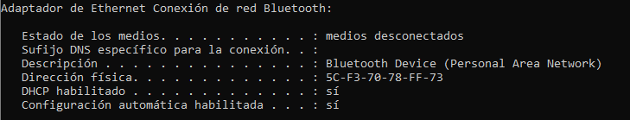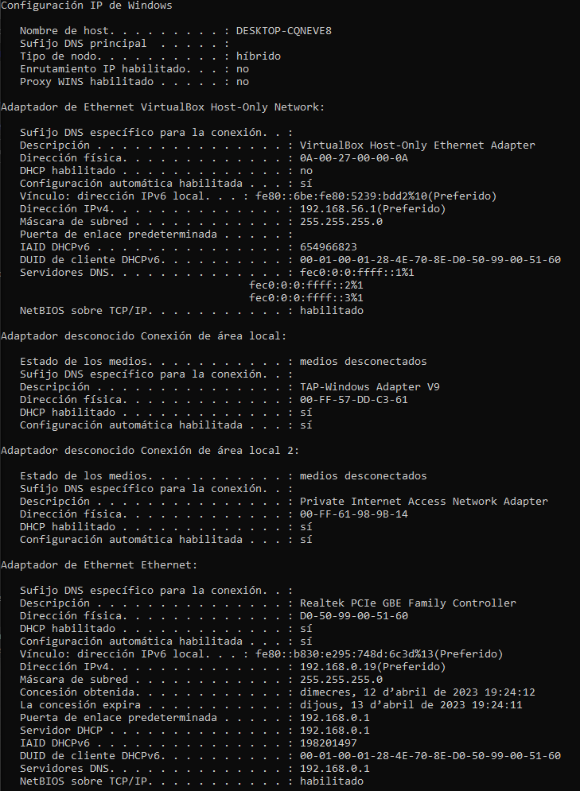

Exercise 2 (2%):
Read CN3-Reading-RFC4862.StatelessAutoconfiguration and describe the autoconfiguration function of IPv6 devices.

Exercise 3 (2%):
With the Wireshark, open the file CN3-Traces1-Ping6WithAddrRes and analyse what you see.
Answer these questions:
- Which is the scope of the involved addresses?
- Which kind of messages can you see and what are they for?

Exercise 4 (3%):
With the Wireshark, open the file CN3-Traces2-ICMP6.
If you connected your computer to the network in which these traces where taken, which IPv6 addresses (link local and global unicast) do you think that your computer would autoconfigure with?

