Communication Networks - Assignment 4

Network level: Routing
To take into account before doing these exercises:
Homework assignments are an integral part of this course. You are expected to complete your work on time and in an honest manner. You may collaborate with other students. However, you should write up and hand in your assignment separately, indicating in which parts and with whom you have collaborated. Failing to do that will be considered as cheating or plagiarism, and the student will be subject to disciplinary actions. The following list would help students to be aware of the related rules and obligations:
- Do not submit work that is not entirely yours, i.e., use of another student’s essay or use of a downloaded essay from the Internet.
- Acknowledge all assistance received, including help from friends or others in terms of proofreading, suggestions or information.
- Do not lend your work to other students unless you feel certain they will not use it dishonestly.
- When in doubt about any practice, ask the teachers. Do not rely on friends, relatives or fellow students for information about what is acceptable academic practice.
- When material you read impresses you, be particularly careful to use your own words.
- Cite sources whenever you use the words of another.
- Whenever you copy a text use quotation marks: "Literal text of a source".
- Make sure that you are able to explain any part of your work if asked by the teacher.
This assignment represents the 7,5% of the final mark of the course.
In the theoretical questions, answer approximately in the blank spaces provided for writing.

Exercise 1 (3%):
RIP analysis. Open file CN4-Traces1-RIP1.pcap with the Wireshark and answer the following questions:
- Which transport protocol does RIP use? and which ports?
As we can see in the following image RIP uses User Datagram Protocol as its transport protocol. It uses the port 520 for either the source and destination ports. (Slide 37)
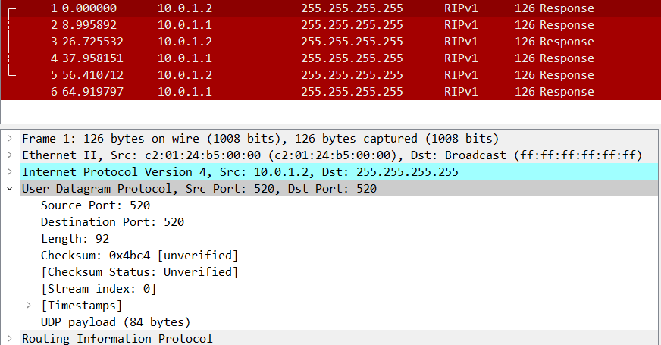
- Write the routing tables of the routers that you see in the traces.
From the traces that we got we can see that there are two routers with the following RIP information exchange:
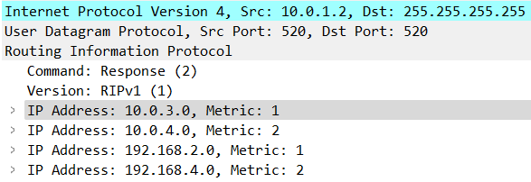 | 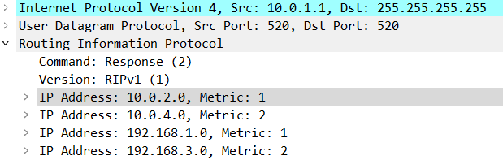
From these we can obtain the following two routing tables:
Router 10.0.1.1 |  |  | Router 10.0.1.2
Destination | Metric |  | Destination | Metric
10.0.2.0 | 1 |  | 10.0.3.0 | 1
10.0.4.0 | 2 |  | 10.0.4.0 | 2
192.168.1.0 | 1 |  | 192.168.2.0 | 1
192.168.3.0 | 2 |  | 192.168.4.0 | 2
- What are the average periods in which each router broadcasts their routing tables? Are these times fixed? Why?
In the traces given the router 10.0.1.2 has an average period of 28.2 seconds and the router 10.0.1.1 has an average period of 27.96 seconds. However according to RFC 1058, which defines RIPv1, a RIP router sends a copy of its routing table to its neighbours every 30 seconds. This time is fixed and is part of the RIP protocol specification. The reason for this fixed time is to ensure that all routers in the network have up-to-date information about the network topology and can make informed routing decisions. But also, is indicated that in some cases, a random time is added to avoid syncronisation.
https://www.rfc-editor.org/rfc/rfc1058.html
Exercise 2 (3%):
RIP analysis. Open file CN4-Traces2-RIP2.pcap with the Wireshark and answer the following questions:
- What can you see in these traces?
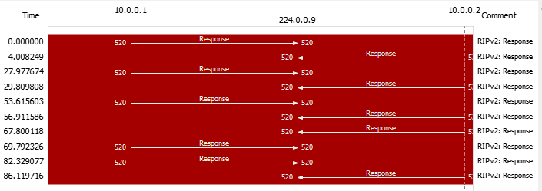
We can see that the routers 10.0.0.1 and 10.0.0.2 are sending information about routing through the multicast IP address 224.0.0.9 with RIPv2. We can see that all traces have the command 2, so all the traces are Responses.
For the first router, 10.0.0.1, we can see that at for the packets 1, 3 and five has the following routing table:
Network ID | Metric | Next hop | Netmask
10.0.0.4 | 1 | 0.0.0.0 | 255.255.255.252
10.0.0.12 | 2 | 0.0.0.0 | 255.255.255.252
192.168.1.0 | 1 | 0.0.0.0 | 255.255.255.0
192.168.3.0 | 2 | 0.0.0.0 | 255.255.255.0
Then in the following packet, sent just 16 seconds after the previous packet, we can see that the router indicates that the network 192.168.2.0 is unreachable by putting the metric to 16, which indicates that the network is unreachable.
Then at the following packet, packet number 9 of the traces, we can see that the router has information on 5 different networks, it has learnt information about the network 192.168.2.0, that continues to be unreachable with the metric to 16. Here is the routing table for the last packet sent:
Network ID | Metric | Next hop | Netmask
10.0.0.4 | 1 | 0.0.0.0 | 255.255.255.252
10.0.0.12 | 2 | 0.0.0.0 | 255.255.255.252
192.168.1.0 | 1 | 0.0.0.0 | 255.255.255.0
192.168.2.0 | 16 | 0.0.0.0 | 255.255.255.0
192.168.3.0 | 2 | 0.0.0.0 | 255.255.255.0
For the second router, 10.0.0.2, we can see that at for the packets 2, 4 and 6 has the following routing table:
Network ID | Metric | Next hop | Netmask
10.0.0.8 | 1 | 0.0.0.0 | 255.255.255.252
10.0.0.12 | 2 | 0.0.0.0 | 255.255.255.252
192.168.2.0 | 1 | 0.0.0.0 | 255.255.255.0
192.168.4.0 | 2 | 0.0.0.0 | 255.255.255.0
Then in the following packet, sent just 11 seconds after the previous packet, we can see that the router indicates that the network 192.168.2.0 is unreachable by putting the metric to 16, which indicates that the network is unreachable.
Then at the following packet, packet number 10 of the traces, we can see that the router has information on the same 4 different networks, but the network 192.168.2.0 continues to be unreachable with the metric to 16. Here is the routing table for the last packet sent:
Network ID | Metric | Next hop | Netmask
10.0.0.8 | 1 | 0.0.0.0 | 255.255.255.252
10.0.0.12 | 2 | 0.0.0.0 | 255.255.255.252
192.168.2.0 | 16 | 0.0.0.0 | 255.255.255.0
192.168.4.0 | 2 | 0.0.0.0 | 255.255.255.0
- Which may it be the reason of this router's behaviour?
It is possible that now the network is not reachable via the current routing table due to a network failure or other network issues that prevent a packet to reach its destination.
Exercise 3 (3%):
BGP analysis. Open file CN4-Traces3-BGP.pcap with the Wireshark and write down the meaning of the messages that you see and explain what routers are doing. Plot the topology of the advertised network indicating AS numbers and which IP prefixes they contain.
In this file we can see packets from the BGP protocol and TCP protocol. The first one aims to interchange information of networks that are in a range between AS and send data on how many AS needs to be crossed to reach the destination. The second one aims to ensure connectivity. Following we have the description of the different message type that we can see:
- TCP: we obtain the information from Wikipedia.
  - ACK: “Indicates that the Acknowledgment field is significant. All packets after the initial SYN packet sent by the client should have this flag set.”
  - FIN: “Last packet from the sender.”
  - SYN: “Synchronize sequence numbers. Only the first packet sent from each end should have this flag set. Some other flags and fields change meaning based on this flag, and some are only valid when it is set, and others when it is clear.”
  - RST: “Reset the connection.”
- BGP: we obtain the information from the Slide 62.
  - Notification: “it is sent when an error is found, and then the connection is closed.”
  - Open: “used to initiate a connection between two BGP routers.”
  - Keepalive: “to test if connections are active.”
  - Update: “Interchange of routing information”
In case of the TCP messages are sent for control porpoises and synchronization protocols and to ensure the connections when the BGP information is sent. Following is a description of the BGP packets:
- Packet 1: In this packet we can see a notification message from router 1.0.0.10 to router 10.0.0.9 to indicate that there has been an administratively reset and the connection is closed.
- Packet 14: Router 1.0.0.9 is indicating to router 1.0.0.10 is initiating a connection for AS 65001 with the BGP identifier 9.0.0.1 with an OPEN Message.
- Packet 19: Router 1.0.0.10 is indicating to router 1.0.0.9 is initiating a connection for AS 65005 with the BGP identifier 11.0.0.1 with an OPEN Message.
- Packet 21: Router 1.0.0.9 is indicating to router 1.0.0.10 is initiating and it test that the connections are active, a connection for AS 65001 with the BGP identifier 9.0.0.1 with an OPEN Message and KEEPALIVE Message.
- Packet 23: Router 1.0.0.10 is indicating to router 1.0.0.9 with two KEEPALIVE Message to test and maintain the connections opened in packets 14 and 19.
- Packet 24: Router 1.0.0.9 is indicating to router 1.0.0.10 with a KEEPALIVE Message to test if the connections are still active.
- Packet 26: Router 1.0.0.10 is indicating to router 1.0.0.9 an interchange of routing information with an UPDATE Message. It indicates that the origin of the prefix information is IGP, the AS_PATH is 65005, the NEXT_HOP is 1.0.0.10 and the MULTI_EXIT_DISC indicates a priority level if two AS are connected by more than one link, in this case 0, which indicates a high priority.
- Packet 27: Router 1.0.0.9 is indicating to router 1.0.0.10 an interchange of routing information with 8 UPDATE Message.
  - Update message 1: ORIGIN is IGP, AS_PATH is 65001, NEXT_HOP is 1.0.0.9, MULTI_EXIT_DISC is 0. Following this path, it can reach the networks 0.0.0.0/8, 9.0.0.0/8, 8.0.0.0/8, 7.0.0.0/8, 6.0.0.0/8, 5.0.0.0/8, 4.0.0.0/8, 3.0.0.0/8, 2.0.0.0/8, 1.0.0.0/8.
  - Update message 2: ORIGIN is IGP, AS_PATH is 65001 65002 65005, NEXT_HOP is 1.0.0.9. Following this path, it can reach the networks: 10.0.0.0/9 and 10.128.0.0/9.
  - Update message 3: ORIGIN is IGP, AS_PATH is 65001 65002, NEXT_HOP is 1.0.0.9. Following this path, it can reach the networks: 11.0.0.0/9 and 11.128.0.0/9.
  - Update message 4: ORIGIN is IGP, AS_PATH is 65001 65003, NEXT_HOP is 1.0.0.9. Following this path, it can reach the networks 12.0.0.0/6, 128.0.0.0/3, 96.0.0.0/3, 64.0.0.0/3, 32.0.0.0/3, 28.0.0.0/6, 24.0.0.0/6, 20.0.0.0/6, 16.0.0.0/6
  - Update message 5: ORIGIN is IGP, AS_PATH is 65001 65003, NEXT_HOP is 1.0.0.9. Following this path, it can reach the networks 160.0.0.0/7, 174.0.0.0/7, 173.0.0.0/8, 170.0.0.0/7, 168.0.0.0/7, 166.0.0.0/7, 164.0.0.0/7 and 162.0.0.0/7.
  - Update message 6: ORIGIN is IGP, AS_PATH is 65001 65002 65005 65008, NEXT_HOP is 1.0.0.9. Following this path, it can reach the networks 172.24.0.0/14, 172.36.0.0/14, 1732.32.0.0/14 and 172.28.0.0/14.
  - Update message 7: ORIGIN is IGP, AS_PATH is 65001 65002 65006, NEXT_HOP is 1.0.0.9. Following this path, it can reach the networks 176.0.0.0/6, 188.0.0.0/6, 184.0.0.0/6 and 180.0.0.0/6.
  - Update message 8: ORIGIN is IGP, AS_PATH is 65001 65003 130004, NEXT_HOP is 1.0.0.9. Following this path, it can reach the networks 192.1068.0.0/17 and 192.168.128.0/17.
- Packet 29: Router 1.0.0.9 is indicating to router 1.0.0.10 an interchange of routing information with an UPDATE Message. It indicates that two routes have been withdrawn. These two routes deleted are the one providing access to the 11.0.0.0/9 and 11.128.0.0/9 routes.
- Packet 57: Router 1.0.0.10 is indicating to router 1.0.0.9 an interchange of routing information with 4 UPDATE Message.
  - Update message 1: ORIGIN is IGP, AS_PATH is 65005 65008, NEXT_HOP is 1.0.0.10. Following this path, it can reach the networks 172.24.0.0/14, 172.28.0.0/14, 172.32.0.0/14 and 172.36.0.0/14.
  - Update message 2: ORIGIN is IGP, AS_PATH is 65005 65002, NEXT_HOP is 1.0.0.10. Following this path, it can reach the networks: 12.0.0.0/6, 16.0.0.0/6, 20.0.0.0/6, 24.0.0.0/6, 28.0.0.0/6, 32.0.0.0/3, 64.0.0.0/3, 96.0.0.0/3, 128.0.0.0/3.
  - Update message 3: ORIGIN is IGP, AS_PATH is 65005 65006 130007, NEXT_HOP is 1.0.0.10. Following this path, it can reach the networks: 10.0.0.0/9 and 10.128.0.0/9.
  - Update message 4: ORIGIN is IGP, AS_PATH is 65005 65006, NEXT_HOP is 1.0.0.10. Following this path, it can reach the networks 176.0.0.0/6, 180.0.0.0/6, 184.0.0.0/6, 188.0.0.0/6.
- Packet 59: Router 1.0.0.9 is indicating to router 1.0.0.10 an interchange of routing information with an UPDATE Message. It indicates that two routes have been withdrawn. These two routes deleted are the one providing access to the 172.24.0.0/14, 172.28.0.0/14, 172.32.0.0/14 and 172.36.0.0/14 networks.
- Packet 63, 65, 67, 69, 71, 72, 74, 76, 78, 79, 81, 88, 89, 91, 92, 94, 95, 97, 98, 100, 101, 103, 104, 106, 108, 110: Router 1.0.0.9 is indicating to router 1.0.0.10 with a KEEPALIVE Message to test if the connections are still active and router 10.0.0.10 is indicating to the router 1.0.0.9.
Following is the topology plot of the network:
