CHAPTER 6
PARTY SYSTEM INSTITUTIONALIZATION AND ELECTORAL FRAUD IN LATIN AMERICA, 1982-2006: THE EMPIRICAL EVIDENCE
I suggested in chapter 2 that the level of party system institutionalization plays a critical role in explaining the variation of vote buying across Latin American countries. More specifically, I argued that weakly institutionalized party systems generate patterns of political competition that increase the uncertainty of politicians about the outcome of electoral processes. This, in turn, lures candidates and political parties to use vote buying rather than political platforms to secure electoral victories. I also suggested more generally in chapter two that the effects of the degree of party system institutionalization on the frequency of vote buying has important consequences for aggregate political outcomes. More specifically, hypothesis 2.4 in chapter two posits that by increasing the probability of vote buying, weakly institutionalized party systems increase the likelihood of aggregate electoral fraud in those countries.
In this chapter, I statistically test this hypothesis on a comprehensive time-series-cross-sectional dataset of 18 Latin American countries between 1982 and 2006. The results of a series of logit models indicate that the level of institutionalization of the party system –operationalized as the level of electoral volatility for each legislative election in each country- has important effects on the likelihood of electoral fraud across Latin American countries thus providing strong empirical support for hypothesis 2.4. More specifically, higher levels of electoral volatility (which indicate low levels of party system institutionalization) increase the likelihood of electoral fraud in the countries included in my sample. My results remain highly robust not only when I use different specifications of the model, but also when I employ different econometric estimators.
The empirical results presented in this chapter have several important implications for the literatures on electoral corruption and party systems in developing democracies. Most previous studies on electoral fraud suggest that economic and sociological factors are the primary determinants of this phenomenon (Auyero 1999; Trejo and Aguilar-Rivera 2002; Alston and Gallo 2009; Eisendstadt 1999; Ziblatt 2009). My results indicate, however, that the likelihood of electoral fraud in Latin America can best be explained by political factors (i.e. the level of instititutionalization of the party system). Hence, my findings suggest that future analyses of this phenomenon should explore in more detail the linkages between this act of corruption and other political institutions. In addition, the results presented in this chapter confirm that by increasing the likelihood of electoral fraud, weakly institutionalized party systems can indeed have devastating effects for democratic politics.
The rest of the chapter is organized as follows. In the next section, I provide a detailed description of the sample, the statistical methodology, the operationalization of the dependent variable, independent as well as control variables that are employed for testing hypothesis 2.3. I then present the results from testing this hypothesis. The chapter ends with a conclusion in which I summarize my results and the main contributions of this analysis to the existing literature.
Testing Hypothesis 2.3
SAMPLE
In the theoretical chapter of this dissertation, I hypothesized that low levels of party system institutionalization increase the likelihood of electoral fraud in Latin America (hypothesis 2.4). To test the aforementioned prediction, I compile an original time-series-cross-sectional (TSCS) dataset of 18 Latin American countries between 1982 and 2006. Since my theory is not limited to this time period, I do not expect that extending the data to previous years would drastically change my inferences. Therefore, my spatial unit of observation is the country. To leverage available country-level data, I use the year as my temporal unit of observation, resulting in a country-year unit of observation. My spatial domain is comprehensive as it includes all the Latin American countries for which data is available to carefully operationalize both the dependent, independent and control variables of interest to test hypothesis 2.4.
The lack of competitive elections in the Latin American region before 1982 prevented me from extending the temporal domain of my sample. However, the fact that my sample is comprehensive in both the temporal and spatial domains between 1982 and 2006 is advantageous because unlike previous studies of electoral fraud that mainly focus on single-case studies (Alston and Gallo 2009; Lehoucq 2002; Trejo and Aguilar-Rivera 2002; Eisendstadt 1999; Dominguez and McCann 1996), I am able to make much more generalizable claims if my hypothesis is supported by the empirical evidence. A second advantage of my sample is that it contains substantial cross-sectional and temporal variation in the dependent and independent variables, therein allowing me to test hypothesis 2.3 more effectively.
DEPENDENT VARIABLE
The aim of this chapter is to link the degree of party system institutionalization with the incidence of electoral fraud. Electoral fraud comes in at least three varieties: coercion and threats from state officials or political parties to induce voters to vote for a particular candidate or party (Kousser 1974; Posada-Carbo 1996; Anderson 2000); vote buying to increase or decrease the number of votes and voter turnout (Schaffer 2008; Nichter 2008); or systematic procedural violations, including, vote rigging, closing of poll stations early, manipulation of voter-registration rolls, and the failure to advertise elections or to distribute ballots in certain constituencies. The multidimensional nature of electoral fraud represents an important measurement challenge, particularly when one tries to operationalize this variable across space and time.
I circumvent this problem using a broader definition of electoral fraud. In the theoretical chapter of this dissertation, I followed Lehoucq (2003) and conceptualize electoral fraud as any electoral “violation of the law” that may or may not be practiced by incumbents in Latin American countries with some probability. Lehoucq’s definition is very useful for the purposes of this chapter as it allows me to measure my dependent variable, namely the phenomenon of electoral fraud, across Latin American countries between 1982 and 2006 using the World Bank’s (2008) Domestic Political Institutions (DPI) variable electoral fraud.
The World Bank’s DPI measure of electoral fraud measures whether vote fraud or candidate intimidation were serious enough to affect the outcome of the elections. It captures extra-constitutional irregularities in electoral processes. Specifically, for each Latin American country in this study, the dependent variable –labeled as electoral fraud- is coded as “0” for countries where, for example, opposition parties are officially or constitutionally banned or where irregularities are not reported (although may still exist). Electoral fraud takes the value of “1” when opposition is officially legal but suppressed anyway. It also takes the value of “1” when the electoral results are rigged by the incumbent or when opposition parties boycott the election because of intimidation of the government. The DPI codes this measure based (partly) on reports of electoral malfeasance or fraud provided by the US State department, Human Rights Watch, OSCE (Europe), the UN and the Organization of American States. Irregularities in elections are coded in the DPI database regardless of whether or not opposition parties claim fraudulent elections.
The bar graph in figure 3.1 shows the frequency of electoral fraud that has occurred across Latin American countries in my sample (1982-2006). This figure shows that the frequency of electoral fraud in Latin American countries is not only reasonably common but also varies significantly. For example, in Nicaragua and Panama, the mean of electoral fraud is .63 and .6 respectively. In Peru, Guatemala, Panama, and Paraguay the mean of the dependent variable –electoral fraud- is substantially higher than in countries such as Argentina, Colombia and Mexico. The mean of electoral fraud across Latin American countries is .123 and its standard deviation is .329.
<<Insert Figure 5.1 about here>>
Statistical Methodology
Given the structure of my dataset, I employ a time-series-cross-section (TSCS) logit model with random effects with controls for time dependence and autocorrelation, as suggested by Beck et al (1998). Hypothesis 2.3, predicts a positive relationship between electoral volatility and the probability of electoral fraud. Given the prediction in the aforementioned hypothesis, it is reasonably safe to assume that the probability of fraud varies monotonically and remains within the bounds of [0,1]. In the logit model the error term is assumed to have a standardized logistic distribution. This distribution has a mean of 0 and a variance of 1 and is very similar to a normal distribution with the same mean and variance (Maddala 1983).
The introduction of controls for time dependence follows Beck et al (1998). According to the aforementioned authors, controlling for time dependence is important when estimating ordinary logit models because the estimates may be biased if the baseline hazard rate is time dependent. This potential problem, however, is avoided by introducing a series of temporal dummies in the models. Another possibility is to include cubic splines as controls for time dependence. But, given the data used in this study, both solutions –i.e. temporal dummies and cubic splines- present some econometric challenges. The inclusion of temporal dummies, for instance, not only uses many degrees of freedom but may also perfectly predict an outcome and drop those observations from the analysis. Likewise, including cubic splines in my models may lead to a perfect prediction of the dependent variable.
To circumvent these potential problems, I follow Wright (2008) and simply include time and various exponential transformations of the time variable in the models. The logit models presented below include the variables time, time-squared, and time-cube (Wright 2008: 232). Moreover, I control for the potential autocorrelation effects by including a lagged dependent variable as an explanatory variable in the all the models presented in tables 3 and 4.
INDEPENDENT VARIABLE
Hypothesis 2.3 predicts a negative relationship between the level of party system institutionalization and my dependent variable across Latin American countries –i.e. higher levels of party system institutionalization decrease the likelihood of electoral fraud-. I thus need one key independent variable to test this prediction: the level of party system institutionalization for each country between 1982 and 2006. I now turn to describe the procedure to operationalize this variable for each country in my sample.
Political scientists have long debated about the characteristics and measures of party system institutionalization in developing countries (Mainwaring and Scully 1995; Coppedge 1997; Mainwaring 1999; Mainwaring and Torcal 2005). These scholars have explained the strength/weakness of party systems in less-developed countries using three characteristics: electoral volatility, the lack of ideological voting and personalism (Mainwaring and Torcal 2005). Given the limited availability of cross-national and cross-temporal data on either ideological voting or personalism, I use electoral volatility as my main measure of party system institutionalization.
The variable electoral volatility allows me to measure the system-level change in party vote percentage from one election to another (Roberts and Wibbels 1999: 580) and is operationalized using the Pedersen index. The Pedersen index of electoral volatility is calculated by summing the absolute value of changes in the percentage of votes gained or lost by each party from one election to the next divided by two. The resultant index yields a scale between 0 (no parties gained, and thus no parties lost either) and 100 (all the parties from the last election were reduced to zero votes), because for every gain there is an equal (in terms of percentage of votes) loss. In other words, the 0-100 index is equal to the net percentage of voters who changed their votes.
Following scholars such as Pedersen (1983), Roberts and Wibbels (1999) and Madrid (2005), I thus calculate the independent variable –electoral volatility- for each legislative election celebrated in the Latin American countries mentioned before between 1982 and 2006 using the following formula:
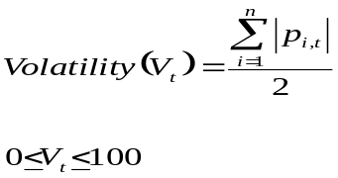
A detailed list of the legislative elections that were used to calculate the index of electoral volatility is presented in Appendix A. To this end, I relied on multiple primary and secondary sources to obtain the electoral results of the countries in my data. These sources include: (i) The Political Database of the Americas, (ii) International Democracy and Electoral Assistance, (iii) Latin American Network Information Center, (iv) Nohlen (1993), (v) Instituto Federal Electoral (Mexico), (vi) The Europa World Year Book, and the (vii) International Almanac of Electoral History. Using data from the aforementioned sources, the electoral volatility across Latin American countries has a mean of 26.27 and a standard deviation of 17.92.
<<Insert Table 5.2 about here>>
Table 5.1 lists the indexes of electoral volatility for each country in my data and illustrated in figure 1. The results presented in both table 5.1 and figure 5.2 suggest that the main independent variable –i.e. electoral volatility- varies substantially across Latin American countries. For example, in countries such as Bolivia (37.05), Brazil (35.50), the Dominican Republic (33.95), Ecuador (33.92), Guatemala (45), Peru (47.78) and Venezuela (31.95), the mean of electoral volatility is significantly higher than that in my whole sample. In contrast, electoral volatility in Chile (16.13), Honduras (6.85), Mexico (15.31), Paraguay (16.04), and Uruguay (14.35) is lower than 26.27, which is the mean across Latin America. These results are in line with previous studies analyzing the causes of electoral volatility in this continent (Roberts and Wibbels 1999; Madrid 2005; Mainwaring 1998).
<<Insert Figure 5.2 about here>>
CONTROL VARIABLES
I include several control variables that have been identified by scholars as important determinants of electoral fraud in both developed (Ziblatt 2009; Anderson 2000) and developing countries (Dominguez and McCann 1996; Eisenstadt 1999; Varela Ortega 2001; Schaffer 2002; Schedler 2002; Lehoucq 2003; Simpser 2005; Hyde and Bailleau 2009; Milner et al 2010). Introducing these control variables in the empirical model is important as it allows me to test several alternative explanations presented by researchers who have already studied the causes of electoral fraud. To begin with, several scholars have already documented that higher levels of economic development makes it harder to political parties to buy votes which, in turn, discourages electoral fraud (Auyero 1999; Shaffer 2002; Schedler 2002). I thus include the log of GDP per capita in the models estimated in this chapter. Following the aforementioned scholars, I hypothesize that higher levels of economic development decrease the likelihood of electoral fraud across Latin American countries. Data for log of GDP per capita is drawn from the Penn World Tables 6.1.
Dominguez and McCann (1996) and Ziblatt (2009) suggest that electoral fraud is more common in urban than in rural areas. This is because more urbanized areas encourage the formation of social networks that tend to give rise to more sustainable acts of mobilization and a greater willingness to protest a wide range of issues, including, perhaps, the outcomes of elections (Ziblatt 2009: 9). I thus include the control variable Urbanization, operationalized as the percentage of a country’s population living in urban areas. Data for this variable is drawn from the World Bank’s World Development Indicators (2003, 2008).
Scholars have also suggested that political factors explain the incidence of fraud. For instance, the partisan makeup of the incumbent government might determine how the election petitions are evaluated. The electoral manipulation of incumbent governments has indeed been extensively documented in several Latin American countries. For example, in Argentina, Botana (1979) argues that incumbent manipulation of the electoral system preserved the conservative’s control of a political system until 1916, when the opposition Radical Civic Union won the general election. Moreover, Eisenstadt (1998) finds that infractions of electoral law picked up in Mexico when the PRI’s domination began to crumble. To test the effects of partisanship on electoral fraud, I include the variable partisanship which is drawn from the World Bank’s (2008) Database of Political Institutions (1998). Partisanship is coded from a left to right scale (1-3 scale), where 1 denotes an incumbent government with a rightist ideology and 3 corresponds to a left-wing incumbent government.
Numerous scholars have argued that fragile political institutions enhance the possibility of electoral fraud as it makes it easier for incumbents to manipulate elections (Alston and Gallo 2009; Schedler 2006). I thus introduce three variables in my models to test this possibility. First, I include the variable democracy. I operationalize polity using the continuous measure from the Polity IV dataset (Gurr, 1989; Ward and Gleditsch 2006; Marshall and Jaggers 2002). This measure of democracy is not only commonly used in the literature that studies political freedom but also is well suited to capture gradual strengthening or weakening of democracy. The Polity IV scores democracy on a scale of -10 (for the most autocratic regime) to 10 (for the most democratic regime) by three main criteria: executive constraints, openness of executive recruitment, and the competitiveness of political participation (Marshall and Jaggers 2002). Rather than measure separately the effects of autocracy and democracy, I adopt the growing convention of combining the two scales into a single index, DEMOC-AUTOC, which runs from -10 to 10, with 10 being the most democratic (Ward and Gleditsch 2006; Elkins 2000; Baum and Lake 2001; Li and Reuveny 2003).
I include the variable new democracy, which is a dummy variable taking the value of 1 in the year (t) in which a democratic transition occurred in each country and the subsequent four post-transition years (t + 4) for each country in my sample that experienced a democratic transition; it is coded as zero for all other years. Put differently, new democracy is coded as 1 in the year of democratic transition and for the immediate four post-transition years – this leads to a total of five years – for each country in the data that experienced a democratic transition (Milner et al 2010). To test the effects of fragile democratic institutions on electoral fraud, I also include a variable that measures the degree of professional independence of the electoral management bodies in each country, labeled as EMB. To code this variable, I rely on Hartlyn, McCoy and Mustillo (2008) who use the number of political actors involved in appointing its staff, the ratio of tenure of EMB staff to tenure of its appointers, and the relevance of the judiciary or civil society in nominating EMB officials to create an index of EMB. This index ranges from 1 to 10, and I code it here so that higher values correspond to higher independence.
To assess the mobilization hypothesis which states that the degree of social mobilization might affect the inclination to file an organized protest against illegal elections (Ziblatt 2009), I include the proxy variable turnout, which is operationalized as the election turnout rate as a percentage of eligible voters for each constituency and each election in my sample. Data for turnout is drawn from the Latin American Network Information Center and the Georgetown’s Political Database of the Americas. Following Ziblatt (2009), I expect a positive relationship between turnout and my dependent variable –electoral fraud-.
Other studies of electoral fraud suggest that this phenomenon is largely a function of sociological factors (Trejo and Aguilar-Rivera 2002; Lehoucq and Molina 2002). For example, in a well-crafted study of electoral manipulation in Mexico, Trejo and Aguilar-Rivera (2002) argue that voting irregularities during the 1997 federal elections in Mexico are positively related to the monolingual share of the population, the effective number of ethnic groups, gender discrimination and the effective number of religions. To control for the potential impact of sociological factors on election fraud, I include two control variables: ethnic fractionalization and religious fractionalization. Ethnic Fractionalization measures the likelihood that two people chosen at random will be from different ethnic groups (Easterly and Levine 1997). Likewise, the variable religious fractionalization measures the probability that two people chosen at random will be from different religious groups. Data for these variables is drawn from Przeworski et al (2000). A detailed description of the descriptive statistics of the dependent, independent and control variables is presented in Table 5.2

RESULTS
Models 1-4 in table 5.4 report the results for testing hypothesis 2.3 for the dependent variable electoral fraud. As mentioned before, these models are each estimated using panel logit estimators with a lagged dependent variable, controls for time dependence and random effects. Specifically, Model 1 in table 5.4 reports the results obtained from a specification where in addition to the main independent variable electoral volatility, I included four variables that control for time dependence and potential autocorrelation: time, time2, time3, and lag fraud. The effect of electoral volatility in model 1 is positive and statistically significant at the 1% level in the panel logit specification which is estimated with random effects. Model 2, table 5.4, reports the results of a basic specification where in addition to the aforementioned variables I include the following economic, political and sociological control variables: polity, log gdp, urban, elf, and religious fractionalization. The estimated effect of electoral volatility on my dependent variable electoral fraud is once again positive and statistically significant at the 1% confidence level. I add new democracy and partisanship to the specification in model 3, while in model 4 I include both the additional control variables mentioned above as well as turnout and EMB. In models 3 and 4, the effect of electoral volatility on the dependent variable remains positive and highly significant (1% confidence level).
<<Insert Table 5.3 about here>>
The positive and statistical significant coefficients on electoral volatility in models 1-4, table 5.4, provide strong support for hypothesis 2.3. Yet they tell very little about the substantive effect of electoral volatility on the main dependent variable –electoral fraud-. To estimate the substantive effects of my main independent variable, I use the Clarify post-estimation software developed by King, Tomz, and Wittenberg (2000). A key advantage of the Clarify software is that it simulates quantities of interest for the logit models used described before. The graph presented in Figure 5.3 allows us to get a more intuitive understanding of the substantive effects of electoral volatility on my dependent variable. Specifically, Figure 5.3 indicates that the likelihood of electoral fraud increases from 1% to 33% when the value of electoral volatility goes from its minimum to its maximum and all other control variables in the model are set to their means. This effect is substantially and statistically significant at the 95% confidence level.
<<Insert Figure 5.3 about here>>
Unlike the strong and substantive support that I obtain for my hypothesis 2.3, I find mixed empirical support for the variables that have been identified by other scholars as the determinants of electoral fraud. To begin with, the variable partisanship has a negative and statistically significant coefficient (1% confidence level) in models 3 and 4. These results suggest that, holding all the other variables constant, incumbent governments with leftist ideological tendencies are more likely to rig elections. In addition, the positive and significant coefficient, at the 10% confidence level, on turnout indicates that the mobilization hypothesis (Ziblatt 2009) finds weak statistical support in my data. In other words, my results suggest that social mobilization, proxied by turnout, may indeed positively affect the likelihood of electoral fraud. I lack space here to carefully analyze the mechanisms through which partisanship or turnout affect the likelihood of electoral fraud, but the statistically significant results found here suggest that they are worth exploring in the future.
In contrast, I do not find statistical support for the alternative hypothesis linking fragile democratic institutions with electoral fraud (Alston and Gallo 2009; Schedler 2006). Although the variables new democracy and EMB have the expected signs (positive and negative respectively), they lack statistical significance. The coefficient of polity is insignificant as well. Likewise, my results do not support previous findings linking electoral fraud with low levels of economic development or urbanization (Auyero 1999; Shaffer 2002; Schedler 2002; Dominguez and McCann 1996; Ziblatt 2009). The coefficients on log gdp and urban are both insignificant. The studies suggesting that sociological factors largely explain electoral fraud (Trejo and Aguilar-Rivera 2002; Lehoucq and Molina 2002) also lack empirical support in the Latin American region between 1982 and 2006. Both elf and religious fractionalization are statistically insignificant. The results of the statistical models presented above suggest that across time and countries it is political and not economic or sociological factors what explains the incidence of electoral fraud in Latin America between 1982 and 2006.
The coefficient on the lagged dependent variable is positive and highly significant at the 1% confidence level in all the models presented in table 3.2, suggesting that occurrence of electoral fraud at (t-1) increases its likelihood at time t. All the time transformations are insignificant across my models, indicating that time dependence is not a problem in my data. Although I am confident about the fit of my models, I measure the goodness of fit of model 4, table 5.4, using the Hosmer-Lemeshow (HL) goodness-of-fit test. The results of the HL test lead me to conclude that the model adequately fits the data (77%). The likelihood ratio test confirms the results from the Hosmer-Lemeshow test.
Briefly summarizing, the results in Table 5.4 provide strong support for the hypothesis that high levels of electoral volatility increase the likelihood of electoral fraud across Latin American countries. To ensure that this result is not driven by the econometric technique employed in models 1-4 or the specification of the models, I conducted a battery of robustness tests.
ROBUSTNESS TESTS
First, I check for the robustness of my results using three additional specifications. To begin with, I asses the robustness of my results using an alternative indicator of the level of institutionalization of the party system. Mainwaring and Torcal (2005: 19) suggest that the level of personalism in electoral campaigns across developing countries is an important indicator of the weak institutionalization of the party system. Following these scholars, I include the variable outsider in model 5, Table 5.5. This variable measures the appearance of individual personalities that have a sizable impact in electoral campaigns regardless of their political affiliation. In other words, outsider captures the importance of personalism in presidential electoral campaigns across Latin America between 1982 and 2006. I use a dummy variable to operationalize outsider. It takes the value of “1” when the election is won by an outsider candidate and “0” otherwise.
I also add the following several control variables that have been identified in existing studies as determinants of electoral fraud: balance of payment crisis (bop crisis), economic crisis (economic crisis), electoral competitiveness (margin), and income inequality (gini) and present the results in Models 6-8, Table 5.4.
Klesner (1993) and Pacek and Radcliff (1995), for example, suggest that rigging election in developing countries is more likely to happen when economic crises occur and domestic economic conditions deteriorate considerably. To assess this possibility, I include the variables: economic crisis (eco crisis) and balance of payment crisis (bop crisis). Specifically, an economic crisis exists if one of two conditions holds: either the country’s inflation rate was 40% or more and it increased by 25% or more from the year before, or per capita GDP fell by 15% or more from the previous year. I label this variable as economic crisis which is coded as 1 if either of the two conditions mentioned above is satisfied, and is coded as 0 otherwise. The dummy variable bop crisis (where bop denotes balance of payments) is coded as 1 if a country’s level of international reserves falls to less than the equivalent of three months’ worth of imports, and is coded as 0 otherwise. Both variables are taken from Milner and Kubota (2005) and are updated in my data until 2006.
Scholars also suggest that post-election conflicts increase where political competition is more intense (Eisenstadt 1998, 1999; Dominguez and McCann 1996; Lehoucq and Molina 1999; Simpser 2004; Ziblatt 2009). To account for the possibility that the level of competitiveness in elections affects the likelihood of electoral fraud, I introduce the variable margin which is operationalized as the difference in votes between the first and second-place winners (Cox 1988). I hypothesize that the narrower the margin of victory, the more likely incumbents are to manipulate elections.
Studying the case of Germany in the nineteenth century, Ziblatt (2009) finds that the level of landholding inequality significantly increases the likelihood of electoral fraud. To evaluate Ziblatt’s finding in my data, I introduce the Gini coefficient in my regressions. The Gini index ranges from 0 to 1. A low Gini coefficient indicates a more equal distribution, with 0 corresponding to complete equality, while higher Gini coefficients indicate more unequal distribution, with 1 corresponding to complete inequality. Data for this variable is drawn from multiple sources including Deininger and Squire (1996), the World Bank’s WDI (2007), and the United Nations’ World Income Inequality Database.
<<Insert Table 5.4 about here>>
Model 5, Table 5.5, shows the results of the model that is estimated using the variable outsider as an indicator of the degree of institutionalization of the party system. The coefficient on outsider is positive and statistically significant at the 5% confidence level. In addition, I find that the coefficients on new democracy and polity have the expected effects on electoral fraud and are statistically significant at the 1% and 10% respectively. Moreover, urban has the expected negative sign and is statistically significant at the 1% confidence level, suggesting that the likelihood of electoral fraud decreases as the percentage of population living in urban areas increases. In sum, the results in Model 5 indicate that the results presented in Table 5.3 remain robust even after using a different indicator of the degree of institutionalization of the party system.
Models 6 and 7, table 5.5, present the results of the specification robustness tests. Specifically, in model 5, I add the variables margin, bop crisis and economic crisis to the full specification presented in model 4 (table 5.3). The results suggest that electoral volatility exerts a positive and statistically significant effect (at the 1% confidence level) on the likelihood of electoral fraud. In substantive terms, the results presented in model 5 suggest that the probability of electoral fraud increases from .06 to significant .39 when the value of electoral volatility goes from its minimum to its maximum and all other variables are set to their means. I then add the variable income inequality to the specifications mentioned above. The sign and statistical significance of the main independent variable, electoral volatility, remain positive and highly significant. Therefore, the results presented in models 1-4, table 3.3, remain robust even when I control for additional variables.
<<Insert Figure 5.4 about here>>
The results in model 6 also provide strong statistical support for hypothesis 2.3. As showed in table 5.5, the coefficient on electoral volatility is positive and statistically significant at the 1% confidence level. The sign on gini (i.e. income inequality) is negative and statistically significant at the 10% level. This result is counterintuitive since I hypothesized that higher levels of income inequality increase the likelihood of electoral fraud.
In addition to specification robustness tests, I check whether my results remain robust when I use different econometric methods to estimate my models. First, the models 1-6 in tables 5.4 and 5.5 are estimated assuming that the errors are normally distributed. Yet, if this assumption is violated, the estimated parameters are likely to be biased and inefficient. The kernel density of the residuals illustrated in graph 3.2 suggests that assuming that the residuals are normally distributed with mean zero may be problematic. To discount the possibility, I thus re-estimate the models using a panel logit estimator with robust standard errors and controls for time dependence and autocorrelation.
Second, the dependent variable –electoral fraud- has dozens to hundreds of fewer ones (events) than zeros (non-events). The rare occurrence of the dependent variable, in turn, may lead popular estimation procedures (i.e. logit) to underestimate the probability of rare events. Hence, following King and Zeng (2000), I implement the rare events logit estimator (RELOGIT) to assess the possibility. The RELOGIT procedure estimates the same models estimate the same model as the standard logistic regression, but the estimates are corrected for the bias that occurs when the sample is small or the observed events are rare, which is the case in this study.
Finally, I assess the robustness of my results when the models are estimated via panel probit models with random effects. In contrast with the logit model, the probit model assumes that the error term is normally distributed with a mean of zero and a unit variance. While the choice of which model to use generally is personal, it should be noted that the ratio of the parameter of a logit model to the parameter of a probit model (using the same data set) usually varies between 1.6 and 2.0. For the sake of space, I do not present a detailed description of the results of the probit models. Yet they confirm the robustness of the results presented in Table 5.4 which were obtained using logit estomators.
I present the results of the models estimated using a logit estimator and robust standard errors in model 7, table 5.5. Model 7 has the specification used in model 4 which includes, in addition to the main independent variable, electoral volatility, the lagged dependent variable and controls for time dependence, the variables polity, new democracy, partisanship, turnout, emb, log GDP, urban, elf, and rel_frac. The sign on the coefficient of electoral volatility remains positive and highly significant (at the 1% level), indicating the robustness of my previous findings. Substantively, this result suggests that the likelihood of electoral fraud increases from a substantial 17% to 44%. As I previously found, the coefficient on partisanship is negative and statistically significant at the 5% confidence level. Turnout is positive and statistically significant at the 10% level and EMB has the expected negative sign –i.e. more independence of electoral management bodies leads to less likelihood of electoral fraud- and is statistically significant at the 10% confidence level. The results of model 7 do not support the hypotheses advanced by other scholars linking economic and sociological factors with electoral fraud in the developing world (Auyero 1999; Trejo and Aguilar-Rivera 2002; Lehoucq and Molina 2002; Shaffer 2002; Schedler 2002).
Model 8, table 5.5, report the results of the RELOGIT estimator. The coefficient on electoral volatility remains positive and statistically significant at the 1% confidence level. Although estimating the substantive effects of the main independent variable is not possible using the RELOGIT estimator, the positive and significant coefficient on electoral volatility suggests that the results reported in models 1-4, Table 5.4, are robust even when the model is estimated via the rare events logit estimator. The lagged dependent variable is also positive and significant (1% confidence level), but the additional control variables lack statistical significance.
CONCLUSION
The frequency and pervasiveness of electoral fraud in developing countries and its potential negative effects for democratic stability and survival has motivated social scientists to increasingly study the causes that fuel this phenomenon (Auyero 1999; Eisendstadt 1999; Alston and Gallo 2009; Ziblatt 2009; Lehoucq 2003; Lehoucq and Molina 2002). These studies have advanced our understanding of electoral fraud in developing countries but they suffer from two important drawbacks. First, most of the existing research suggests that economic and sociological factors are the main determinants of electoral fraud, ignoring that democratic political institutions could have an important effect on this act of political corruption. In addition, the lack of reliable data on electoral fraud has prevented scholars from assessing the validity and generalizability of their claims in a cross-sectional setting. In this chapter, I avoid these problems estimating the effects of a political variable (i.e. the level of institutionalization of the party system) on electoral fraud using a comprehensive time-series-cross-sectional dataset of 18 Latin American countries between 1980 and 2006.
I find that high levels of electoral volatility (used as a proxy for the level of institutionalization of the party system) increase the likelihood of electoral fraud. In substantive terms, my results indicate that the likelihood of electoral fraud increases from 1% to 33% when the value of electoral volatility goes from its minimum to its maximum and all other control variables in the model are set to their means. Therefore, my results strongly support the claim posited in hypothesis 2.3 –that low levels of party system institutionalization increase the likelihood of electoral fraud.- Interestingly, my results also suggest that partisanship and turnout also influence the probability of electoral fraud across Latin America. In contrast to previous studies, I don not find any empirical evidence supporting the alternative hypotheses that link electoral fraud with economic and sociological factors.
Two important substantive conclusions emerge from this chapter. First, much of the existing literature on the determinants of electoral fraud focuses its attention in explaining the existence of this phenomenon using economic and sociological factors (Auyero 1999; Trejo and Aguilar-Rivera 2002; Alston and Gallo 2009; Eisendstadt 1999; Ziblatt 2009). However, the empirical analysis presented here suggests that political factors better explain the likelihood of electoral fraud in Latin America between 1982 and 2006. More specifically, the results presented here suggest that a key characteristic of the party systems in Latin America, namely the degree of party system institutionalization substantively affects the probability of this act of political corruption. Therefore, my results suggest that scholars should devote more time and effort to carefully analyze, theoretically and empirically, whether other political institutions affect the likelihood of electoral fraud and to what extent.
Second, the results presented in this chapter confirm the intuition that weak party system institutionalization has important consequences for democratic politics (Mainwaring and Scully 1995; Moser 1999, 2001; Stoner Weiss 2001; and Mainwaring and Torcal 2005). Yet they only provide empirical support for one (i.e. electoral fraud) of arguably many different causal mechanisms through which party system institutionalization may affect democratic politics. I lack space here to analyze other potential mechanisms but such research agenda is worth pursuing.

APPENDIX

Figure 5.1. Mean of Electoral Fraud in Latin America, 1982-2006
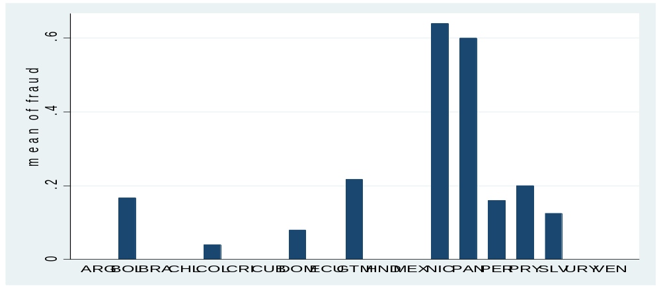

Figure 5.2. Average Electoral Volatility in Latin America, 1982-2006.
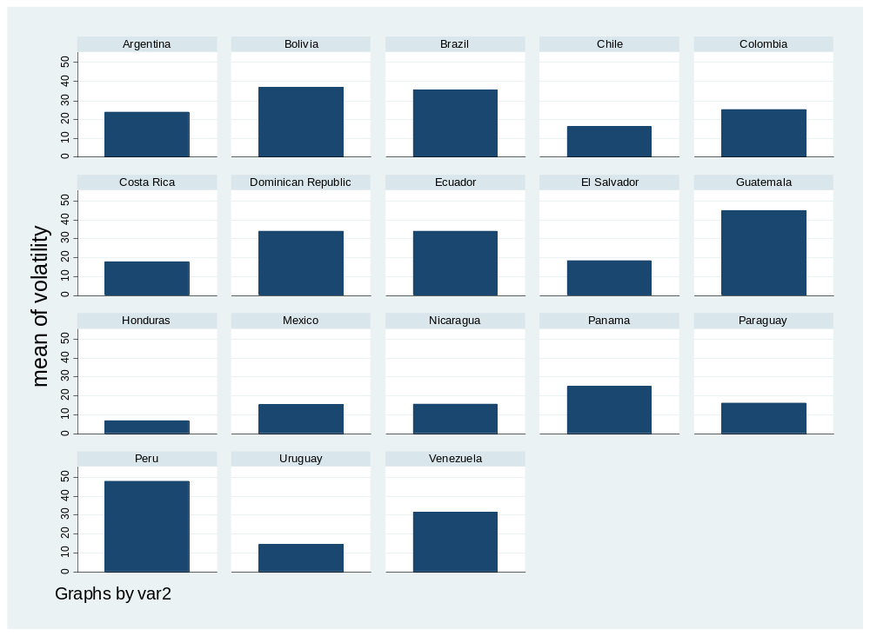

Figure 5.3 Substantive Effect of Electoral Volatility on Electoral Fraud
0
.1
.2
.3
.4
.5
0
100
Electoral Volatility
Substantive effect
Probability of Electoral Fraud

Figure 5.4. Kernel Density Estimate of Residuals
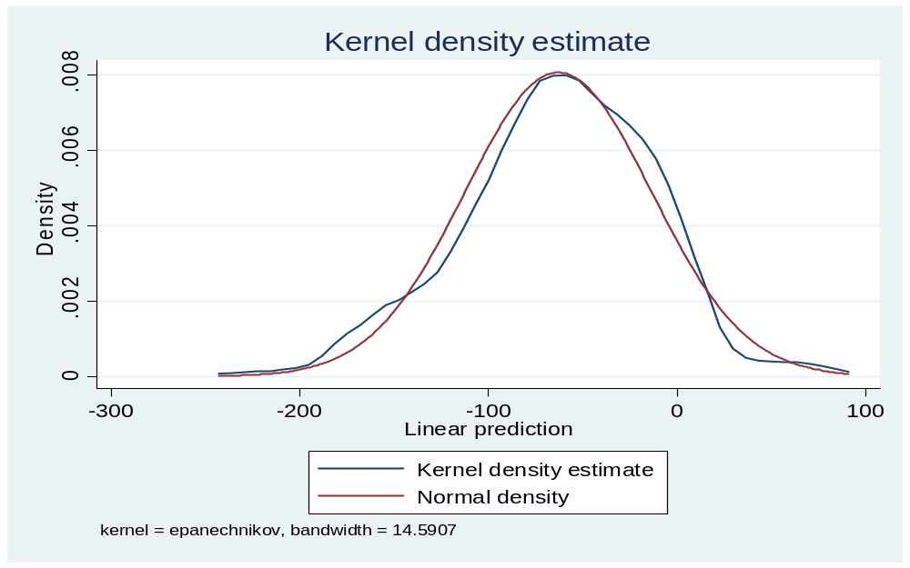

Table 5.1 Country List
Country | Elections in sample | Country | Elections in sample
Argentina | 1983, 1985, 1987, 1991, 1993, 1995, 1997, 1999, 2001, 2003, 2005 | Guatemala | 1985, 1989, 1993, 1997, 2001, 2005
Bolivia | 1985, 1989, 1993, 1997, 2001, 2005 | Honduras | 1985, 1989, 1993, 1997, 2001, 2005
Brazil | 1986, 1990, 1994, 1998, 2002, 2006 | Mexico | 1982, 1985, 1988, 1991, 1994, 1997, 2000, 2003, 2006
Chile | 1993, 1997, 2001, 2005 | Nicaragua | 1990, 1996, 2002
Colombia | 1982, 1986, 1990, 1994, 1998, 2002, 2006 | Panama | 1989, 1994, 2000, 2005
Costa Rica | 1982, 1986, 1988, 1990, 1992, 1994, 1996, 1998, 2000, 2002, 2004 | Paraguay | 1983, 1988, 1993, 1998, 2003
Dominican Republic | 1982, 1986, 1990, 1994, 1998, 2002, 2006 | Peru | 1985, 1990, 1995, 2000, 2005
Ecuador | 1984, 1986, 1988, 1990, 1992, 1994, 1996, 1998, 2000, 2002, 2004, 2006 | Uruguay | 1989, 1994, 1999, 2004
El Salvador | 1985, 1990, 1995, 2000, 2005 | Venezuela | 1983, 1988, 1993, 1998, 2003

Table 5.2 Average Electoral Volatility in Latin America, 1982-2006
Country | Electoral Volatility | Country | Electoral Volatility
Argentina | 24.12 | Guatemala | 45
Bolivia | 37.05 | Honduras | 6.85
Brazil | 35.50 | Mexico | 15.31
Chile | 16.13 | Nicaragua | 38.59
Colombia | 25.12 | Panama | 24.43
Costa Rica | 17.87 | Paraguay | 16.04
Dominican Republic | 33.95 | Peru | 47.78
Ecuador | 33.92 | Uruguay | 14.35
El Salvador | 45.76 | Venezuela | 31.95

Table 5.3 Descriptive Statistics
Variable | Mean | Standard Dev. | Minimum | Maximum
Electoral Fraud | .123 | .329 | 0 | 1
Electoral Volatility | 28.54 | 19.05 | 3.5 | 100
Polity | 5.48 | 5.15 | -8 | 10
New Democracy | .103 | .304 | 0 | 1
Partisanship | 1.52 | .693 | 1 | 3
Turnout | 67.34 | 22.23 | 21.3 | 94.7
EMB | 3.36 | 2.39 | 1 | 8
Margin | 13.99 | 11.47 | .32 | 58
Log GDP | 8.59 | .412 | 7.67 | 9.44
Urban | 61.93 | 16.58 | 33 | 91
BOP Crisis | .298 | .457 | 0 | 1
Eco Crisis | .041 | .199 | 0 | 1
ELF | .428 | .183 | .132 | .743
Religious Frac | .173 | .167 | .019 | .598
Inequality | 50.84 | 5.53 | 36.85 | 62.1
Outsider | .077 | .268 | 0 | 1

Table 5.4. Panel-Logit Estimations. Electoral Fraud and Electoral Volatility
 | Model 1: Logit | Model 2: Logit | Model 3: Logit | Model 4: Logit
Lag Fraud | 4.88***  (.585) | 4.53***  (.625) | 4.61***  (.778) | 5.05***  (1.11)
Electoral Volatility | .043***  (.014) | .048***  (.018) | .060***  (.019) | .092***  (.029)
Polity |  | .009  (.121) | .114  (.136) | .052  (.179)
New Democracy |  |  | .494  (1.40) | .033  (1.50)
Partisanship |  |  | -1.88***  (.805) | -2.58***  (1.13)
Turnout |  |  |  | 10.7*  (6.32)
EMB |  |  |  | -.373  (.346)
Log GDP |  | -1.15  ( 1.11) | -1.43  (1.26) | -1.72  (1.93)
Urban |  | -.009  (.035) | -.003  (.035) | -.008  (.053)
ELF |  | -2.17  (1.97) | -2.04  ( 2.23) | -2.00  (2.92)
Religious Fract. |  | 1.08  ( 1.99) | .500  (2.00) | 3.47  (3.67)
Time | .737  (.696) | .327  (.846) | .192  (1.01) | -.338  (1.15)
Time² | -.052  (.052) | -.013  (.071) | .013  (.093) | .056  (.113)
Time³ | .001  (.001) | .000  (.001) | -.001  (.002) | -.002  (.003)
Constant | -8.02***  (.3.05) | 4.07  (9.60) | 7.17  (10.7) | 4.86  (12.8)
Wald (x2) | 72.04 | 57.65 | 43.67 | 33.07
Log Likelihood | -52.02 | -44.51 | -37.19 | -27.76
N | 382 | 323 | 316 | 308
Notes: ***, ** and * denotes significance at the 1%, 5% and 10% level, respectively. The panel-logit models in this table are each estimated with random-effects.

Table 5.5. Robustness Tests. Fraud and Electoral Volatility
 | Model 5: Logit | Model 6: Logit | Model 7: Logit | Model 8: Logit w/robust s.e. | Model 9:  Relogit
Lag Fraud | 4.25***  (.713) | 8.44***  (2.86) | 4.52***  (1.00) | 5.05***  (1.28) | 3.42***  (1.21)
Electoral Volatility |  | .072***  (.034) | .084***  (.028) | .092***  (.027) | .063***  (.027)
Outsider | 2.23**  (1.30)
Polity | -.172*  (.101) | .180  (.282) | .002  (.183) | .052  (.231) | .062  (.219)
New Democracy | 2.09***  (1.08) | 4.90*  (3.06) | 2.44  (1.75) | .033  (1.80) | .279  (1.71)
Partisanship | -.968  (.680) | -5.20***  (1.78) | -3.28**  (1.89) | -2.58**  (1.48) | -1.55  (1.34)
Turnout | -.032  (.028) | .131*  (.079) | .018  (.038) | 10.7*  (5.97) | 5.37  (5.67)
EMB |  | -.167  (.345) | -.143  (.256) | -.373*  (.231) | -.157  (.219)
Margin |  | -.216*  (.134)
Log GDP | -.926  (.885) | -7.05***  (3.37) | .581  (1.77) | -1.79  (2.36) | -1.31  (2.24)
Urban | -1.91***  (.725) | .063  (.095) | -.061  (.058) | -.008  (.048) | -.003  (.045)
BOP crisis |  | 2.20  (2.12)
ECO crisis |  | -32.8  (44.4)
Inequality |  |  | -.224*  (.129)
ELF | 4.24  (2.09) | 9.12  (5.50) | .541  (4.12) | -2.00  (3.00) | -1.82  (2.24)
Religious Fract. | -1.63  (1.87) | 2.01  (4.34) | -.628  (3.20) | 3.47  (2.35) | 1.89  (2.23)
Time | -.277  (.821) | -2.27  (2.70) | -1.36  (1.56) | -.338  (1.01) | -.373  (.961)
Time² | .049  (.077) | .346  (.258) | .185  (.143) | .056  (.106) | .042  (.100)
Time³ | -.001  (.002) | -.012  (.006) | -.006  (.003) | -.002  (.003) | -.001  (.002)
Constant | 24.01***  (11.09) | 42.8  (42.2) | 3.38  (14.8) | 4.86  (16.1) | 6.33  (15.2)
Wald (x2) | 145.23 | 77.90 | 93.01 | 83.46
 | -41.44 | -48.29 | -26.32 | -27.76
N | 333 | 290 | 182 | 308 | 298
Notes: ***, ** and * denotes significance at the 1%, 5% and 10% level, respectively. The panel-logit models (5-7) in this table are each estimated with random-effects.

References
Auyero, Javier. 1999. “From the Client’s Point(s) of View’: How Poor People Perceive and Evaluate Political Clientelism,” Theory and Society 28,2: 297-334
Alston, L.J., and A.A. Gallo. 2010. “Electoral Fraud, the rise of Peron and demise of checks and balances in Argentina,” Explorations in Economic History 47: 179-97.
Anderson, Margaret, L. 2000. Practicing Democracy: Elections and Political Culture in Imperial Germany. Princeton NJ: Princeton University Press.
Beck, T., G. Clarke, A. Groff, P. Keefer, and Patrick Walsh. 2002. “New Tools in Comparative Political Economy: The Database of Political Institutions.” World Bank Economic Review, 15(1): 165-176.
Botana, N. 1979. El Orden Conservador: LaPolitical Argentina entre 1880-1916. Buenos Aires. Editorial Sudamericana
Calderon-Alzati, E., and D. Cazes. 1996. Las Elecciones Presidenciales de 1994. Mexico, D.F.: La Jornada/CIICH, UNAM.
Cazes. D, and 843 coauthors. 1996. Memorial de las Elecciones de 1994: Testimonios de Observadores. Mexico, D.F.: La Jornada/CIICH, UNAM.
Coppedge, Michael. 1997. “A Classification of Latin American Political Parties,” Kellogg Institute Working Paper # 244, University of Notre Dame.
Cramer, J. S. (2003). Logit Models from Economics and Other Fields (Cambridge: Cambridge University Press).
Dominguez, J.I., and J.A. McCann. 1996. Democratizing Mexico: Public Opinion and Electoral Choices. Baltimore: Johns Hopkins University Press.
Eisendstadt, T.A. 1999. “Weak Electoral Institutions or Legacies of Social Conflict? Modeling causes of Mexico’s local Post-Electoral Mobilizations, 1989-1998. Presented at the Annual Meeting of the American Political Science Association. Atlanta, Georgia.
Elkins, Z. 2000. “Gradations of Democracy? Empirical Tests of Alternative Conceptualizations.” American Journal of Political Science, 44(2): 287-94.
Fearon, J. D. and D. D. Laitin. 2003. “Ethnicity, Insurgency, and Civil War.” American Political Science Review, 97(1): 75–90.
Gurr, T. 1986. “Political Origins of State Violence and Terror: A Theoretical Analysis.” In Government Violence and Repression: An Agenda for Research, ed. Michael Stohl and George Lopez, eds. New York: Greenwood Press.
Hicken, Allen. 2009. Building Party Systems in Developing Democracies. New York: Cambridge University Press.
Kramon, Eric. 2009. “Vote Buying and Turnout in Kenia’s 2002 Elections,” Mimeo, Department of Political Science, University of California at Los Angeles.
Kousser, J.M. 1974. The Shaping of Party-Politics: Suffrage Restrictions and the Establishment of the One-Party South. New Haven, CT: Yale University Press.
Ladd, G. W. (1966). Linear Probability Functions and Discriminant Functions. Econometrica 34: 873-888.
Lehoucq, Fabrice E., and I. Molina. 2002. Stuffing the Ballot Box: Fraud, Electoral Reform, and Democratization in Costa Rica. New York: Cambridge University Press.
Lehoucq, Fabrice, E. 2003. “Electoral Fraud: Causes, Types and Consequences,” American Review of Political Science 6: 233-56.
Li, Q. and R. Reuveny. 2003. “Economic Globalization and Democracy: An Empirical Analysis.” British Journal of Political Science, 33(1): 29-54.
Hosmer, D.W., and S. Lemeshow. 1980. “A goodness-of-fit test for the multiple logistic regression,” Communications in Statistics A10: 1043-69.
King, Gary, Michael Tomz, and Jason Wittenberg. 2000. “Making the Most of Statistical Analyses: Improving Interpretation and Presentation,” American Journal of Political Science 44: 341-355.
Maddala, G. S. (1983). Limited-Dependent and Qualitative Variables in Economics. Cambridge: Cambridge University Press.
Mainwaring, Scott. 1998. “Party Systems in the Third Wave of Democratization,” The Journal of Democracy 9(3): 67-81.
Mainwaring, Scott. 1998. “Electoral Volatility in Brazil,” Party Politics 4(4): 523-
Mainwaring, Scott. 1999. Rethinking Party Systems in the Third Wave of Democratization: The Case of Brazil. Stanford, CA: Stanford University Press.
Mainwaring, S. and T. Scully. 1995. Party Systems in Latin America. In Scott Mainwaring and Timothy R. Scully (Eds.), Building Democratic Institutions: Party Systems in Latin America (pp. 1-34). Stanford, CA: Stanford University Press.
Mainwaring, S., and M. Torcal. 2005. “Party System Institutionalization and Party System Theory after the Third Wave of Democratization,” Kellogg Institute Working Paper # 319, University of Notre Dame.
Moser, Robert. 1999. “Electoral Systems and the Number of Parties in Post-Communist States,” World Politics 51(3): 359-84.
Moser, Robert. 2001. Unexpected Outcomes: Electoral Systems, Political Parties, and Representation in Russia. Pittsburgh, PA: University of Pittsburgh Press.
Nichter, Simeon. 2008. “Vote Buying or Turnout Buying? Machine Politics and the Secret Ballot,” American Political Science Review, 102(February): 19-31.
Penn World Tables. Version 6.1. http://pwt.econ.upenn.edu/php_site/pwt_index.php
Pfeiffer, Silke. 2006. “Vote Buying and its Implication for Democracy: Evidence from
Latin America,” Global Corruption Report 2004. Sterling, VA: Transparency
International.
Posada-Carbo, E. 1994. ‘Elections and Civil Wars in Nineteenth-Century Colombia: The 1875 Presidential Campaign,” Journal of Latin American Studies 26: 621-49.
Przeworski A., M. Alvarez, J. A. Cheibub and F. Limongi. 2000. Democracy and Development: Political Institutions and material well-being in the World, 1950-1990. Cambridge University Press, New York NY.
Schaffer, Frederic Charles and Andreas Schedler. 2007. “What is Vote Buying?” In Frederic Charles Shaffer, ed. Elections for Sale: The Causes and Consequences of Vote Buying, pp. 24-47.
Schedler, A. 2002. “Elections without Democracy: The Menu of Manipulation,” Journal of Democracy 13(2): 36-50.
Simpser, Alberto. 2005. “Making Votes Count: Strategic Incentives for Electoral Corruption,” Ph.D. Dissertation, Political Science, Stanford University.
Stoner Wise, Kathryn. 2001. “The Limited Reach of Russia’s Party System: Underinstitutionalization in Dual Transitions,” Politics and Society 29(3): 385-414.
Tavits, Margit. 2008. “On the Linkage between Electoral Volatility and Party System Instability in Central and Eastern Europe,” European Journal of Political Research 47(5): 537-55.
Trejo, G., and J.A. Aguilar-Rivera. 2002. Etnicidad y Consolidacion Democratica: La Organizacion de las Elecciones en la Regiones Indigenas de Mexico. In Los Dilemas de la Democracia en Mexico, A. Hemond and D Recondo (eds.). Mexico, DF: CEMCA and IFE.
Varela Ortega, J. 2001. Los Amigos Politicos: Partidos Elecciones y Caciquismo en la Restauracion, 1875-1900. Madrid: Marcial Pons/ Junta de Castilla y Leon, Consejeria de Educacion y Cultura.
Ward, M.D., and K.S. Gleditsch. 2006 “Diffusion and the International Context of Democratization.” International Organization 60(4): 911–933.
Wright, Joseph. 2008. “Political Competition and Democratic Stability in New Democracies,” British Journal of Political Science 38:211-245.
Zibblat, Daniel. 2009. “Shaping Democratic Practice and the Causes of Electoral Fraud,” American Political Science Review

Specifically, these countries are: Argentina, Bolivia, Brazil, Chile, Colombia, Costa Rica, the Dominican Republic, Ecuador, El Salvador, Guatemala, Honduras, Mexico, Nicaragua, Panama, Paraguay, Peru, Uruguay, and Venezuela. Cuba is excluded from the sample due to a lack of democratic elections during this period.
In substantive terms, the likelihood of electoral fraud increases from 1% to 33% when electoral volatility goes from its minimum to its maximum value.
The dependent variable, electoral fraud, measures whether vote fraud or candidate intimidation were serious enough to affect the outcome of the elections
This intuition has been suggested before by scholars such as Mainwaring and Scully 1995; Moser 1999, 2001; Stoner Weiss 2001; and Mainwaring and Torcal 2005. However, this chapter is the first systematic test of this argument.
However, extending the temporal domain to the years previous to 1982 is a very difficult task since election records are not easily available for all the democratic elections that occurred in Latin America before 1982.
Cuba is excluded from the analysis because competitive elections did not take place in this country.
Schedler (2002: 105) provides another broader definition of electoral fraud. Specifically, he defines electoral fraud as the “introduction of bias into the administration of elections such that the voting process itself is distorted.”
This measure of electoral fraud has been previously used in studies conducted by Hyde and Bailleau (2009) and Simpser (2004).
Recording is irrespective of whether only opposition claims of fraudulent elections have occurred or whether allegations are backed by independent international observers.
I also estimated all the models presented in tables 3 and 4 using probit models. The statistical significance and direction of the independent and control variables remain unchanged, suggesting that my results are robust even when I use a different estimator.
See Ladd (1966).
Likelihood ratio tests suggest that these time transformations are jointly significant. Thus, they need to be included as controls for time dependence.
Personalism is also used for robustness purposes. As described later in this chapter, my main results are not affected when using this variable.
Dividing by two effectively ensures that the gains and losses are not effectively double counted (Mainwaring et al, 2009).
The first election after the onset of democracy in each country serves as the baseline for calculation.
Argentina, Bolivia, Brazil, Chile, Colombia, Costa Rica, the Dominican Republic, Ecuador, El Salvador, Guatemala, Honduras, Mexico, Nicaragua, Panama, Paraguay, Peru, Uruguay, and Venezuela.
Available at: http://pdba.georgetown.edu/Elecdata/elecdata.html.
See: http://www.idea.int
For this see: http://www1.lanic.utexas.edu/info/newsroom/elections/
Mackie and Rose (1989).
The minimum value is 3.5 (country, year here) and the maximum is 100 (country here).
In Mexico, Calderon and Cazes (1996) and Cazes (1996) find that violations of the secret ballot are more common in rural than in urban areas.
Urban areas are cities with more than 1 million people (WDI, 2008).
A distinction that is fundamental in the developing world and not captured in important works of democracy such as Przeworski et al (2000).
Hartlyn et al (2008) also provide an index of formal authority. My results remain robust even when I use the index of formal rather than profession autonomy in the regressions.
The index of EMB is available for all the countries included in this analysis.
Trejo and Aguilar-Rivera (2002) also find that elections are negatively related to geographic dispersion.
The ethnic fractionalization variable is calculated using a simple Herfindhal concentration index.
The results remain robust when I include the percentage of catholic population rather than religious fractionalization in the models.
Substantive effects are estimated using the statistical software Clarify Version 2.0. In short, the Clarify software converts the raw output of statistical procedures into meaningful results for researchers using a Monte Carlo simulation. For more, please see King, Tomz and Wittenberg (2000).
I re-ran all my models without the time dependence variables –time time² and time³-. The sign and statistical significance of electoral volatility remain unchanged.
For more, see Hosmer and Lemeshow (1980).
This is because the results are not statistically significant.
For example, in Brazil, Fernando Collor de Mello won the 1989 presidential election representing the National Reconstruction Party, a centrist political party formed in early 1989. So the variable outsider takes the value of “1” in Brazil from 1989 to 1992. Another example is the 1990 presidential election in Peru, when Alberto Fujimori won the presidency also as an outsider candidate. Additional examples include Venezuela in 1993 and 1998, Colombia and Ecuador in 2002 and Bolivia in 2005.
For instance, Dominguez and McCann (1996) argue that accusations of fraud in Mexican elections were more common in competitive districts. Using a sample of more than 300 municipal elections in Mexico between 1998 and 1999, Eisenstadt (1999) finds that competitive elections are positively correlated with accusations of electoral fraud.
I use the following sources to estimate the variable margin: (i) The Political Database of the Americas,? (ii) International Democracy and Electoral Assistance,? (iii) Latin American Network Information Center,? (iv) Nohlen (1993), (v) Instituto Federal Electoral (Mexico), (vi) The Europa World Year Book, and the (vii) International Almanac of Electoral History
The inclusion of this variable reduces the sample by more than 40%, thus I computed a separate model to test the effects of income inequality –Gini-.
Since data on income inequality is had to get for some Latin American countries, I tried to maximize the number of observations using several databases. To ensure that the data points are as comparable as possible, I used observations that satisfied the following criteria: (i) they use national representative surveys, (ii) they cover the entire population rather than subsets –rural or urban-, and (iii) they include all types of income.
Alternative hypothesis based on Ziblatt (2009).
The assumption that the variance is equal to 1 is due to technical considerations (Cramer 2003).
These results are available upon request.
This is when electoral volatility goes from its minimum to its maximum and all other variables are set at their means.
Lehoucq and Molina 2002 and Lehoucq 2003 are some exceptions.
Substantive effects were estimated using the results from Model 4, Table 3.x.

