Machine Learning for Modelling High Dimensional Joint Dependency
MSc Data Analytics and AI. School of Computing and Mathematical Sciences. Birkbeck, University of London
Author: Sergii Arkhypov, Supervisor: Dr Alessandro Provetti
10 September 2026. Word count: 9430. Git: https://github.com/SergioArkhypov/MLCopula
Abstract
The modelling of high‑dimensional joint dependence among financial risk factors remains a significant major challenge for the financial industry and Data Science. Classical statistical approaches, notably Gaussian copulas, fail to capture tail dependence adequately, leading to systematic under‑estimation of extreme portfolio losses. This MSc project aims to develop a scalable algorithm for calibrating high‑dimensional copulas that exhibit non‑Gaussian tail dependence while preserving observed marginal and correlation structures. The methodology combines semi‑analytical techniques with Machine Learning models to generate realistic joint‑distribution scenarios for up to several hundred risk factors. A proof‑of‑concept Python software implementation will be built to (i) retrieve and cache market data via the Yahoo Finance API, (ii) compute a portfolio Value‑at‑Risk using both historical and Monte‑Carlo simulations, and (iii) integrate the calibrated copulas as modular components within our new Monte‑Carlo engine. Empirical experiments will assess the impact of copula selection on Value‑at‑Risk estimates across a range of selected portfolios, followed by calibration routine to fit copula parameters to observed data. Finally a testing suite will verify adherence to prescribed dependence and tail criteria. The expected contributions are threefold: (1) a novel high‑dimensional copula calibration framework capable of reproducing empirical tail dependence, (2) a software prototype for market‑data acquisition, risk‑metric computation, and scenario generation, and (3) an empirical evaluation of how alternative copula assumptions affect risk‑measure outcomes, thereby offering a more robust toolset for stress‑testing and capital‑planning in high‑dimensional settings.
Table of Contents
1. Introduction 3
2. Aims and Objectives 3
3. Description of the problem and relevant work 4
Key concepts 4
Value-at-Risk (VaR) and expected shortfall (ES) 4
Copulas 5
Copulas in Value-at-Risk 6
Economics of the Cauchy copula 7
Skewing copulas 8
Literature review 9
4. Methodology and methods 10
5. Requirements specification and Design 12
6. Implementation 14
Market data gathering and preparation 14
Joint simulation 14
Value-at-Risk calculation 16
Copula calibration notebooks 16
7. Testing and Evaluation 17
Testing copulas generation 17
Testing Value-at-Risk calculation 21
Testing optimisation 24
8. Results/Findings and Discussion 26
9. Conclusion/Recommendations/Future Work 30
10. References 32
11. Appendixes 33
Appendix A: List of used AI tools 33
Appendix B: Copula examples 33
Appendix C: Analysis of different VaR methodologies/percentiles 38

Introduction
Despite the popularity of ML/AI algorithms in finance, they have mainly been used for either one or a small number of random factors. Nevertheless, joint analytics of high dimensionality (e.g., >100 random factors) still present serious challenges. This task is hard to address with classical statistical methods, and the available toolset is quite limited, i.e., mainly based on Gaussian copulas. There is hope that advances in ML/AI algorithms and corresponding software libraries will help expand this toolset and provide alternative approaches for modelling high-dimensional joint dependency.
This MSc project proceeds by outlining its primary goals and objectives. Subsequently, it explains the problem under investigation, along with pertinent work that provides essential concepts and a literature review. The subsequent sections detail the methodology and techniques employed to achieve the previously outlined objectives.The subsequent part of the document will explain the project design and implementation, providing rationales for the chosen code architecture. Following this, a section dedicated to testing and evaluation will be presented. It is followed by an analysis of the results, focusing on their implications, and concluding with suggestions for future research direction.

Aims and Objectives
The main aim of this project is to develop a Machine Learning algorithm for calibrating a high-dimensional copula with tail dependence different from Gaussian, while still reflecting the observed history with regards to selected measures (i.e., matching correlation matrix, matching Value-at-Risk measures or pairwise tail dependence at the specific percentile, etc.). On the simulation part, a range of different approaches can be considered, starting from semi-analytical methods to Variational Autoencoders (VAEs) and Generative Adversarial Networks (GANs).
To create this new algorithm empirically requires to develop a software for extracting and caching market data, with subsequent incorporation of calculations of portfolio Value-at-Risk (VaR) and/or Expected Shortfall (ES) measures, which are computationally intensive on their own. To create my ‘workbench’ I will implement Monte Carlo simulations using various copulas within the application, in addition to providing support for the pure historical calculation methods (which will serve as an assessment baseline).
Upon completion of the initial software development, I plan to conduct an experimental analysis to evaluate the impact of copula assumptions on the selected VaR / ES measures (defined below) across distinct portfolios. Following this, establish a calibration procedure aimed at fitting appropriate copulas to real-world market data. Lastly, devise a testing exercise to verify whether the calibrated copulas align with the prescribed conditions and evaluate results against the literature baselines.

Description of the problem and relevant work

Key concepts

Value-at-Risk (VaR) and expected shortfall (ES)
According to classic Jorion’s work [1], portfolio Value-at-risk (VaR) can be defined as the quantile (usually high 99%, 99.9% etc.) of the projected distribution of gains and losses over the target horizon. In simple terms it summarizes the worst loss that will not be exceeded with a given level of confidence.
$${VaR}_{α}(L)=F_{L}^{-1}(α)$$
where $α$ is a confidence level and $F_{L}^{-1}$ is an inverted loss distribution.
On the other hand, Expected Shortfall (ES) measures the average loss in the tail of a loss distribution:
$$ES_{α}(L)=\frac{1}{1-α}\int_{α}^{1}{V}aR_{p}(L)dp.$$
Additional details and relevant industry discussions about ES are available in Cont et. al. [4].
Today there are several main contesting industry spread approaches to VaR (see [1] for additional details):
- Historical Value-at-Risk (HVaR);
- Monte Carlo Value-at-Risk (MC VaR) and
- their hybrids.
When assessing Historical Value-at-Risk (HVaR), several inherent limitations are apparent, particularly when applied to high-percentile risk measures i.e. its inability to estimate extreme percentiles beyond the 99% threshold, as the method relies solely on observed historical data, which often lacks sufficient extreme observations to produce stable tail estimates (e.g. 1 year of data means approx. 250 observations, so the worst one would correspond to 99.6 % and hence being quite unstable). While HVaR does allow for filtration techniques to refine marginal distributions, this flexibility does not extend to the dependence structure, meaning it cannot effectively separate the modelling of marginals from the copula that links them. As a result, the approach struggles to capture complex joint behaviours in a structured way. Another related critical drawback is the high numerical error associated with HVaR, stemming from the finite and often sparse nature of historical data, especially in the tails. On the other hand, the relative strength of the method is its low model error (very few assumptions used), since it does not impose strong parametric assumptions but instead directly uses empirical distributions. This makes it robust in scenarios where the true data-generating process is unknown and there are no other available benchmarks, though at the cost of precision in extreme quantiles.
In contrast, Monte Carlo Value-at-Risk (MC VaR), whether based on parametric assumptions or Extreme Value Theory (EVT) see [1], offers distinct advantages for high-percentile risk estimation. Unlike HVaR, these methods are well-suited for quantiles far beyond 99%, as they generate synthetic data to populate the tails more densely. A key structural benefit is their ability to decouple marginal distributions from the copula, allowing for independent calibration of each component. This separation enhances flexibility in modelling dependence structure while maintaining control over individual risk factors.
From a computational perspective, MC VaR methods exhibit low numerical error, as the simulated datasets can be made arbitrarily large to smooth out estimation noise. However, this precision comes at the expense of higher model error, particularly when parametric assumptions are mis specified or when EVT extrapolations deviate from true tail behaviour. While these methods provide greater control and extensibility in extreme-risk modelling, their reliability hinges on the accuracy of the underlying assumptions, whether in the choice of distributions, copula functions, or tail decay parameters.

Copulas
In this section we briefly introduce the concept of copulas and provide additional references, followed by a discussion of the impact it has on VaR/ES measures.
$C:[0,1]^{d}->[0,1]$ is a d-dimentional copula if $C$ is a joint cumulative distribution function of a d-dimentional random vector on the unit cube $[0,1]^{d}$ with marginals (i.e. each dimension) following a uniform distribution.
Sklar’s theorem (see also in [2]). Every multivariate cumulative distribution function $H(x_{1},…,x_{d})=Pr[X_{1}≤x_{1},…,X_{d}≤x_{d}]$ of a random variable $(X_{1},X_{2},…,X_{d})$ can be expressed in terms of its marginals $F_{i}(x_{i})=Pr[X_{i}≤x_{i}]$ and a copula $C$, as:
$$H(x_{1},…,x_{d})=C(F_{1}(x_{1}),…,F_{d}(x_{d})),$$
For more details on copula and their applications in finance please see [2]. However it is important to introduce several properties of copulas which will be significant for the current project:
- A convex combination (i.e. all weights are non-negative and sum to exactly one) of copulas is also a copula. It is often called a mixture copula and can be expressed as a weighted sum of copulas $C_{i}$, defined as $C_{mix}=Σ_{i=1}^{n}w_{i}C_{i}(u,v)$, where all $w_{i}>0$ and sum to one $Σ_{i=1}^{n}w_{i}=1.$
- There exists a class of functions (W-transforms) applied to copula and also returning copula but with modified properties.
- For additional details on these transformations and their properties please see [9].
One of the most widely used copula is the one constructed from a multivariate normal distribution by using the probability integral transform, Gaussian copula, see [2] for additional details.

Copulas in Value-at-Risk
The selection of a copula has a significant influence on the assessment of tail‑risk measures such as Value‑at‑Risk (VaR) / Expected Shortfall (ES). This influence becomes increasingly pronounced as we move to more extreme quantiles (e.g. 99 % and 99.9 % VaR). The principal limitation of the Gaussian copula lies in its asymptotic independence: as one approach the far ends of the distribution, the probability that two (or more) variables exceed a high threshold simultaneously tends to zero at the same rate as if the variables were independent. Consequently, the Gaussian Copula systematically under‑estimates the likelihood of joint extreme events and, therefore, under‑states tail‑risk metrics.
Tail dependence provides a concise way to expose this shortcoming, some introduction to the use of tail dependence can be found in [6]. Formulas below define lower and upper tail dependence respectively:
$$τ_{ij}^{L}=\lim_{q→0^{+}}P[X_{i}≤G_{i}^{-1}(q)∣X_{j}≤G_{j}^{-1}(q)]/(1-q),$$
$$τ_{ij}^{U}=\lim_{q→1^{-}}P[X_{i}>G_{i}^{-1}(q)∣X_{j}>G_{j}^{-1}(q)]/q,$$
where $G_{i},G_{j}$ are marginal CDFs, while $G_{i}^{-1},G_{j}^{-1}$ are inverse CDFs respectively.
High levels of tail dependence essentially means that the extremes of $X_{i}$ and $X_{j}$ occur more in unison. By computing these tail‑dependence coefficients, one can directly compare how different copulas treat extreme co‑movements. The contrast is stark: while a Gaussian copula predicts virtually no joint tail events, for example Cauchy (Student-T with zero degrees of freedom) assigns a non‑negligible probability to simultaneous extreme losses. See Appendix A for the visual comparison between two copulas both reflecting equivalent correlation values. This disparity translates into markedly different VaR and ES estimates, especially at the highest percentiles. Consequently, when modelling portfolio risk that is sensitive to rare but severe events, choosing a copula with appropriate tail dependence is essential. Otherwise, VaR and ES risk measures may be substantially understated.
Figure 1 below compares historically observed tail dependence (the orange line) with the one of Gaussian and Cauchy copulas i.e. Student-T with zero degrees of freedom (the blue and green lines respectively). The vertical axis measures tail dependence, while the horizontal axis displays the chosen percentile. As the graphs reveal, the discrepancy between the observed and Gaussian tail dependence expands significantly when more risk factors considered together. It is based on 20Y of market price historical observations data (2002-2022) for 2 names Microsoft and Morgan Stanley and 5 names with additionally Google, Amazon and JP Morgan.
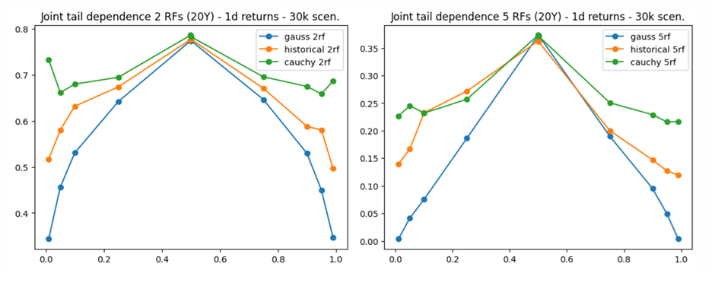
Figure 1: Tail dependence for different types of copulas and different number of random variables.

Economics of the Cauchy copula
The Cauchy copula is a statistical technique for capturing dependence structures, especially when modelling tail‑risk or extreme events. Its principal advantage lies in preserving the overall correlation matrix of the underlying variables while simultaneously enabling the generation of scenarios that exhibit much heavier tails (joint‑movement) and de-correlation. In practice, this means that the copula retains the familiar linear dependence captured by Pearson‑type correlations, yet it can produce joint realisations that reflect the heightened co‑movement observed during rare, high‑impact shocks.
De‑correlation scenarios describe circumstances in which variables that normally exhibit a strong positive (or negative) relationship suddenly lose that linkage when stress or extreme events materializes. In other words, the usual together‑ness of the data breaks down. A classic illustration comes from equity markets: two stocks that historically track each other, e.g., because they belong to the same industry, may abruptly move in opposite directions during a stress event. For example, Google vs. Microsoft - Google taking over Microsoft business after Microsoft collapses.
On the other hand, joint‑movement scenarios involve a set of variables that, despite exhibiting only modest or even negligible correlation under normal conditions, all swing in the same direction because they are all exposed to a common extreme driver. Examples are severe natural disasters that simultaneously spike commodity prices, or a sovereign default that forces both sovereign bond yields and the domestic currency to deteriorate together. In these cases, the common shock creates a temporary, high‑intensity dependence that standard correlation estimates fail to capture.
Both types of scenarios are crucial for robust risk assessment. De‑correlation highlights the risk of assets that are supposed to hedge each other stop doing so, while joint‑movement emphasizes the danger of hidden tail‑dependence that can generate simultaneous losses across seemingly unrelated positions. Modelling frameworks that can generate both behaviours would provide a more realistic picture of potential extreme outcomes than approaches that rely solely on historic linear correlations.

Skewing copulas
While generating scenarios that exhibit heavier tails and dynamic de-correlation addresses one crucial aspect, it is equally important to accurately capture tail asymmetries (a well-documented stylised fact that standard symmetric Gaussian and Cauchy copulas fail to represent). Empirical stock market data demonstrates that extreme financial events are inherently asymmetric. The underlying market dynamics and joint dependencies observed during severe crises fundamentally differ from those seen during periods of sustained growth, with massive, simultaneous downturns occurring far more frequently than equivalent rapid expansions. To successfully incorporate this critical asymmetry into the dependency structure, a specific type mathematical transformation can be applied directly to the copula. In this study we utilize the following piecewise function to distort the probabilities:
$$T(u)=\left\{\begin{matrix}\frac{u}{θ}, & \text{when }u≤θ \\ \frac{1-u}{1-θ}, & \text{when }u>θ\end{matrix}\right.$$
This uniformity-preserving function is applied to each dimension of the copula independently. Because this rather than attempting to distort the entire joint distribution simultaneously, it effectively bypasses the exponential computational overhead often referred to as the curse of dimensionality. Ultimately, this elegant transformation ensures that the system can rapidly and reliably simulate complex, asymmetric tail risks across massive portfolios without sacrificing computational speed or performance. Formally, a transformation $T:[0,1]→[0,1]$ is defined as uniformity-preserving if the transformed variable maintains a uniform distribution, meaning that $T(u)∼U(0,1)$ given $u∼U(0,1)$. This specific functional mapping belongs to the broader mathematical category known as W-transforms, which can be used to introduce controlled asymmetry into the dependency models. A more rigorous theoretical analysis of the W-transform class and its statistical properties can be found in [8]. Figure 2 provides an illustration of this technique in practice, clearly demonstrating how the application of W-transform functions successfully injects structural asymmetry directly into the baseline copula. It is also important to mention another important property of the proposed transformation, if $theta$ parameter is close to one it has negligible impact on the overall correlation but still introduces required asymmetry at the extreme tails.
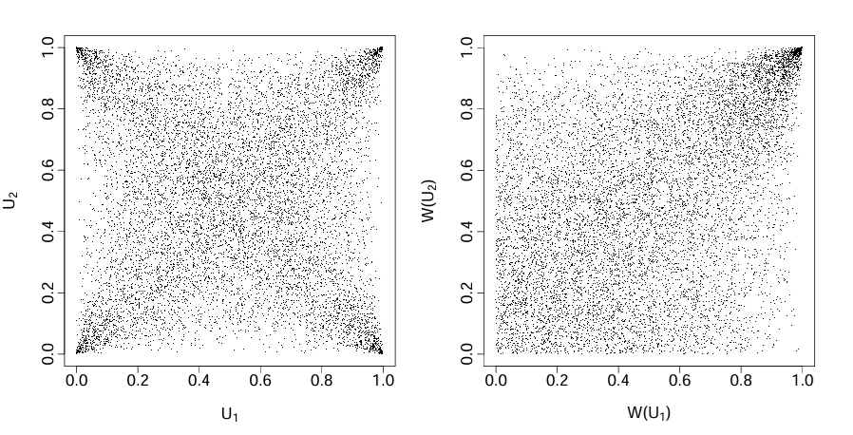
Figure 2: A sample of scenarios from the original 2d Cauchy copula (left) and its W-transformed equivalent (right).

Literature review
The rapid advancement of generative Machine Learning techniques has generated significant interest within the financial industry, as evidenced by numerous studies (e.g., see [8] for a review). However, much of the existing research has primarily focused on generating paths for either a single asset or a limited number of risk factors (as discussed in [7]). Moreover, the majority of these efforts have cantered on simulating so-called “central scenarios,” with limited attention given to the generation of realistic extreme scenarios. An exception to this trend can be found in [5], which explicitly target the generation of tail events using Generative Adversarial Network (GAN) (see Cont R. et al for examples and implementation) architectures, though even these approaches remain constrained to relatively low-dimensional environments, i.e., up to 20–50 factors.
Inspired by these works, this research seeks to extend the dimensionality of scenario generation while relaxing the requirement for path dependence. This adjustment allows us to leverage more classical tools for modelling joint dependencies, such as copulas. However, even within this framework, only Gaussian copulas (and selected Student-T) have demonstrated the capacity to scale effectively to very high dimensions. This project aims to bridge the gap between the data-driven GAN-like approaches from the literature and the scalability of copulas by developing a high-dimensional copula model capable of capturing historical tail dependence properties. The ultimate goal is to generate realistic ‘extreme’ scenarios that reflect the complex dependencies observed in financial markets.

Methodology and methods
As mentioned above, unlike studies where the intricacies of underlying asset path dynamics (such as time-dependent volatility or complex stochastic processes) are critical, this work deliberately abstracts from such details. As such there is no need to include dynamically-changing portfolios (i.e. dynamic trading strategies), we limit portfolio dimension optimisation to the static core. Portfolios of approx. 500 names with all long positions and 500 long/short hedged positions will be used in this study.
Figure 2 presents the overall workflow of the project. The aim is to calibrate copula to historical timeseries related to a list of selected portfolios.
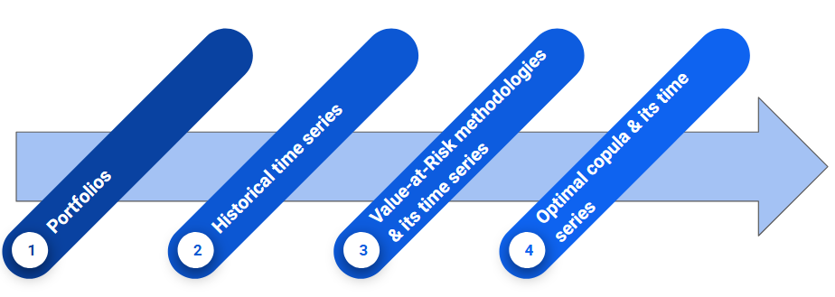
Figure 3: The proposed copula calibration workflow.
Figure 3 further details the cumulative process of constructing different time series based on the observed history and representing the required data transformations.
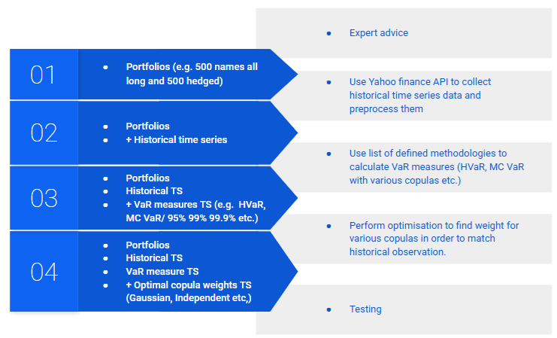
Figure 4: The proposed process of data transformations for copula calibration.
Beyond scalability, another key advantage of the proposed architecture lies in the interpretability of results. While alternative approaches, such as Tail-GAN-based simulations, often produce outputs that are difficult to dissect or explain (see [5] for a discussion), the methodology employed here offers a structure for understanding extreme scenarios. The framework decomposes market dynamics into a weighted combination of copulas (see Copulas properties in the previous section), each with a clear and intuitive economic or statistical meaning. Not only will it enhance transparency but also provide a more actionable foundation for stress testing and capital planning. Indeed, the ability to attribute risk contributions to specific copula components is a significant improvement in practical applicability and model governance.
The workflow described in Figure 3 will be implemented in Python with recourse to well-known Python modules that are frequently used for such type of data processing. In particular, the Scikit-learn module described in Geron’s textbook (see [10]) supply us with Python classes required to implement the workflow above and testing phase.
It is important to note that the final phase of this process requires an optimisation procedure designed to identify the optimal coefficients for the various copulas under consideration. The core objective during this stage is to minimize the distance between the Value-at-Risk (VaR) measures generated by our target copula model (used in Monte-Carlo VaR) and those empirically observed in the historical data (HVaR). Achieving this precise calibration, however, presents a significant mathematical challenge. Because the mapping from the underlying copula parameters to the final VaR metrics does not offer straightforward analytical gradients, the system cannot rely on traditional calculus-based optimisation methods. Instead, this calibration process effectively transforms into the complex task of optimizing a noisy (i.e. seed changes), black-box function. In this environment, evaluations can be computationally expensive, and the outputs are often subject to statistical noise inherent in both the empirical data and the simulation processes. This scenario is conceptually identical to the challenge of hyperparameter optimisation in advanced machine learning models, where practitioners must efficiently search a vast and complex parameter space without knowing the underlying structure of the objective function. To overcome this challenge and find the best-fitting coefficients, the application utilizes the scikit-optimize package (see [11]). In this study we tried all tree different methods available in the package:
- Bayesian optimisation using Gaussian Processes;
- Sequential optimisation using gradient boosted trees;
- Sequential optimisation using decision trees;

Requirements specification and Design
In terms of implementation this project requires two parts a) efficient code which is able to calculate Value-at-Risk for the prescribed portfolio b) research part which is able to calibrate joint high-dimensional copula, exploring different settings, algorithms and parametrisation. Due to its different nature it was decided to follow different design approach for the each part. Part a) was implemented by following object oriented approach, where each class abstraction performs its own role of the calculations. It is composed of the following parts:
- Market data gathering and preparation, where the solution fetches and pre-processes all required data (i.e. ‘market.py’ module);
- Joint simulation part is the central component of the current project, it serves to create scenarios expressing joint behavior, based on provided market data and different statistical hypotheses (i.e. ‘jointsim.py’ module);
- Value-at-Risk calculation, where generated scenarios are combined with the portfolio information to calculate profit and loss distribution. Once distribution is ready it can be queried for the specific percentile (i.e. ‘var.py’ module);
The figure below represents the UML class diagram for the Value-at-Risk calculation; each component is discussed in detail further in the section.
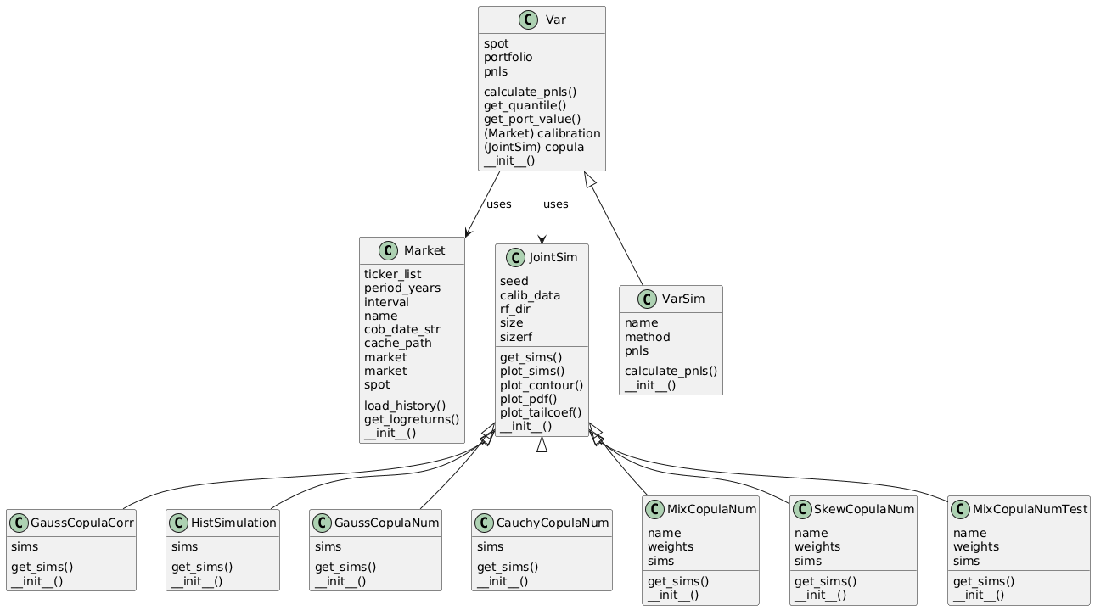
Figure 5: Value-at-Risk calculation UML class diagram.
Part b) is done in a list of jupyter notebooks designed for the quick interactions with the results and exploitive study of different settings and parameters.
- The study_copula_and_var.ipynb notebook evaluates various copula models by visualizing their complex dependency structures in an accessible, two-dimensional space. Additionally, it calculates Value-at-Risk time series to demonstrate how the choice of copula directly impacts portfolio risk estimates at different percentiles.
- The study_optimisation.ipynb notebook iteratively calibrates copula weights and parameters on a monthly basis across a twenty-year historical dataset. Central to this process is the evaluation of a composite model that blends a standard Gaussian copula with a Skewed Cauchy copula to capture both normal market fluctuations and extreme tail events. By reducing the Cauchy component’s skewness coefficient (see details in previous section), the model accurately simulates the heavy left-tail risks and severe downturns characteristic of real-world equity markets.
- The study_optimisationn_ts.ipynb notebook plots final timeseries for the weights and skew performing postprocessing of the results produced in the previous notebook.

Implementation
In this section, we systematically revisit each of the architectural components introduced before and provide a more comprehensive explanation of its implementation.

Market data gathering and preparation
To execute the complete workflow as detailed in the previous section, we start with the portfolio information provided as an input. Subsequently, we access historical stock price data from Yahoo Finance API, according to the specified timeframe duration. The existing implementation, presented within the ‘Market’ class in the ‘market.py’ file (see Figure 5), performs storing of all retrieved data in a locally saved CSV file for the reference in case multiple runs be necessary. After the gathering stage of all required timeseries, they undergo pre-processing to calculate log-returns, segmented into the chunks of dedicated length.

Joint simulation
The JointSim class serves as an abstract base class specifically designed to provide a standardized framework for all copula implementations within the project. By defining a list of virtual functions, it enforces a consistent interface that all descendant classes must implement to ensure architectural integrity. Beyond that, the class centralizes the core analytical logic required for investigations, including the automated plotting of all simulations, resulting contour plots and tail coefficients. This centralized approach ensures that common statistical visualisations and diagnostic tools are applied uniformly across all models. The current project has integrated several specific copula models into its framework:
- The HistSimulation class implements a historical simulation approach, which generates data by returning a sample of normalized observations derived directly from actual historical time series. Rather than assuming an underlying parametric distribution, this method relies on the empirical distribution of the observed data.
- The GaussCopulaCorr class implements the Gaussian copula model by utilizing a specified correlation matrix as its primary input. To perform simulations, the class employs classical sampling techniques derived from a multivariate normal distribution. This process leverages the highly optimized multivariate_normal implementation provided by the NumPy library.
- The GaussCopulaNum class provides an alternative implementation of the Gaussian copula designed specifically for applications involving actual historical time series data. Unlike traditional approaches, this implementation bypasses the potentially problematic process of calculating a formal correlation matrix from raw data. This design choice is intended to avoid the numerical instability and computational intensity often associated with such matrices, particularly the risk of generating a matrix that is not positive semi-definite. By avoiding this step, the class provides a more robust framework for working with empirical datasets where some irregularities might otherwise lead to mathematical errors.
- The CauchyCopulaNum class implements a Cauchy copula, which can be viewed as a special case of the Student-T distribution with one degree of freedom. Much like the “GaussCopulaNum” implementation, this class is designed to accept actual historical time series as an input. This approach intentionally bypasses the computationally intensive and numerically sensitive task of calculating an explicit correlation matrix, thereby avoiding the common risk of encountering a matrix that is not positive semi-definite. Instead, the implementation is grounded in the properties of a standard multivariate Cauchy distribution with zero mean and unit scale, providing a robust method for modelling heavy-tailed dependencies without the instability of traditional matrix estimation. An addition benefit of the Cauchy copula is the ability to produce an alternative diagonal and generate de-correlation scenarios (see section 3 for discussion). This capability is particularly valuable for stress-testing and risk management, as it enables the simulation of scenarios where assets or variables may de-correlate unexpectedly during periods of high volatility or extreme market stress.
- The SkewCopulaNum class implements a skewed Cauchy copula, which serves as an asymmetric extension to the original Cauchy copula. Similarly to the CauchyCopulaNum implementation, this class utilizes actual historical time series as its primary input. To achieve asymmetric tail behaviour, the class applies a W-transform (see [9] for details) to the underlying Cauchy copula. This transformation allows the model to capture directional dependencies and tail asymmetries that a standard symmetric Cauchy and Gaussian copulas would otherwise fail to represent, making it particularly effective for modelling empirical data with non-symmetric extreme events (i.e. market crisis behaviour is different to the periods of growth, see section 3 for discussion).
- The MixCopulaNumTest class is designed to perform mixture simulations by combining skewed Cauchy and Gaussian copulas. This approach is mathematically grounded in the principle that a convex combination of various copulas also constitutes a valid copula (see section 3 for details), thereby allowing for the modelling of complex, hybrid dependency structures. The user can define the specific composition of the mixture by providing the relative proportions of each constituent copula as an input parameter, enabling the simulation of data that exhibits both symmetric and asymmetric tail behaviours simultaneously, in addition to the alternative diagonal (i.e. de-correlation scenarios).

Value-at-Risk calculation
As before the Var class serves as an abstract base class, designed to establish a standardized, cohesive framework for Value-at-Risk (VaR) calculations. This foundational class integrates the core computational components of the risk model by combining the portfolio definition, the underlying copula specification, and the empirical market data required to construct marginal distributions. Although VarSim is currently the sole concrete child class implemented within this project, the object-oriented architecture is inherently extensible, deliberately leaving room to seamlessly incorporate alternative models and methodologies in future research. In its execution, processes output scenarios generated by the copula, which manifest as uniformly distributed coordinate vectors situated within a $d$-dimensional hypercube $[0,1]^{d}$. To translate these theoretical, uniform probabilities into realistic market conditions, the system maps them against the market data serving as the marginal distribution for each individual stock. This transformation is executed utilizing the “quantile” function (effectively the inverse cumulative distribution function) provided by the NumPy package. During this step, the model explicitly relies on the standard assumption of log-normality, which is widely accepted convention for modeling the behavior of equity returns. Once a simulated vector of individual asset returns is generated, it is multiplied with the portfolio weights to calculate the aggregated return of the entire portfolio. To ensure statistical robustness and accurately capture a wide spectrum of potential market movements, this exact procedure is iterated 10,000 times (i.e. number of Monte-Carlo simulations). Such sampling effectively constructs a probability distribution of the overall portfolio returns, from which specified VaR metrics can be extracted (e.g. 75th, 90th, 99th and 99.5th percentiles).

Copula calibration notebooks
- The study_copula_and_var.ipynb notebook serves as a dedicated environment for evaluating and visualizing the underlying copula generation processes. To provide an incite of the distinct mathematical dependency structures inherent to each model, the notebook features visual illustrations of the considered copulas in a two-dimensional space. This targeted bivariate approach allows for clear, accessible graphical representations of complex joint distributions, making it significantly easier to observe tail dependence that might otherwise be obscured in higher-dimensional data. The notebook further extends into empirical assessment by calculating and plotting Value-at-Risk (VaR) time series of the various copulas across multiple percentiles. Such comparative analysis demonstrates how the specific choice of dependency model impacts the accuracy of extreme tail risk estimates over time.
- The study_optimisation.ipynb notebook is dedicated to the calibration of copula weights and associated parameters, executing this process iteratively on a month-by-month basis across twenty-year historical timeframe. Central to this analysis is the evaluation of a composite dependency structure that intricately blends a standard Gaussian copula with a Skewed Cauchy copula in order to capture both normal market fluctuations and extreme tail events. The Cauchy component is modified by a skewness coefficient. At a baseline of 100%, this parameter represents a standard, symmetric Cauchy copula. However, when decreased, the model introduces a pronounced negative skew into the distribution. This adjustment intentionally generates a higher frequency of simulated scenarios corresponding to severe market downturns and localized company defaults, rather than assuming symmetrical extreme growth. Implementing this asymmetry is crucial for accurately reflecting the behavior of real-world equity markets, which characteristically exhibit heavy left tails and are historically far more prone to sudden, catastrophic losses than to equivalent exponential gains. Initially, a simultaneous two-dimensional optimisation approach was attempted to calibrate both the copula weights and the skewness parameter. However, this joint calibration proved unstable, yielding excessively noisy parameter estimates due to the complex, non-linear nature of the objective function. To overcome this computational instability the methodology was refined into a more robust, conditional optimisation strategy.Instead of allowing both variables to float freely during the search, the system strictly optimizes the Cauchy copula weight while holding the skewness parameter constant. This procedure is executed across eleven distinct, pre-defined skewness levels ranging from 0.9 to 1.0. By discretising the skewness dimension into a fixed grid and performing isolated one-dimensional optimisations, the model bypasses the previously observed noise.
- The study_optimisationn_ts.ipynb notebook plots final timeseries for the weights and skew performing postprocessing of the results produced in the previous notebook.

Testing and Evaluation

Testing copulas generation
To validate the computational implementation of the copula models, we conduct a specialized two-dimensional simulation focused on the stock returns of Apple and Microsoft as of 31 December 2025. This bivariate approach is selected because it permits a clear, intuitive visual analysis of the underlying dependency structures before scaling to higher dimensions. The accompanying figure below presents 10,000 uniform scenarios generated across four distinct copulas. Crucially, to ensure a valid and strictly controlled comparison, every model in this simulation is calibrated using the exact same set of input information (comprising one year of historical observations), has almost identical Pearson correlation coefficient. The visualization is organized into four distinct panels to highlight the behavioral characteristics of each dependency structure. The top-left quadrant displays the standard Gaussian copula, which establishes a baseline of symmetric, light-tailed dependence typical of normal market conditions. In contrast, the top-right quadrant features the Cauchy copula, clearly demonstrating significantly heavier tails and an alternative diagonal for de-correlation scenarios. The bottom-left panel illustrates a composite model that equally blends the Gaussian and Cauchy copulas with a 50% weight assigned to each. Finally, the bottom-right quadrant presents the Skewed Cauchy copula configured with a 95% skew coefficient. This configuration introduces the critical left-tail asymmetry discussed previously, providing clear visual confirmation of the model’s ability to simulate realistic, highly correlated market downturns. By strategically shifting the probability mass, the copula effectively captures the severe, synchronized crashes that characterize genuine financial crises, where asset prices tend to collapse simultaneously. Equally important is the model’s treatment of positive market movements, the transformation ensures a light-tailed structure throughout the growth region. This dual-sided approach ensures that while the system correctly anticipates correlated losses, it avoids the common pitfall of erroneously simulating symmetrically extreme, simultaneous market booms.
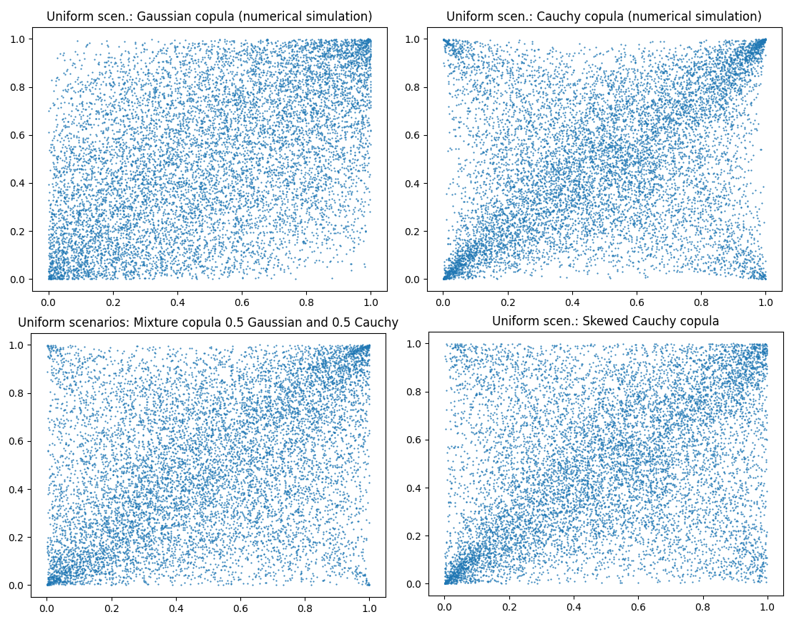
Figure 6: Uniform scenarios from various copulas: Gaussian(top left), Cauchy (top right), Mixed Gaussian/Cauchy (bottom left) and Skewed Cauchy (bottom right)
To provide further empirical support for the rationale outlined above, we graphically analyse the tail dependence coefficients (see definition in section 3) across a wide range of probability percentiles for each of the evaluated copula models:
- Gaussian(top left);
- Cauchy (top right);
- Mixed Gaussian/Cauchy (bottom left), with 50% weight each;
- Skewed Cauchy (bottom right), with skew coefficient of 95%.
By plotting these coefficients, we can visually quantify the exact degree to which extreme events are correlated within the distinct dependency structures. This visual analysis allows for a precise observation of how tail dependence dynamically evolves as the distribution extends further into the extreme regions. Ultimately, charting these metrics provides concrete mathematical evidence that highlights the profound structural differences between models and confirms correctness of the implementation.
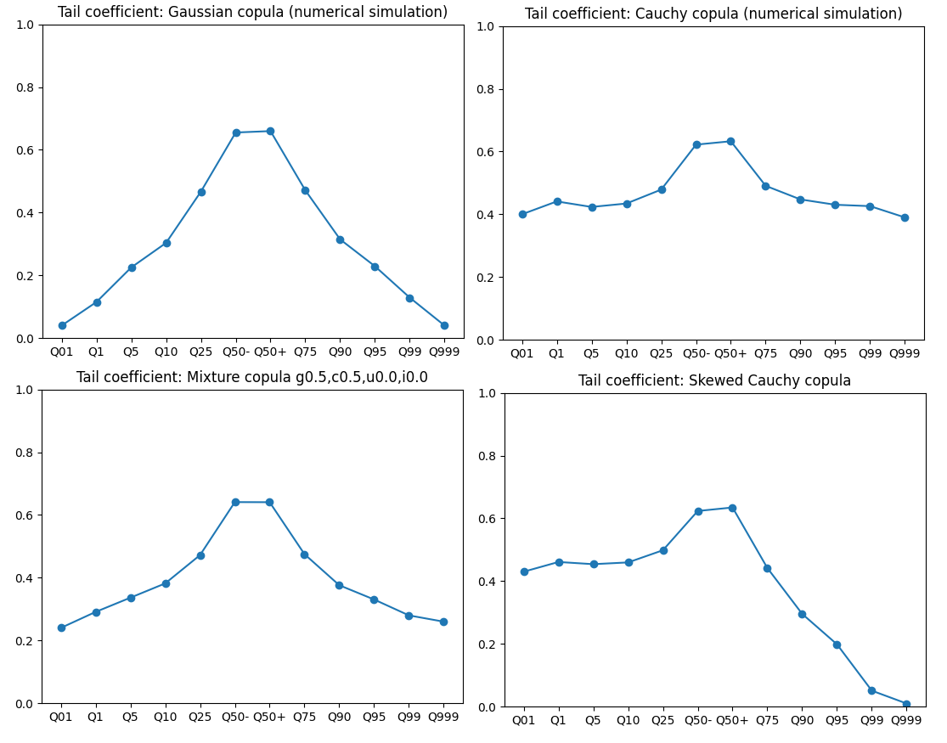
Figure 7: Tail dependence for various copulas: Gaussian(top left), Cauchy (top right), Mixed Gaussian/Cauchy (bottom left) and Skewed Cauchy (bottom right).
Beyond the primary models previously discussed, the analysis must also consider two crucial theoretical boundary cases: the independent copula and the comonotonicity copula. Integrating these theoretical copulas is beneficial as it provides an additional support for the implementation of a sophisticated mixture copula and allows studying extremes. The independent copula models a scenario of absolute zero dependence between variables, reflecting a state of complete market decoupling. Conversely, the comonotonicity copula represents perfect positive dependence, illustrating an extreme environment where all prices move in exact synchronization. By purposefully blending these boundary conditions with standard dependency structures, the system can account for rare but highly impactful shifts in market regimes.
To practically demonstrate this concept, the current implementation constructs a complex composite mixture that aggregates the Gaussian, Cauchy, independent, and comonotonicity copulas using assigned weights of 50%, 40%, 5%, and 5%, respectively. Inclusion of the minor 5% weights for the independent and comonotonicity copulas ensures that the model reserves a small but vital probability for edge-case scenarios, specifically: moments of total market fragmentation or periods of absolute systemic lockstep during a severe crisis. Use of minor 5% weights also ensures very limited impact on the total Person correlation. Both the independent and comonotonicity copulas can be implemented by leveraging the Gaussian copula with a specific correlation matrix input. In the case of the independent copula, the correlation matrix is constructed such that all elements are zero. Conversely, the comonotonicity case is achieved by setting all elements of the correlation matrix to one.
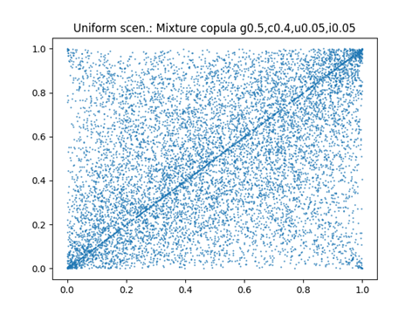
Figure 8: Uniform scenarios from composite mixture copula: the Gaussian (50%), Cauchy (40%), independent (5%) and comonotonicity (5%)

Testing Value-at-Risk calculation
In this section, we validate our MC VaR framework by testing how different copula-based dependency structures impact risk estimates at different percentiles. Our methodology involves computing monthly figures for the period spanning from 2020 to 2025, with each value being driven by the preceding twelve months of market data to which it is calibrated. To test the robustness of the implementation, we apply this process to three specific portfolio configurations. The first is a long-only portfolio following the S&P 500 index weights published in February 2026. The second test case consists of a mirror-image short portfolio, which maintains the exact same weight distribution as the long-only portfolio but utilizes inverted signs for all position exposures. Finally, we implement a third “hedged” portfolio by randomly alternating the sign of the positions (long or short) for each stock, thereby creating a portfolio with a randomized, market-neutral exposure.
The figure presented below shows the evolution of standard 99% VaR (which is commonly utilized for both internal risk management and regulatory capital calculation). It is calculated across the various copula models detailed in the preceding section, specifically including the Gaussian copula, the Cauchy copula, a mixture copula (with weights 40%, 40%, 10%, 10%), and a Skewed Cauchy copula configured with a skewness parameter of 0.95. By comparing these models, one can observe how different dependency and tail assumptions significantly alter the resulting risk estimates. To provide an empirical baseline, the copula-based results are complemented by historical simulations and the parametric dependency structures modelled by the various copulas can be evaluated against the actual realised distributions found in the historical data. By comparing these two approaches, we can assess the extent to which different copula assumptions deviate from or align with observed market realities.
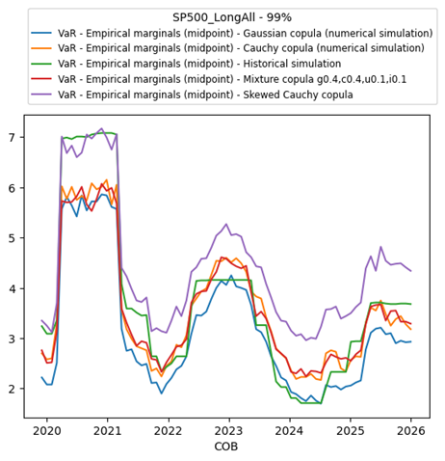
Figure 9: Monthly 99% HVaR level and MC VaR levels with different copulas from 2020 to 2025 (all long portfolio)
An analysis of the time series data reveals three pronounced humps consistently present across all evaluated VaR methodologies. The synchronised appearance of these elevated risk levels provides some empirical validation for the correctness of the model’s computational implementation, as they accurately reflect the underlying market dynamics during known periods of severe macroeconomic instability. Specifically, these spikes in the VaR estimates directly correspond to major systemic shocks that occurred within the analysed timeframe: the unprecedented global market volatility triggered by the onset of the COVID-19 pandemic, the profound geopolitical turbulence and subsequent commodity crisis stemming from the war in Ukraine, and the sharp economic disruptions caused by the aggressive tariff regimes introduced following “Liberation” day.
The Historical VaR (HVaR) metric generated exceptionally high value during the onset of the COVID-19 pandemic. However, these extreme peaks are likely overstated due to the methodological limitations of HVaR discussed in section 3 — most notably its over-reliance on a sparse number of discrete, severe empirical observations without the benefit of structured tail smoothing. Among the parametric MC VaR approaches evaluated, only the framework utilising the Skewed Cauchy copula reaches comparable magnitudes of 99% percentile during these highly volatile periods. By mathematically incorporating left-tail asymmetry and heavy downside dependencies, the Skewed Cauchy model consistently produces the most conservative VaR estimates. In contrast, and perfectly aligning with theoretical expectations, the standard Gaussian copula persistently generates the lowest risk figures across the observation window. This chronic underestimation is a direct consequence of the Gaussian model’s thin-tailed structure and inherent asymptotic independence, which severely restrict its capacity to properly account for the severe, synchronised asset collapses characteristic of genuine market crises.
To ensure a comprehensive evaluation we provide our analysis of 99% VaR estimates also for a market-neutral hedged portfolio and a strictly short portfolio. By examining these distinct structural configurations, we can rigorously test the robustness and versatility of the various copula methodologies across fundamentally different directional exposures and trading strategies. Furthermore supplementary figures with additional percentiles are detailed in Appendix C, offering readers a deeper, more granular insight into the tail risk dynamics under varying market conditions.
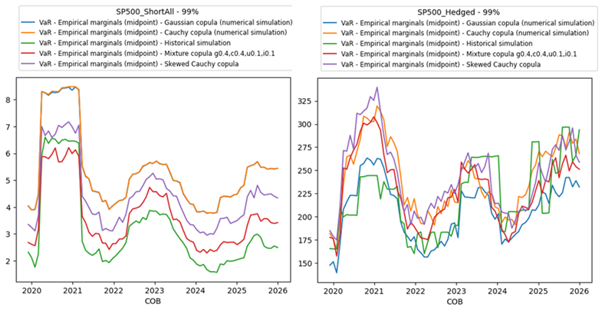
Figure 10: Monthly 99% HVaR level and MC VaR levels with different copulas from 2020 to 2025 - all short (left) and hedged (right)
During the testing of the composite dependency structures, the framework was further expanded to incorporate both independent and comonotonicity copulas into the overarching mixture blend. As illustrated in the accompanying figure 11 below, the independent copula serves as an effective mechanism for generating de-correlation scenarios, offering a structural alternative to the the Cauchy copula. By purposefully injecting instances of absolute zero dependence into the simulation, the model can realistically replicate idiosyncratic shocks or severe market breakdowns where historical asset linkages abruptly dissolve. It is noteworthy that whe this mixture copula is applied to the market-neutral hedged portfolio, it yields the most conservative 99% Value-at-Risk (VaR) estimates among all the evaluated methodologies. This is a direct consequence of the model’s design: the deliberate inclusion of de-correlation and perfect synchronization events severely disrupts the assumed offsetting positions that a hedged strategy relies upon. By simulating these hedge breakdowns, the mixture copula could expose the portfolio’s hidden vulnerabilities to sudden shifts in underlying correlation structures, thereby providing a rigorous and prudent tool for stress-testing and capital planning.
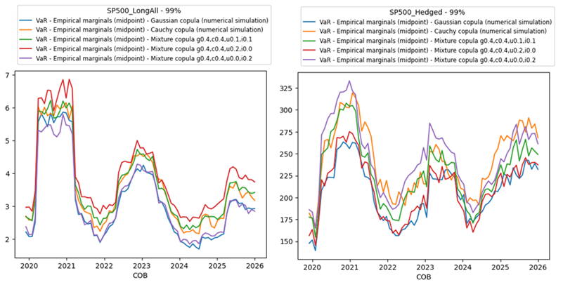
Figure 11: Monthly 99% HVaR level and MC VaR levels with different copulas from 2020 to 2025 - all long (left) and hedged (right)

Testing optimisation
Having validated the computational framework for the VaR calculations, the analysis progresses to the testing of the high-dimensional copula calibration process. Initial calibration efforts focused on a composite model: blending standard Gaussian and Cauchy copulas, applied specifically to the S&P 500 long portfolio. While this preliminary mixture yielded promising baseline results, it exhibited significant estimation errors during the extreme market volatility of the COVID-19 pandemic. To fix this shortcoming, we hypothesised that incorporating a Skewed Cauchy copula would better capture the severe downside risks and asymmetric tail dependencies characteristic for such crisis, thereby substantially reducing the calibration error. VaR calculation is a computationally expensive and noisy procedure, attempting a simultaneous two-dimensional optimization across both the weight and skewness parameters proved unstable. To ensure robust and reliable convergence, the methodology was refined into a systematic one-dimensional optimization strategy. Under this approach, the copula weight was dynamically optimized while the skewness parameter was strictly discretized, iterating from 90% to 100% in fixed 1% increments, allowing the system to isolate the absolute best-performing configuration. The subsequent figure illustrates the outcomes of this targeted calibration over the period spanning from 2020 to 2025. The objective function was designed to minimize the deviation between the simulated model estimates and the empirical Historical VaR values across four confidence intervals: the 75th, 90th, 99th, and 99.5th percentiles. To execute this complex, derivative-free search efficiently, the system employed Bayesian optimization utilizing Gaussian Processes. Specifically, the implementation relied on the skopt package and was constrained to 40 objective function calls to perfectly balance computational efficiency with accurate parameter discovery (for further technical details regarding this package, see [11]).
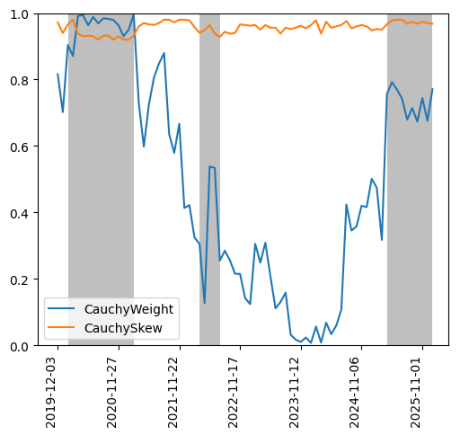
Figure 12: Calibrated timeseries for Cauchy copula weight and skew from 2020 to 2025
An analysis of the plotted results reveals a meaningful signal in the time series of both the Cauchy weight and the skewness parameter. During documented periods of market stress (visually highlighted in the figure by the grey-shaded backgrounds) the optimised weight assigned to the Cauchy component systematically increases to nearly 100%. Concurrently, the skewness coefficient drops into the 92% to 93% range. This coordinated parametric shift correctly encapsulates the reality of crisis behavior in financial markets, adapting the model to account for the heavy, left-tailed asymmetric dependencies that dominate when standard market correlations break down.
This exact empirical pattern consistently repeats itself across all three major macroeconomic shocks captured within the 2020 to 2025 observation window: COVID-19 pandemic, geopolitical turbulence stemming from the war in Ukraine and US tariffs introduction following “Liberation” day. The consistent responsiveness of these calibrated parameters serves as a definitive confirmation of both: the accuracy of the computational implementation and the broader relevance of the underlying approach. It demonstrates that a dynamically calibrated, composite mixture copula can reproduce complex, empirically observed historical tail behaviors while retaining the vital mathematical properties required to scale efficiently to very high-dimensionality.

Results/Findings and Discussion
To confirm conclusions presented in the previous section, the calibration analysis was extended backward to encompass a much broader historical window initiating the dataset from 2006. Because processing nearly two decades of high-dimensional financial data introduces substantial computational overhead, maintaining a tractable execution time for the algorithm became a practical necessity. Consequently, the optimization constraints were adjusted, systematically reducing the maximum number of objective function evaluations to 15 per calibration cycle. Despite this forced reduction in computational depth, the accompanying figure clearly demonstrates that the fundamental dynamics observed in the shorter timeframe remain entirely consistent across this extended twenty-year horizon. Specifically, the calibrated weight of the heavy-tailed Cauchy component within the composite mixture systematically surges whenever the market enters periods of macroeconomic distress. Conversely, the time series trajectory for the skewness parameter exhibits a higher degree of statistical noise over this prolonged period. This heightened variance is likely a direct consequence of the restricted number of optimization iterations, which occasionally prevents the algorithm from reaching absolute convergence. Yet, even with this increased volatility in the parameter estimates, a meaningful signal remains intact. Clear, distinct drops in the skewness coefficient are still observable at the immediate onset of major stress events (highlighted in the visualization by the grey-shaded backgrounds) further reaffirming the model’s capacity to adapt to sudden left-tail asymmetries during the initial stages of a market shock.
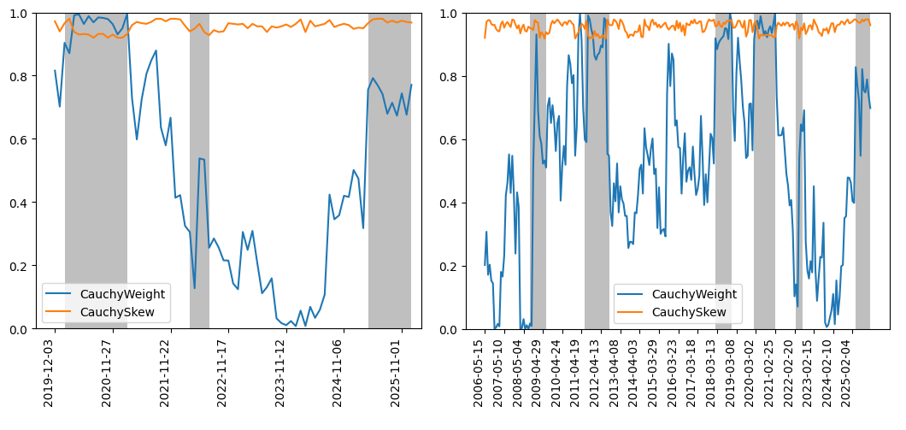
Figure 13: Calibrated timeseries for Cauchy copula weight and skew from 2020 to 2025 (left) and from 2006 to 2025 (right)
To ensure the methodological soundness of the calibration process and verify that the findings are not strictly dependent on a single algorithmic approach, the identical analytical framework was applied to two alternative optimisation strategies. Specifically, the system’s performance was evaluated using sequential optimisation driven by gradient boosted trees (visually detailed in the left-hand panel of the figure below), as well as a sequential optimisation method utilising decision trees (right-hand panel). While the precise numerical estimates for the calibrated parameters naturally exhibit variations due to the distinct mathematical mechanics of each underlying solver, the overarching empirical trajectories remain remarkably consistent. Both alternative techniques successfully replicate the fundamental structural dynamics observed in the primary analysis, systematically increasing the weight of the heavy-tailed copula component and amplifying left-tail skewness during periods of documented macroeconomic distress. This strong cross-algorithmic consistency ultimately reinforces the inherent stability and reliability of the proposed architecture. It conclusively demonstrates that the model’s capacity to accurately capture severe, asymmetric market shocks is a robust feature of the dependency structure itself, rather than a mere statistical artifact of the chosen optimization engine.
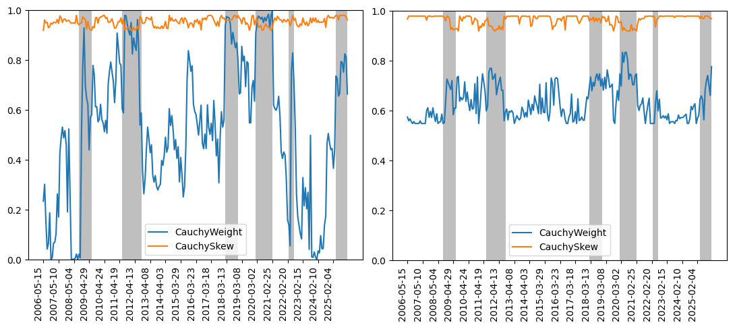
Figure 14: Calibrated timeseries for Cauchy copula weight and skew from 2006 to 2025 with sequential optimisation using gradient boosted trees (left) and sequential optimisation using decision trees (right)
The identical exercise was subsequently applied to the market-neutral hedged portfolio. The accompanying figure illustrates the outcomes of this application under two distinct structural scenarios. The left panel details an objective function calibrated across a broad spectrum of confidence intervals, systematically minimising statistical errors at the 75th, 90th, 99th, and 99.5th percentiles. Conversely, the right panel isolates the calibration entirely on the extreme tail, focusing the objective function exclusively on the severe 99.5th percentile. These targeted analyses were executed exclusively utilising Bayesian optimization driven by Gaussian processes. The empirical results yield a particularly compelling observation regarding the structural dynamics of the hedged portfolio: during periods of the market crisis, the calibrated weight of the heavy-tailed Cauchy copula behaves inversely to the long-only strategy, decreasing almost to zero. This parametric shift may imply that during severe systemic shocks, the offsetting nature of a balanced long/short portfolio effectively neutralises heavy-tailed extreme co-movements at the aggregated level. Consequently, the joint dependency structure and overall tail risk profile of the hedged portfolio are actually more accurately modeled by the standard, light-tailed Gaussian copula.
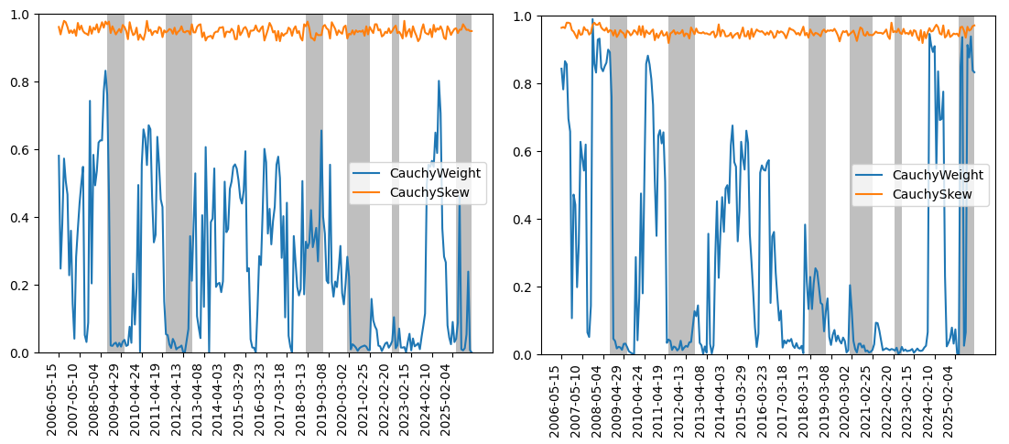
Figure 15: Calibrated timeseries for Cauchy copula weight and skew from 2006 to 2025 for S&P 500 hedged portfolios with the 75th, 90th, 99th, 99.5th percentiles in objective function (left) and 99.5th percentile only(right)
In conclusion, the results demonstrate that it is feasible to successfully calibrate a complex mixture copula using a selection of analytical models that inherently scale to high-dimensional environments. Naturally, the overall accuracy of the system and the resulting calibration error are highly contingent upon the specific combination of copulas selected for the structural blend. From a theoretical perspective, this methodology effectively functions as an advanced form of dimensionality reduction, conceptually analogous to Principal Component Analysis (PCA). Rather than attempting to compute an intractable, ultra-high-dimensional problem where every single underlying asset represents an isolated mathematical dimension, the framework strategically compresses the overarching market dynamics into a vastly simplified latent space. Within this reduced architecture, the complex web of asset dependencies is elegantly mapped onto just a few core dimensions, with each latent dimension strictly governed by a specific copula component within the broader mixture. Furthermore, even in this foundational implementation, the dynamically calibrated Cauchy weight and skewness parameters emerge as highly valuable analytical outputs in their own right. By continuously aggregating massive quantities of complex, high-dimensional market data into concise, interpretable metrics, these specific parameters provide a clear reflection of underlying market state. Consequently, they hold significant potential to function as robust, real-time macroeconomic crisis indicators, offering a powerful, data-driven signal for monitoring shifting market regimes and emerging systemic threats. Furthermore, proposed framework extends far beyond standard risk measurement by empowering practitioners to actively construct and evaluate realistic, extreme stress scenarios alongside with the setting up a reverse stress testing framework. We will elaborate on both points in the next section.
While the proposed framework could successfully captures complex joint dependencies, the empirical evaluation within this study relies on several structural simplifications that warrant critical acknowledgment. The current implementation maps the simulated uniform copula outputs to empirical marginal distributions utilising a standard log-normal assumption for equity returns. Although the skewed Cauchy component could inject heavy-tailed dependence and structural asymmetry into the joint distribution, forcing the individual marginals into a log-normal framework inherently restricts the severity of idiosyncratic shocks. Future iterations could seamlessly resolve this limitation by pairing the advanced mixture copula structure with Extreme Value Theory (EVT) for the marginal distributions, ensuring that both the overarching dependency structure and the individual asset behaviors reflect authentic crisis dynamics. Also the data acquisition architecture introduces potential survivorship bias, as delisted equities are often excluded from standard historical market extracts. Additionally, strict computational constraints necessitated a significant reduction in optimisation iterations, when scaling the calibration across a two-decade historical window. While the optimisation engine demonstrated remarkable directional stability under these constraints, the resulting statistical noise in the skewness parameter underscores the pressing need to transition toward more scalable, neural-network-driven calibration methodologies in subsequent research.

Conclusion/Recommendations/Future Work
The primary objective of this research was not to prescribe a definitive recipe, but rather to establish a robust proof-of-concept demonstrating that a high-dimensional mixture copula framework is both practically feasible and empirically effective. Based on the provided results, this milestone has been achieved. While the current methodology captures complex joint dependencies, future iterations must prioritize the development of a significantly more robust and computationally efficient optimisation procedure. Within the considered framework where the standard Gaussian copula was blended with the Skewed Cauchy, the optimization dynamics of the two primary parameters diverged. The calibrated weight or proportion of the Cauchy component proved highly robust, reliably adapting to capture the necessary degree of heavy-tailed dependence across the tested market conditions. Conversely, the skewness coefficient exhibited noticeable numerical instability. This parametric variance became particularly pronounced when computational constraints required a reduction in the total number of objective function evaluations. The skewness coefficient which dictates the asymmetry of the extreme left tail seems more sensitive and requires more exhaustive algorithmic search to reach true convergence.
The framework’s conceptual resemblance to Principal Component Analysis, whereby complex market dimensions are compressed into a curated blend of specific dependency structures, presents an interesting theoretical field. Currently, the system relies on a manually predefined list of constituent copulas; however, subsequent studies could explore algorithmic methods to automatically identify and dynamically select the optimal components required for the mixture.
Another highly promising direction for future research involves the integration of advanced machine learning techniques, specifically leveraging deep neural networks to learn the optimal copula weights directly from raw historical market data. If such a neural network architecture proves to be sufficiently stable and accurate, it would drastically accelerate the calibration process by bypassing the currently slow, computationally expensive black-box optimisation loops. This technological enhancement would theoretically enable risk management systems to recalculate and adjust copula weights on a daily basis. Such rapid calibration would ensure vastly superior, real-time model responsiveness, allowing the dependency structure to instantly adapt to rapidly evolving market crises or sudden shifts in macroeconomic regimes. Having successfully extracted the historical time series of the calibrated copula weights, we now possess the empirical foundation necessary to connect traditional econometric modeling with advanced machine learning techniques. Specifically, these historical parameter trajectories can serve as the target variables for training deep neural networks, allowing the system to learn the complex, non-linear mappings directly from raw, multidimensional market data. If the algorithm can robustly identify the latent macroeconomic signals that drive these parametric shifts, it opens up for a promising predictive application. Rather than solely utilising the framework to retroactively measure tail risk, continuously monitoring these model-inferred weights in real-time could provide additionally a proactive early-warning system. By detecting the subtle, early-stage deterioration of market dependencies before severe structural breaks fully materialise, risk managers would be equipped with a forward-looking mechanism to anticipate and preemptively navigate systemic crises.
Beyond these algorithmic refinements, several analytical expansions remain necessary to fully realise the comprehensively envisioned scope of this research. Due to strict time constraints, the current empirical study focused exclusively on Value-at-Risk metrics; however, repeating this analysis using Expected Shortfall could provide additional insights, as this measure provides a mathematically superior representation of the average losses incurred deep within the extreme tail. Furthermore, to maximize the accuracy of these tail risk measurements, future research should integrate Extreme Value Theory (EVT) to construct the individual marginal distributions. Coupling robust EVT marginals with the dynamically calibrated mixture copulas would ensure that both the overarching market dependency structure and the idiosyncratic tail risks of individual assets are realistically captured during severe shocks. Additionally, while the theoretical capacity for high dimensionality has been established, future work must supply concrete, empirical evidence quantifying the model’s computational scalability when processing hundreds of distinct underlying assets simultaneously. Finally, the practical application of this framework must be formally extended into advanced risk management protocols, specifically detailing how these dynamically calibrated copulas can be utilised to construct targeted stress tests and execute sophisticated reverse stress testing scenarios to systematically uncover hidden portfolio vulnerabilities.
Beyond risk measurement and stress testing, a promising domain for the application of this framework is the field of credit derivative pricing, specifically within correlation trading portfolios. These structured financial products, such as bespoke tranches or nth-to-default baskets,typically feature underlying pools of approximately 100 distinct corporate names. This level of dimensionality is significantly higher than the standard basket sizes generally encountered in other asset classes, presenting a unique challenge. Accurately mapping the joint default probabilities and cascading credit events across huge and interconnected space often pushes traditional quantitative pricing models to their limits. By leveraging this highly scalable, dynamically calibrated mixture copula methodology, practitioners could establish an alternative to conventional pricing methodologies, many of which inherently struggle to capture extreme, simultaneous credit events. Furthermore, even in institutional environments where legacy models remain the valuation standard, deploying this framework in parallel would provide an efficient benchmarking mechanism. It would help to systematically measure model uncertainty, highlighting the precise pricing deviations and hidden risk premiums that materialise only when severe, heavy-tailed default correlations are accurately incorporated into the valuation of the credit baskets.
Within the broader domain of machine learning and artificial intelligence, this approach holds substantial promise for enhancing generative models, particularly Variational Autoencoders (VAEs). In modern deep learning applications, the latent embedding space generated by these networks is inherently of very high dimensionality, designed to encode an enormous array of complex, interacting features. Currently, many of these sophisticated models rely on a standard Gaussian copula prior to structure this massive latent space and govern the corresponding data embeddings. While computationally convenient, this assumption forces overly restrictive, symmetric, and light-tailed constraints upon the learned representations, limiting the network’s ability to model extreme or asymmetric feature interactions across the embeddings. By substituting Gaussian copula with a dynamically calibrated mixture, which is explicitly engineered to scale efficiently across such high dimensions, it could be possible to alter how these neural networks map and interpret internal representations. Such structural upgrade could allow the VAE to capture the far more complex, asymmetric, and extreme dependencies embedded within the underlying data.

References
- Jorion P., 2006. Value as Risk: The New Benchmark for Managing Financial Risk. New York: The McGraw-Hill.
- Cherubini U. et al, 2004. Copula methods in finance. England: Wiley finance.
- Chollet F., 2021. Deep learning with Python. New York: Manning Publications Co.
- Acerbi C., Szekely B., 2014. Back-testing expected shortfall. Risk, 27(11):76–81.
- Cont R. et al, 2022. Tail-GAN: Nonparametric scenario generation for tail risk estimation. (link)
- Oh D., Patton A., 2015. Modelling dependance in High dimensions with factor copulas. (link)
- Buhler H., Horvath B., 2021. A data-driven market simulator for small data environments. (link)
- Horvath B. et al, 2025. Generative Models in Finance: Market Generators, a Paradigm Shift in Financial Modeling.(link)
- Hofert M. and Pang Z., 2025. W-transforms: Uniformity-preserving transformations and induced dependence structures.(link)
- Geron A., 2019. Hands-On Machine Learning with Scikit-Learn, Keras, and TensorFlow: Concepts, Tools, and Techniques to Build Intelligent Systems. Sebastopol: O’Reilly Media. 2nd Edition.
- Scikit-optimize contributors, 2017 - 2020. User Guide.(link)

Appendixes

Appendix A: List of used AI tools
- Gemini via Google Search and as a chatbot;
- Mistral-7B-Instruct-v0.3 for polishing the text. Prompt: “You’re an academic assistant with an expertise in software engineering to proofread and rewrite as a single connected text. Keep academic tone.”

Appendix B: Copula examples
Gaussian copula.
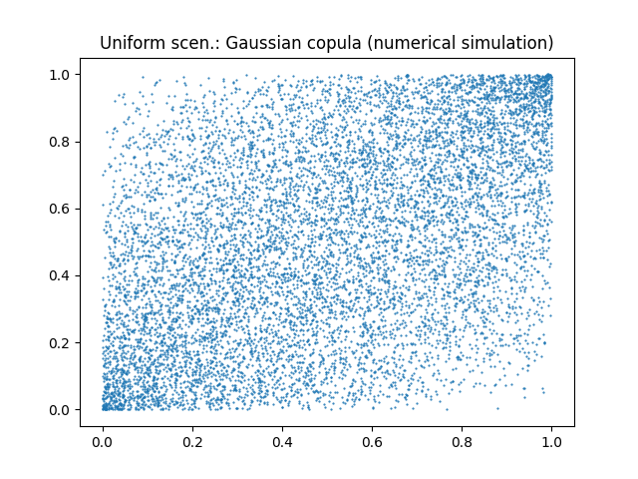
Figure A.1: Uniform scenarios for Gaussian_copula, numerical simulation.
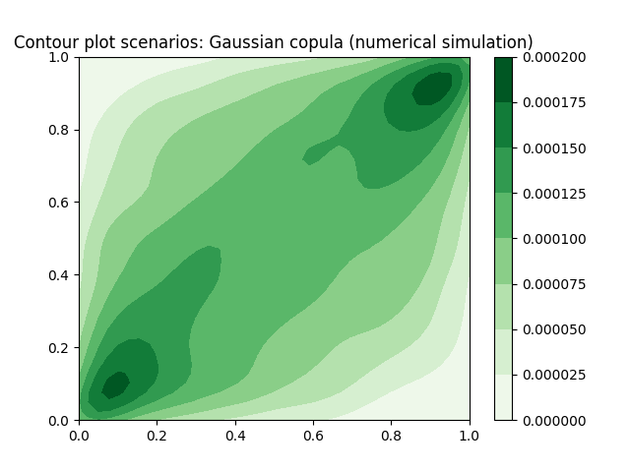
Figure A.2: Contour plot for Gaussian copula, numerical simulation.
Cauchy copula.
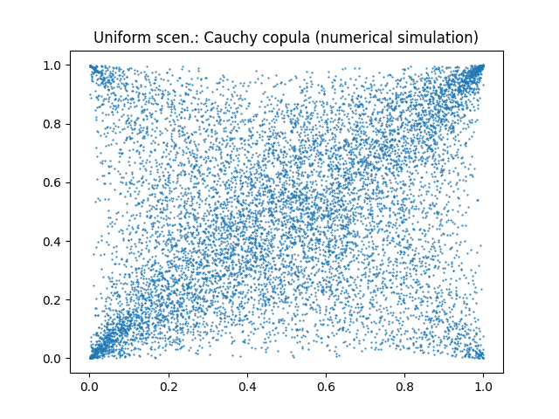
Figure A.3: Uniform scenarios for Cauchy copula, numerical simulation.
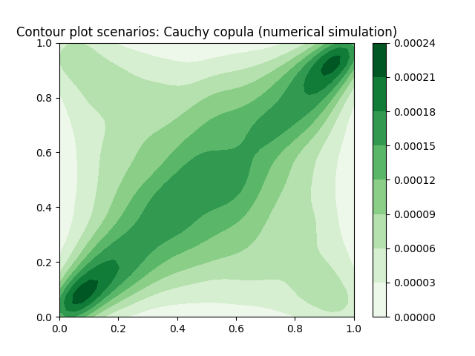
Figure A.4: Contour plot for Cauchy copula, numerical simulation.

Appendix C: Analysis of different VaR methodologies/percentiles
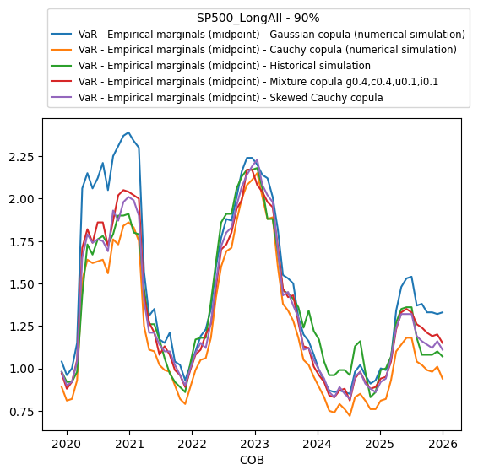
Figure A.5: Monthly 90% HVaR level and MC VaR levels with different copulas from 2020 to 2025 all long S&P 500 portfolio
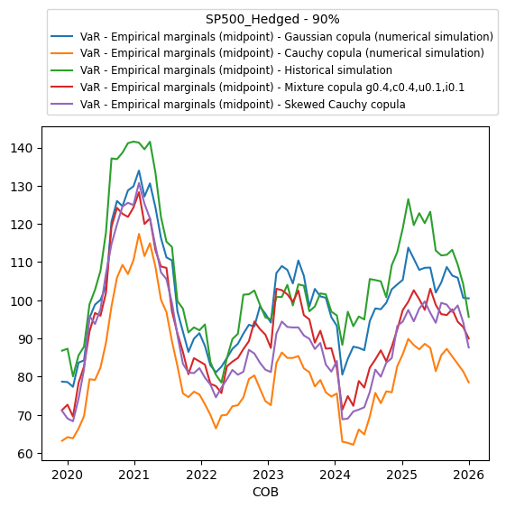
Figure A.6: Monthly 90% HVaR level and MC VaR levels with different copulas from 2020 to 2025 hedged portfolio
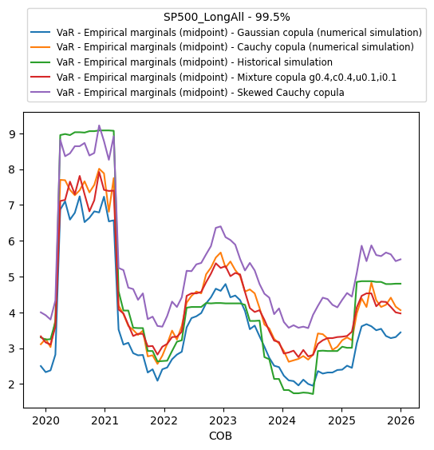
Figure A.7: Monthly 99.5% HVaR level and MC VaR levels with different copulas from 2020 to 2025 all long S&P 500 portfolio
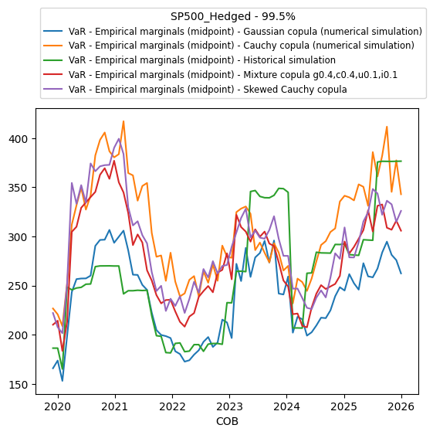
Figure A.8: Monthly 99.5% HVaR level and MC VaR levels with different copulas from 2020 to 2025 hedged portfolio

