Machine Learning for Modeling High Dimensional Joint Dependency
  - MSc Data Analytics and AI. School of Computing and Mathematical Sciences. Birkbeck, University of London
Author: Sergii Arkhypov, Supervisor: Dr Alessandro Provetti
30 September 2026. Word count: XXX
Abstract
xxx to populate xxx
Table of Contents

Introduction
Despite the popularity of ML/AI algorithms in finance, they have mainly been used for either one or a small number of random factors. Nevertheless, joint analytics of high dimensionality (e.g., >1000 random factors) present serious challenges. This task is hard to address with classical statistical methods, and the available toolset is quite limited, i.e., mainly based on Gaussian copulas. There is hope that modern advances in ML/AI algorithms could help expand this toolset and provide alternative approaches for modeling high-dimensional joint dependency.

Background research

Key concepts
Copulas. $C:[0,1]^{d}−>[0,1]$ is a d-dimentional copula if $C$ is a joint cumulative distribution function of a d-dimentional random vector on the unit cube $[0,1]^{d}$ with uniform marginals.
Sklar’s theorem. Every multivariate cumulative distribution function $H(x_{1},...x_{d})=Pr[X_{1}≤x_{1},...X_{d}≤x_{d}]$ of a random $(X_{1},X_{2},...,X_{d})$ can be expressed in terms of its marginals $F_{i}(x_{i})=Pr[X_{i}≤x_{i}]$ and a copula $C$, as:
$$H(x_{1},...,x_{d})=C(F_{1}(x_{1}),...,F_{d}(x_{d})) (Eq.1)$$
Gaussian copula.
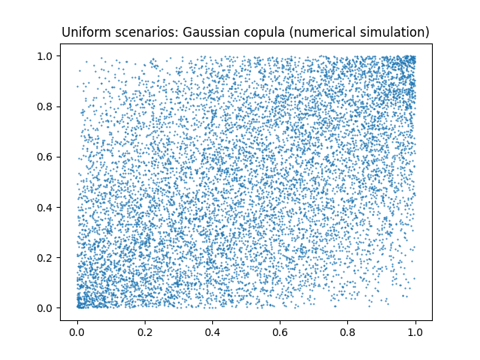
Figure 1: Uniform scenarios Gaussian_copula, numerical simulation
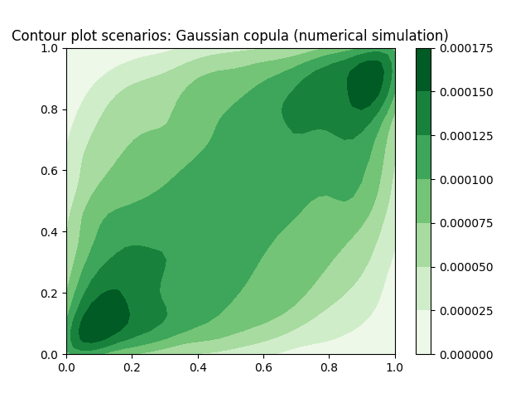
Figure 2: Contour plot Gaussian copula, numerical simulation
Cauchy copula.
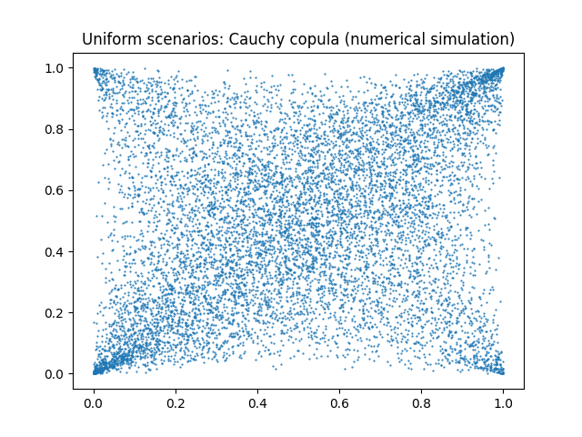
Figure 3: Uniform scenarios Cauchy copula, numerical simulation
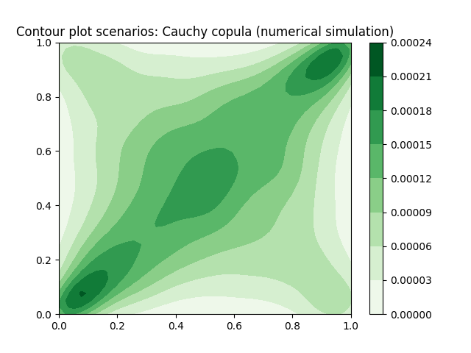
Figure 4: Contour plot Cauchy copula, numerical simulation

Literature review

Aims and Objectives
The main aim of this work would be to develop a machine learning algorithm for calibrating a high-dimensional copula with tail dependence different from Gaussian, while still reflecting the observed history with regards to selected measures (i.e., matching correlation matrix, matching pairwise tail dependence at the specific percentile, etc.). The latter is expected to require the creation of a custom loss function to achieve minimization with regards to those measures. On the simulation part, a range of different approaches can be considered, starting from semi-analytical methods to Variational Autoencoders (VAEs) and Generative Adversarial Networks (GANs).

Description of the problem and relevant work

Methodology and methods

Organise and plan the project

Literature
- D.Oh, A.Patton (2015). Modelling dependance in High dimensions with factor copulas. (link)
- R.Cont et al. (2022). Tail-GAN: Nonparametric scenario generation for tail risk estimation. (link)
- H.Buhler, B.Horvath (2021). A data-driven market simulator for small data environments. (link)
- M.Vuletic, R.Cont (2025). VolGAN: a generative model for arbitrage-free implied volatility surfaces.(link)
- B.Horvath et al. (2025). Generative Models in Finance: Market Generators, a Paradigm Shift in Financial Modeling.(link)
- M.Vuletic, M.Cucuringu (2025). GraFiN-Gen: graph-based ensemble generative modelling for multi-asset forecasting. (link)
- A.Sancetta, S.Satchell (2004). The Bernstein Copula and Its Applications to Modeling and Approximations of Multivariate Distributions. (link)
- M.Wiese et al. Multi-Asset Spot and Option Market Simulation. (link)

Appendixes
See corresponding equation (Eq.1)

Appendix A: List of used AI tools
- Gemini via Google Search;
- Mistral-7B-Instruct-v0.3 for polishing the text. Prompt: “You’re an academic assistant with an expertise in software engineering to proofread and rewrite as a single connected text. Keep academic tone.”

