OPTIMIZATION THEORY

DMDO



Sergio Barbero, Maaz Ashiq

Introduction to the problem
We want to implement a method of direct dynamical optimization without additional constraints.
In order to make it we start from these formulas:

With the parameters directly passed to the program A, B, Q, R, x0

Implementation
This is the main function, it runs all the procedure of our algorithm
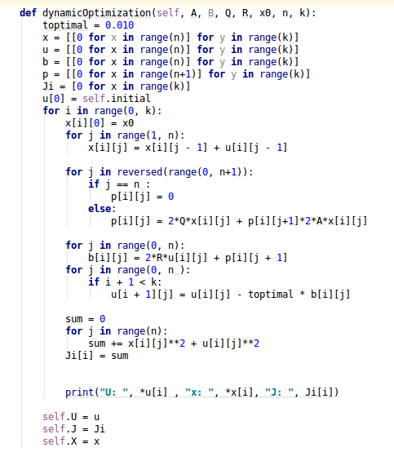

Results
We run the program under 15 iterations: This the graphic iterations/J:
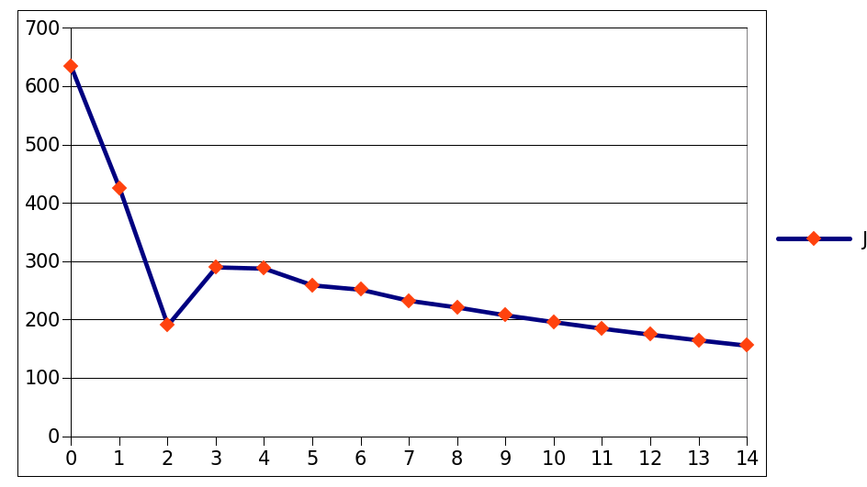
And this is the graphic for each trajectory:
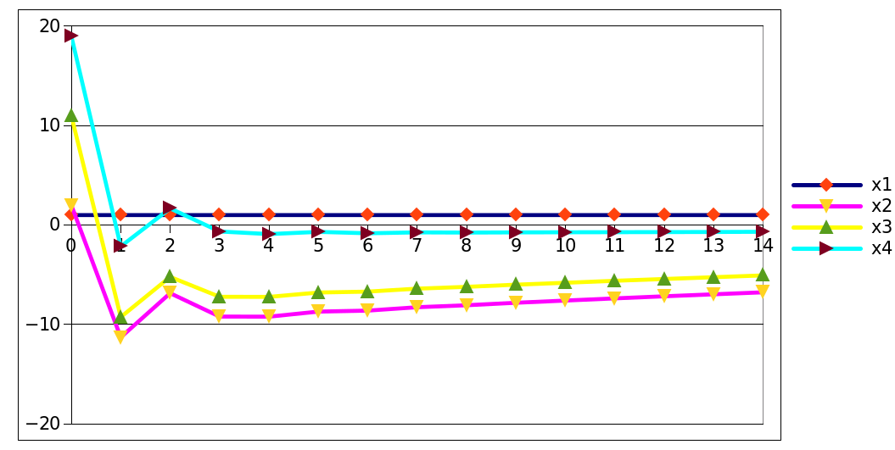
We can see a gradual minimization of our results for every iteration.

