NUMERICAL METHODS

APPROXIMATE SOLVING OF INTEGRAL EQUATIONS



Sergio Barbero, Mateusz Korusiewicz

Introduction to the problem
We will study the next Fredholm II equation:

Our task is analyze the error for a given set of points between this numerical method and the analytic solution given by Laplace transformation:

Our problem
We are going to analyze two different cases, note that

For this given set of points
In our first case the function obtained analytically is:
In our second case the function obtained analytically is

Implementation
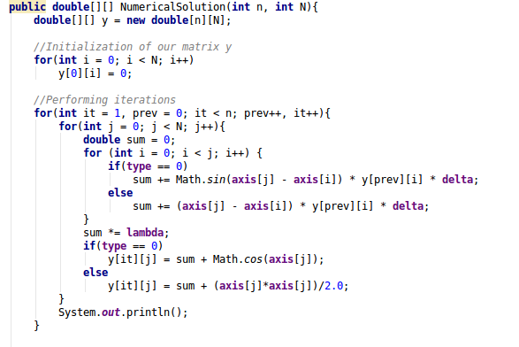

This is the function which calculates the approximation of our integral, for type 0 we will run the first exercice, and for any other value we will perform the second one.

Results
We are going to analyze the result and also the absolute error
- Results of first exercice
For our set of values on the x-axis, this will be our table of approximations for each iteration, every column represent one single iteration and every row one value on x-axis.

This is the graphic representation, we can observe for every iteration we are getting closer of our analytical solution, being the 10th iteration not much better than the 9th, so we can assert from that iteration we don’t have too much margin of improvement.
Taking into account this data we can get easily our absolute error graph:

In this case the closer to 0 the more accurate, we can observe improvements for each single iteration.
2. Results of the second exercice

In this case the first iterations are very inaccurate, for every iteration the improvement is really big, we cannot see the plots of last iterations properly, so let’s zoom in the graph:
We could say the last iterations are very good approximations to our analytic solution, let’s check it with the absolute error graph:

As we said, this approximation is very close to the analytical solution, being the 10th iteration a pretty good approximation, with an error between 0.02 and 0.05 for our points.

