NUMERICAL METHODS

NUMERICAL INTEGRATION



Sergio Barbero, Mateusz Korusiewicz

Introduction to the problem
We will study several differents methods of approximation of integrals and we will study the error
- Rectangular
- Trapezoid
- Simpson formula
- Chebyshev method

Our problem
We are going to analyze this function: in the range
In order to get the analytical result we should perform:

Rectangular formula
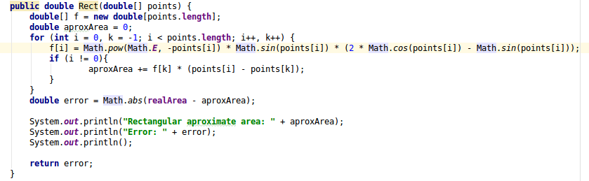
This is the implementation of the method. We should get the area of the rectangle from one point to the next, and keep adding them to the final result. It’s a very simple method, but not so accurate.

Trapezoid formula
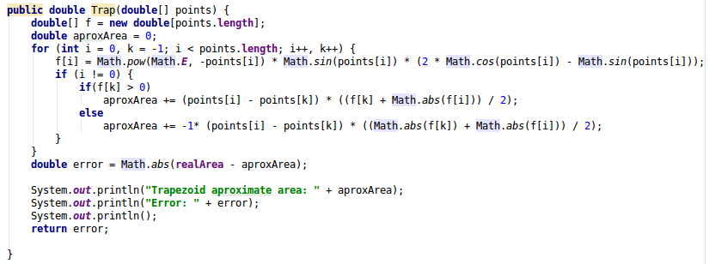
In this case accuracy is a little bit increased, we are taking the area of the point in f(x_{i}) and the next f(x_{i+1}).

Simpson formula
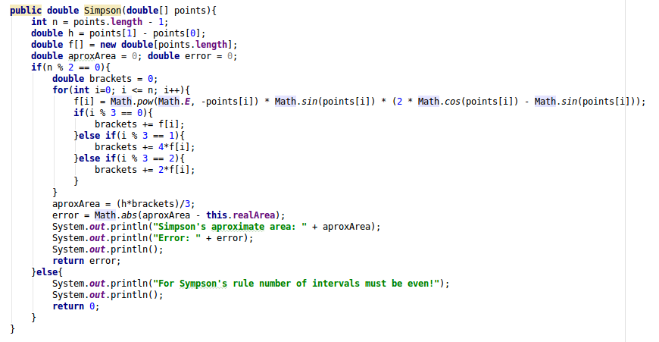
This is a very good approximation generally. We are taking a quadratic function in every section.

Chebyshev method
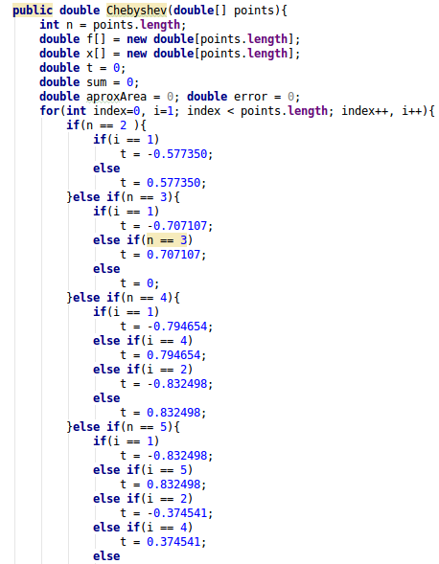

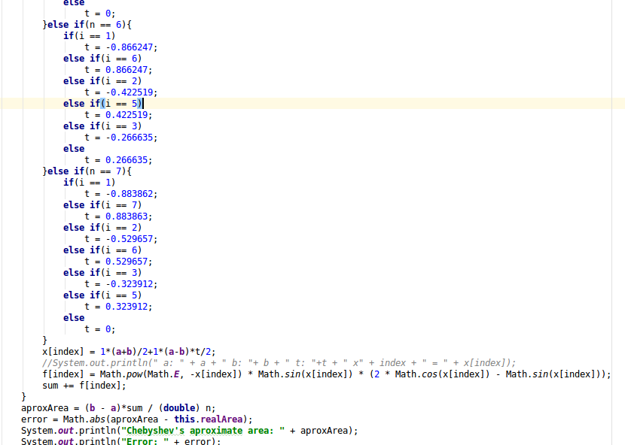
As we can observe, we’re taking chebyshev nodes t in order to calculate an approximate solution to our problem.

Results
We will perform this methods for two cases and we will evaluate the results:
- 3 nodes → 2 sections
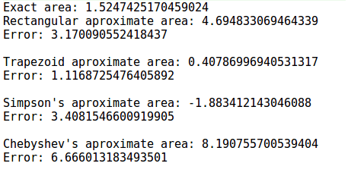
In this case, rectangular is not good at all, the error is 3 times the real area, it’s not a good approximation.
For the Trapezoid approximate area the error is less, 3 times less than the real area.
For the Simpson’s formula the error is even bigger than rectangular approximation, and it’s also negative.
For Chebyshev’s nodes the result is the worst one.

In conclusion, the little accuracy of the results is given for a little quantity of nodes. Let’s analyze for more of them
- 31 nodes → 30 sections
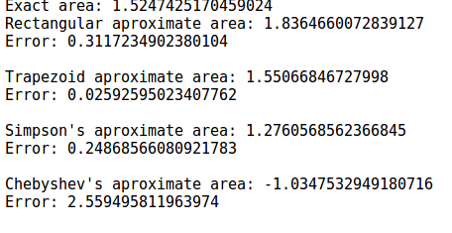

Now we can see an improvement in general terms with the first approximation, Chebyshev’s quadrature is the worst one and trapezoid approximation is the best one.

