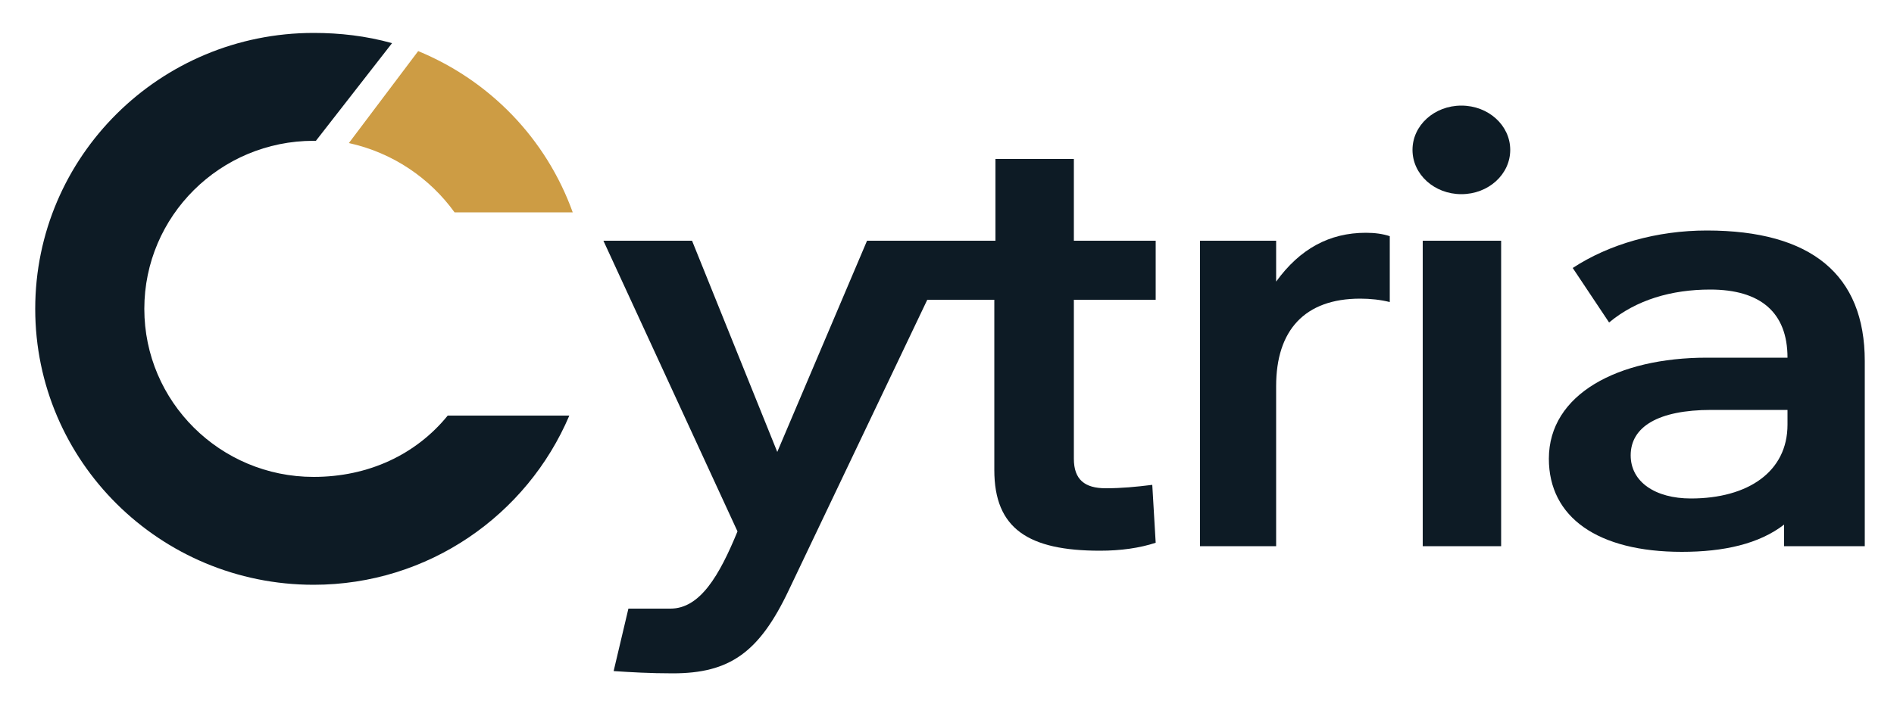

BRAND ASSET SYSTEM

Cytria logo usage guide
Editable standards for logo selection, safe use, social profiles and website implementation

VERSION 2.0 | SEPTEMBER 2026

01

Approved logo versions
Always select the artwork designed for the background beneath it. SVG is the preferred production format.
PRIMARY LOGO ON LIGHT BACKGROUNDS


REVERSED LOGO ON DARK BACKGROUNDS

Selection rule
Use the navy and gold version on white, off-white and other pale surfaces. Use the white and gold version on navy, dark grey and other dark surfaces. Use one-colour artwork only when colour reproduction is unavailable or technically constrained.

02

C symbol and social profiles
Use the C symbol when the full name would be too small, repetitive or visually constrained.
  C symbol on light |   C symbol on dark

  Light profile master |   Dark profile master

Social profile rule
Use the prepared square masters rather than placing a transparent C directly into each platform. Their padding protects the symbol when platforms apply circular or rounded cropping.

03

Colour palette
The production artwork uses flat colours to remain sharp, reproducible and accessible across digital and print environments.
Role | Sample | HEX | RGB
Cytria Navy |  | #0D1B25 | 13, 27, 37
Cytria Gold |  | #CD9C44 | 205, 156, 68
Cytria Off-white |  | #F7F8F6 | 247, 248, 246
White |  | #FFFFFF | 255, 255, 255

Colour integrity
Do not sample colours from screenshots, social media images or compressed files. Use the values above or the supplied SVG masters. Keep the gold segment consistent across all applications.

04

Clear space and minimum size
Give the identity enough room to remain recognisable, calm and authoritative.

Clear space
Maintain empty space equal to the width of the main C stroke around every side of the full logo and C symbol. Do not allow text, borders, photography or other marks to enter this area. The social files already include crop-safe padding.

Minimum size
Asset | Minimum
Full logo | 120 px digital or 30 mm print
C symbol | 24 px digital
Bicolour C preferred | 32 px or larger
Below 32 px | Use the prepared favicon assets

05

Forbidden usage
Consistency protects recognition and prevents the identity from becoming visually unstable.
- Do not stretch, compress, rotate, skew, crop or rearrange the artwork.
- Do not recolour, resize or reposition the gold segment.
- Do not recreate the wordmark using live text or a substitute font.
- Do not add shadows, glows, outlines, gradients or decorative effects.
- Do not place the navy version on dark backgrounds or the white version on pale backgrounds.
- Do not place the logo over busy photography without a clean, high-contrast holding area.
- Do not violate the minimum clear space or use illegibly small artwork.
- Do not use the original raster preview as a production master.

Photography
When the logo appears over photography, select a quiet area with consistent tone and adequate contrast. If none exists, use a controlled navy or off-white holding area rather than applying effects to the logo.

06

Website implementation
Keep the full lockup as one SVG image. Do not combine a C image with typed text.

Header and footer
Use cytria-logo-on-light.svg on white and pale surfaces. Use cytria-logo-on-dark.svg on navy or dark surfaces. Preserve the SVG viewBox and natural aspect ratio.
<Image
src="/brand/cytria-logo-on-light.svg"
alt="Cytria"
width={190}
height={70}
priority
/>

Favicon system
Copy the files in the Web folder to the Next.js public directory and reference favicon.svg, apple-touch-icon.png and site.webmanifest in application metadata. The supplied SVG favicon adapts the navy portion for dark browser themes while retaining Cytria Gold.

Accessibility
Use the accessible name Cytria for the linked logo. When the adjacent page title already identifies the organisation and the logo is purely decorative, an empty alternative may be appropriate. Never place important explanatory copy inside the SVG artwork.

07

File selection
Use the master appropriate to the application and avoid creating uncontrolled duplicates.
Folder | Contents | Use
01 Master SVG | Vector logos and marks | Preferred production source
02 PNG | Transparent high-resolution exports | Documents and constrained platforms
03 Social | Crop-safe square avatars | LinkedIn, X and social profiles
04 Web | Favicons, touch icons and manifest | Website and web application
05 Guidelines | PDF, Markdown and editable guides | Governance and handoff

Source of truth
Keep the complete Cytria logo kit as the approved source of truth. New exports should be derived from the supplied SVG masters. Record future geometry or colour changes as a new kit version rather than silently replacing individual files.

