sesion2_1310.R

Usuario

2021-10-18

#################################################  
#Variables Aleatorias DISCRETAS  
##################################################  
#Modelo Binomial  
#X=n de hijos con ojos azules de 3 hijos  
#REPRESENTAR: Funcion puntual de probabilidad y Funcion de distribucion B(n=3,p=0.25)  
  
o=par(mfrow=c(1,2))  
x=0:3  
plot(x,dbinom(x,size=3,prob=0.25),xlab="n exitos", ylab="probabilidad", xlim=c(0,3),main="Func. Probabilidad Puntual",type="h")  
points(x,dbinom(x,size=3,prob=0.25),pch=16,col="green")  
abline(h=0,col="blue",lty = 3)  
  
plot(x,pbinom(x,size=3,prob=0.3),xlab="n exitos", ylab="probabilidad acumulada",ylim=c(0,1),main="Func. Distribucion Acumulada",type="s")  
abline(h=1,col="red",lty = 3)  
points(x,pbinom(x,size=3,prob=0.3),pch=16,col="green")

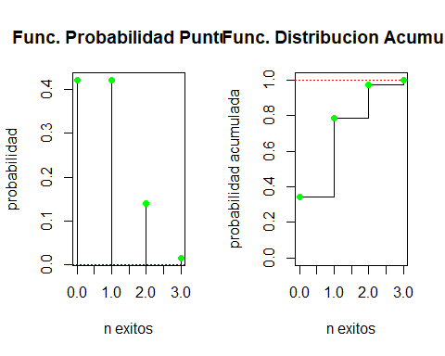

par(o)  
  
#oBTENER: Funcion puntual de probabilidad y Funcion de distribucion B(n=3,p=0.5)  
dbinom(x,size=3,prob=0.25)

## [1] 0.421875 0.421875 0.140625 0.015625

pbinom(x,size=3,prob=0.25)

## [1] 0.421875 0.843750 0.984375 1.000000

##Probabilidad de que 1 de los 3 hijos tenga los ojos azules  
dbinom(1,size=3,prob=0.25)

## [1] 0.421875

#Probabilidad de que al menos 1 de los 3 hijos tenga los ojos azules  
pbinom(1,size=3,prob=0.25)

## [1] 0.84375

#Probabilidad de que mas de 1 hijo tenga los ojos azules  
pbinom(1,size=3,prob=0.25,lower.tail = F)

## [1] 0.15625

#modelo poisson  
#X=n de ninos con ojos azules nacidos en una hora~Poisson (lambda=10)  
rm(x)  
x=0:30  
dpois(x,lambda=10)

## [1] 4.539993e-05 4.539993e-04 2.269996e-03 7.566655e-03 1.891664e-02  
## [6] 3.783327e-02 6.305546e-02 9.007923e-02 1.125990e-01 1.251100e-01  
## [11] 1.251100e-01 1.137364e-01 9.478033e-02 7.290795e-02 5.207710e-02  
## [16] 3.471807e-02 2.169879e-02 1.276400e-02 7.091109e-03 3.732163e-03  
## [21] 1.866081e-03 8.886101e-04 4.039137e-04 1.756147e-04 7.317277e-05  
## [26] 2.926911e-05 1.125735e-05 4.169389e-06 1.489067e-06 5.134715e-07  
## [31] 1.711572e-07

sum(dpois(x,lambda=10))

## [1] 0.9999999

ppois(x,lambda=10)

## [1] 4.539993e-05 4.993992e-04 2.769396e-03 1.033605e-02 2.925269e-02  
## [6] 6.708596e-02 1.301414e-01 2.202206e-01 3.328197e-01 4.579297e-01  
## [11] 5.830398e-01 6.967761e-01 7.915565e-01 8.644644e-01 9.165415e-01  
## [16] 9.512596e-01 9.729584e-01 9.857224e-01 9.928135e-01 9.965457e-01  
## [21] 9.984117e-01 9.993003e-01 9.997043e-01 9.998799e-01 9.999531e-01  
## [26] 9.999823e-01 9.999936e-01 9.999977e-01 9.999992e-01 9.999997e-01  
## [31] 9.999999e-01

o=par(mfrow=c(1,2))  
curve(dpois(x,lambda=10),from=0, to=50, n=51, xlab="n exitos", ylab="probabilidad", xlim=c(0,50),main="Func. Probabilidad Puntual",type="h")  
points(x,dpois(x,lambda=10),pch=16,col="green")  
abline(h=0,col="blue",lty = 3)  
  
plot(x,ppois(x,lambda=10),xlab="n exitos", ylab="probabilidad acumulada",main="Func. Distribucion Acumulada",type="s")  
abline(h=1,col="red",lty = 3)  
points(x,ppois(x,lambda=10),pch=16,col="green")

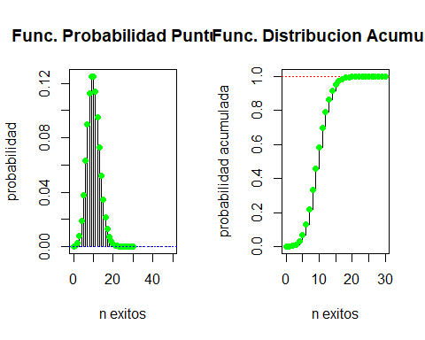

par(o)  
  
#modelo geometrico  
#X=n de hijos con ojos marrones antes de tener 1 hijo con ojos azules sigue G (p=0.25)  
#Probabilidad de que la familia acabe teniendo 3 o mas hijos  
pgeom(2,0.25,lower.tail=F)

## [1] 0.421875

#REPRESENTAR: Funcion puntual de probabilidad y Funcion de distribucion   
  
o=par(mfrow=c(1,2))  
curve(dgeom(x,0.25),from=0, to=10, n=11, xlab="n fracasos", ylab="probabilidad", xlim=c(0,10),main="Func. Probabilidad Puntual",type="h")  
points(x,dgeom(x,0.25),pch=16,col="green")  
abline(h=0,col="blue",lty = 3)  
  
x=0:10  
plot(x,pgeom(x,0.25),xlab="n fracasos", ylab="probabilidad acumulada",ylim=c(0,1),main="Func. Distribucion Acumulada",type="s")  
abline(h=1,col="red",lty = 3)  
points(x,pgeom(x,0.25),pch=16,col="green")  
abline(h=0,col="blue",lty = 3)

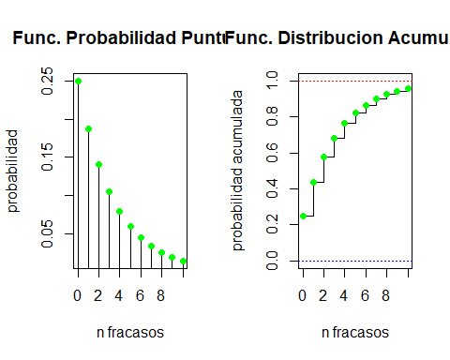

par(o)  
  
  
#REPRESENTAR: Funcion puntual de probabilidad y Funcion de distribucion   
  
o=par(mfrow=c(1,2))  
curve(dgeom(x,0.25),from=0, to=10, n=11, xlab="n fracasos", ylab="probabilidad", xlim=c(0,10),main="Func. Probabilidad Puntual",type="h")  
points(x,dgeom(x,0.25),pch=16,col="green")  
abline(h=0,col="blue",lty = 3)  
  
x=0:10  
plot(x,pgeom(x,0.25),xlab="n fracasos", ylab="probabilidad acumulada",ylim=c(0,1),main="Func. Distribucion Acumulada",type="s")  
abline(h=1,col="red",lty = 3)  
points(x,pgeom(x,0.25),pch=16,col="green")  
abline(h=0,col="blue",lty = 3)



par(o)  
  
#modelo hipergeometrico  
#X=n de personas con ojos azules de 5 elegidas al azar de un grupo de N=50 con N1=35 con ojos azules sigue H(50,5,p=35/50=0.7)  
#Probabilidad de que al menos 2 tengan los ojos azules  
phyper(2,35,15,5)

## [1] 0.1517411

#MAS EJEMPLO DE MODELOS DISCRETOS  
#DISTRIBUCIoN BINOMIAL#  
#Si en secuencias de ARN de tamaño 20, la probabilidad de purina sigue una binomial con probabilidad 0.7.  
#1 Representa la funcion de probabilidad y la funcion de distribucion.  
x=0:20  
o=par(mfrow=c(1,2))  
x<-0:20  
plot(x,dbinom(x,size=20,prob=0.2),xlab="n exitos", ylab="probabilidad", xlim=c(0,20),main="Func. Probabilidad Puntual",type="h")  
points(x,dbinom(x,size=20,prob=0.2),pch=16,col="green")  
abline(h=0,col="blue",lty = 3)  
  
plot(x,pbinom(x,size=20,prob=0.2),xlab="n exitos", ylab="probabilidad acumulada",main="Func. Distribucion Acumulada",type="s")  
abline(h=1,col="red",lty = 3)  
points(x,pbinom(x,size=20,prob=0.2),pch=16,col="green")  
for(i in 0:20){abline(v=i,col="grey",lty=9)}

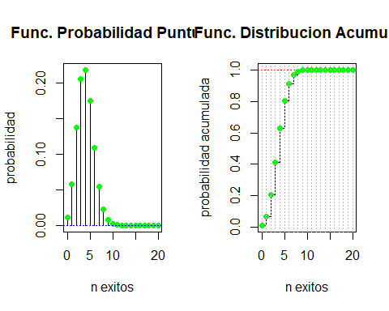

par(o)  
  
  
#2 Cual es la probabilidad de que haya 10 purinas? P(X=10)  
dbinom(10,20,0.7)

## [1] 0.03081708

#3 Cual es la probabilidad de que haya menos de 10 purinas? P(X<10)  
pbinom(10,20,0.7)

## [1] 0.0479619

#4 Cual es la probabilidad de que haya mas de 10 purinas? P(X>10)=1-P(X<=10)  
pbinom(10,20,0.7,lower.tail = F)

## [1] 0.9520381

#Ejemplo. Si una persona que ha sufrido cancer de colon tiene una probabilidad de mutacion en el gen p53 de 70 por cient,   
#para una muestra aleatoriamente seleccionada de 10 pacientes con este tipo de cancer. Calcular:  
# 1 La probabilidad de que 2 pacientes tengan el gen mutado.  
dbinom(2,10,0.7)

## [1] 0.001446701

#2 La probabilidad de que como mucho 2 pacientes tengan el gen mutado.  
pbinom(2,10,0.7)

## [1] 0.001590386

#3. La probabilidad de que al menos 2 pacientes tengan el gen mutado.  
pbinom(1,10,.7,lower.tail = F)

## [1] 0.9998563

#4. Los cuartiles de esta variable aleatoria  
qbinom(.25,10,0.7);qbinom(.5,10,0.7);qbinom(.75,10,0.7)

## [1] 6

## [1] 7

## [1] 8

#5. Generar una muestra aleatoria de tamano 50 de una distribucion binomial de parametros n=10 y p=0.5.   
#Importante: semilla de aleatorizacion  
set.seed(12345);rbinom(50,10,0.5)

## [1] 6 7 6 7 5 3 4 5 6 9 2 3 6 1 5 5 5 5 4 8 5 4 8 6 6 5 6 5 4 5 6 1 4 6 4 4 7 7  
## [39] 5 3 6 5 7 6 4 4 3 2 3 6

###################################################  
#Variables Aleatorias DISCRETAS: Modelo de Poisson#  
###################################################  
#Si el numero medio de celulas en un cultivo de 20 micrometros al cuadrado es 5, y se distribuyen de forma estable.  
#Cuantas celulas podriamos esperar en 16 microm2   
lambda=4  
#Calcular la probabilidad de que no haya ninguna celula en un cultivo de 16 micrometros al cuadrado,   
dpois(0,lambda)

## [1] 0.01831564

#y representar las correspondientes funciones de probabilidad y de distribucion.  
  
par(mfrow=c(1,2))  
x<-0:20  
plot(x,dpois(x,lambda),xlab="n celulas", ylab="probabilidad", xlim=c(0,20),main="Func. Probabilidad Puntual",type="h")  
points(x,dpois(x,lambda),pch=16,col="green")  
abline(h=0,col="blue",lty = 3)  
  
plot(x,ppois(x,lambda),xlab="n celulas", ylab="probabilidad acumulada",main="Func. Distribucion Acumulada",type="s")  
abline(h=1,col="red",lty = 3)  
points(x,ppois(x,lambda),pch=16,col="green")  
for(i in 0:20){abline(v=i,col="grey",lty=9)}

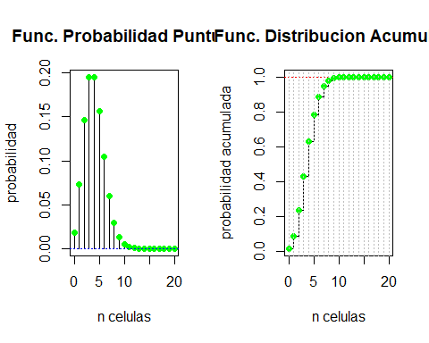

par(par(mfrow=c(1,2)))  
  
#Ejemplo. Las mutaciones del genoma del VIH ocurren al azar con una tasa de 5x104   
#por nucleotido por ciclo de replicacion, i.e., el numero de mutaciones de un genoma de 1000 nucleotidos  
#seguira una distribucion con tasa 5 despues de un ciclo. Calcular la probabilidad de que ocurran 3 mutaciones.  
dpois(3,5)

## [1] 0.1403739

#################################################  
#Variables Aleatorias CONTINUAS#  
##################################################  
  
###############################################  
#Variables Aleatorias CONTINUAS: Modelo Normal#  
###############################################  
  
  
#La distribucion de los valores de expresion del gen Zyxin en paciente ALL sigue una N(media=1.5, sigma=0.5).  
#1 Representar la funcion de densidad y la funcion de distribucion.  
  
rm(x)  
x=seq(-0.5,3.5,length=10000)  
par(mfrow=c(1,2))  
plot(x,dnorm(x,mean=1.5,sd=0.5), xlab="x", ylab="densidad", main="Func. Densidad", type="l")  
abline(v=1.5,col="magenta",lty = 3,lwd=5)  
plot(x,pnorm(x,mean=1.5,sd=0.5), xlab="x", ylab="probabilidad",main="Func. Distribucion",type="l")

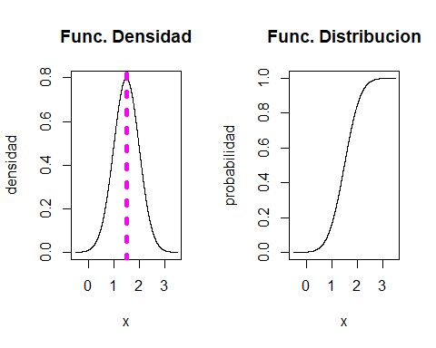

par(par(mfrow=c(1,2)))  
#2. Cual es la probabilidad de que los valores de expresion sean menores que 1.2?  
pnorm(1.2,mean=1.5,sd=0.5)

## [1] 0.2742531

#3. Cual es la probabilidad de que los valores de expresion sean mayores que 1.2?  
pnorm(1.2,1.5,0.5,lower.tail = F)

## [1] 0.7257469

#4. Cual es la probabilidad de que los valores de expresion esten entre 0.8 y 2.4?  
pnorm(2.4,mean=1.5,sd=0.5)-pnorm(0.8, 1.5,0.5)

## [1] 0.883313

#5. Genera una muestra aleatoria de tamano 1000 de la poblacion dada,   
#esto es, que se distribuya segun una normal de parametros con media = 1.5 y desv. tipica = 0.5.  
set.seed(12345);rnorm(1000,1.5,0.5)

## [1] 1.7927644 1.8547330 1.4453483 1.2732514 1.8029437 0.5910220 1.8150493  
## [8] 1.3619079 1.3579201 1.0403390 1.4418761 2.4086560 1.6853139 1.7601082  
## [15] 1.1247340 1.9084499 1.0568212 1.3342112 2.0603563 1.6493618 1.8898110  
## [22] 2.2278925 1.1778358 0.7234313 0.7011452 2.4025488 1.2591763 1.8101899  
## [29] 1.8060617 1.4188445 1.9059366 2.5984168 2.5245952 2.3162228 1.6271356  
## [36] 1.7455941 1.3379567 0.6689749 2.3838669 1.5129005 2.0642554 0.3098210  
## [43] 0.9698672 1.9685703 1.9272259 2.2303647 0.7934506 1.7837016 1.7915938  
## [50] 0.8466006 1.2298070 2.4738463 1.5267951 1.6758314 1.1645117 1.6389768  
## [57] 1.8455856 1.9118977 2.5725325 0.3265280 1.5747960 0.8287343 1.7766515  
## [64] 2.2949814 1.2065602 0.5838113 1.9440697 2.2967442 1.7584273 0.8521642  
## [71] 1.5273078 1.1076753 0.9753236 2.6652560 2.2013527 1.9713004 1.9131291  
## [78] 1.0942298 1.7381241 2.0106292 1.8226915 2.0215718 1.3478154 2.7385555  
## [85] 1.9856103 2.4335496 1.8360212 1.3460233 1.7682619 1.9124350 1.0180493  
## [92] 1.0724587 2.4434735 1.3040903 1.0096835 1.8436661 1.2474782 2.5788599  
## [99] 1.2001012 1.1527267 1.6119627 0.9218883 1.7112093 0.8376224 1.5705422  
## [106] 1.2319760 1.3441970 2.2780548 1.2759834 1.6605618 0.8849139 0.8379707  
## [113] 2.1306211 2.1596159 1.4596231 1.2474551 1.4739232 1.8144303 2.5900012  
## [120] 1.4654913 2.2724318 2.1607260 1.6610758 2.2654776 1.2893802 0.9205895  
## [127] 0.5773159 2.0786626 0.4382251 0.9019842 2.3210960 1.9418274 1.7624379  
## [134] 0.9076705 2.8278941 0.9760431 0.9944387 1.8344608 1.5645886 1.2887116  
## [141] 0.9298679 0.8531424 1.2026506 0.7495930 1.5079278 1.7700848 0.7263540  
## [148] 1.9248265 1.9480066 1.5693455 0.6903358 1.7741990 1.5976411 1.0967510  
## [155] 1.4456879 1.3745267 2.3496733 1.3278506 1.5338860 1.1747151 1.2561807  
## [162] 1.6515756 1.3790130 1.2591332 1.0040986 1.3596754 1.8165087 0.8800908  
## [169] 2.3821570 1.4881601 1.5999602 2.1735964 1.5180367 1.9122906 0.6486641  
## [176] 1.7404751 2.7417750 1.7006825 1.6075886 0.5921438 1.0441303 1.4754777  
## [183] 1.2973063 2.0651909 1.9077324 1.5382088 2.2268737 1.6870605 1.4145480  
## [190] 1.2488936 1.7717611 1.2474070 1.8933979 1.6504747 2.1551120 1.8992169  
## [197] 1.9254302 1.2782160 1.2766126 1.5066525 0.7819271 1.1853702 1.6217609  
## [204] 2.0291811 1.9156744 1.5526059 0.6291435 1.8226235 1.5485521 1.4616332  
## [211] 1.9959753 1.0703746 1.3592102 2.5331236 1.1942235 1.6578064 1.8301467  
## [218] 0.6388988 0.4326870 1.5344728 1.9339109 0.3549779 1.4249049 1.3656091  
## [225] 2.3956660 1.8361340 1.3953494 1.5060913 2.2670584 1.5386459 1.5392188  
## [232] 1.1103695 1.5832798 1.6326623 1.9453904 1.2660558 1.8791873 1.1791318  
## [239] 1.8138359 1.6241651 1.1499621 1.2162992 1.3693030 0.9680575 1.4468157  
## [246] 1.8855519 2.8737018 1.4580326 1.7717838 1.8764306 1.0956629 2.0005599  
## [253] 1.7280263 0.7828748 1.3673476 1.8208846 1.2924895 1.2702122 1.1037530  
## [260] 0.9207304 1.8554450 2.1338009 1.4284245 1.2424855 2.2414456 1.4187055  
## [267] 1.5208546 1.7415199 0.9099364 1.1682131 1.1826751 1.1490185 1.7884252  
## [274] 0.4434598 1.6304548 2.0735636 1.5073968 1.3441304 1.0219019 1.7367069  
## [281] 0.7430680 1.5821405 1.0645674 2.2966645 1.8232988 1.6786848 1.5511965  
## [288] 1.1623666 1.9860425 1.8779350 1.2858572 1.1430376 1.4048080 1.6999324  
## [295] 1.0110775 1.5918685 0.4248447 1.1885167 1.1172803 1.7321547 1.7611411  
## [302] 1.5048969 1.2797369 2.0997448 1.4412658 1.5191049 2.0974028 1.6719792  
## [309] 1.3354635 2.3354290 1.0409709 1.4560963 2.1601469 2.3653931 2.5812980  
## [316] 1.3421338 1.2124519 0.7968218 2.6339299 1.1145730 1.6901578 1.8025684  
## [323] 2.0098371 1.7374715 0.4070268 1.9665961 1.7377177 1.6951408 1.1363359  
## [330] 1.9932780 2.2119918 1.7423653 1.6746182 1.9300621 1.7023056 1.6835225  
## [337] 0.7404005 2.2749017 1.7499405 1.7304364 2.5383550 1.3461747 1.9761854  
## [344] 1.7663941 1.4522261 1.4289683 0.9084871 1.7726592 0.2090723 1.8894500  
## [351] 1.6464702 1.4566460 0.7668203 0.9584103 2.0288687 1.3198396 1.6752969  
## [358] 1.5141288 1.7365241 1.0404226 1.3120883 0.5935831 1.6443001 1.4051887  
## [365] 1.5089301 1.8252151 1.6551275 2.3341786 1.8363073 1.3612410 1.4269868  
## [372] 2.3507159 1.7356789 1.7908500 1.8330103 1.1105489 2.0816624 0.5177279  
## [379] 1.8845853 2.6298860 1.2613639 1.4487097 1.6843481 1.2322835 1.7533010  
## [386] 1.4247215 1.9521218 2.6210181 0.9024386 1.2907387 1.8991257 1.7490861  
## [393] 1.5597801 1.3163986 1.6311655 1.6313521 1.8203694 1.6535449 1.4834353  
## [400] 0.8126247 1.8139826 1.5010720 1.6421889 0.9991105 1.1913890 1.9140971  
## [407] 1.4575907 1.2826400 0.8975824 0.9896566 1.0143854 1.4195433 2.1023435  
## [414] 1.5333731 1.0587712 1.4900401 1.6640082 1.0346857 0.9342925 2.0431152  
## [421] 1.7571211 1.6465842 1.2186726 1.6035714 2.1140387 1.2849937 2.1659542  
## [428] 1.1183664 2.1161594 1.8045293 1.0887300 1.4761758 1.5853390 0.8874643  
## [435] 1.6936664 1.7453339 2.6195630 1.9461062 1.8994663 2.4677214 1.6971249  
## [442] 1.8162607 1.5512956 2.0051055 2.1073392 1.7504353 1.0452660 0.4013957  
## [449] 1.7192727 0.9852926 1.8565391 2.0141343 1.2146836 1.2829957 2.0026587  
## [456] 2.1017724 2.2480913 1.4217008 1.0319847 1.6762693 0.8569057 1.3637386  
## [463] 1.5784574 1.0590936 1.4390511 1.0723747 0.9971356 1.0430238 0.4608832  
## [470] 1.4296764 2.1498188 1.4853156 0.3816891 1.7725150 1.9154210 1.2512104  
## [477] 1.1994863 1.2439011 1.4975338 1.4514260 1.4879823 1.4363048 1.4340572  
## [484] 1.7268711 0.7968321 1.6054654 1.8761680 1.5691898 1.5798400 1.6142177  
## [491] 0.9186081 1.9273293 1.3789521 0.4920023 1.3861548 1.6120849 1.1315875  
## [498] 1.0766446 1.4442706 1.3441992 0.7898381 0.2665307 1.7423579 1.0310138  
## [505] 3.1653667 1.4185273 1.6102279 1.9381054 0.4255185 1.3831243 0.5007536  
## [512] 0.8826098 1.9231519 1.4767526 1.7018214 1.8837273 1.9335508 0.8727094  
## [519] 1.4211010 1.2438416 1.7065104 1.7821281 1.8630330 1.2924489 1.5208077  
## [526] 1.6121460 1.8932046 1.2883186 1.3162330 0.6164898 1.4082311 1.9174360  
## [533] 1.2063997 1.3205338 2.5570644 1.8227055 1.3438400 2.0927241 1.7768995  
## [540] 1.4731230 2.5637315 1.4061468 1.5493789 2.4551891 2.3107279 2.5465340  
## [547] 1.1538820 0.3564009 0.6721992 1.7847547 1.2643887 1.4833952 1.6886835  
## [554] 2.0788590 2.1993250 2.5592520 0.9562701 2.1080167 1.8386127 1.1368115  
## [561] 1.5564220 1.5326068 1.1846864 1.7594277 1.0985278 1.1591884 1.4814186  
## [568] 1.3563628 0.9869864 2.1991796 1.9183451 1.3350519 1.7674011 0.8963734  
## [575] 1.8143837 1.7880824 2.1181119 1.7377698 0.7264263 1.5277344 1.8400310  
## [582] 0.8248992 1.6225512 1.3463257 1.8656823 1.6006909 0.7122686 1.5117694  
## [589] 1.9008206 0.2221863 1.2365447 0.8435706 1.9004307 1.8565504 2.0159574  
## [596] 2.3409042 1.3868448 1.4010355 2.0218511 1.2791313 0.6816855 1.6057813  
## [603] 1.2675841 1.1688214 1.4335232 0.8391491 1.5383464 1.3075046 1.9736532  
## [610] 1.5108431 1.2708530 1.6144311 0.8017962 1.9621471 1.5331080 1.9014454  
## [617] 1.4697374 1.5446643 1.7006557 1.0557197 2.2245847 1.6027552 1.4719400  
## [624] 1.1800703 1.8588905 1.4677499 1.5662148 1.5173575 1.6408263 1.9596391  
## [631] 0.9786384 1.3931887 2.3889735 2.2304704 1.3177246 1.1934198 1.7479534  
## [638] 1.6228193 1.4360476 0.8747803 2.3171755 1.9877179 2.0420390 1.3203064  
## [645] 0.9922402 2.1677607 1.4222189 1.9633042 1.9446228 1.5725585 1.0906767  
## [652] 0.8815886 2.6586128 1.5253622 1.6454178 0.5943551 0.9274262 2.1404364  
## [659] 0.8202650 2.4424854 0.8156992 1.7719702 0.8809849 2.4385662 0.7770950  
## [666] 1.4233163 1.0271557 1.6562025 1.6373622 1.3422788 1.3078162 0.7855321  
## [673] 1.9817088 1.8068908 1.3157228 0.5964777 2.1777192 1.7228401 1.5823974  
## [680] 1.5149889 1.1619435 2.0680248 2.5846661 0.9554904 0.9486370 2.1513181  
## [687] 0.1108372 1.6706558 1.3882251 1.4006142 2.3166513 0.5651892 1.3749556  
## [694] 0.8146203 2.2256309 0.4310451 1.2113695 1.6182247 2.0499283 1.7806414  
## [701] 2.6518135 2.5104479 1.4710607 1.7210467 0.8483344 1.4823898 1.9621272  
## [708] 1.3195858 1.7335863 1.3993816 1.4973263 1.2334984 1.2422924 1.4575445  
## [715] 1.7179667 1.9989771 0.9184054 2.3404469 2.1085603 1.4862806 1.3542272  
## [722] 1.9863139 1.3801466 1.0491412 1.1844128 0.6870125 0.4252520 2.5563140  
## [729] 1.6345402 1.2402639 1.4921328 1.4243735 1.5441157 1.8894513 1.6933601  
## [736] 1.6739767 0.5502143 1.4711588 1.2643475 1.8173656 1.0196282 1.0975877  
## [743] 1.2520266 1.2907615 1.1725078 2.1977432 3.0468483 2.4504128 1.3023405  
## [750] 1.2066488 1.7308827 1.5486047 1.8380128 1.1256147 2.0127763 1.1517023  
## [757] 0.8614323 1.4537881 2.4237318 1.0351853 0.9845999 0.8402428 1.4578971  
## [764] 1.8869511 1.4200263 1.9316538 1.9846854 1.8070645 2.7484593 2.0776324  
## [771] 2.4374358 1.3812213 1.2736102 1.1416242 1.7444671 1.9171008 1.9629324  
## [778] 1.9715776 1.2199628 1.8438496 1.6099127 0.9973813 1.6865506 1.7346958  
## [785] 1.5323130 2.0024077 1.3130853 1.9680543 1.9224943 2.0463291 1.8146223  
## [792] 2.0186173 1.9353085 1.1862958 1.7178645 1.6197035 0.8719398 1.6117849  
## [799] 1.7522949 2.5585073 1.0912539 1.3753671 1.7314993 1.8336632 1.7440849  
## [806] 2.0382437 2.0746479 0.6889384 2.0631415 1.7952138 1.1297075 1.6262270  
## [813] 1.3315011 1.9740198 1.1698248 1.8415269 1.5391958 1.7666840 1.9377933  
## [820] 1.5692553 1.9700940 1.1681615 1.0787939 2.6821810 1.4835685 1.8252149  
## [827] 1.1508096 1.2812497 1.1404563 1.3625054 1.9484589 1.1801283 1.4619341  
## [834] 1.9243395 1.8085294 0.5057575 1.8157976 0.5279273 1.7386875 2.3893650  
## [841] 1.9439463 0.9484180 1.3486831 1.9168977 0.2952348 1.6287262 0.4131308  
## [848] 1.5130838 1.2130551 1.6385364 1.6319020 1.9447290 1.2341542 1.3555616  
## [855] 2.6621189 1.9025348 1.0876293 1.8070038 1.5030918 1.7532316 0.9818622  
## [862] 0.4709085 0.9081492 1.2390627 0.9220119 2.3536055 1.2992771 1.4609759  
## [869] 1.1553838 1.1482987 1.6028348 1.7100875 2.0318575 1.1361593 1.9368537  
## [876] 0.8057879 1.6550159 1.5950271 1.4180976 1.7567453 1.9500481 1.5599355  
## [883] 1.9707637 1.7577446 1.2226193 1.8861885 1.8717982 1.2051738 1.8131501  
## [890] 0.5618171 1.5699231 1.6201521 1.5599910 0.4941447 1.3131699 1.0014148  
## [897] 0.9344488 1.5076047 1.7018527 1.2293947 1.1075695 0.2199738 1.5364004  
## [904] 1.8751218 1.4358756 1.2560666 1.9543939 0.5737679 1.3449260 1.3430675  
## [911] 1.5117756 2.0917298 1.2235834 1.7985201 1.8404847 1.5059805 1.3965962  
## [918] 1.8694245 1.4871392 0.6016362 0.5921946 1.3711273 1.4696364 1.9959369  
## [925] 1.0157795 1.6903603 1.6067549 1.0157467 2.2474365 1.3318901 0.6496860  
## [932] 0.7661612 1.3918257 2.0758925 1.8167402 1.3613452 0.6283261 0.9907236  
## [939] 1.3452594 1.2429972 1.1292669 1.5956083 0.9165082 0.6869294 1.0115514  
## [946] 1.1556894 1.7039004 0.9392974 0.7185329 1.6173307 0.5081197 1.9890162  
## [953] 1.3370266 1.3865934 1.7111652 1.4032373 1.3644916 1.3675288 1.2233059  
## [960] 1.2816460 1.6625433 1.1089275 1.7605160 2.4439303 2.2915890 1.4340862  
## [967] 0.7109617 1.1151346 0.9553492 1.1312348 1.9510754 1.3252965 1.7949650  
## [974] 1.4210958 1.8989368 2.0432809 1.9174785 1.3515672 2.4271507 2.1491661  
## [981] 1.2323795 1.0578343 2.4305165 1.3647040 1.7928205 1.2114711 1.3404925  
## [988] 1.3429874 1.1703307 0.8884201 1.5546021 1.3827963 1.5809723 1.0720481  
## [995] 0.8931951 1.4661393 2.2282343 0.7785305 1.2437351 1.6219919

##################################################################  
#Distribuciones de probabilidad relacionadas con el modelo normal#  
##################################################################  
  
#Distribucion chi-cuadrado de Pearson con n grados de libertad  
rm(x)  
x<- seq(0, 30, length=400)  
par(mfrow=c(1,2))  
plot(x, dchisq(x, df=3), xlim=c(0,10),xlab="x", ylab="Densidad", main="Distribucion Chi-cuadrado: g.l. = 3", type="l")  
plot(x, pchisq(x, df=3), xlim=c(0,30),xlab="x", ylab="Probabilidad", main="Distribucion Chi-cuadrado: g.l. = 3", type="l")

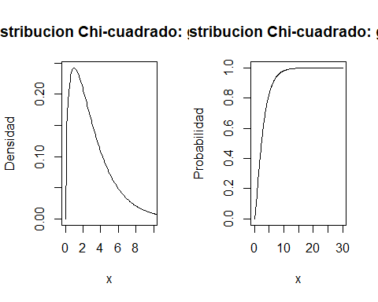

par(par(mfrow=c(1,2)))  
#Distribucion t de Student con n grados de libertad  
rm(x)  
x<- seq(-3.291, 3.291, length=100)  
par(mfrow=c(1,2))  
plot(x, dt(x, df=3),col="red", ylab="Densidad", main="Distribucion t Student: g.l. = 3", type="l",ylim=c(0,0.5))  
curve(dnorm(x,0,1),-3.291,3.291, col=3,add=T)   
plot(x, pt(x, df=3),col="red", ylab="Probabilidad",main="Distribucion t Student: g.l. = 3", type="l")

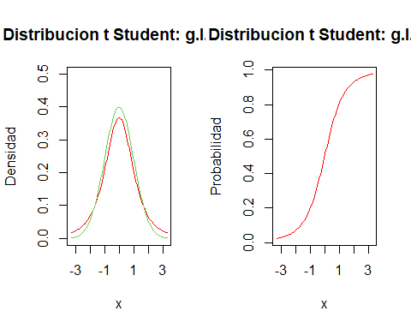

par(par(mfrow=c(1,2)))  
  
  
#Distribucion F de Snedecor con m y n grados de libertad  
rm(x)  
x<- seq(0, 300, length=4000)  
par(mfrow=c(1,2))  
plot(x, df(x, df1=5, df2=2), xlim=c(0,5),xlab="x", ylab="Densidad", main="Distribucion F(5,2)", type="l")  
plot(x, pf(x, df1=5, df2=2), xlab="x", ylim=c(0,1),ylab="Probabilidad", main="Distribucion F(5,2)", type="l")

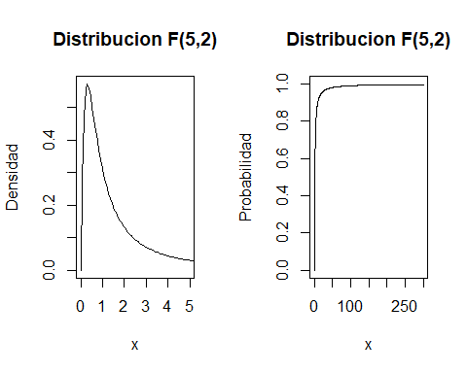

par(par(mfrow=c(1,2)))  
  
##########################################################################  
#3.Revision de inferencia estadistica basica parametrica y no parametrica#  
#########################################################################  
  
load("D:/6648 Bioestadistica/DataMaster_2021.RData")  
  
summary(ElPulso)

## Pulso1 Pulso2 Ran Smokes Sex   
## Min. : 48.00 Min. : 50 Min. :1.00 Min. :1.000 Min. :1.00   
## 1st Qu.: 64.00 1st Qu.: 68 1st Qu.:1.00 1st Qu.:1.000 1st Qu.:1.00   
## Median : 71.00 Median : 76 Median :2.00 Median :2.000 Median :1.00   
## Mean : 72.87 Mean : 80 Mean :1.62 Mean :1.696 Mean :1.38   
## 3rd Qu.: 80.00 3rd Qu.: 85 3rd Qu.:2.00 3rd Qu.:2.000 3rd Qu.:2.00   
## Max. :100.00 Max. :140 Max. :2.00 Max. :2.000 Max. :2.00   
##   
## Height Weight Activity Peso.kg   
## Min. :61.00 Min. : 95.0 Min. :1.000 Min. :43.10   
## 1st Qu.:66.00 1st Qu.:125.0 1st Qu.:2.000 1st Qu.:56.80   
## Median :69.00 Median :145.0 Median :2.000 Median :65.80   
## Mean :68.72 Mean :145.2 Mean :2.132 Mean :65.90   
## 3rd Qu.:72.00 3rd Qu.:155.5 3rd Qu.:2.000 3rd Qu.:70.62   
## Max. :75.00 Max. :215.0 Max. :3.000 Max. :97.60   
## NA's :1   
## Altura.cm Actividad Fumar Sexo Correr Peso.int  
## Min. :154.9 Suave : 9 Fuma :28 Hombre:57 No:35 M:10   
## 1st Qu.:167.6 Moderada:61 No Fuma:64 Mujer :35 Si:57 N:30   
## Median :175.3 Alta :21 S:52   
## Mean :174.5 NA's : 1   
## 3rd Qu.:182.9   
## Max. :190.5   
##

var.test(ElPulso$Pulso1~ElPulso$Fumar)

##   
## F test to compare two variances  
##   
## data: ElPulso$Pulso1 by ElPulso$Fumar  
## F = 1.9344, num df = 27, denom df = 63, p-value = 0.0328  
## alternative hypothesis: true ratio of variances is not equal to 1  
## 95 percent confidence interval:  
## 1.055115 3.859449  
## sample estimates:  
## ratio of variances   
## 1.934427

t.test(ElPulso$Pulso1~ElPulso$Fumar)

##   
## Welch Two Sample t-test  
##   
## data: ElPulso$Pulso1 by ElPulso$Fumar  
## t = 1.0846, df = 39.723, p-value = 0.2847  
## alternative hypothesis: true difference in means between group Fuma and group No Fuma is not equal to 0  
## 95 percent confidence interval:  
## -2.645663 8.770663  
## sample estimates:  
## mean in group Fuma mean in group No Fuma   
## 75.0000 71.9375

#Test t de Student para una muestra: Prueba de conformidad de la media  
######################################################################  
#Ejemplo Contrastar si el pulso medio antes de la actividad realizada es 75.  
t.test(ElPulso$Pulso1,mu=75)

##   
## One Sample t-test  
##   
## data: ElPulso$Pulso1  
## t = -1.8562, df = 91, p-value = 0.06666  
## alternative hypothesis: true mean is not equal to 75  
## 95 percent confidence interval:  
## 70.58973 75.14940  
## sample estimates:  
## mean of x   
## 72.86957

#Ejemplo Contrastar si el pulso medio antes de la actividad realizada para hombres es 75.  
t.test(ElPulso$Pulso1[ElPulso$Sexo=="Hombre"],mu=75)

##   
## One Sample t-test  
##   
## data: ElPulso$Pulso1[ElPulso$Sexo == "Hombre"]  
## t = -3.4751, df = 56, p-value = 0.0009933  
## alternative hypothesis: true mean is not equal to 75  
## 95 percent confidence interval:  
## 67.78150 73.06061  
## sample estimates:  
## mean of x   
## 70.42105

#Ejemplo 3.9 Contrastar si el pulso medio antes de la actividad realizada para hombres fumadores es 75.  
t.test(ElPulso$Pulso1[ElPulso$Sexo=="Hombre"&ElPulso$Fumar=="Fuma"],mu=75)

##   
## One Sample t-test  
##   
## data: ElPulso$Pulso1[ElPulso$Sexo == "Hombre" & ElPulso$Fumar == "Fuma"]  
## t = -1.3757, df = 19, p-value = 0.1849  
## alternative hypothesis: true mean is not equal to 75  
## 95 percent confidence interval:  
## 65.41875 76.98125  
## sample estimates:  
## mean of x   
## 71.2

#Test t de Student para dos muestras independientes  
####################################################  
#Ejemplo 3.12 Contrastar la igualdad de pulsos medios despues de la actividad entre hombres y mujeres.  
t.test(ElPulso$Pulso2~ElPulso$Sexo)

##   
## Welch Two Sample t-test  
##   
## data: ElPulso$Pulso2 by ElPulso$Sexo  
## t = -2.7849, df = 51.047, p-value = 0.007494  
## alternative hypothesis: true difference in means between group Hombre and group Mujer is not equal to 0  
## 95 percent confidence interval:  
## -18.64912 -3.02507  
## sample estimates:  
## mean in group Hombre mean in group Mujer   
## 75.87719 86.71429

var.test(ElPulso$Pulso2~ElPulso$Sexo)

##   
## F test to compare two variances  
##   
## data: ElPulso$Pulso2 by ElPulso$Sexo  
## F = 0.40384, num df = 56, denom df = 34, p-value = 0.002546  
## alternative hypothesis: true ratio of variances is not equal to 1  
## 95 percent confidence interval:  
## 0.2141786 0.7271842  
## sample estimates:  
## ratio of variances   
## 0.4038387

#Test t de Student para dos muestras dependientes (o apareadas)  
######################################################################  
t.test( ElPulso$Pulso1,ElPulso$Pulso2, paired=T, conf.level=0.95)

##   
## Paired t-test  
##   
## data: ElPulso$Pulso1 and ElPulso$Pulso2  
## t = -5.0769, df = 91, p-value = 2.023e-06  
## alternative hypothesis: true difference in means is not equal to 0  
## 95 percent confidence interval:  
## -9.920273 -4.340597  
## sample estimates:  
## mean of the differences   
## -7.130435