Activity 1. Factor 1 (problem size)

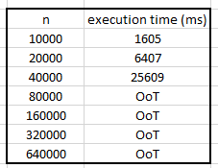

Activity 2. Factor 2 (computer power)

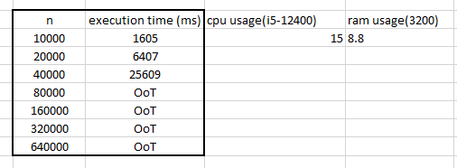

Activity 3. Factor 3 (Implementation environment)

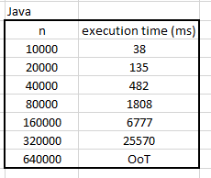

Activity 4. Factor 4 (algorithm that is used)