

Activity 1. Bubble algorithm
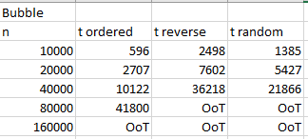

Bubble methods check if the element at the left is higher than the right, if so, it swaps then with the method vector.interchange().
Since the ordered vector is already sorted, vector.interchange() is never executed.
On the other way, when applying bubble algorithm to a reverse vector, vector.interchange() will always be executed. That’s why random vector have better times, since sometimes elements will already be sorted.

Activity 2. Selection Algorithm
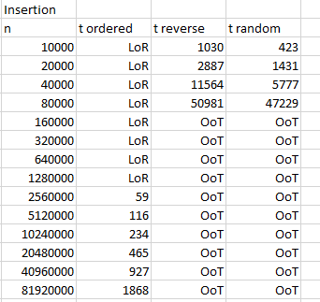
In the worst case, the complexity of method insertion() is O(n^2), but in the best case (that is ordered vector) the complexity is O(n) since the while loop is execute when j>=0 AND pivot < a[j], as pivot is i-1 (the element at the left), this condition is never met because in an ordered vector the element at the left will always be lower than the ones at the right.

Activity 3. Insertion Algorithm
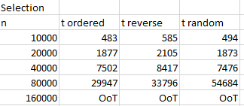
This algorithm works with a minimum position, this position is change every time a right element is higher than the left element, so works exactly the opposite of bubble, but in this case vector.interchange() is always executed, that’s why times don’t differ that much.

Activity 4. Quicksort Algorithm
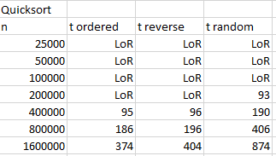

Activity 5. Quicksort + Insertion Algorithm

