AI for Medicine Project Report
Prof. Stefano Diciotti
University of Bologna

How Early Can Heart Disease Be Predicted?
A Staged Machine Learning Analysis of the Cleveland UCI Dataset
A leakage-safe and reproducible staged analysis of the Cleveland Heart Disease dataset.
Academic Year: 2025/2026
Student Name: Sergio Pascual Redondo
Degree Program: ERASMUS
Submission Date: 04/06/2026
Project focus: estimating how much diagnostic information is gained when moving from routine clinical data to more specialised cardiovascular tests.

Table of Contents
This report follows the complete workflow of the project: clinical motivation, dataset understanding, leakage-safe methodology, model evaluation, interpretation, and conclusions.
1. Project Title
2. Problem Statement
3. Objective of the Study
4. Dataset Description
5. Data Preprocessing
6. Avoiding Data Leakage
7. Machine Learning Pipeline
8. Results
9. Discussion
10. Conclusions and Future Work
11. Ethics and Data Privacy
12. Code and Reproducibility
13. References
Main deliverables: staged clinical comparison, nested cross-validation, final test ROC analysis, confusion matrices by stage, threshold discussion, and model interpretation.

1. Project Title
How Early Can Heart Disease Be Predicted? A Staged Machine Learning Analysis of the Cleveland UCI Dataset

2. Problem Statement
In clinical practice, patient information is not obtained all at the same time. Some variables, such as age, sex, resting blood pressure, cholesterol, and fasting blood sugar, can be available from an initial assessment. However, other variables require more steps, such as a medical consultation, a resting electrocardiogram, an exercise stress test, or advanced diagnostic tests such as nuclear myocardial perfusion imaging or coronary angiography.
These advanced tests may require more time, specialised equipment, trained medical staff, and higher cost for the healthcare system. This difference in availability can cause delayed diagnosis, especially if clinical suspicion is not identified until late stages of the diagnostic process. In cardiovascular disease, late diagnosis can be harmful because it may delay referral, follow-up, or more specific testing.
For this reason, it is clinically relevant to study whether a useful estimation of heart disease risk can be obtained before the full diagnostic process is completed. This could help to prioritise patients for further tests and use clinical resources more efficiently. The project is not designed to replace a physician, but to study how the available information changes across a possible diagnostic pathway.

3. Objective of the Study
The objective of this study is to evaluate how effective each stage of the cardiac diagnostic pathway is for predicting heart disease. Rather than using all clinical variables at once, the project simulates a progressive medical workflow, from routine risk factors to advanced diagnostic tests, to understand at which point the available information becomes useful for supporting clinical decisions and prioritising patients for further assessment.
To do this, the Cleveland Heart Disease variables are organised into four clinical stages, according to when they could be available in a possible diagnostic process. The target variable is the presence or absence of heart disease. However, the main goal is not only to build a binary classifier, but to compare how predictive performance changes when more specific clinical information is progressively added.
The project also has a methodological objective. It applies the main ideas studied in the AI for Medicine course: understanding the medical issue first, building a reproducible pipeline, avoiding data leakage, using cross-validation correctly, tuning hyperparameters only inside the training process, and interpreting results in a clinical context.

4. Dataset Description
This project uses the Heart Disease Cleveland UCI dataset, derived from the Cleveland database of the UCI Heart Disease dataset [1]. The dataset contains clinical information related to the diagnosis of heart disease. The original UCI database includes more attributes, but the commonly used Cleveland version contains 14 variables: 13 input features and one target variable.
The local dataset used in this project contains 297 patients and 14 columns. The data are tabular and include numerical, binary, and categorical clinical variables. Each row represents one patient.
Variable | Clinical meaning | Stage
age | Patient age | Stage 1
sex | Biological sex | Stage 1
trestbps | Resting blood pressure | Stage 1
chol | Serum cholesterol | Stage 1
fbs | Fasting blood sugar > 120 mg/dl | Stage 1
cp | Chest pain type, including asymptomatic presentation | Stage 2
restecg | Resting electrocardiographic result | Stage 2
thalach | Maximum heart rate achieved during exercise | Stage 3
exang | Exercise-induced angina | Stage 3
oldpeak | ST depression induced by exercise compared with rest | Stage 3
slope | Slope of the peak exercise ST segment | Stage 3
ca | Number of major vessels coloured by fluoroscopy | Stage 4
thal | Thallium/nuclear stress test result | Stage 4
condition | Target: presence or absence of heart disease | Label

The target variable is condition. In this project, condition = 0 represents no heart disease and condition = 1 represents heart disease. Therefore, the task is a binary classification problem. The class distribution is relatively balanced, with 160 patients without heart disease and 137 patients with heart disease. This means that severe class imbalance is not a major problem in this dataset.
The clinical stages are defined to represent a possible order in which information may become available. Stage 1 contains early and routine variables. Stage 2 adds symptoms and resting ECG. Stage 3 adds functional information from exercise stress testing. Stage 4 adds advanced diagnostic information, including ca and thal.
Stage | Clinical meaning | Variables | Role in workflow
Stage 1 | Routine risk factors and basic assessment | age, sex, trestbps, chol, fbs | Early and low-cost information
Stage 2 | Symptoms and resting ECG | cp, restecg | First clinical assessment
Stage 3 | Exercise stress test variables | thalach, exang, oldpeak, slope | Functional cardiac assessment
Stage 4 | Advanced diagnostic tests | ca, thal | More specialised diagnostic information

The exploratory analysis was useful for understanding the dataset before modelling. It showed that chest pain type is highly informative: in this dataset, many patients with heart disease are coded in the asymptomatic chest pain category. This is clinically important because the absence of typical chest pain does not necessarily exclude heart disease.
The exploratory figures show that the variables are not equally related to the target. In the correlation heatmap, thalach has a negative correlation with condition, meaning that lower maximum heart rate is associated with heart disease in this dataset. Other variables such as cp, exang, oldpeak, ca, and thal show positive associations. The heatmap is used only for understanding the data, not for automatic feature selection.
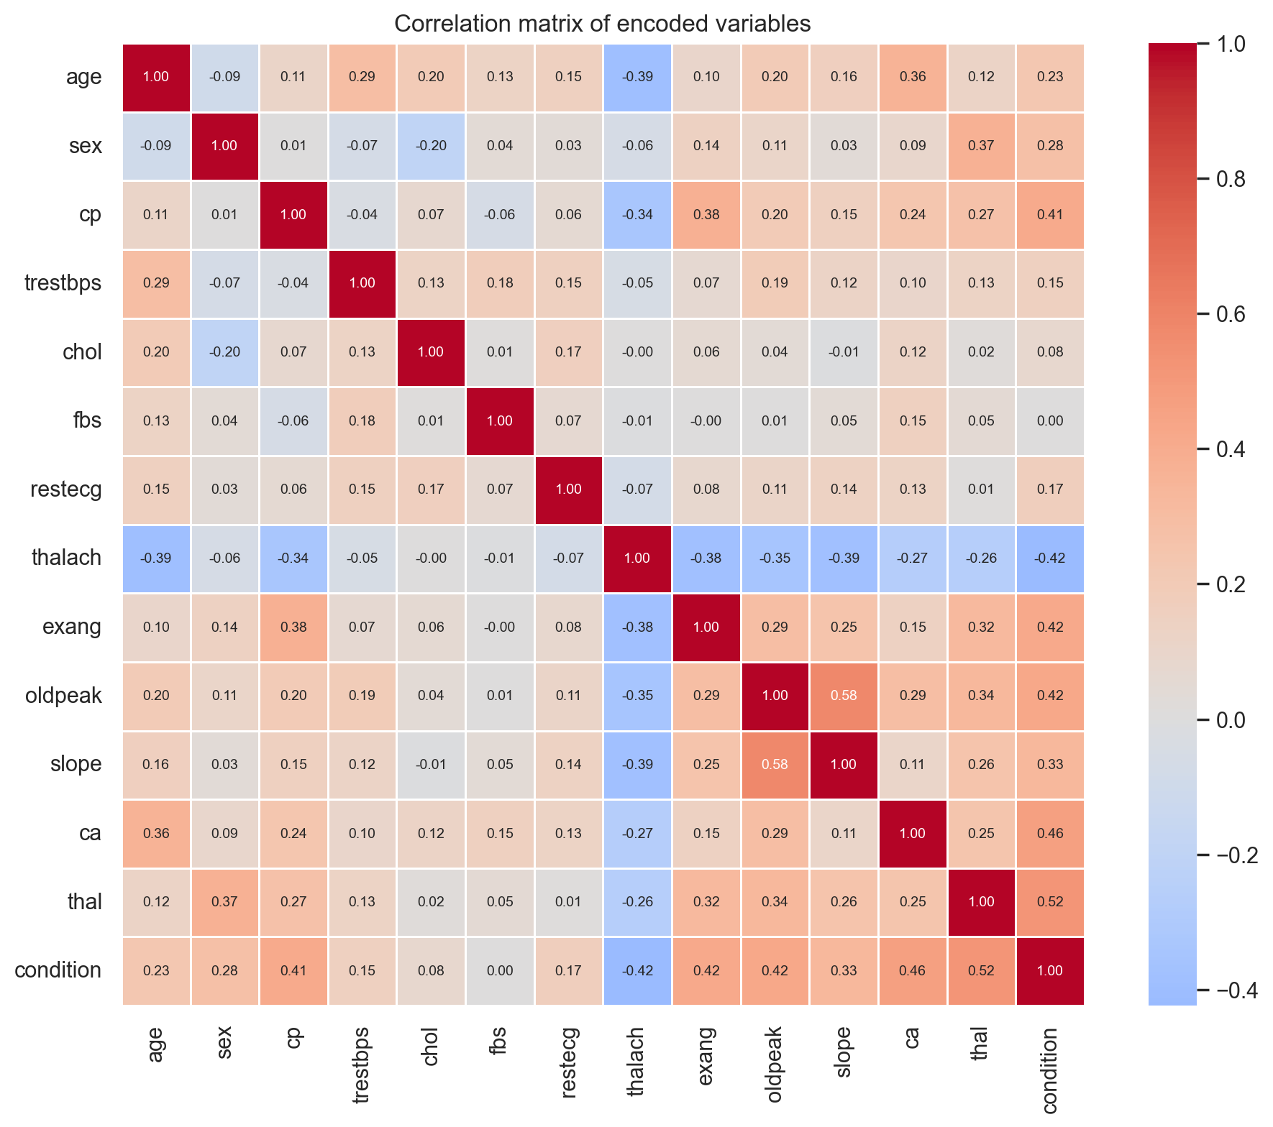
Figure 1. Correlation heatmap with annotated values.
No missing values, duplicated rows, or '?' values were found. Therefore, the main challenge was not cleaning the file, but building a correct validation workflow and interpreting the variables clinically.

5. Data Preprocessing
The preprocessing is intentionally simple and transparent because the dataset is small and tabular. After the initial quality check, no patient rows were removed.
The variables have different types, so they are processed differently. Numeric variables are imputed with the median and standardised. Binary variables are imputed with the most frequent value. Categorical variables are imputed with the most frequent value and transformed with one-hot encoding.
One-hot encoding is important for variables such as cp, restecg, slope, and thal. These variables are coded with numbers, but the numbers represent categories, not continuous values. For example, thal is split into transformed variables such as thal_0 and thal_2. This avoids forcing an artificial order into clinical categories. It also explains why the SHAP plot shows some variables divided into several encoded columns.
Even if the current CSV has no missing values, imputation remains inside the pipeline. This makes the workflow more explicit and robust if a similar dataset with missing values is used later. It also ensures that every transformation is learned only from training data during cross-validation.

6. Avoiding Data Leakage
Avoiding data leakage is one of the most important methodological parts of this project. Data leakage happens when a spurious relationship between the input variables and the outcome is introduced during data collection, sampling or processing. This can produce inflated and falsely optimistic model performance.
Following the leakage taxonomy discussed in the course, the first family is L1 leakage: lack of clean separation between training and test data. This project addresses it by creating a locked stratified test set before model selection. It also avoids preprocessing on the full dataset: imputation, scaling and one-hot encoding are placed inside the scikit-learn Pipeline, so they are fitted only on the training folds. Feature groups are clinically defined before modelling, and duplicated rows were checked before the split.
The second family is L2 leakage: illegitimate features. This means using variables that would not be available at prediction time or that indirectly reveal the outcome. To reduce this risk, variables are organised into clinical stages according to when they could plausibly become available. Stage 4 variables such as ca and thal are interpreted as advanced diagnostic information, not as early-screening variables.
The third family is L3 leakage: the test set does not represent the distribution of interest or is not independent. In this dataset, each row represents one patient, so the split is performed at patient level. There are no multiple images or slices from the same patient that could appear on both sides of the split. The main remaining limitation is external validity: the Cleveland dataset is small, old and from a specific clinical cohort. In the terminology of Kapoor and Narayanan, this creates a risk of sampling bias (L3.3), because performance may change under distribution shift in a different hospital or a modern cohort.
Finally, nested cross-validation is used inside the development set. The inner loop tunes hyperparameters with GridSearchCV, while the outer loop estimates performance. Thresholds are inspected using development data, not by optimising the locked test set. For the stage comparison, the selected threshold maximises balanced accuracy on development predictions, using sensitivity as a secondary criterion. The pipeline mainly protects against L1 preprocessing leakage, while L2 and L3 are addressed by clinical feature design, patient-level splitting and cautious interpretation.

7. Machine Learning Pipeline
The machine learning pipeline has two main parts: preprocessing and classification. The preprocessing block handles numeric, binary, and categorical variables. The classifier is either Logistic Regression or Random Forest.
Logistic Regression is the primary model because it is simple, interpretable, and appropriate for a small tabular medical dataset. Random Forest is included as a non-linear comparator, because it can model more complex relationships. The aim is not to test many algorithms, but to compare clinical stages using a controlled and understandable workflow.
GridSearchCV is used for hyperparameter tuning. For Logistic Regression, the main hyperparameter is the regularisation strength C. For Random Forest, the grid includes parameters such as the number of trees, maximum depth, and minimum samples per leaf. The grids are kept small because the dataset is small and the project should remain reproducible and understandable.
The main metric for model comparison is ROC-AUC, because it evaluates ranking performance independently of a fixed decision threshold. However, the final clinical interpretation also uses sensitivity, specificity, precision, balanced accuracy, and confusion matrices. These metrics are important because false negatives and false positives have different consequences in medicine.

8. Results
The nested cross-validation results show a clear staged pattern. With Logistic Regression, the mean ROC-AUC rises from about 0.66 in Stage 1 to 0.81 in Stage 2, 0.85 in Stage 3, and 0.89 in Stage 4. Stage 1 has the weakest performance, which means that routine risk factors alone are not enough for reliable prediction in this dataset. The largest single improvement, of almost 0.15 in ROC-AUC, appears when Stage 2 variables are added, while the later stages add progressively smaller gains. This suggests that symptoms and resting ECG provide important information for early clinical triage.
Stage | Model | Mean ROC-AUC | Std | Mean balanced acc.
S1 - Routine risk factors | Logistic Regression | 0.658 | 0.076 | 0.616
S1 - Routine risk factors | Random Forest | 0.692 | 0.061 | 0.652
S2 - Symptoms and resting ECG | Logistic Regression | 0.806 | 0.067 | 0.745
S2 - Symptoms and resting ECG | Random Forest | 0.801 | 0.066 | 0.732
S3 - Exercise stress test | Logistic Regression | 0.847 | 0.051 | 0.768
S3 - Exercise stress test | Random Forest | 0.851 | 0.054 | 0.742
S4 - Advanced diagnostic tests | Logistic Regression | 0.890 | 0.048 | 0.821
S4 - Advanced diagnostic tests | Random Forest | 0.889 | 0.052 | 0.814

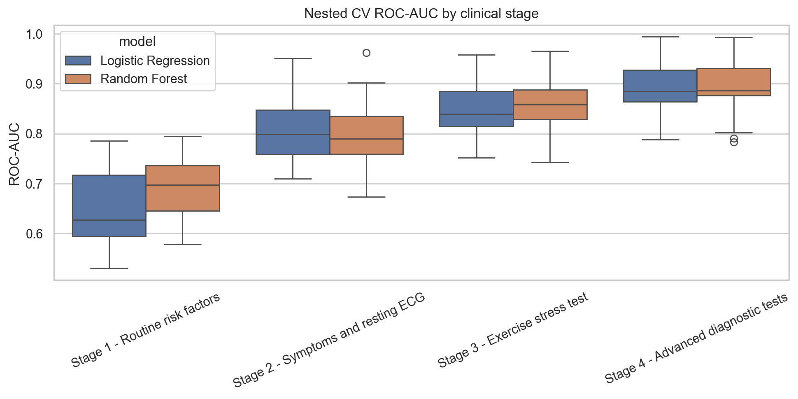
Figure 2. Nested CV ROC-AUC distribution by clinical stage and model.
The best development result is obtained with Stage 4 and Logistic Regression. Random Forest performs similarly in some stages, but it does not clearly outperform Logistic Regression. Because the dataset is small and interpretability is important, Logistic Regression is selected as the final model.
The final test evaluation by stage confirms the clinical interpretation. Stage 1 reaches a ROC-AUC of 0.823, with a 95% bootstrap confidence interval of 0.703-0.920, but has low sensitivity, with 12 false negatives. This contrast is important: an apparently acceptable ranking performance can coexist with an unacceptable miss rate. Stage 2 improves to a ROC-AUC of 0.919 (95% CI: 0.842-0.975) and clearly reduces false negatives. Stage 3 gives a similar ROC-AUC of 0.908 (95% CI: 0.826-0.967), but improves specificity. Stage 4 gives the best final performance, with ROC-AUC 0.955 (95% CI: 0.900-0.993), accuracy 0.900, and balanced accuracy 0.893. However, the confidence intervals overlap, especially between later stages, so small differences should not be overinterpreted.
Stage | Threshold | ROC-AUC (95% CI) | Sensitivity | Specificity | Accuracy | TN/FP/FN/TP
S1 - Routine risk factors | 0.5 | 0.823 (0.703-0.920) | 0.571 | 0.844 | 0.717 | 27/5/12/16
S2 - Symptoms and resting ECG | 0.5 | 0.919 (0.842-0.975) | 0.750 | 0.844 | 0.800 | 27/5/7/21
S3 - Exercise stress test | 0.6 | 0.908 (0.826-0.967) | 0.714 | 0.906 | 0.817 | 29/3/8/20
S4 - Advanced diagnostic tests | 0.5 | 0.955 (0.900-0.993) | 0.786 | 1.000 | 0.900 | 32/0/6/22

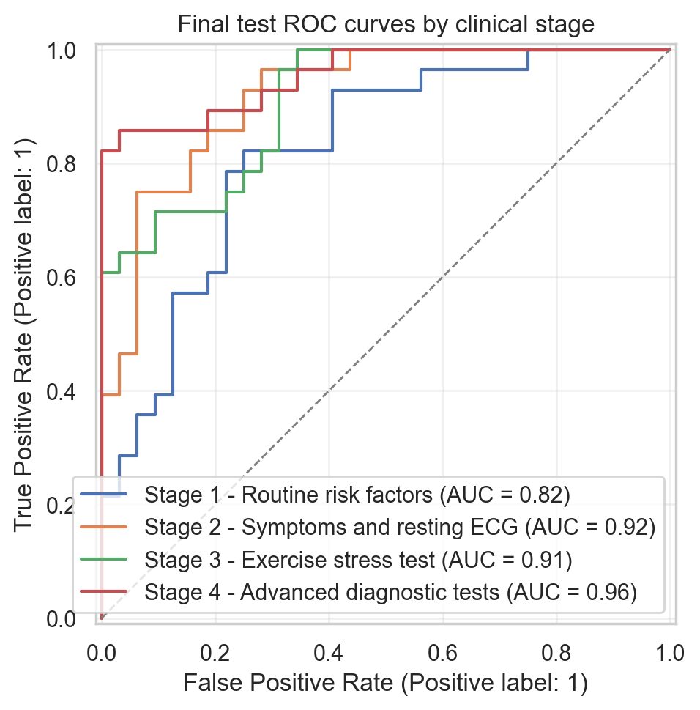
Figure 3. Final test ROC curves by clinical stage.
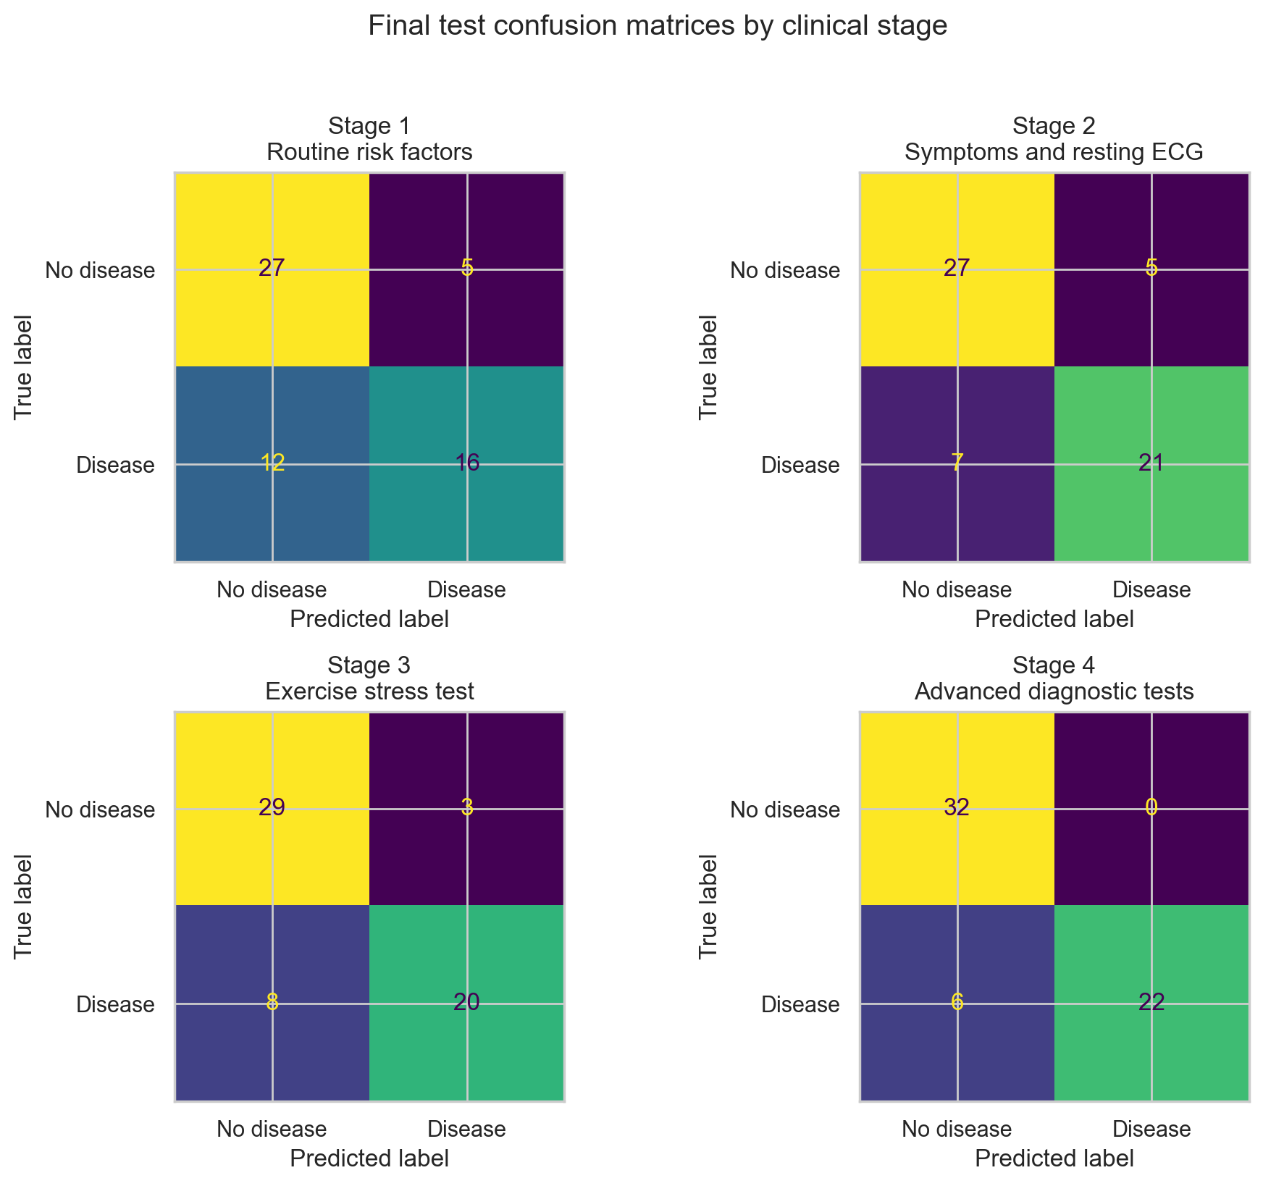
Figure 4. Final test confusion matrices by clinical stage.
The threshold analysis shows that the default value of 0.5 should not be accepted automatically. In the final stage comparison, thresholds were selected only from development predictions: 0.5 for Stage 1, 0.5 for Stage 2, 0.6 for Stage 3, and 0.5 for Stage 4. This avoids using the locked test set to choose the operating point. In a screening-like early stage, a lower threshold could be clinically reasonable if the objective is to reduce false negatives. In later stages, when more specific information is available, a stricter threshold may be acceptable to improve specificity and precision. In this project, thresholds are analysed as a methodological and clinical trade-off, not as a real clinical recommendation.
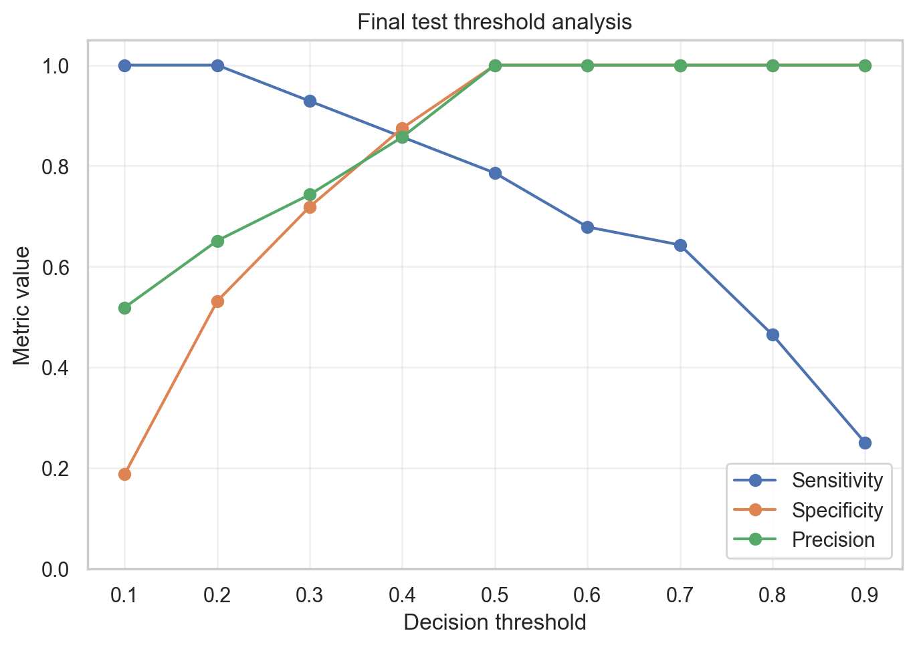
Figure 5. Final test threshold trade-off for the selected final strategy.
SHAP is used only as an interpretability tool for the final Logistic Regression model. The most influential individual feature is ca, which belongs to Stage 4. Important Stage 3 variables such as thalach, oldpeak, and exang also appear among the top features. Stage 2 contributes through chest pain categories such as cp_3 and cp_2. Stage 1 variables appear lower in the ranking.
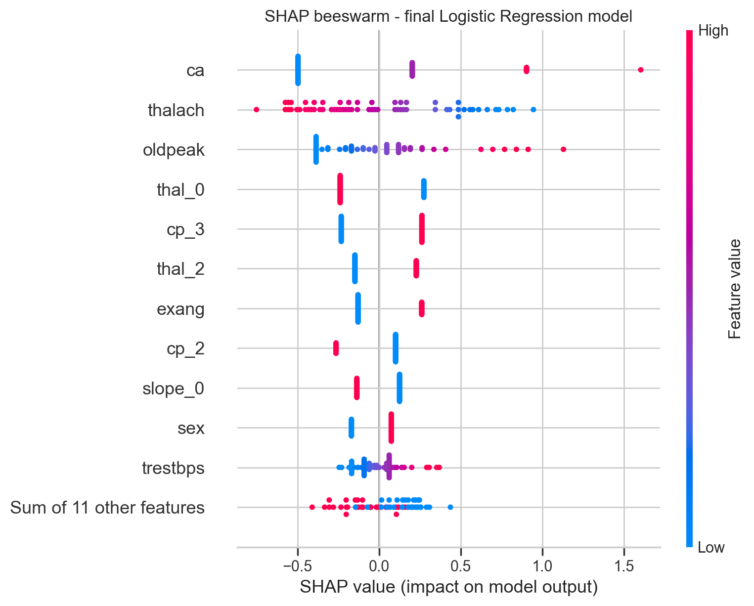
Figure 6. SHAP beeswarm plot for the final Logistic Regression model.

9. Discussion
The results support the main idea of the project: the clinical value of the dataset depends on when the variables become available. If all variables are used at once, the project becomes a standard binary classification task. By organising the variables into stages, the analysis becomes closer to a real clinical workflow.
Stage 1 is useful as a baseline, but it is not sufficient for reliable detection. It uses routine risk factors, but these variables do not directly measure the functional or anatomical state of the coronary arteries. This explains why the model misses many patients with disease in the final test evaluation.
The most interesting improvement appears from Stage 1 to Stage 2. This does not simply mean that chest pain detects all disease. In the Cleveland dataset, the chest pain variable includes an asymptomatic category, and many patients with heart disease are coded as asymptomatic. This suggests that absence of typical chest pain should not be interpreted as absence of disease. Stage 2 may therefore be useful for early triage, because it adds clinical presentation and resting ECG while still being more accessible than advanced tests.
Stage 3 does not always produce a very large improvement over Stage 2 in ROC-AUC, but it should not be considered irrelevant. SHAP shows that exercise-related variables such as thalach, oldpeak, and exang are important in the final model. This suggests that Stage 3 provides functional information that helps refine the prediction, even if the gain is not dramatic in every metric.
Stage 4 gives the best performance, but this result should be interpreted with caution rather than enthusiasm. It is almost expected, because ca and thal are advanced diagnostic variables that lie very close to the diagnostic process that defines the target itself. The ca variable, related to the number of major vessels coloured by fluoroscopy, is close to an anatomical coronary assessment, so predicting confirmed disease from an almost-angiographic feature is not a surprising achievement. This is not data leakage in the technical sense, because these are legitimate input features, but it does reduce the clinical novelty of the Stage 4 result. The thal variable is also useful, but its importance is split across one-hot encoded categories, so it should not be judged only by one transformed feature such as thal_0 or thal_2. For this reason, the most genuinely valuable finding is not Stage 4 but Stage 2, precisely because it is located upstream in the diagnostic pathway and uses cheaper and more accessible information.
The main clinical interpretation is that advanced tests remain important for confident classification, but earlier information may already help prioritise patients for further assessment. The model should not decide which test a patient receives. Instead, the staged analysis can support the idea of risk stratification: early stages may identify patients who need closer follow-up or more specific testing.
There are important limitations. The dataset is small and old, and it comes from a specific clinical context. This is a sampling bias risk (L3.3): the test set may not represent the distribution of patients in another hospital, country, or modern clinical protocol. Therefore, distribution shift is a real concern and external validation would be necessary before any clinical use. The final test set contains only 60 patients, so small changes can affect the metrics. Also, the project does not perform a cost-effectiveness analysis, so it cannot claim that the workflow saves money. It can only suggest that earlier prediction may help use diagnostic resources more efficiently.

10. Conclusions and Future Work
This project shows that heart disease prediction can be studied as a staged clinical workflow rather than a single table-based classification problem. The first conclusion concerns clinical usefulness. Routine risk factors alone (Stage 1) are not sufficient: although Stage 1 reaches a ROC-AUC of 0.823, its confidence interval is wide and it misses many patients, with 12 false negatives on the final test set. The largest practical improvement appears when symptoms and resting ECG are added (Stage 2, ROC-AUC 0.919), using information that is fast, low-cost, and widely available. A Stage 2 model could therefore act as an early triage layer that prioritises which patients should continue to more specialised testing.
The second conclusion concerns whether all the data are really needed. The incremental gain from Stage 2 to Stage 4 is small in ranking terms (ROC-AUC 0.919 to 0.955), even though Stage 4 gives the best final classification and the single most influential feature, ca, belongs to it. Because the 95% confidence intervals overlap, this difference should be interpreted cautiously. Advanced and resource-intensive tests are most valuable for confident final diagnosis, but they may not be necessary to obtain a useful early risk estimate.
The third conclusion concerns the significance of the differences. With only 60 patients in the locked test set, the confidence intervals are wide. The Stage 1 to Stage 2 jump is the most clinically meaningful change, but the differences among Stages 2, 3 and 4 fall within a range where statistical noise cannot be excluded. Taken together, the practical message is not simply that Stage 4 performs best, but that a staged model can support risk stratification, where earlier and cheaper information may already be enough to decide who needs closer follow-up, while advanced testing is reserved for confirmation.
The clearest limitation of this project is the small sample size. The dataset contains only 297 patients, and the locked test set contains 60 patients. For this reason, bootstrap confidence intervals are reported for ROC-AUC, and small differences between later stages should not be overinterpreted.
Future work should first develop a cost-sensitive threshold analysis. In early stages, the model could prioritise sensitivity to reduce false negatives and identify patients who may need further assessment. In later stages, when more specific diagnostic information is available, the threshold could be adjusted to prioritise specificity or precision. A second related direction is calibration analysis. The Brier score improved from Stage 1 to Stage 4 in this project, but a real triage tool would require a more complete calibration study to check whether predicted probabilities correspond to realistic clinical risks.
A second future direction is synthetic data. Since the dataset is small and tabular, synthetic patients could be generated from the training data to test whether data augmentation improves stability across cross-validation folds and random seeds. This experiment would be especially useful for checking whether the stage comparison remains stable when the model has more training examples.
However, synthetic data should not be used blindly. Its quality would need to be evaluated in terms of fidelity, diversity, and privacy. Synthetic samples should preserve realistic clinical relationships, but they should not simply copy real patients. The locked real test set should remain the only data used for final evaluation, so that synthetic data does not introduce a new form of data leakage.

11. Ethics and Data Privacy
The dataset used in this project is publicly available and de-identified. No direct patient identifiers are used in the analysis. The project is developed for academic purposes and should not be interpreted as a clinical diagnostic device.
Even with public data, medical machine learning has ethical risks. A model trained on a small and old dataset may not generalise to other populations, hospitals, or clinical protocols. This is not only a generic limitation, but a sampling bias and distribution shift problem. If used without external validation, it could produce misleading predictions. For this reason, the limitations are clearly reported.
The project also considers the clinical meaning of errors. False negatives may delay further assessment for patients with disease, while false positives may lead to unnecessary anxiety or testing. This is why the report includes threshold analysis, sensitivity, specificity, and confusion matrices, instead of only reporting accuracy.

12. Code and Reproducibility
The main notebook is notebooks/heart_disease_clinical_stages.ipynb. The project is organised as a small reproducible repository. The folder src/ contains code for data loading, preprocessing, model definition, validation, evaluation, and visualisation. The folder data/raw/ contains the dataset. The folder results/ contains generated figures and tables.
Reproducibility is supported by a fixed random seed, a stratified locked test split, scikit-learn Pipeline objects, GridSearchCV, nested cross-validation, pinned package versions, saved outputs, and bootstrap confidence intervals. The notebook can be opened from GitHub in Google Colab using the Colab badge at the top of the notebook.
The separation between the notebook and Python files is intentional. The notebook explains the workflow and shows the main results, while the Python files contain reusable pipeline components. This makes the project easier to inspect, reproduce, and modify.

13. References
Cleveland Heart Disease Dataset
Janosi, A., Steinbrunn, W., Pfisterer, M., & Detrano, R. (1989).
Heart Disease [Dataset]. UCI Machine Learning Repository.
https://doi.org/10.24432/C52P4X
Lecture Notes – Artificial Intelligence for Medicine
Diciotti, S. (2025/2026).
Lecture notes, Artificial Intelligence for Medicine / Machine Learning for Bioengineering. Università di Bologna.
Course material used for project support on pipelines, nested cross-validation, data leakage, reproducibility, and medical AI methodology.
Data Leakage and Reproducibility Crisis
Kapoor, S., & Narayanan, A. (2023).
Leakage and the reproducibility crisis in machine-learning-based science. Patterns, 4(9), 100804.
https://doi.org/10.1016/j.patter.2023.100804
Cross-Validation and Small Sample Sizes
Varoquaux, G. (2018).
Cross-validation failure: Small sample sizes lead to large error bars. NeuroImage, 180, 68–77.
https://doi.org/10.1016/j.neuroimage.2017.06.061
ROC Analysis
Fawcett, T. (2006).
An introduction to ROC analysis. Pattern Recognition Letters, 27(8), 861–874.
https://doi.org/10.1016/j.patrec.2005.10.010
Synthetic Data in Medicine
Chen, R. J., Lu, M. Y., Chen, T. Y., Williamson, D. F. K., & Mahmood, F. (2021).
Synthetic data in machine learning for medicine and healthcare. Nature Biomedical Engineering, 5, 493–497.
https://doi.org/10.1038/s41551-021-00751-8
Health Dataset Standards and Bias
Arora, A., Alderman, J. E., Palmer, J., Ganapathi, S., Laws, E., McCradden, M. D., et al. (2023).
The value of standards for health datasets in artificial intelligence-based applications. Nature Medicine, 29(11), 2929–2938.
https://doi.org/10.1038/s41591-023-02608-w
MRI Features and Dementia Prediction
Marzi, C., Scheda, R., Salvadori, E., Giorgio, A., De Stefano, N., Poggesi, A., Inzitari, D., Pantoni, L., Mascalchi, M., & Diciotti, S. (2023).
Fractal dimension of the cortical gray matter outweighs other brain MRI features as a predictor of transition to dementia in patients with mild cognitive impairment and leukoaraiosis. Frontiers in Human Neuroscience, 17, 1231513.
https://doi.org/10.3389/fnhum.2023.1231513
MRI Harmonization and Machine Learning Pipelines
Marzi, C., Giannelli, M., Barucci, A., Tessa, C., Mascalchi, M., & Diciotti, S. (2024).
Efficacy of MRI data harmonization in the age of machine learning: A multicenter study across 36 datasets. Scientific Data, 11, 115.
https://doi.org/10.1038/s41597-023-02421-7
ChatGPT
OpenAI. (2026).
ChatGPT [Large language model]. Used for project support, explanation, writing assistance, and code suggestions.
https://chatgpt.com/
Claude
Anthropic. (2026).
Claude [Large language model]. Used for project support, explanation, writing assistance, and code suggestions.
https://claude.ai/
Google NotebookLM
Google. (2026).
NotebookLM [Generative AI research and note-taking tool]. Used for document-based project support, summarization, and source organization.
https://notebooklm.google.com/

