AI for Medicine - Project Report
Prof. Stefano Diciotti - University of Bologna
Academic Year: 2025/2026
Student Name: Sergio Pascual Redondo
Degree Program: ERASMUS
Submission Date: ____________________
How Early Can Heart Disease Be Predicted?
A Staged Machine Learning Analysis of the Cleveland UCI Dataset

This report studies heart disease prediction as a progressive clinical workflow, from routine risk factors to advanced diagnostic information.

Table of Contents
- 1. Project Title
- 2. Problem Statement
- 3. Objective of the Study
- 4. Dataset Description
- 5. Data Preprocessing
- 6. Avoiding Data Leakage
- 7. Machine Learning Pipeline
- 8. Results
- 9. Discussion
- 10. Conclusions and Future Work
- 11. Ethics and Data Privacy
- 12. Code and Reproducibility
- 13. References

1. Project Title
How Early Can Heart Disease Be Predicted? A Staged Machine Learning Analysis of the Cleveland UCI Dataset

2. Problem Statement
In clinical practice, patient information is not obtained all at the same time. Some variables, such as age, sex, resting blood pressure, cholesterol, and fasting blood sugar, can be available from an initial assessment. However, other variables require more steps, such as a medical consultation, a resting electrocardiogram, an exercise stress test, or advanced diagnostic tests such as nuclear myocardial perfusion imaging or coronary angiography.
These advanced tests may require more time, specialised equipment, trained medical staff, and higher cost for the healthcare system. This difference in availability can cause delayed diagnosis, especially if clinical suspicion is not identified until late stages of the diagnostic process. In cardiovascular disease, late diagnosis can be harmful because it may delay referral, follow-up, or more specific testing.
For this reason, it is clinically relevant to study whether a useful estimation of heart disease risk can be obtained before the full diagnostic process is completed. This could help to prioritise patients for further tests and use clinical resources more efficiently. The project is not designed to replace a physician, but to study how the available information changes across a possible diagnostic pathway.

3. Objective of the Study
The objective of this study is to evaluate how effective each stage of the cardiac diagnostic pathway is for predicting heart disease. Rather than using all clinical variables at once, the project simulates a progressive medical workflow, from routine risk factors to advanced diagnostic tests, to understand at which point the available information becomes useful for supporting clinical decisions and prioritising patients for further assessment.
To do this, the Cleveland Heart Disease variables are organised into four clinical stages, according to when they could be available in a possible diagnostic process. The target variable is the presence or absence of heart disease. However, the main goal is not only to build a binary classifier, but to compare how predictive performance changes when more specific clinical information is progressively added.
The project also has a methodological objective. It applies the main ideas studied in the AI for Medicine course: understanding the medical issue first, building a reproducible pipeline, avoiding data leakage, using cross-validation correctly, tuning hyperparameters only inside the training process, and interpreting results in a clinical context.

4. Dataset Description
This project uses the Heart Disease Cleveland UCI dataset, derived from the Cleveland database of the UCI Heart Disease dataset [1]. The dataset contains clinical information related to the diagnosis of heart disease. The original UCI database includes more attributes, but the commonly used Cleveland version contains 14 variables: 13 input features and one target variable.
The local dataset used in this project contains 297 patients and 14 columns. The data are tabular and include a mix of numerical, binary, and categorical clinical variables. Each row represents one patient, and each column represents a clinical measurement or coded clinical finding.
Variable | Clinical meaning | Stage
age | Patient age | Stage 1
sex | Biological sex | Stage 1
trestbps | Resting blood pressure | Stage 1
chol | Serum cholesterol | Stage 1
fbs | Fasting blood sugar > 120 mg/dl | Stage 1
cp | Chest pain type, including asymptomatic presentation | Stage 2
restecg | Resting electrocardiographic result | Stage 2
thalach | Maximum heart rate achieved during exercise | Stage 3
exang | Exercise-induced angina | Stage 3
oldpeak | ST depression induced by exercise compared with rest | Stage 3
slope | Slope of the peak exercise ST segment | Stage 3
ca | Number of major vessels coloured by fluoroscopy | Stage 4
thal | Thallium/nuclear stress test result | Stage 4
condition | Target: presence or absence of heart disease | Label

The target variable is condition. In this project, condition = 0 represents no heart disease and condition = 1 represents heart disease. Therefore, the task is a binary classification problem. The class distribution is relatively balanced, with 160 patients without heart disease and 137 patients with heart disease. This means that severe class imbalance is not a major problem in this dataset.
The clinical stages are defined to represent a possible order in which information may become available. Stage 1 contains early and routine variables. Stage 2 adds symptoms and resting ECG. Stage 3 adds functional information from exercise stress testing. Stage 4 adds advanced diagnostic information, including ca and thal.
Stage | Clinical meaning | Variables | Role in workflow
Stage 1 | Routine risk factors and basic assessment | age, sex, trestbps, chol, fbs | Early and low-cost information
Stage 2 | Symptoms and resting ECG | cp, restecg | First clinical assessment
Stage 3 | Exercise stress test variables | thalach, exang, oldpeak, slope | Functional cardiac assessment
Stage 4 | Advanced diagnostic tests | ca, thal | More specialised diagnostic information

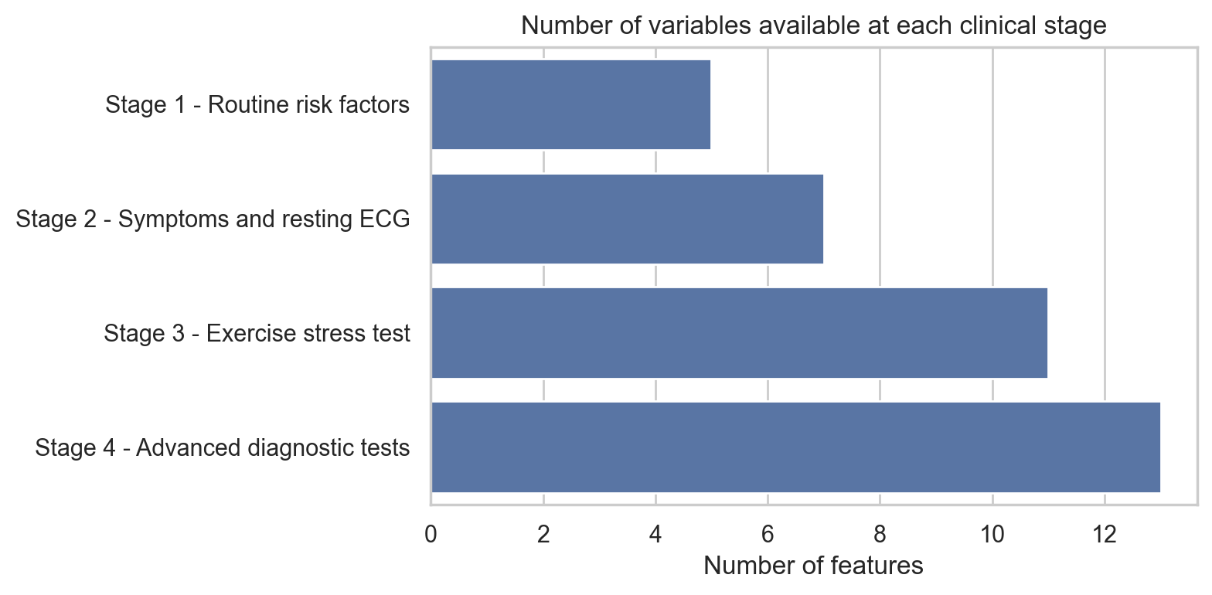
Figure 1. Number of variables included in each clinical stage.
The exploratory analysis was useful for understanding the dataset before modelling. The categorical plots showed that chest pain type is highly informative. In this dataset, many patients with heart disease are coded in the asymptomatic chest pain category. This is clinically important because the absence of typical chest pain does not necessarily exclude heart disease.
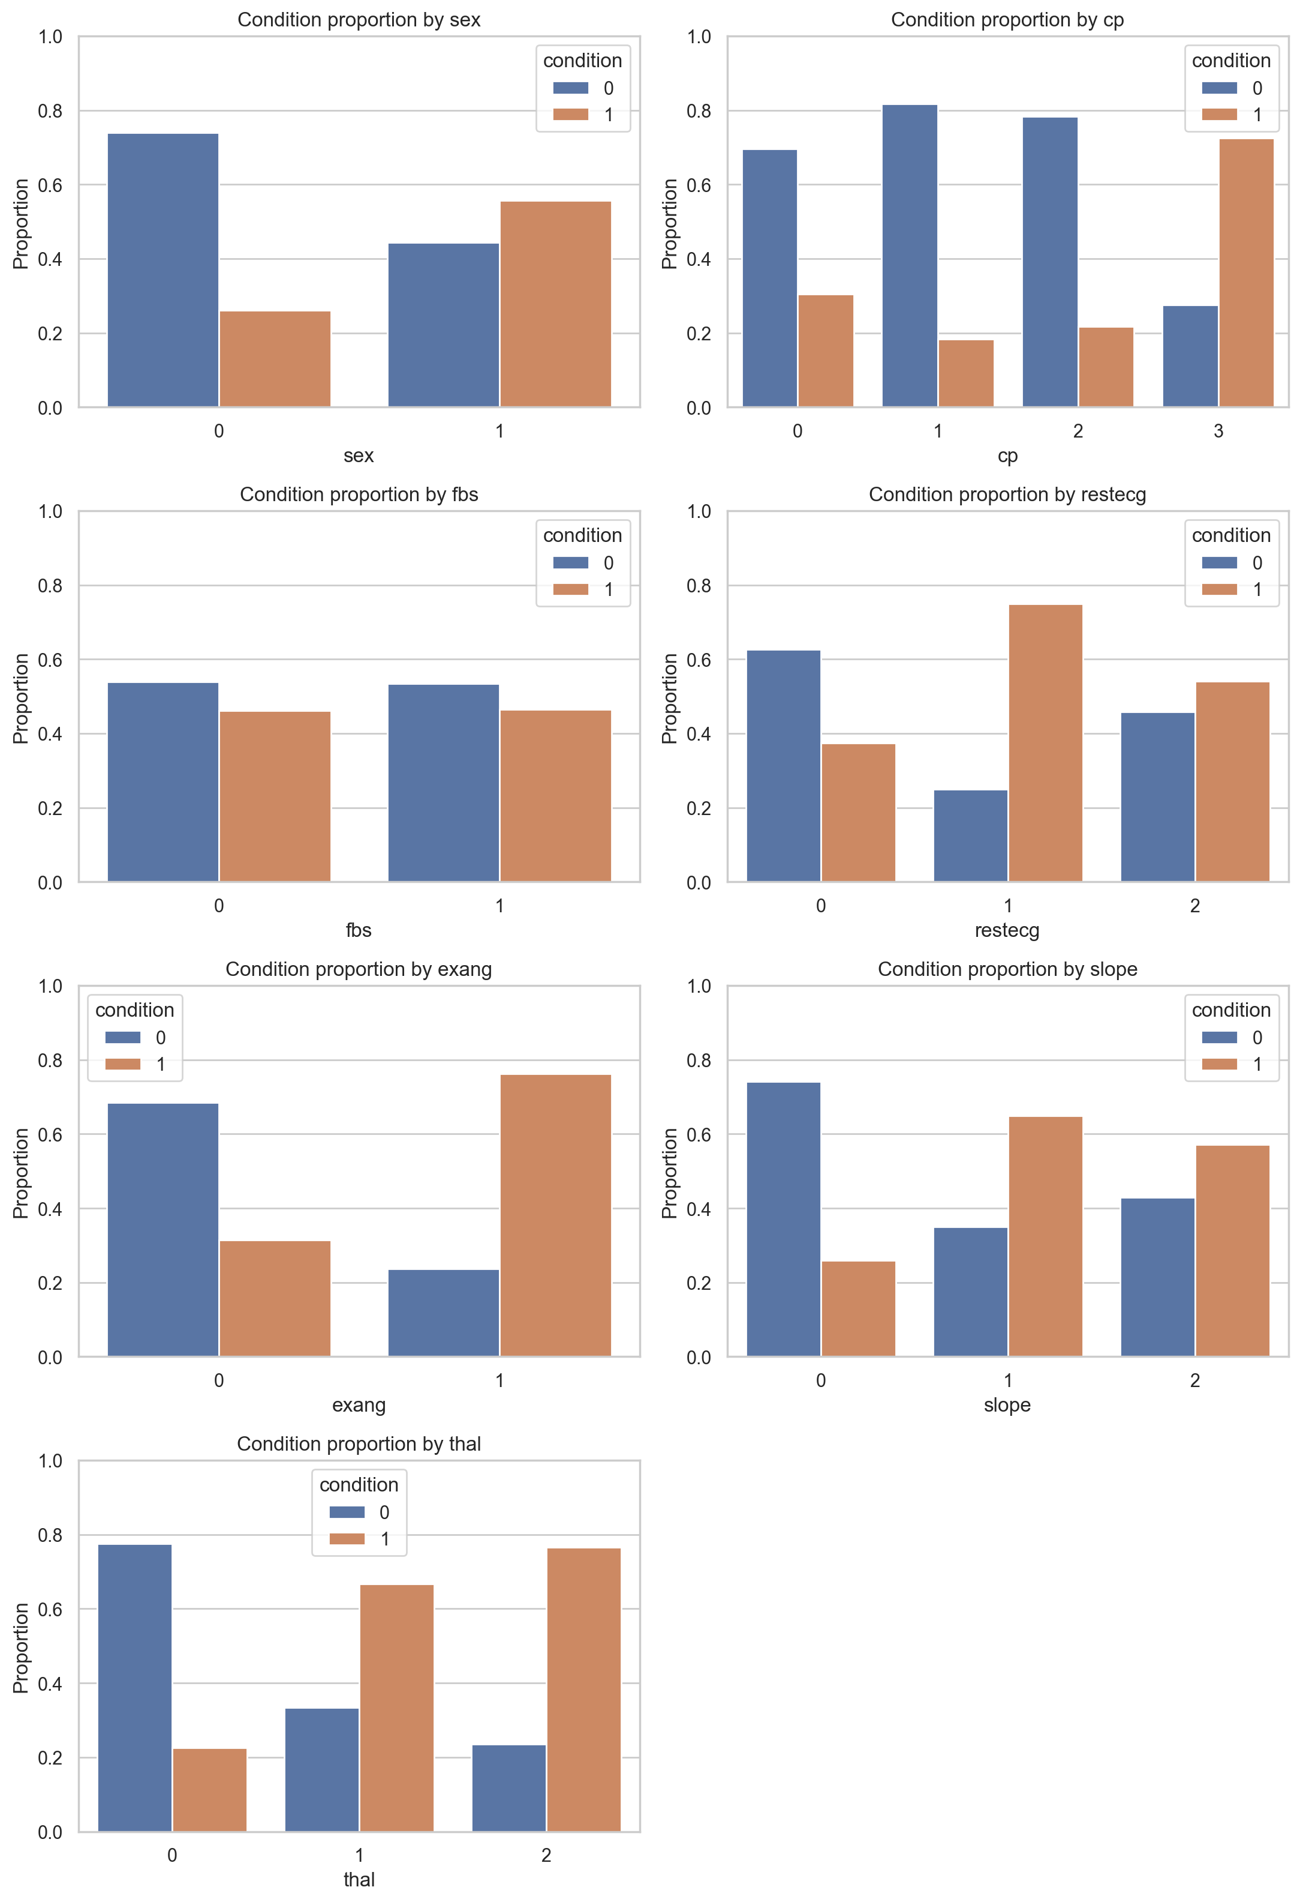
Figure 2. Proportion of heart disease by categorical variables.
The numerical distributions showed that some routine variables overlap strongly between classes, while exercise-related variables show clearer differences. For example, thalach and oldpeak are more informative than simple routine variables such as cholesterol alone. The correlation heatmap was used only as an exploratory tool, not for automatic feature selection.
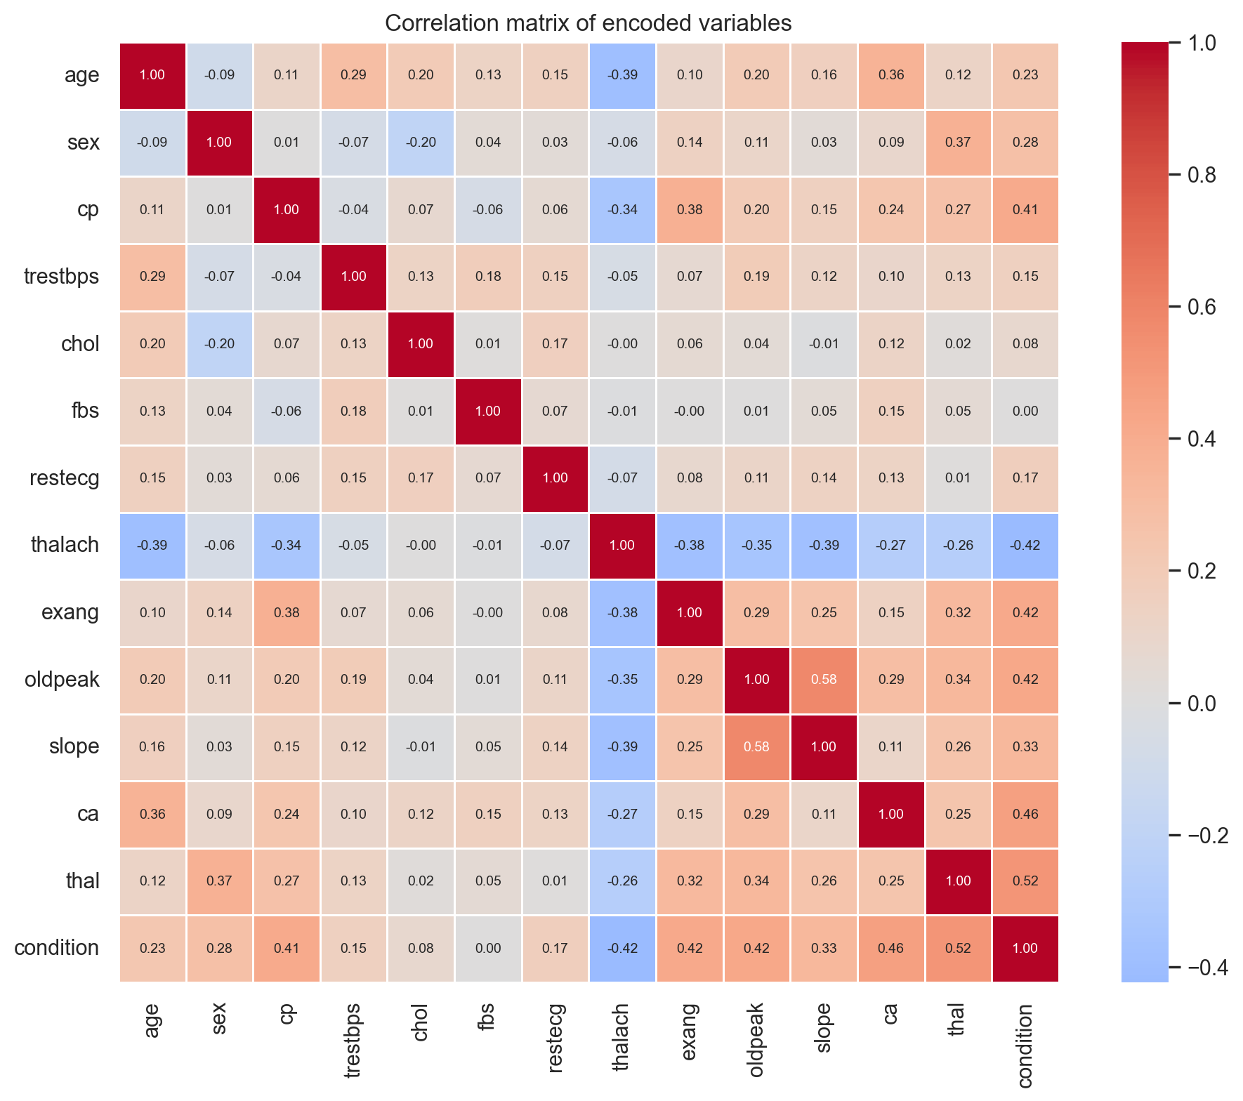
Figure 3. Correlation heatmap with annotated values.
The local file was checked before modelling. No missing values, no duplicated rows, and no '?' values were found. Therefore, the main challenge was not heavy data cleaning, but correct preprocessing, validation, and clinical interpretation.

5. Data Preprocessing
The preprocessing is intentionally simple and transparent because the dataset is small and tabular. First, the dataset was inspected for missing values, duplicated rows, target distribution, variable types, and descriptive statistics. Since no missing values or duplicated rows were found, no patient rows were removed.
The variables have different types, so they are processed differently. Numeric variables are imputed with the median and standardised. Binary variables are imputed with the most frequent value. Categorical variables are imputed with the most frequent value and transformed with one-hot encoding.
One-hot encoding is important for variables such as cp, restecg, slope, and thal. These variables are coded with numbers, but the numbers represent categories, not continuous values. For example, thal is split into transformed variables such as thal_0 and thal_2. This avoids forcing an artificial order into clinical categories. It also explains why the SHAP plot shows some variables divided into several encoded columns.
Even if the current CSV has no missing values, imputation remains inside the pipeline. This makes the workflow more explicit and robust if a similar dataset with missing values is used later. It also ensures that every transformation is learned only from training data during cross-validation.

6. Avoiding Data Leakage
Avoiding data leakage is one of the most important methodological parts of this project. Data leakage happens when information from validation or test data influences training. This can make the model appear better than it really is.
First, a stratified locked test set is created before model selection. This test set is not used to choose the best model, tune hyperparameters, define clinical stages, or inspect thresholds. It is used only at the end for final evaluation.
Second, preprocessing leakage is avoided by using scikit-learn Pipeline and ColumnTransformer. Imputation, scaling, and one-hot encoding are fitted only on the training folds during cross-validation. The validation fold is transformed using parameters learned from the corresponding training data.
Third, hyperparameter leakage is avoided with nested cross-validation. The inner loop tunes hyperparameters with GridSearchCV, while the outer loop estimates performance. This is important because using the same validation data for both tuning and final estimation can produce optimistic results.
Fourth, threshold leakage is avoided by selecting thresholds using development data, not by optimising the final test set. This is especially important because threshold choice changes sensitivity, specificity, precision, and the confusion matrix.

7. Machine Learning Pipeline
The machine learning pipeline has two main parts: preprocessing and classification. The preprocessing block handles numeric, binary, and categorical variables. The classifier is either Logistic Regression or Random Forest.
Logistic Regression is the primary model because it is simple, interpretable, and appropriate for a small tabular medical dataset. Random Forest is included as a non-linear comparator, because it can model more complex relationships. The aim is not to test many algorithms, but to compare clinical stages using a controlled and understandable workflow.
GridSearchCV is used for hyperparameter tuning. For Logistic Regression, the main hyperparameter is the regularisation strength C. For Random Forest, the grid includes parameters such as the number of trees, maximum depth, and minimum samples per leaf. The grids are kept small because the dataset is small and the project should remain reproducible and understandable.
The main metric for model comparison is ROC-AUC, because it evaluates ranking performance independently of a fixed decision threshold. However, the final clinical interpretation also uses sensitivity, specificity, precision, balanced accuracy, and confusion matrices. These metrics are important because false negatives and false positives have different consequences in medicine.

8. Results
The nested cross-validation results show a clear staged pattern. Stage 1 has the weakest performance, which means that routine risk factors alone are not enough for reliable prediction in this dataset. The largest improvement appears when Stage 2 variables are added. This suggests that symptoms and resting ECG provide important information for early clinical triage.
Stage | Model | Mean ROC-AUC | Std | Mean balanced acc.
S1 - Routine risk factors | Logistic Regression | 0.659 | 0.084 | 0.616
S1 - Routine risk factors | Random Forest | 0.694 | 0.061 | 0.654
S2 - Symptoms and resting ECG | Logistic Regression | 0.808 | 0.062 | 0.748
S2 - Symptoms and resting ECG | Random Forest | 0.801 | 0.057 | 0.731
S3 - Exercise stress test | Logistic Regression | 0.854 | 0.043 | 0.766
S3 - Exercise stress test | Random Forest | 0.853 | 0.050 | 0.746
S4 - Advanced diagnostic tests | Logistic Regression | 0.894 | 0.041 | 0.821
S4 - Advanced diagnostic tests | Random Forest | 0.891 | 0.045 | 0.813

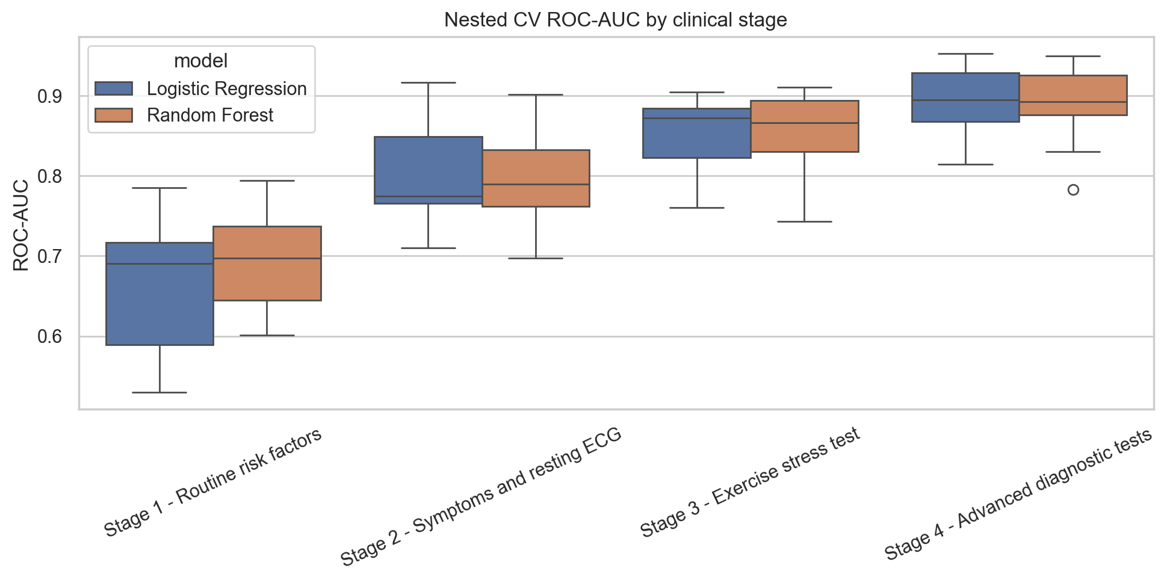
Figure 4. Nested CV ROC-AUC distribution by clinical stage and model.
The best development result is obtained with Stage 4 and Logistic Regression. Random Forest performs similarly in some stages, but it does not clearly outperform Logistic Regression. Because the dataset is small and interpretability is important, Logistic Regression is selected as the final model.
The final test evaluation by stage confirms the clinical interpretation. Stage 1 reaches a ROC-AUC of 0.823 but has low sensitivity, with 12 false negatives. Stage 2 improves to a ROC-AUC of 0.919 and reduces false negatives. Stage 3 gives a similar ROC-AUC but improves specificity. Stage 4 gives the best final performance, with ROC-AUC 0.955, accuracy 0.900, and balanced accuracy 0.893.
Stage | Threshold | ROC-AUC | Sensitivity | Specificity | Accuracy | TN/FP/FN/TP
S1 - Routine risk factors | 0.5 | 0.823 | 0.571 | 0.844 | 0.717 | 27/5/12/16
S2 - Symptoms and resting ECG | 0.5 | 0.919 | 0.750 | 0.844 | 0.800 | 27/5/7/21
S3 - Exercise stress test | 0.6 | 0.908 | 0.714 | 0.906 | 0.817 | 29/3/8/20
S4 - Advanced diagnostic tests | 0.5 | 0.955 | 0.786 | 1.000 | 0.900 | 32/0/6/22

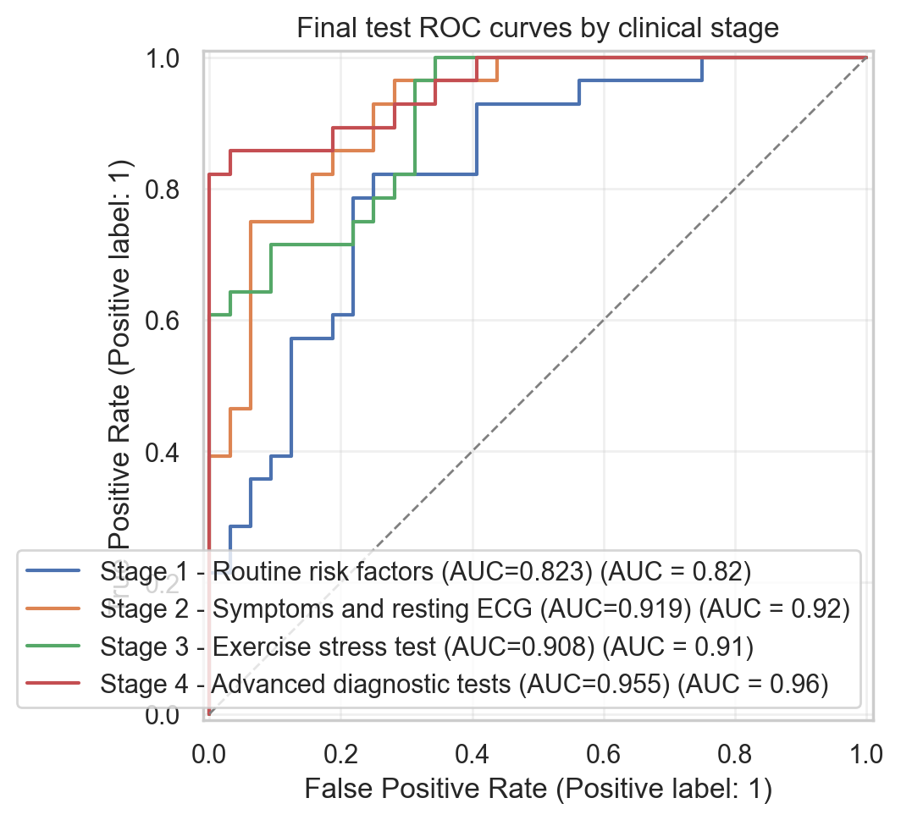
Figure 5. Final test ROC curves by clinical stage.
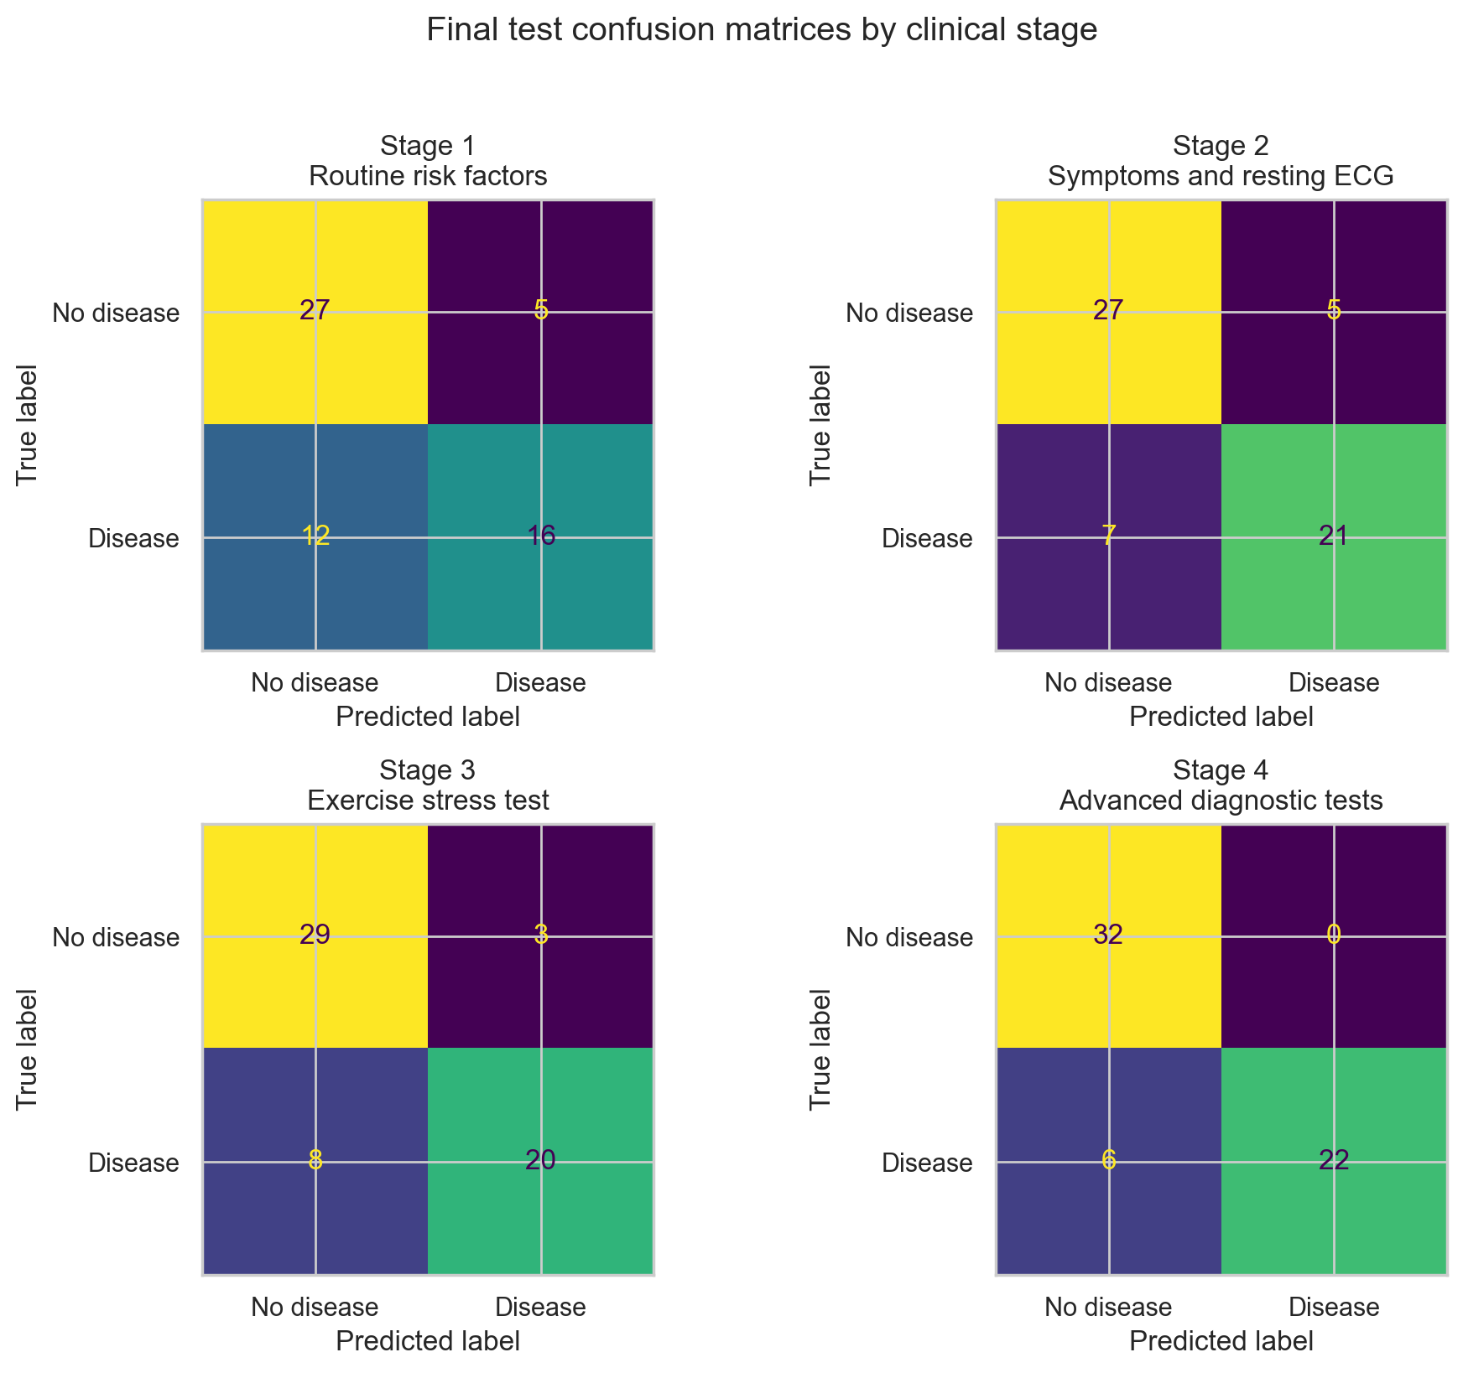
Figure 6. Final test confusion matrices by clinical stage.
The threshold analysis shows that the default value of 0.5 should not be accepted automatically. In a screening-like early stage, a lower threshold could be clinically reasonable if the objective is to reduce false negatives. In later stages, when more specific information is available, a stricter threshold may be acceptable to improve specificity and precision. In this project, thresholds are analysed as a methodological and clinical trade-off, not as a real clinical recommendation.
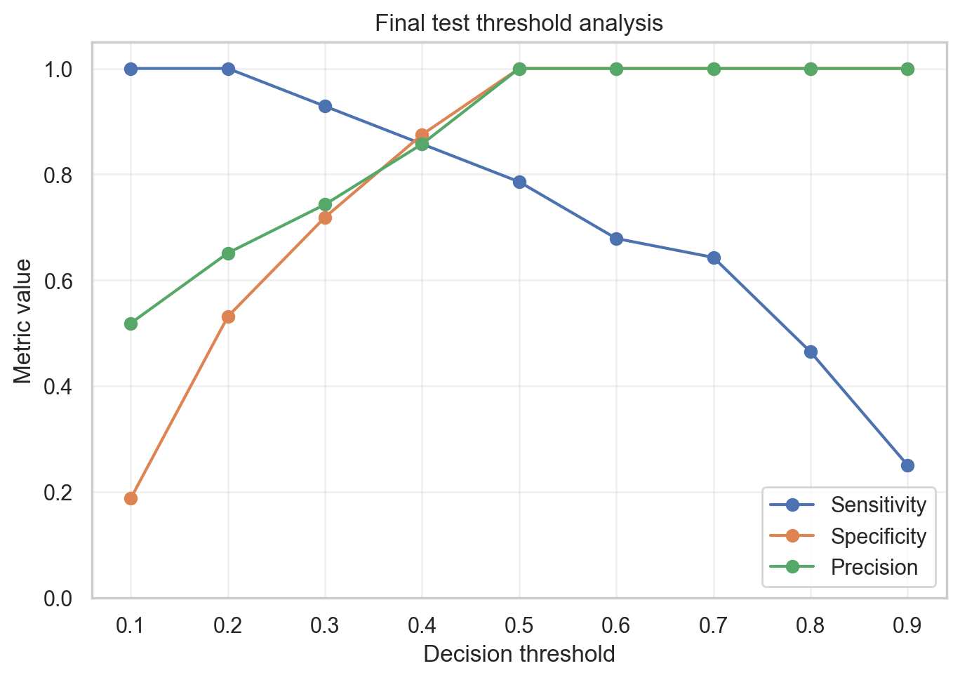
Figure 7. Final test threshold trade-off for the selected final strategy.
SHAP is used only as an interpretability tool for the final Logistic Regression model. The most influential individual feature is ca, which belongs to Stage 4. Important Stage 3 variables such as thalach, oldpeak, and exang also appear among the top features. Stage 2 contributes through chest pain categories such as cp_3 and cp_2. Stage 1 variables appear lower in the ranking.
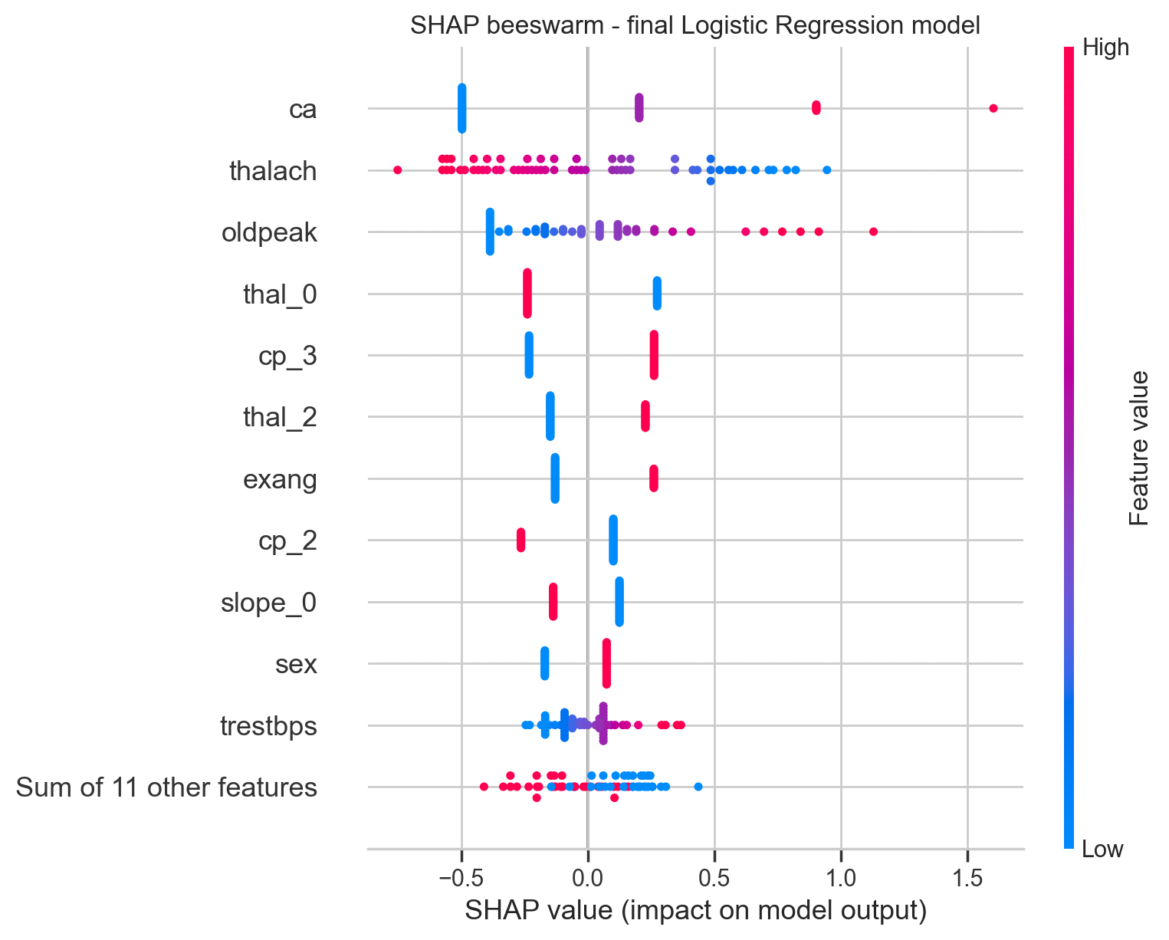
Figure 8. SHAP beeswarm plot for the final Logistic Regression model.

9. Discussion
The results support the main idea of the project: the clinical value of the dataset depends on when the variables become available. If all variables are used at once, the project becomes a standard binary classification task. By organising the variables into stages, the analysis becomes closer to a real clinical workflow.
Stage 1 is useful as a baseline, but it is not sufficient for reliable detection. It uses routine risk factors, but these variables do not directly measure the functional or anatomical state of the coronary arteries. This explains why the model misses many patients with disease in the final test evaluation.
The most interesting improvement appears from Stage 1 to Stage 2. This does not simply mean that chest pain detects all disease. In the Cleveland dataset, the chest pain variable includes an asymptomatic category, and many patients with heart disease are coded as asymptomatic. This suggests that absence of typical chest pain should not be interpreted as absence of disease. Stage 2 may therefore be useful for early triage, because it adds clinical presentation and resting ECG while still being more accessible than advanced tests.
Stage 3 does not always produce a very large improvement over Stage 2 in ROC-AUC, but it should not be considered irrelevant. SHAP shows that exercise-related variables such as thalach, oldpeak, and exang are important in the final model. This suggests that Stage 3 provides functional information that helps refine the prediction, even if the gain is not dramatic in every metric.
Stage 4 gives the best performance. This is clinically reasonable because ca and thal are advanced diagnostic variables. The ca variable is especially important because it is related to the number of major vessels coloured by fluoroscopy, which is close to anatomical coronary assessment. The thal variable is also useful, but its importance is split across one-hot encoded categories. Therefore, it should not be judged only by one transformed feature such as thal_0 or thal_2.
The main clinical interpretation is that advanced tests remain important for confident classification, but earlier information may already help prioritise patients for further assessment. The model should not decide which test a patient receives. Instead, the staged analysis can support the idea of risk stratification: early stages may identify patients who need closer follow-up or more specific testing.
There are important limitations. The dataset is small and old, and it comes from a specific clinical context. The final test set contains only 60 patients, so small changes can affect the metrics. There is no external validation on another hospital or a modern cohort. Also, the project does not perform a cost-effectiveness analysis, so it cannot claim that the workflow saves money. It can only suggest that earlier prediction may help use diagnostic resources more efficiently.

10. Conclusions and Future Work
This project shows that heart disease prediction can be studied as a staged clinical workflow instead of a single table-based classification problem. Routine risk factors alone are not enough for reliable prediction, but adding symptoms and resting ECG produces a large improvement. Exercise stress test variables add relevant functional information, and advanced diagnostic variables give the best final performance.
The most important conclusion is not only that Stage 4 performs best. The clinically useful conclusion is that Stage 2 already adds strong predictive value and could be useful as an early triage layer before more complex tests are available. Stage 4 remains important for more confident final classification, but it is also more specialised and resource-intensive.
Future work should include external validation on a larger and more recent dataset, calibration analysis, comparison with additional cardiovascular cohorts, and a more detailed threshold study based on explicit clinical costs of false negatives and false positives. A future version could also include a more formal analysis of whether each stage significantly improves ROC-AUC compared with the previous stage.

11. Ethics and Data Privacy
The dataset used in this project is publicly available and de-identified. No direct patient identifiers are used in the analysis. The project is developed for academic purposes and should not be interpreted as a clinical diagnostic device.
Even with public data, medical machine learning has ethical risks. A model trained on a small and old dataset may not generalise to other populations, hospitals, or clinical protocols. If used without external validation, it could produce misleading predictions. For this reason, the limitations are clearly reported.
The project also considers the clinical meaning of errors. False negatives may delay further assessment for patients with disease, while false positives may lead to unnecessary anxiety or testing. This is why the report includes threshold analysis, sensitivity, specificity, and confusion matrices, instead of only reporting accuracy.

12. Code and Reproducibility
The main notebook is notebooks/heart_disease_clinical_stages.ipynb. The project is organised as a small reproducible repository. The folder src/ contains code for data loading, preprocessing, model definition, validation, evaluation, and visualisation. The folder data/raw/ contains the dataset. The folder results/ contains generated figures and tables.
Reproducibility is supported by a fixed random seed, a stratified locked test split, scikit-learn Pipeline objects, GridSearchCV, nested cross-validation, and saved outputs. The notebook can be opened from GitHub in Google Colab using the Colab badge in the README and at the top of the notebook.
The separation between the notebook and Python files is intentional. The notebook explains the workflow and shows the main results, while the Python files contain reusable pipeline components. This makes the project easier to inspect, reproduce, and modify.

13. References
[1] UCI Machine Learning Repository. Heart Disease Dataset. https://archive.ics.uci.edu/dataset/45/heart+disease
[2] CDC. About Coronary Artery Disease. https://www.cdc.gov/heart-disease/about/coronary-artery-disease.html
[3] Mayo Clinic. Coronary angiogram. https://www.mayoclinic.org/tests-procedures/coronary-angiogram/about/pac-20384904
[4] Mayo Clinic. Nuclear stress test. https://www.mayoclinic.org/tests-procedures/nuclear-stress-test/about/pac-20385231
[5] Fawcett, T. An introduction to ROC analysis. Pattern Recognition Letters, 2006.
[6] AI for Medicine course slides: From models to pipelines; Data Leakage; CV and nested CV; Reproducibility in AI for Medicine; Supervised learning and model evaluation.
[7] Course-provided papers on data leakage and harmonisation, including Marzi et al. material used to support the principle of fitting preprocessing inside the machine learning pipeline.
[8] Lundberg, S. M. and Lee, S. I. A unified approach to interpreting model predictions. NeurIPS, 2017.

