A HISTORY IN PLASTER, WAX, AND BRONZE
──────── ❧ ────────
The History of the Death Mask
Faces of the Famous and the Condemned
──────── ❧ ────────
Faces of the Famous and the Condemned
❧

Contents
──────── ❧ ────────
Dedication
Prologue
Chapter 1 Why Humans Preserve the Faces of the Dead
Chapter 2 Ancient Traditions of the Death Mask
Chapter 3 From Funerary Ritual to Portraiture
Chapter 4 Death Masks of Kings, Artists, Scientists, and Revolutionaries
Chapter 5 The Condemned and the Unknown Dead
Chapter 6 Death Masks and the Birth of Forensic Identification
Chapter 7 Plaster, Wax, Bronze, and the Art of Reproducing a Face
Chapter 8 Famous Masks, Lost Identities, and Historical Mysteries
Chapter 9 Museums, Collections, Ethics, and the Afterlife of the Dead
Chapter 10 The Enduring Fascination with the Death Mask
Bonus What the Faces Leave Behind
──────── ❧ ────────
Page numbers appear centred on each leaf.

Dedication
──────── ❧ ────────
This book is dedicated to the hands that have, across centuries, reached toward a face that could no longer look back.
To the sculptors and moulders who knelt beside a deathbed with plaster and oil, working quickly against the slow betrayal of time, trying to hold a likeness before it slipped away. Their names are, in most cases, lost to us. We know them only through the objects they left behind — a jawline, a closed eyelid, the faint impression of a life just ended. This book is written in recognition of that anonymous labor, and of the strange intimacy it required: to touch, gently and deliberately, the face of a stranger or a sovereign, a poet or a prisoner, and to ask nothing of it except that it remain.
It is dedicated, too, to the conservators and archivists who have spent their careers in the quiet company of these objects — cataloguing cracked plaster, stabilizing brittle wax, correcting the record when a mask long attributed to one person is later found to belong to another, or to no one certain at all. Their work is rarely dramatic. It is patient, exacting, and often invisible, and it is the reason that so much of what follows in these pages can be written with any confidence at all. Where this book is able to distinguish evidence from legend, it is because someone, somewhere, did the unglamorous work of checking.
It is dedicated to the historians of medicine, of crime, and of the body, who have had to reckon honestly with a difficult inheritance — the ways in which the study of the dead face was, for long periods, entangled with theories of character, race, and criminality that we now recognize as false and often harmful. To write about that history without excusing it, and without looking away from it, is its own form of respect for the people whose faces were once measured, mapped, and misjudged.
And it is dedicated, above all, to the dead themselves — the famous and the unnamed alike. To the kings and the condemned. To the scientists whose features were preserved so that later generations might study genius, and to the unidentified drowned, whose faces were cast not for glory but so that someone, somewhere, might one day recognize them and give them back their name. Too often, history has treated these faces as curiosities: objects to be displayed, admired, or shuddered at, detached from the lives that produced them. This book tries, wherever the record allows, to do otherwise — to remember that behind every cast lay a family that grieved, a community that gathered, or a silence that was never filled.
Finally, this is written for the museum curators and the descendants, sometimes at odds and sometimes in quiet partnership, who continue to ask the questions that matter most in this field today: who has the right to hold a person's face after death, under what circumstances it should be displayed, and what is owed — to history, to science, and to the dead — when the answer is not simple. Their ongoing work, often unresolved and always in motion, reminds us that the history of the death mask is not a closed chapter. It is still being written, one difficult decision at a time.
To all of them — the hands, the archives, the questions, and the faces — this book is offered with gratitude and with care.

Prologue
──────── ❧ ────────
There is a particular kind of silence that settles over a room shortly after someone has died — not the silence of absence, but the silence of a presence that has just changed its terms. The body is still there. The face, for a little while longer, still looks like itself. And in that narrow window, across many centuries and in many different cultures, someone has occasionally chosen to act: to reach for plaster, or wax, or clay, and to take an impression of what will not remain.
You are about to enter the long and uneven history of that impulse.
It is not, this book must say at the outset, a single history. The idea of the "death mask" conjures, for most readers, a fairly specific image — the pale plaster cast, the closed eyes, the nineteenth-century artist's studio hung with the faces of poets and murderers alike. That image is real, and it belongs to a particular set of European traditions that flourished with unusual intensity between the Renaissance and the early twentieth century. But it is only one branch of a much older and more varied set of practices. Long before plaster casting existed as a technique, other cultures found other ways to hold on to the face of the dead — through funerary portraiture, through symbolic coverings, through sculpture made from memory rather than direct impression. These traditions are related in spirit more than in method, and this book will be careful, throughout, not to flatten that difference in the interest of a tidier story.
What unites them is a question rather than a technique: why does a society, again and again, choose to preserve the face of someone who has died?
The answers, as you will see, are not uniform. Sometimes the motive was love — a family wanting something more direct than a painted portrait, something that had actually touched the person they were mourning. Sometimes it was power — a ruler's features fixed in plaster so that authority could survive the body that had carried it. Sometimes it was curiosity dressed as science, as when nineteenth-century physicians and criminologists began collecting the faces of the condemned and the unidentified, convinced, often wrongly, that the skull and the features could reveal something about character or guilt. And sometimes it was simply the oldest form of hope there is: that a face, kept, might someday be recognized, and a name restored to someone who had died without one.
This book moves through that history chronologically in its broad shape, but it lingers, deliberately, on the human stories inside the plaster — the artists who worked against time in a dying man's bedroom, the museum collections that grew, gallery by gallery, into places where the famous and the anonymous dead came to share the same shelves, and the ongoing, unresolved conversations about what we owe to a face once its owner can no longer consent to how it is used.
It is, in the end, a book about faces — but also about memory, and grief, and the peculiar comfort human beings have long taken in an object that says: *this is what they looked like, once, and we did not let it disappear entirely.*
That is where the story begins.

Chapter 1

Why Humans Preserve the Faces of the Dead
──────── ❧ ────────
A face, once it stops changing, becomes something else entirely — no longer a person in motion, but a single, held moment that others will spend centuries trying to interpret.

The Face Before It Changes
Picture a room that could belong to almost any century between the Renaissance and the early twentieth: shuttered windows, the smell of candle smoke and damp plaster, a bed at the center where someone has just died. What follows is not a documented event — no specific letter, diary, or studio record describes this precise scene — but it is a composite drawn from the kind of encounter that recurred, in different forms, across hundreds of years of European practice. An artist, or perhaps a physician's assistant, has been sent for. They arrive quickly, because they understand what every practitioner of this craft understood: that the dead face does not hold its expression indefinitely. Within hours, sometimes less, the muscles begin to slacken in ways that change the set of the mouth, the angle of the brow, the particular quality that made the face recognizable as belonging to one person and no one else. The artist works fast, coating the skin — hair oiled or protected, features carefully isolated — with a material that will hold an impression: plaster, in most European contexts by the eighteenth and nineteenth centuries, though earlier and non-European traditions used other substances entirely, including wax, clay, or resin-soaked cloth. When the material sets, it is lifted away in sections, and from that negative impression a positive cast can eventually be made — a three-dimensional record of a face that technically no longer exists.
This is, at its simplest, what a death mask is: an impression or reproduction of a person's features taken directly from the body after death, intended to preserve something of their physical likeness. But that simple definition conceals an enormous amount of variation. Techniques differed by period, region, and available materials. The skill of the practitioner differed. The condition of the body differed, sometimes dramatically, depending on how much time had passed, how the person had died, and how the corpse had been handled beforehand. A death mask, in other words, was never one single, standardized thing — it was a family of practices unified more by intention than by method.
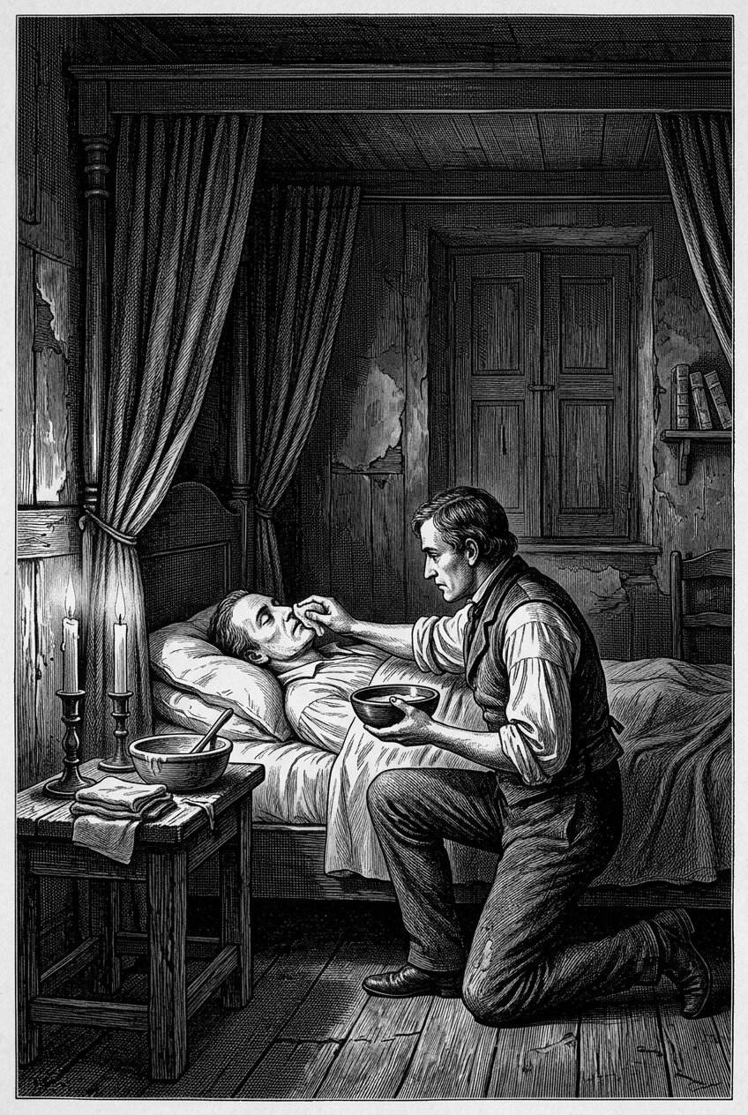
In rooms that could belong to almost any century between the Renaissance and the early twentieth, the work began while the face was still itself. Oil, linen, and wet plaster had to be applied before muscle tone failed and the features settled into a later, less personal shape. The sculptor was racing a biological clock that no piety could slow.

A Mask Is Not One Thing
It would be a mistake to treat the death mask as though it sprang into existence fully formed, or as though it represents a universal human response to mortality. It does not. Many cultures across history developed ways of representing or honoring the faces of the dead, but these traditions were not interchangeable, and this book will resist the temptation to flatten them into a single, tidy lineage. Ancient Egyptian funerary masks, most famously the golden mask associated with Tutankhamun, were not casts taken from a corpse's face at all; they were idealized, often stylized artistic representations intended for religious and symbolic purposes, meant to help the deceased in the afterlife rather than to record their actual appearance. Ancient Roman elite families, by contrast, are described in surviving literary sources as keeping wax ancestor images — the *imagines maiorum* — displayed in the household and carried in funeral processions, though the exact relationship between these images and any direct facial casting remains debated among historians, and few physical examples have survived for us to examine directly.
What later became recognizable as the "European death mask" — the plaster or wax cast taken directly from a recently deceased face, later reproduced in multiples and sometimes cast again in bronze — is a more specific tradition, one that took shape gradually and became especially prominent from the Renaissance onward, reaching a particular intensity of practice in the eighteenth and nineteenth centuries. This book focuses primarily on that tradition, while returning, in later chapters, to the older and adjacent practices that both anticipated and diverged from it. The point, for now, is simply this: when people preserved the faces of their dead, they did so for many different reasons, using many different methods, and it does us no favors to assume those reasons were always the same.
Points of orientation
– A death mask (a cast taken directly from a corpse) is not the same thing as a funerary mask (a symbolic or artistic covering, not necessarily cast from life or death).
– Not every mask displayed in a museum today as a "death mask" was actually taken directly from the deceased's face — some are later replicas, artistic reconstructions, or disputed attributions.
– The practice was never universal across cultures; it flourished with particular intensity in certain periods of European history.

The Argument for Directness
Why would anyone prefer a plaster cast to a painted portrait? The answer has to do with a very old anxiety about the reliability of images. Painted and sculpted portraits, for as long as they have existed, have also been acts of interpretation. An artist working from life — or worse, from memory, or from a sitter eager to look younger, nobler, or more serene than they actually were — inevitably shaped the final image according to convention, flattery, or personal style. Kings were painted taller. Statesmen were given firmer jaws. Even the most skilled portraitists of the Renaissance and Baroque periods were, consciously or not, participating in a kind of negotiation between likeness and legend.
A cast taken directly from a face bypassed that negotiation, or at least appeared to. There was no interpretation between the skin and the plaster; no flattering adjustment of a sagging jaw or a broken nose. For this reason, a death mask could carry an unusual kind of authority — it seemed to say, *this is not what an artist believed this person looked like, but what their actual face, unmediated, left behind.* That authority explains a great deal about why death masks became so valuable to artists themselves. Sculptors, in particular, prized death masks as working references, because a cast preserved structural details of bone and feature that were extraordinarily difficult to reconstruct accurately from memory or from earlier, less exact portraits. A death mask of a monarch or a celebrated writer could become the single most reliable physical record available to later generations of artists trying to represent that person.
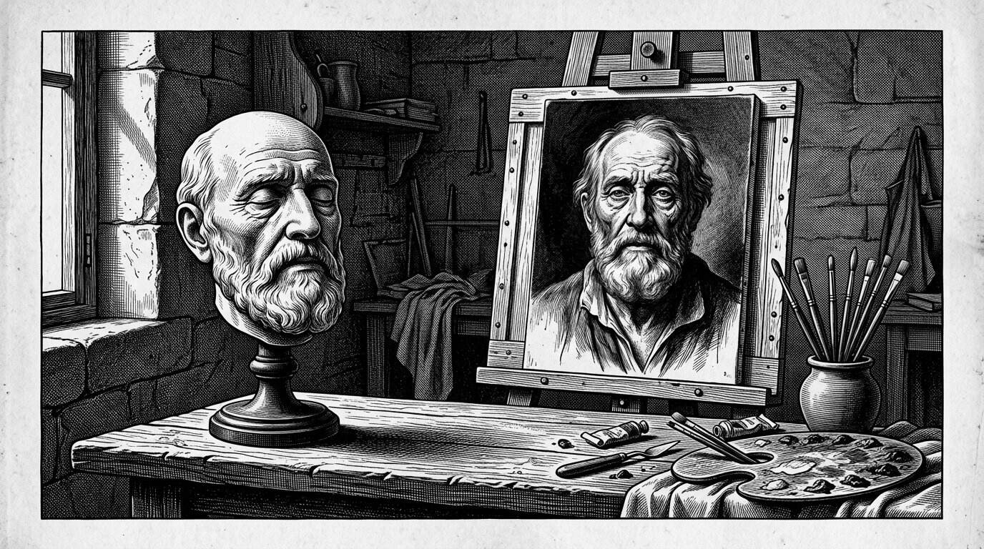
The case for the cast, as later collectors would make it, was an old anxiety about painted likeness. A portrait is always an interpretation: flattery, memory, and the sitter’s wishes intervene. A mould taken from the skin promised something harder to argue with — not a better picture, but a different kind of claim on truth.

The Limits of a Face in Plaster
And yet — this directness has real limits, and treating a death mask as a perfect, neutral photograph of a person's living face would be a serious historical error. The dead face is not the same as the living one. Muscle tone changes almost immediately after death; the skin can settle, swell, or sink depending on cause of death, illness, age, and the interval between death and casting. A face that had been gaunt from prolonged illness might appear even more hollow in plaster than it had in life. A face that had suffered trauma might require careful, sometimes invasive, preparation before casting was even possible — preparation this book will not describe in technical detail, both because such information falls outside the purpose of a cultural history and because the specifics are, frankly, beside the point of what these objects mean to us now.
Beyond the condition of the body itself, the final object was shaped by decisions made by the person doing the casting: how much oil or release agent was used, how carefully the plaster was applied, how the mold was separated from the skin, and — critically — how the resulting cast was later cleaned, repaired, or "improved" before being displayed or sold. Death masks were regularly retouched by sculptors after casting, smoothing imperfections, correcting damage from the casting process itself, or subtly adjusting features toward a more dignified or recognizable appearance. Some surviving masks have been recast multiple times from earlier molds, with each generation of casting losing a small amount of the finest surface detail. Others, held in private hands for generations before entering a museum collection, come to us with incomplete or contested documentation about exactly when, how, and from whom they were made.
None of this means death masks are historically worthless as records of appearance — quite the opposite. It means they need to be read the way any historical document is read: with attention to how they were produced, who produced them, and what interests or limitations shaped the final result. A death mask is powerful evidence. It is not incontrovertible evidence.

Recognizable, Yet Not Quite Present
There is something genuinely unsettling about standing in front of a death mask of someone whose face you already know — a face from paintings, engravings, photographs, or simply cultural memory. The features are familiar in a way that triggers instant recognition, and yet something essential is missing, and that absence is disorienting precisely because the resemblance is so exact. You are not looking at a stranger. You are not quite looking at the person either. You are looking at the specific, physical residue of the last moment their face held any expression at all, deliberately or otherwise arranged by hands that were not their own.
This tension — between the intimacy of an exact likeness and the strangeness of its stillness — is part of what has made death masks such emotionally charged objects across history, and it helps explain why museums, private collectors, and ordinary visitors have continued to be drawn to them long after their original scientific or memorial purposes faded. A painting can feel distant because we know it was composed. A death mask feels close because we know, at some level, that it was not.

A Century That Loved to Collect
If death masks had existed quietly as memorial objects for centuries before, it was the nineteenth century, especially in Europe, that turned them into something closer to a cultural institution. Several forces converged. Portraiture itself was becoming more widely accessible, no longer the exclusive privilege of royalty and the aristocracy. Museums, in the modern sense — public or semi-public institutions organized around education and the display of significant historical objects — were expanding rapidly, and many actively sought objects connected to famous individuals: composers, poets, revolutionaries, scientists, and statesmen. Scientific collecting, too, was booming, driven by an era deeply invested in observation, classification, and the belief that careful physical measurement could unlock hidden truths about human beings.
Death masks sat at the convergence of all these trends. A single mask might begin as a private memorial object commissioned by a grieving family, pass into the hands of the sculptor who made it or a colleague who acquired a duplicate cast, circulate among artists' studios as a working reference, and eventually be purchased or donated to a museum or scientific institution — sometimes decades later, and sometimes with its provenance only partially recorded along the way. Multiple plaster casts could be taken from a single original mold, meaning that death masks of especially famous figures often exist today in several versions, scattered across different collections, of varying quality and historical reliability. This circulation is part of why any serious history of death masks has to pay close attention to provenance — the documented chain of ownership and production — rather than assuming that a widely reproduced image or a confidently labeled museum object is automatically authentic.
Points of orientation
– Museums were rapidly expanding as public institutions eager to display objects connected to famous lives.
– Scientific collecting and classification were culturally prestigious, encouraging the systematic gathering of anatomical and facial material.
– Multiple casts from a single mold meant death masks could circulate widely — and inconsistently — across studios, collections, and markets.
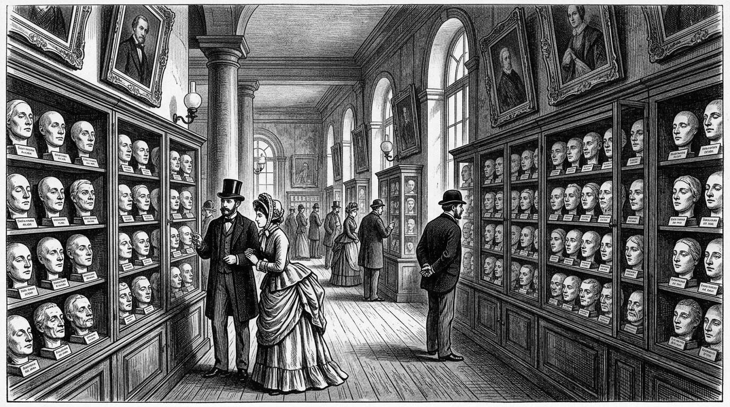
The nineteenth century turned private memorial objects into a public institution. Museums, print culture, and a widening market for portraiture made it ordinary to stand before a stranger’s plaster features and feel that history had been made graspable. Collecting faces became a way of collecting the century itself.

The Shadow of Physiognomy
This same century also entangled the death mask with a body of theory that later history has judged, correctly, to be scientifically unfounded and often actively harmful. Physiognomy — the belief that character and moral tendency could be read from facial features — and its close cousin phrenology, which claimed similar insights could be drawn from the shape of the skull, both enjoyed significant credibility among educated Europeans during this period. Death masks, along with casts of skulls, became objects of interest to those pursuing these theories, on the assumption that the fixed, unchanging features of the dead offered ideal material for measurement and comparison.
This interest extended, with particularly troubling consequences, into the emerging field of criminology. Some nineteenth-century theorists, most notoriously the Italian criminologist Cesare Lombroso, argued that criminal tendency could be identified through specific physical features, an idea now thoroughly discredited but influential enough in its time to shape both scientific practice and popular attitudes toward crime and, disturbingly, toward entire groups of people marked by prejudice. Death masks of executed criminals were collected partly in service of this theory, treated as specimens in a supposed science of the criminal face.
It is important to be direct about this history rather than softening it. The men and women who pursued physiognomy and criminal anthropology were not conducting science in any sense we would recognize today; they were often constructing elaborate justifications for prejudices that already existed. And yet the objects this flawed science produced — the masks, the measurements, the meticulous catalogues — did not simply disappear when the theories behind them were discredited. Many of those masks survive in museum and university collections today, and their historical value now lies not in what they supposedly proved about character or criminality, but in what they document about how a society once thought, what it feared, and whom it was willing to dehumanize in the name of science. A death mask's importance to history, in other words, is not fixed at the moment of its creation. It can shift, sometimes completely, as our understanding of the past changes around it.

The Grammar of Fame and Anonymity
Not every death mask belonged to someone whose name we know. Alongside the masks of kings, composers, and revolutionaries sits a second, quieter category: masks taken from the unidentified dead, often as a practical tool rather than a memorial gesture. In several major European cities during the nineteenth century, morgues displayed the bodies, and sometimes plaster casts, of unidentified deceased individuals, in the hope that a member of the public might recognize and name them. This practice sat at the uneasy intersection of civic duty, public spectacle, and, later, forensic necessity — and it produced some of the most emotionally resonant objects in this entire history.
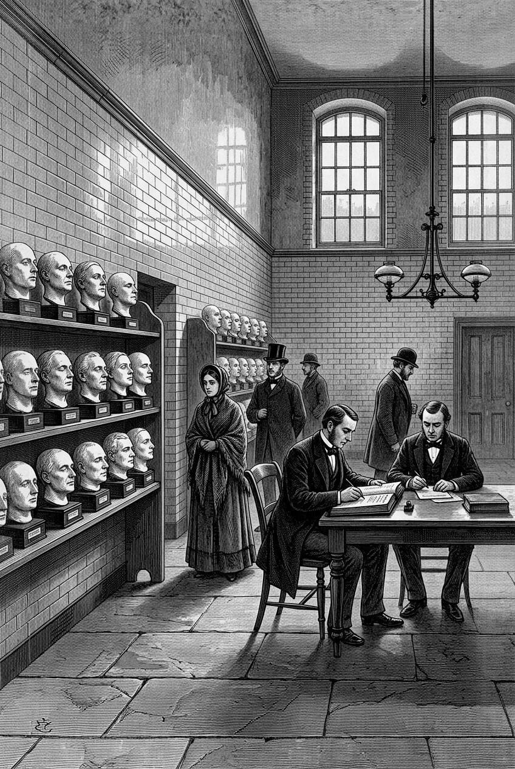
Beside the named masks of kings and composers sat a quieter category: casts taken from the unidentified dead. In several European cities the morgue was not only a place of custody but a civic instrument, where a likeness might be the last chance that someone, walking past, would recognise a missing person.

A Face Without a Name
Among these, one case has achieved a genuinely unusual cultural afterlife: the so-called Unknown Woman of the Seine, or *L'Inconnue de la Seine*. According to a long-circulating story, the mask was cast, in Paris sometime in the late nineteenth century, from the face of a young woman recovered from the river, whose serene, faintly smiling expression struck a mortuary worker or mask-maker as strikingly beautiful, and who was never identified. Multiple casts of her face were reportedly made and sold, and the image went on to captivate a remarkable range of writers and artists across the following decades, drawn to the mystery of her unknown identity and the unusual calm of her expression.
This is where the historian's obligation to caution becomes especially important, because very little of that story can actually be verified. There is no confirmed documentation establishing her real identity, the specific circumstances of her death, or even conclusive proof that the mask was taken from a corpse at drowned from the river at all, rather than, as some researchers have suggested, from a living model. What can be said with more confidence is that a mask matching this description circulated widely from the late nineteenth century onward, that it inspired a substantial body of literary and artistic responses, and that — in one of the stranger turns in this entire history — her face was later chosen, in the mid-twentieth century, as the model for a training mannequin used to teach cardiopulmonary resuscitation, meaning that this unidentified woman's features, whoever she truly was, have quite plausibly been seen and touched by more people than almost any other face in modern history. Later chapters will return to her story in more depth, along with the scholarly debate over how much of it is documented fact and how much is accumulated legend.

Why This Book Begins Here
What connects a Roman wax ancestor image, a Renaissance monarch's plaster cast, a nineteenth-century criminologist's specimen collection, and an anonymous woman's face pulled from the Seine is not a single technique or a single motive. It is a recurring human decision, made across very different centuries and for very different reasons, to resist the ordinary erasure that death brings to a face. Sometimes that decision was an act of love. Sometimes it was an act of power, an assertion that a person's authority or genius deserved a physical record that would outlast their body. Sometimes it was an act of flawed science, reaching for answers about human character in the wrong place entirely. And sometimes, as with the unidentified dead, it was simply an act of hope — that someone, someday, might look at a preserved face and say, *I know who this is.*
This book is organized around that recurring decision and its many forms. The chapters ahead will move from the older, adjacent funerary traditions that preceded the European death mask, through the golden age of nineteenth-century mask-making and collecting, into the darker territory of physiognomy and criminal identification, and finally into the modern museum, where curators, conservators, and descendants continue to negotiate what respect for the dead actually requires. Along the way, this book will introduce specific masks belonging to specific historical figures, examine what can and cannot be verified about them, and explore how these objects have been used, misused, displayed, hidden, and reinterpreted across the centuries since they were made.
For now, it is enough to sit with the central question that will run beneath everything that follows: why have human beings, again and again, tried to hold on to a face that its owner could no longer claim — and what does the answer tell us about memory, identity, art, science, and our long, unresolved relationship with mortality itself?
That is the story this book sets out to tell.

Chapter 2

Ancient Traditions of the Death Mask
──────── ❧ ────────
Long before anyone pressed plaster to a dying face in a European studio, other societies were already asking what a covered face could do for the dead — and their answers looked nothing alike.

A Face for the Afterlife
Imagine a workshop attached to a temple complex on the west bank of the Nile, sometime in the second millennium BCE — a reconstructed scene, not a documented one, but representative of a craft that operated for centuries across ancient Egypt. Artisans work in a space thick with the smell of resin and hot metal, hammering thin sheets of gold over a wooden or plaster core, inlaying the eyes with obsidian and quartz, the brows and cosmetic lines with lapis lazuli or blue glass. What they are making is not intended to look like the deceased as they appeared in life. It is intended to look like something better: an idealized, eternally youthful face, modeled on established artistic conventions for how a transfigured, divine version of the person should appear in the afterlife. This is the crucial point at which the story of ancient Egyptian funerary masks diverges sharply from the tradition this book will spend most of its pages examining. These were not casts of an individual's actual features. They were carefully constructed religious objects, meant to help secure the deceased's identity and protection in the next world, regardless of what that person's living face had actually looked like.
The most famous surviving example, the solid gold mask found covering the mummified head of the young pharaoh Tutankhamun when his tomb was opened in 1922, illustrates this idealization clearly. Inlaid with semiprecious stones and colored glass, the mask presents a serene, symmetrical, almost ageless face, styled according to royal artistic convention rather than individual likeness. Egyptologists generally agree that such masks were not attempts at naturalistic portraiture in the sense we might expect from a modern photograph or a European death mask. Their purpose was cosmological and protective: to ensure that the deceased's spirit — in Egyptian belief, closely tied to concepts such as the *ka* and the *ba* — could recognize and reoccupy the body, and to present the dead in a divine, eternal form associated with the god Osiris, ruler of the underworld.
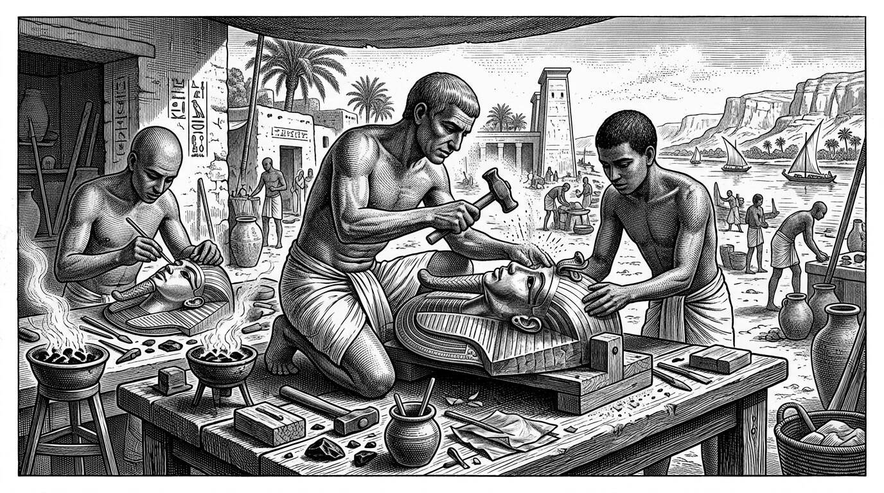
On the west bank of the Nile, for centuries, artisans shaped gold and inlay for the faces of the dead. Those coverings were not plaster portraits in the later European sense. They were equipment for a journey, bound to theology, status, and workshop craft that this book refuses to flatten into a single lineage.

Gold, Wax, and the Language of Status
Egypt was far from alone in developing elaborate facial coverings for its dead, though the specific materials, beliefs, and purposes varied enormously from one culture to another — a variation this book must keep returning to, because it is easy, and historically careless, to lump all of these practices together simply because they share the broad category of "covering the face of the dead." Status was almost always part of the equation. Elaborate funerary masks were expensive, time-consuming to produce, and typically reserved for royalty, priests, or the wealthy elite; ordinary people across most ancient societies were buried with far simpler coverings, if any at all, a pattern that itself tells historians a great deal about how these objects functioned as declarations of rank as much as expressions of grief or belief.
In parts of what is now China, burial practices during the Han dynasty and in some earlier periods involved elaborate jade objects associated with the body, including face coverings and, in the most extravagant royal and noble burials, full jade suits stitched together with metal thread, reflecting a belief that jade possessed protective and preservative properties for the body and spirit after death. On the other side of the world, in the Maya city of Palenque, the seventh-century ruler K'inich Janaab' Pakal was buried with an extraordinary mosaic mask assembled from hundreds of individually shaped pieces of jade, shell, and obsidian, discovered by archaeologists in 1952 within the elaborate tomb beneath the Temple of the Inscriptions. Like the Egyptian gold mask, Pakal's jade mosaic face was not a cast of his actual features; it was a constructed, symbolic image, associated with jade's significance in Maya cosmology as a material linked to life, breath, and royal power.
Points of orientation
– Most ancient funerary masks — Egyptian, Maya, and others — were sculpted or assembled artistic objects, not molds taken directly from the deceased's face.
– Their goal was typically symbolic, religious, or status-related: presenting an idealized or protected version of the dead, not a naturalistic record of appearance.
– This distinguishes them from the later European tradition of the direct facial cast, even though both fall under the broad modern umbrella term "death mask."

The Golden Face of Mycenae
A different, and in some ways more contested, example comes from Bronze Age Greece. In 1876, the archaeologist Heinrich Schliemann, excavating royal shaft graves at Mycenae, uncovered several gold masks that had been placed over the faces of high-status burials, dating to roughly the sixteenth century BCE. Schliemann, convinced he had located the burial site described in Homeric legend, famously — and almost certainly incorrectly, since the graves predate the traditional dating of the Trojan War by several centuries — associated one particularly striking mask with the legendary king Agamemnon, a name that has stuck to the object in popular culture ever since despite having no verified historical connection to him.
The so-called Mask of Agamemnon has also attracted more specific controversy. While most archaeologists today accept it as a genuine Bronze Age artifact, some scholars have raised pointed questions over the decades about the extent to which the mask may have been altered, embellished, or even partially fabricated during or after its excavation, given Schliemann's well-documented history of dramatic self-promotion and occasionally questionable handling of his finds. This book will not attempt to resolve that debate, which remains a matter of ongoing scholarly discussion rather than settled fact; it is raised here specifically because it illustrates a theme that will recur throughout this book — that even objects displayed confidently in major museums can carry real, unresolved uncertainty about their authenticity and history, and that responsible historical writing has an obligation to say so rather than presenting institutional confidence as proof.
What can be said with more confidence is that Mycenaean gold masks, like their Egyptian counterparts, appear to have been symbolic and status-marking objects rather than direct facial impressions. They were thin, hammered sheets of gold, shaped to a generalized human face, placed over the deceased as part of elaborate royal burial customs, and there is no persuasive evidence that they were produced by pressing a mold against actual human skin.
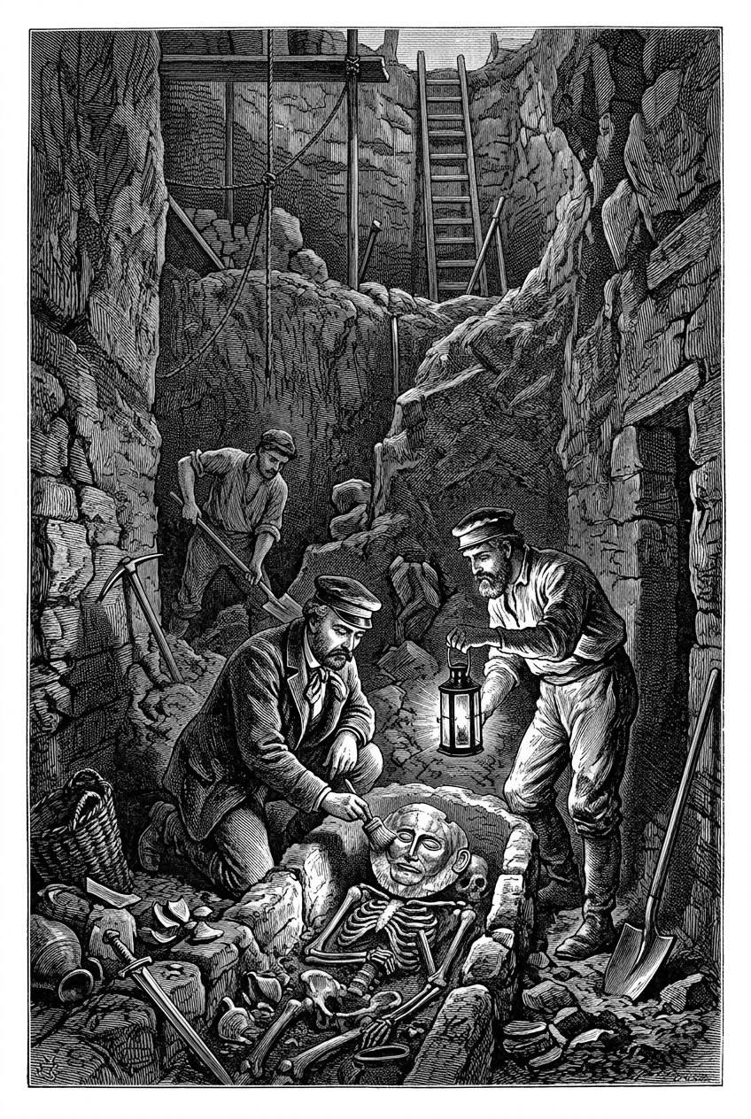
In 1876 Heinrich Schliemann, excavating shaft graves at Mycenae, uncovered beaten-gold face coverings from the sixteenth century BCE. He announced a Homeric king; later archaeology has been far more cautious. The objects remain extraordinary, and the story of their naming remains a warning about desire dressed as discovery.

Ancestors Kept in Wax: The Roman Practice
Roman tradition offers a case that sits closer, at least in spirit, to what later became the European death mask, though even here the historical picture is more complicated than popular accounts sometimes suggest. Ancient sources, including the Greek historian Polybius writing in the second century BCE, describe a distinctive practice among elite Roman families: the keeping of wax portrait images, known as *imagines maiorum*, representing notable ancestors. According to these accounts, the images were displayed in the household, typically in a prominent cabinet within the atrium, and were carried — worn as masks by actors selected to resemble the deceased ancestors — in the funeral processions of family members, a practice intended to visually assert the lineage, achievements, and continued political relevance of the family across generations.
Whether these wax images were originally produced by taking a direct impression from the face of the deceased, in the manner of a later death mask, or were instead sculpted from observation and convention in the way Egyptian and Mycenaean masks were, remains genuinely debated among classical historians, in large part because no confirmed physical examples of these Roman wax ancestor images have survived; our knowledge comes entirely from written descriptions rather than surviving objects. Some historians argue that the practice may represent an early, precedent for direct facial casting; others caution that the ancient sources are not explicit enough about technique to support that conclusion with confidence. What is clear, regardless of the exact method, is that the underlying motivation — using a preserved image of a dead face to assert status, lineage, and continued political legitimacy — anticipates a theme that will recur throughout later European history, particularly among royal families and political figures whose death masks served similarly commemorative and legitimizing purposes.
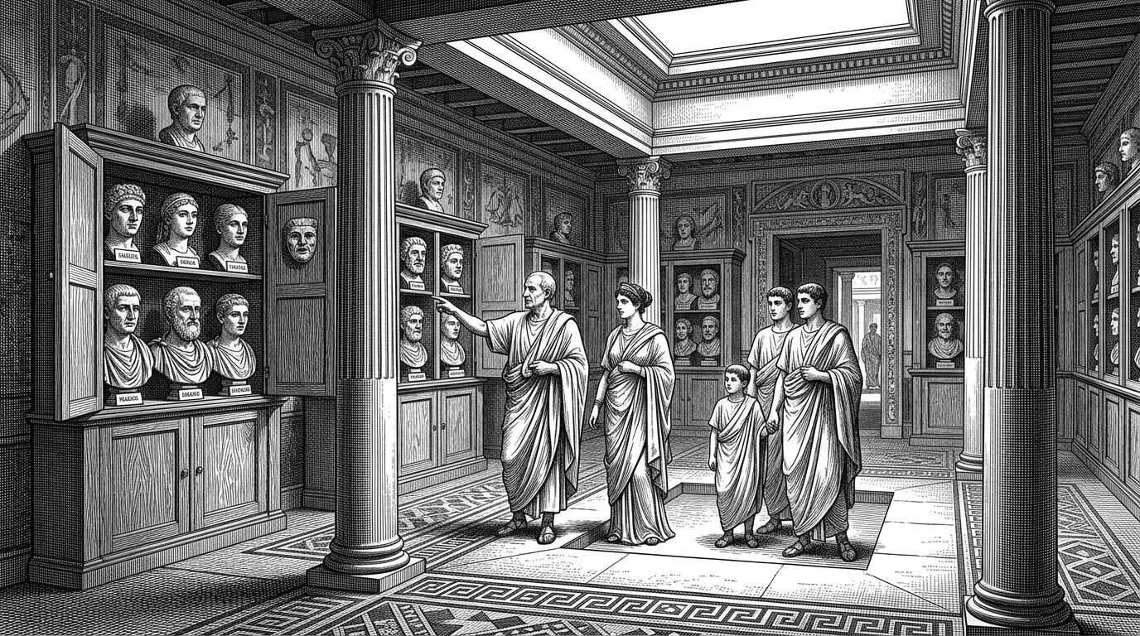
Polybius, writing in the second century BCE, described elite Roman families who kept wax ancestral images and brought them out in funeral processions. The imagines maiorum were about lineage made visible — a politics of descent — rather than a naturalistic cast of a newly dead face, however close they sit, in spirit, to later European practice.

Different Cultures, Different Solutions
It is worth pausing here to resist a natural but misleading impulse: the temptation to read these varied ancient practices as early, imperfect versions of a single idea that would eventually mature into the "real" death mask of later European history. That framing imposes a false continuity onto societies that, in most cases, had no contact with one another and no shared technical or religious tradition connecting their treatment of the dead face. Egyptian funerary masks emerged from a specific and elaborate theology concerning the afterlife and the preservation of the physical body. Maya jade mosaics reflected an entirely different cosmology, centered on jade's association with breath, life force, and royal divinity. Han-era Chinese burial jade reflected still other beliefs about the preservative and protective qualities of particular materials. Roman wax ancestor images served an essentially political and familial function tied to the specific structures of Roman elite society. None of these traditions were reaching toward the same goal as a nineteenth-century sculptor casting the face of a dying poet; they were solving entirely different problems, using entirely different logics, for entirely different societies.

What These Objects Were Not
This distinction matters practically as well as conceptually, because it shapes how these ancient objects should be understood and discussed today. They were not attempts at what modern viewers would recognize as realistic portraiture. They were not, in most documented cases, produced by any technique resembling a direct facial cast. And they should not be treated, in a history of death masks, as simply earlier, cruder examples of the same practice examined elsewhere in this book. They belong in this story because they share a broad, recurring human impulse — the desire to give the dead face continued presence, meaning, or protection — but the specific mechanics, beliefs, and purposes behind that impulse varied so widely across these ancient cultures that treating them as a single unbroken tradition would misrepresent the historical record.
Points of orientation
– Major objects in this chapter — the Mask of Agamemnon, the Roman wax *imagines* — come with real, unresolved historical uncertainty about their authenticity, technique, or surviving evidence.
– Good historical practice means naming that uncertainty clearly, rather than presenting museum labels or popular retellings as settled fact.
– This caution will apply throughout the rest of this book, especially when later chapters turn to disputed or poorly documented European death masks.

The Ethics of Ancient Faces in Modern Museums
There is also a more contemporary issue worth raising before moving forward, one that will return with greater urgency in later chapters devoted specifically to museums and collecting. Many of the ancient objects discussed here — gold masks, jade mosaics, and the burial goods surrounding them — were removed from tombs and burial contexts by archaeologists and collectors operating under very different ethical and legal standards than those that govern archaeological and museum practice today. Tutankhamun's mask, along with the rest of his tomb's contents, was excavated under early twentieth-century colonial-era conditions in Egypt that would not meet modern standards for international collaboration, consent, and repatriation. Questions about the appropriate ownership, display, and treatment of ancient funerary objects — including the human remains sometimes found alongside them — remain active and often contentious subjects in museum ethics today, and this book will return to them directly when it turns, in a later chapter, to the modern history of collecting and displaying the material culture of death. For now, it is enough to note that even these ancient objects, sitting behind glass in major museums around the world, carry histories of removal and display that are not ethically neutral, however dazzling the gold or however skillfully cut the jade.
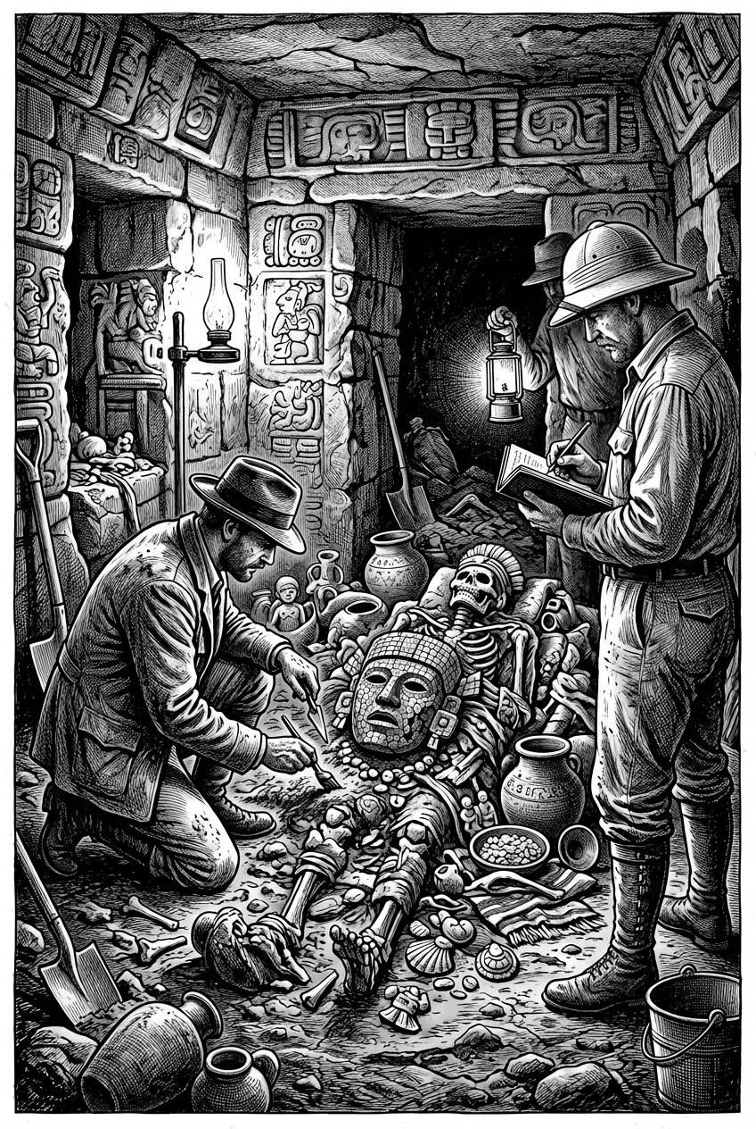
Gold, jade, and mosaic burial faces entered modern museums through excavations and collecting regimes that would not now be authorised in the same way. The ethical problem is not an afterthought to this history: many of the ancient faces discussed here were removed from tombs under assumptions about ownership that later generations have had to reopen.

Toward the Portrait: What Comes Next
None of the traditions examined in this chapter is, in a strict technical sense, the direct ancestor of the European death mask this book will spend most of its remaining chapters exploring. That practice — pressing plaster or wax directly against a recently deceased face to capture an individual, naturalistic likeness — emerged from a different set of historical conditions: the Renaissance revival of naturalistic portraiture, a growing cultural investment in individual identity and achievement, and, eventually, the expanding scientific and museum culture of the eighteenth and nineteenth centuries already introduced in the previous chapter. What the ancient world offers instead is something arguably more valuable than a tidy point of origin: proof that the desire to hold onto the face of the dead is not a single historical thread but a recurring pattern, arising independently across radically different societies, each answering the same basic human unease — the disappearance of a familiar face — in its own particular way.
The next chapter turns to that pivotal shift: the gradual movement from ritual and symbolic funerary representation toward the individualized, naturalistic portrait, and the specific historical conditions in Renaissance and early modern Europe that made a direct cast of the dying or recently dead face newly desirable, newly possible, and newly meaningful.

Chapter 3

From Funerary Ritual to Portraiture
──────── ❧ ────────
Somewhere between the symbolic gold of Mycenae and the plaster casts that would fill nineteenth-century artists' studios, Europe decided that an individual face, exactly as it had been, was worth keeping for its own sake.

A Sculptor's Workshop, Reimagined
Picture a workshop in Florence, or Bruges, or Nuremberg, sometime in the fifteenth or sixteenth century — again, a composite scene rather than a documented one, but representative of a kind of encounter that became increasingly common in this period. A notable citizen has died: a merchant of standing, a scholar, perhaps a minor court official. A sculptor is summoned, not primarily for religious or dynastic reasons, but because the family, or the man's own students and admirers, want something specific and comparatively new in the history explored so far in this book — an accurate, individual, physical record of exactly what he looked like, to be used in completing a memorial bust, a tomb monument, or simply kept as a private object of remembrance. The sculptor applies oiled cloths, then plaster, working with techniques that had been part of the sculptural trade for generations, used previously mostly for anatomical study or for taking casts of hands and other body parts as working references. What is new is not the technique. What is new is the reason it is being used, and what that reason reveals about how European culture had begun to think about the value of an individual human likeness.
This chapter is about that shift: the gradual movement, across the medieval and early modern periods, from the symbolic, often religiously coded funerary representations examined in the previous chapter, toward something closer to what modern readers recognize as portraiture — an attempt to preserve not an idealized type, but a specific, individual face, understood to be worth remembering precisely because it belonged to one particular person and no one else.
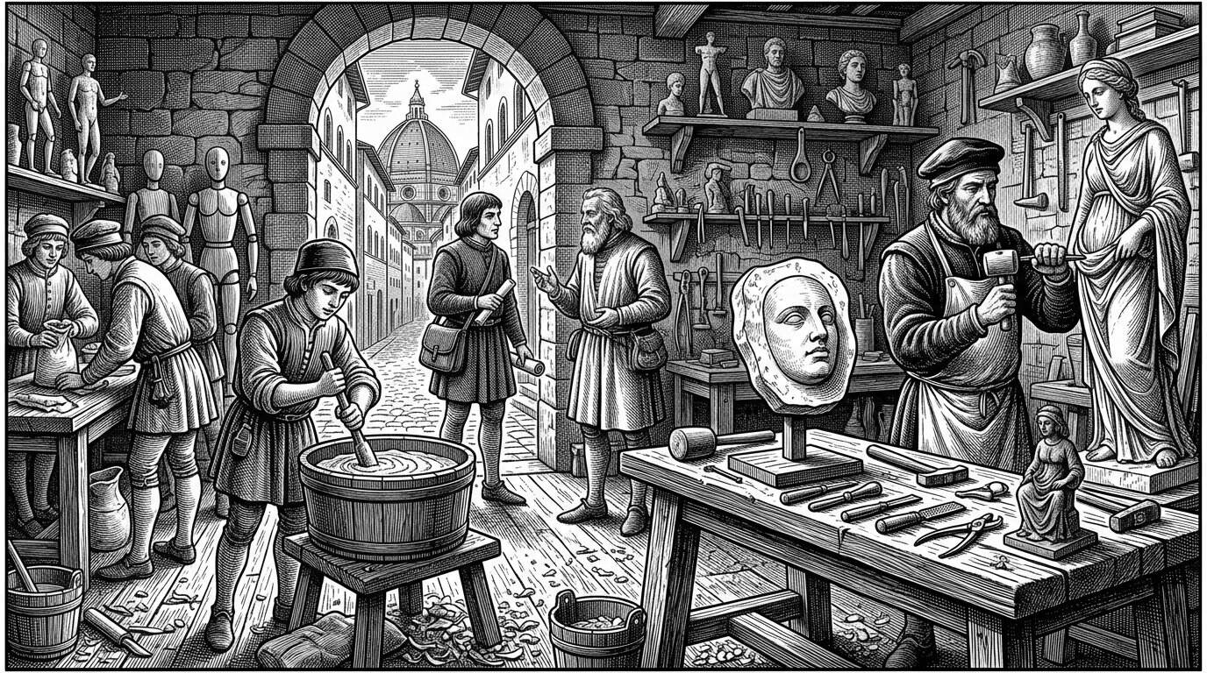
In Florence, Bruges, or Nuremberg a sculptor might be summoned after a merchant, a scholar, or a minor official died — not first for liturgy, but for likeness. The workshop scene is a composite, yet it marks a real shift: the individual biography had become something a household was willing to pay to keep.

The Individual Becomes Worth Remembering
The cultural change underlying this shift did not happen quickly, and it did not happen for purely artistic reasons. Historians of the Renaissance generally connect it to a broader intellectual movement often labeled humanism, which placed increasing emphasis on individual human achievement, character, and biography, in addition to religious devotion and dynastic status. Where earlier medieval commemorative art had frequently subordinated individual likeness to symbolic or devotional convention — a donor portrait rendered small and generic beside a much larger, idealized sacred figure, for instance — Renaissance patrons increasingly wanted to be remembered as themselves: specific, recognizable, physically particular people, with their own faces, their own histories, their own claims to significance.
This shift mattered enormously for the future of the death mask, because it created cultural demand for exactly the kind of unmediated, individual record that a direct facial cast could provide. A death mask, as the previous chapter discussed, carried a particular kind of authority precisely because it bypassed artistic interpretation. In a cultural moment increasingly invested in individual identity and achievement, that authority became newly valuable — not primarily for religious or cosmological reasons, as in ancient Egypt, and not primarily for asserting family lineage, as in the Roman practice of the *imagines maiorum*, but for a more direct and increasingly secular purpose: preserving, as exactly as possible, what a particular, historically significant person had actually looked like.
Points of orientation
– Renaissance and early modern sculptors used facial casting for more than death masks — casts taken from a living sitter, known as life masks or *vita* masks, served as working references for portrait busts completed while the subject was still alive.
– Distinguishing a documented life mask from a documented death mask matters historically, and museum records do not always make the distinction clear or reliable.
– Both practices relied on essentially the same casting technique, which is one reason the two are sometimes confused in later collections and popular accounts.

Cast From Life, Cast From Death
It is worth pausing on a distinction that becomes genuinely important from this period onward, and that this book will return to repeatedly: the difference between a mask cast from a living sitter and one cast from a body after death. Both practices existed side by side in early modern European sculptural workshops, and both used essentially the same technical process. A life mask, or *vita* mask, allowed a sculptor working on a portrait bust or effigy to capture precise facial proportions directly from a living subject, without requiring the sitter to remain motionless for the many hours a traditional sculpted or painted portrait session might demand. A death mask served a related but distinct purpose: capturing the features of someone who could no longer sit for a portrait at all, whether because death had come suddenly, before a planned portrait could be completed, or because the family or community wanted a final, direct record specifically because the person had died.
The distinction matters historically because the two types of object can be difficult to tell apart by examining a cast alone, and because museum and collection records from this period are not always reliable or complete on the point. A mask labeled for centuries as a "death mask" of a particular historical figure may, on closer scholarly examination, turn out to have been cast from life, or to be a later copy made from an original life or death cast whose current whereabouts are unknown. This book will flag this uncertainty specifically wherever it applies to individual masks discussed in later chapters, rather than assuming that a traditional or popular label is necessarily accurate.
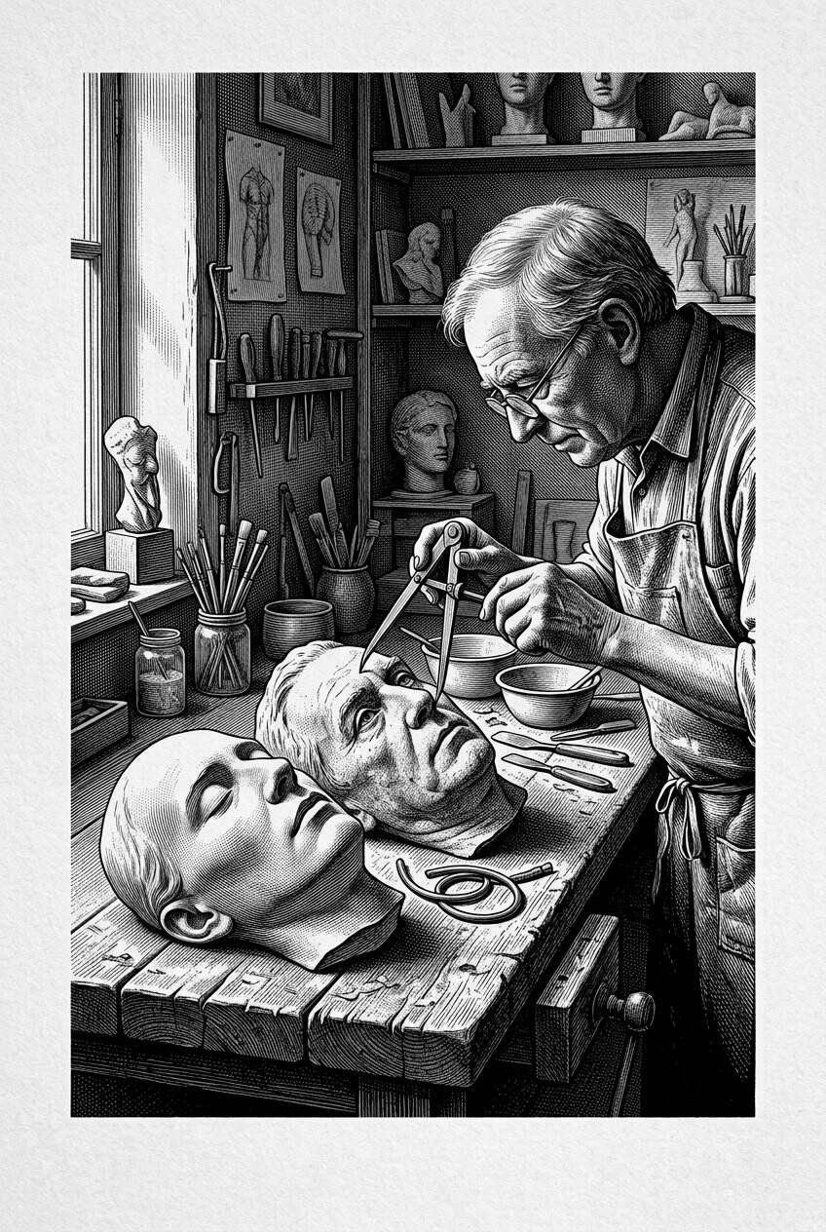
Life masks and death masks used essentially the same technical process in early modern studios, and both circulated as sculptors’ tools. The distinction still matters. One records a person who could still object, breathe, and arrange their expression; the other records a face that can no longer negotiate how it will be seen.

The Tomb Effigy and the Cast Face
One of the clearest points of contact between the older funerary tradition and the newer portrait tradition can be found in the European custom of the recumbent tomb effigy — a sculpted figure of the deceased, typically shown lying in repose, placed atop or near their tomb. This practice, which developed across the medieval period and continued into the Renaissance and beyond, existed on a spectrum. Some effigies were generalized, idealized representations, following established conventions for how a noble or pious figure ought to appear, much like the ancient Egyptian and Mycenaean masks discussed in the previous chapter. Others, particularly from the fourteenth century onward, increasingly aimed at individual likeness, and in a meaningful number of documented cases, sculptors are known or strongly believed to have used a death mask taken shortly after the person's death as a direct reference for the effigy's face, in order to achieve a more accurate, individualized result than convention alone could provide.
A particularly well-documented example of this crossover between death masks and funerary commemoration comes from the English royal tradition of funeral effigies: lifelike wood or wax figures, dressed in the deceased monarch's actual robes and regalia, displayed atop the coffin during state funeral processions and later preserved, in a number of surviving cases, within Westminster Abbey. Several of these effigies are documented or reasonably believed by historians of the collection to have been modeled with reference to death masks taken from the monarch soon after death, although the surviving evidence for precisely which effigies relied on this method, and how directly, is incomplete and remains a subject of ongoing research among specialists who study the collection. What can be said with confidence is that the underlying logic driving the practice mirrors exactly the shift this chapter is tracing: an increasing cultural investment in an individually accurate, physically specific likeness of a significant person, achieved in part through the same direct-casting technique already established for portrait sculpture.
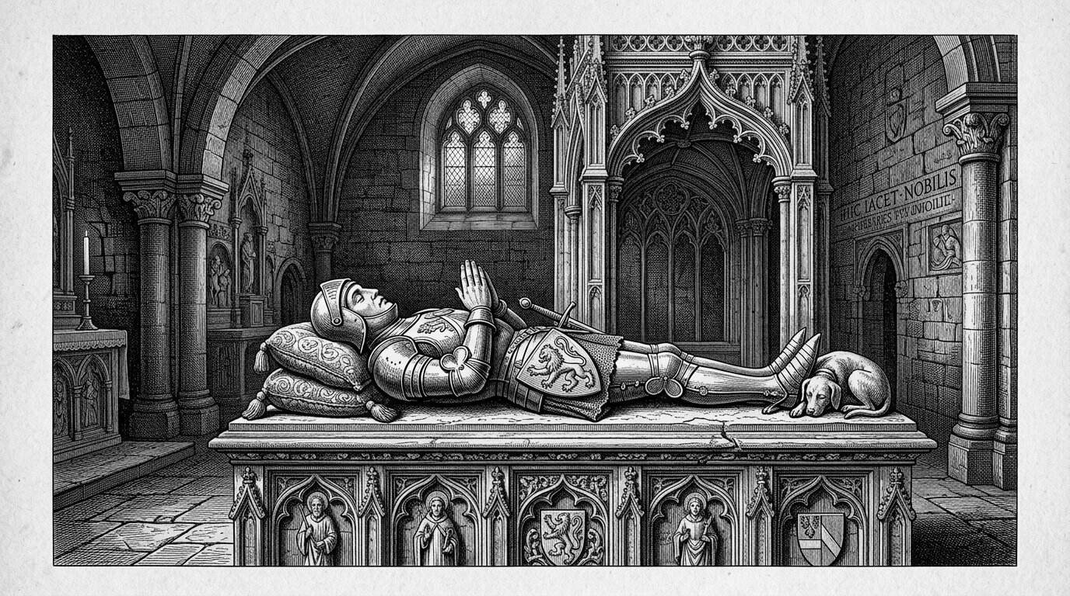
The recumbent tomb effigy — the sculpted body lying in repose above a grave — is one of the clearest bridges between medieval funerary symbolism and the later cult of exact features. Some effigies were ideal types; others leaned toward portraiture. The death mask offered a new way to feed that hunger for the particular.

A Face That May Not Be Genuine: The Case of Dante
This period also offers an instructive early example of a problem that will recur throughout this book: the gap between a famous, widely reproduced "death mask" and the actual, verifiable historical evidence supporting it. Among the most reproduced death masks in Western art history is one long associated with the Florentine poet Dante Alighieri, who died in 1321. Copies and casts claiming to represent Dante's death mask have circulated for centuries, and the image is instantly recognizable to many people who could not otherwise identify a single other death mask by name.
The historical case for its authenticity, however, is extremely weak. There is no reliable contemporary documentation from the fourteenth century describing the taking of a death mask from Dante's face, and the casting technique required to produce the object we know today may not have been in common use, in the form required, at the time of his death. Most specialists who have studied the object's history now believe the mask associated with Dante is very likely a later invention — quite possibly created during the Renaissance or even as late as the nineteenth century, when interest in Dante as a national literary hero was especially intense in Italy — rather than a genuine fourteenth-century artifact taken directly from the poet's face. This does not mean the object is without historical interest; it simply means that its interest lies elsewhere, in what it reveals about later centuries' desire to claim a direct, physical connection to a revered cultural figure, rather than in any claim to represent Dante's actual features. This book will return to this pattern — the manufactured or retrospectively attributed "death mask" of a beloved figure — again in later chapters, because it turns out to be far more common than popular accounts of famous masks generally acknowledge.
Points of orientation
– Some of the most widely reproduced "death masks" in Western culture, including the mask long associated with Dante Alighieri, lack solid documented evidence connecting them to the moment of the subject's actual death.
– Objects like these may still hold genuine historical and cultural significance — but as evidence of later reverence, invention, or myth-making, rather than as reliable records of appearance.
– This distinction between documented masks and disputed or later attributions will recur throughout this book.
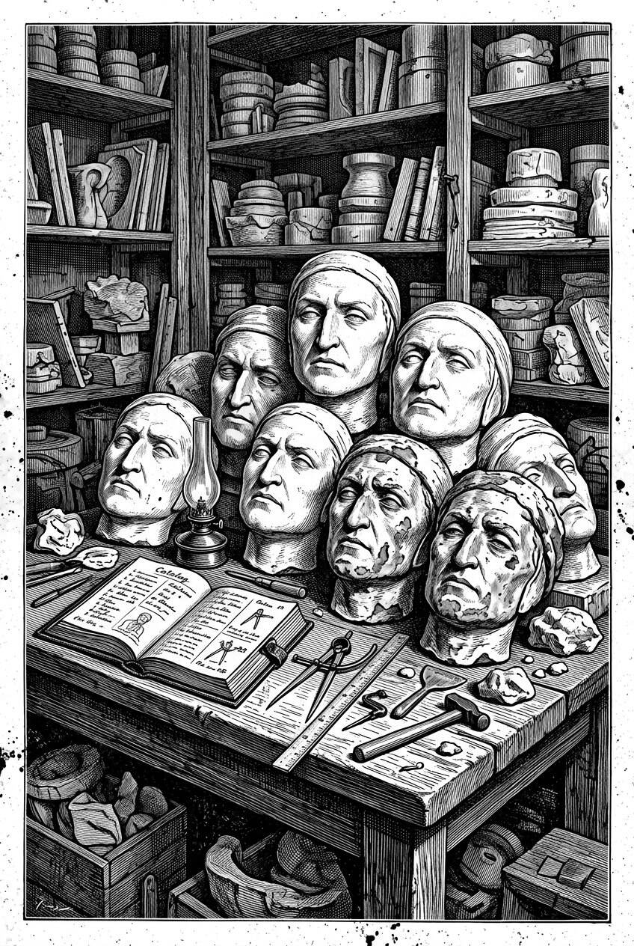
Among the most reproduced “death masks” in Western art history is one long attached to Dante, who died in 1321. Copies have multiplied for centuries. The documented chain from a face in Ravenna to the familiar plaster is far thinner than the image’s fame, and that gap is itself part of the history this book has to tell.

Multiplying the Face: Casts, Copies, and the Sculptor's Trade
As the practice of death-mask casting became more established within European sculptural workshops, it also became increasingly commercial and increasingly social, in ways that shaped how these objects moved through the world. A single original mold, taken directly from a face, could yield multiple plaster casts, and those casts, in turn, could be further copied and recast, sometimes losing fine surface detail with each successive generation. Sculptors shared casts with students and colleagues as valuable reference material for anatomical accuracy. Families sometimes commissioned multiple copies to distribute among relatives. And as the market for portrait busts, prints, and biographical commemoration expanded in the following centuries, death masks increasingly became not just private memorial objects, but working professional tools and, eventually, collectible items in their own right — a transformation this book will examine in much greater depth in later chapters devoted to the nineteenth-century boom in mask collecting and to the museums that grew up around it.

Between Ritual and Record
It would be a mistake to describe this period as marking a clean, total break from the symbolic and ritual purposes that had dominated earlier funerary representation. Renaissance and early modern death masks and effigies continued to serve religious functions in many cases, continued to assert family status and lineage in ways not entirely different from the Roman *imagines maiorum*, and continued to exist within broader cultural traditions of memento mori — the reminder of mortality — that pervaded European art, literature, and religious practice throughout this period, appearing everywhere from vanitas still-life paintings filled with skulls and extinguished candles to elaborate sermons on the brevity of earthly life. What changed was not that ritual and symbolic meaning disappeared, but that a new layer of meaning was added alongside it: the death mask increasingly functioned as a record, valued for its documentary accuracy about a specific individual's appearance, in addition to whatever religious or commemorative role it continued to play.

What Comes Next
By the close of this period, the essential elements of what would become the great nineteenth-century tradition of death-mask making and collecting were already largely in place: the casting technique itself, the cultural value placed on individual likeness, the professional networks of sculptors who created and circulated these objects, and the recurring, sometimes troubling gap between an object's popular reputation and what can actually be documented about its origins. What remained was a matter of scale and intensity, as the practice moved out of scattered aristocratic and artistic circles and into a much broader, more public, and more systematically documented culture of commemoration — one populated by kings and revolutionaries, composers and scientists, and, increasingly, by ordinary people whose deaths meant something to no one beyond their own households.
The next chapter turns to that broader stage: the death masks of specific, documented historical figures — monarchs, artists, scientists, and revolutionaries — whose preserved faces became some of the most emotionally resonant and historically significant objects in this entire tradition.

Chapter 4

Death Masks of Kings, Artists, Scientists, and Revolutionaries
──────── ❧ ────────
By the time this chapter's story begins in earnest, the death mask had become something almost paradoxical: a deeply private object, taken in the rawest hours after a death, that was also, increasingly, a public one — reproduced, sold, displayed, and argued over.

A Gallery of Names
The previous chapter traced how the direct facial cast moved from ritual and symbolic practice toward something closer to individual portraiture. This chapter turns to the people themselves — specific, documented historical figures whose faces were cast after death, and whose masks went on to have lives of their own, sometimes more dramatic and more contested than the circumstances of their creation. What follows is not a complete catalogue; entire books have been written about individual masks in this chapter. It is instead a deliberately varied selection, chosen to illustrate how differently the same basic practice could unfold depending on who the subject was, who did the casting, and what happened to the resulting object afterward.

The Face of an Emperor: Napoleon on Saint Helena
Few death masks carry as much documented controversy as the one associated with Napoleon Bonaparte, who died in exile on the remote South Atlantic island of Saint Helena in May 1821. A cast of his face was taken in the hours following his death, an act generally credited to his personal physician on the island, Francesco Antommarchi, though the exact sequence of events has been disputed almost from the start. Several people present at the deathbed later claimed involvement in the casting process, and in the years that followed, multiple plaster casts circulated across Europe, some showing subtle differences from one another in surface detail. This has left historians and collectors without a single, universally agreed "original" mask, and it has fueled more than a century of debate over which surviving casts most faithfully represent the very first impression taken from the emperor's face, and which are later, less direct copies.
This uncertainty is not simply an academic curiosity. It illustrates, with unusual clarity, a pattern that runs throughout this book: even a death attended by multiple witnesses, extensively documented in letters, memoirs, and official records, can still leave behind real and lasting uncertainty about the physical object meant to record it. Napoleon's fame guaranteed that his death mask would be reproduced, discussed, and disputed far more than most; it did not guarantee that a single, settled truth about its origins would survive along with it.
Points of orientation
– The more historically significant a person was, the more likely their death mask was to be recast, copied, and circulated — and the more likely competing claims about "the true original" were to emerge.
– Napoleon's death mask exists today in multiple versions across different collections, with genuine scholarly disagreement about their relative authenticity and sequence of production.
– This pattern — fame producing both wide circulation and documentary confusion — recurs with several of the masks discussed later in this book.
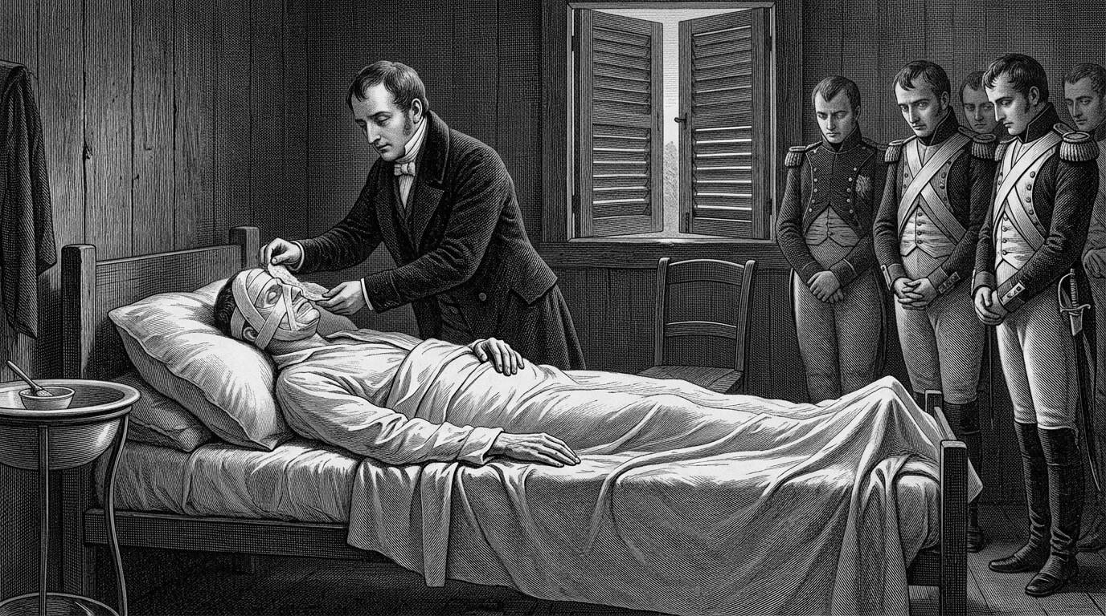
Napoleon died in exile on Saint Helena in May 1821. A cast of his face was taken in the hours that followed, an act generally credited to his physician Francesco Antommarchi, though the exact sequence has been argued ever since. Rival plaster versions later travelled Europe as if a single imperial face could be owned.

Composers Under Glass: Beethoven and Chopin
Among artists, the death masks of composers occupy a particularly prominent place in this history, in part because musical genius held enormous cultural prestige in nineteenth-century Europe, and in part because several of these masks are unusually well documented. When Ludwig van Beethoven died in Vienna in March 1827, the sculptor Josef Danhauser was called to the apartment and produced a death mask within hours, an object that has since become one of the most widely reproduced images associated with the composer, instantly recognizable even to people with no particular knowledge of death-mask history. Notably, this was not the only cast of Beethoven's face to survive: fifteen years earlier, in 1812, the sculptor Franz Klein had already produced a life mask of the composer, made while Beethoven was living, as a reference for a portrait bust. Having both objects survive from the same historical figure offers historians a genuinely useful opportunity, discussed further in a later chapter, to compare how a face changes across the interval between a life cast and a death cast — evidence not of any single "true" Beethoven face, but of the same person at two very different moments.
A similar pattern appears with the composer Frédéric Chopin, who died in Paris in October 1849. His death mask, along with a separate cast taken of his hand, was made by the sculptor Auguste Clésinger, who was connected to Chopin's circle through his marriage to Solange, the daughter of the writer George Sand, herself Chopin's former companion. Both objects have been reproduced extensively and are held today in museum and private collections, valued not only as historical artifacts but as physical points of connection to a figure whose musical legacy remains central to the Western classical tradition.
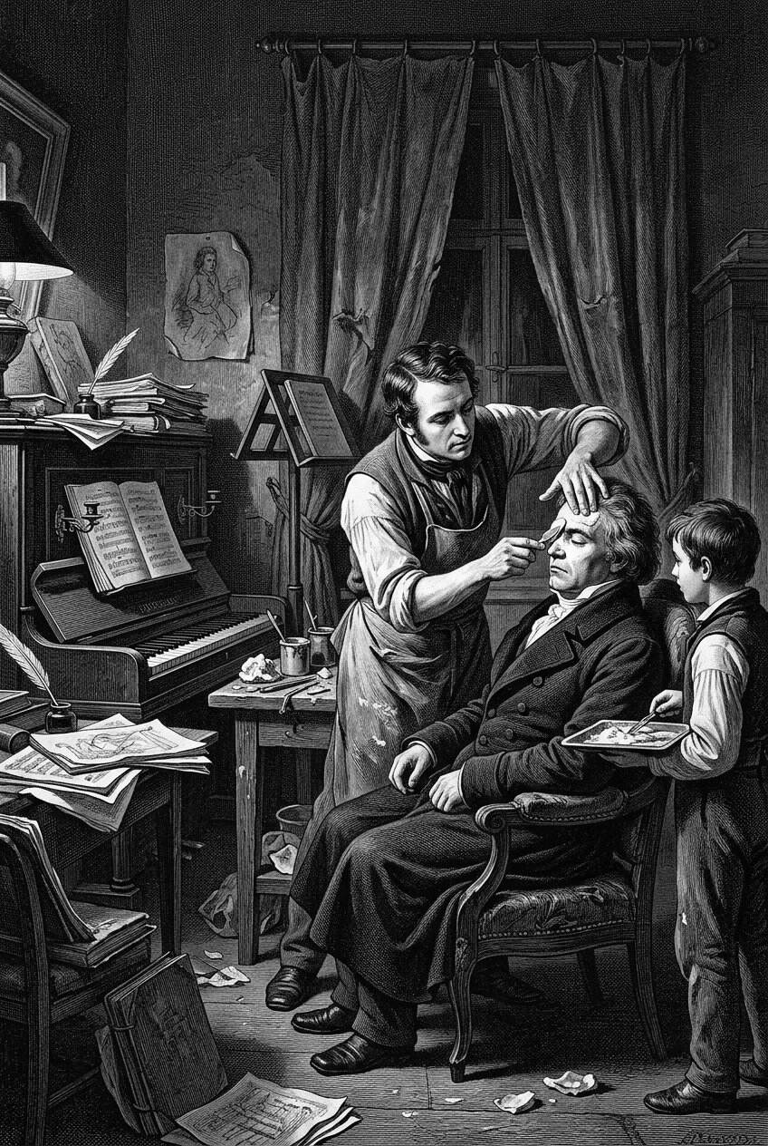
When Beethoven died in Vienna in March 1827, the sculptor Josef Danhauser took a cast that would become one of the most familiar composer-masks in Europe. Musical genius already carried public prestige; the plaster face gave that prestige a portable, almost relic-like form, copied and recopied long after the funeral.

The Reformer Who Became His Own Monument: Bentham's Auto-Icon
One of the most unusual cases in this entire history belongs to the philosopher and legal reformer Jeremy Bentham, who died in London in 1832, and whose story differs from nearly every other example in this chapter in one crucial respect: Bentham explicitly consented, in advance and in writing, to what would happen to his body after death. His will directed that his body be preserved and displayed as what he termed an "auto-icon" — a full-body preservation intended to be exhibited publicly, a request rooted in his broader utilitarian belief that even a person's remains could continue to serve a useful social or educational purpose.
The execution of this plan did not go entirely as intended. While Bentham's skeleton was preserved and dressed in his own clothing, the attempt to preserve his actual head using a desiccation technique left the result too discolored and damaged for public display, and a wax head, sculpted to resemble him, was substituted for exhibition purposes instead — a wax head very likely informed by a death mask or existing portraits of Bentham, though the documentary record of exactly how it was modeled is not entirely complete. Bentham's actual preserved head was stored separately, and, in one of the stranger footnotes to this history, became the target of repeated student pranks at University College London over the following decades, occasionally stolen and held for ransom by rival student societies. Bentham's auto-icon remains on public display at University College London today. His case is worth pausing on specifically because it inverts the ethical question that runs through so much of this book: rather than asking whether it was appropriate to use a dead person's face or body without their consent, Bentham's story asks what it means when a person deliberately requests exactly that kind of use for themselves, and what obligations, if any, an institution takes on when it agrees to fulfill such a request across future generations.
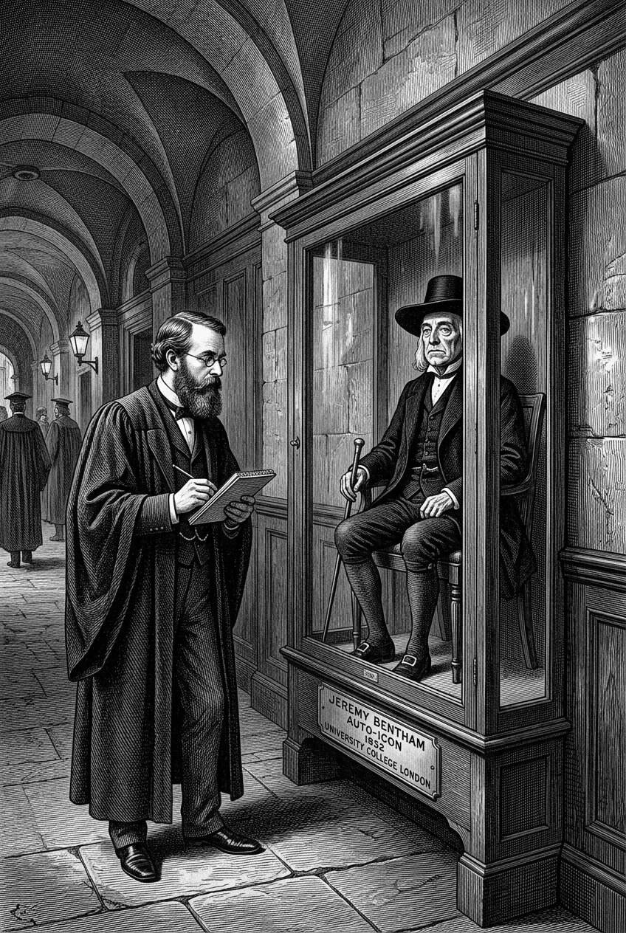
Jeremy Bentham, dying in London in 1832, had already consented in writing to the fate of his body. His Auto-Icon — the preserved figure still associated with University College London — is unlike almost every other case in this history: not a mask taken despite the dead, but a monument the dead had designed for himself.

A Scientist's Face for Later Generations
Death masks associated specifically with scientists are somewhat less consistently documented in the historical record than those of kings, composers, and revolutionaries, in part because scientific achievement did not always carry the same immediate, widely recognized public prestige in earlier centuries that it would acquire later. Even so, examples survive. A mask long associated with Sir Isaac Newton, following his death in 1727, has been referenced in accounts of later commemorative sculpture, including work connected to his monument at Westminster Abbey, though — consistent with the caution this book has tried to apply throughout — the precise circumstances of its creation are less fully documented than historians might wish, and it should be treated with the same care applied elsewhere in this book to objects whose full provenance cannot be verified with certainty.
What is better documented is the broader nineteenth-century pattern this book will examine in far more depth in a later chapter devoted specifically to physiognomy and forensic science: an increasing scientific interest, however methodologically flawed by modern standards, in the physical features of accomplished or notable individuals, including detailed measurement and, in some documented cases, preservation of skulls or brains alongside facial casts, in pursuit of theories connecting anatomy to genius or intellectual achievement. Death masks of scientists sat within this broader culture of collection and measurement, valued not only as memorial objects but, increasingly, as specimens in a study of exceptional minds that later generations would come to regard as scientifically unfounded.

Wax, the Guillotine, and Madame Tussaud's Contested Legacy
The French Revolution produced one of the most dramatic and most historically contested chapters in the story of the death mask. Marie Grosholtz, later known to history as Madame Tussaud, trained in wax modeling in Paris under her uncle, the physician and modeler Philippe Curtius, during the years leading up to the Revolution. In her later memoirs, dictated and published decades afterward in 1838, Tussaud claimed to have personally taken death masks and casts from the heads of several prominent victims of the Revolution's violence, including figures associated with the guillotine, in circumstances she described as harrowing and, at times, coerced by revolutionary authorities eager to display the likenesses of the fallen.
Historians studying this period have urged real caution about accepting these later accounts uncritically. Tussaud's memoirs were composed many years after the events they describe, apparently with the assistance of a collaborator, and contain claims that have proven difficult or impossible to independently verify, along with occasional inconsistencies that have led some scholars to suspect embellishment, whether for dramatic effect, commercial promotion of her wax exhibition, or simply the ordinary distortions of memory recalled across decades. This does not mean her account is entirely fabricated — Tussaud was demonstrably active as a wax modeler in Paris during this exact period, and the broader practice of casting the faces of guillotine victims for public exhibition is independently documented as a phenomenon of the Revolutionary era, driven by a mixture of political propaganda, morbid public fascination, and, in some cases, an early and troubling entanglement with the physiognomic theories discussed elsewhere in this book. It means, rather, that the specific, dramatic details of Tussaud's personal involvement should be read as a contested historical claim rather than settled fact — precisely the kind of distinction this book has tried to draw consistently between documented evidence and later, retrospectively shaped narrative.
Points of orientation
– Madame Tussaud's own later accounts of casting the death masks of Revolutionary victims are widely repeated in popular history, but were written decades after the events, and historians regard several specific claims as unverified or possibly embellished.
– The broader practice she describes — casting the faces of guillotine victims for public display — is independently documented as a real phenomenon of the period, separate from the question of her personal role in every individual case.
– This is a useful reminder that a compelling personal narrative, even from someone genuinely present during historic events, requires the same scrutiny this book applies to any other historical claim.
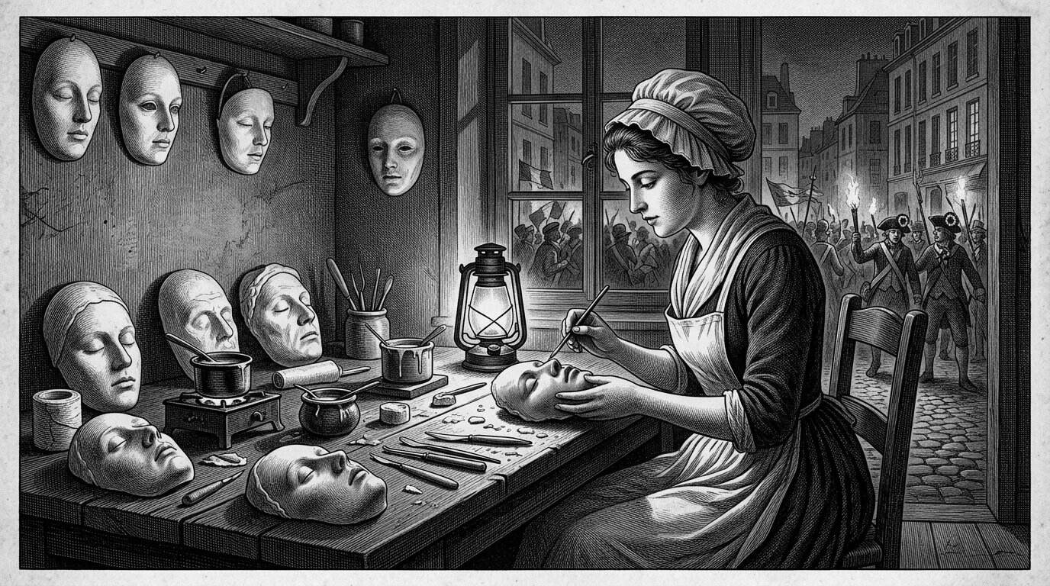
Marie Grosholtz, later Madame Tussaud, trained in wax under Philippe Curtius in the years before the French Revolution. Her later memoirs place her at the work of modelling faces in a city that was producing the dead at a political pace. How much is workshop fact and how much later legend remains contested; the cultural afterlife of those waxes is not.

From the Guillotine to the Mausoleum: Lenin and the Twentieth Century
The tradition of casting the faces of politically significant revolutionary figures did not end with the eighteenth century. When the Soviet leader Vladimir Lenin died in January 1924, a death mask was produced as part of an elaborate, state-organized project to memorialize him, work generally associated with the Soviet sculptor Sergei Merkurov, who became known during this period for producing death masks of several prominent state figures. Lenin's case extended the underlying impulse examined throughout this book into distinctly modern territory: alongside the traditional death mask, his body itself was preserved through modern embalming techniques for indefinite public display in a specially constructed mausoleum in Moscow's Red Square, a practice that continues to generate its own ethical and scientific discussion to this day. Where earlier revolutionary figures in this chapter were remembered through a single cast face, Lenin's memorialization combined the older tradition of the mask with an entirely new, twentieth-century ambition: preserving not just the impression of a face, but, as closely as modern science could manage, the appearance of the body itself.

What These Masks Share, and Where They Differ
Considered together, the figures in this chapter reveal both a common thread and a set of real differences worth holding onto. In every case, the underlying impulse echoes what earlier chapters have already identified: a conviction that this particular face, having belonged to this particular person, deserved to be preserved in some direct, physical way rather than left to fade from memory or survive only through interpreted portraiture. But the purposes driving that impulse varied considerably. Napoleon's mask served the commemoration of imperial and historical significance. Beethoven and Chopin's masks served an artistic and biographical function, tied to genius understood primarily through creative achievement. Bentham's case served his own explicit philosophical convictions about the ongoing utility of the human body. The masks associated with Revolutionary and Soviet figures served overtly political purposes, tied to the legitimacy and memory of political movements rather than individual mourning alone. And the more diffuse, less individually documented tradition of scientists' masks served an emerging, if often misguided, scientific ambition to locate genius within the physical structure of the body itself.

What Comes Next
Every figure examined in this chapter was, by any measure, famous — someone whose death was recorded, whose mask was documented by name, and whose face, cast in plaster or wax, retained an identity that history has largely preserved alongside it. The next chapter turns to a very different category of subject: the condemned and the unidentified, people whose death masks survive, in some cases in far greater numbers than those of kings or composers, but whose stories were shaped by punishment, anonymity, or simple bad fortune rather than by fame — and whose faces raise a different, harder set of questions about what it means to preserve the likeness of someone history was never meant to remember by name.

Chapter 5

The Condemned and the Unknown Dead
──────── ❧ ────────
Not every face preserved in plaster belonged to someone mourned. Some belonged to people the state had just killed, and others to people no one, as far as the record shows, had come looking for at all.

A Body No One Has Claimed
Picture a low-ceilinged room near the banks of the Seine in Paris, sometime in the middle of the nineteenth century — again, a composite, representative scene rather than a documented single event. An attendant moves along a row of marble slabs behind a glass partition, where the bodies of the recently drowned or otherwise unidentified dead are laid out, clothed, for public viewing. Outside, a queue has formed: not grieving relatives, for the most part, but ordinary Parisians and visiting tourists, drawn by curiosity, newspaper reports, or simple morbid habit, filing past the glass to look at the faces of strangers, in the faint hope — genuine, if statistically rare — that someone might recognize a missing husband, a runaway daughter, a vanished lodger, and put a name to a body that would otherwise be buried, and eventually forgotten, entirely unidentified.
This chapter turns to two categories of the dead who have appeared only at the margins of the story so far: the condemned, whose faces were cast in the aftermath of judicial execution, often for purposes closer to study and spectacle than to mourning; and the unidentified, whose faces were preserved not to honor a known life, but in the hope, sometimes fulfilled and more often not, of recovering a name that had otherwise been lost.
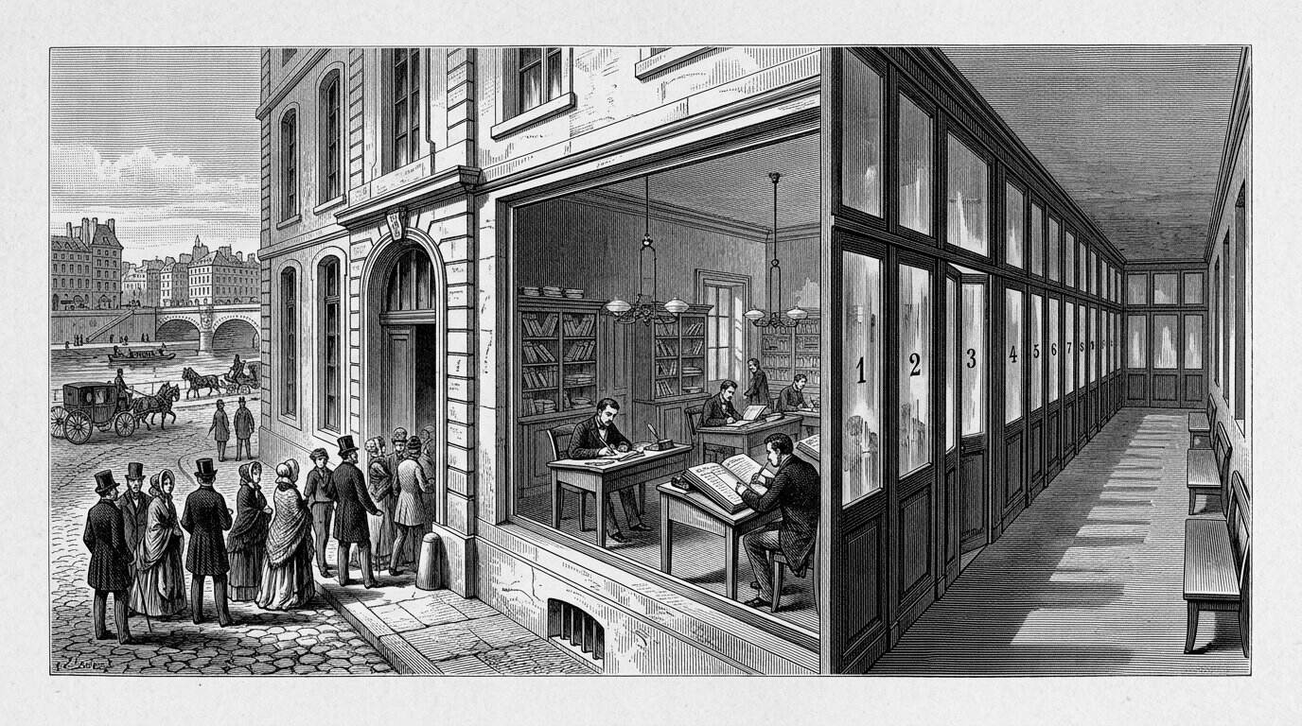
For much of the nineteenth century the Paris morgue operated with a public viewing area. Citizens could walk past the unclaimed dead behind glass — a civic hope of recognition tangled with spectacle. The institution on the Seine is one of the best-documented places where identification, curiosity, and the city met.

Two Kinds of Facelessness
The previous chapter examined death masks belonging to some of the most famous individuals in European history — people whose names, achievements, and even the specific circumstances of their deaths were recorded in exhaustive detail. The subjects of this chapter present, in a sense, a mirror image of that fame. A condemned criminal's face might be cast precisely because of what they had done, their identity fixed permanently to a single act of violence or transgression, reduced in public memory to that one moment regardless of whatever else their life had contained. An unidentified body's face, by contrast, was cast in the absence of any name at all — preserved not because of who the person was, but specifically because no one yet knew.
Both categories share something the masks of kings and composers largely did not: an almost complete absence of consent. Napoleon's mask, however contested its exact provenance, was taken in service of commemorating a man whose historical significance was never in doubt. Beethoven's and Chopin's masks were taken by sculptors connected to their own artistic circles, in a spirit continuous with how they had been regarded in life. The people examined in this chapter had no comparable say in how their faces would be used after death, and in the case of the unidentified, often no surviving community positioned to advocate on their behalf at all.

The Mask as Evidence of Guilt
In Britain and elsewhere in Europe during the first half of the nineteenth century, it became a documented practice in some prisons to take plaster casts of the heads and faces of executed criminals, particularly in the period when phrenology — the theory, discussed in earlier chapters, that character and criminal tendency could be read from the shape of the skull — held significant scientific credibility among physicians and social reformers. Collections of such casts survive today in several British museum and university archives, including sets associated with London's Newgate Prison and other institutions, gathered specifically so that phrenologists and interested physicians could study the physical features of individuals convicted of serious crimes, in pursuit of theories about the anatomical basis of criminality that later scientific understanding would thoroughly discredit.
These collections occupy an uncomfortable but historically important place in this book's larger story. The men whose faces were cast in this context had no opportunity to object; their bodies, already forfeit to the state through capital punishment, were treated as a further resource for scientific — or pseudo-scientific — investigation, in a period when the rights of the condemned, and indeed of the poor more generally, carried far less social and legal weight than they would come to hold later. And yet, as with the physiognomic and criminological collections raised in Chapter 1, these objects have not lost their historical value simply because the theories that motivated their creation were wrong. Today, historians of medicine, science, and criminal justice study these same casts to understand how a flawed scientific movement actually operated in practice — who it targeted, what assumptions it carried, and how those assumptions intersected with existing prejudices about class, poverty, and crime. The masks survive as evidence of a troubling chapter in the history of science, even though they were never, in the way their original collectors believed, evidence of anything reliable about the individuals they depicted.
Points of orientation
– Nearly every mask discussed in the previous chapter was taken with at least the implicit cooperation of the deceased's family, community, or, in Bentham's unusual case, the deceased themselves.
– The masks discussed in this chapter — of executed criminals and unidentified bodies — were made almost entirely without any such consent, reflecting the far weaker social and legal status afforded to the condemned and the poor in this period.
– Recognizing this asymmetry does not require dismissing these objects as historically worthless; it requires reading them with a different, more critical set of questions about power, consent, and whose interests a given collection actually served.
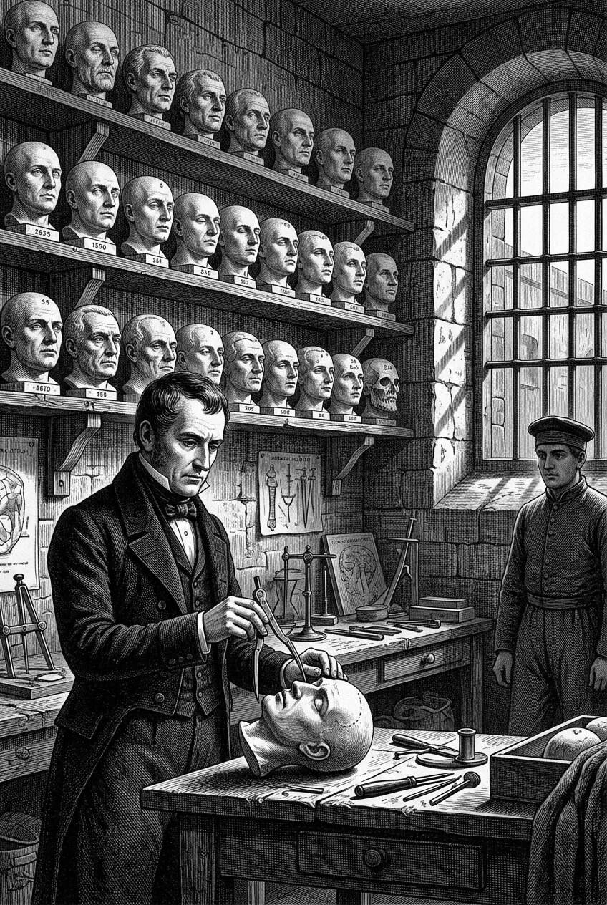
In Britain and elsewhere, some prisons took plaster casts of executed men in the decades when phrenology claimed that character could be read from the skull. The casts were filed as if they were evidence of a type. Later history has judged the science unfounded; the objects remain as records of that confidence.

Curiosity Dressed as Study
Scientific interest was rarely the only motive at work. Public fascination with the faces of infamous criminals ran parallel to, and often blended directly with, the phrenological and physiognomic study already discussed. Wax exhibitions across nineteenth-century Europe, including the popular "Chamber of Horrors" display that became a signature attraction of Madame Tussaud's London exhibition — a direct continuation of the wax-modeling tradition already examined in the previous chapter — drew enormous crowds eager to view lifelike representations of notorious murderers and executed criminals, sometimes based directly on death masks or casts taken after execution. This was popular entertainment as much as it was education, and it reveals an important truth about this period: the line between scientific specimen and public spectacle was frequently blurred, if it existed in any meaningful sense at all. A cast taken in the name of phrenological research might, within a few years, find its way into a commercial exhibition designed primarily to thrill and unsettle paying visitors, its original scientific framing quietly receding behind its more marketable function as a grim curiosity.
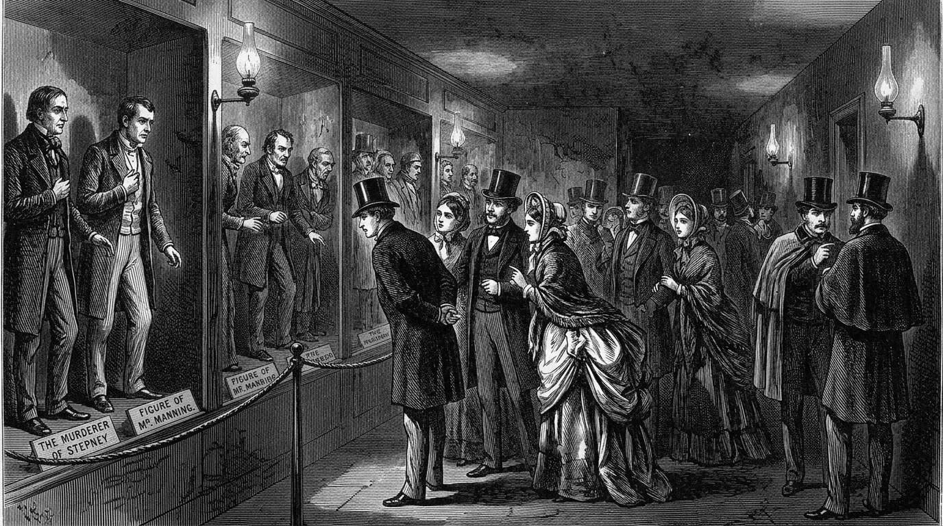
Scientific language was rarely the only motive. Wax exhibitions across Europe, including the Chamber of Horrors associated with Tussaud’s, sold the public a chance to look at infamous faces. Study and entertainment shared a room, and the condemned, who could not refuse, supplied the inventory.

The Paris Morgue and the Theater of the Unknown
The public morgue in nineteenth-century Paris represents one of the most striking, and most historically documented, examples of how the practical need to identify the unclaimed dead became entangled with public spectacle. For much of the century, the Paris morgue operated with a public viewing area, allowing ordinary citizens to walk past the displayed bodies of the recently deceased and unidentified, in the explicit hope that a passerby might recognize someone and provide the information needed to establish an identity. The practice served a genuine administrative and compassionate purpose: unidentified deaths needed to be resolved, families needed to be located, and in an era before photography was in routine police use and long before any systematic fingerprint identification existed, public viewing was, however imperfect, one of the only practical tools available.
But the morgue also became, almost immediately, a significant tourist attraction in its own right, drawn into contemporary guidebooks and written about extensively by journalists and social commentators of the period as a site of morbid popular fascination, particularly among visitors eager for a glimpse of the sensational side of Parisian life. Crowds that gathered outside the morgue's viewing window were, by most contemporary accounts, only rarely there because they recognized someone; far more often, they were there simply to look, drawn by the same impulse that would later fill wax museum chambers of horrors and, in a very different register, motivates the continued fascination with death masks that this book is itself an exploration of. The identification of the unclaimed dead and the entertainment of the curious living occupied, uncomfortably, the very same physical space.

A Face Without a Name, Revisited
It was from within this exact institutional and cultural context — a public morgue accustomed to displaying unidentified bodies for a mixture of practical and voyeuristic reasons — that the story of *L'Inconnue de la Seine*, the Unknown Woman of the Seine, first introduced in Chapter 1, took shape. According to the long-circulating account, a young woman's body, recovered from the river and never identified, was displayed at the Paris morgue sometime in the late nineteenth century, and a mask-maker, struck by the unusually serene and faintly smiling expression on her face, took a plaster cast that was subsequently reproduced and sold, eventually finding its way into artists' studios and private homes across Europe.
As already noted, very little of this narrative can be independently verified through documented historical sources. No confirmed record establishes her actual identity, the precise circumstances or even cause of her death, or the specific date and location of the casting itself, and some researchers have seriously questioned whether the mask was taken from a corpse at all, suggesting instead that it may have been modeled from a living subject and only later attached, through popular retelling, to the romantic legend of an anonymous drowning victim. What can be documented with much greater confidence is the mask's extraordinary cultural afterlife from the early twentieth century onward: reproductions of her face became fashionable decorative objects in bohemian artistic circles, and her image — an unidentified young woman, apparently at peace despite the implied violence of her presumed death — inspired a substantial body of poetry, prose, and visual art across the twentieth century, precisely because her lack of a confirmed identity left so much open to imaginative interpretation. In one of the more genuinely strange turns in this book's entire history, her face was later adopted, in the middle of the twentieth century, as the model for a training mannequin used in cardiopulmonary resuscitation instruction, meaning that whoever she actually was, her preserved features have quite plausibly been seen, and even physically practiced upon, by an extraordinary number of people across the world.
Points of orientation
– Documented: a mask matching this description circulated widely in Europe from the late nineteenth century onward and inspired significant literary and artistic responses across the twentieth century.
– Undocumented or disputed: her specific identity, the exact circumstances and cause of her death, the precise date of casting, and even whether the mask was taken from a deceased person at all.
– The gap between these two categories is itself part of the story — her fame rests as much on the space left open by uncertainty as on any verified biographical fact.
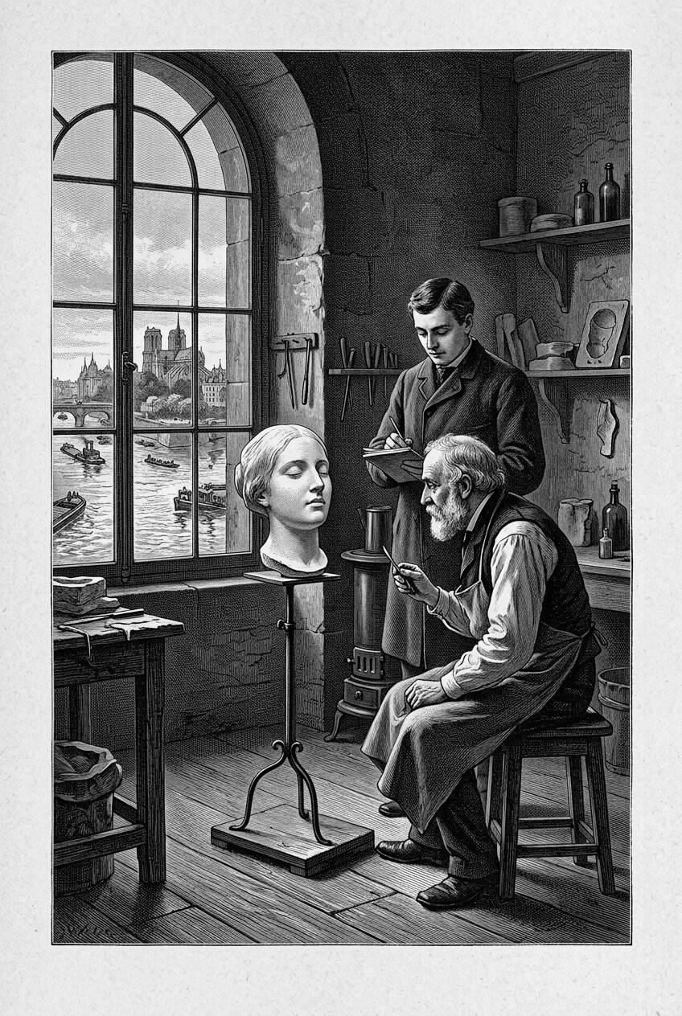
According to a long-circulating account, a young unidentified woman taken from the Seine left a plaster face of unexpected serenity. L’Inconnue de la Seine became a studio prop, a literary muse, and later something stranger still. Her name was never securely recovered; her likeness would not stay in the morgue.

Whose Face Is This, and Who Decides?
The stories gathered in this chapter raise a question that this book has touched on before but that deserves to be stated directly here: who has the right to decide what happens to a dead person's face, particularly when that person cannot advocate for themselves and left behind no family in a position to do so? For the executed criminals studied by nineteenth-century phrenologists, the answer, in practice, was the state and the scientific establishment, operating within a legal and social framework that afforded the condemned essentially no protection over how their remains might be used after punishment had been carried out. For the unidentified dead displayed at the Paris morgue, the answer was, in effect, no one in particular — a gap in accountability filled instead by institutional practicality and public curiosity, with the person's own interests, whatever they might have been, entirely unrepresented in the process.
This is not a comfortable observation, and this book does not intend to make it one. It is included specifically because any honest history of the death mask has to reckon with the fact that the same basic technique — capturing a face in plaster after death — served radically different ethical purposes depending on who the subject was, how much social power they or their families held, and how willing the society around them was to treat their remains with the same consideration extended, almost automatically, to the famous and the wealthy. Modern museum and archival practice, examined in much greater depth in a later chapter of this book, has increasingly had to confront exactly this imbalance, asking what obligations institutions now holding these objects owe to the memory of people who never had any say in how their faces would be used.

What Comes Next
The scientific interest that surfaced repeatedly throughout this chapter — in the skulls and faces of condemned criminals, in the theories of phrenology and physiognomy that shaped how those objects were studied — represents only the earlier, cruder stage of a much longer, more consequential story. The next chapter turns directly to that story: the gradual development, over the second half of the nineteenth century and into the twentieth, of genuinely reliable methods of identifying the dead, from measurement systems that built directly on the flawed assumptions already introduced in this book, to the far more rigorous forensic techniques — fingerprinting prominent among them — that would eventually replace the death mask itself as a tool of identification, even as the mask's older, more emotional purposes endured alongside them.

Chapter 6

Death Masks and the Birth of Forensic Identification
──────── ❧ ────────
For most of the nineteenth century, identifying an unknown body meant trusting a stranger's memory, a family's grief, or the accuracy of someone's eye. By the century's end, an entirely new science had set out to replace all three with numbers.

A Science in Search of Certainty
Picture a small, cluttered office within the Paris Prefecture of Police, sometime in the 1880s — a reconstructed scene, representative of a practice that became increasingly formalized during this decade, rather than a record of any single documented visit. A clerk positions a seated man against a measuring apparatus, calling out figures as an assistant records them in a ledger: the length and breadth of the skull, the span of the outstretched arms, the length of the left foot, the length of the left middle finger, the length of the left forearm. The man being measured is not a corpse. He is a living suspect, recently arrested, and the ritual being performed on him belongs to an ambitious new system that its inventor believed could finally solve one of the most persistent practical problems facing nineteenth-century police work: how to reliably prove that the person standing in front of you today is the same person who was arrested, under a different name, several years before.
This chapter turns to that problem directly, and to the systems — some scientifically sound, others deeply flawed — that nineteenth- and early twentieth-century Europe developed to solve it. The death mask and the broader tradition of facial casting examined throughout this book sit at the edge of this story rather than its center, but the connection between them is real and worth tracing carefully, because the same cultural moment that produced the elaborate collecting culture of death masks also produced the first serious attempts at what we would now call forensic identification, and the two pursuits were, for several decades, far more entangled than most popular accounts acknowledge.

Alphonse Bertillon and the Grammar of the Body
The system being performed in the scene above belonged to Alphonse Bertillon, a French police record clerk who, in the early 1880s, developed what became known as anthropometry, or more informally, Bertillonage: a method of identifying individuals through a standardized set of precise bodily measurements, combined with detailed, systematized descriptions of physical features, including the shape of the ear, the color of the eyes, and other distinguishing marks. Bertillon's underlying insight was reasonably sound in principle — that the combination of several independent physical measurements, each varying naturally across a population, would produce a set of figures unique enough, in combination, to distinguish one individual from millions of others, in an era before any comparably reliable biometric alternative existed.
Bertillon's system was adopted with real enthusiasm by police forces across France and, before long, in other countries as well, and it represented a genuine methodological advance over what had preceded it: essentially, the memory and personal judgment of individual police officers and witnesses, supplemented at best by written physical descriptions that varied enormously in detail and reliability from one record to the next. For roughly two decades, anthropometric measurement stood as the most rigorous identification technology available to European and American law enforcement, and it is worth recognizing this achievement honestly, even though, as this chapter will discuss, the system's dominance would prove considerably shorter-lived than its inventor hoped.
Bertillon is also significant to this book's story for a second, related reason: he was instrumental in standardizing what became known as forensic or judicial photography — the practice of taking consistent, front-facing and profile photographs of arrested suspects, taken under controlled lighting and framing conditions specifically designed to allow reliable comparison across different arrests and different years. This standardized photograph, still recognizable today as the modern mug shot, represented a direct and largely successful competitor to an older, cruder tradition already discussed in the previous chapter: the practice of displaying or casting the faces of the unidentified and the criminal for purposes of recognition. Where a nineteenth-century police morgue had relied on the public simply walking past a body and hoping for recognition, and where earlier collections of criminal masks had relied on the (largely discredited) hope that a skull's shape might reveal criminal character, Bertillon's photographic system offered something genuinely new: a fast, cheap, reproducible, and comparatively objective visual record, one that did not require an artist's hours of careful plaster work, and that could be filed, copied, and distributed to other police departments with far greater ease than any physical cast.
Points of orientation
– A death mask required time, skill, and materials, and produced a single, heavy, easily damaged physical object.
– A standardized police photograph could be produced in minutes, copied cheaply, and mailed or telegraphed to other jurisdictions — a practical advantage that mattered enormously to police work.
– This practical gap is a major reason why, by the early twentieth century, the death mask had largely lost its earlier role as a tool of criminal or forensic identification, even as its symbolic and memorial functions endured.
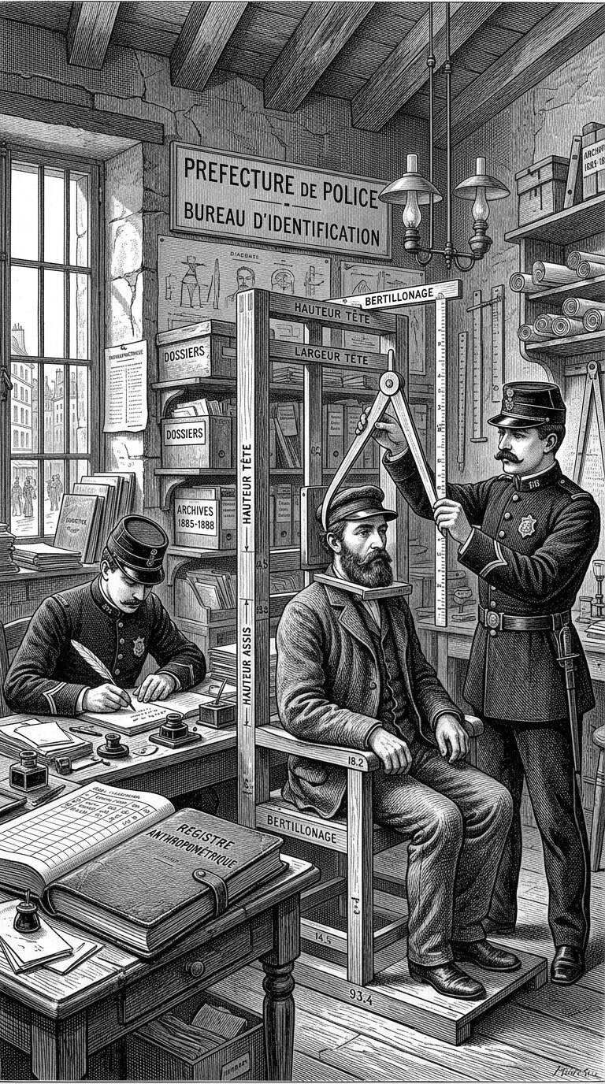
In the 1880s, inside the Paris Prefecture of Police, Alphonse Bertillon built a grammar of the living body: standardised measurements, coded descriptions, a ledger where a person became a set of numbers. Anthropometry was an attempt to replace recognition-by-memory with a system that could be taught.

The Face Enters the Police File
The rise of forensic photography under Bertillon and his contemporaries marks a genuinely important turning point in this book's larger story, because it represents the moment when the practical work of identifying bodies — living suspects and unidentified dead alike — began to separate decisively from the older tradition of the physical facial cast. For most of the century examined in the previous chapter, a death mask taken from an unidentified body, or the public display of the body itself, had represented one of the only realistic tools available for eventual identification, however unreliable and inefficient that tool actually was in practice. By the final decades of the nineteenth century, standardized photography offered something faster, cheaper, and considerably easier to circulate between institutions, and police departments and morgues across Europe gradually adopted photographic records in place of, or alongside, the older practice of physical display and casting.
This shift had a direct and documented effect on one institution already discussed in this book: the public morgue in Paris, whose open display of unidentified bodies had, by the early twentieth century, become increasingly regarded as both impractical and, to a growing number of contemporary critics, distasteful — a form of entertainment dressed as public service. The morgue's public viewing gallery was eventually closed to casual visitors, with identification work shifting toward photographic records that could be examined, and where necessary published in newspapers, without requiring the physical, and increasingly controversial, spectacle of crowds filing past a glass partition. The underlying goal — helping the public assist in identifying the unclaimed dead — remained essentially unchanged. The method through which that goal was pursued had been transformed almost completely, moving from the physical presence of the body itself, or a plaster impression of it, toward a printed or projected image that could travel far beyond the walls of a single mortuary.
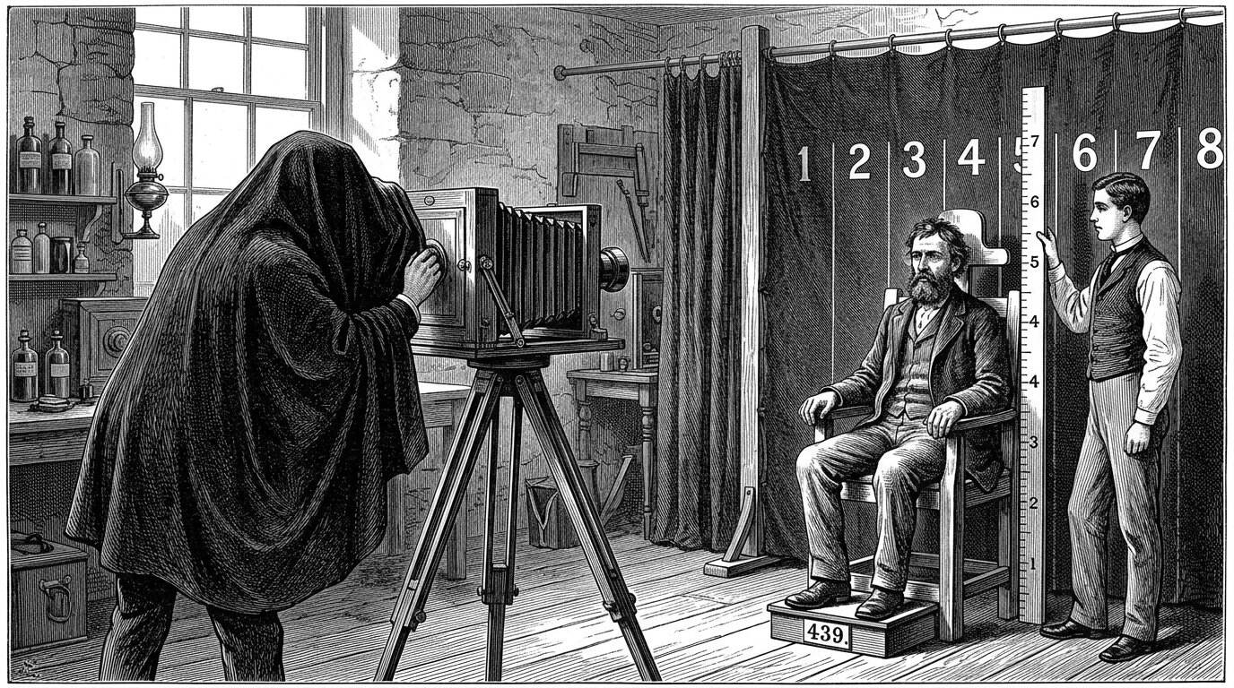
Forensic photography, developed under Bertillon and his contemporaries, marks the moment when identifying the living and the dead began to leave the physical cast behind. The camera promised a cheaper, faster, more easily filed face — still an image, but one that police archives could multiply without plaster.

When the System Failed: The Case of the Two Wests
Bertillon's anthropometric system, for all its genuine methodological ambition, contained a serious and ultimately fatal flaw: it assumed that the combination of measurements it relied upon was, for practical purposes, unique to each individual, an assumption that proved considerably less reliable than its early advocates believed, particularly once the system was applied at a large scale across millions of records, and particularly in cases involving close biological relatives.
The clearest documented illustration of this weakness comes from an American case widely discussed in the history of forensic identification: in 1903, at the federal penitentiary in Leavenworth, Kansas, prison officials processing an incoming inmate named Will West found that his Bertillon measurements matched, in extraordinarily close detail, those already on file for a prisoner already incarcerated at the same institution under the very similar name William West. Investigation revealed that the two men, despite the striking similarity in both name and anthropometric measurement, were apparently unrelated individuals — though some later accounts of the case have raised the possibility of an undocumented family connection, a detail that remains genuinely uncertain in the historical record. Whatever the precise relationship between the two men, the case became, almost immediately, a powerful and widely circulated argument against the reliability of anthropometric measurement as a stand-alone identification system, since two apparently distinct individuals had produced measurements too similar to reliably distinguish between them using Bertillon's method alone.
The Leavenworth case did not, by itself, single-handedly end the use of anthropometric measurement — the practice continued in various police departments for some additional years after 1903 — but it became a frequently cited symbol of the system's fundamental limitation, arriving at almost exactly the moment when an alternative biometric technology, already under serious scientific development for over a decade, was beginning to demonstrate a level of individual uniqueness and reliability that Bertillon's careful measurements simply could not match.

Fingerprints and the End of an Era
That alternative technology was the fingerprint, and its rise to prominence as the dominant tool of criminal identification through the first decades of the twentieth century represents one of the genuine scientific success stories connected to this book's broader history, standing in sharp and welcome contrast to the pseudo-scientific theories of physiognomy and phrenology examined in earlier chapters. The English scientist Francis Galton, building on earlier observations by other researchers working in British India and elsewhere, published influential work in the early 1890s establishing that fingerprint patterns were both effectively permanent across an individual's lifetime and sufficiently varied to distinguish reliably between different people, and proposed a practical system for classifying and comparing prints.
Galton's classification work was subsequently refined into a more practical operational system by Edward Henry, a British police official working in colonial India, whose method — generally known as the Henry Classification System — was adopted by Scotland Yard's newly established fingerprint bureau in London in 1901, marking one of the first large-scale institutional adoptions of fingerprinting as a primary tool of criminal identification. Over the following two decades, fingerprinting spread rapidly through police forces across Europe and North America, gradually displacing Bertillon's anthropometric measurements as the preferred method of positively identifying both criminal suspects and, increasingly, unidentified bodies, a role in which fingerprints offered a significant additional advantage that neither Bertillonage nor photography could fully match: a fingerprint could, in principle, be recovered directly from a crime scene itself, independent of any prior photograph or measurement of a particular suspect, opening an entirely new category of forensic investigation that had simply not existed before.
This transition mattered directly to the story of the death mask, because it marked the effective end of any serious claim that a physical facial cast could serve a genuinely useful forensic function. Where earlier chapters in this book described death masks and skull measurements being collected in service of criminal identification, physiognomic theory, or simple morgue record-keeping, the combination of standardized photography and fingerprint classification had, by the 1910s and 1920s, rendered the death mask essentially obsolete as a practical tool of forensic science. What remained afterward — and what the rest of this book will continue to explore — was the mask's older, more enduring set of purposes: memorial, artistic, and increasingly, historical and collectible, purposes that had, in truth, motivated the practice long before criminology ever laid claim to it, and that would continue to motivate it long after criminology moved on to more reliable tools.
Points of orientation
– Physical display and facial casting (early to mid-nineteenth century): slow, unreliable, dependent on chance recognition or flawed physiognomic theory.
– Anthropometric measurement and standardized photography (1880s–1900s): faster and more systematic, but ultimately limited by the non-uniqueness of body measurements, as the Leavenworth case demonstrated.
– Fingerprint classification (1890s onward): the first method in this sequence considered genuinely reliable by modern forensic standards, and the one that effectively ended the mask's practical role in identification.
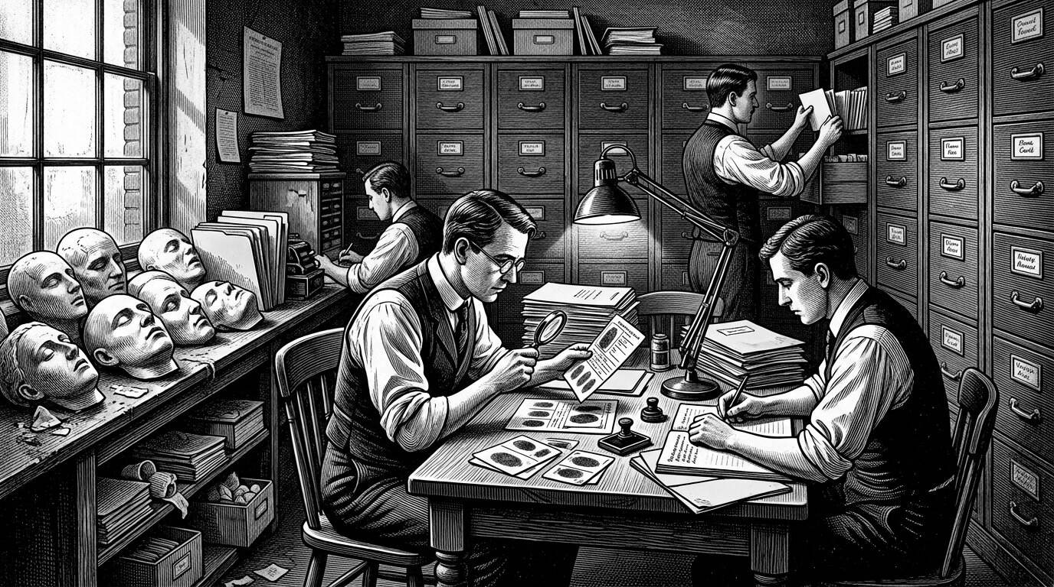
Bertillonage assumed that a combination of measurements was, for practical purposes, unique. The assumption failed in public, most famously when two different men named West could not be told apart by the system. Fingerprints, in the early twentieth century, took the job the rulers and the casts could not keep.

Lombroso's Skulls, and His Own
No figure connects the flawed science of criminal physiognomy discussed in earlier chapters to the forensic developments of this one more directly, or more strangely, than the Italian physician and criminologist Cesare Lombroso, already introduced briefly in Chapter 1. Lombroso, working from the 1870s onward, developed an influential and now thoroughly discredited theory holding that certain individuals were, in effect, "born criminals," identifiable through specific inherited physical traits — a theory he framed as a kind of atavism, or evolutionary throwback to earlier, supposedly more primitive human types. In building his case, Lombroso assembled an extensive personal collection of skulls, photographs, and other physical evidence gathered from executed criminals and psychiatric patients, treating these individuals' remains and features as raw material for a theory that modern criminology and anthropology regard as scientifically baseless and deeply entangled with the racial and class prejudices of his era.
What makes Lombroso's story especially striking, and especially relevant to the themes of consent already raised in earlier chapters through the case of Jeremy Bentham, is that Lombroso, apparently confident in the validity of his own theories to the very end, arranged for his own remains — his skeleton and preserved brain — to be added, after his death in 1909, to the very museum collection in Turin that he had spent his career assembling, where they remain on public display today alongside the specimens he had gathered from others during his lifetime. Unlike the executed criminals and unidentified dead discussed in the previous chapter, Lombroso's own inclusion in his museum was entirely voluntary, a final act of confidence in a body of work that subsequent generations of scientists would go on to reject almost entirely. His case offers a genuinely unusual historical irony: the founder of a school of thought responsible for treating so many other people's remains as scientific specimens without their consent ultimately volunteered his own body for exactly the same treatment, apparently seeing no contradiction in the gesture at all.
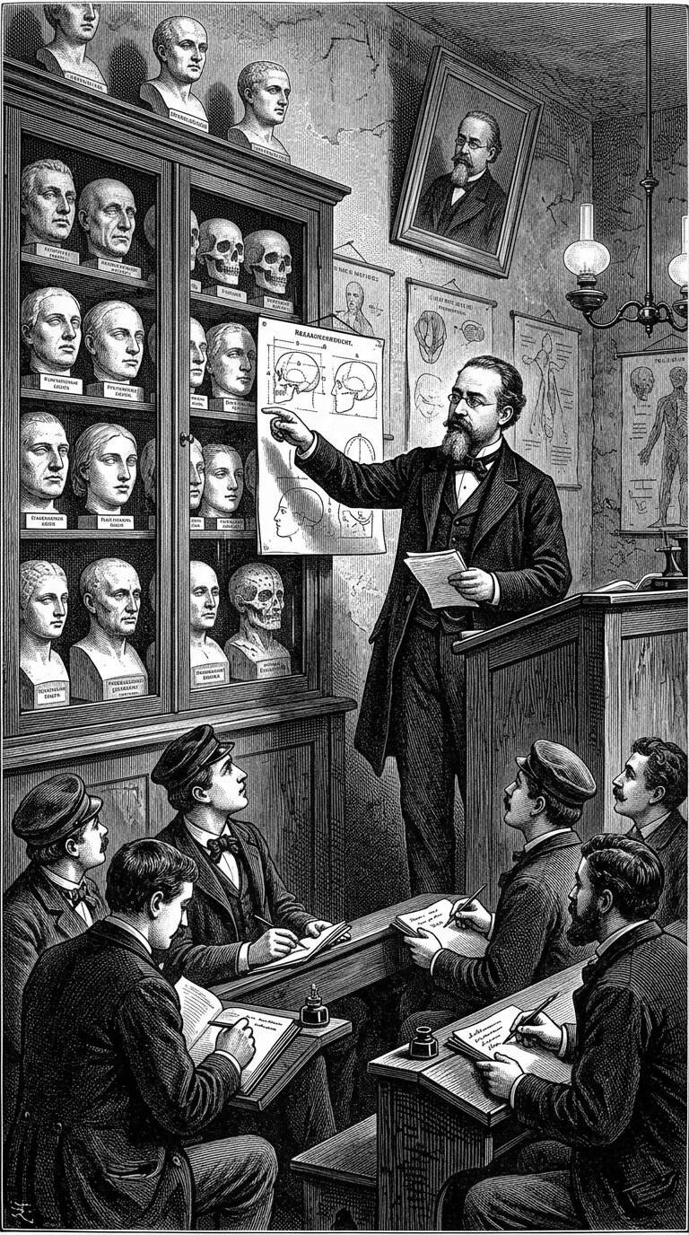
Cesare Lombroso gathered skulls, casts, and photographs in the service of a theory that criminality could be read on the body. That theory is now thoroughly discredited. The collection he left behind — and the later fate of his own remains within it — is one of this book’s sharpest lessons about science that wanted faces to confess.

The Mask Loses Its Job, But Not Its Meaning
It would be easy to read this chapter's story as one of straightforward technological progress displacing an older, cruder practice, and there is real truth in that reading. But it would be a mistake to conclude from this chapter that the death mask simply disappeared once photography and fingerprinting rendered it forensically obsolete. What actually happened was more interesting, and more consistent with the broader argument this book has been building since its first chapter: stripped of whatever practical identification function it had briefly, imperfectly served, the death mask was freed to be understood more clearly for what it had always primarily been, even during the decades when criminologists and phrenologists had tried to press it into scientific service — an object of memory, art, and historical commemoration, rather than a tool of evidence.
Sculptors and artists continued to take death masks of notable figures throughout the twentieth century, entirely independent of any forensic purpose. Museums continued to collect and display existing masks, increasingly for their historical, biographical, and artistic significance rather than any claim to scientific utility. And the broader public continued to find these objects emotionally compelling for exactly the reasons explored in the earliest chapters of this book: the strange, unmediated directness of a face taken from life's final moments, familiar and unsettling in equal measure. The forensic chapter of the death mask's history, in other words, turns out to have been something of a detour — an important one, worth understanding in detail, but ultimately a shorter and less central part of the mask's long story than the memorial and artistic purposes that both preceded it and outlasted it.

The Morgue Behind Glass, Revisited
It is worth returning briefly to the image that opened the previous chapter: the public morgue in Paris, its glass partition, its curious crowds. That institution's eventual closure to casual public viewing, discussed earlier in this chapter, marks a fitting symbolic endpoint for the specific historical period this chapter has examined. The impulse that had once sent ordinary Parisians filing past the bodies of strangers — a genuine, if often exploited, desire to help restore a name to the nameless — did not disappear when the morgue's doors closed to the public. It was redirected, gradually and imperfectly, into photographic archives, police records, and eventually the more rigorous forensic databases of the twentieth century, tools that could accomplish the same underlying goal with considerably less spectacle, and considerably more respect for the dignity of the dead than a public queue outside a mortuary window had ever really allowed.

What Forensic Science Owes, and Does Not Owe, to the Death Mask
It is tempting, given how closely the two subjects have been intertwined throughout this chapter, to describe modern forensic science as a direct descendant of the death mask tradition. That framing overstates the connection. Modern forensic identification, at its best, rests on principles the original death-mask and physiognomic traditions never approached: statistically grounded claims about biological uniqueness, rigorously tested and repeatedly verified, developed by scientists who, in the case of fingerprinting at least, largely succeeded in separating genuine biological evidence from the kind of unfounded character judgment that had corrupted physiognomy and phrenology from the outset. The death mask's actual contribution to this story is narrower, but still worth naming honestly: it represents the earlier, more intuitive, and considerably less rigorous ancestor of an impulse that forensic science eventually made systematic — the conviction that the physical particularities of an individual body could, in principle, distinguish that person reliably from every other person who had ever lived. The death mask tried to capture that particularity through the blunt, physical directness of plaster and wax. Fingerprint science eventually captured it through mathematics. Both, in their very different ways, pursued the same underlying question this book keeps returning to: what, physically, makes one person unmistakably themselves, and how much of that can actually survive them?

What Comes Next
Having followed the death mask through its forensic detour and back out the other side, this book now turns to a question that has been present since its opening pages but never yet addressed directly: how, exactly, were these objects made? The next chapter steps back from individual biographies and historical episodes to examine the material craft itself — plaster, wax, and bronze, the tools and techniques sculptors relied upon across several centuries, and the surprisingly significant ways in which the choice of material shaped not only how a death mask looked, but how faithfully, and for how long, it managed to preserve the face it had been made to remember.

Chapter 7

Plaster, Wax, Bronze, and the Art of Reproducing a Face
──────── ❧ ────────
The material a sculptor reached for after someone died was never a neutral choice. Plaster, wax, and bronze each carried their own practical limits and their own quiet symbolism, and the object that survives today often owes as much to that choice as to the face it was meant to record.

The Craft Behind the Curtain
Every death mask discussed so far in this book — Napoleon's contested cast, Beethoven's familiar plaster face, the countless unidentified faces displayed at the Paris morgue — was, before it was anything else, a physical object made by a person using a particular material and a particular set of techniques. This book has, until now, kept that craft largely in the background, focusing instead on who these masks belonged to and what they came to mean. This chapter steps forward to look directly at the workshop itself: the materials sculptors relied on, the practical advantages and limitations of each, and the ways those material choices shaped which objects survived, in what condition, and how faithfully they preserved the faces they were made to remember.
This chapter will describe these materials and their general use in broad, historical terms, in keeping with the purpose of a cultural history rather than a technical manual. It does not provide, and does not intend to provide, step-by-step instructions for casting a face from human remains; the specifics of preparing or handling a body for this purpose fall well outside what this book sets out to do, and outside what any reader needs in order to understand the history and significance of the objects themselves.

Plaster: The Workhorse of the Trade
Of the three materials named in this chapter's title, plaster — more precisely, gypsum plaster, sometimes called plaster of Paris after the extensive gypsum deposits historically mined near the French capital — was by far the most commonly used across the centuries this book has covered. Its popularity rested on a combination of practical advantages that made it, in effect, the default medium of the trade. Gypsum plaster was relatively inexpensive and widely available, particularly in regions like the Paris basin where raw gypsum could be quarried locally and processed into fine casting powder by artisans and specialized suppliers. Mixed with water, it formed a workable paste that could be applied in a soft, moldable state and that set, hardening into a rigid, stable form, within a relatively short window of time — a crucial practical advantage for a craft that so often had to work quickly, in the limited hours before a recently deceased face began to change.
Once set and carefully removed, a plaster negative mold could itself be used to produce one or more positive casts, typically also in plaster, though the material of the final positive cast could vary depending on the sculptor's intentions. Plaster's relative cheapness and speed made it the natural choice for the vast majority of death masks discussed throughout this book, from Beethoven's mask in 1827 Vienna to the countless less famous casts taken in police mortuaries and private homes across nineteenth-century Europe. Its principal drawback lay not in the casting process itself but in its long-term durability: plaster is a comparatively brittle, porous material, vulnerable to chipping, cracking, moisture damage, and surface discoloration over years and decades of handling, storage, and display, a vulnerability that has created real and ongoing challenges for the museums and conservators who care for these objects today, a subject this chapter will return to later on.
Points of orientation
– Plaster: cheap, quick to work with, widely available — but comparatively fragile and prone to long-term damage, making it the most common but often the least well preserved of the three materials over time.
– Wax: capable of an unusually lifelike, translucent surface quality that closely resembled skin — but soft, temperature-sensitive, and vulnerable to melting, warping, or insect damage, limiting how many original wax masks survive intact today.
– Bronze: durable and essentially permanent once cast — but a more expensive, technically demanding secondary process, generally used to reproduce an existing plaster or wax mold rather than to take a direct impression from a face.
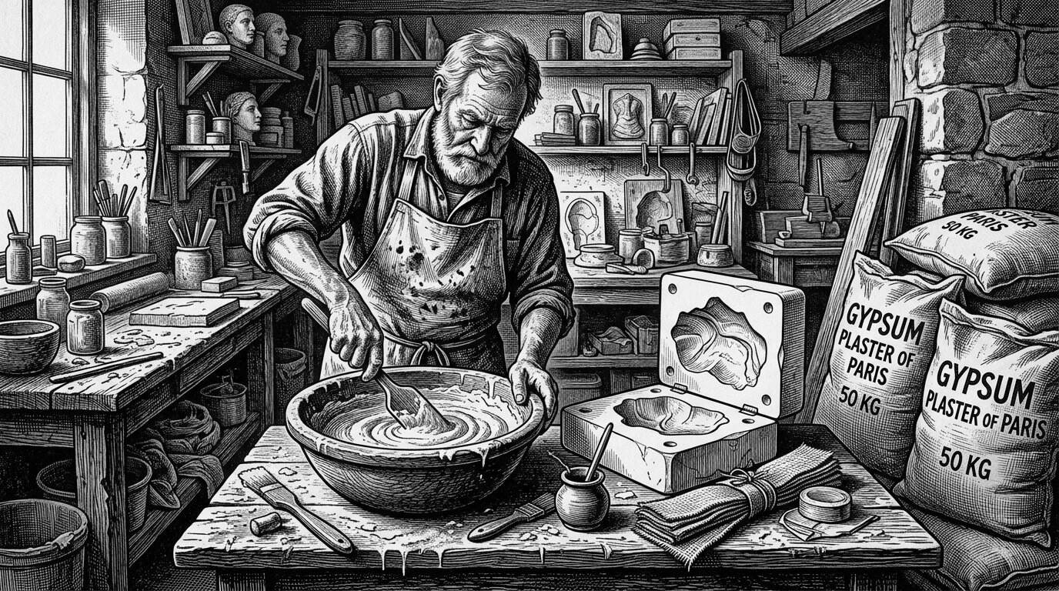
Gypsum plaster, often called plaster of Paris after the quarries near the capital, was the workhorse of the trade. It set quickly, took fine detail, and was cheap enough to copy. Almost every famous mask in these chapters began, before bronze or celebrity, as a bowl of wet gypsum and a race against time.

What the Cast Could Not Show
It is worth pausing here to acknowledge, without dwelling on it in graphic detail, that the casting process placed real and sometimes considerable strain on everyone involved. Family members present in the room, already grieving, had to tolerate the practical business of a stranger's hands working over the face of someone they loved. Sculptors themselves, working against time and often under emotional pressure from the family, could not always achieve the technically ideal result; historical accounts and surviving objects both suggest that hair was occasionally caught and damaged in the setting plaster, that skin could be marked or bruised during the careful process of separating a set mold from a face, and that some casting attempts were simply unsuccessful, requiring a second attempt or producing a final result the family considered unsatisfactory and chose not to preserve or display. None of this diminishes the historical value of the objects that did survive successfully. It is a reminder, consistent with points raised in earlier chapters, that a death mask was never a simple, effortless, mechanically perfect transcription of a face — it was the product of a difficult, sometimes imperfect human process, undertaken under some of the most emotionally charged circumstances imaginable.

Wax and the Illusion of Living Skin
Wax offered sculptors something plaster could not: a surface quality with genuine translucency, capable of suggesting the subtle glow of living skin in a way that opaque, chalky plaster never quite managed. This quality made wax an especially prized material for portrait busts and effigies intended for close, ongoing display, including the royal funeral effigies discussed in an earlier chapter, and it connected the death-mask tradition to a broader and genuinely fascinating culture of wax modeling that flourished in parts of Europe, particularly Italy, from the eighteenth century onward. In Florence, the anatomical wax models produced under sculptors such as Clemente Susini for the museum today known as La Specola achieved a level of anatomical detail and lifelike color so precise that they were used for genuine medical instruction, allowing students to study the structures of the human body in a level of vivid, three-dimensional detail that no illustration could fully match, without requiring the constant availability of actual cadavers. A related tradition, sometimes called moulage, produced detailed wax models of diseased tissue and skin conditions for use in medical teaching collections well into the twentieth century — a practice adjacent to, though distinct from, the death mask tradition proper, sharing its underlying material and, in a sense, its underlying instinct: that a carefully colored, textured wax surface could preserve visual medical information more vividly and durably than any two-dimensional image.
Wax's expressive advantages came at a real practical cost. It is a soft, temperature-sensitive material, vulnerable to warping or even melting under heat, prone to gradual discoloration and cracking with age, and, unlike plaster, attractive to certain insects and pests capable of damaging its surface over long storage. As a result, far fewer original wax death masks have survived in good condition across the centuries compared to their plaster counterparts, and many wax funeral effigies and masks known to historians through written and visual records no longer exist in their original form at all, having deteriorated, been damaged, or been deliberately replaced over the generations — a pattern of loss this chapter will return to shortly, when it turns to how museums and conservators think about "original" and "copy" today.
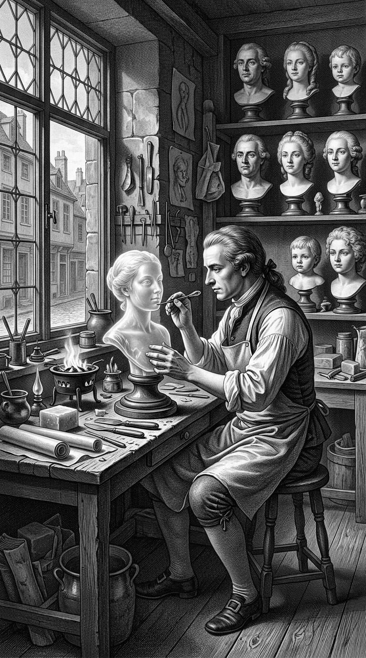
Wax offered what chalky plaster could not: a surface with translucency, a suggestion of living skin. It was prized for busts and funeral effigies meant to be looked at closely. It was also softer, more vulnerable to heat and handling — a material of intimacy and of conservation trouble.

From Plaster to Permanence: The Turn to Bronze
Bronze occupies a different position in this material history altogether. Unlike plaster and wax, bronze was almost never used to take a direct impression from a face; the metal-casting process required for bronze work involves intense heat entirely unsuited to contact with human skin, living or dead. Instead, bronze entered this story as a secondary material, used to produce especially durable, permanent reproductions from an existing plaster or wax original, through a casting process — closely related to methods used in bronze sculpture generally, including the long-established lost-wax casting technique — that could faithfully translate the fine surface detail of an original mold into a metal object capable of lasting, essentially unchanged, for centuries.
This durability made bronze the material of choice whenever a death mask was intended for permanent public display, incorporation into a monument or memorial, or long-term preservation in a major museum or institutional collection, and it explains why some of the most widely reproduced and publicly familiar death-mask images in this book's story — including versions of masks associated with figures such as Napoleon and Beethoven — exist today in bronze editions produced sometime after the original plaster casting, sometimes considerably later, based on the original mold or an early plaster cast taken from it. This creates a genuinely important point of historical nuance that this book has returned to repeatedly and will return to again: in a meaningful number of cases, the object a visitor encounters today in a museum case, admired as though it were the direct, unmediated product of a single historical moment, is in fact a later bronze reproduction, one or more removes from the original plaster impression taken from the actual face — durable, faithful in surface detail, and historically significant in its own right, but not, in the strictest sense, the same physical object that first touched the deceased.
Points of orientation
– Bronze's durability means that bronze reproductions of famous death masks have, in a number of documented cases, survived in better condition than the original plaster or wax mold used to create them.
– This means the object most visible to the public today — often prominently displayed, confidently labeled — may be a later, if faithful, reproduction rather than the first physical impression taken from the deceased.
– Recognizing this does not diminish these bronze casts' historical and artistic value; it simply requires being precise about what, exactly, a given object represents.
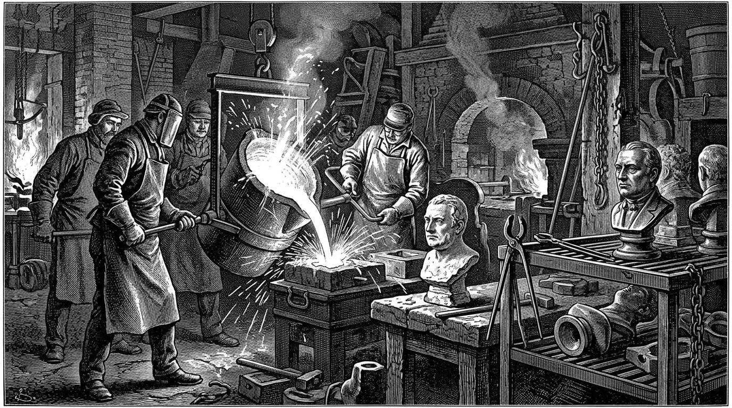
Bronze almost never touched a face. The heat of metal casting forbids it. Bronze entered this history as a second generation: a durable translation of a plaster original, made for monuments and for the kind of permanence that households and states believed a great name required.

The Traveling Trade in Plaster Faces
Alongside the individually commissioned masks of specific historical figures examined throughout this book, plaster's affordability supported an entire, less prestigious commercial trade that deserves mention here. From at least the early nineteenth century onward, itinerant sellers — many of them Italian craftsmen working a well-documented trade sometimes referred to by the Italian term *figurinai* — traveled across European towns and cities selling small, mass-produced plaster busts, statuettes, and, in some cases, reproductions of well-known death masks, to a general public eager for affordable versions of images otherwise associated with wealth, fame, or scholarly institutions. A middle-class household in nineteenth-century England or France might display a modestly priced plaster reproduction of Napoleon's or a favorite poet's death mask on a parlor shelf, purchased not from a sculptor's private commission but from a traveling cart or a shop specializing in this kind of affordable decorative reproduction. This commercial trade illustrates something this book has emphasized before: that by the height of the nineteenth-century death-mask culture, these objects had moved well beyond their origins as private memorial commissions, becoming, for a significant portion of the European public, an ordinary and widely available category of domestic decoration and popular commemoration, produced and sold at a considerable remove from the original, more intimate act of casting.
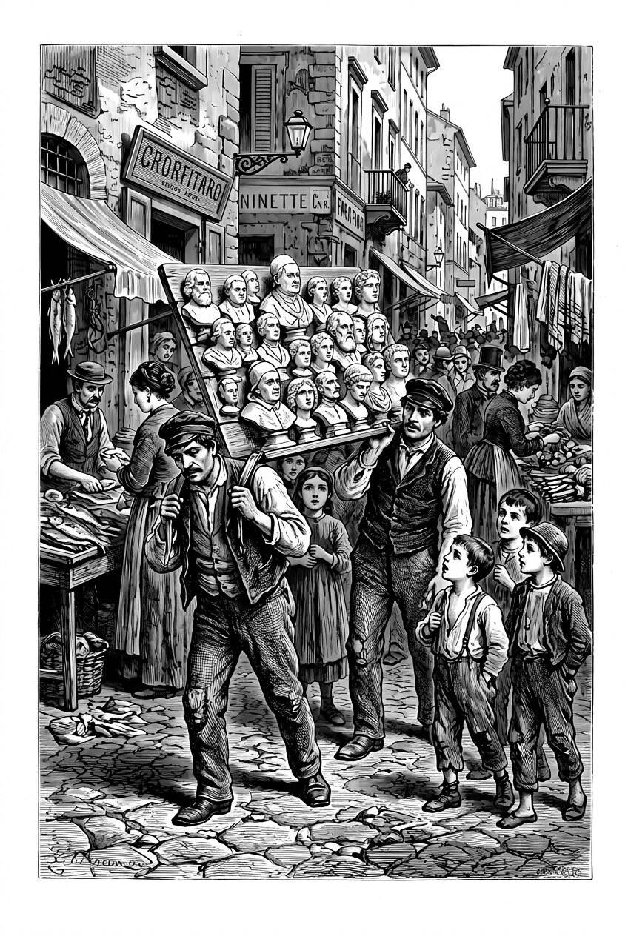
From at least the early nineteenth century, itinerant sellers — many of them Italian craftsmen — carried cheap plaster portraits through European streets. The same chemistry that preserved emperors also stocked a popular trade. Likeness, once a privilege, could be bought from a board on a man’s back.

Materials as Meaning
Beyond their practical properties, the three materials examined in this chapter carried distinct symbolic associations that shaped how contemporaries understood the objects made from them, even if this symbolism was rarely stated explicitly at the time. Plaster, cheap and workaday, carried an implicit democratic or at least practical character — the material of the ordinary, functional death mask, accessible to families and institutions without great wealth, and correspondingly, the material in which the vast majority of masks discussed throughout this book, famous and anonymous alike, were actually produced. Wax, with its lifelike translucency and its genuine physical impermanence — its literal vulnerability to melting and decay — carried an almost poetic appropriateness to its subject matter that contemporary observers occasionally noted directly: a material that could itself dissolve and disappear, used to memorialize a person who had already done exactly that. Bronze, by contrast, carried associations of permanence, civic honor, and public commemoration inherited directly from its long prior history in monumental sculpture and portrait busts of the powerful; a death mask reproduced in bronze implicitly asserted that its subject deserved to be remembered not just privately, within a family or a scholarly collection, but publicly and more or less permanently, in the same material tradition as the statues of generals and monarchs that had lined European public squares for centuries before.

Conserving a Face Twice Removed
The material realities explored throughout this chapter carry direct consequences for the museums, conservators, and archivists who care for these objects today, work already touched on in earlier chapters and examined in far greater depth in a later chapter of this book devoted specifically to museum collections and their ethics. A plaster mask that has survived for a century and a half has typically survived several rounds of handling, minor damage, and repair, sometimes performed by skilled conservators using techniques and materials well documented in institutional records, and sometimes performed decades or centuries earlier by less careful hands, using methods that are difficult to fully reconstruct today. Conservators examining a historic death mask must often work to distinguish original nineteenth-century plaster from later restoration filler, original surface texture from a later, well-meaning but historically inaccurate touch-up, and, in the case of masks that survive in multiple plaster, wax, and bronze versions across different collections, must grapple directly with the question raised earlier in this chapter: which surviving object, if any, most closely represents the original moment of casting, and how much does that distinction actually matter to the object's historical and cultural significance today.
This is not merely a technical or academic puzzle. It bears directly on how confidently a museum can label an object, how a historian can respectfully and accurately describe it to the public, and how honestly this book itself has tried, throughout its preceding chapters, to distinguish documented fact from confident-sounding tradition whenever the two diverge. The material history explored in this chapter is, in the end, inseparable from the questions of authenticity and evidence that have run through this book from its opening pages.

What Comes Next
Having examined the materials and methods behind these objects, this book now turns to some of the specific masks whose stories have become genuinely mysterious — cases where disputed attribution, lost documentation, or outright historical uncertainty have left researchers and museums without confident answers about a mask's true origin, its authenticity, or even, in some instances, the identity of the face it claims to represent. The next chapter gathers several of these cases together, examining what can be verified, what remains genuinely unresolved, and what these unresolved mysteries reveal about the limits of even the most careful historical scholarship applied to an object as intimate, and as easily misattributed, as a human face preserved in plaster, wax, or bronze.

Chapter 8

Famous Masks, Lost Identities, and Historical Mysteries
──────── ❧ ────────
Not every death mask in a museum case is what its label claims. Some are honest reproductions of honest originals. Others are the product of wishful thinking, commercial ambition, or simple confusion, repeated so often across the generations that the confusion itself became a kind of tradition.

A Museum of Doubt
If the preceding chapters have established anything clearly, it is that the history of the death mask cannot be told as a simple sequence of verified facts. Nearly every chapter so far has paused, at some point, to separate documented evidence from popular tradition, disputed attribution, or outright legend — the uncertain provenance of Napoleon's several surviving casts, the doubtful reliability of Madame Tussaud's own later account of her work during the French Revolution, the unresolved question of who exactly the Unknown Woman of the Seine actually was. This chapter gathers several additional cases where that gap between reputation and evidence becomes not just a passing complication, but the entire story worth telling. These are masks, heads, and preserved remains whose fame rests, in large part, precisely on the mystery surrounding them.

The Face That May Not Be Shakespeare's
Among the most persistently discussed disputed objects in this entire history is the so-called Kesselstadt Death Mask, a plaster cast that surfaced in Germany in 1849, when it was discovered among the belongings of a noble family, the Kesselstadts, bearing a painted inscription including the date 1616 — the same year William Shakespeare died in Stratford-upon-Avon. The mask's resemblance to established portraits of Shakespeare, combined with the matching date, generated enormous excitement among scholars and the public alike when it was first publicized, and the object has continued to attract serious, if largely inconclusive, scholarly attention ever since.
The case for authenticity has never been especially strong, judged by the standards this book has tried to apply consistently throughout. There is no contemporary seventeenth-century documentation describing a death mask being taken from Shakespeare's face at all, a striking absence given how much scholarly effort has gone into reconstructing the details of Shakespeare's life and death from surviving records. The inscribed date on the mask itself has been subjected to close physical and stylistic examination, with some specialists arguing the lettering style is inconsistent with genuine early seventeenth-century practice, suggesting a later addition intended to enhance the object's apparent significance, whether through innocent misattribution or more deliberate embellishment. Facial comparison with the small number of portraits reasonably accepted as authentic depictions of Shakespeare — themselves a subject of ongoing scholarly debate — has produced genuine disagreement rather than consensus, with some researchers finding meaningful resemblance and others finding the comparison unconvincing.
Most Shakespeare scholars today treat the Kesselstadt mask with considerable skepticism, regarding it as, at best, an unproven and probably unprovable claim, and at worst, a later fabrication or honest misattribution that gained momentum simply because the idea of a surviving physical trace of Shakespeare's actual face proved too appealing to resist. The mask continues to be exhibited and discussed, and reproductions of it remain widely available, but it stands today as a useful illustration of a pattern this book has now traced through several chapters: an object's persistent popularity and its actual evidentiary strength are, disappointingly often, almost entirely unrelated to one another.
Points of orientation
– Contemporary documentation describing the casting itself, ideally naming who made it, when, and under what circumstances.
– A continuous, traceable chain of ownership connecting the object from its claimed origin to its present location, without unexplained gaps.
– Physical and stylistic analysis consistent with the claimed period of creation, rather than later materials, techniques, or lettering styles.
– The Kesselstadt mask fails, or at minimum cannot satisfy, most of these tests, which is precisely why serious scholars remain unconvinced despite the object's enduring popular appeal.
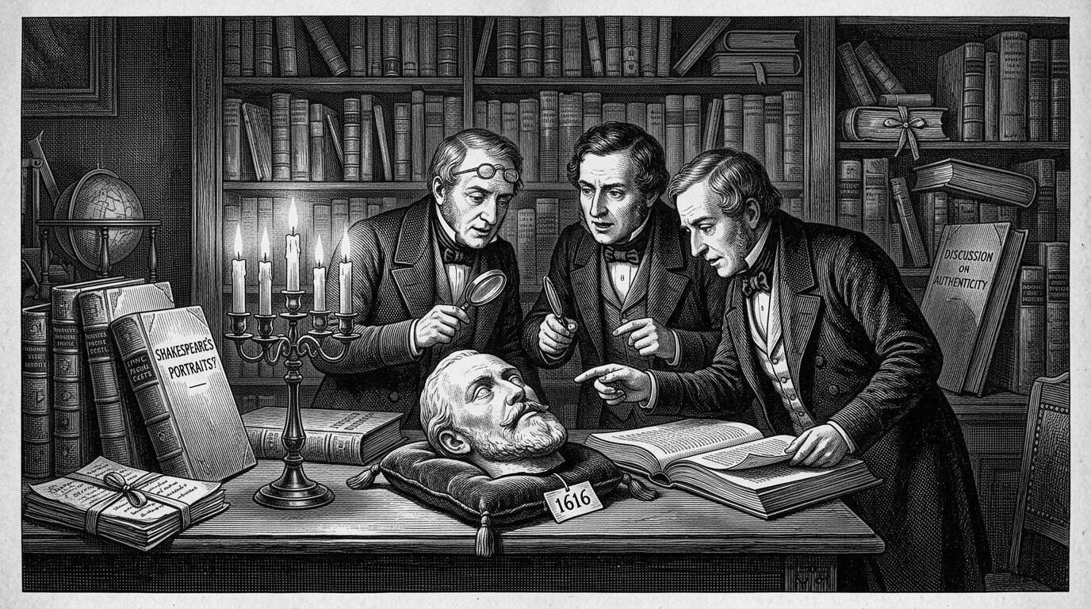
The so-called Kesselstadt death mask surfaced in Germany in 1849 among a noble family’s belongings, with a painted date of 1616 — the year Shakespeare died. Wish and commerce did the rest. Serious attribution has never been able to carry the object from a German attic to a bed in Stratford.

The Mask That Was Never Made: Mozart's Missing Face
A different, and in some ways more instructive, kind of mystery surrounds the composer Wolfgang Amadeus Mozart, who died in Vienna in December 1791. Popular imagination has long assumed, understandably given how thoroughly this book has documented the death-mask tradition surrounding other major composers, that a death mask of Mozart must exist somewhere, waiting to be properly recognized. The historical record does not support this assumption. Mozart was buried, in keeping with common Viennese burial customs of the period for individuals of his social and financial standing, in a common grave rather than an individually marked plot, and no reliable contemporary source describes a death mask being taken from his face at the time of his death. Various objects have, over the subsequent two centuries, been proposed or rumored as possible Mozart death masks or life masks, but none has achieved anything close to scholarly consensus regarding authenticity, and the most careful modern assessments generally conclude that no credible death mask of Mozart survives, if one was ever made at all.
This case is worth including specifically because it inverts the pattern of the Kesselstadt mask. Rather than a specific, disputed physical object commanding ongoing debate, Mozart's case involves the near-total absence of any object at all, standing in tension with a persistent popular belief that one ought to exist. The gap between what people assume must be true, given a figure's fame and the era's documented customs, and what the historical record actually supports is, in its own way, just as revealing as the more dramatic controversies surrounding objects like the Kesselstadt mask. It is a reminder that even genuinely well-documented historical periods and figures can leave real, permanent gaps in the physical record, gaps that popular memory tends to fill with confident assumption rather than comfortable uncertainty.
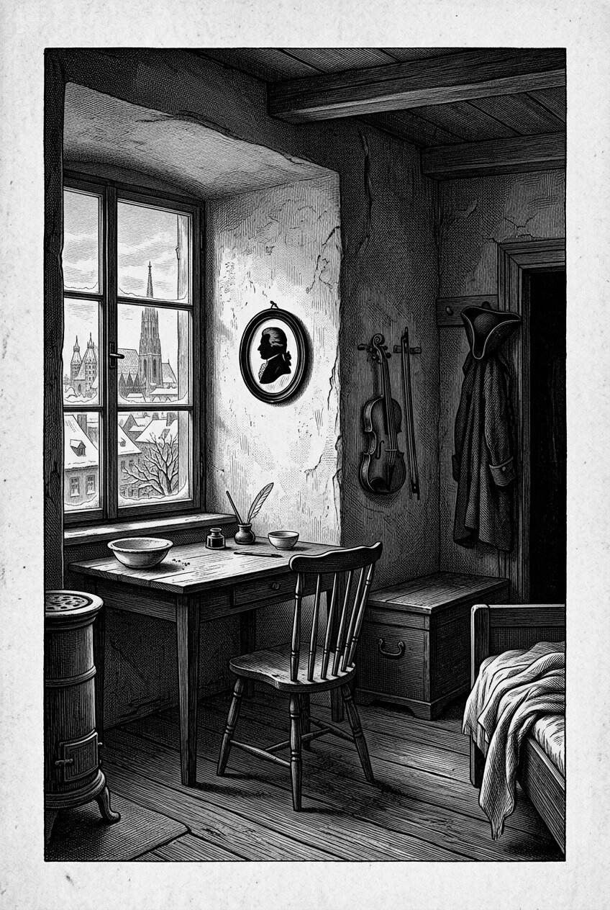
Mozart died in Vienna in December 1791. Popular imagination, trained by the well-documented masks of later composers, has long assumed that his face must exist in plaster somewhere. The documentary trail that would be needed to say so is not there. Absence, in this case, is the historical fact.

A Head With No Mask At All: Cromwell's Long Journey
Some of the strangest stories in this book's broader territory involve not a cast taken from a face, but the astonishing post-mortem fate of an actual preserved head — a case that belongs in this chapter precisely because it illustrates, in unusually vivid and well-documented form, the same questions of authenticity, provenance, and custody that surround the disputed masks already discussed. Oliver Cromwell, the military and political leader who governed England as Lord Protector following the execution of King Charles I, died of natural causes in 1658 and was given an elaborate state funeral and burial at Westminster Abbey. Following the restoration of the monarchy under Charles II in 1660, however, Cromwell's body was exhumed in an act of deliberate political retribution, subjected to a posthumous ritual of execution, and his head was severed and displayed on a pole outside Westminster Hall, where, according to well-documented historical accounts, it remained on public view for a number of years.
What followed is a genuinely remarkable, if grim, chain of custody, traceable through a sequence of private owners, collectors, and exhibitors across the following three centuries: the head reportedly blew down from its pole at some point and was recovered by a soldier, subsequently passing through a series of private hands, occasional public exhibition as a curiosity, and periods of more discreet, private ownership, before eventually being acquired by descendants of the Cromwell family in the early twentieth century. Scientific examination conducted in the 1930s, comparing the preserved head against Cromwell's known portraits and the documented historical account of his death and burial, concluded that the head was very likely genuine, and it was finally given a formal, permanent burial in 1960 in the grounds of Sidney Sussex College, Cambridge, Cromwell's own college as a young man, at a location that has been kept deliberately unmarked and undisclosed in order to prevent any further disturbance.
Cromwell's case does not involve a death mask in the technical sense this book has used throughout, but it belongs squarely within this chapter's larger concerns. It demonstrates, in an unusually extreme and well-documented form, how thoroughly a society's treatment of a notable person's physical remains can be driven by political meaning rather than simple commemoration, how many hands and how much uncertainty can accumulate around even a genuinely authenticated relic across several centuries, and how modern scientific examination — comparable in spirit to the authenticity assessments applied to disputed masks like the Kesselstadt cast — can eventually bring a measure of confident resolution to a story that spent centuries as pure rumor and curiosity.
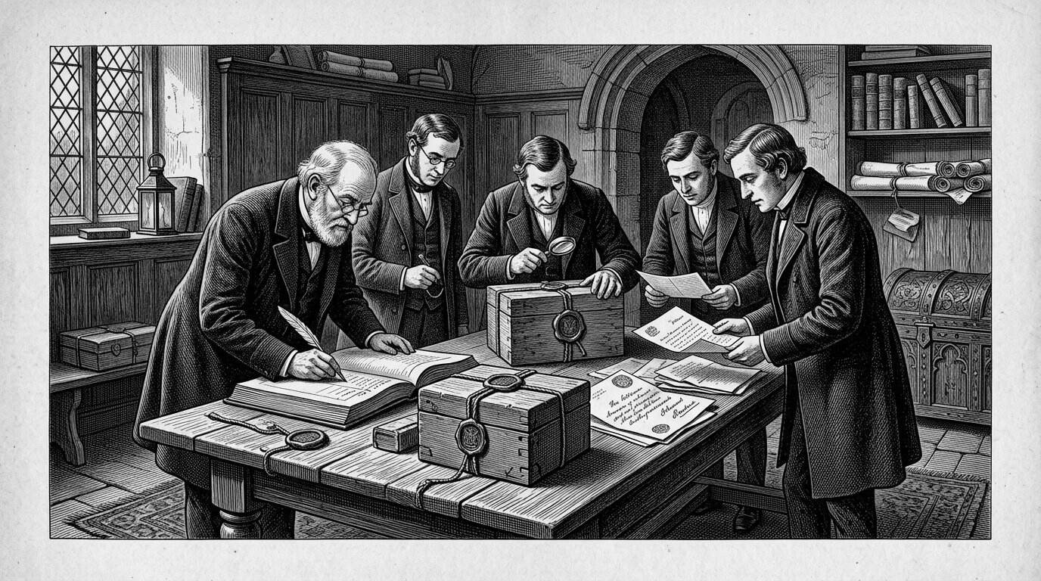
Some of the strangest provenances in this territory do not involve a cast at all, but the custody of actual remains — most famously the long, well-documented wanderings associated with Oliver Cromwell’s head. The questions are the same ones that haunt disputed masks: authenticity, ownership, and who has the right to keep a person as an object.

The Business of Believing: How Fake Masks Enter the Market
The Shakespeare and Mozart cases, taken together, point toward a broader pattern worth naming directly: throughout the period this book examines, and particularly during the height of nineteenth-century collecting culture already discussed in earlier chapters, there existed real commercial incentive to produce, or simply to claim, death masks of famous historical figures, regardless of whether reliable evidence actually supported the attribution. A plaster cast confidently labeled as the death mask of a beloved poet, composer, or historical hero commanded far greater interest, and far greater commercial value, than an honestly labeled later reconstruction or an object of genuinely uncertain origin. This incentive did not necessarily require outright, deliberate fraud in every case; honest confusion, optimistic wishful thinking passed down across generations of ownership, and the simple, gradual erosion of accurate provenance records over decades of private sale and inheritance could all produce the same practical result as intentional forgery, an object confidently presented to the public as something the available evidence does not actually support.
This pattern has left modern museums, auction houses, and historians with an ongoing, genuinely difficult task: assessing claimed death masks not by their popular reputation or the confidence of their existing labels, but through the kind of careful, multi-pronged verification process outlined earlier in this chapter's discussion of the Kesselstadt mask — documentary evidence, unbroken provenance, and physical and stylistic analysis consistent with the claimed period of origin. Where that verification succeeds, as with the Cromwell head's twentieth-century scientific examination, a long-uncertain object can be given a genuinely confident historical identity. Where it fails, or where the evidence remains permanently too thin to resolve one way or the other, honest historical practice requires living with the uncertainty rather than resolving it through confident assertion, however unsatisfying that uncertainty might be to museum visitors hoping for a definitive answer.

Relics Beyond the Face: Hearts, Fingers, and the Wider Cult of Remains
It is worth briefly widening the lens here, because the impulse driving the death mask tradition examined throughout this book did not confine itself to faces alone, and understanding that broader context helps explain why claims like the Kesselstadt mask found such a receptive public in the first place. The desire to retain some direct physical connection to a revered figure after death produced, across the same historical period, a wider and genuinely striking culture of preserving other bodily fragments of the notable dead. Frédéric Chopin's heart, removed following his death in 1849 according to his own reported wishes and the customs of the period, was transported to Warsaw and sealed within a pillar of the Holy Cross Church, where it remains today, periodically the subject of renewed scholarly and medical interest regarding the cause of his final illness. The astronomer and physicist Galileo Galilei, who died in 1642, had several fingers, a tooth, and a section of vertebra removed from his remains during a documented eighteenth-century exhumation and reburial, relics that were subsequently displayed and, after passing through private hands for over a century, eventually reunited and placed on public display at the Museo Galileo in Florence.
These relics operated according to a logic closely related to, though distinct from, the death mask tradition examined throughout this book: where a death mask preserved the appearance of a face, these physical relics preserved a literal, unmediated fragment of the person themselves, offering an even more direct, if considerably more unsettling to modern sensibilities, form of physical connection to a revered historical figure. Understanding this wider culture of relic preservation helps explain why claims surrounding objects like the Kesselstadt mask found such fertile ground among nineteenth-century audiences already primed, by a well-established broader tradition, to believe that a direct physical trace of a beloved historical figure might plausibly have survived, waiting to be rediscovered.
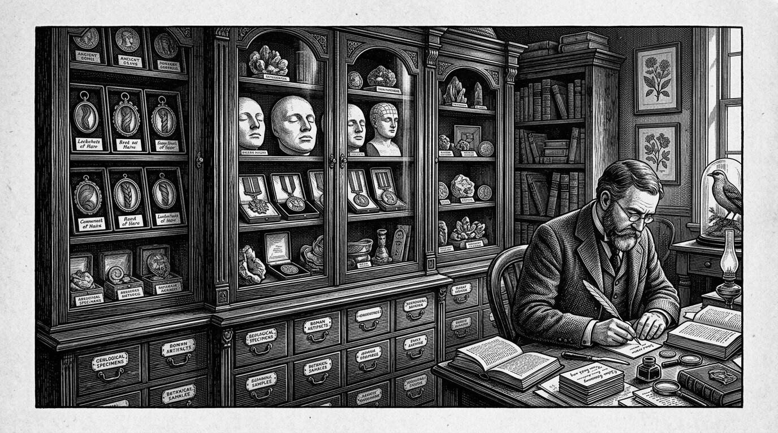
Nineteenth-century collecting culture created a market incentive to produce, or simply to claim, the faces of the famous. Hair, hearts, fingers, and plaster all fed the same hunger for a direct physical link. Relic culture did not end with the saints; it found new saints in poets, generals, and composers.

What These Mysteries Have in Common
Considered together, the cases gathered in this chapter — a disputed mask, a mask that most likely never existed at all, an authenticated head with an extraordinary and well-documented chain of custody, and a wider culture of bodily relics extending well beyond the face — share a single underlying dynamic that this book has returned to from its opening pages. The desire to hold onto some direct, physical trace of a person who mattered is powerful enough to generate not only genuine, carefully documented historical objects, but also honest confusion, wishful misattribution, and outright commercial fabrication, often in roughly equal measure, and frequently tangled together within the history of a single object. Separating one from the other requires exactly the kind of patient, unglamorous documentary and physical analysis this book has tried to model throughout its preceding chapters: checking dates against known biography, tracing ownership across generations, comparing surviving portraits with careful attention rather than eager assumption, and, perhaps most importantly, remaining genuinely willing to conclude, as the honest answer regarding Shakespeare's disputed mask and Mozart's missing one both ultimately require, that the true and complete answer may simply be that we do not, and quite possibly cannot, know for certain.
That uncertainty is not a failure of this book, or of the historians and conservators whose careful work it draws upon. It is, in its own way, as central to the real history of the death mask as any confidently attributed, well-documented object examined in the chapters before this one — a reminder that even our deepest, most persistent desire to hold onto the face of someone we have lost does not, by itself, guarantee that what survives is genuinely theirs.

Chapter 9

Museums, Collections, Ethics, and the Afterlife of the Dead
──────── ❧ ────────
A death mask does not stop accumulating history the moment it is cast. It keeps being owned, displayed, argued over, and reassessed, sometimes for centuries longer than the person it depicts was ever alive.

From Studio Shelf to Glass Case
Nearly every mask examined in this book has followed some version of the same broad trajectory: made in private, in the immediate aftermath of a death, by a sculptor working for a grieving family, a scientific institution, or the state, and only later — sometimes within years, sometimes only after a century or more of private ownership — finding its way into the kind of public museum or university collection where most readers of this book have likely encountered a death mask for themselves. That final step, from private object to public artifact, is not a neutral or automatic one. It involves decisions, made by specific people and institutions, about what an object means, who has the right to hold and display it, and what obligations, if any, the institution takes on toward both the historical record and the memory of the person the object represents.
This chapter turns directly to those decisions, and to the broader, still unresolved questions of ethics and stewardship that now surround death masks and related human remains held in museum and university collections around the world. It draws together threads raised throughout the preceding chapters — the consent so rarely granted by the condemned and the unidentified, the scientific ambitions that once justified collecting the skulls and faces of criminals, the commercial trade that turned private grief into a marketable curiosity — and asks what responsible modern institutions owe to all of it now.
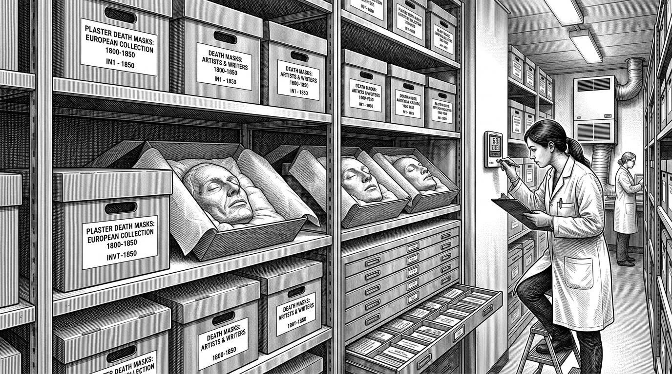
Almost every mask in this book was made in private and only later — sometimes after a century of household shelves — entered a museum or a university. The afterlife of the object is longer than the life it records. Storage, loan, and cataloguing become part of the face’s biography.

A Question the Object Cannot Answer for Itself
The question of consent, raised at several points earlier in this book, deserves to be gathered together explicitly here, because it sits at the center of nearly every serious ethical debate modern museums now have about these collections. The range of circumstances under which the masks discussed in this book were made is genuinely wide. Jeremy Bentham, examined in an earlier chapter, explicitly and deliberately consented in advance to the display of his own preserved remains, leaving detailed instructions in his will. Beethoven's and Chopin's families, by contrast, commissioned masks of their loved ones without any documented instruction from the deceased themselves on the matter, acting instead from grief and a desire for commemoration that most modern readers would likely find sympathetic and understandable, even without formal consent from the person being cast. The executed criminals whose skulls and faces filled nineteenth-century phrenological collections had no meaningful opportunity to consent or object at all, their bodies treated as a further extension of a punishment the state had already decided they deserved. And the unidentified dead displayed at institutions like the Paris morgue existed in a kind of consent vacuum entirely: no family present to grant or withhold permission, no documented wishes of any kind, simply an anonymous body processed according to institutional necessity.
A responsible modern institution holding objects from across this entire spectrum cannot apply a single, uniform ethical standard to all of them, because the objects themselves did not originate under a single, uniform set of circumstances. This has pushed many museums and universities toward a more case-by-case, deliberately researched approach to their collections — examining, wherever possible, exactly how and under what circumstances a given mask or set of remains was originally obtained, and using that research to inform decisions about display, description, and, in some cases, whether the institution should continue to hold the object at all.
Points of orientation
– Voluntary, explicit consent (Bentham's auto-icon): the clearest ethical case, though even here questions remain about how future generations should honor a centuries-old personal wish.
– Family-commissioned memorial masks (Beethoven, Chopin, and most of the masks examined in this book): made without the direct consent of the deceased, but within a recognizable and broadly sympathetic tradition of grief and commemoration.
– State-collected masks of the condemned: made under conditions of essentially total power imbalance, with the subject unable to object in any meaningful sense.
– Masks of the unidentified: made in the complete absence of any consenting party at all, raising distinct questions about who, if anyone, can meaningfully speak for the deceased today.

The Museum That Had to Reckon With Itself
Few institutions illustrate the practical stakes of this ethical reassessment more directly than the Museum of Criminal Anthropology in Turin, the very collection assembled by Cesare Lombroso and examined in an earlier chapter, which today holds not only the skulls, casts, and photographs Lombroso gathered from executed criminals and psychiatric patients over the course of his career, but Lombroso's own donated skeleton and preserved brain as well. The museum's modern curators face an unusually direct version of a challenge shared by many institutions holding similar nineteenth-century scientific collections: how to preserve and present historically significant material — material that documents, in vivid and irreplaceable physical form, exactly how a deeply flawed and often prejudiced scientific movement actually operated — without either endorsing the discredited theories the collection was originally built to support, or simply hiding the collection away as too uncomfortable to display at all.
The approach adopted by institutions in this position, including the Turin museum, has generally involved substantial contextual reframing rather than either uncritical display or outright removal: extensive interpretive material explaining the racist and pseudo-scientific assumptions that shaped the original collection, explicit acknowledgment that the individuals represented in the collection could not consent to their inclusion, and a deliberate curatorial shift toward presenting the museum itself as a historical artifact of a discredited scientific movement, rather than as a straightforward scientific resource in the tradition Lombroso himself had intended. This reframing does not resolve every ethical tension the collection raises — critics have continued to debate whether display of these remains under any interpretive framing adequately respects the individuals involved, particularly given how thoroughly their inclusion in the collection violated the standards of consent modern institutions claim to uphold — but it represents a genuine, ongoing attempt to hold two things true at once: that the collection retains real historical and educational value, and that the circumstances of its creation were genuinely unjust.
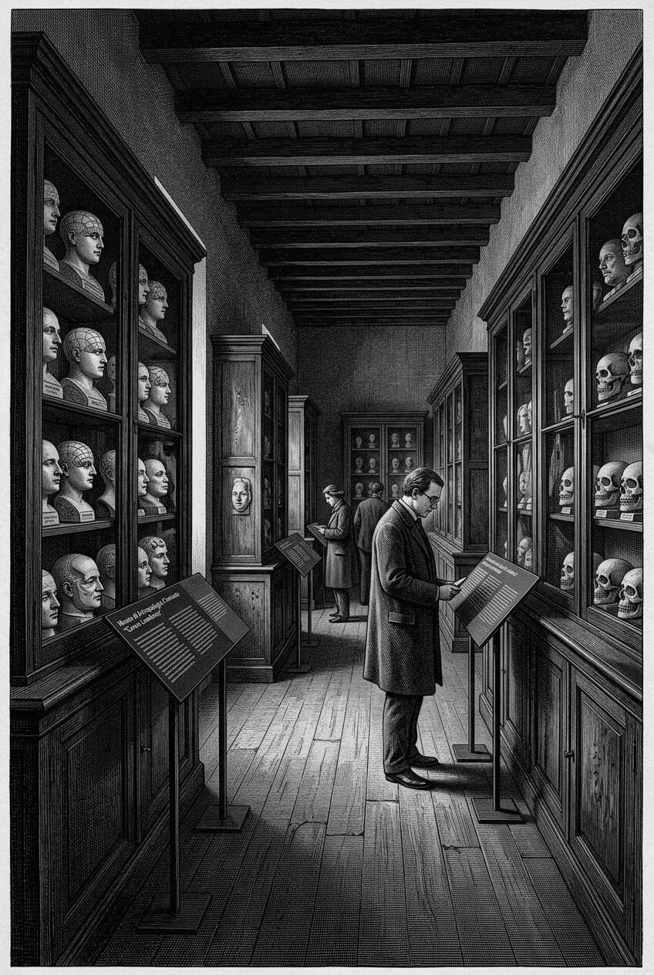
The Museum of Criminal Anthropology in Turin, built around Lombroso’s collection, has had to exhibit not only the casts he gathered from prisoners and patients, but the problem of the gathering itself. Few institutions show more clearly how a scientific museum can be forced to become a critique of its own founder.

Law Catches Up: Regulating Human Remains in Collections
Museum practice in this area has increasingly been shaped by formal legal frameworks, rather than institutional discretion alone. In the United Kingdom, for example, the Human Tissue Act, passed in 2004 following a series of earlier controversies over the retention of human tissue and organs without adequate consent, established a formal legal framework governing the storage, display, and use of human remains less than one hundred years old, including specific licensing requirements for public display, and created formal guidance encouraging, though not always strictly requiring, similar standards of care and documentation for older remains as well. Comparable legal and regulatory frameworks, varying considerably in their specific requirements, have developed in other countries, generally reflecting a broader international shift, accelerating from the late twentieth century onward, toward treating human remains held in museum and scientific collections as subject to genuine ethical and legal obligation, rather than simply as scientific or artistic property belonging outright to the institution that happened to possess them.
This legal evolution has directly affected how institutions approach the kinds of objects examined throughout this book. A death mask itself, being a plaster, wax, or bronze reproduction rather than actual human tissue, typically falls outside the strictest provisions of laws like the UK's Human Tissue Act, which is generally concerned with genuine bodily material. But masks are frequently held and displayed alongside genuine human remains — skulls, preserved organs, and in cases like Lombroso's own donated brain, actual anatomical material — within the same collections and often the same physical displays, meaning that institutions holding significant death-mask collections have generally had to develop broader ethical and legal policies covering their collections as a whole, rather than treating masks as entirely exempt from the more serious obligations attached to actual human remains.

To Display or Not to Display
For institutions holding these collections today, the practical question of what to actually put on public view, and how, has become a genuinely difficult and actively debated area of museum practice. Several distinct approaches have emerged across different institutions, each carrying its own advantages and its own critics. Some museums have chosen to continue displaying disputed or ethically fraught material largely as before, adding contextual signage and interpretive material — the approach broadly taken by the Lombroso museum — on the reasoning that removing the objects from view risks erasing an important and uncomfortable history rather than confronting it honestly. Others have moved more sensitive material out of permanent public galleries and into restricted access collections, available to researchers and scholars under specific application but no longer part of the general visitor experience, a compromise intended to preserve the material's research value while limiting its exposure as public spectacle. A smaller number of institutions have gone further still, choosing in specific, carefully considered cases to return particular remains to descendant communities or, where no such community can be meaningfully identified, to arrange respectful burial or other disposition, effectively ending the object's institutional life altogether.
None of these approaches has emerged as a clear, universally accepted standard, and this book does not attempt to argue that one is straightforwardly correct. The right answer, in the judgment of most museum ethicists working in this area today, appears to depend heavily on the specific circumstances of each object: how it was obtained, whether identifiable descendants or communities exist and what their own wishes are, how significant the object's historical or scientific value genuinely is, and how effectively an institution can actually provide the kind of careful contextual framing that makes continued display defensible rather than merely convenient.
Points of orientation
– Continued display with expanded context: preserves public access and confronts difficult history directly, but risks normalizing continued exhibition of objects obtained without consent.
– Restricted research access: limits the object's exposure as public spectacle while preserving its scholarly value, though it removes the material from the kind of public engagement that can also serve genuine educational purposes.
– Repatriation or respectful disposition: directly addresses the original absence of consent, but is only meaningful where identifiable descendants or communities exist to receive the remains, and permanently forecloses future historical and scientific study.
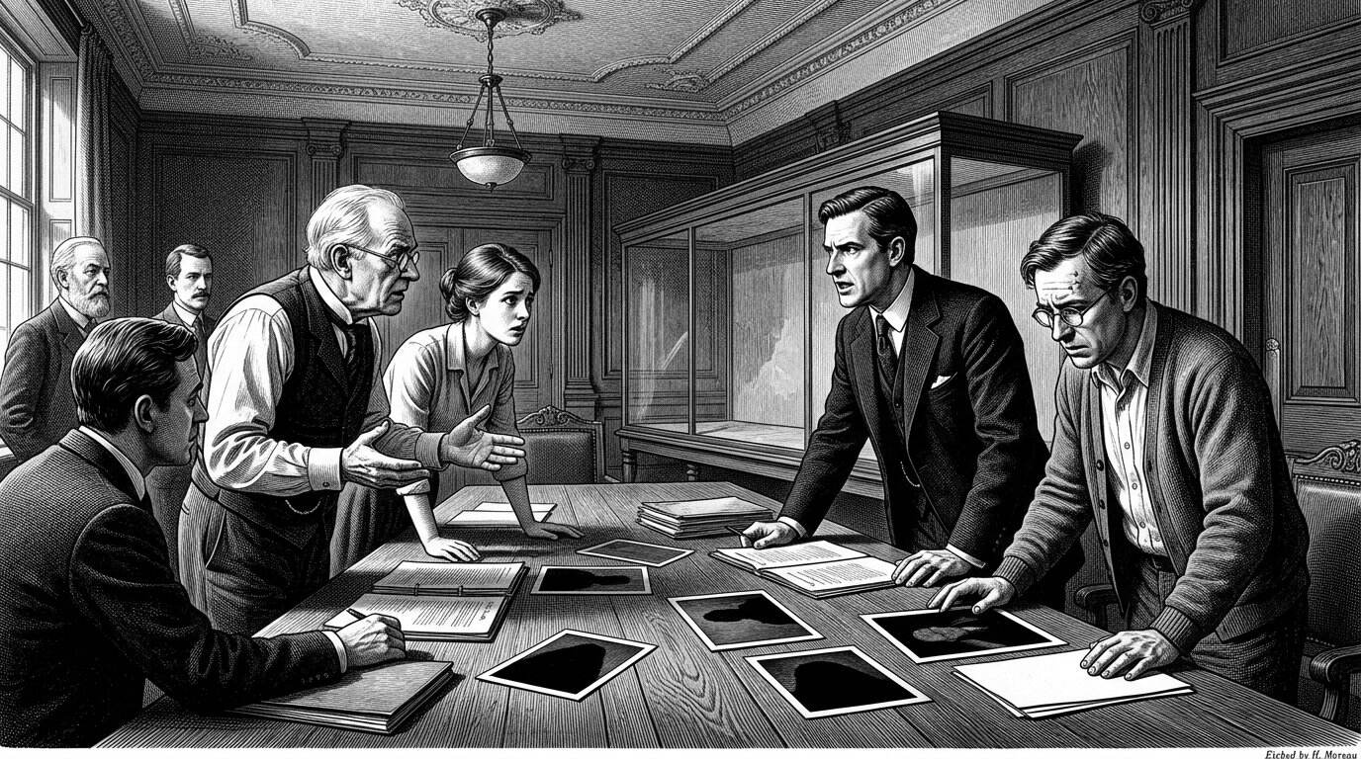
Law has begun to limit what discretion once decided. In the United Kingdom the Human Tissue Act 2004, written after scandals over organs kept without adequate consent, set rules for storage and display. Curators now sit with lawyers and families, asking whether a face should be in a case at all.

Provenance Now: What Museums Owe the Objects They Hold
The disputed masks examined in the previous chapter — the Kesselstadt cast claimed as Shakespeare's, the various competing versions of Napoleon's death mask — point toward a second, related obligation that has become increasingly central to responsible museum practice: rigorous, honestly documented provenance research, conducted and published with the same transparency this book has tried to model throughout its own account of these objects. Where earlier generations of museum curators were often content to display an object under whatever attribution had accompanied it into the collection, contemporary museum practice increasingly expects institutions to actively research, and honestly publish, exactly what can and cannot be verified about an object's origin, including cases where that research undermines a treasured, long-standing attribution the museum itself had previously promoted.
This shift reflects a broader professional recognition, well established in museum ethics literature by the early twenty-first century, that an institution's credibility depends on this kind of honesty, even when it is commercially or reputationally inconvenient. A museum that continues to display a disputed mask under a confident, unqualified attribution it privately knows to be unsupported by the evidence is not simply making an interpretive choice; it is participating in exactly the kind of confident-sounding misinformation this book has tried to identify and correct throughout its account of figures like Shakespeare, Dante, and the many contested versions of Napoleon's cast.

The Private Market and Its Different Rules
It is worth noting directly that the ethical and legal frameworks discussed in this chapter apply far more consistently, and far more strictly, to public museums and universities than to the private market in historical death masks, which continues to operate today through auction houses, specialist dealers, and private collectors, generally subject to considerably less regulatory oversight and considerably less consistent standards of provenance research than major public institutions maintain. Historic death masks, along with related material such as life masks and cast reproductions of famous faces, continue to appear at auction and in private sale on a fairly regular basis, valued by collectors for reasons ranging from genuine historical interest to the same kind of morbid, intimate fascination this book has traced back to the earliest chapters of its story.
This private market operates under a different and generally weaker set of incentives than public institutions face. A private collector or dealer has far less obligation, whether legal or reputational, to conduct or publish rigorous provenance research before offering an object for sale, and the same commercial pressures that historically encouraged confident, insufficiently supported attributions — discussed at length in the previous chapter's account of the market for supposed masks of famous historical figures — continue to operate in the contemporary private market largely unchanged. Buyers in this market, whether private collectors or, on occasion, museums acquiring new material, generally bear the primary responsibility for conducting their own due diligence regarding an object's authenticity and history, a considerably less reliable safeguard than the more formalized research standards increasingly expected of major public institutions.

Scanning Instead of Touching: Digital Preservation
One genuinely promising development in recent decades offers a partial resolution to some of the tensions this chapter has examined, without fully resolving the underlying ethical questions. High-resolution three-dimensional scanning technology now allows museums and researchers to create extremely detailed digital models of fragile physical masks, capturing surface detail with a level of precision that can support serious scholarly study, public digital access, and even physical reproduction through modern printing techniques, all without requiring the kind of repeated physical handling that has historically damaged fragile plaster and wax originals over generations of use. Several major collections holding significant death-mask material have begun digitizing their most historically important and physically vulnerable objects, making detailed digital models available to researchers and the public alike, while the fragile physical originals themselves are handled far less frequently and preserved instead in carefully controlled storage conditions.
Digitization does not resolve the deeper ethical questions this chapter has examined regarding consent, display, and repatriation — a perfect digital scan of a mask taken from an executed criminal without any consent raises many of the same underlying questions as the physical object itself, simply in a new and more widely distributable form, and some ethicists have specifically raised concerns about whether unrestricted digital reproduction of sensitive human-remains-adjacent material might actually increase inappropriate circulation and use rather than limiting it. But as a tool for reducing physical damage to irreplaceable historical objects, and for expanding legitimate scholarly and educational access without requiring an object to leave secure, carefully monitored storage, digital preservation represents a genuinely valuable addition to the conservation practices this book examined in an earlier chapter, one that would have been entirely unavailable to the museums and collectors who first assembled these collections across the eighteenth, nineteenth, and early twentieth centuries.
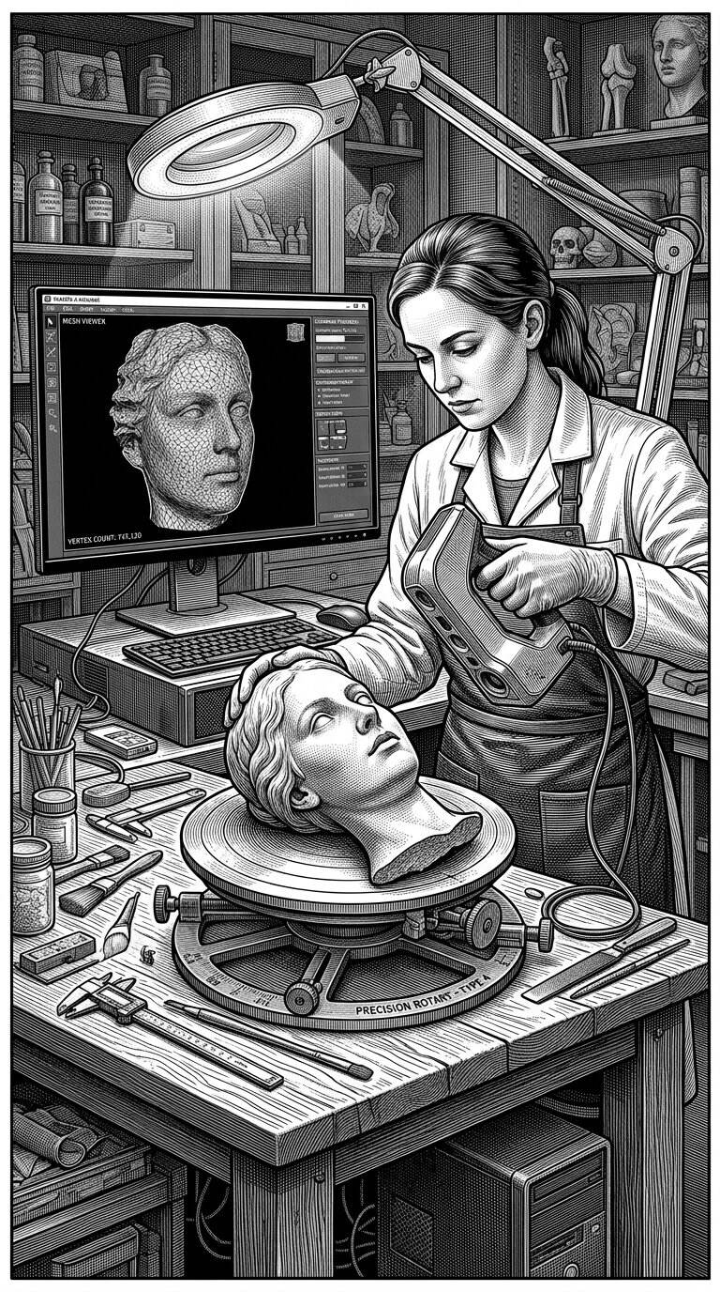
High-resolution three-dimensional scanning lets institutions model a fragile cast without passing it from hand to hand. The digital copy does not dissolve the ethical question of the original, but it changes the practical one: research and teaching can continue while the plaster stays in the dark.

What We Choose to Keep, and Why
The questions raised throughout this chapter do not resolve into a tidy conclusion, and that absence of resolution is itself an accurate reflection of where serious museum ethics on this subject currently stands. Institutions holding death masks and related human remains today are, in most well-run cases, no longer operating under the confident, largely unexamined assumptions that guided the original nineteenth-century collectors this book has spent so many chapters describing — the phrenologists convinced they were advancing legitimate science, the morgue administrators convinced public display served an unambiguous public good, the private collectors and dealers largely indifferent to the question of consent altogether. In their place has come a far more careful, far more self-critical, and still genuinely unsettled set of institutional practices, shaped by law, by professional ethics, by ongoing scholarly debate, and by the ongoing, case-by-case work of curators and conservators trying to honor both the historical significance of what they hold and the basic dignity of the people those objects were once, however briefly and however imperfectly, a direct physical trace of.

Chapter 10

The Enduring Fascination with the Death Mask
──────── ❧ ────────
The plaster and the wax have mostly given way to scanners and software, but the question underneath them has not changed at all: what, if anything, can we keep of a face once its owner is gone?

A Sculptor's Workshop, Today
Picture a small studio, not in nineteenth-century Vienna or Paris but in a city today, somewhere in Europe or North America — a composite, imagined scene rather than a documented one, though it describes a kind of appointment that genuinely still takes place, quietly, in the present day. A family has contacted an independent sculptor, one of a small number who continue to offer this specific, unusual service, asking that a cast be taken of a parent's or partner's face in the hours after death, in keeping with a tradition this book has now traced across several centuries and several continents. The materials have changed only modestly — alginate, a fast-setting dental and medical impression material largely unavailable to nineteenth-century practitioners, has in many cases replaced plaster as the preferred medium for the initial mold, offering greater precision and gentler removal, with the final positive cast still typically finished in plaster, wax, or occasionally a more durable resin. The underlying motivation, and the underlying scene, would be entirely recognizable to the sculptors and grieving families examined throughout this book: a desire, in the rawest and most disorienting hours of loss, to hold onto something more direct than a photograph, something that had actually, physically touched the person now gone.
This final chapter turns to that continuity, and to the question this book has asked from its opening pages, revisited now with the full weight of everything the preceding chapters have gathered: why does this impulse endure, across so many centuries, so many technologies, and so many changes in how societies understand death, science, art, and identity — and what, if anything, does its persistence tell us about what a face actually means to the people left behind.
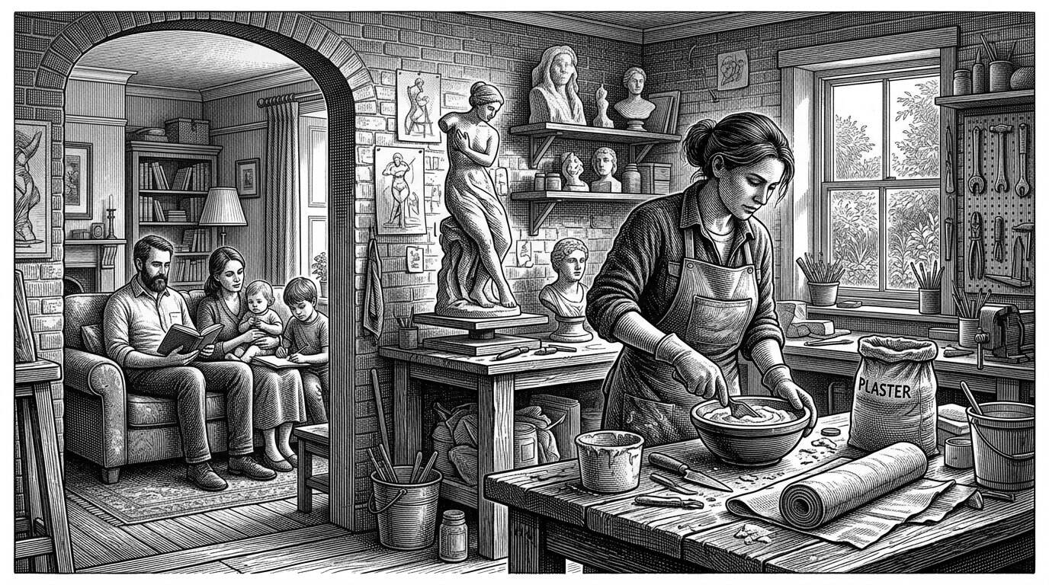
The traditional commission has not entirely vanished. A small number of independent sculptors still take a cast when a family asks, quietly, in ordinary rooms. The tools would be recognisable to a nineteenth-century moulder. The surrounding world — cameras, hospitals, crematoria — would not.

The Old Impulse in New Materials
The death mask in its traditional form, while it has not disappeared, now occupies a genuinely small corner of a much larger, technologically transformed landscape of practices aimed at preserving or reconstructing the human face after death. Forensic facial reconstruction, a direct technological descendant of the identification concerns examined in an earlier chapter of this book, has developed enormously since the early twentieth century, now employing detailed clay or digital modeling built up over an actual or scanned skull, informed by statistical data about typical soft-tissue depth at dozens of specific points across the human face, allowing forensic specialists and archaeologists to generate a reasonably confident approximation of how an unidentified individual, whether a modern missing person or an ancient historical figure, likely appeared in life. This technique has been used both in ongoing criminal investigations, helping identify long-unclaimed remains in a direct continuation of the identification work examined in this book's chapter on forensic science, and in historical and archaeological research, generating widely circulated reconstructed images of historical figures known previously only through skeletal remains or, in some documented cases, through a genuine surviving death mask used to check the reconstruction's accuracy against a verified physical record.
Three-dimensional scanning and printing technology, already discussed in the previous chapter as a tool for preserving fragile historic masks, has also opened an entirely new category of practice: the creation of detailed digital or physically printed facial models directly from a living or recently deceased person, without any of the physical casting process this book has spent so much time describing. A hospital or hospice, in some documented cases, now offers families the option of a detailed photographic or digital scan of a loved one's face and hands in the final period of life, producing a record that can, if the family chooses, later be used to generate a physical model through modern printing technology — accomplishing, through an entirely different technical process, something recognizably similar to the goal that motivated the plaster casts examined throughout this book.
Points of orientation
– Traditional death mask: a direct physical impression, requiring skilled hands and immediate, in-person access to the body.
– Modern forensic facial reconstruction: a scientifically informed approximation built from skeletal remains, used primarily for identification rather than memorialization.
– Digital scanning and 3D printing: a technologically mediated record that can be captured before death and reproduced physically afterward, sidestepping the traditional casting process altogether while pursuing a closely related goal.
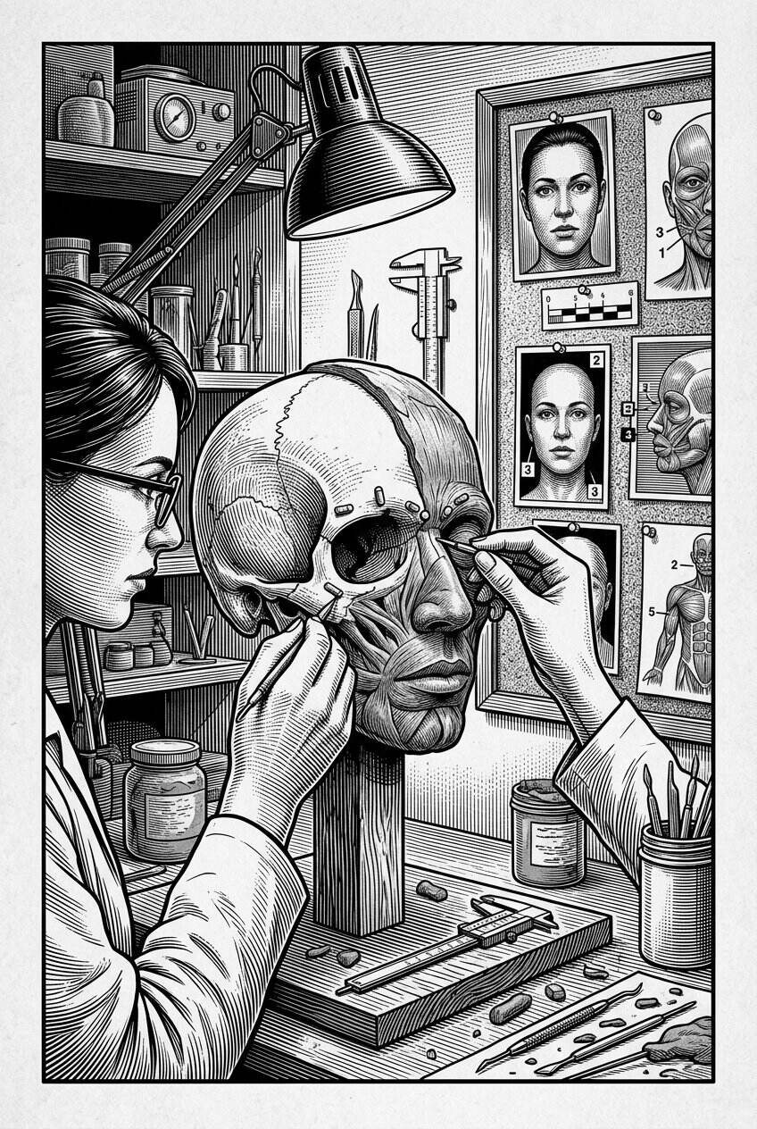
Forensic facial reconstruction, a technological descendant of the identification problem traced earlier in this book, builds a plausible face from a skull when no photograph and no name remain. It is a different craft from the death mask, but it answers a related wish: that a face should be available to the living again.

Grief Finds New Technology
A more recent and considerably more ethically unsettled development deserves mention here, precisely because it extends the underlying impulse this book has traced so far into genuinely new and unresolved territory. In the past several years, a small but growing number of companies and independent researchers have begun offering services that use a deceased person's photographs, voice recordings, written messages, and other digital traces to generate interactive chatbot-style representations, or in some cases synthesized video and audio, intended to allow grieving family members a form of ongoing, if artificial, interaction with a digital approximation of someone who has died. These services, sometimes discussed under informal terms like digital resurrection or grief technology, remain a genuinely new and actively debated area, with ethicists, grief counselors, and technology researchers raising serious and largely unresolved questions about their psychological effects on mourners, the consent of the deceased person whose data is being used to generate the representation, and the commercial incentives of companies operating in this space.
It would be a significant overstatement to describe these digital tools as a direct technological descendant of the plaster death mask in any strict sense — the material, the process, and the immediate cultural context are almost entirely different. But the underlying human motivation connecting them is difficult to miss, and this book would be incomplete without naming it directly: both the nineteenth-century family commissioning a plaster cast of a beloved father's face and the twenty-first-century family exploring a digital chatbot built from a beloved father's old text messages are responding to essentially the same disorienting fact, that a familiar and irreplaceable presence has abruptly stopped being available, and that some direct, tangible trace of that presence might make the absence marginally more bearable. Whether that impulse is served well or poorly by any particular technology, old or new, is a genuinely open question, and one this book, as a work of history rather than of technology criticism or grief counseling, is not positioned to resolve. It is raised here simply because any honest account of why the death mask tradition endures has to acknowledge that the same underlying need it once served has not disappeared — it has simply found new tools, not all of which have yet earned the kind of settled ethical understanding that this book's final chapters have shown museums slowly, imperfectly developing for the physical objects examined throughout its earlier chapters.

The Faces That Keep Finding Us
Beyond these new technologies, the traditional death masks examined throughout this book have found a robust and, if anything, expanding second life in contemporary media and popular culture. Documentary filmmakers, podcast producers, museum curators, and journalists working in the historical mystery and true crime genres have returned repeatedly, across the past several decades, to many of the exact cases this book has explored in detail: the disputed authenticity of Napoleon's several surviving masks, the persistent unsolved mystery of the Kesselstadt cast's connection to Shakespeare, the strange and enduring cultural life of the Unknown Woman of the Seine. Museum exhibitions specifically devoted to death masks and related memorial practices have drawn significant public attention and visitor interest in recent years, suggesting that the underlying fascination this book has traced across several centuries remains, if anything, undiminished by the passage of time or the advent of newer technologies capable of accomplishing similar goals.
This continued attention is not simply idle curiosity, though the element of curiosity this book has been honest about throughout certainly plays a real part. These stories continue to resonate because they sit at a genuinely rich intersection of themes that remain as urgent to contemporary audiences as they were to nineteenth-century ones: the desire to hold onto someone we have lost, the tension between scientific ambition and ethical restraint, the unreliability of even our most confident historical and forensic claims, and the strange, persistent human tendency to find meaning and mystery in the material traces the dead leave behind.
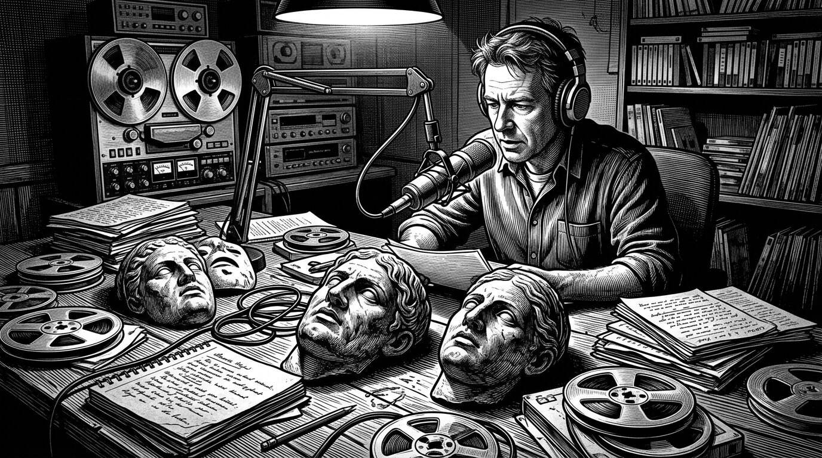
Documentary makers, podcasters, and journalists in the historical-mystery and true-crime traditions keep returning to these objects. The masks have a second life as stories. Public curiosity, which once lined up at the Paris morgue, now arrives through headphones and archive stills.

The Woman Who Is Kissed a Million Times a Year
No single image gathered across this book illustrates the strange, unresolved continuity between the nineteenth-century death mask tradition and contemporary life quite as vividly as the Unknown Woman of the Seine, introduced in this book's opening chapter and examined in greater depth in its fifth. Her identity, as this book has emphasized throughout, remains genuinely unknown, and even the basic facts of her death — whether she drowned at all, whether the mask was ever taken from an actual corpse — remain unresolved and likely permanently unresolvable. And yet, through the well-documented mid-twentieth-century decision to model a cardiopulmonary resuscitation training mannequin on her distinctive features, her face, whoever it actually belonged to, has plausibly been encountered, practiced upon, and by widespread informal tradition even affectionately nicknamed, by an extraordinary number of people across the world in the decades since, through CPR training programs conducted in schools, workplaces, and community centers on every continent.
There is something genuinely fitting, if entirely unplanned, about the fact that an anonymous face preserved by uncertain nineteenth-century sentimentality became, by pure historical accident, the practical vehicle through which an enormous number of ordinary people have learned a skill capable of saving actual, living lives. It is difficult to imagine a more unexpected answer to this book's opening question about why societies preserve the faces of the dead than an unidentified woman's uncertain plaster likeness becoming, quite by accident, one of the most functionally useful objects this book has examined — a death mask whose ultimate legacy has almost nothing to do with mourning or memory at all, and everything to do with the ordinary, practical work of keeping other people alive.
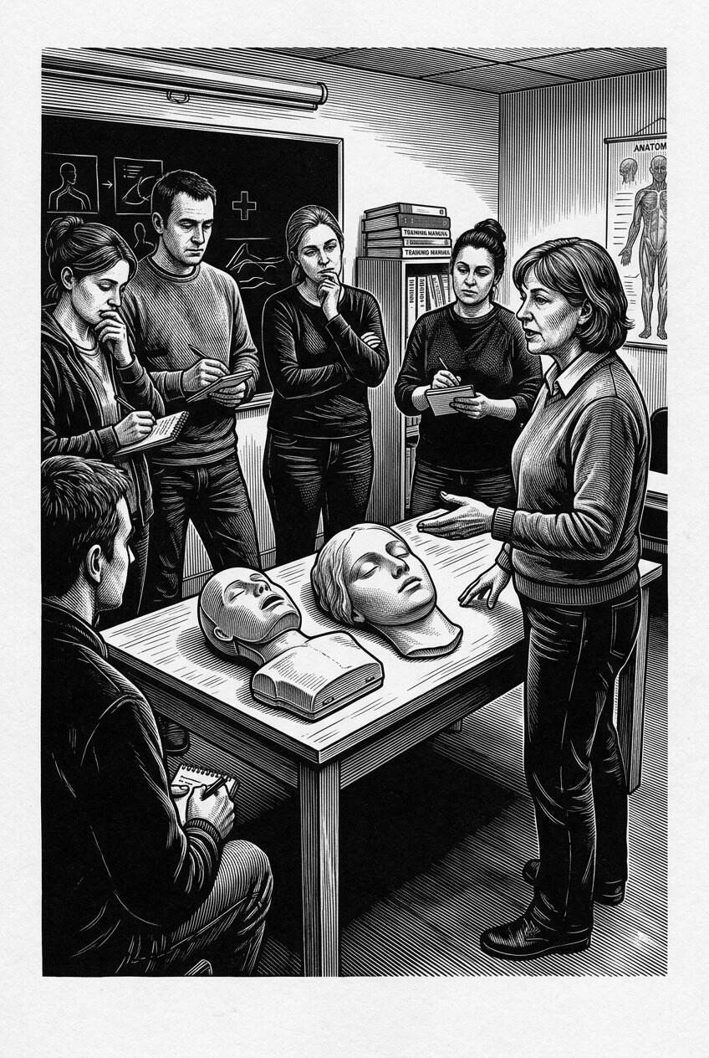
No image in this history binds the nineteenth century to ordinary modern life more tightly than L’Inconnue de la Seine. Her unidentified face, copied into studios and then into a resuscitation manikin, is said to be the mouth on which millions have learned to breathe for others. Identity failed; the likeness did not.

Why We Keep Asking the Same Question
This book opened with a central question: why have societies, across so many different centuries and cultures, repeatedly tried to preserve the face of the dead, and what do those preserved faces reveal about memory, identity, art, science, and our relationship with mortality? Having traced that question through ancient funerary traditions, the emergence of individual portraiture, the death masks of kings and composers and revolutionaries, the darker territory of criminal physiognomy and forensic identification, the material craft of plaster, wax, and bronze, the persistent mysteries surrounding disputed and missing masks, and the genuinely difficult ethical questions confronting the museums that hold this material today, it should be clear by now that no single answer adequately covers the full range of what this book has actually found.
Sometimes the impulse was love, plain and direct — a family wanting something more immediate than a painted portrait, something that had actually touched the person they were grieving. Sometimes it was power, an assertion that a ruler's or a revolutionary's authority deserved a physical record capable of outlasting the body that had carried it. Sometimes it was curiosity dressed convincingly as science, as with the physiognomists and criminologists who genuinely believed, wrongly, that a cast face or measured skull could reveal hidden truths about character and guilt. Sometimes it was the simple, practical hope that a preserved face might someday be recognized, and a name restored to someone who had died without one. And sometimes, as this final chapter has shown, it is something considerably newer and less settled still: a grieving family's attempt to use unfamiliar new technology to hold onto a presence that has become, in an unprecedented way, only partially absent.
Points of orientation
– Love and family memory — the most common and most enduring motive across every period this book has examined.
– Power and political legitimacy — from Roman ancestor images to Napoleon and Lenin.
– Flawed science — physiognomy, phrenology, and criminal anthropology, whose objects retain value today only as evidence of the theories themselves.
– Hope for identification — the unclaimed dead of the Paris morgue and their modern forensic descendants.
– Curiosity and spectacle — wax exhibitions, popular fascination, and the market that has always existed alongside more solemn motives.
– New and unresolved technological grief responses — a still-developing chapter in this same long story.

What a Face Cannot Tell Us, and What It Can
This book has also tried, consistently and deliberately, to resist a temptation that death masks themselves seem almost designed to encourage: the temptation to treat a preserved face as a simple, reliable window into truth, whether about a specific individual's appearance, their character, or the exact circumstances of their death. Chapter after chapter has shown why that temptation should be resisted. Death masks can be damaged, retouched, recast, misattributed, or outright fabricated. The scientific theories once used to interpret them were, in some of the most consequential cases examined in this book, badly and harmfully wrong. Even a mask everyone agrees is genuine records only a single, artificially arranged moment, shaped by the condition of a particular body and the skill and choices of a particular sculptor, not a complete or neutral record of a life.
What a death mask can offer, when approached with the kind of careful, honest scrutiny this book has tried to model throughout, is something different, and in its own way more valuable than a simple, uncomplicated truth: direct, physical evidence of how a particular society, at a particular historical moment, chose to understand and respond to death, identity, fame, guilt, and loss. Read this way, a death mask becomes less a window onto the specific person it depicts, and more a mirror held up to the people who made, kept, studied, displayed, sold, and argued over it in the years and centuries since.

The Face You Cannot Quite Let Go Of
There is a particular kind of silence, described at the very start of this book, that settles over a room shortly after someone has died — not the silence of absence, but the silence of a presence that has just changed its terms. That silence has not changed across the centuries this book has traveled through, even as nearly everything surrounding it has: the materials sculptors reached for, the theories scientists tried and failed to build on top of these objects, the laws and ethical frameworks now governing how museums hold and display them, and, most recently, the unfamiliar new technologies families are only beginning to work out how to use responsibly.
What has remained constant, through every version of this story this book has told, is the underlying human refusal to let a face simply disappear the moment its owner can no longer claim it. That refusal has produced genuine acts of love, genuine artistic achievement, and genuinely important historical evidence. It has also produced flawed science, exploited grief, and troubling collections that modern institutions are still learning how to hold responsibly. Both of these legacies are part of the true history of the death mask, and this book has tried, throughout, to hold them together honestly rather than choosing the more comfortable of the two.
Somewhere, today, in a hospital room or a family home, someone is likely making a version of the same decision examined in this book's opening pages — reaching, in whatever form their own century makes available to them, for some direct, physical trace of a face they are not yet ready to let become only a memory. That decision, repeated across so many centuries in so many different forms, is where this book's story began, and it is where, in one quiet room or another, it will keep on being written, long after the last page of this particular account has been turned.

Bonus Chapter

What the Faces Leave Behind
──────── ❧ ────────
Every object examined in this book began as a stranger's face and ended, eventually, as a question — and a question, unlike a face, never really finishes being asked.

Why Write a Book About Held Breath and Plaster
There is a particular difficulty in writing a history of the death mask that no amount of careful research entirely resolves, and it seems right, now that the ten chapters of this book have run their course, to name it plainly rather than leave it quietly buried beneath the footnotes and the caveats. Every object in this book began as someone's final hours. Behind every plaster cast discussed across these pages sat a room much like the one described in this book's opening pages — a family standing at a slight, respectful distance, a sculptor working quickly against a body that would not hold its expression much longer, a silence that had only just begun. To write about that silence for the length of an entire book is to spend a great deal of time in the company of other people's grief, secondhand and centuries removed, and it would be dishonest to pretend that this company left no mark on how this book came to be written.
What kept this project from becoming simply a catalogue of the macabre, or a museum of curiosities parading past a reader for entertainment, was the recurring discovery, chapter after chapter, that these objects were never really about death at all, not primarily. They were about the people death left behind — the widow who wanted one more physical trace of her husband's face, the sculptor's apprentice trying to master a difficult and unglamorous craft, the phrenologist convinced, wrongly but sincerely, that he was advancing human understanding, the museum curator today trying to decide whether a nineteenth-century collection can be displayed honestly without repeating its original sins. A death mask, it turns out, is a remarkably efficient way of asking what the living owe the dead, and what the dead, in turn, continue to demand of the living long after they can no longer ask for anything at all.

The Hands That Never Signed Their Work
This book opened with a dedication to the largely anonymous artisans who performed this strange, intimate labor across so many centuries, and it seems worth returning to them here, at the close, because their absence from the historical record turned out to be one of the quietest but most persistent themes running through everything that followed. Again and again, across chapter after chapter, this book found itself able to say a great deal about the famous dead — Napoleon, Beethoven, Chopin, Lenin — and comparatively little about the specific, individual hands that had actually done the casting. Josef Danhauser and Auguste Clésinger are, by the standards of this history, unusually well documented; far more of the sculptors and mortuary attendants who performed this work across the centuries examined in this book left no name behind at all, their labor absorbed entirely into the fame of the face they had preserved.
There is something worth sitting with in that asymmetry. The masks themselves survive, in some cases for centuries, carefully conserved, endlessly reproduced, argued over by scholars and collectors. The people who made them, more often than not, do not survive in any comparable way, their skill and their long hours of careful, difficult, emotionally demanding work folded quietly into an object credited, in the end, almost entirely to the person it depicts. This book has tried, wherever the historical record allowed, to give those hands their due. It has not always been able to, and that inability is itself a small, honest confession about the limits of even the most careful historical research: some contributions simply were not recorded, and no amount of later curiosity can fully retrieve what was never written down.

What the Ancient World Refused to Let Us Simplify
Looking back across the earlier chapters of this book, one of the more genuinely useful discoveries, at least for a project like this one, was how thoroughly the ancient world resisted being folded neatly into a single origin story. It would have been easier, in a certain narrative sense, to describe Egyptian funerary masks, Mycenaean gold, Roman ancestor wax, and the later European death mask tradition as one continuous thread, gradually refining itself across the centuries into its familiar plaster form. That version of the story would have been tidier. It would also have been wrong, or at least far less accurate than the messier, more honest picture this book has tried to present instead — a picture in which entirely separate societies, working from entirely separate beliefs about the body, the soul, and the afterlife, arrived independently at broadly similar gestures without ever needing to borrow the idea from one another.
This resistance to false continuity turned out to matter for reasons well beyond simple historical accuracy. It is a reminder, easy to lose sight of in a book organized chronologically and moving steadily forward through the centuries, that the impulse this book has spent so much time examining is not really a single historical development at all. It is something closer to a recurring answer that different human societies, isolated from one another by centuries and oceans, kept independently arriving at whenever they faced the same basic problem: a face that would not hold still much longer, and a group of people who were not yet ready to let it go.

Kings Who Needed Plaster and Prisoners Who Had No Choice
Few contrasts in this book proved more uncomfortable, or more clarifying, than the one that emerged gradually between the masks of the famous and the masks of the condemned. It would have been possible to write an entire, considerably more comfortable book focused only on kings, composers, and revolutionaries — a book about genius and fame and the poignant human desire to remember greatness. That book would have left out most of the actual history. For every mask taken in a grieving family's parlor, there was another taken in a prison mortuary or a public morgue, under circumstances the person it depicted had no power whatsoever to shape or refuse.
This book has tried not to look away from that second category, even when it would have been easier, and more purely enjoyable for a reader, to linger instead on Napoleon's contested cast or Beethoven's familiar plaster face. The masks of the condemned and the unidentified are, in their own way, just as historically significant as the more famous objects examined earlier in this book, and arguably more urgent to understand honestly, because they reveal something the masks of kings and composers largely cannot: exactly how much power, status, and social standing shaped who got to be remembered with tenderness, and who was instead absorbed into someone else's scientific theory, someone else's public spectacle, or simply someone else's professional routine. A death mask, this book has come to understand across its long research, is never only a record of a face. It is also, whether its makers intended this or not, a record of exactly how much the society around that face was willing to value the person behind it.

The Science That Was Wrong and the Science That Worked
One of the more genuinely difficult tensions running beneath this entire project involved holding two very different scientific stories in mind at once, without letting either one simplify the other. Physiognomy and phrenology, examined at length across several chapters of this book, were not simply quaint or old-fashioned; they were actively harmful, providing pseudo-scientific justification for prejudice, for the mistreatment of the condemned, and for theories of criminality that caused genuine damage to real people's lives and reputations. It would be irresponsible for a book like this one to treat that history gently, or to describe it primarily as an interesting historical curiosity rather than what it actually was.
And yet fingerprinting, developed during almost exactly the same historical period, by scientists working in an intellectual culture not entirely separate from the one that produced phrenology, turned out to be genuinely, rigorously, verifiably sound — a real scientific achievement that transformed forensic identification for the better and continues to serve exactly that purpose today. Holding both of these stories together, without letting the failure of one discredit the genuine success of the other, or letting the success of one excuse the genuine harm of the other, turned out to be one of the more demanding balancing acts this book required. It seems worth naming here, at the end, because it captures something true about the larger history this book has told: the nineteenth century's relationship with the dead face was never simply progress, and never simply error. It was both, tangled together, sometimes within the very same institution, sometimes within the very same researcher's career.

Objects That Outlive Their Own Certainty
If there is a single thread this book has returned to more often than any other, it is probably this one: how frequently, and how honestly, this history requires admitting what cannot be known. Napoleon's several competing casts. The disputed Kesselstadt mask. The missing mask of Mozart that popular belief insists must exist somewhere. The uncertain, possibly entirely mythologized story of the Unknown Woman of the Seine. Chapter after chapter, this book found itself arriving at objects whose fame and whose actual documented history had drifted, sometimes quite far, apart from one another.
This was, at times, genuinely frustrating to research and to write. There is a strong, understandable pull toward resolution in any historical narrative, a desire to end each chapter with a settled, confident answer rather than an honest shrug. This book has tried, wherever the evidence actually supported it, to provide exactly that kind of resolution. But it has tried just as hard, in the many cases where the evidence simply does not support a confident answer, to resist manufacturing one anyway, out of a sense that uncertainty makes for a less satisfying chapter. What became clear across the long process of writing this book is that the uncertainty itself is not a failure of the history. It is, quite often, the most historically honest thing this book has to offer — a reminder that even an object as physically direct and seemingly unambiguous as a face pressed into plaster can carry with it centuries of genuine, unresolved doubt about where it actually came from, and whom it actually belonged to.

What We Owe the Dead Who Cannot Speak for Themselves
The chapter of this book devoted to museums and ethics was, by a fair margin, the hardest to write honestly, because it is the one chapter where this book's own present moment is still actively, unfinishedly working out its answers. Every other chapter in this book examines a history that has, in some meaningful sense, already happened — the facts may remain disputed, but the events themselves are over. The ethical questions surrounding how museums, universities, and private collectors ought to treat death masks and the human remains so often held alongside them are not over. They are being argued about, revised, and reconsidered right now, in institutions around the world, by curators and ethicists and, increasingly, by descendant communities whose ancestors' remains were taken without any meaningful consent at all.
This book has tried to describe that ongoing argument honestly, without pretending it has already been settled, and without pretending this book itself has anything definitive to add to it. What this book can offer instead, drawn from everything the preceding chapters have gathered, is a kind of accumulated context: a reminder that the objects at the center of these contemporary debates carry genuinely complicated histories, made under wildly different circumstances of consent and power, and that any responsible answer to what museums owe the dead has to begin by taking that complexity seriously, rather than reaching for a single rule capable of covering every case at once.

A Face Is Never Only a Face
It seems fitting, in closing, to return to the observation that opened this book's very first chapter: that there is something genuinely strange about looking at a death mask of someone whose face you already know. The features are recognizable, sometimes startlingly so, and yet something essential is unmistakably absent, and that absence changes everything about how the recognizable features are actually perceived. Having spent ten chapters and this final reflection examining exactly why societies have gone to such lengths, across so many centuries, to create and preserve that strange, unsettling object, it is worth asking plainly what this book has actually concluded about it.
The conclusion, if it can be called that, is less a single answer than a kind of accumulated respect for the question itself. A death mask is never only a face. It is a face plus everything the society around it decided that face was worth: a family's love, a state's ambition, a scientist's flawed theory, a stranger's unanswered hope, a museum's unfinished reckoning with its own history. Strip away all of that accumulated meaning, and what remains is simply plaster, or wax, or bronze, shaped into the rough approximation of a human face. It is everything this book has tried to add back — the names where they could be recovered, the uncertainty where it could not, the consent that was so often absent, and the love that, more often than this book's darker chapters might suggest, was very frequently present too — that turns that plaster into something worth an entire book's careful attention.

A Closing Word to the Reader
You began this book, several chapters ago now, with a description of the particular silence that settles over a room shortly after someone has died. It seems right to end there as well, because that silence, more than any single mask or any single historical figure examined across these pages, is the actual subject this book has been circling from its first page to its last. Every death mask discussed in this book was an attempt, however imperfect, however scientifically misguided in some cases, however ethically troubling in others, to answer that silence with something — anything — that could be held, examined, and kept.
You will likely never take a death mask yourself, in the old, literal sense this book has spent so long examining. But you have almost certainly already felt the same impulse that produced every object in this book, in whatever quieter, more ordinary form your own life has offered it: a photograph kept a little too carefully, a voicemail never deleted, a handwriting sample folded into a drawer, a scent on an old sweater you cannot quite bring yourself to wash. The materials change. The impulse, this book has tried to show across every one of its chapters, does not. It is, as much as anything else examined in these pages, simply what it looks like to have loved someone, and to still be looking, however hopelessly, for some way to keep a little more of them than time was ever willing to allow.

