# CS 340 README Template

## About the Project/Project Title

Grazioso Salvare Dashboard

## Motivation

Filter animal shelter databases to find potential candidates for animal rescue training.

## Screen Recording Demonstration

## Installation

Jupyter Notebook install:

pip install notebook

To run the notebook:

jupyter notebook

Mongo Shell download and install:

<https://downloads.mongodb.com/compass/mongosh-1.4.2-darwin-arm64.zip>

Run Mongo:

From the shell, use the ‘mongo’ command.

## Usage

### Code Examples

Here we set up the queries necessary to filter the databases according to the needed specifications

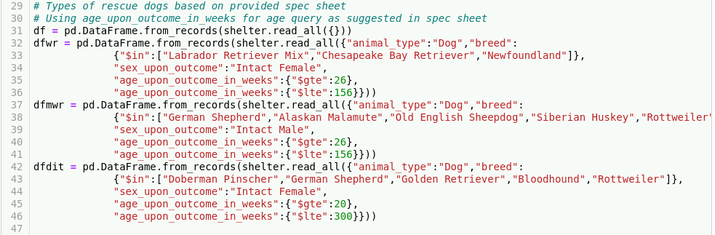

Here is an example of formatting the layout of the dashboard, with an included image (“import base64” required) that contains the hyperlink to SNHU’s website. Line 68 also demonstrates the beginning of using the Dash RadioItems component.

### Macintosh HD:Users:OnyxStudios:Desktop:Screen Shot 2022-06-19 at 4.03.11 PM.png

### Defining the data table

### Macintosh HD:Users:OnyxStudios:Desktop:Screen Shot 2022-06-19 at 4.03.49 PM.png

### Creating filtering functionality from the Dash RadioItems defined previously

### Macintosh HD:Users:OnyxStudios:Desktop:Screen Shot 2022-06-19 at 4.04.15 PM.png

Creating a pie chart based on occurrences found within the dataset and setting titles accordingly. See Dash pie chart documentation for more information

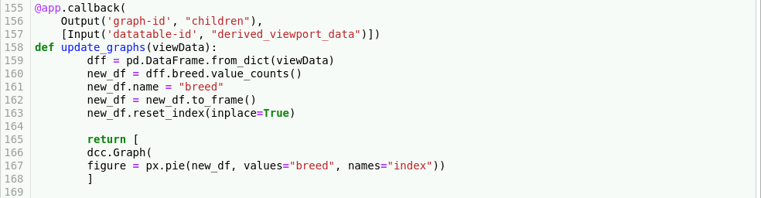

Setting up geolocation map with markers based on the first entry from the data table. Updates according to filtering options

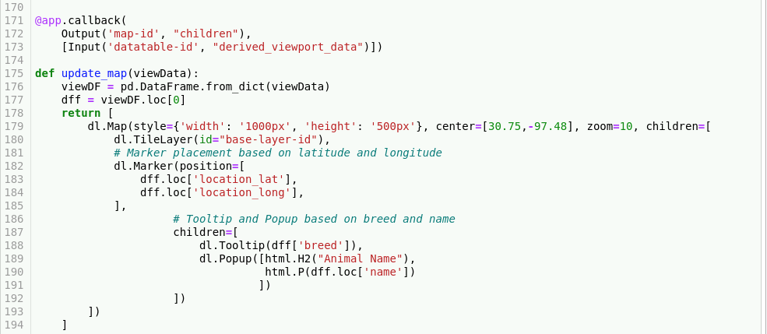

## Roadmap/Features (Optional)

*Provide an open issues list of proposed features (and known issues). If you have ideas for releases in the future, it is a good idea to list them in the README. What makes your project stand out?*

* Currently only the first item in the dataset populates as a marker on the map. Multiple selections with corresponding markers are planned for the future

## Contact

Sergio Udave

[sergio.udave@snhu.edu](mailto:sergio.udave@snhu.edu) – School email

[serg.udave@gmail.com](mailto:serg.udave@gmail.com) – Personal Email