Criteria C

Introduction
The project consist of a web page that shows the weather and forecasts the quality of observation. Also, the users can see on a map how many searches have been made on a location and send contact messages to the admin. The admin can also read them. To differentiate between normal users and admin a login is required. To answer this requirements, the techniques used have been:
- Personal Home Page (PHP) framework for the backend
- Hypertext Markup Language (HTML) and Cascade Stylesheet (CSS) for the Graphical User Interface (GUI)
- Java Script (JS) for the front-end processing
- The MySQL database to store the data
- External Application Programming Interfaces (APIs) as Plotly or Darksky to enhance the functionality.

File structure
The files have been organized following the tree structure:
- /
  - Backend
    - php files
  - CSS
    - style css files
  - JS
    - javascript files and libraries
  - contact.php
  - index.html
  - login.html
  - register.html
  - topcities.html
By doing so the code was easier to read, organize and debug. Also, this allowed me to encapsulate the code, simplifying the debugging.

Web structure and procedures

Main page
The page functionality is presented in the data flow diagram:
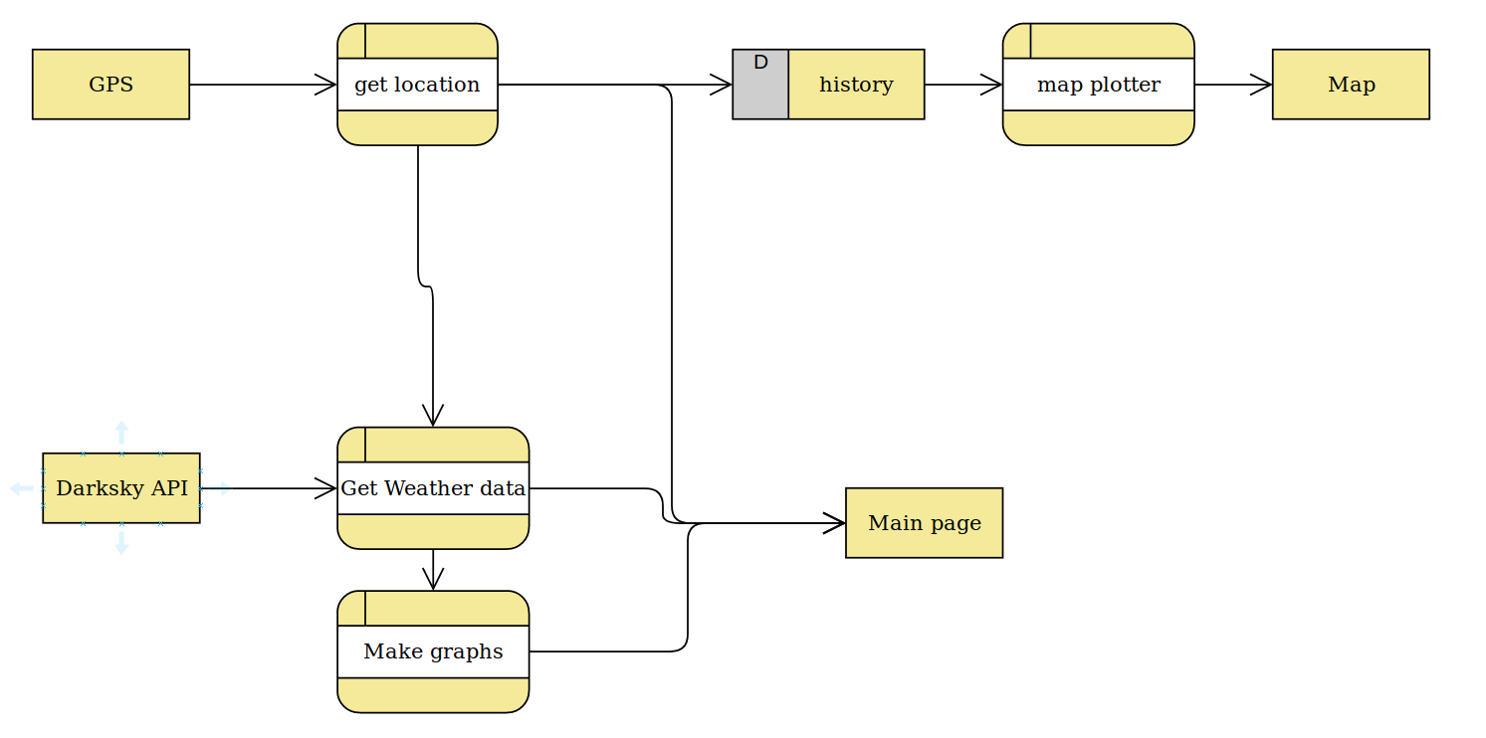
Figure 1. Main page data flow diagram

For this purpose it is necessary to request the location from the browser using JS. This data is sent to the dark sky host using their API, which returns the current weather and the hourly and daily forecast. I only used the current data and the hourly forecast because it is the most precise data. The current data is shown on the right and using the plotly api the hourly forecast is plotted.
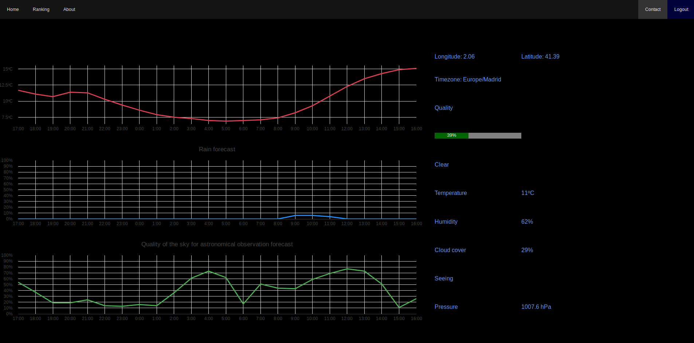
The location is also stored on a database. To keep the user privacy we reduce the precision of the location and keep only the global count of the location with no timestamp.

Map page
When loading the page a js script is executed that loads the data from the database using my own API. It fetches the information from the database and sends it to the client in a json format. The reason for using json is because is the standard to send data between php and js. An example of the code is presented below:
$sql = "SELECT * FROM History";
$result = $conn->query($sql);
$data=[];
if ($result) {
while ($row = mysqli_fetch_assoc($result)) {
$d=[];
$d['lat']=$row['lat'];
$d['lon']=$row['lon'];
$d['count']=$row['count'];
$data[$row['id']]=$d;
}
echo json_encode($data);
}
Figure 2. Request from the server
The data is fetched and plotted using p5js and mappa API. P5js is an API designed for drawing and graphics generation for js. In this case what we did was:
- convert the location and scale to pixels
- draw circles on each location with the radius according to the scale and number of user from that location
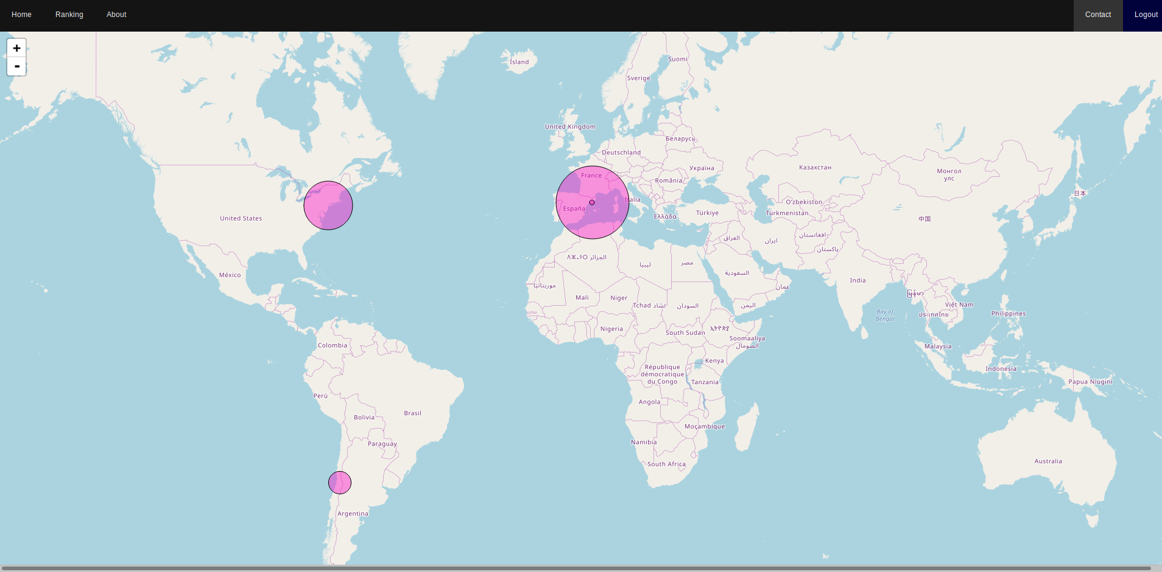

Login and Register
The purpose of login and register the user is to allow the admin to manage contact massage and set a ground for other future improvements.

It is important to provide a robust and secure access. For this purpose, a salt schema is used. When the user registers, a random string is generated(salt). This string is stored with the username and email, as presented in the following code:
$sql = "INSERT INTO user_data (name, password, email,username,surname,salt)
VALUES ('$name','$pw','$email','$username','$surname','$salt')";
if ($conn->query($sql) === true) {
echo "New record created successfully";
} else {
echo "Error: " . $sql . "<br>" . $conn->error;
}
$conn->close();
header('Location: '.'index.html');
Figure 3. Register code
The salt string is prefixed to the password and the resulting string hashed. The hash value is then stored.This way no password is stored in plain text making it more secure.

When a user is logging the salt is retrieved and the same process is applied. The resulting hash and the stored one are compared to check if it is correct, as presented in the following source:
$sql = "SELECT * FROM user_data WHERE username='$lname' OR email='$lname'";
$result = $conn->query($sql);
if ($result->num_rows>0)
{
$row=$result->fetch_assoc();
$salt=$row['salt'];
$pw=hash('sha256', $pss . $salt);
$resp=[];
if($row['password']==$pw){
$resp['status']=1;
$resp['user']=$lname;
$resp['salt']=$salt;
}else{
$resp['satus']=0;
}
}else {
$resp['satus']=2;
}
echo json_encode($resp);
Figure 4. Login code
The result is reported encoded in json. This json includes:
- status: a bite that states if it has been logged in
- username
- salt
Last two is for keep users logged until they press the logout button.

Docker
Docker is a technology that allows developer to execute programs in a contained environments. That way they can be setted up and configured and then it works in any conditions. This is because the complete os is contained in the container preventing compatibility problems when updating.
In this case we will use docker compose which allows us to configure everything in one file and then everything works.
In my case, the config file was:
version: "3.1"
services:
www: //web server
build: .
ports:
- "8001:80"
volumes:
- ./www:/var/www/html/
links:
- db
networks:
- default
db: //sql server setup
image: mysql:8.0
ports:
- "3306:3306"
command: --default-authentication-plugin=mysql_native_password
environment:
MYSQL_DATABASE: astroweather
MYSQL_USER: astroweather
MYSQL_PASSWORD: astroweather
MYSQL_ROOT_PASSWORD: test
volumes:
- ./dump:/docker-entrypoint-initdb.d
- ./conf:/etc/mysql/conf.d
- persistent:/var/lib/mysql
networks:
- default
phpmyadmin: //phpmyadmin set up
image: phpmyadmin/phpmyadmin
links:
- db:db
ports:
- 8000:80
environment:
MYSQL_USER: astroweather
MYSQL_PASSWORD: astroweather
MYSQL_ROOT_PASSWORD: test
volumes:
persistent:

In this file we setup each element: a web server, an sql server and a phpmyadmin. The first one is to be able to have a backend. The second one is to store the database and manage them. The last one is to be able to manage the databases using a GUI.

