Sergio Andres Sanabria Castillo, M1, W4, 29/05/24

TECHNICAL REPORT

Executive Summary
This technical report details the development of a Vehicle Management System, which allows users to manage different types of vehicles, such as cars, motorcycles, trucks, yachts, among others. The system includes subsystems for managing engines, vehicle types, user authentication, and facilitates the creation and manipulation of vehicles.

Introduction
The Vehicle Management System was developed to provide a platform that allows users to perform various operations related to vehicle management, such as creating, searching, and modifying vehicle information, as well as user authentication.

Class diagram

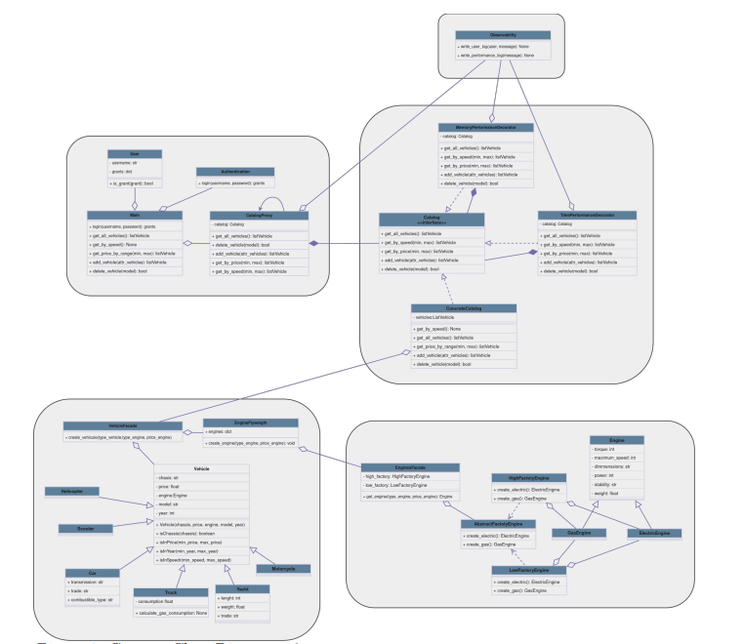

Technologies Used
- Python: The primary programming language used for developing the system.
- Pytest: Framework used for creating and executing unit tests.
- Pylint: Tool used for static code analysis of Python code.
- JSON: Format used for storing user and vehicle data.
- Git: Version control system used for tracking changes in the source code.

System Architecture
The system consists of several interconnected subsystems, each designed to manage a specific part of the system. The main components of the system are:
- Vehicle Subsystem: Manages the creation, searching, and manipulation of vehicles of different types.
- Engine Subsystem: Manages the creation and retrieval of engines for vehicles.
- User Authentication Subsystem: Manages user authentication and authorization to access the system.

Development of Vehicle Subsystem
The vehicle subsystem allows users to create and manipulate different types of vehicles, such as cars, motorcycles, trucks, yachts, among others. An object-oriented architecture was used to model the different types of vehicles, with a base class Vehicle and derived classes for each specific type of vehicle.

Unit Testing
Comprehensive unit tests were developed to ensure the proper functioning of the vehicle subsystem. The tests include:
- Initialization tests to ensure that attributes are assigned correctly.
- Tests of specific and inherited methods to ensure their correct operation.
- __str__ method tests to verify if the string representation is as expected.

Development of Engine Subsystem
The engine subsystem allows the creation and retrieval of engines for vehicles. A Flyweight design pattern was implemented to reuse common engines and minimize object duplication.

Unit Testing
Unit tests were developed to ensure the proper functioning of the engine subsystem. The tests include:
- Verifying that the get_engine method returns the correct engine.

Development of User Authentication Subsystem
The user authentication subsystem allows users to authenticate in the system and access its functionalities. An authentication system based on JSON files was implemented to store and manage user data.

Unit Testing
Unit tests were developed to ensure the proper functioning of the user authentication subsystem. The tests include:
- Verifying that existing users can authenticate correctly.
- Verifying that new users can register successfully.

Create in the code
- A new class HybridEngine was created with an additional parameter.
- Functions for creating small and large engines were created, along with unit tests.
- The creational factory pattern was applied.
Create the function to restore a vehicle. Create the function to search for vehicles by price. Create the function to return a vehicle by model in order to enable vehicle restoration.

Update in the code
- The authentication system was updated to display when a user was logged in.
- The remove_vehicle function in the core and catalog proxy was updated as it was not functioning properly.The creational factory pattern was applied.
- Vehicle search was updated as it was not working correctly.
- Getters in the engine facade were updated.

Conclusions
The Vehicle Management System provides a robust and user-friendly platform for vehicle management. The use of unit tests ensures code quality and system reliability. Further improvements and new features will be considered in future iterations. These updates and creations can be seen in the code with "update Sergio Sanabria" or "create Sergio Sanabria".

