Activity Diagram
Hytte Monitoring System
This activity diagram shows the decision logic of a single monitoring cycle. After the sensors are read and the readings stored, the flow forks (the horizontal bar) into three parallel, independent checks — temperature, energy and security — each of which may raise its own alert. The flows join again, and if any alert was generated a push notification is sent to the owner before the system waits for the next interval and repeats.
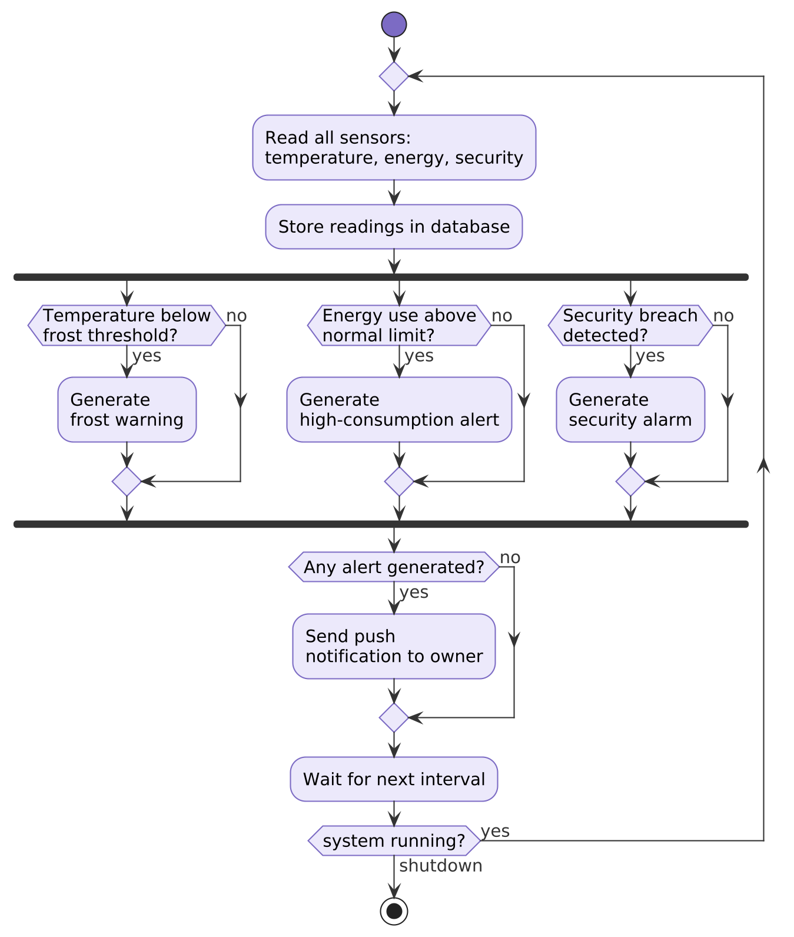
Figure 2. Monitoring cycle logic with parallel threshold checks and consolidated alerting.

