Class Diagram
Hytte Monitoring System
A class diagram shows the system's structure: the classes (types of object), their attributes and methods, and how they relate. In each box, attributes sit above operations; - marks private members and + public ones. The relationships are the key part: hollow triangles are inheritance (TemperatureSensor, PowerMeter and SecuritySensor are each a kind of Sensor); the filled diamond (Cabin–Gateway) is composition, an integral part-of; the hollow diamond (Gateway–Sensor) is aggregation, a looser has-a. Plain arrows with numbers are associations with multiplicities (a Sensor produces many Readings, 1 to *), and dashed arrows are dependencies (Threshold evaluates a Reading).
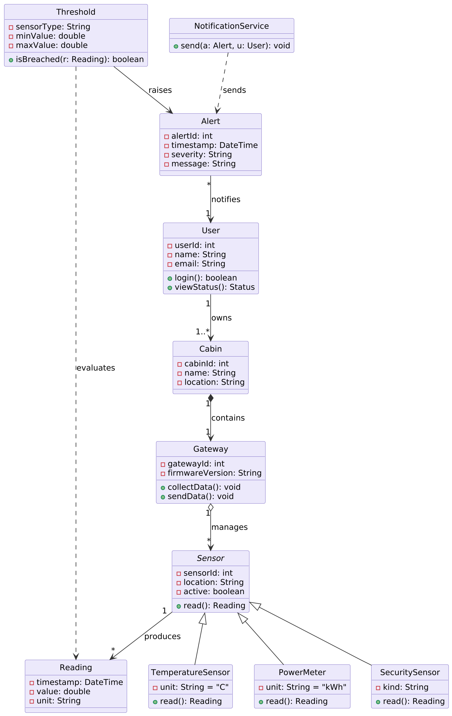
Figure 2. Classes, attributes, operations, and their relationships.

