Sequence Diagram
Hytte Monitoring System
This sequence diagram shows how the system's components interact over time. During each periodic monitoring cycle the cabin gateway reads the temperature, energy and security sensors and reports the readings to the backend server, which stores them and — only when a reading falls outside its safe threshold (the alt fragment) — raises an alert to the owner. The final exchange shows the owner requesting the current status on demand from the mobile app.
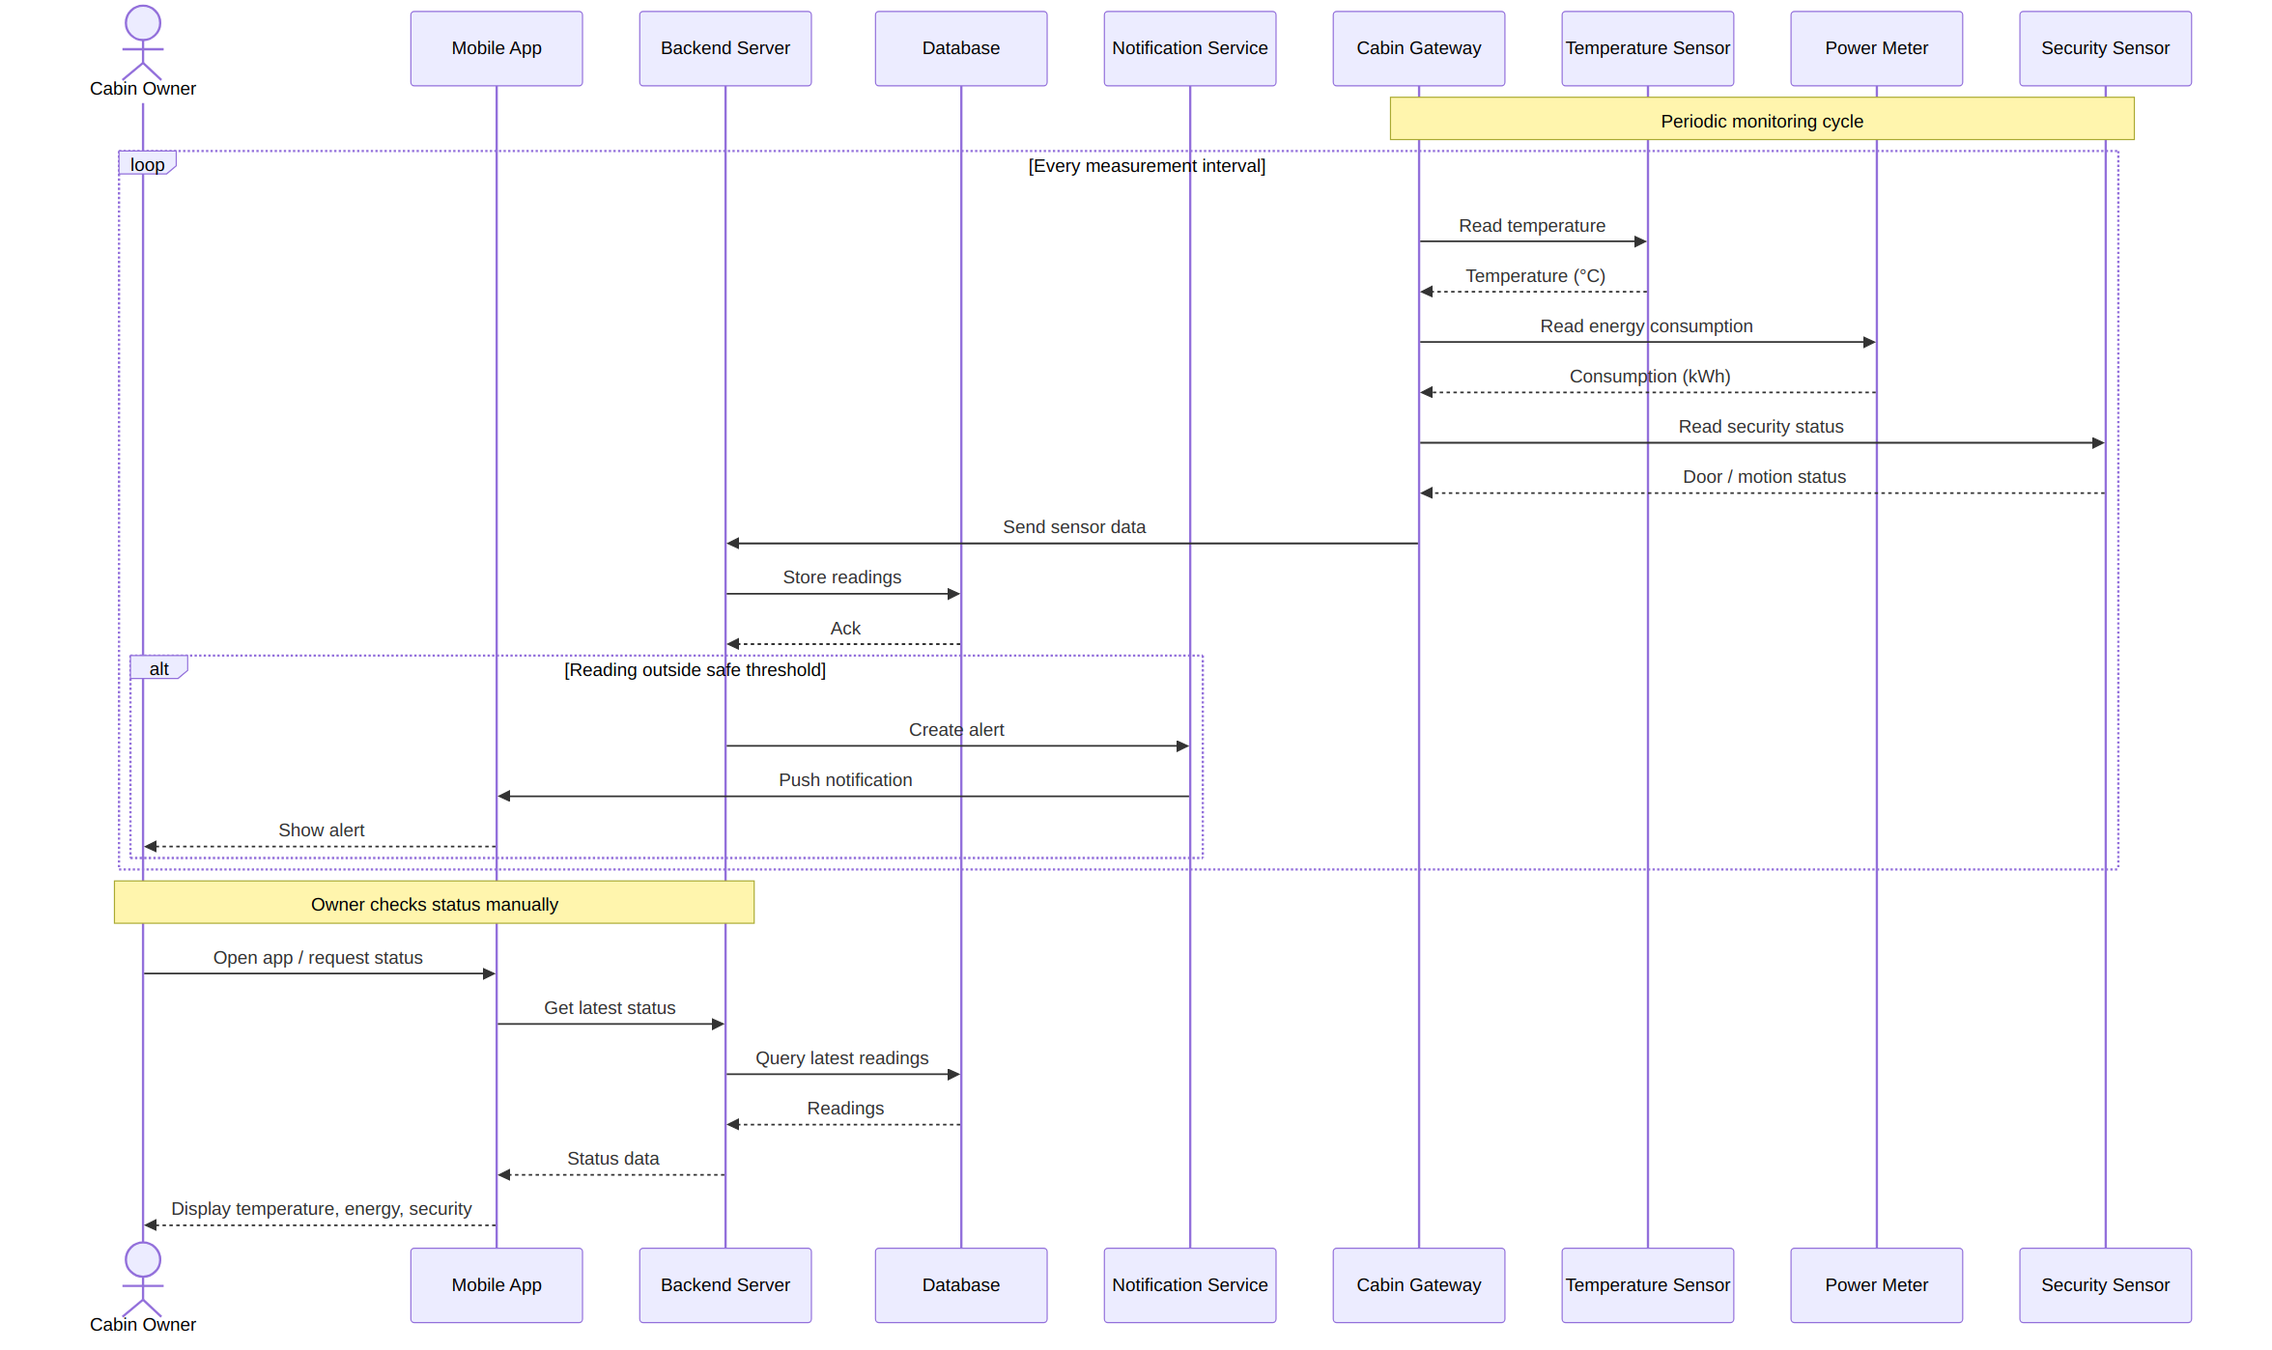
Figure 1. Sequence of interactions for periodic monitoring, alerting, and manual status checks.

