State Machine Diagram
Hytte Monitoring System
A state machine diagram shows the different modes one object moves through over its lifetime, and the events that move it between them. Here the object is the monitoring system. It starts (filled circle) in Initializing, then settles into Monitoring, whose do activity reads the sensors each interval. An out-of-range reading fires a transition into Alarm — a composite state holding one sub-state per concern — and entering Alarm runs an entry action that notifies the owner. Once acknowledged it returns to Monitoring. Losing the link moves it to Offline, and shutdown reaches the final state (the ringed circle). The arrow labels are the triggering events.
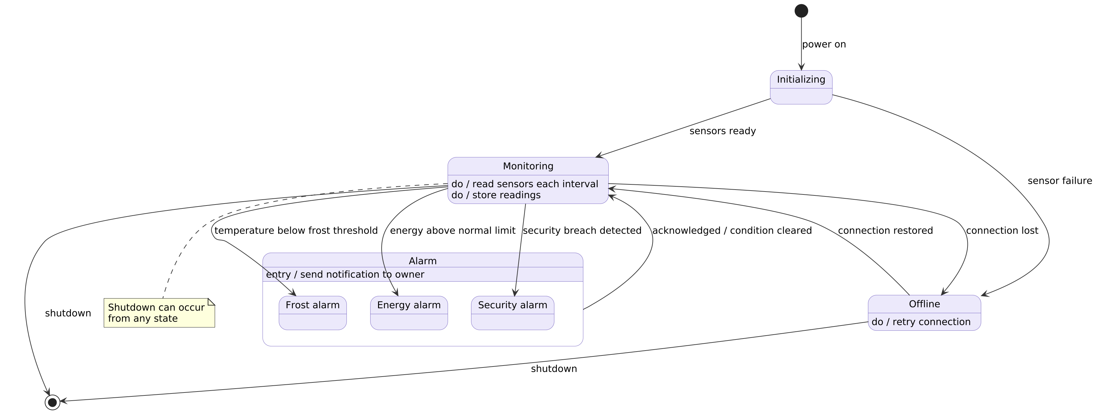
Figure 3. Operating states of the monitoring system and the events between them.

