Use Case Diagram
Hytte Monitoring System
A use case diagram captures what the system does from the outside — the goals each user can achieve — without showing how. The stick figures are actors: the Cabin Owner and Administrator are people, while the Notification Service is an external system the software depends on. The box is the system boundary, and each oval is a use case (a user goal). Two relationships are shown. «include» means a use case always uses another as a sub-step — here the data actions include Authenticate, because you must log in first. «extend» means optional behaviour added to a base case — Acknowledge alert only sometimes follows Receive alert.
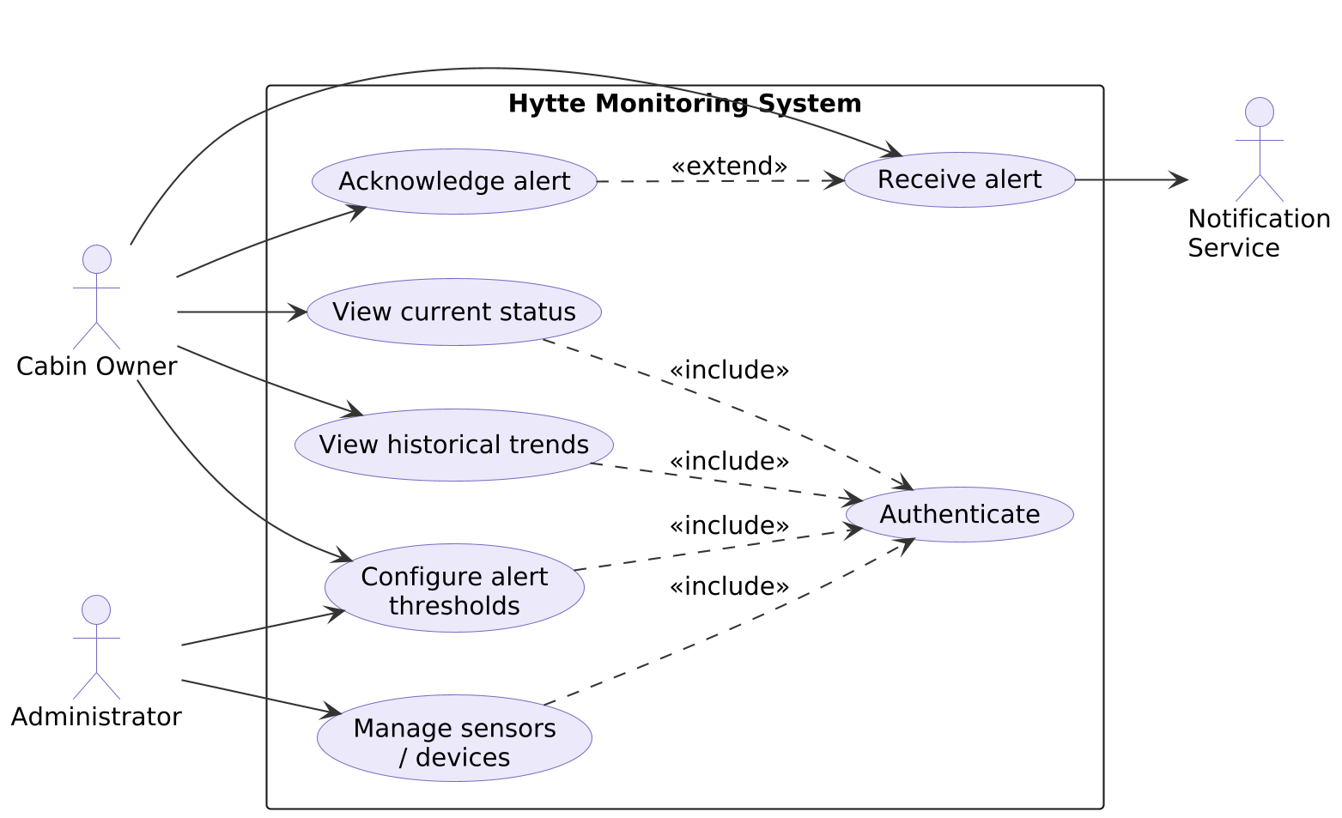
Figure 1. Actors and use cases, with «include» and «extend» relationships.

