Weather Forecast Filtering Web Application
Goian Sergiu
244

This web app allows users to search for any location in the world and get a table of filtered forecasts for the next 7 days, based on temperature limits given as input optionally by the user (min and max temperatures). For filtering, they are compared to min and max temperatures of the every day’s forecats for the given location. Only those forecasts with min and max interval included by the min and max interval given by the user are retrieved. The project is implemented using Jakarta Servlets and JSP pages.

Functional Flow
Users enter:
-a location name
-minimum temperature (optional)
-maximum temperature (optional)
ForecastsServlet validates the inputs
-sets defaults for missing values
-forwards the valid request to WeatherServiceServlet
WeatherServiceServlet:
-calls the Geoapify API to obtain latitude and longitude
-calls the Open Meteo API to retrieve daily forecast info
-filters the forecast results by temperature constraints
-dispatcehs the response with filtered forecasts to the index.jsp
The JSP displays:
-the forecast table
-or an error message if no results match or location coordinates are not found
External Services:
For this task, 2 APIs were used:
-Geoapify Geocoding API: converts location / address to coordinates, which are extracted form the JSON response; this API needs an API_KEY
-Open Meteo Forecast daily API: Retrieves for the extracted coordinates the weather forecast for the next 7 days, for each day a max and min temp, extracted from the JSON response; API_KEY is not required
Components:
The components of the system work interact as below:
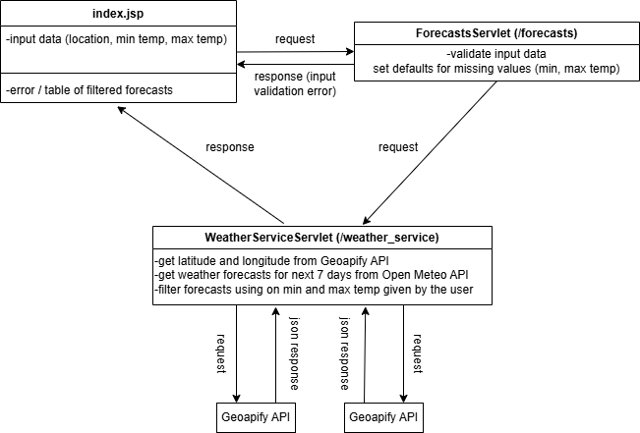
Index:
-collects user input from 3 input fields (location, min temp, max temp), constraints min and max to be only numbers in interval [-90, 90] with an approximation / step of 0.01
-on form submit sends get request to the /forecasts servlet with the query parameters of locaiton, min_temp and max_temp
-displays filtered results in a table format or shows the validation errors
ForecastsServlet:
-validates the query parameters send through the get request from the index.jsp, location must not be empty, min and max must be of type double if send
-if min and max are not send, they are defaulted: min is defaulted to -90, max to 90
-if max > min or location is empty, the response is dispathced back to the index, such that it can be printed as an error
-if all condiitons are checked, the request is dispatched to the /weather_service servlet
-throws ServletException / IOException, both handled by the servlet containers
Methods:
protected void doGet(HttpServletRequest request, HttpServletResponse response)
-reads parameters, validates locaiton and temperatures; forwards request to the WeatherServiceServlet;
WeatherServiceServlet:
Fields:
private final String API_KEY: holds the api key for the Geoapify Geocoding API
Methods:
Coordinates getGeocodingAPICoordinates(String location): calls Geoapify to obtain latitude and longitude, returns them as an Coordinates object
-could throw IOException, handled by the doGet method
List<Forecast> getWeatherAPIForecasts(Coordinates coords): calls Open-Meteo to fetch forecast list for the specific coordinates, returns the results as a list of objects of type Forecast
-could throw IOException, handled by the doGet method
List<Forecast> filterForecasts(List<Forecast> forecasts, double min, double max): filters results between user min/max temperatures
protected void doGet(HttpServletRequest req, HttpServletResponse res):
-connectes all the methods inside the servlet to get the data from API, filter it and send it back to the index
-in case some exception is thrown in one of the API funcitons, it is caught here and send to the index as an error in the response
-catches eventual exceptions from APIs
-could throw ServletException / IOException, both handled by the servlet containers Entity Objects: Forecast:
Fields: date: String, minTemp: double, maxTemp: double
Constructor: +Forecast(String date, double minTemp, double maxTemp)
Methods:
+String getDate()
+double getMinTemp()
+double getMaxTemp()

Coordinates:
Fields: latitude: double, longitude: double
Constructor: +Coordinates9double latitude, double longitude)
Methods:
+double getLatitude()
+double getLongitude()

Dependencies:
-servlets: jakarta-servlet-api
-gson: used for parsing the json response from the APIs

Deployment:
The app was deployed on 3 servlet containers:
Apache Tomcat running on port 8081
Jetty running on port 8082
Wildfly running on port 8083
The .war file was put in the webapps folder inside Jetty and Tomcat, and in ./standalone/deployments for Wildfly. The .war contains the 2 compiled servlets, the jsp and the dependencies.

Example usage:
Use web app on either of: http://localhost:8081/weather_app, http://localhost:8082/weather_app, http://localhost:8083/weather_app
Input:
Location: London
Max: 20
Min: 5
Output:
Date 2025-10-29 7 18
Min 2025-10-30 6 19
Max 2025-10-31 8 17

